A critical evaluation and the identification of next teaching and learning steps focusing on a case study of an individual learner or a group of learners, based on an observed critical incident.

Submitted in partial fulfilment of the requirements of the degree of PCGE Secondary Art and Design

Catrin Angharad Walsh
155397
4103 Words + Appendices (1000 words)
October 2020

‘Nothing has such power to broaden the mind as the ability to investigate systematically and truly all that comes under thy observation in life.’
Marcus Aurelius (121 AD – 180 AD)

Introduction
Critical incidents in teaching are invaluable opportunities for educators to analyse and review their own teaching methods based on real life occurrences. The discussion of critical incidents within the context of a learning environment, are key to unlocking new and potentially better teaching and learning steps. Analysing critical incidents enable us to uncover flaws in previously unquestioned assumptions of right and wrong within the classroom environment.
What can be considered a critical incident is simply any unplanned event that one can critically analyse and reflect on the reasons behind why it happened. The moment an incident becomes critical is when we bring critical thinking into the equation. To paraphrase David Tripp, ‘critical incidents don’t just happen, they are created’ (Tripp, 2011). This incident can form the basis of an in depth investigation and reflection. Reflecting upon this newly acquired information, teachers can develop insights and then use these insights to address the inconsistencies they discover between theory and reality by reconstructing their thinking and action. Without reflection on teaching practices there can be no professional or personal development, which are both essential for remaining relevant and effective in the field of education, ultimately for the benefit of the learner.
This essay firstly evaluates and identifies a critical incident, then explores the next teaching and learning steps by focusing on the case study of a lesson in a secondary school classroom. Secondly it delves deeper into the reasons and methodology behind the case study, which is based on an observed critical incident. Finally, it reflects on the incident with a view to personal and professional development.
Observation
While undertaking this observation, close consideration was given to the ethical guidelines for educational research set by the British Educational Research Association (BERA). In any educational research, it is of vital importance to understand and apply ethical and responsible practice. The school where the observation took place is an English-medium 3 to 16 all-age school. It opened in 2015 and was created through the amalgamation of three secondary schools and one primary school. There are currently 1,512 pupils on roll, 1,226 of whom are of secondary school age. According to a report by Estyn in 2019, over 30% of pupils are eligible for free school meals, which is higher than the national average, and over two-thirds of pupils live in the 20% most deprived areas of Wales. The percentage of pupils with additional learning needs is around 26%, which is again higher than the national average of 22.9%. Currently, about 9.2% of pupils have statements of special educational needs, which once again is well above the national average of 2.2%. It is therefore true to say that the school faces many challenges as it seeks to engage with its learners. The school focuses on promoting the acquisition of knowledge, the development of a wide range of skills and the understanding of key concepts. In addition, the curriculum in the school includes the development of personal qualities, attitudes and values.
On the day of the observation, I arrived for an 8am start to firstly familiarise myself with the timetable for the day and review other school documents including the risk assessment. Due to the current situation of Covid-19, extra precautions are in place to ensure the safety of learners. Year 7, 8 and 9 learners remain in the same groups and rooms for the duration of the school day, while the teaching staff rotate around them. Other measures that are in place at the moment include teachers having to stand and teach from the front of the classroom, while trying to maintain a distance of two metres as much as possible. Without the freedom to move around the room, the learning environment has changed considerably.
I observed five year 8 lessons in total. The learners in this class were of different abilities, but the majority were described as ‘relatively challenging’. There were twenty learners in the class for each of the five lessons, with teachers rotating between classrooms. I was welcomed to sit at the front left side of the classroom on a desk that gave a wide view of the class, including the teacher, the interactive board, and the learners’ faces. At certain points, the learners became easily distracted and noisy. Any change, for example, the transition between lessons, caused a lot of disruption in particular, despite the learners remaining in the same room. Towards the end of the day, there was an unplanned fire alarm, which further disrupted the learners. The lessons observed, along with the teaching styles varied greatly. I entered this day of observation with a set of predetermined objectives, however, I took care not to allow them to completely dictate what would be noted down or further investigated.

Methodology
All research demands the organisation of concepts in order to build bridges between what is known and what is to be discovered. Educational research is no exception. Specific research methodologies and a range of approaches are used to gather and interpret data. This data is then used as a basis for inference and interpretation, for explanation and prediction. (Cohen, Manion and Morrison, 2007) As natural observers of the world around us, it is no surprise that we gravitate towards observation methods in order to collect data. Most of our observation is routine, we don’t put conscious thought into it. We observe in order to gather information, most of the time this is unsystematic (Merriam and Tisdell, 2016). The difference between routine observation and research observation comes when it is systematic, thought out and answers a specific question.
The methodology I have used in order to observe is a case study. A case study is an investigation into a specific instance or phenomenon in its real life context (Anderson and Arsenault, 2002). As with every other observation model, case studies have both their advantages and disadvantages. Being naturalistic in nature, what makes a case study difficult is the fact that ‘the social and educational world is a messy place, full of contradictions, richness, complexity, connectedness, conjunctions and disjunctions’ (Cohen, et al, 2007). Firstly, some of the disadvantages are that the researcher inevitably falls into the trap of invoking their privilege of interpretation. Applying their own assumptions to an incident can unfortunately narrow their findings and prove limiting. Our biases can cloud our objective analysis and put into question the validity of our findings. It is also easy to become overloaded with input and lose sight of the focus of the study in the first place.
Despite its limitations and variables, the case study approach has many benefits. Case studies take place in real life contexts, giving depth and scope to research. The study can be broad but also has the potential to become an investigation into a specific phenomenon. My decision to use a case study stems from the fact that it allowed specificity in the creation of an observed critical incident, allowing ideas to grow and questions to be asked. Putting into question what has happened, what caused it to happen and why is it happening. In this instance, the case study falls into the category of a non-participant observation technique since there is no engagement between the observer and the observed.
Critical Incident
I had the opportunity to observe the same group of year 8 children for the entire school day. The critical incident at the heart of this case study took place in an English lesson. The lesson started with a brief recap of what the class had been studying previously, this being ‘what is an adjective?’ The question was written of the board as a visual cue and aide memoir that the learners could refer to when considering and answering questions. This starter took around ten minutes to complete and was discussion based. Only the most vocal children took part in this section and were encouraged to shout out their answers to the teacher. After this, the learners were shown a short clip from the film ‘Harry Potter and the Prisoner of Azkaban’. They were simply asked to watch the clip in silence, not looking out for anything in particular. After watching it, there was an open class discussion about what they had seen and how they would describe it. They were given the opportunity to take notes and record their own thoughts and the thoughts of their classmates. The remainder of the lesson was focused on the task of writing their own paragraph describing a setting from their own imagination titled ‘my setting’. The teacher set a time limit in which they were to complete the task and a timer was displayed on the board to help them stay on track. Some learners who were struggling with the task were presented with a slightly less challenging option with support from the teacher. After a brief conversation about what they were finding hard, the learners who were having difficulty of knowing where to start were asked to describe the scene from the film clip that they had watched. The teacher discussed ideas with them before they started to work independently. One learner continued to be disruptive and refused to write anything, nothing was done about this or his lack of interaction with the lesson in general. Those learners who were engaging with the task seemed enthusiastic and happy with the work set.
It was at this point I noted an interesting incident, which I have chosen to investigate in this essay. Towards the end of the lesson, one girl spoke out and was very keen to share what she had written in her exercise book. Though unplanned, the teacher was pleasantly surprised and delighted that the learner wanted to share with the class. The teacher encouraged the learner to speak while the class listened intently. She stood up at her desk and read very confidently and received a round of applause from the rest of the class. Subsequently, four other learners asked if they could do the same. There were other learners who really wanted to share their work however, time was running out and the lesson came to a close. It was clearly visible on the learners’ faces that they had really enjoyed this section of the lesson. It was an example of learner-led learning and was extremely effective as the learners felt as though they had some autonomy within the classroom. They displayed focus when listening to their peers, possibly because they were hearing a different voice to that of the teacher. The sense of engagement, responsibility and ownership of their own learning, even for a few minutes, is one example of how to build up confidence and communication skills. As a whole the lesson had had an organic and fluid feel where the voices and needs of the children were acknowledged and understood. There were clear correlations between this lesson and the four ‘purposes’ outlined in ‘Successful Futures – Independent Review of Curriculum and Assessment Arrangements in Wales’ (Donaldson, 2015). Donaldson addressed the issue of how to improve attainment and identifies what children and young people in Wales should become and achieve through their school education. He proposed that the four purposes of the curriculum are that all learners should be:
- Ambitious, capable leaners, ready to learn throughout their lives.
- Enterprising creative contributors, ready to play a full part in life and work.
- Ethical, informed citizens of Wales and the world.
- Healthy confident individual, ready to lead fulfilling lives as valued members of society.
The observed critical incident particularly relates to the second of the four purposes in that the learners displayed the ability to think creatively and grasp an opportunity to express ideas and emotions. The critical incident also highlighted the transferable skills of the learners who have the potential to use these skills to the benefit of others.
Literature Review
There are several interesting avenues to take and explore further based on this critical incident. It opens up a discourse about learner centred teaching and ways in which educators could enhance peer learning. It also invites us to explore the meaning and possibilities of long term, inter-dependent collaboration within the classroom. To develop an in depth evaluation of these key issues, it is important to consider and refer to the existing literature. Firstly, we will look at the nature of collaboration in the classroom, specifically from a constructivist viewpoint. Secondly, we focus on the positive effects these strategies can have on the emotional and mental health and well being of learners, with reference to the critical incident. While considerable research supports the idea and implementation of peer learning and collaboration as part of learning and teaching methods, relatively little research exists to link this strategy with effect on health and well-being. That being said, one could argue that the links exist and are evident.
Collaboration is Key
The idea of a learner assuming an active and participatory role in the classroom is not a new approach to teaching or learning, but one that is not always implemented in an effective way. The roots of this particular approach lie in constructivism. Constructivism is a pedagogical theory developed in the early 20th century. An early pioneer of this education theory was Russian educational theorist Lev Vygotsky (1896-1934) who, unlike theorists of behaviourism, believed that learning should be embedded in experience. This approach is based around the idea that taught content and skills should be built upon the prior knowledge of the learner, and ideally assessed formatively rather than only summatively. Therefore, enabling learners to become more self-aware and develop critical thinking. The main thread running through this theory is that the learner ultimately takes an active and participatory role in his or her own learning and is a great way of engaging learners. The role of the teacher, therefore, is to guide and facilitate learning rather than serve merely as ‘transmitters’ of information. Greek philosopher Plutarch (046 AD – 120 AD), is apparently quoted as saying, ‘The mind is not a vessel that needs filling, but wood that needs igniting.’ This evocative analogy essentially summarises Vygotsky’s principal of activating and building upon prior knowledge rather than ‘starting from scratch’. The constructivist approach places emphasis on the concept of the ‘zone of proximal development,’ which Vygotsky defined as follows:
“…the distance between the actual developmental level as determined by independent problem solving and the level of potential development as determined through problem solving under adult guidance or in collaboration with more capable peers” (Vygotsky and Cole, 1981).
Despite the wide acceptance of these ideas, not all theorists are in complete agreement with contemporary interpretations. According to Gredler, (2012 p119) there are problems with later interpretations of Vygotsky’s theories. Specifically, Gredler challenges the extent to which learners can facilitate their own cognitive development without the direct intervention of adults. Quoting Vygotsky, Gredler writes that, learners’ conversations, “cannot serve as a source of any significant development for them” (Vygotsky, 1934/1994). However, laying aside the objections of Gredler, it is evident that cooperation and collaboration contribute significantly to the learner’s development. The key theme we can extract and explore further from this definition is collaboration. Without collaboration between teacher and learner and between peers, it is difficult to bridge the gap between ‘actual development’ and ‘potential development’. Jean Piaget (1896-1980) would later develop this theory further and construct the four stages of development (Bates, 2016).
A key point within the framework of the new Curriculum for Wales, is that ‘in order to fully engage with learning, children and young people require rich, stimulating environments where they can explore and experiment with ideas and resources, collaborate actively with their peers and make dynamic connections with a clear sense of purpose to construct meaning’ (Donaldson, 2015). To unpack this, in order to engage with learning and actualise this predominantly constructivist approach to learning and teaching, specific environments are required. Environments must be stimulating and open to exploration and experimentation. In these collaborative spaces, dynamic learning can take place in which learners can build skills in communication, critical thinking and creativity. All three of which are innately human characteristics and essential for learning and growth. This way of thinking can be applied not only within a specific classroom or lesson, but also more widely across disciplines. Cross-curricular and inter-disciplinary planning, teaching and learning are at the heart of the new Curriculum for Wales. The integrated approach aims to enable learners to develop a sophisticated understanding of key knowledge with consideration to the wider context of what they are learning (www.hwb.gov.wales).
Within the environment of the classroom, learners will have a diverse range of learning styles, meaning not every child will learn in the same way. This was apparent in the observed critical incident. Some learners were content to listen and take in the information while others wanted to verbalise and share ideas aloud. Certain learners required more support in generating ideas than others. In this example, the teacher was able to provide scaffolded support, which is a key aspect of the Zone of Proximal Development (Kozulin, et al, 2003). Meaning that teachers are able to meet the learner where they are on their own learning continuum rather than running into the issue of cognitive overload. Within this case study, there was an example of the teacher providing scaffolded support to a learner through communication and exchange of ideas. Even more interestingly there was an example of peer scaffolding, where one learner encouraged her peers through reading her piece of writing out loud. While the teacher did not plan this occurrence, it was encouraged to continue resulting in learner initiated learning. Scaffolding takes place in a social context where collaborative input is required from both the learner and teacher. During the critical incident the lesson changed course to the benefit of the whole class. The critical incident demonstrated the value of learner centred learning and, one could argue, the positive effects this has on health and well-being.
Heath and Well-Being
There are various and often-complex definitions of ‘health and well being’. Different people’s definitions will be influenced by their own socio-cultural context. Within the constitution of the World Health Organisation, it states that ‘health is a state of complete physical, mental and social well-being and not merely the absence of disease or infirmity’ (www.who.int). This definition recognises that health and well-being is all encompassing. Acknowledging the physical, mental and emotional aspects, not as isolated areas, but unified components is key. The new curriculum for Wales places a big emphasis on understanding the importance of the health and well being of children and young people in Wales, dedicating one of the six ‘Areas of Learning and Experience’ to it. Within the guidelines for the new curriculum it summaries the area as follows:
“The Health and Well-being Area of Learning and Experience (Area) provides a holistic structure for understanding health and well-being. It is concerned with developing the capacity of learners to navigate life's opportunities and challenges. The fundamental components of this Area are physical health and development, mental health, and emotional and social well-being. It will support learners to understand and appreciate how the different components of health and well-being are interconnected, and it recognises that good health and well-being are important to enable successful learning” (www.hwb.gov.wales).
From this holistic point of view, health and well-being encompasses and connects all the components for the physical, mental, emotional and social development of children and young people. Therefore, reinforcing the fact that a multi-dimensional perspective is essential in order to understand the meaning of health and well-being and how best to promote both (Rose, Gilbert and Richards, 2016).
So why are each of these areas and their inherent interconnectedness important in enabling successful learning? Now that we’ve established a general idea of health and well being, let us consider the observed incident that initiated this enquiry. Essentially, an encounter occurred between learners and a positive learning environment. An environment in which, they felt supported by the teacher and peers, safe to express ideas. Of course there are other spheres of experience that exist outside of the classroom environment that have an effect on each individual learner’s development. These other environments or ‘circles of influence’ (Bronfenbrenner, 2005), that children and young people encounter are identified in Bronfenbrenner’s ecological theory and are made up of different layers that include firstly the microsystem, secondly the exosystem and thirdly the macrosystem. The relationship between each is known as the mesosystem (Rose, Gilbert and Richards, 2015, p.5). All three of these layers of experience with the child being at the very centre all effect each other. Each layer does not exist in isolation but works in relation to, and even in collaboration with each other in what Bronfenbrenner (2005) describes as a ‘bi-directional’ relationship. Based on this idea, we can conclude that children and young people play an active and participatory role in their own development and learning.
In this case study, by allowing the learner to express and speak their ideas to the class, the teacher empowered the learner to be an active participant in their own learning. This in turn, according to Rose (2015, p.85), raises confidence and self-esteem by developing a sense of achievement. According to Boyden and Dercon (2012), participation in meaningful activates generates opportunities of satisfaction as a significant contributor and so improves well-being, self esteem, and mental health.

Reflection, Evaluation and Next Steps
Through observation we have been able to gather data and identify areas of research, however, this observation is ultimately futile without reflection. Just as observation is second nature to us, so too is reflection, but it needs to be approached critically. So what makes reflection critical in the context of education? Brookfield (2017) states that, ‘critical reflection is quite simply, the sustained and intentional process of identifying and checking the accuracy and validity of our teaching assumptions.’ These assumptions that Brookfield mentions arise from numerous sources and are essentially indwelt beliefs of the world and our place within it. They may be informed by our own understanding derived from personal experience or from other thinkers. Brookfield (2017) argues the point that we should consistently ‘unearth’ and ‘scrutinize’ our teaching assumptions through the eyes of others and our own experience. This is the basis of any critical reflection. Looking through Brookfield’s four lenses of critical reflection can illuminate different parts of our own teaching. The different lenses include that of the student, colleagues, personal and theoretical. The objective of peering through these lenses is, as has already been stated, to shed light on our teaching practice and challenge existing assumptions with a view to personal and professional development. If one is able to integrate critical reflection and make it habitual in one’s own practice, then instead of just ‘fixing’ problems encountered, one is able to take a stance of permanent inquiry (Brookfield, 2017, p.80). Based on continual critical observations and reflections, we are able to make informed decisions about our next learning and teaching steps. Informed action can only be taken against the backdrop of critical reflection. This process is lengthy and happens incrementally over time, just as learning is a continuum, so too is reflection.
Based on this case study of a critical incident, there are implications for the future of my own practice and development that will be carried forward into my teaching. In understanding the benefits of creating an active and collaborative learning environment, I will be able to support learners by meeting them where they are on their individual learning continuum. Through whole class engagement and by allowing learners to be participators in lessons they will have the opportunity to make decisions about their own learning.
It is important to note that all these multi-faceted environments mentioned by Bronfenbrenner (2015), will impact a child’s learning and development. This will be particularly evident currently due to the Covid-19 pandemic, where we are seeing learning environments rapidly changing and adapting. A study is set to be carried out by the Mohn Centre for Children’s Health and Wellbeing at Imperial College, London and will draw on the experience of 5,000 teenagers since the closure of schools in March 2020 (O'Hare and Campus, 2020). A surge of screen exposure as remote learning increases, combined with limited physical and social activity is likely to have a huge impact on the health and well being of learners. This is something important to bear in mind moving forward, especially in relation to teaching methods.

Conclusion
In conclusion, it is useful to summarise what methods of research have been undertaken in order to arrive at this point. This investigation commenced with the objective of carrying out a critical evaluation and identification of next learning and teaching steps. The methodology used to achieve this was an observation in the form of a case study, which was designed to inform and promote critical reflection of an incident. Throughout this study, the effectiveness of teacher-to-learner and peer-to-peer collaboration has been evaluated, and the positive effects on the health and well being of learners noted. The thoughts outlined in the reflection, focus on what has been learned and what can and will be carried into professional practice. Reflective practice is essential in professional development. Through continued reflection upon my own practice I aim to build upon the learning gained through undertaking and evaluating this critical incident. The implementation of rigorous self-reflection backed up by thorough research is the key to increasing understanding of learners and their development. Reflective practice underpinned by a strong evidence base is essential in supporting the development of a dynamic and collaborative learning space in the classroom. Such practice is fully aligned to the values and dispositions of the new Professional Standards for Teaching and Leadership in Wales, namely, pedagogy, leadership, collaboration, innovation and professional learning (Hwb.gov.wales.) The development of which will enable learners to thrive within a supportive and creative environment.

References

Anderson, G. and Arsenault, N., 2002. Fundamentals Of Educational Research. London: Routledge Falmer, pp.152-160.
Bassey, M., 1999. Case Study Research In Educational Settings. Buckingham [England]: Open University Press.
Bates, B., 2016. Learning Theories Simplified. London: SAGE, pp.46-47.
Bera.ac.uk. 2019. Ethical Guidelines For Educational Research, Fourth Edition (2018). [online] Available at: https://www.bera.ac.uk/publication/ethical-guidelines-for-educational-research-2018-online#participants [Accessed 25 October 2020].
Boydon, J and Dercon, S., (2012). Child Development and Economic Development: Lesson and Future Challenges. Available at: https://www.gov.uk/research-for-development-outputs/child-development-and-economic-development-lessons-and-future-challenges-190009
Bronfenbrenner, U., (2005) Making Human Beings Human: BioecologicalPerspectives on Human Development. London: SAGE.
Brookfield, S., (2017), Becoming A Critically Reflective Teacher. San Fransisco: Jossey-Bass.
Cohen, L., Manion, L. and Morrison, K., (2011), Research Methods In Education. 7th ed. Abingdon: Routledge, pp.47, 170.
Donaldson, G., (2015), Successful Futures. [ebook] pp.28-31, 66-67, 69-70. Available at: https://gov.wales/sites/default/files/publications/2018-03/successful-
Gredler, M.E., (2012), Understanding Vygotsky for the Classroom: Is it too late? Educational Psychology Review, March 2012, Vol 24 No.1 pp. 113-131.
Hwb.gov.wales. 2020. Health And Well-Being: Introduction - Hwb. [online] Available at: https://hwb.gov.wales/curriculum-for-wales/health-and-well-being/ [Accessed 24 October 2020].
Hwb.gov.wales. 2020. Introduction - Hwb. [online] Available at: https://hwb.gov.wales/curriculum-for-wales/introduction/ [Accessed 25 October 2020].
Hwb.gov.wales. 2020. Professional Standards for Teaching and Leadership. Available at: https://hwb.gov.wales/api/storage/19bc948b-8a3f-41e0-944a-7bf2cadf7d18/professional-standards-for-teaching-and-leadership-interactive-pdf-for-pc.pdf
Kozulin, A., Gindis, B., Ageyev, V. and Miller, S., (2003). Vygotsky's Educational
Theory In Cultural Context. Learning In Doing. Cambridge University Press, pp.48-49.
Merriam, S. and Tisdell, E., (2016). Qualitative Research: A Guide To Design And Implementation. San Fransisco: Jossey-Bass, p.138.
O'Hare, R. and Campus, S., (2020). Exploring The Impact Of COVID-19 On Teen Mental Health | Imperial News | Imperial College London. [online] Imperial News. Available at: https://www.imperial.ac.uk/news/206853/exploring-impact-covid-19-teen-mental-health/ [Accessed 24 October 2020].
Rose, J., Gilbert, L. and Richards, V., (2015). Health And Well-Being In Early Childhood. London: SAGE Publications, p.3.
Stake, R., (1995). The Art Of Case Study Research. Sage Publications.
Tripp, D., (2012). Critical Incidents In Teaching: Developing Professional Judgement. Abingdon: Routledge as part of the Taylor and Francis Group, p.8.
Vygotsky, L. and Cole, M., (1981). Mind In Society. Cambridge, Mass: Harvard Univ. Press.
Vygotsky, L.S., (1994), In R. Van der Veer and J. Valsiner (Eds.), The Vygotsky Reader (pp338-354), Cambridge: Blackwell. Original work published 1935
Estyn.gov.wales. (2020). Welcome To Estyn | Estyn. [online] Available at:
https://www.estyn.gov.wales/ [Accessed 25 October 2020].

Who.int. (2020). Constitution. [online] Available at:
https://www.who.int/about/who-we-are/constitution [Accessed 25 October 2020].

Appendix 1

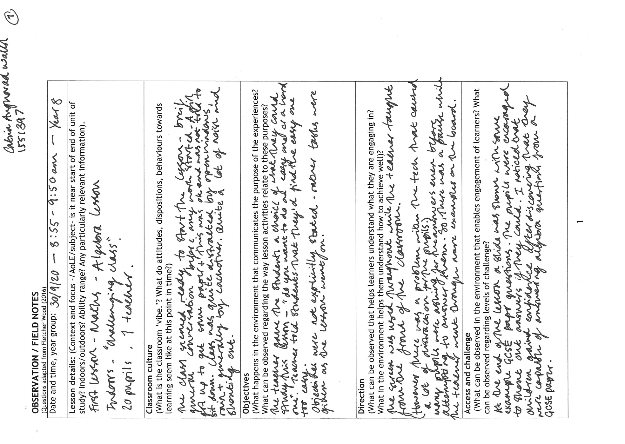

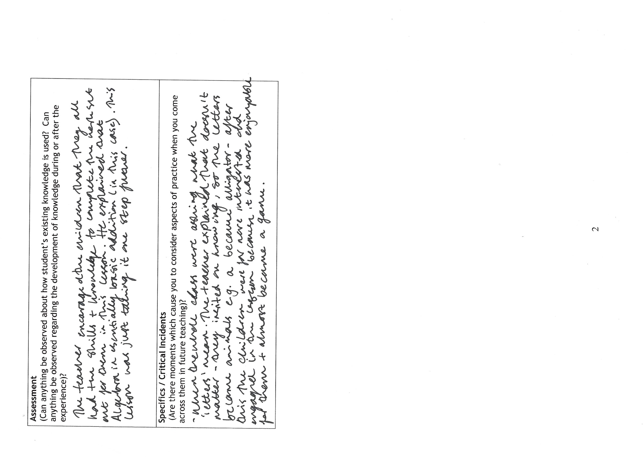

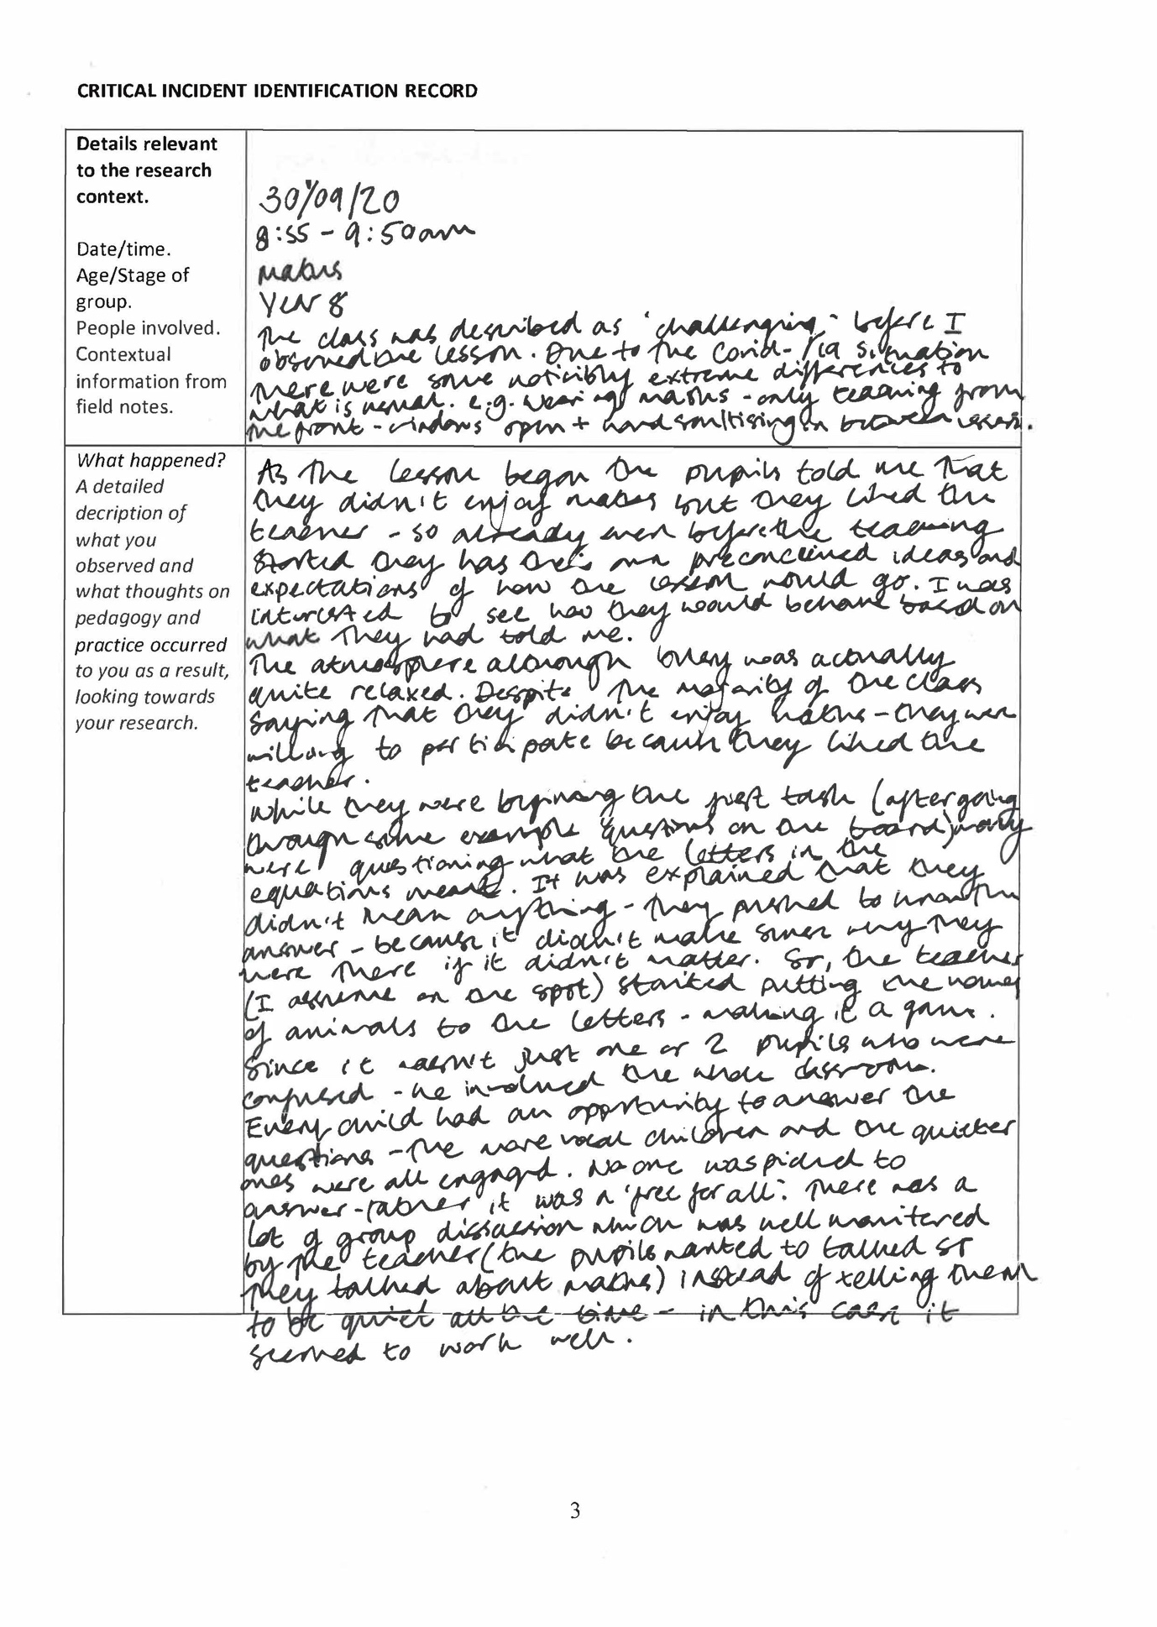

Appendix 2

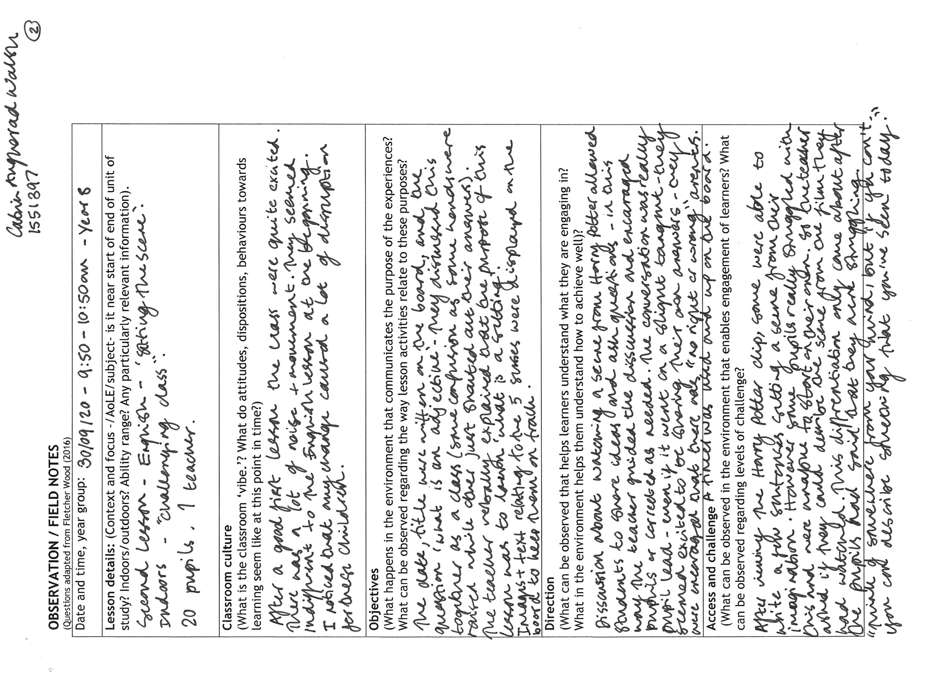

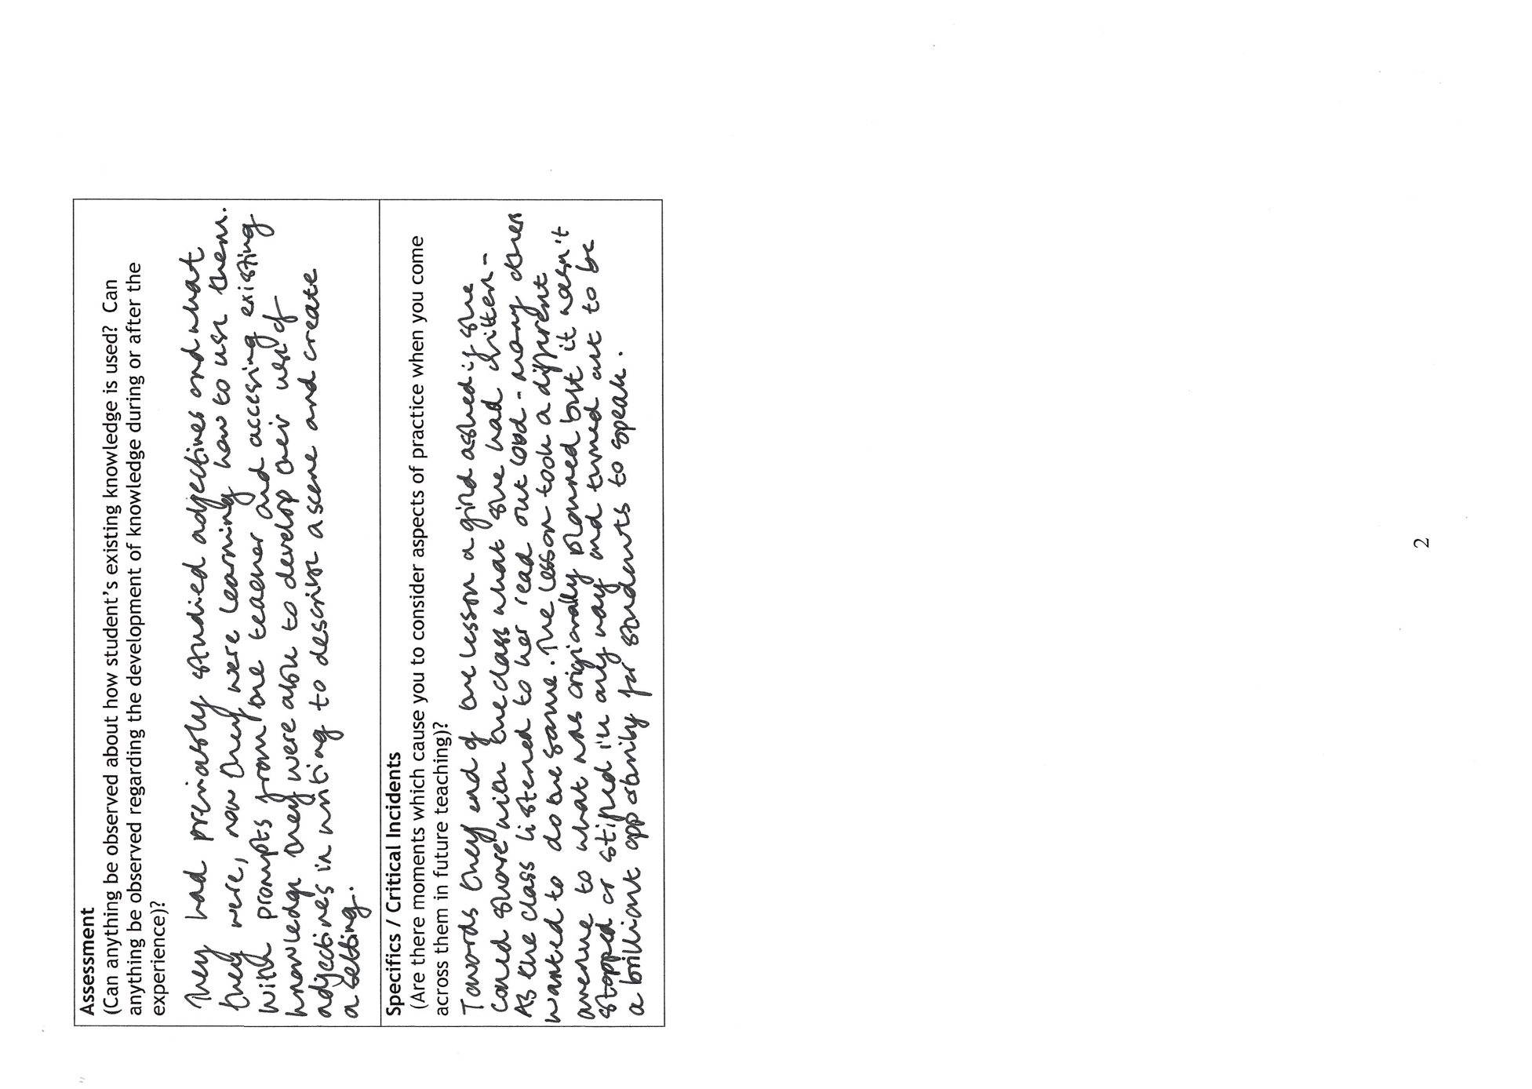
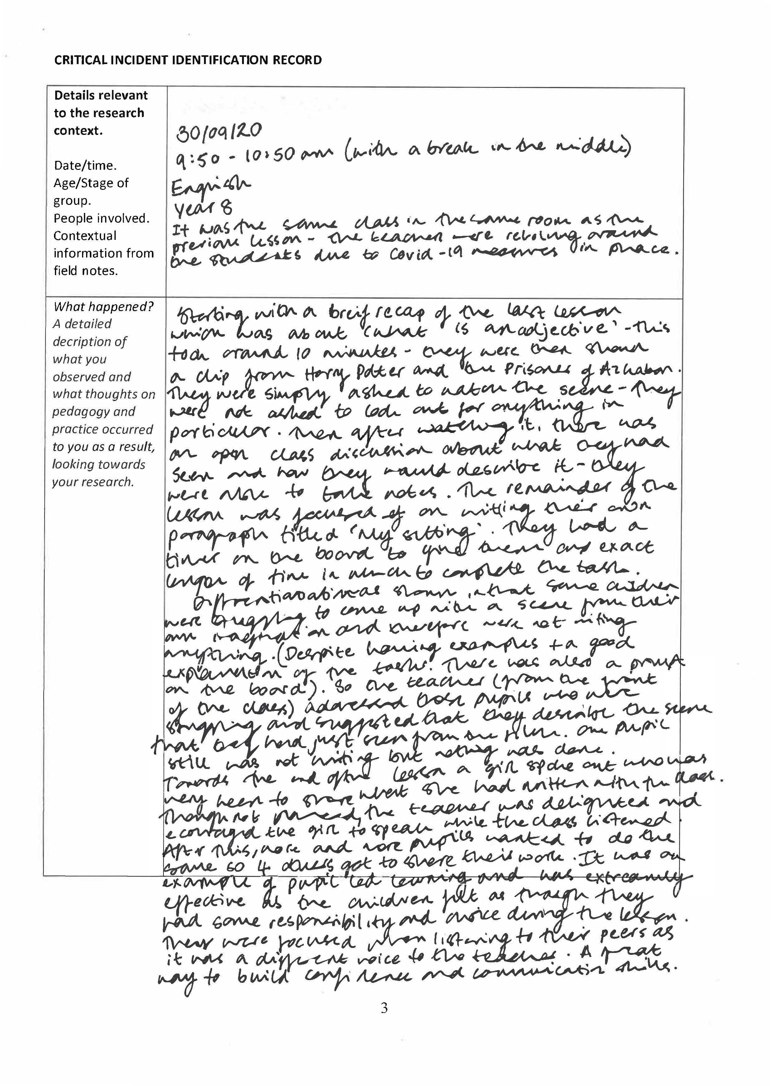

Appendix 3

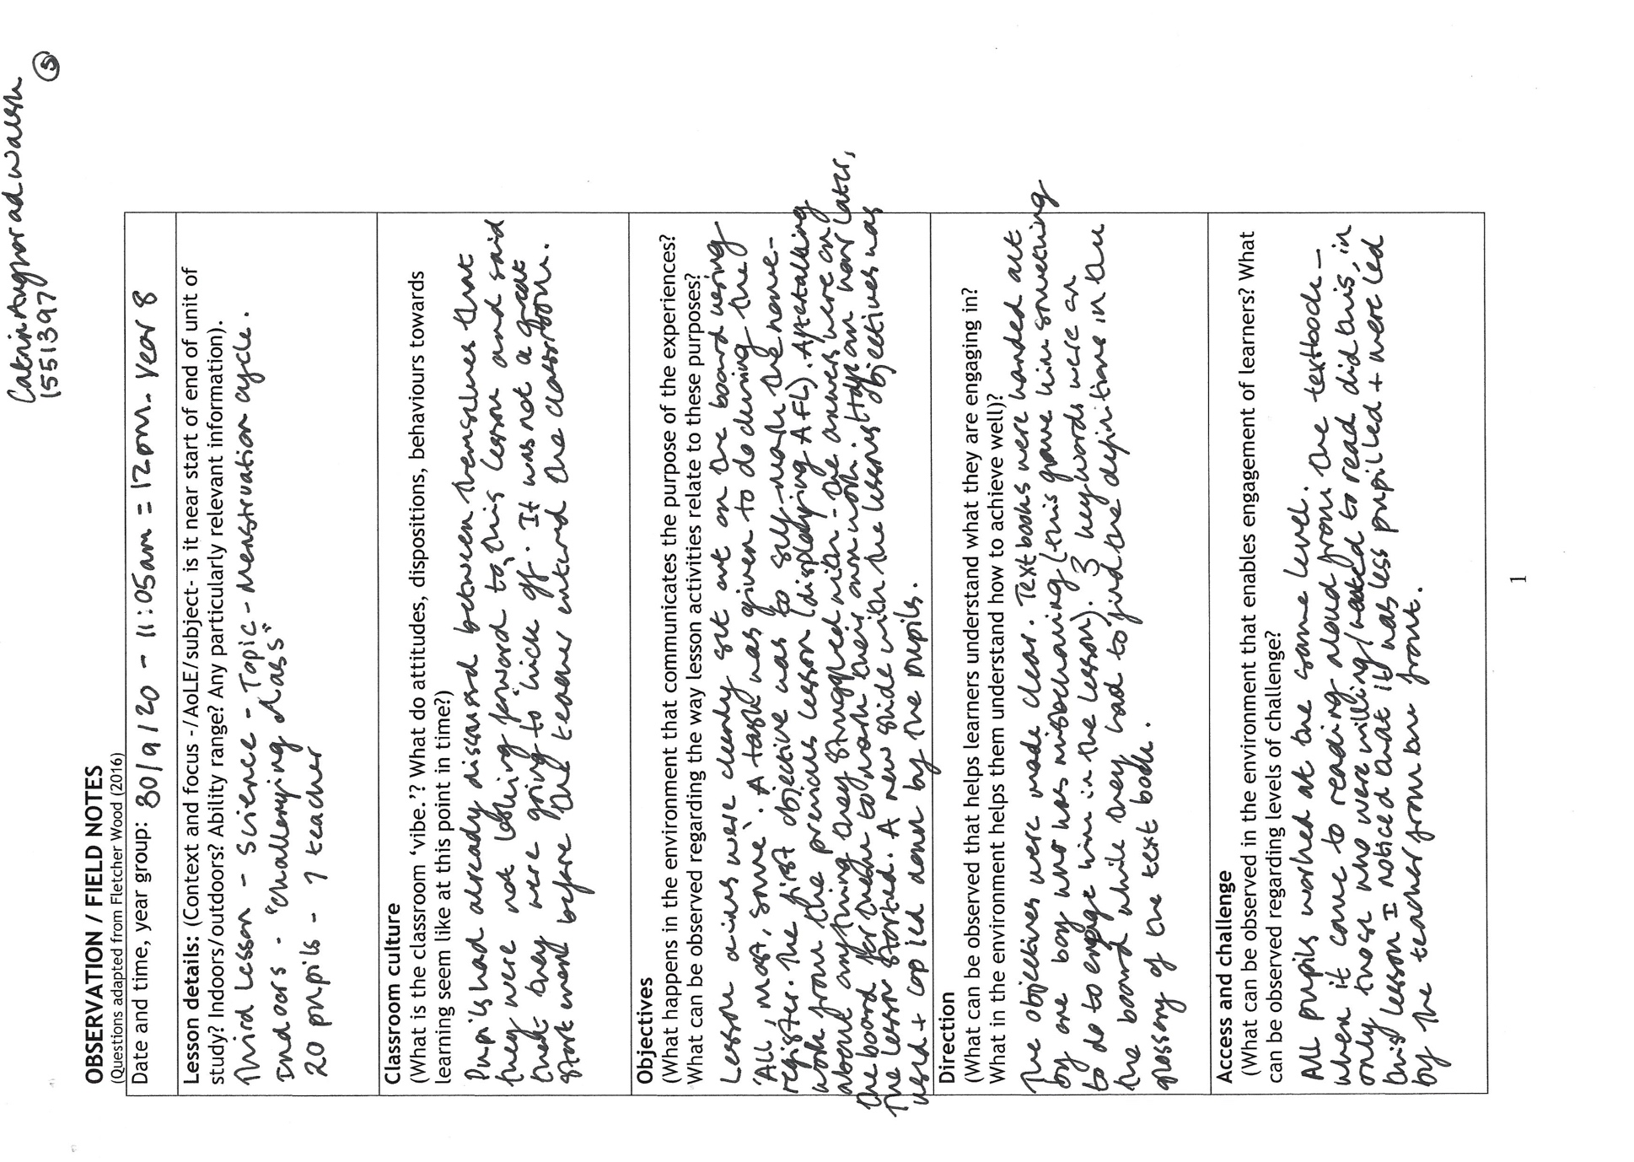
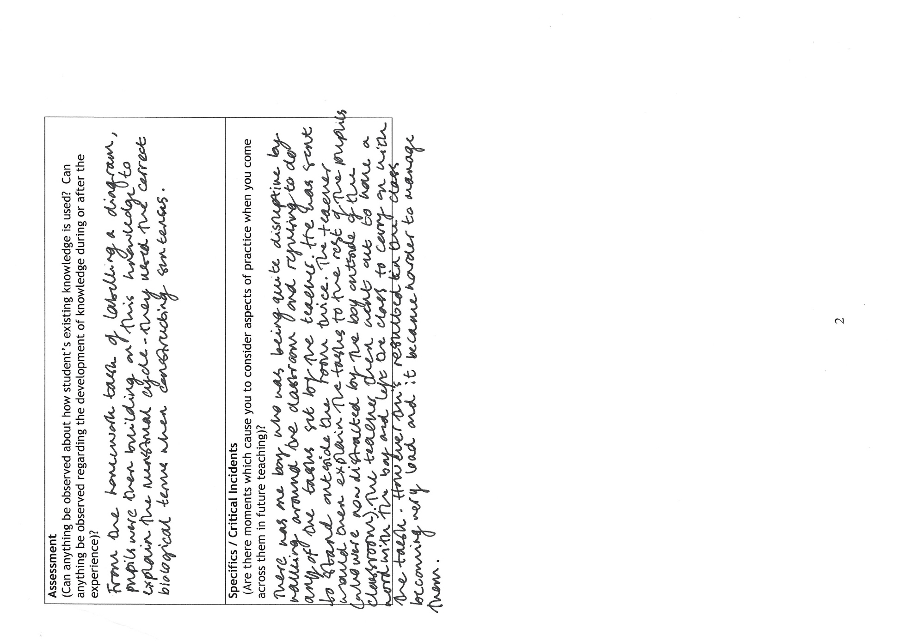
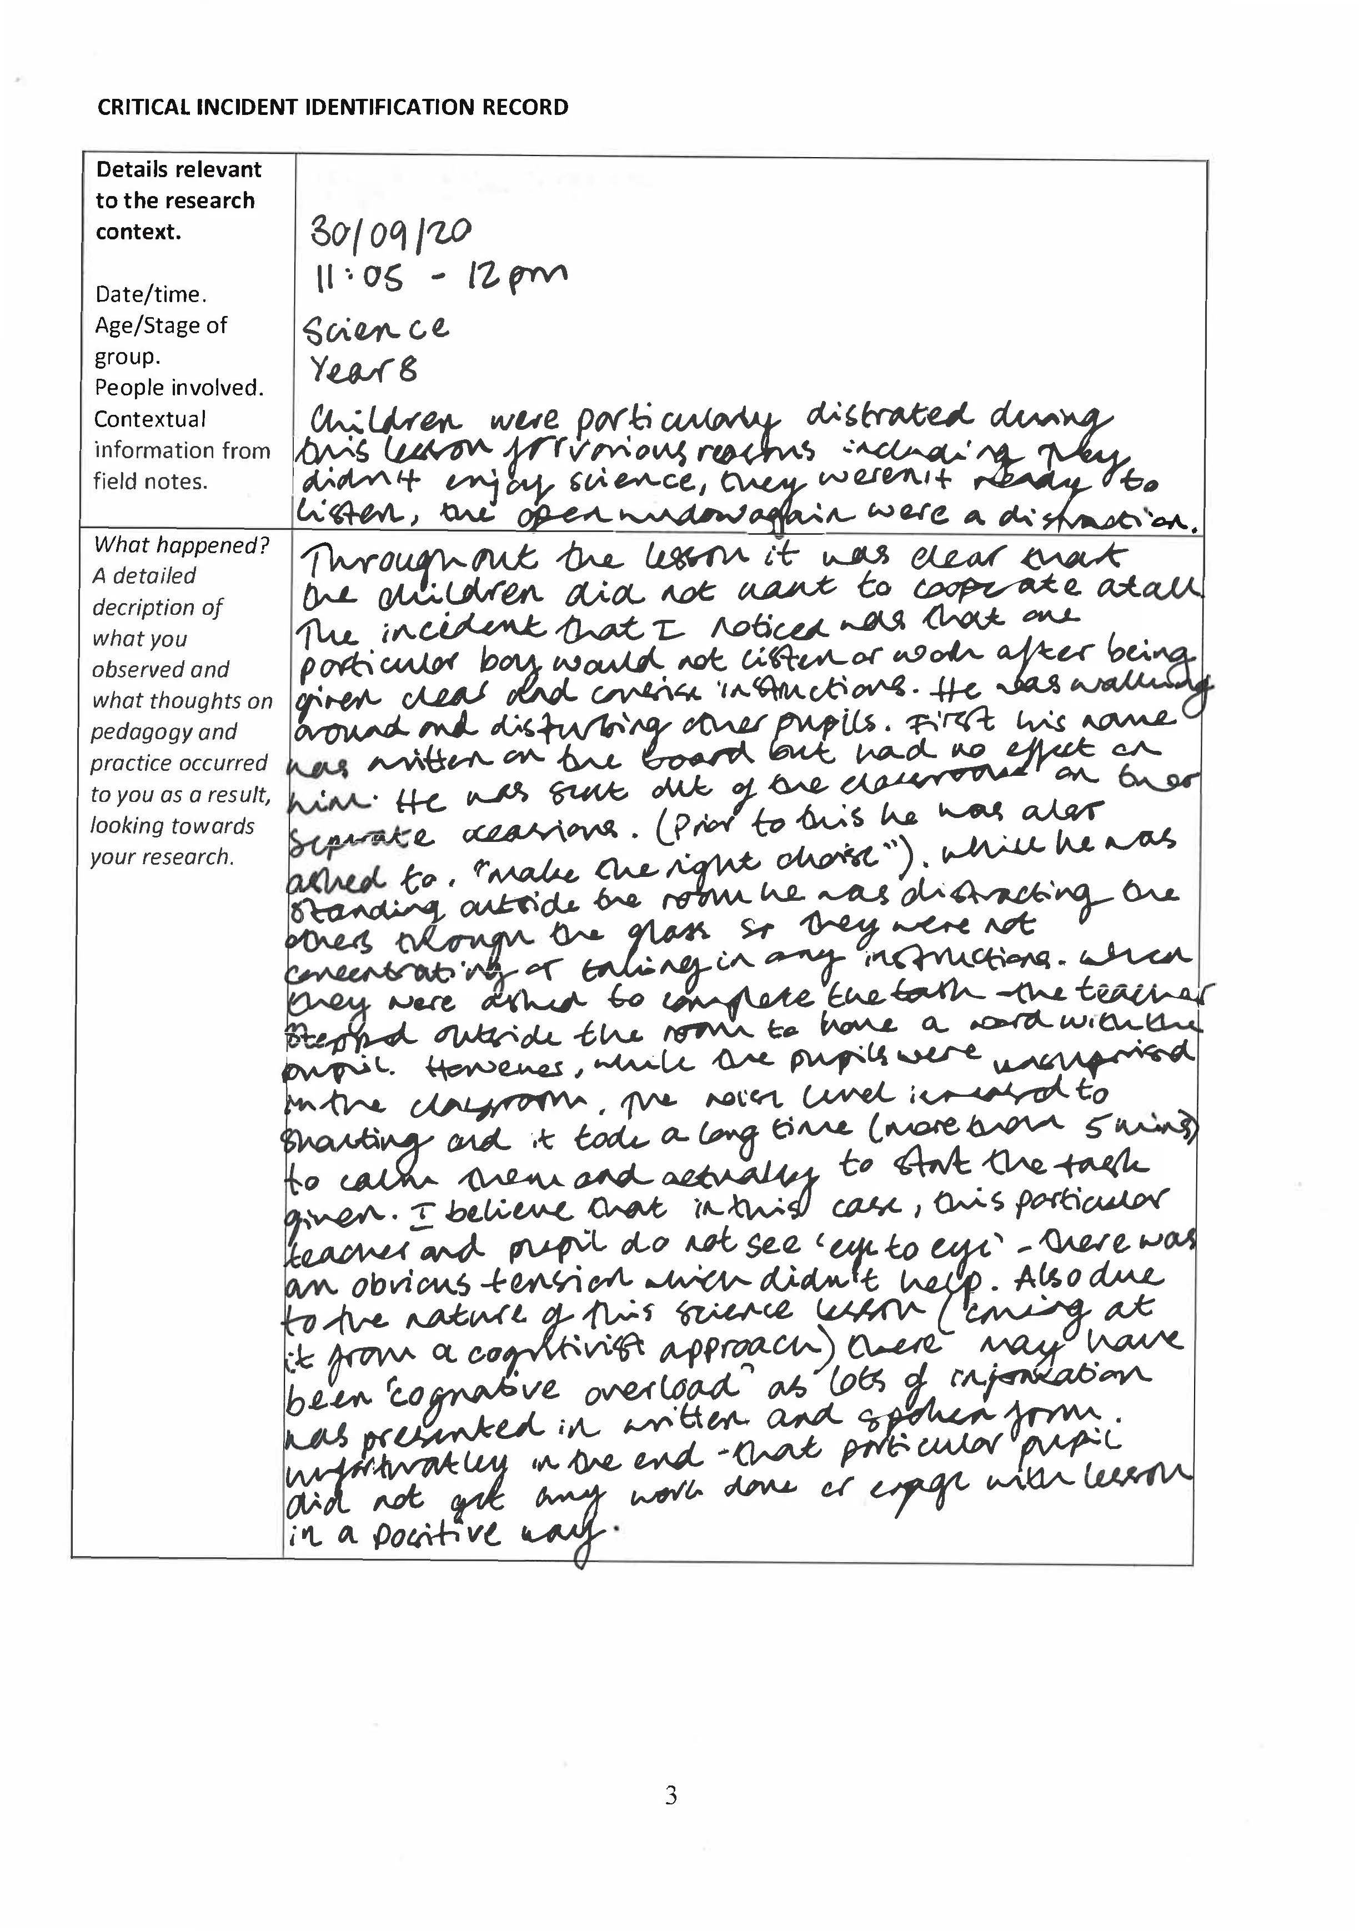
Appendix 4



