January 2016
Polymorphism recap
Distributed Enterprise Applications
Tim Bashford

The goal of this worksheet is to:
- Review the Class Diagram contained within with a view to refining it for polymorphic relationships where appropriate.
- Implement the changed scheme in code.

This should serve firstly as a recap in OO design, and help to polish any rusty ability with C#. There are a few key considerations , as discussed during the lecture:
- Aim to reduce repetition code as much as possible.
- Try to combine data where possible. Remember that you can always store a list of base classes.
- Remember that inheritance can come in layers; a derived class may implement another derived class if desired.
- Pick judiciously between abstract and virtual.

I strongly recommend you write the modified class diagram before attempting to implement code – the StarUML sheet for this is uploaded to moodle.
Consider carefully where you can make savings. Which methods or classes should be abstract, which methods should be virtual, if any?
Aim to make the code easier to write and maintain – feel free to make enormous changes to the structure if you wish; you have carte blanche to modify whatever you see fit. Do not, however, make changes which will impact on the functionality of the system, or which stem from poor programming practice.
See below for a description of methods.
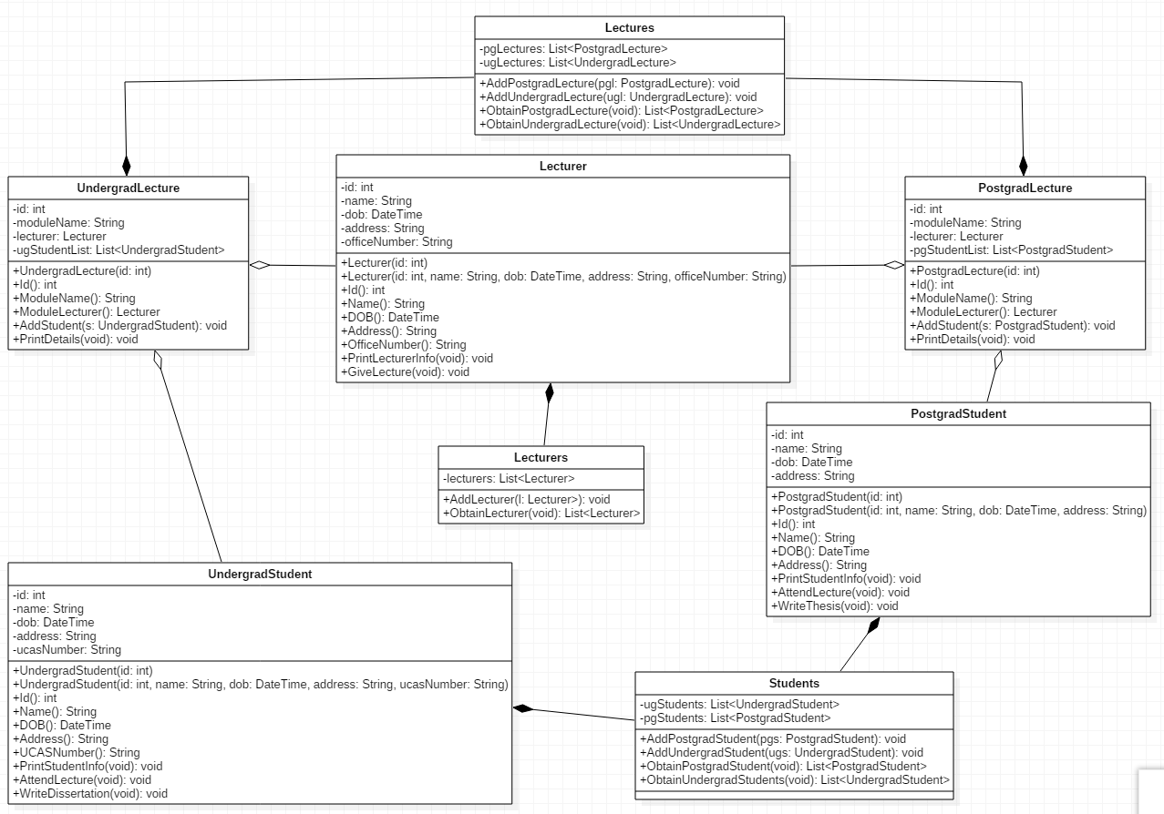

Methods
Many of the methods should be self-explanatory. The entry point to this system is intended to be the “Lectures” class – giving the ability to add and retrieve previously constructed Lectures. Take care with class names; many are (deliberately) quite similar. This is something you may, or may not wish to change. Note that Lectures, Lecturer and Lecturers are different classes.
Postgrad::PrintDetails/Undergrad::PrintDetails should write to console:
- The name of the module
- The lecturer
- A list of the students studying the module
PostgradStudent::PrintStudentInfo / PostgradStudent::PrintStudentInfo / Lecturer::PrintLecturerInfo should write all relevant variables (including ucasNumber and officeNumber where appropriate) to console.
Lecturer::GiveLecture / PostgradStudent::WriteThesis / UndergradStudent::WriteDissertation should print a simple message to console, such as “[Lecturer Name] gives a lecture”, “[Postgrad Name] works on their thesis”, “[Undergrad name] works on their dissertation”.

Test Harness
You may use the following test harness to test your code. You will need to adjust this test harness to reflect changes you make in your code.
class Program
{
static void Main(string[] args)
{
Students students = CreateStudents();
Lecturers lecturers = CreateLecturers();
Lectures lectures = CreateLectures(students, lecturers);

foreach(UndergradLecture ul in lectures.ObtainUndergradLecture())
{
ul.PrintDetails();
}

foreach (PostgradLecture pl in lectures.ObtainPostgradLecture())
{
pl.PrintDetails();
}

Console.ReadLine();

}

static Students CreateStudents()
{
//Test harness for creating students.

Students s = new Students();

UndergradStudent s1 = new UndergradStudent(0, "Winston Smith", new DateTime(1990, 9, 17), "19 A road, Swansea, SA1 1EA", "UA08483437723");
UndergradStudent s2 = new UndergradStudent(1, "Emmanuel Goldstein", new DateTime(1988, 2, 22), "84 Another road, Swansea, SA1 1EA", "UA01616515566");
UndergradStudent s3 = new UndergradStudent(2, "Tom Parsons", new DateTime(1994, 6, 13), "3 A different road, Llanelli, SA14 7JY", "UA054564654656");
UndergradStudent s4 = new UndergradStudent(3, "Katharine Smith", new DateTime(1993, 1, 19), "1 Some street, Bridgend, SA22 5LM", "UA02345646531");
UndergradStudent s5 = new UndergradStudent(4, "Aaron Jones", new DateTime(1997, 4, 4), "14 A different lane, Swansea, SA2 3EN", "UA03532509813");
s.AddUndergradStudent(s1);
s.AddUndergradStudent(s2);
s.AddUndergradStudent(s3);
s.AddUndergradStudent(s4);
s.AddUndergradStudent(s5);

PostgradStudent p1 = new PostgradStudent(5, "Jack Cockrell", new DateTime(1980, 3, 1), "31 Waindell Lane, Swansea, SA4 5IL");
PostgradStudent p2 = new PostgradStudent(6, "Laurence Clements", new DateTime(1987, 12, 7), "22 Wellesley Road, Bridgend, SA23 4AR");
s.AddPostgradStudent(p1);
s.AddPostgradStudent(p2);

return s;
}

static Lecturers CreateLecturers()
{
//Test harness for creating lecturers

Lecturers l = new Lecturers();

Lecturer l1 = new Lecturer(0, "Guy Montag", new DateTime(1977, 4, 11), "22 Faber Road, Swansea, SA2 9AC", "MH405");
Lecturer l2 = new Lecturer(1, "Clarisse McClellan", new DateTime(1977, 4, 11), "22 Stoneman Road, Bridgend, SA23 9LM", "MH302");

l.AddLecturer(l1);
l.AddLecturer(l2);

return l;
}

static Lectures CreateLectures(Students students, Lecturers lecturers)
{
Lectures lectures = new Lectures();
UndergradLecture ugl1 = new UndergradLecture(0);
UndergradLecture ugl2 = new UndergradLecture(1);
UndergradLecture ugl3 = new UndergradLecture(2);

PostgradLecture pgl1 = new PostgradLecture(0);
PostgradLecture pgl2 = new PostgradLecture(1);

ugl1.ModuleName = "Network Services";
ugl1.ModuleLecturer = lecturers.ObtainLecturer()[0];
ugl1.UgStudentList.Add(students.ObtainUndergradStudent()[0]);
ugl1.UgStudentList.Add(students.ObtainUndergradStudent()[1]);
ugl1.UgStudentList.Add(students.ObtainUndergradStudent()[2]);
ugl1.UgStudentList.Add(students.ObtainUndergradStudent()[3]);
ugl1.UgStudentList.Add(students.ObtainUndergradStudent()[4]);

ugl2.ModuleName = "Advanced Web Development";
ugl2.ModuleLecturer = lecturers.ObtainLecturer()[0];
ugl2.UgStudentList.Add(students.ObtainUndergradStudent()[0]);
ugl2.UgStudentList.Add(students.ObtainUndergradStudent()[4]);

ugl3.ModuleName = "Intro to Programming";
ugl3.ModuleLecturer = lecturers.ObtainLecturer()[1];
ugl3.UgStudentList.Add(students.ObtainUndergradStudent()[2]);
ugl3.UgStudentList.Add(students.ObtainUndergradStudent()[3]);
ugl3.UgStudentList.Add(students.ObtainUndergradStudent()[4]);

lectures.AddUndergradLecture(ugl1);
lectures.AddUndergradLecture(ugl2);
lectures.AddUndergradLecture(ugl3);

pgl1.ModuleName = "Management and Leadership";
pgl1.ModuleLecturer = lecturers.ObtainLecturer()[0];
pgl1.PgStudentList.Add(students.ObtainPostgradStudent()[0]);
pgl1.PgStudentList.Add(students.ObtainPostgradStudent()[1]);

pgl2.ModuleName = "AGILE Development";
pgl2.ModuleLecturer = lecturers.ObtainLecturer()[1];
pgl2.PgStudentList.Add(students.ObtainPostgradStudent()[1]);

lectures.AddPostgradLecture(pgl1);
lectures.AddPostgradLecture(pgl2);

return lectures;
}
}
This should give an output similar to:
========================================
Undergrad lecture: 0
Network Services
Lecturer 0
Guy Montag
11/04/1977 00:00:00
22 Faber Road, Swansea, SA2 9AC
MH405
Student list:
---
Student 0
Winston Smith
17/09/1990 00:00:00
19 A road, Swansea, SA1 1EA
UA08483437723
---
Student 1
Emmanuel Goldstein
22/02/1988 00:00:00
84 Another road, Swansea, SA1 1EA
UA01616515566
---
Student 2
Tom Parsons
13/06/1994 00:00:00
3 A different road, Llanelli, SA14 7JY
UA054564654656
---
Student 3
Katharine Smith
19/01/1993 00:00:00
1 Some street, Bridgend, SA22 5LM
UA02345646531
---
Student 4
Aaron Jones
04/04/1997 00:00:00
14 A different lane, Swansea, SA2 3EN
UA03532509813
========================================
Undergrad lecture: 1
Advanced Web Development
Lecturer 0
Guy Montag
11/04/1977 00:00:00
22 Faber Road, Swansea, SA2 9AC
MH405
Student list:
---
Student 0
Winston Smith
17/09/1990 00:00:00
19 A road, Swansea, SA1 1EA
UA08483437723
---
Student 4
Aaron Jones
04/04/1997 00:00:00
14 A different lane, Swansea, SA2 3EN
UA03532509813
========================================
Undergrad lecture: 2
Intro to Programming
Lecturer 1
Clarisse McClellan
11/04/1977 00:00:00
22 Stoneman Road, Bridgend, SA23 9LM
MH302
Student list:
---
Student 2
Tom Parsons
13/06/1994 00:00:00
3 A different road, Llanelli, SA14 7JY
UA054564654656
---
Student 3
Katharine Smith
19/01/1993 00:00:00
1 Some street, Bridgend, SA22 5LM
UA02345646531
---
Student 4
Aaron Jones
04/04/1997 00:00:00
14 A different lane, Swansea, SA2 3EN
UA03532509813
========================================
Postgrad lecture: 0
Management and Leadership
Lecturer 0
Guy Montag
11/04/1977 00:00:00
22 Faber Road, Swansea, SA2 9AC
MH405
Student list:
---
Student 5
Jack Cockrell
01/03/1980 00:00:00
31 Waindell Lane, Swansea, SA4 5IL
---
Student 6
Laurence Clements
07/12/1987 00:00:00
22 Wellesley Road, Bridgend, SA23 4AR
========================================
Postgrad lecture: 1
AGILE Development
Lecturer 1
Clarisse McClellan
11/04/1977 00:00:00
22 Stoneman Road, Bridgend, SA23 9LM
MH302
Student list:
---
Student 6
Laurence Clements
07/12/1987 00:00:00
22 Wellesley Road, Bridgend, SA23 4AR

