
University of Wales Trinity Saint David
School of Engineering

Marina Kleaner development
Materials & Manufacturing
M4X01511

Gwydion Gwyn Clement
Student ID: 1804252
Date: 26/04/2019

Contents
1 Introduction 1
2 Materials & production for 1:2 scale Prototype 2
2.1 Aims & Objectives 2
2.2 Literature Review & Research 2
2.3 Discussion 2
2.4 Conclusion 3
3 Full scale Trial unit 4
3.1 Aims & Objectives 4
3.2 Research & Discussion 4
3.3 Conclusion 5
4 Full Production 6
4.1 Aims & Objectives 6
4.2 Discussion & Conclusion 6

Introduction
This report aims to show three stages of the production and manufacture of two hulls of a catamaran. The hulls will be places to hold a driver and a conveyor system to remove wastes from mariners, canals and small waterways. To begin with, the steps for rapid prototyping will be outlined from there moving on to trail units and then to full scale production. The materials used will be considered in each stage along with costs, product life and environmental factors while meeting deadlines of each production. Each step needs to take into consideration time to manufacture which Bing underline for love clear. With exception 1:2 scale prototype the full-scale trial unit under full production unit will used in small waterways docs and marinas it will be used overnight.

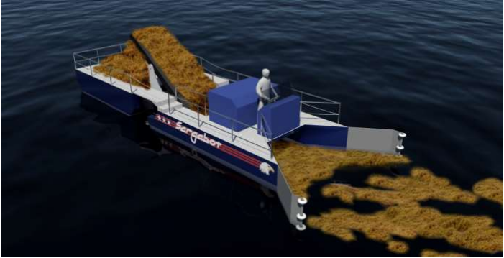
Figure 1

Materials & production for 1:2 scale Prototype

Aims & Objectives

The aim is to have a marketing prototype produced within a week. The units will not be used in water ways. However, it must show a true representation of the design on a 1:2 scale model. Its aim is to be presented at trade presentation shows to show the potential of the design.

Literature Review & Research

There are three possibilities to rapid prototyping, being additive manufacturing, subtractive manufacturing (turning, milling, drilling) or casting.
Through using CAD files and 3D printers additive manufacturing would give a reliable and quick prototype. Each part would have to be broken down into sections then assembled unless a large enough 3D printer could be sourced. Seeing as this will only be for a prototype ABS plastic could be used to keep costs at a minimum.
Subtractive manufacturing and opposite approach to 3D printing could be another option. This does mean that more waste of materials will occur, however it can offer more options to the materials that could be used. If the product were to be made from wood or steel the prototype could then hold the same properties as the final unit. In turn giving a clearer representation of the units at trade shows
The third option would be to use casting using additive manufacturing technology a mould could be created this would be a lengthier process however like subtractive manufacturing it could allow for a variety of other materials to be used. Again, giving clearer representation of a final product at trade shows.

Discussion

Additive manufacturing is by far the fastest means to achieve a prototype within a week, it is also the most efficient for production of low volume units. This is mostly down to needing less time to prepare the machines. As stated, it is also a good way for keeping costs low by using a ABS plastic.
Subtractive manufacturing does offer a better finish with the highest precision it is the most precise rapid prototyping however these technologies are more expensive but do offer better tolerances to 3D printing. Providing a tougher product. It will take more time though due to being more labour intensive.
Casting will offer similar benefits to subtractive manufacturing however it also presents us with similar issues. Due to the requirement of having a mould to begin with, casting comes with many steps. This would add time to the production of the units. However, it could be beneficial if a larger amount of units were required and the moulds had already been created.

Conclusion

Taking all these prototyping methods into account the most cost effective and efficient for a one week turn around would be additive manufacture. The parts would have to be printed in separate pieces and assembled afterwards. This would add to the time however, it would still be much quicker than other methods due to the quantity that is needed.

Full scale Trial unit

Aims & Objectives

A full-scale trial unit needs to be created for use for up to one year. It will be deployed in local areas and must be produced in a quantity of 50. They will undergo regular analysis to discover which will be best suited to take to full production.

Research & Discussion

Some of the most common materials for hulls on catamarans consist of Fibre Glass, Steel, wood, ferro cement and in some cases Plastic. Some qualities of each are outlined below.
Ferro-cement provides one of the cheaper hull options and is required to be laid in one go using a mould. It is a very labour-intensive material.
One of the strongest materials to use for the hulls would be steel, unlike fibreglass its toughness would allow it to withstand any potential collisions. A downside to steel would corrosion, a water-resistant epoxy would have to be applied regularly. Meaning it would have much the same maintenance issues as the wooden hulls although regular maintenance would make for a longer lifespan.
The most popular material for use in hulls is fibreglass, mainly due to low costs and not needing to be made water resistant like wood. The material is brittle by nature so some negative sides to using fibre glass are damage it may sustain if it were to hit an object while out on the water.
A plastic Polyethylene has become more popular in boats in recent years. It is very impact resistant however it isn't as structurally stiff is fibre glass or Steel. This would give a size limitation for the units. Another advantage over fibre glass especially is that polyethylene is considered more environmentally friendly as It can be recycled.
Wooden hulls provide another option. There is a danger of wood attracting marine life onto its hull. This could cause long term effects. Or mean that the material would require regular maintenance. There would also be more waste in the manufacture of a wooden hull due to having to use subtractive manufacturing.
With the unit production of 50 required in a lead time of one month, one of the best methods to be used would be casting. Once the moulds have been made the lead time would be easily met. However, this does limit us as to the materials we could use. Injection moulding could be another advantageous method, limiting the costs. Due to the size of the unit’s separate pieces would have to be assembled. Much like the 3D printed prototype.

Conclusion

With the recyclability of plastic being an appealing concept for this project, and for getting the units needed in the one-month lead time. The option of casting would mean less waste and if the trials are a success the moulds could be used instantly when taking the units to full production.

Full Production

Aims & Objectives

The final step it to take the hulls into full production. These units are intended for use full time in a marine environment. With a projected market of 10,000 being sold in the first year. The product will be crowd funded and in turn will require batch manufacturing over a period of 8 to 10 weeks.

Discussion & Conclusion

For batch manufacturing the ideal material to be used would be Polyethylene Using much the same process as the trial unit injection moulding could be used so set up a manufacturing chain of hulls. There would also be the added benefit of the weight of plastic being far less than some of the other materials. If the products are going to be shipped worldwide, then the polyethylene would save costs over steal and wood due to it weight. Yet still have a high enough toughness to be used for its intended purpose.

