Sofaia Midtskau
1813661@uwtsd.ac.uk
Project Planning and Management in workplace
SAMRA Project

Table of Contents
1.0 Terms of Reference…………………………………………………………………………………………………2
2.0 Introduction……………………………………………………………………………………………………3
3.0 What is Project Management………………………………………………………………………………………………………….4
3.1Project Life Cycle……………………………………………………………………………………………….5
3.1.1 Project Initiation………………………………………………………………………………………………5-7
3.1.2 Project Planning Phase……………………………………………………………………………………7-11.
3.1.3 Project Execution Phase…………………………………………………………………………………11-13
3.1.4Project Closure Phase……………………………………………………………………………………. 13-14
4.0 Recommendation…………………………………………………………………………………………………14
5.0 Reference List …………………………………………………………………………………………………………….15-18

1.0 Terms of References

The purpose of this report is to demonstrate the researcher’s knowledge and understanding of ability to apply theories relating effective team working, stakeholders, risk management and communication within a project management process. The report was requested by S. Khan on the 23rd of October 2020. The report with recommendation is due by the 4th of December 2020.
The researcher had worked collaborated with her colleague to investigate at police and seeing how the less represented groups like BAME and women amongst others might not see this as an organisation to work for, how can you encourage them by promoting their organisation and recruitment opportunities, by :
- Holding focus groups with BAME and Women to identify reason for not applying to work for police
2. Promote and create awareness amongst BAME and vulnerable groups regarding recruitment initiatives in police.

The researcher identifies, evaluate, and recommend what is achievable for a project. Therefore, through research, the researcher provides critical assessment of the project management tools and demonstrate the ability to plan, implement the project life cycle within a workplace.
The researcher develops recommendation to improve methods, effective team working efficiently and evaluate, review managing project with future recommendation.
This report contains sources of information such as books, websites, journals, and articles. It provides details description and complete information relates to the facts and skills that the researcher acquired through learning. Therefore, through the researcher’s research to break down information, make implementation, compile, and contrast information.

  - Introduction

“Management is, above all, a practice where art, science, and craft meet.” –Henry Mintzberg (Landau, 2018)
To define Project is referring to an activity that is fixed period from a starting and to end point. An activity that is managed by firm resources, planned in a detailed way, involve variations of task given and achieved for a positive change. A project does not only feature planning, but it also features aims, objectives and goals. By focusing on a project’s objective is vital to avoid misguided of the aim or mission statement of a project. (What is a Project,2020)
However, in this report the researcher described a project that was formed by 3 students who investigated of how to create awareness of BAME community representing in the POLICE FORCE. Why are not lot of BAME community are not engaging or wanting to join the Police Force in general?
The researcher and the project team choose a minority group focusing for South Asian Muslim Women.
The group project named, SAMRA. SAMRA consisted of a skilled and knowledgeable team.
The diagram below describer each team member information and details.
Figure 1.
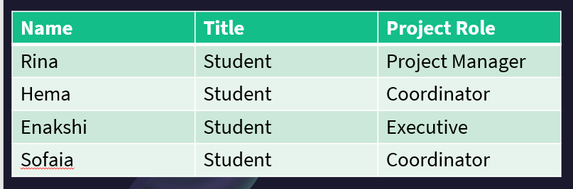
SAMRA known for SOUTH ASIA MUSLIM AGENCY is an Organisation that alliance with the South Wales & Powys Department. SAMRA aim was to engage 10 South Asian Muslim Women to join the South Wales &Powys Police Force by 2021. SAMRA starting Project was from the 23rd of October and ended on the 20th of November 2020.
Why are did SAMRA engaged into this group to encourage and joining the Police Force? Fundamentally, it is to break the barrier of “islamophobia”, increase diversity and inclusion within the police force, support community practice, racism, promote career development within the police force and uniform network support.
SAMRA Objective of the project was to assist these women during their recruiting program, support their religious and welfare needs. To assist also in their career development and creation of fair and working environment.
3.0 What is Project Management?
Project disaster is every project manager’s vilest dream. One of the purposes is lack of communication between team members and project managers. However, this discrepancy of knowledge and understanding makes it difficult for not only team members and managers to be on the same page, but also slows down the project execution by manifold (Management, 2020)
The researcher revealed, in 1985, Coca- Cola presented a new coke and one of the main reasons the project failed was market research. Coca- cola did not researched enough of its customer feedback regarding the new product. Coca-Cola needed to comprehend its customers reaction regarding the new product, but Coca-Cola oversee the problem and made a big financial loss (Malsam, 2018).
The purpose of project management(Lock,2007) is to forecast or expect as several of the risk and issue as potential and to plan, establish and management activities in order that comes are completed with success in spite of all the risk. This method ought to begin well before any resources is obligated and should continue till al work is completed.
Therefore, the researcher concluded that having a knowledgeable skill within the team management it avoids mismanagement within the organisation. Ensuring that team members are on the identical page and united for a project goal, thus involving stakeholders critical path importance to the team project success. All this will reduce the potentials of project failure.

3.1 Project Life Cycle
Figure 2.
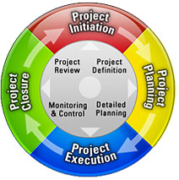
Diagram of Project Life Cycle.

Project Life Cycle is defined (Nediger, 2019) as a 4-step framework designed to assist project managers guide their comes with success from begin to finish. The aim of the project life cycle is to form direction of framework to guide projects.
There are four stages of a project life cycle thus as, Initiation, Planning, Execution and Closure.
3.1.1 Project Initiation
In this phase identifying the aim of project is formed, understand the goal, launched the project scope, and propose proposal for approval. However, (Heiser and Jiang,2004) stated that Initial phase refers to the time frame during which strategic is needed to be recognized by project management. It starts with identifying the needs and desires of the user of the project deliverables—the customer.
However, most company’s major business objectives and strategies need to be identified and understood so that project goals can be accurately associated with them. In this phase, top management needs to be outward looking to serve as project champion, publicist, and persuader, harnessing the approval and commitment of investors, regulatory bodies, government, interest groups, and even the public.
The researcher revealed that Reviewing Initiation Phase is vital to ensure that no steps are missed, communication with stakeholders are met at all time. Therefore, monitoring and reviewing the result of project progress that is on track.

Quad Chart is one of the tools that is use during Project Initiation. What is a Quad Chart? What is the importance of having a Quad Chart in a project?

See below SAMRA PROJECT QUAD CHART.

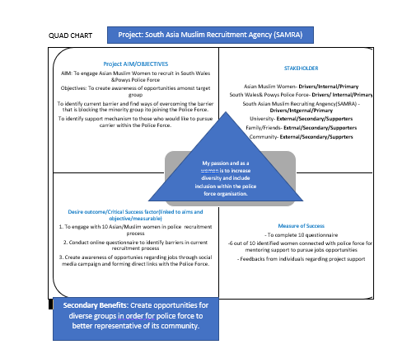
Figure 3.
A quad chart is a one -page summary of a project that is pictorial and expressive. The chart offer solution to a problem, helps to assemble an idea in a wider perspective to outline the aim of the project before it starts the process.
(Ford and Wei, 2015), state that quad chart is for reinforcing technical evaluation for communication. The Quad Chart to the left is the background information of SAMRA; Aims and Objectives, Desire Outcome, Stakeholder, Measure of Success and Secondary Benefit. SAMRA objective: Create awareness of opportunities among target group. Identify current barrier and find ways of overcoming the barrier that is blocking the minority group joining the Police Force. Conducting online questionnaire identify barriers For SAMRA in current recruitment process. Therefore, it reflects the critical factor to success in a project cycle goal.
Stakeholders Analysis
Why it is important?
When it comes to managing tasks and enforcing ideas, your actions can influence a lot of people. Some of them will have greater impact on than others. Therefore, it is very vibrant to comprehend who your stakeholders are when it comes to managing a project. What do they offer? What action do you need for them to involve or informed within a project? What are they perspective? Do they influence? What are they interest?
Stakeholders are individual (Smith,2000), community or oganisation that are energetically involve in the projects or who may interest, positively or negatively moved as an outcome of project closure or successful completion.
One must reach an understanding not only of the inner project environment, however conjointly the entities, together with interfaces, extending into the external environment. This needs multiple skills to discriminate among project teams and facilitate develop potential coalitions of support or, if necessary, scale back the impact of unseen opposition (Smith,2000).
The researcher revealed, that having Stakeholder analysis for project SAMRA can see what barrier that stops Muslim Women of joining the Police Force. It identifies which stakeholder are most priorities what action is been made to meet the perspective reason. Stakeholder analyses focus mainly on the importance of factors and interest of groups in the policy making process. Therefore, thus prospective measure can inspire the future of SAMRA.
SAMRA STAKEHOLDER ANALYSIS:
Figure 4.
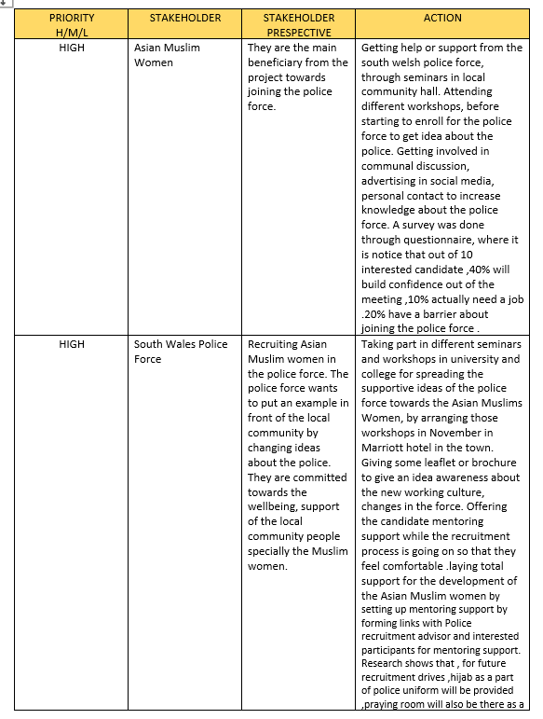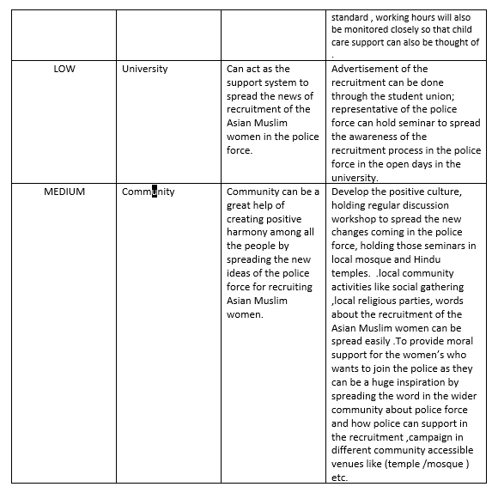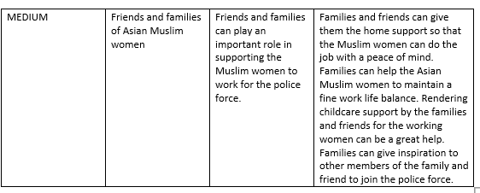

3.1.2 Project Planning Phase
During planning phase (Bridge,2019) the project's roadmap is developed. It will be observed by those involved within the project. This segment starts by setting successful (specific, concrete, attainable, practical, timely) targets. The scope of the project is outlined and the configuration of the project management, the characteristic cost, efficiency, resources, and timetable are organised. A variety of options for this process include a scope declaration, milestone setting, coordination, risk management plans and task breakdown structure.
According to Kloppenborg &Petrick (1999) as cited, Heiser and Jiang (2004) The project manager must encourage the look of experts, discuss, and negotiate with useful departments and deal with all administrative and different supervisory bodies. Assigned team members to jointly fulfil the main tasks that need to be done at the macro level of information. A few project team members, or in smaller teams, will usually describe the key points required to apply to their respective fields.
However, by applying scheduling tools that uses in project management it will allow team and project manager to plan successfully and accomplished target goal.
See below 4 tools that SAMRA had used during Strategic Planning Phase.
Figure 5. SAMRA GANTT CHART
SAMRA project conducted a Gantt Chart that shows tasks given in several weeks from the beginning to the ending.
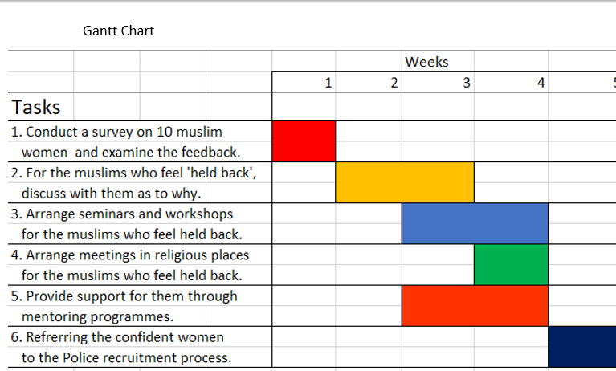
The benefit of providing a Gantt Chart puts the plan at the core of a project and offers an overall summary of the project process. According to (Cobb,2012; Maund,2018) that Gantt Chart is an extremely useful method to use when attempting to envision project projects over time and to convey this knowledge to the project team and others. However, (Kpvida,2008) crucial direction of the Gantt Map does not reflect the scale of the project or the relative size of the task items, so the severity of the backlog state is easily miscommunicated. If two projects are the same number of days behind budget, the larger project would have a greater effect on resource usage, but Gantt does not reflect the distinction.

Figure 6.
SAMRA RISK ANALYSIS
(Zwikael &Ahn,2010) revealed that risk assessment is extremely significant to the project management area, since this discipline includes a variety of institutional roles and their related risks. In contrast, it often occurs where it comes from.
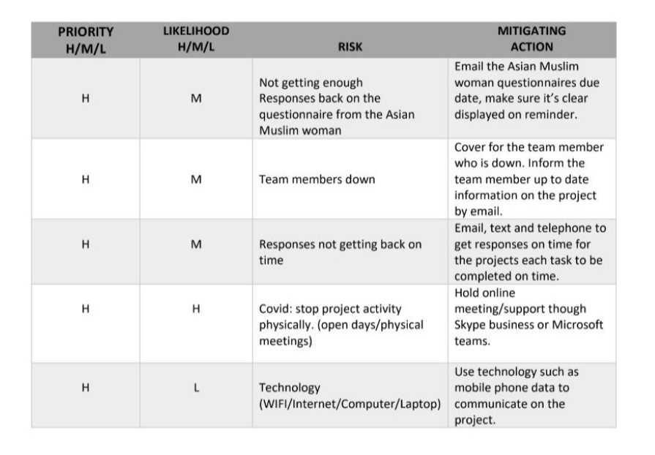
High levels of uncertainty resulting from their strict schedules, insufficient or unpredictable budgets, designs that come close to the possible limits of feasible success and frequently complex specifications. However, identifying the types of uncertainty in a project could be impacted such as, project budget, product performance, market sales and project strategic. Therefore, project risk management is considered as the key core area.
SAMRA High Potential risk during the Project Management was COVID 19. This pandemic had stopped project activity physically into interact with its stakeholders and potential candidates. However, SAMRA hold online meeting through Microsoft Teams enable to communicate on the project. Therefore, SAMRA team had identified the risks that had arose, access the potential impact, developed plans, and reviewed the risk.
Applying one of PESTLE Analysis in the project would be Political. SAMRA one to one mentor with its potential candidates were restricted due to the government guideline (Coronavirus (COVID-19): guidance, 2020). SAMRA could not conduct face to face meeting and interview with potential candidates, stakeholders, and minority communities due to restricted guidelines that will impact the spreading of the virus. COVID-19 had made a big impact on limited resources for SAMRA to pursue its project goal.

Figure 7.
SAMRA WBS
Work Breakdown Structure (WBS)
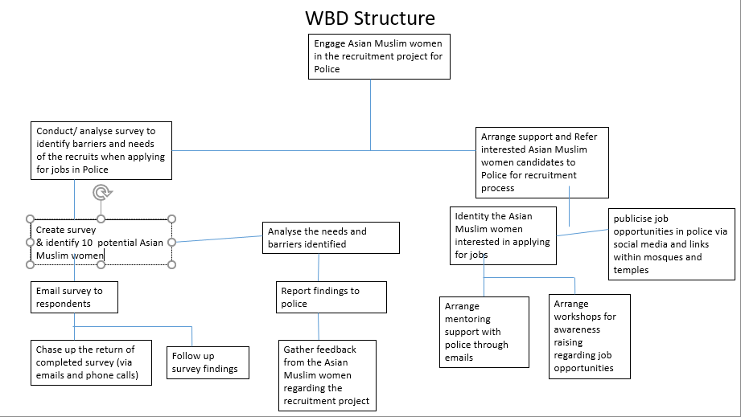
WBS is link tool that plays a vital diagram in the Planning Phase. It detects the task that required to be completed in a project. WBS is a tree like structure that allows the number of subordinate costs for tasks, resources, etc., to be applied to their successively higher level of “parent” tasks, material, etc. A summary of the task to be performed is created for each aspect of the job breakdown structure. This technique is used to describe and coordinate the overall scope of the project(KPVIDAS BLOG,2008).Therefore, the best way to observe 100% rule is to describe the elements of WBS in results, better planned the result not planned actions.
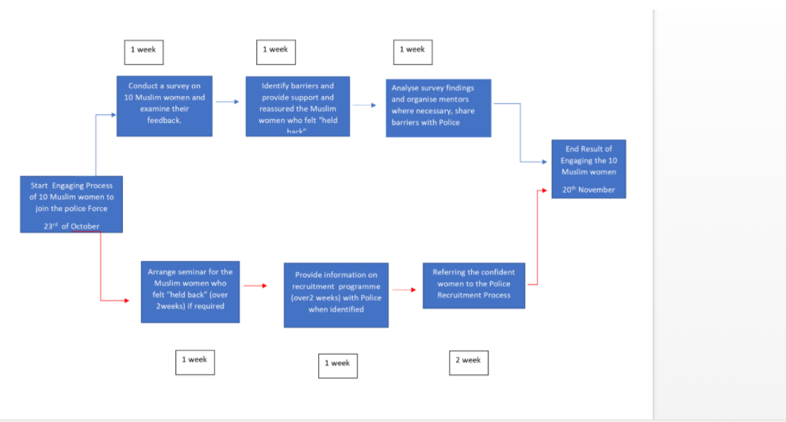
Figure. 7 NETWORK DIAGRAM FOR SAMRA Network project diagram is a graphical presentation of all sequential and related operations within the project. Relationships between all events are represented by arrows and nodes. The toll is commonly used in project management because of its usefulness in helping the project team to accomplish its goal successfully, planning out project cycle dates and identifying the vital direction of the project.
When designing a (How does a Network Diagram work in Project Management | Sinnaps, 2020)strategic course for a project, that is, working out the tasks are most critical to the project process, you need to think which nodes would require the most and the least amount of time. The vital path moves through all the nodes with the longest estimated completion periods. SAMRA NETWROK DIAGRAM it indicates the critical path with red arrows reacting to the negative risk of overlapping the schedule tasks by detecting the most critical. Therefore, project managers must not oversee the impact of the risk but investigate the impact of the critical level.

3.1.3 Project Execution Phase
Midterm Evaluation
What happens at this stage? At this stage, the plan of a project turned into accomplishment and project performance is monitored. During monitoring phase(PMI,2018) the team manages all the undertakings and indicators required to ensure that the concurred and approved undertaking that is performed is within degree, on budget and within the investment plan, ensuring that the activity proceeds with the least risk.
Why it is important to monitor? To ensure that projects results are assessed, endorse learning, understand stakeholders’ values and visions to minimize conflicts in the future project plan.(Nediger, 2019) stated that at this stage the project implementation period is turned into monitoring, evaluation and continuous supervision is needed. Expect to change priorities along the ending of the project.
However (Milstein and Wetterhall, 2000), discovered steps to take into consideration at this stage thus as stakeholders’ engagement. How were they affected in their involvement, communication barrier during planning stage, stakeholders’ value that partners bring into the table and what project mangers can learn from feasibility. Moreover, aspects of the context of a project, resources, attention to all different areas and how reliable evidence is used to make a credible information that gives raw material.

See below SAMRA MID REVIEW EVALUATION

Figure.8
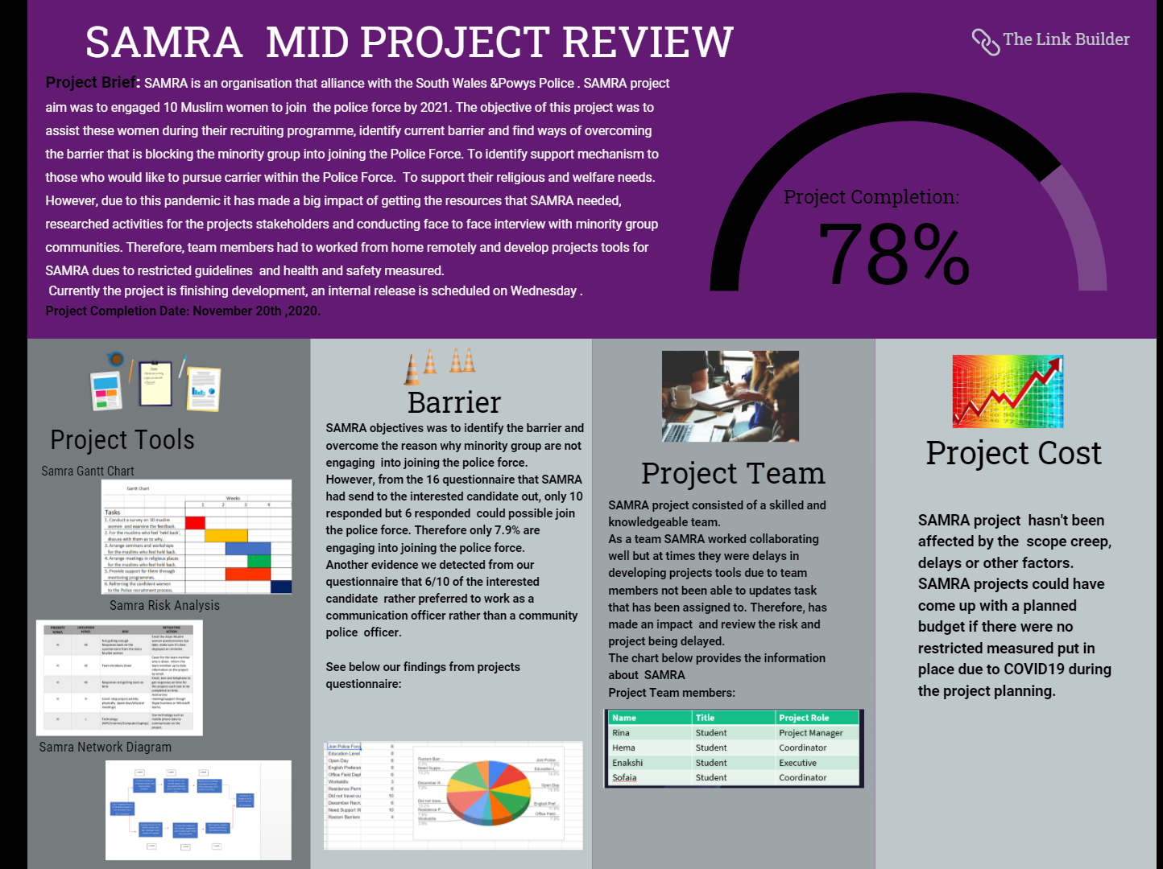
SAMRA as a team were face with restricted resources, limited face to face interview to conduct mentoring with their candidates. SAMRA not only faced by restricted resources but also detected findings from questionnaire that 6/10 potential candidates that SAMRA engaged into joining the police force, rather preferred to be working as IT Officer rather than community policing. They did not see policing itself as a carrier pathway into policing.
SAMRA project cost was not affected by the scope creep, other delays, and factors. SAMRA project could have come up with a planned budget by using the financial to promote project goal to communities and public area due to restricted measured put in place, pandemic COVID-19 impacted the project.
SAMRA hard evaluation as project cost did not made a profit but SAMRA softer evaluation were measured at different level. What skills and behavior have changed during this journey of project management? What was the most outcome that made the positive change? As a group, SAMRA had learned and taken into consideration of using the tools and diagram to analyses the risk and critical path during a project.
During SAMRA project there were communication barrier between the team members and potential candidates. Emails and meetings appointment were not met due to lack of monitoring, review, and feedback. Timely provision on each stage of the project were not comprehensive control and made impact on project performance. Different level of barriers was found across the teams’ member face to face interaction. Due to restricted measured team members were forced to work remotely and collaborate from home through google drive/whatsup/ team meetings.
According to (Hern,2020)the unexpected growth in working from home raises both obstacles and opportunities: on the one hand, start-ups such as Slack and Zoom and existing giants like Google and Microsoft are providing their platforms free of charge, in the expectation that people who start using them in a crisis can continue to do so until normality returns.
Therefore, (Zwikael and Ahn,2010) concluded that it is important to take project risk management into place and find the tools that works best for all stakeholders and team members.

3.1.4 Project Closure Phases
Closure Phase known as End Evaluation. What has SAMRA as a team learned from this experience? What went wrong and what quality control did SAMRA find?
Figure.9 SAMRA END EVALUTION REVIEW
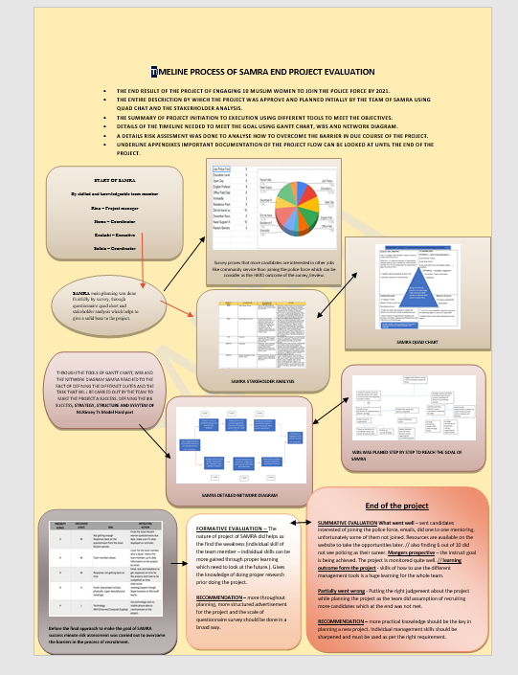
The final step of the life cycle of the project is the phase of completion. During the process from execution to completion, the project manager directs the project team to support end-users in the operation of a new product or service. Once the scope of the project has been completed, the money committed to the project must be published (UWTSD Moodle 2020/21: Log in, 2020).
SAMRA end review has given the team the time to reflect and review what new skills they have taken upon. What mistakes they have learned from this project journey? What gaps, decision and experience they have found and learned? What recommendation can be managed in the future project planning?
As stated from the diagram of SUMMATIVE EVALUATION : SAMRA goal was to engaged 10 Muslim women but it was a fail project due to restricted resources, not engaging enough candidates to join the police force and did not find policing as their career development. One to one mentor was provided, and the potential candidates were given information of where to get the relevant site online. The potential candidates were aware of the opportunities if they wished to be pursued into policing. What could have done more here to achieve the project goal?
According to (Zwikael and Ahn, 2010) having data collection is vital thus as gather broaden information from larger group and expand geographic coverage. As a project manager, SAMRA did not broaden its geographic coverage among the minority community to guarantee anonymity to participate in online questionnaire. The researcher identify here that the risk was not met and reported that made an impact of project failure. Out of the 10 potential candidates only 6 could see themselves of engaging into joining the police force.

4.0 Recommendation
Practical knowledge could have been the key in planning a new project. Individual management skills should be sharpened and must be used as per the right requirement. SAMRA project did not delivered its service to the South Wales&Powys Police Force. SAMRA project was a failure due to lack of knowledge skills, political critical factors and other critical factors that did not make the project succeed. However, (Milstein and Wetterhall,2000) stated that things need to be taken into account in order to enhance the situation 1) the recording of information gained in programs, 2) the processing of data, the preservation of knowledge. When submitting an online questionnaire sample, the results must be cautiously considered from a variety of different stakeholder backgrounds to draw a decision. Moreover, the researcher revealed that lack of visibility could be the failure here. Communication and transparency are the key factors. Therefore, it is vital to justify review, monitoring and risk management.
The researcher concluded to be a successful project manager is to have the knowledge management skills. Having the knowledge management skills results in a project performance.

5.0 Reference List
eBooks
1.Geoff Reiss (2007) Project Management Demystified Vol. 3rd ed. London: Routledge. Available at: https://search-ebscohost-com.ezproxy.uwtsd.ac.uk/login.aspx?direct=true&db=nlebk&AN=197231&site=ehost-live
(Accessed: 3 December 2020).
2.Lock, D., 2007. Project management 9th ed., Aldershot: Gower.
Article
3.Łapuńka, I., and Pisz, I. (2014). Knowledge Management in the Project Life Cycle - Initial Research on Polish Smes. Foundations of Management 6, 2, 67-82, Available From: Sciendo https://doi.org/10.1515/fman-2015-0012 [Accessed 03 December 2020]
4.Milstein, B. and Wetterhall, S., 2000. A Framework Featuring Steps and Standards for Program Evaluation. Health Promotion Practise, 1(3), pp.221-228.
5.Zeynalian, M., Trigunarsyah, B. and Ronagh, H. R. (2013) ‘Modification of Advanced Programmatic Risk Analysis and Management Model for the Whole Project Life Cycle’s Risks’, Journal of Construction Engineering & Management, 139(1), pp. 51–59. doi: 10.1061/(ASCE)CO.1943-7862.0000571.
6.Zwikael, Ofer & Ahn, Mark, 2011. The Effectiveness of Risk Management: An Analysis of Project Risk Planning Across Industries and Countries. Risk analysis, 31(1), pp.25–37.
7. Zeynalian, M., Trigunarsyah, B. and Ronagh, H. R. (2013) ‘Modification of Advanced Programmatic Risk Analysis and Management Model for the Whole Project Life Cycle’s Risks’, Journal of Construction Engineering & Management, 139(1), pp. 51–59. doi: 10.1061/(ASCE)CO.1943-7862.0000571.

Journal
8.Eadie, Robert et al., 2013. BIM implementation throughout the UK construction project lifecycle: An analysis. Automation in construction, 36, pp.145–151.

9. Ford, J. D. and Wei, T. (2015) ‘Quad Charts in the Classroom to Reinforce Technical Communication Fundamentals’, Journal of Technical Writing and Communication, 45(3), pp. 275–284. doi: 10.1177/0047281615578848.
10.Ford, J. and Wei, T., 2015. Quad Charts in the Classroom to Reinforce Technical Communication Fundamentals. Journal of Technical Writing and Communication, [online] 45(3), pp.275-284. Available at: http://jtw.sagepub.com
[Accessed 29 November 2020].
11.Tserng, H. Ping et al., 2009. A study of ontology-based risk management framework of construction projects through project life cycle. Automation in construction, 18(7), pp.994–1008

Website
12.Aston, B., 2019. Project Management Life Cycle: Complete Guide To Project Delivery Process. [online] The Digital Project Manager. Available at: https://thedigitalprojectmanager.com/project-management-life-cycle/
[Accessed 17 November 2020].
13.Bridges, J., 2019. The 5 Phases Of The Project Management Life Cycle - Projectmanager.Com. [online] ProjectManager.com. Available at: https://www.projectmanager.com/training/what-is-the-project-management-life-cycle
[Accessed 2 December 2020].
14.Egeland, B., 2020. How Will A Global Pandemic Affect Project Delivery. [online] Project Times. Available at: https://www.projecttimes.com/articles/how-will-a-global-pandemic-affect-project-delivery.html [Accessed 1 December 2020].
15.GOV.UK. 2020. Coronavirus (COVID-19): Guidance. [online] Available at: https://www.gov.uk/government/collections/coronavirus-covid-19-list-of-guidance
[Accessed 2 December 2020].
16.Janse, B., 2019. Planning Cycle, A Powerful Project Management Tool | Toolshero. [online] toolshero. Available at: https://www.toolshero.com/project-management/planning-cycle/
[Accessed 29 October 2020].
17.Landau, P., 2018. 10 Best Project Management Quotes - Projectmanager.Com. [online] ProjectManager.com. Available at:
https://www.projectmanager.com/blog/10-best-project-management-quotes
[Accessed 22 October 2020].
18.Management, P., 2020. Why Do Projects Fail? | Common Reasons For Project Failure. [online] ProProfs Learning. Available at: https://www.proprofs.com/c/project/common-reasons-for-project-failure/#:~:text=One%20of%20the%20biggest%20reasons%20for%20project%20failure,also%20slows%20down%20the%20project%20execution%20by%20manifold.
[Accessed 1 December 2020].
19. Malsam, W., 2018. 5 Notorious Failed Projects & What We Can Learn From Them. [online] ProjectManager.com. Available at: <https://www.projectmanager.com/blog/failed-projects>
[Accessed 31 November 2020].
20.Mindtools.com. 2020. Stakeholder Analysis Video:. [online] Available at:
https://www.mindtools.com/pages/videos/stakeholder-analysis-transcript.htm
[Accessed 30 October 2020].
22.Moodle.uwtsd.ac.uk. 2020. UWTSD Moodle 2020/21:Log In. [online] Available at: https://moodle.uwtsd.ac.uk/pluginfile.php/292579/mod_resource/content/1/frame%20work.pdf
[Accessed 30 November 2020].
23.Smith, L. W. (2000). Stakeholder analysis: a pivotal practice of successful projects. Paper presented at Project Management Institute Annual Seminars & Symposium, Houston, TX. Newtown Square, PA: Project Management Institute.
24.Online Project Management. 2020. How Does A Network Diagram Work In Project Management | Sinnaps. [online] Available at: https://www.sinnaps.com/en/project-management-blog/network-diagram-project-management
[Accessed 4 December 2020].
25.PMI (2018) Project Management Institute [online] available from https://www.pmi.org/
[19 November 2020]
Blog
26.Hasan, S., 2016. 6 Reasons Why Projects Fail And How To Avoid Them. [online] TaskQue. Available at: https://blog.taskque.com/why-projects-fail/
[Accessed 30 November 2020].
27.Nediger, M., 2019. The 4 Project Life Cycle Phases (With Templates For Each Stage) - Venngage. [online] Venngage. Available at: https://venngage.com/blog/project-life-cycle/
[Accessed 30 November 2020].
28.Ray, S., 2018. Project Initiation: How To Start Off A Project Right. [online] ProjectManager.com. Available at: https://www.projectmanager.com/blog/project-initiation
[Accessed 30 November 2020].
29.Kpvida, 2008. Work Breakdown Structure – Kpvida’S Weblog. [online] Kpvida's Weblog. Available at: https://kpvida.wordpress.com/tag/work-breakdown-structure/
[Accessed 29 November 2020].
30..Knowledgehut.com. 2020. Why Project Monitoring & Smart Ways To Implement It With AI. [online] Available at: https://www.knowledgehut.com/blog/project-management/important-project-monitoring-implement-ai
[Accessed 18 November 2020].
Newspaper
31.Hern, A., 2020. Covid-19 Could Cause Permanent Shift Towards Home Working. [online] the Guardian. Available at: https://www.theguardian.com/technology/2020/mar/13/covid-19-could-cause-permanent-shift-towards-home-working
[Accessed 2 December 2020].

