Harbour Porpoise Report: (Assessment 1)
Are numbers of Harbour Porpoise (Phocoena phocoena) around the UK declining?
Martyn Hart 2008947

07/12/20

Contents
1 Introduction 1
2 Methodology 2
3 Results 3
4 Analysis 4
4.1 Current status of Harbour porpoises 4
4.2 Distribution 4
4.3 Physiological attributes 4
4.4 Threats 5
4.5 Current legislation 6
5 Conclusion 8
6 References 9

Table of figures

Figure 3-1: Porpoise sightings and group sizes in Europe during 2013 survey [2]. 3
Figure 3-2: Sightings and areas of concentration in the Swansea/Gower study region (on-shore) from 2011-2013 [4]. 3

Introduction
With both marine and terrestrial animals coming under threat by both climate change and anthropogenic activities, it is important now more than ever that we try to conserve and reverse any environmental damage before it is too late. With the irresponsible use of plastics and pollution of the worlds’ oceans in the news, and hundreds of marine species (both salt water and fresh water) known to have consumed some kind of plastic in their diet or become caught up in other plastic pollution (Lau et al, 2020). Looking after the environment has become a high priority for most people, with beach cleans regularly organised along with raising awareness of marine codes of conduct, looking after our coastline has a huge impact on the animal species that call it home. By studying different academic sources, in this paper, I aim to find out whether or not there has been any impact on the population size of the Harbour porpoise (Phocoena Phocoena) around the coastline of the UK, specifically in the Swansea/Gower region of South Wales.

Methodology
I studied various academic journals, and conducted my own research via the internet to gain an understanding of how the harbour porpoise have been monitored globally and in the UK. Using spatial and temporal data provided by research during 2002-2005 in the Swansea/Gower area, I have analysed strandings and tidal data analysis in the region at that time. It is my interpretation of this data that I have compared to other research papers based in this area. In order to form a more rounded, unbiased opinion, I selected sources from different authors that I thought would be of use and were relevant to the aim of this paper.

Results

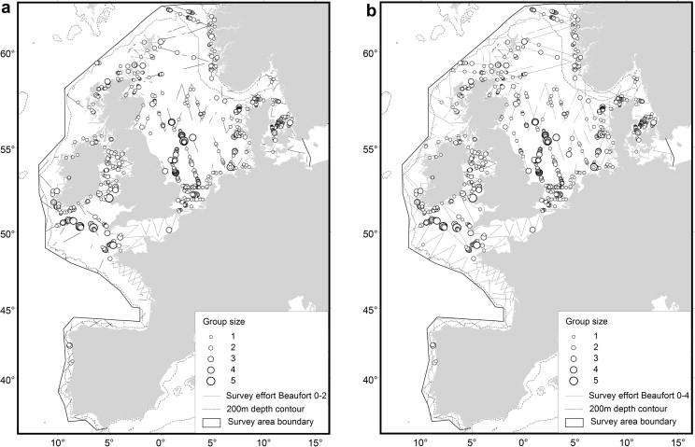
Figure 3-1: Porpoise sightings and group sizes in Europe during 2013 survey (Hammond et al, 2013).
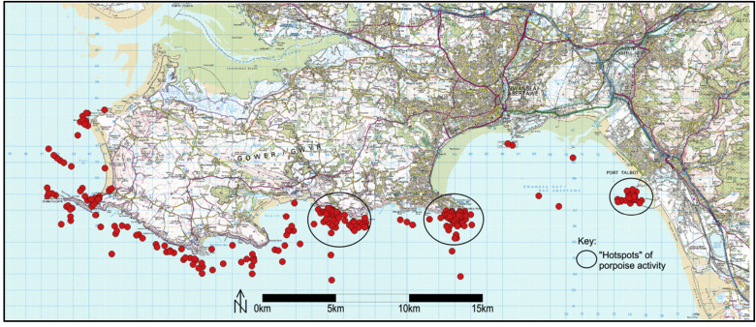
Figure 3-2: Sightings and areas of concentration in the Swansea/Gower study region (on-shore) from 2011-2013 (Oakley et al, 2016).

Analysis

Current status of Harbour porpoises
Harbour porpoises are the smallest and most abundant cetacean observed in waters surrounding the UK, and are predominantly found in the northern hemisphere. Although they may look similar, they are smaller and less sociable animals than the common dolphin that is also observed in harbours and coastal areas. In 2013, a single month- long survey studying the ‘abundance and distribution of cetaceans in European Atlantic shelf waters’ estimated that the number of harbour porpoise around the UK was 177,000, although this figure will fluctuate depending on the time of year (Hammond et al, 2013),(‘A Conservation Literature Review for the Harbour Porpoise’, 2015).

Currently the Harbour porpoise are classified as of ‘least concern’ according to the IUCN Red List, although the current global population is unknown. I would suggest that until further research is carried out on the population size of the porpoise, (globally and domestically) it is inaccurate to class it in the ‘Least Concern’ category.

Distribution
Some sources have noted that they are observing Harbour porpoise (both on shore and on water) less frequently, which means the population is declining. Because the porpoise is concentrated in areas that are also used for various methods of fishing [fig 3-1] and other marine activities, it is possible that they are frightened of sea vessels and remain out of sight until they feel safe. However, studies on bycatch statistics and echo location may suggest otherwise.

Porpoise are found in coastal waters in depths of 20m-200m, mainly the temperate and sub-arctic waters that have temperatures of between 11°C-14°C (Waggitt et al, 2020). They are not found everywhere along the UK coastline, with West Wales and the Irish Sea being favoured over the South Wales coast [fig 3-1]. Data from an on-shore survey from 2002-2005 shows that sightings increase in the Swansea/Gower region between the months of June, July and September (Oakley et al, 2016). This could be because porpoise migrate to the area to breed, and tend to stay for at least a few weeks in more sheltered areas with newborn calves until they have developed the necessary skills/confidence to travel from the nursery. A study from 2011-2013 shows that there is a significant presence of Harbour Porpoise in the Swansea/Gower region but still not as many as the West Wales coast [fig 3-2].

Physiological attributes
Harbour porpoise are generally described to be a newborn if they measure between 70cm-90cm, a calf is 90cm-110cm, juveniles are 110cm-140cm and anything over 140cm is classified as an adult specimen. Living up to 24 years old in the wild, and reaching sexual maturity between 3-5 years old. Giving birth to one offspring annually (unless ideal conditions are not met) means the porpoise population is likely in deficit due to the reproduction rate being so slow. This becomes a major factor if any conservation projects were needed to restore population numbers should be found to be declining. The calf spends up to ten months relying on the mothers’ milk before hunting for itself.

As porpoise are mammals and have lungs as opposed to gills, they need to come to the surface to breath, this exposes them not just to waterborne pollution, but to airborne pollutants too such as boat exhaust fumes. As mentioned previously, the Harbour porpoise can easily be confused with the common dolphin as they share much of the same habitat and the bodies are of a similar shape. The main differences physically being that the porpoise has a short, blunt head with no forehead or beak and that its whole body is stockier compared to the more streamlined dolphin. The social lives and actions are also noticeably different, with the porpoise mostly being solitary cetaceans or seen in small groups of up to three including mothers and calves. But when there are opportunities to feed on large groups of prey or migration paths cross, there have been sightings of mass gatherings of over a hundred individuals in close proximity to each other.

As Harbour porpoise mostly have a dark grey colour on the back and little colour differences on dorsal fin it can be very difficult to spot them especially in rougher seas. Because breaching behaviour is less frequent compared to the common dolphin, you can rarely spot their white belly or flippers as they tend to only propel themselves out of the water during the mating season or feeding. Approaching or playing with small vessels, also known as bow riding is also uncommon (Waggitt et al, 2020).

Threats
Bycatch (when non-target species are caught in fishing gear) is one of the bigger threats to the harbour porpoise, because there is a large crossover where most fishing vessels operate and where the porpoise are often observed. Although it is wrong to assume, it is thought most of the bycatch reported is not intentional but it is occurring frequently thanks to the use of various nets being used by commercial fishermen.

The use of gillnets and other types of nets in areas that porpoise occupy increase the likelihood of bycatch due to its non-selective nature. In the UK nets are primarily used by trawlers in coastal areas or estuaries for salmon or sea trout, but the way that some nets are cast and then left for days before being checked mean that it is impossible to instantly release a non-target species from the net. It is for this reason that the use of nets is strictly monitored in both rivers and coastal areas by the NRW (Natural Resources Wales) and on a county level. Using nets to fish may be the easiest way for a commercial trawler to gain a large catch in a short period of time, but reel and rod methods mean you catch one fish at a time and can instantly release any non-target fish back into the water, this also minimises the risk of over-fishing and depleting fish reserves unnecessarily.

Ways of minimising bycatch from gillnets have been introduced, such as using pingers, (small battery powered devices that are attached to the nets and emit sounds that are audible to cetaceans), and have shown to reduce the number of porpoise’ caught. But because it hasn’t eliminated the problem altogether, it is far from being a solution and more sustainable methods of fishing should be supported for the future. Onboard cameras set up to monitor bycatch of cetaceans have been trialled in some European countries but there are still pros and cons that do not make this type of technology 100% efficient at tackling the problem.

There is also the murky issue of reporting bycatch, as there are different rules and regulations regarding the reporting of bycatch depending on the size of the vessel used. Vessels over 10m long have different reporting requirements than those smaller vessels, the problem being that it is mainly the smaller vessels that are typically operating closer to shore and having the bigger impact on the harbour porpoise. Adding to the problem is the theory that smaller engines emit a higher frequency sound underwater that interfere with the echo location senses of the porpoise, therefore causing some individuals to become confused or lost and either being attracted towards the noise or becoming stranded. This is backed by evidence gained by observing porpoise behaviour during rainfall, with noise that is of a frequency that is outside of biosonar range of the porpoise could distract the porpoise from conducting any essential behaviour such as feeding (Miller and Wahlberg, 2013). With further studies demonstrating temporary effects on behaviour in vessel traffic, this could also prevent individuals from mating and consequently a decrease in population numbers (Oakley, Williams and Thomas, 2017).

After studying raw data gathered from on shore observations and onboard a research vessel in the Swansea/Gower region in 2002-2005, I had thought that it would depend on the marine vessels’ behaviour on whether or not any porpoise would be sighted in the area. With low numbers of boats of various sizes in the immediate area, porpoise’ were seen and most occasions were not exhibiting behaviour suggesting that it felt threatened, and would seemingly remain calm. However, when the number of boats increased to twenty or thirty with some stationary there would be a significant drop in the number of sightings for that day. Comparing my findings to those of a study conducted in the Swansea/Gower region but with more recent data, it suggests that it was the vessels that were fast moving at a constant speed were more likely to disturb/distress any harbour porpoise in the vicinity regardless of the number of boats there are (Oakley, Williams and Thomas, 2017).

With Harbour porpoise sharing the majority of their habitat with heavily fished coastlines or seasonal tourist areas, it is inevitable that they will experience an increase in noise and harassment from both fishing vessels and pleasure craft, which in turn create more pollution. Although they have been seen to almost ignore stationary vessels, they clearly continue to feel threatened by fast moving smaller boats and jet ski’s which significantly increase during certain times of the year, with summer and autumn being peak times of vessels observed. This coincides with the peak sightings of harbour porpoise in the same areas most likely due to mating or feeding opportunities, therefore increasing the likelihood of porpoise being disorientated due to engine noise and become stranded or coming into direct contact with a vessel (Oakley et al, 2016).

Current legislation
Currently the harbour porpoise is protected under the Habitats and Species Directive (92/43/EEC) and listed as a priority species in the City and County of Swansea’s Biodiversity Action Plan (BAP). As of 2009 there were sixteen UK relevant Government Acts, 20 European & International directives and conventions as well as conservation, shipping, pollution prevention and fisheries legislation that all apply to the Harbour porpoise and its habitat (Jenkins, Brown and Phillips, 2009). Yet this still doesn’t seem to be enough to adequately protect the species from the consequences of anthropogenic behaviour.

This could be improved with the allocation of SAC’s (Special Areas of Conservation). If the areas of Swansea/Gower were to be designated SAC’s then the local fishing legislation would have to be amended and restricted in various ways. Some ways this can be changed is to ban the use of nets in those areas to eliminate bycatch, not just of harbour porpoise but of all species therefore improving the diversification of fish species in those areas. During certain times of year, May to September (mating season), for example is when there appears to be an increase in neonatal deaths by either stranding or by collision with vessels so a seasonal restriction could be introduced to certain areas along with speed restrictions to reduce the probability of collisions.

In regards to construction such as harbour developments, off shore wind turbines and oil rigs, there has been insignificant research done in the long term effects the piling/drilling has on species that use echolocation. A short term or permanent shift in the hearing threshold is one of the auditory injuries that can affect cetaceans due to the noise caused by piling or other underwater noise, this in turn can drive away a species from the area as it is no longer habitable for them causing species displacement (Verfuss et al, 2016). Although studies in the German North Sea have shown that use of noise reduction systems can reduce the area impacted, these devices were still under development and not all of them provided desired results (Brandt et al, 2018). If for example the Swansea Bay Tidal Lagoon project was to go ahead, much more research would have to be conducted in the area to make sure that the residential pods of Harbour porpoise were not disturbed at all, as this could have detrimental effects on them especially during mating season. Although EIA’s would be carried out to try and safeguard the surrounding habitat, long term effects are unknown.

Conclusion
After conducting my research, my conclusion is that firstly more research is needed on the
Harbour Porpoise and the effects of anthropogenic activities on it. More accurate surveys should be carried out in the Swansea/Gower regions to positively identify areas that are of significance (and why) for the porpoise such as dedicated breeding grounds or nurseries, or seasonal fluctuations in food resources where migratory fish are abundant at certain times of year. It is once we have data from these studies that more protective and efficient measures can be brought in such as fishing restrictions etc. With bycatch being a main threat, I think there should be more restrictions or cetacean deterrents used in the fishing industry to try and reduce the number caught, as the species does not reproduce regularly enough to naturally increase population numbers. I do not think that the Harbour Porpoise numbers around the UK are declining, but there is evidence that the population distribution in other parts of Europe have shifted. This could be a natural process or it could be because the amount of disturbance around our coastline is increasing due to fishing, tourism and renewable energy sectors.

References

- ‘A Conservation Literature Review for the Harbour Porpoise’, n.d., 98.
- Brandt, Miriam J., Anne-Cecile Dragon, Ansgar Diederichs, Michael A. Bellmann, Veronika Wahl, Werner Piper, Jacob Nabe-Nielsen, and Georg Nehls. ‘Disturbance of Harbour Porpoises during Construction of the First Seven Offshore Wind Farms in Germany’. Marine Ecology Progress Series 596 (28 May 2018): 213–32. https://doi.org/10.3354/meps12560.
- Calderan, Susannah, and Russell Leaper. ‘Review of Harbour Porpoise Bycatch in UK Waters and Recommendations for Management’, n.d., 57.
- Hammond, Philip S., Kelly Macleod, Per Berggren, David L. Borchers, Louise Burt, Ana Cañadas, Geneviève Desportes, et al. ‘Cetacean Abundance and Distribution in European Atlantic Shelf Waters to Inform Conservation and Management’. Biological Conservation 164 (1 August 2013): 107–22. https://doi.org/10.1016/j.biocon.2013.04.010.
- Jenkins, Rhian E., Raymond D.H. Brown, and Michael R. Phillips. ‘Harbour Porpoise (Phocoena Phocoena) Conservation Management: A Dimensional Approach’. Marine Policy 33, no. 5 (September 2009): 744–49. https://doi.org/10.1016/j.marpol.2009.02.003.
- Lau, Winnie W. Y., Yonathan Shiran, Richard M. Bailey, Ed Cook, Martin R. Stuchtey, Julia Koskella, Costas A. Velis, et al. ‘Evaluating Scenarios toward Zero Plastic Pollution’. Science 369, no. 6510 (18 September 2020): 1455–61. https://doi.org/10.1126/science.aba9475.
- Miller, Lee A., and Magnus Wahlberg. ‘Echolocation by the Harbour Porpoise: Life in Coastal Waters’. Frontiers in Physiology 4 (15 April 2013). https://doi.org/10.3389/fphys.2013.00052.
- Oakley, J.A., R.E. Jenkins, T. Thomas, A.T. Williams, and M.R. Phillips. ‘Assessing Harbour Porpoise Populations in South-West Wales, Data Issues and Implications for Conservation and Management’. Ocean & Coastal Management 119 (January 2016): 45–57. https://doi.org/10.1016/j.ocecoaman.2015.09.011.
- Oakley, Judith A., Allan T. Williams, and Tony Thomas. ‘Reactions of Harbour Porpoise (Phocoena Phocoena) to Vessel Traffic in the Coastal Waters of South West Wales, UK’. Ocean & Coastal Management 138 (15 March 2017): 158–69. https://doi.org/10.1016/j.ocecoaman.2017.01.003.
- Verfuss, U.K., Plunkett, R., Booth, C.G. & Harwood, J.: Assessing the benefit of noise reduction measures during offshore wind farm construction on harbour porpoises. Report number smruc-wwf-2016-008 provided to WWF UK, June, 2016. ‘15_11_24_wwf___finalreport[1].Pdf’. Accessed 29 November 2020. https://www.wwf.org.uk/sites/default/files/2016-10/15_11_24_wwf___finalreport[1].pdf.
- Waggitt, James J., Peter G. H. Evans, Joana Andrade, Alex N. Banks, Oliver Boisseau, Mark Bolton, Gareth Bradbury, et al. ‘Distribution Maps of Cetacean and Seabird Populations in the North‐East Atlantic’. Edited by Andre Punt. Journal of Applied Ecology 57, no. 2 (February 2020): 253–69. https://doi.org/10.1111/1365-2664.13525.

