  Component One:  What are the key skills required when working in the housekeeping team? 750 words (+/- 10%)  Contribution to Overall Module Assessment: 25% | Student No: | 2124414
 | Module Title: | Operating hotel facilities
 | Module Code: | BMIH006
 | Lecturer: | Lola Villard
Housekeeping is a heart of a hotel. It is a department in a hotel where there are a management of cleaning, maintenance, aesthetic upkeep of rooms, public areas, back areas and the surroundings. They clean and maintain everything in the timely manner so that hotel looks fresh and attractive, which makes better comfort for guest and they feel like a home (Hilton,2016).
Housekeepers performing their duties to ensure guest satisfaction and companies betterment. According to Little hotelier(2022), "85% reviews are mainly focus on cleanliness. Housekeepers clean the guest rooms, bathrooms and sanitize it, remove used amenities, dirty towels, linen, rubbish and replace the items. Making bed , cleaning all over to ensure all extras are add on for guests before arriving".
Housekeeping also synchronize closely with the engineering team when they found different issues during cleaning the rooms for example- lighting, furniture, bulb and so on. Housekeeping duty can regulated by the type, size or category of a hotel.
A 5 star hotel, executive housekeeper working as a head of the department where he or she report the general manager about any issues. The deputy housekeeper assist the executive housekeeper and taking care of public areas, the floors, the linen room, controlling the desk, recruitment and so on (Hollander,2022).
Nowadays , hotels are focusing on paying attention to every details for a cosy stay. According to Indeed (2020), there are following seven common skills of professional housekeeper need :
Time managing skills: Housekeepers work on alone or a team to clean the room for clients in the time frame where they scheduled plan for their cleaning.
Attention on details: Housekeepers are extremely work on detail and organizing everything perfect to make sure floors and windows are properly clean.
Communication skills: Communication is very important for housekeepers to understand his colleagues and clients needs so that they can successful done their job.
Interpersonal skills: Housekeepers directly works with their client & colleagues. So, they need to learn this skills.
Flexibility: It is very important skills as they can be there whenever customer need.
Customer service: Guest satisfaction is first and most priority for a housekeeper. So, a successful housekeeper need to have a great customer service skills.
Housekeeping hard skills: Carpet cleaning, sweeping, deep cleaning, mopping, vacuums rooms or lobby , dusting, bathroom and bedroom cleaning etc are the common hard skills for a housekeepers to develop a successful future.
Housekeeping plays an important rule for any hotel where they helps to prevent slip and falls as well as reduce the risk of cold, flu and other serious diseases. After using any tools , a good housekeeper put it in the right place as possible. Also clean up messes such as- broken glasses clean it as soon as possible. Be sure to uses appropriate signage and clean up your workplace as soon as you finish it, empty the trash as soon as you finished to work with it, clean the high touch point very often and report any things you need to repair (GotSafety,2022).
Cleanliness and an efficient operation are at the heart of guest satisfaction. For that , it is important to choose a housekeeping software to ensure that this department is working in the best way possible. Hotelkit, Flexkeeping, Optii solutions, Room checker, HKeeper, Unifocus, Xenia, Hub OS, Alice, Lodgistic etc are the software which are working for housekeeping department. These software can do customize, messaging, integrate the systems, interdepartmental communication , Gathering and delivering data by reporting tools (Hotel Tech Report,2022).
I experienced to work as a housekeeper where I work directly with colleagues and the supervisors in my placement. And also I was worked closely with other department heads and the general manager. Housekeepers patience label is very high. I learnt that how to pay attention on details, how to clean everything properly, how to tidy the beds and put the amenities in place for guest, also learn the cleaning procedure and how to maintain scheduled the room. I also observe the situation that how to remain calm in stressful situations and how to inspect rooms to make sure that standards have been met. If there are any fault or damage , record it and repair it .
Housekeeping contribution is really huge overall reputation of a property. A good housekeeper can give hotels an edge by providing the right support at right time which can enhance the guest experience to making each guest visit are affectionate and hospitable one. So, be accountable, hard-working, honest, detail-oriented, flexible, sincere, and trustworthy person can be a good housekeeper. A more productive team means more efficient operations.

Word Count | 767

Component Two:
Contribution to Overall Module Assessment: 25%
In this scenario– You have just been promoted to team leader for a floor within the hotel.A guest complains that on their arrival, their room had not been properly cleaned.Create an action plan and answer the following questions.

Problem | Why did it happen? | What are you going to do? | How will you prevent this from happening in the future? | What measures would you introduce to improve team effectiveness?
Not enough towels. | Not properly trained. | Apologies and send more  towels on the room. | Target training. | Ensure proper  communication.
Bathrooms floor is wet. | Lack of communication. | Apologies and send  someone to clean it up  ASAP. | Improve  communication. | Rewards the employee.
T-shirts in the closet | Irregular inspection. | Apologies and remove  it. send it to the lost  interface. | Scheduled inspection  regularly. | Identify your teams  strengths and  weaknesses.
Carpets are wet. | Don't have any  checklist. | Apologies and try to dry  it. If possible request the  guest to remove an  another room. | Invest in quality  cleaning products. | Giving them work  environment.
Etc.

- As everyone is not properly trained, lack of communication, missing the checklist, irregular inspection, cleaning products qualities are poor etc.
- Understand the guest's needs , apologies and send it ASAP to them.
- By creating a regular checklist, scheduled inspection regularly, proper training for staff and using good quality cleaning products.
- Ensuring good communication, identifying staff's strengths and weaknesses, giving them work environment, motivating employees by giving them rewards and making the workflow more efficient for daily uses.

Component Three:
Contribution to Overall Module Assessment: 50%
Yourtaskistocreateandprepareapresentationfollowing the detailed scenario provided below.

As the floor housekeeping manager and given the recent guest complaints you need to put together a basic training presentation for your colleagues within the housekeeping team to get the best out of them, ensure that brand standard is being achieved and that Health and Safety procedures are also being followed.

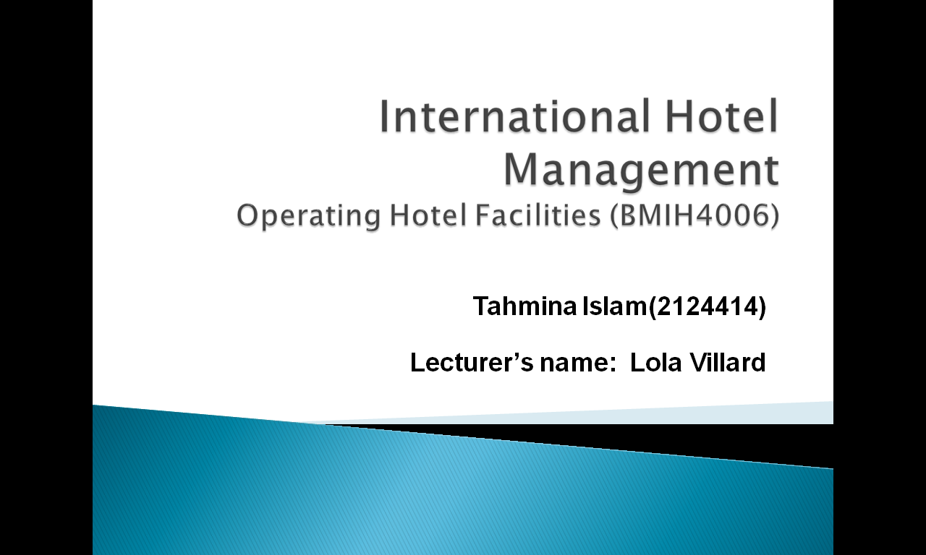

Notes of training: Hello everyone. My name is Tahmina Islam. I am your new housekeeping manager. Today, I have a basic presentation to you as I received some complaints from guest. I hope you will get the best out from them. So, let's begin from the outcomes of this training.

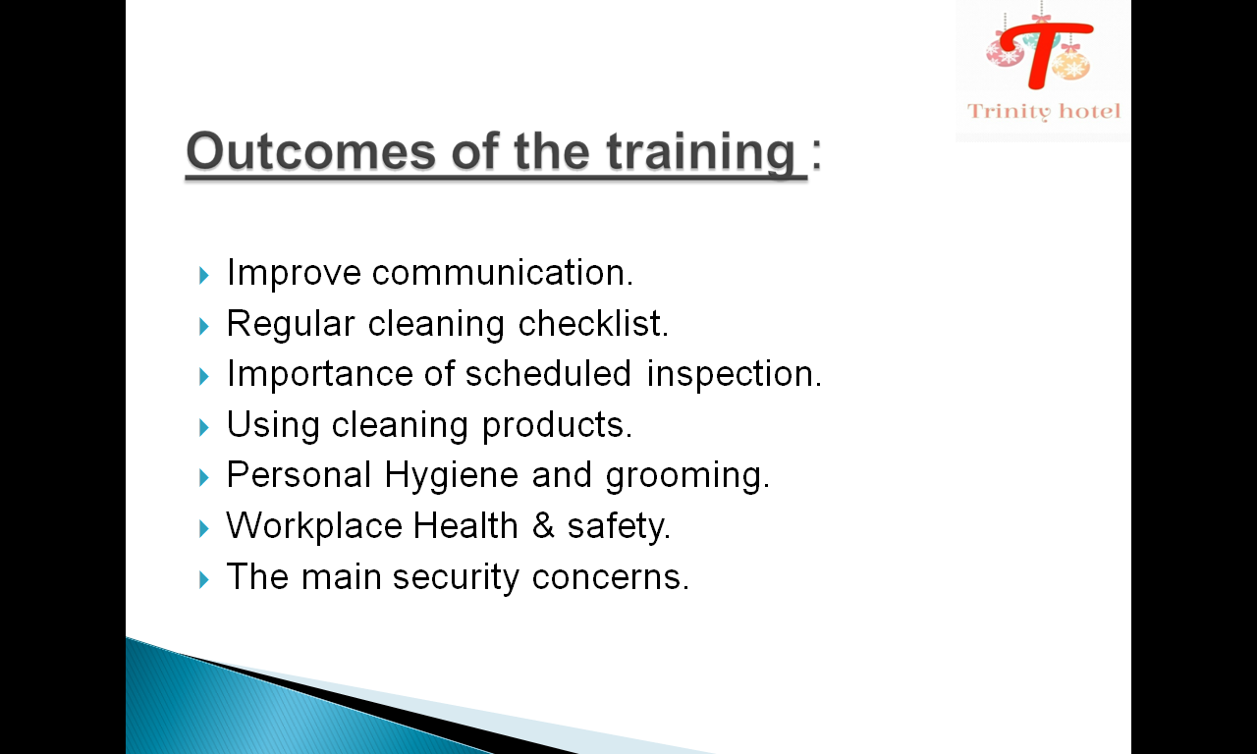

Notes of training : At first , I will discuss about how we can improve our communication and the housekeeping software. Secondly, I will tell you about regular cleaning checklist. Then I will discuss about the importance of scheduled inspection. Next, I will tell you the cleaning products that the Trinity hotel use as maintain their quality and standards. After that I will discuss about the personal hygiene and grooming. Next I will discuss about the workplace health and safety. In the end I will tell you the main security concerns.
You will also get chances to ask any questions in the end.

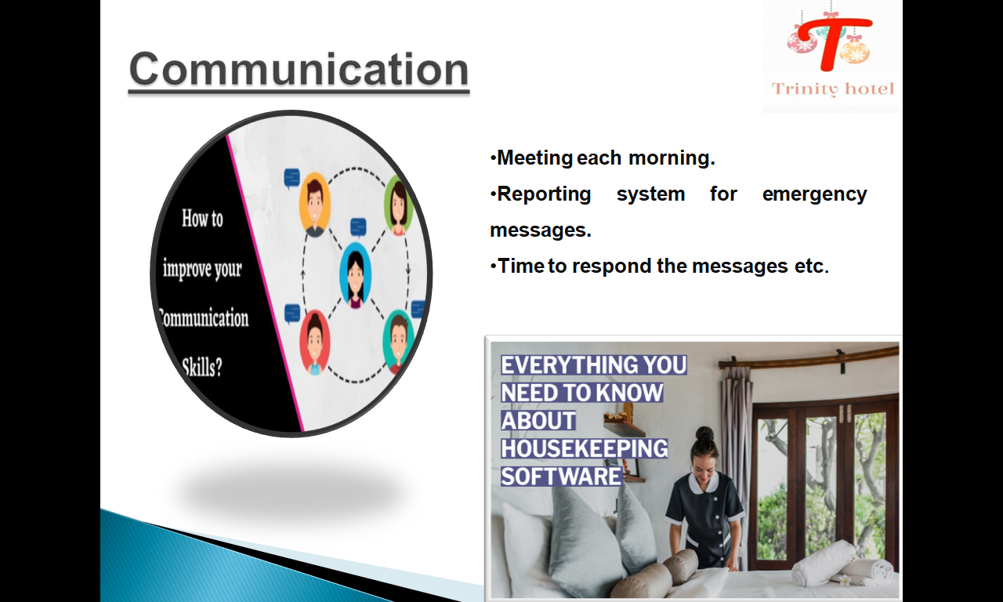

Notes of training: In our everyday life, communication helping us to build relationships by share our experiences, needs, and helping us bond to others. It's the real meaning of life which allow us to express feelings, pass on information and share our thoughts. So, We have to make sure all staff are comfortable to communicate with others. Enforcing clear communication overall by doing meeting each morning, a reporting system for emergency messages, time to respond the messages etc.
Moreover, Technology reduces the stress amongst hotel housekeeper which makes faster room cleaning which makes guests happy. Eventually, this software helps our teams more efficient so that we can deliver better guest service.
With the help of this technology you can create housekeeping schedules, tracking room progress, and adjust to changing requirements in real-time which is really simple. This software able to track the room attendants & their cleaning progress and instantly report any sudden issues.
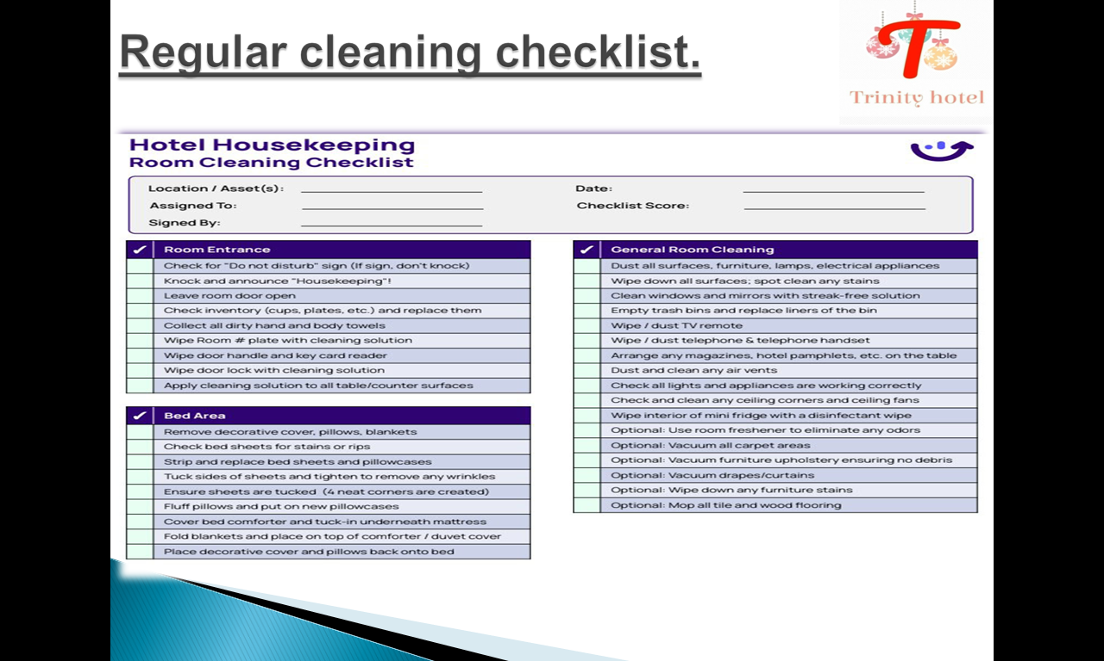

Notes: Checklists are a great way to increase employee accountability and keep track of cleaning data which help you to be prepared and manage the cleaning procedure of occupied rooms, deep cleans, and more.
You need check the room thoroughly before guest arrival. Clean and sanitize countertops and surfaces, Inspect the bed and change sheets, Clean and sanitize bathroom, Replace towels & toiletries etc. The common area you need to clean such as- Wipe and sanitize all surfaces, Dust light fixtures, surfaces, and décor, Vacuum carpets and rugs, mop hard floor etc.
Brand standard of a hotel is depend on housekeeping team. For that you have to create a clear and detailed cleaning protocol. So, you must follow the level of attention to detail required to meet your standard. Moreover, cleaning checklists empowers teams and reduce miscommunication and poor training. Not only does this reduce confusion, it provide housekeepers at the same granularity with a rubric to review each other's work that you could.

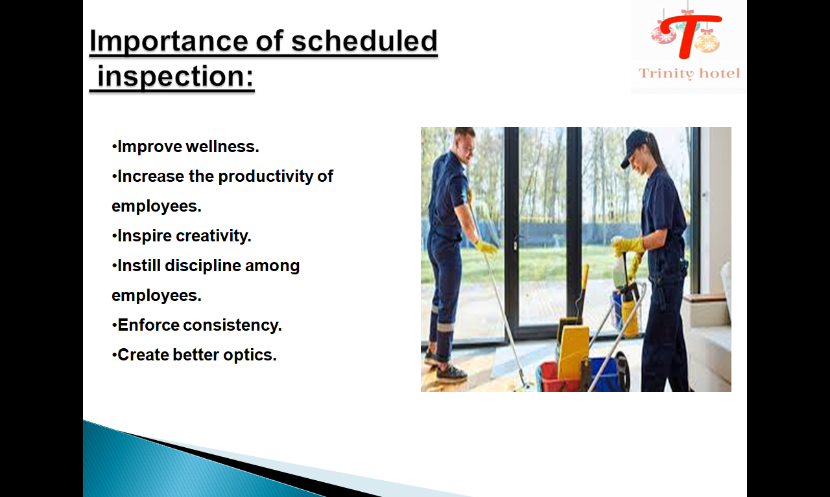

Notes: As first impression is very important so, cleaning in the public area in a timely manner and also need to regular check for this area by assigned employee to clean according to standard operating procedures (SOPs) so that the property can meet quality and brand standards. If someone needs help, they step in to lend a hand. The housekeeper encourage guest interaction if the guest want any extras for example-Towels, pillows etc. Scheduling inspection is very important for a housekeeping team. Its Improve wellness of anyone working in the establishment
Increase the productivity of employees, Inspire creativity, enthuse discipline among employees, enforce consistency, generate better optics etc.

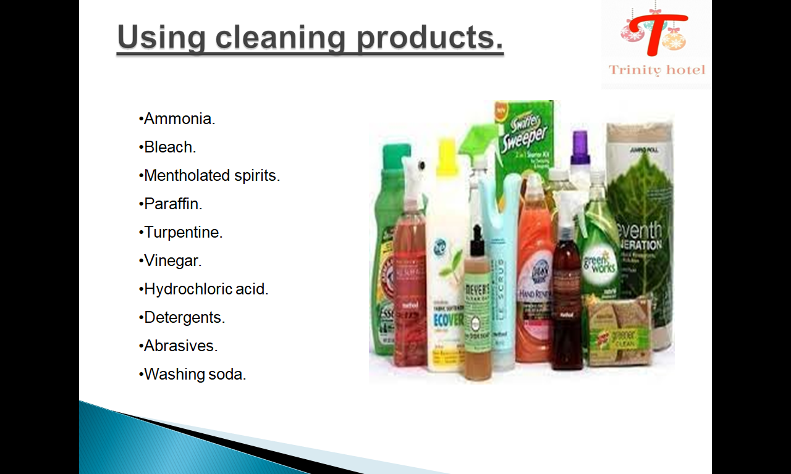

Notes: Cleaning agents are very useful to removing any types of dirt's, stains ,odour etc. Where Water gives the final touch of cleaning any products. Warm soft water can be used if you are cleaning anything with soap. It is more effective than cold water. If you use hard water with any cleaning agents ,please re check the place as it can remain in the cloth.
You can use liquid form of ammonia to remove the lubricants but you have to make sure put it aside from bleach. Otherwise, both combinations can makes a dangerous hazardous gas.
Mentholated spirits used to remove grease stains , dirt, ink etc. Also , everyone need to be very careful as it is lethal which can effect severely.
Paraffin is a colourless and odourless agents to clean lubricant soils.
Turpentine is also colourless but it can odour to use for shining the paints.
Vinegar is using to clean chores and remove light bath soil.
Hydrochloric acid is using very cautiously use for bathroom cleaning.
Detergents are very popular to use in any hotel for remove dust and dirt. At first put a right amount of detergent pour into right temperature of water and make sure it properly soluble.
Abrasives are using to shine and polish any material, but you have to cautious as its harmful.
Washing soda is using clean the pipe line clean for bathrooms. Like other hotel, Trinity hotel is also using detergents rather than washing soda.

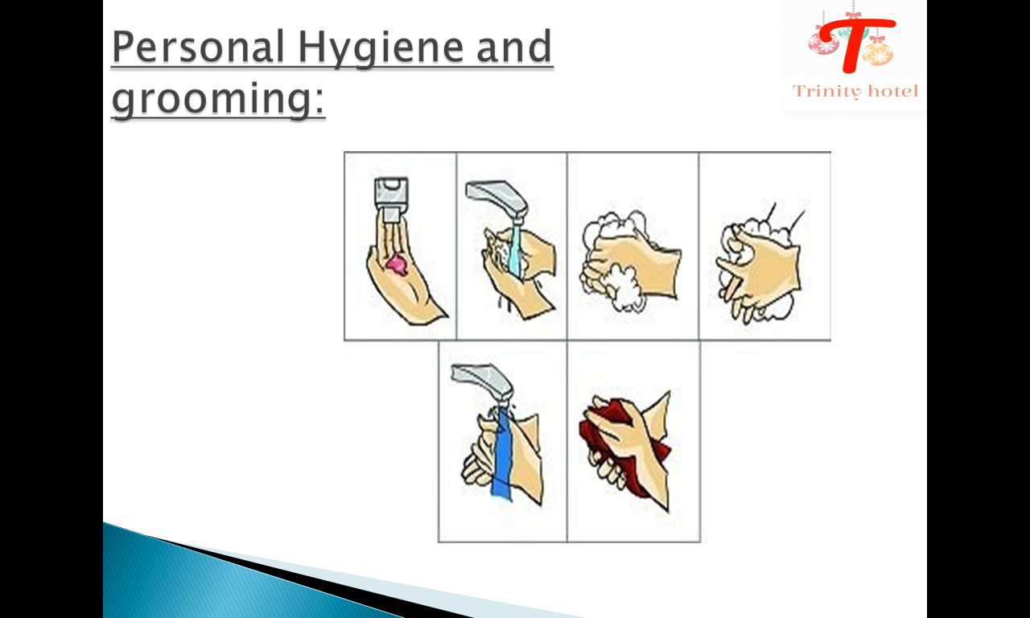

Notes: Hygiene is very important for any person. Good body washing practices can reduce the spread of hygiene-related diseases. Changing socks and underclothing every day. Brushing teeth at least twice a day. Washing hair frequently, keep hair and breads neatly trimmed. Keeping your finger nails short and clean; avoid using of nail polish, make-up and perfumes. It's essential to identify housekeepers' hard work and also the importance of maintain their health. Keeping the germs away and stop the spread of infection by throughout proper hand hygiene practices. Always you have to remember that washing your hands in the specific wash basin, use boiled water to get rid of the bacteria, rub soap over hands between fingers and under fingernails for 20 seconds, rinse your hands and wipe your hands with dry paper towel.

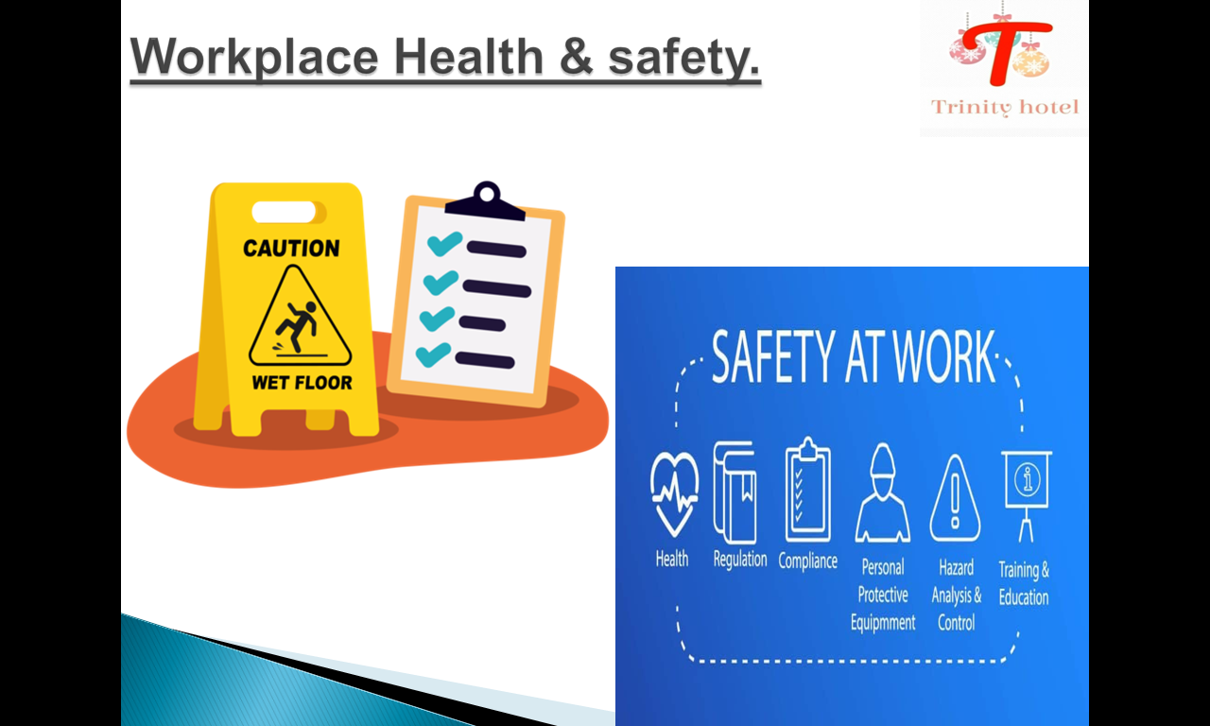

Notes: The Health and Safety at Work Act 1974 is a primary legislation and Act of Parliament where a legal duty on employers, manufacturers, and all employees who work for such organizations. So, Everyone in the hotel need to follow the health and safety regulation. You should care of your health and safety & stop work if there’s a safety concern, you have to remember that you don’t put others in danger, inform supervisor or me if there’s a safety concern and report accidents.
Risk assessments follow some steps. They are -identify and assess the hazards & have to work out how you can control the risks, record and review your findings .

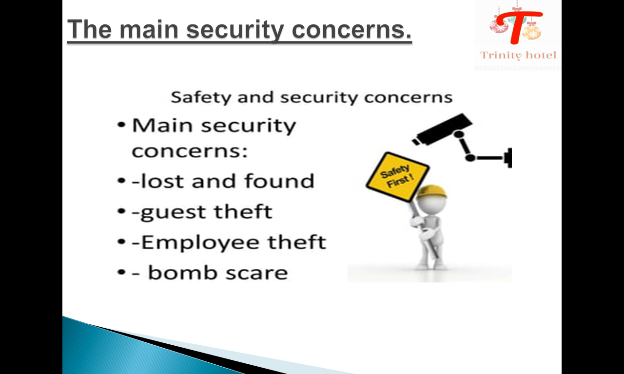

Notes: Like all other hotel , our Trinity hotel also growing concern about lost and found , guest theft, employee theft, suspicious activity etc. Guest take hotel’s item as they can useful in home. If you couldn’t find them ,you have to think that it’s theft by guest already. So, you have to check any suspicious movement by guest , inform the security. Employee has limited access in the hotel. But, still they can steal anything from hotel. Bomb scare or any type of terrorism can happen, so we have to be alert and if you saw anything suspicious like anyone carrying lots of phones, riffles or any types of maps etc. Don’t wait ,just inform the security and on duty manager.
In our hotel we have a real time messaging system so we can contact each other in the crisis time.

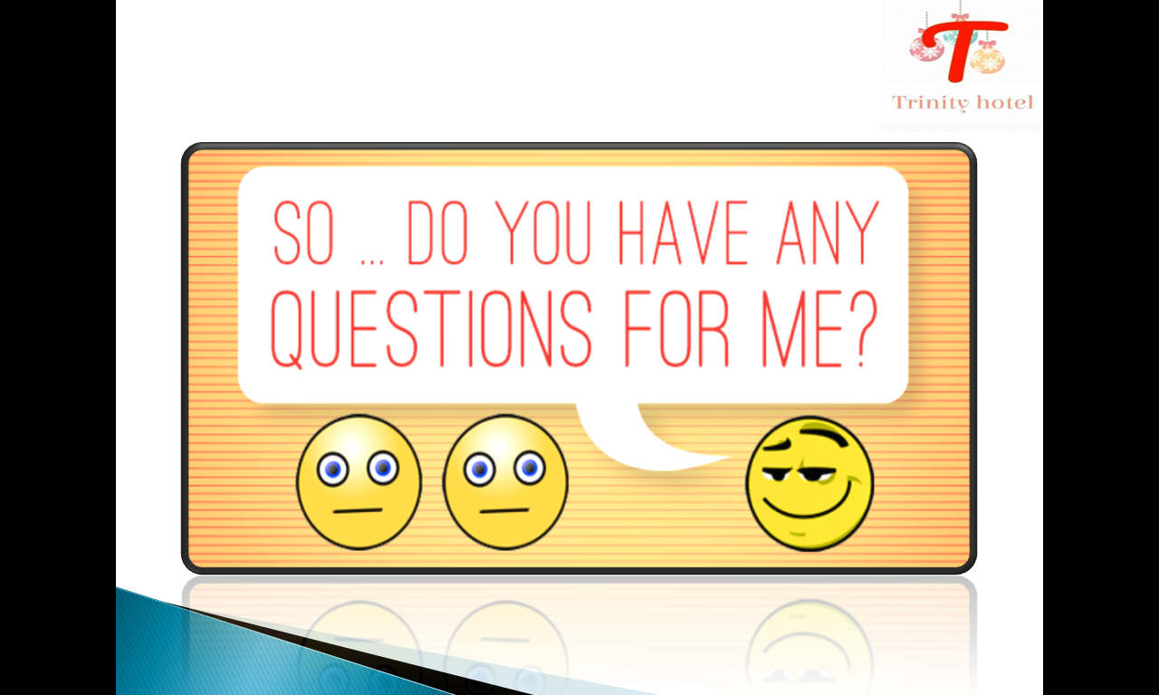

Notes of training:
In the end, the hospitality industry has been taught a harsh lesson by COVID. Where housekeeping plays an important rule for a hotel. Now a day's hotels increase improvement by paying attention to every detail of what makes a relaxing and secure stay. Majority of hotel guests leave reviews or feedback about the service which mention about the cleanliness about their rooms. So, we have to be very careful while doing our job..
So, in addition to a clean bathroom and fresh bedding and towels –
providing guests with comfortable pillows and duvets, modern appliances, do some extra of services, luxury guest amenities etc can enhance a guest’s experience which set a clear division between one hotel to another.
I hope this training is helpful for all of you . If you need any help give me a shout, I will be there for you.
& also if you have any questions please feel free to ask me, I am happy to answer.

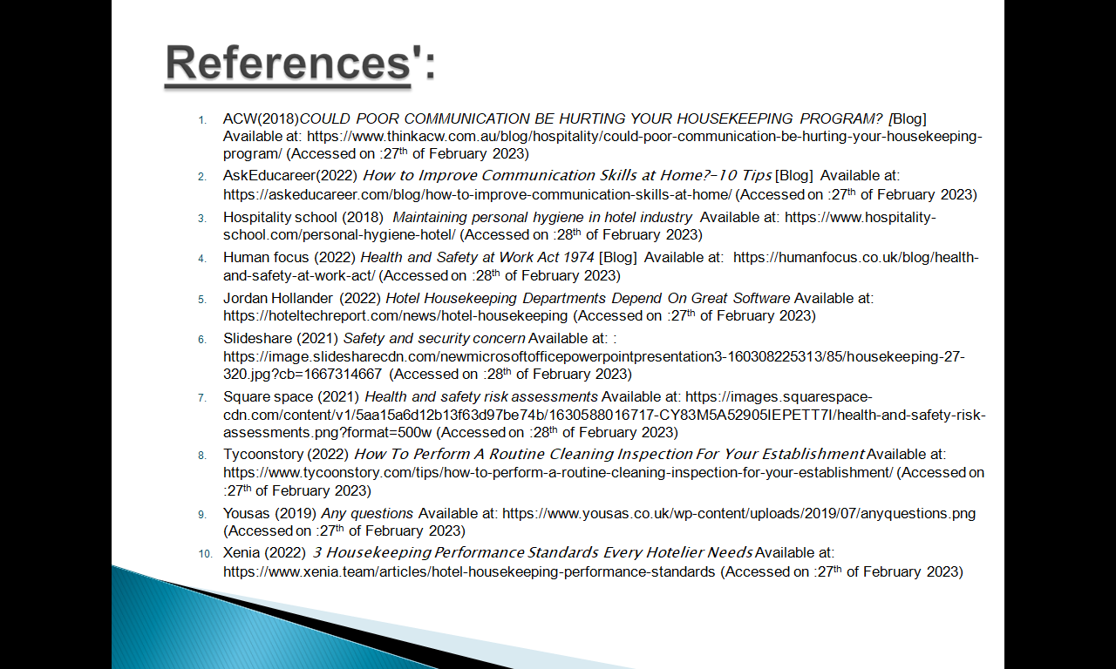

Training Notes:
Here’s some references' for your help. Thank you for your time. Bye.

References:
C-1
GotSafety (2022) Good housekeeping in the workplace . [Video] Available at : https://youtu.be/NeNNZZGBwHw (accessed on: 25th February 2023).
Hilton (2016) We are Hilton: An Inside Look - Housekeeping. . [Video] Available at : https://www.youtube.com/watch?v=ZnUQiiRFp-k&t=98s (accessed on: 22nd February 2023).
Hotel Tech Report(2022) 10 Best Housekeeping Software for Hotels in 2023 Available at : https://hoteltechreport.com/operations/housekeeping-software (accessed on: 25th February 2023).
Indeed (2020) Guide to Housekeeping Skills (With Tips and Examples) Available at : https://www.indeed.com/career-advice/career-development/housekeeping-skills (accessed on: 22nd February 2023).
Jordan Hollander(2022) Hotel Housekeeping Duties: A Day in the Life Available at : https://hoteltechreport.com/news/hotel-housekeeping-duties (accessed on: 22nd February 2023).
Little hotelier(2022) Hotel housekeeping: A complete guide for your business [Blog] Available at : https://www.littlehotelier.com/blog/running-your-property/hotel-housekeeping-complete-guide/ (accessed on: 25th February 2023).
-------------------------------------------------------------------------------------------------------------
C-2
Hotel cleaning service (2022) How to improve housekeeping service standards checklist. Available at: https://hotelcleaningservices.com/how-to-improve-hotel-housekeeping-service-standards-checklist/ (accessed on: 22nd February 2023).
Indeed (2020) Guide to Housekeeping Skills (With Tips and Examples) Available at : https://www.indeed.com/career-advice/career-development/housekeeping-skills (accessed on: 22nd February 2023).
Oaky (2022) Hotel Housekeeping: increase efficiency amid staff shortage [Blog] Available at: https://oaky.com/en/blog/hotel-housekeeping (accessed on: 25th February 2023).
Rubbermaid(2022) How to improve your housekeeping department [Blog] Available at : https://www.rubbermaidcommercial.com.au/blog/hospitality/how-to-improve-your-housekeeping-department/ (accessed on: 25th February 2023).
Sheweta Mirani (2021) How to improve Hotel housekeeping service to increase productivity? [Blog] Available at: https://www.hotelogix.com/blog/how-improve-hotel-housekeeping-service-increase-productivity/ (accessed on 23rd February 2023).

-----------------------------------------------------------------------------------------------------
C-3

- ACW(2018)COULD POOR COMMUNICATION BE HURTING YOUR HOUSEKEEPING PROGRAM? [Blog] Available at: https://www.thinkacw.com.au/blog/hospitality/could-poor-communication-be-hurting-your-housekeeping-program/ (Accessed on :27th of February 2023)
- AskEducareer(2022) How to Improve Communication Skills at Home?-10 Tips [Blog] Available at: https://askeducareer.com/blog/how-to-improve-communication-skills-at-home/ (Accessed on :27th of February 2023)
- Hospitality school (2018) Maintaining personal hygiene in hotel industry Available at: https://www.hospitality-school.com/personal-hygiene-hotel/ (Accessed on :28th of February 2023)
- Human focus (2022) Health and Safety at Work Act 1974 [Blog] Available at: https://humanfocus.co.uk/blog/health-and-safety-at-work-act/ (Accessed on :28th of February 2023)
- Jordan Hollander (2022) Hotel Housekeeping Departments Depend On Great Software Available at: https://hoteltechreport.com/news/hotel-housekeeping (Accessed on :27th of February 2023)
- Slideshare (2021) Safety and security concern Available at: : https://image.slidesharecdn.com/newmicrosoftofficepowerpointpresentation3-160308225313/85/housekeeping-27-320.jpg?cb=1667314667 (Accessed on :28th of February 2023)
- Square space (2021) Health and safety risk assessments Available at: https://images.squarespace-cdn.com/content/v1/5aa15a6d12b13f63d97be74b/1630588016717-CY83M5A52905IEPETT7I/health-and-safety-risk-assessments.png?format=500w (Accessed on :28th of February 2023)
- Tycoonstory (2022) How To Perform A Routine Cleaning Inspection For Your Establishment Available at: https://www.tycoonstory.com/tips/how-to-perform-a-routine-cleaning-inspection-for-your-establishment/ (Accessed on :27th of February 2023)
- Yousas (2019) Any questions Available at: https://www.yousas.co.uk/wp-content/uploads/2019/07/anyquestions.png (Accessed on :27th of February 2023)
- Xenia (2022) 3 Housekeeping Performance Standards Every Hotelier Needs Available at: https://www.xenia.team/articles/hotel-housekeeping-performance-standards (Accessed on :27th of February 2023)

