Using an entrepreneur of my choice, critically evaluate their entrepreneurial motivations and characteristics using appropriate academic models

Table of Contents
Introduction 3
My selected entrepreneur 3
Theories related to entrepreneurship 3
Linkage between the theories and Peter Jones 3
Motivation of Peter Jones 5
Reasons behind Peter’s success 6
Conclusion 6
References 7
Presentation 8

Introduction
This paper is all about focusing on one of my favorite entrepreneur Peter Jones. His life has observed some events that might be meaningful to the entrepreneurs. I have described a brief history of Peter Jones. I applied the academic theories in his success story and finally showed his personal motivations.

My selected entrepreneur
Peter Jones is one of my favorite entrepreneurs. I would like to talk about his activities and success story in this report. Peter Jones is from Berkshire and was born in 1966. His father was a businessman and Peter was very much fond of sitting in his fathers big chair from his childhood. He told in his website that his parents worked for a long time of their life to support the family and Peter observed it very closely. He cherished to be a multi-millionaire from his childhood. A well known business tycoon Peter Jones is also known as a TV star (Peterjones.com, 2020). A famous program in BBC2 news channel named Dragon’s den is operated by Peter Jones. He has interests in some other fields also. These fields include cell phones, hospitality, travel and real estate. His success story does not flourished in a single day. His success consists of struggles. In this paper, I will demonstrate the struggles and success stories of Peter Jones (Startups.co.uk, 2020).

Theories related to entrepreneurship
Entrepreneurship theories can be related to the real experience of the entrepreneurs. The theory for innovation, achievement theory, status withdrawal, social changes theory and many more theories are available for the entrepreneurs (Kuratko, 2016). I will cover the theories that are related to the story of Peter Jones.

Linkage between the theories and Peter Jones
Peter Jones does not become successful overnight. His success is surrounded by struggles. He worked hard and sincerely to attain success. I have demonstrated the linkage between him and the entrepreneurship theories.
- Theory of innovation: This theory deals with the meaningful innovations of the entrepreneur. The invention made by the entrepreneur should have an effect in a particular field. His idea must have economic value. This idea should generate something new. This theory is applicable in the life of Peter Jones. Peter Jones is an idea generator. He has generated ideas for many TV shows. The Dragon’s Den in BBC2 television channel is one of his greatest ideas. He is also generator of the famous American Inventor show. This show was able to fetch a huge audience response, which indicates that Peter Jones is a talented inventor (Audretsch, 2006).
- Theory of need for achievement: A person always try to make the best use of opportunity and this behavior is derived from need for achievement theory. An entrepreneur is engaged in doing well. He tries to utilize his talents and opportunities in a profitable way. That’s why an entrepreneur works for improving the work condition to increase the profitability of his organization. An entrepreneur starts working with a new idea for attaining success. Peter Jones is not different from that. He cherished to be a businessman from his early life. He observed the daily life of his parents and took lessons from their life so that he could use the lessons in the real world (Hansemark, 2003).
- Leadership: An organization is operated with the help of human resources. Money and materials cannot operate an organization without the help of humans. The resources and other materials needs to be organized. And the human resources works to organize the resources. A leader organize the human resources according to the size and type of the organization. A leader motivates the employees and makes them enable of employing the best possible efforts from them. A leader works for the development of both the employees and the organization. Peter operates a wide range of businesses. These businesses includes thousands of employees. Managing these employees needs a good understanding of managerial knowledge and leadership qualities. Peter Jones has successfully manages these employees. All of his businesses are successful. So, he can be considered as a successful leader (Cogliser and Brigham, 2004).
- Model personality theory: An entrepreneur should have a charming personality. His personality should be able of influencing others. He should be honest and dedicated to his occupation. Peter Jones has some outstanding qualities in his personality. First of all, Peter has visionary power. Peter can preview the future events. He can make an evaluation of the future activities. He has an influence over others. He can make a change among his employees through his positive thinking. He also manages the time properly. Doing the right thing at the right time is a good side of his personality. Perseverance made the personality of Peter Jones a charismatic one. The above qualities helps an individual improve his personality. Peter Jones have these qualities from his early age, which has made him a successful entrepreneur (Marcati, Guido, and Peluso, 2008).
- Systematic innovation theory: An entrepreneur needs to find the opportunities around him. The opportunities should be utilized properly. Peter Jones is not engaged with one business. He has made a portfolio to expand his business. He started with a TV show and gradually spread his business in other possible sectors. This means he is capable of tracing the changes around him, which is an implementation of the systematic innovation theory (Riel, Tichkiewitch and Paris, 2015).
- Psychological theories: Psychological theories also have applications to the development and establishment of an entrepreneur. This theory insists that a person gets a psychological support for becoming an entrepreneur from the environment he belongs. If there are many successful faces in a society, a person feels motivated to become an entrepreneur. Peter Jones is from a successful family. His parents worked for a long time of their life. Peter got motivation from their activities, which made him attracted towards the success (Østergaard, Santos and Costa, 2018).
- Sociological theory: Entrepreneurs are not built by born. An individual has to develop himself before starting as an entrepreneur. The institutions and elements available in the society The society should serve an individual first. An entrepreneur should get all the facilities and opportunities from the society to grow. Peter Jones got the highest support from his society. He came with new ideas and these ideas were widely accepted in the society (Hardy and Maguire, 2017).
- Economic theory: Money is the main reason behind any step taken by any entrepreneur. An entrepreneur comes with new thoughts and ideas for earning money. Peter Jones is not different from this idea. He stated in his website that he cherished to become a Multi-Millionaire from his childhood. Money has worked as a motivator for Peter Jones as well as other entrepreneurs (Bylund and McCaffrey, 2017).

Motivation of Peter Jones
Peter tried to establish his own empire from his early age. The main motivation for Peter was his parents. Peter started to dream big from his school days. He was sent to private schools by his parents. But he did not like that schools at all. That’s why he joined the state schools. His parents worked hard to contribute in the family. Peter Jones have learned from their hard work and took it as a motivation for him (Peterjones.com. 2020).

Reasons behind Peter’s success
Peter has a visionary personality. He described in his website about his childhood dreams. He used to go to his father’s office and sit in his chair. He is an entrepreneur from his early age. In his twenties, he started a computer business (Peter Jones Foundation, 2020). He got a large amount of income and other luxuries. But it did not last long. The empire felt dramatically. Then Peter started a cocktail bar. This indicates that peter never stopped. He tried again and again. Then he started an international phone business, which became popular. Peter’s another success story is the “Jessops” (Jessops Photo, 2020). which is a photography retail company in UK. He took the company at a zero profit. But he made the company successful with his “Peter can do” attitude and a huge investment. Another reason behind Peter’s success is he loved to spread the business. He then entered into the TV field and produced some popular TV shows.

Conclusion
Peter’s dream started from his father’s small office, which ended in a large effort. Peter has proved himself as one of the successful entrepreneurs. He has made his own fate. He has utilized each opportunities in an excellent way. He designed his efforts towards success. Perseverance and proper use of time has brought him ultimate success. He has observed ups and downs in his life. But now, he is a successful person.

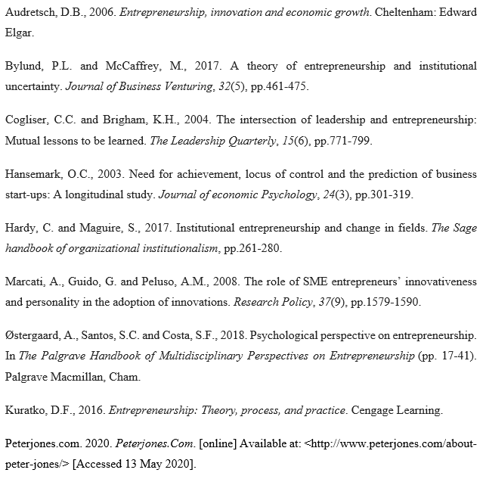
References
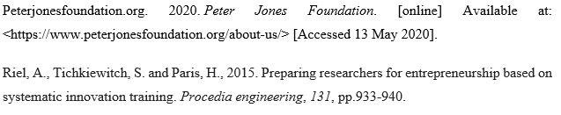
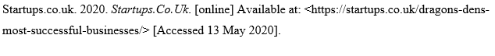

Presentation
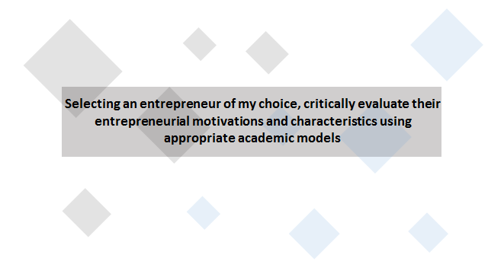
Speaker Note:
Welcome to the presentation.
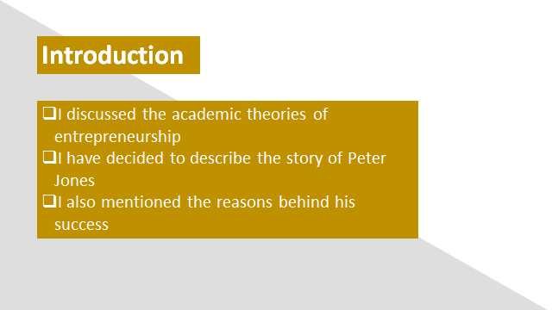
Speaker Note:
Here, I discussed the academic theories of entrepreneurship. I have decided to describe the story of Peter Jones. I also mentioned the reasons behind his success.

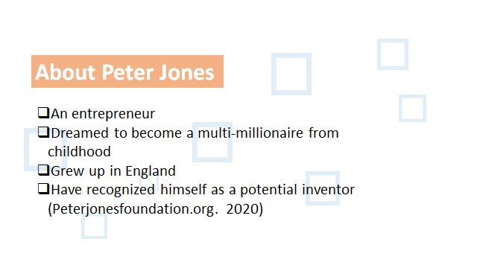
Speaker Note: Peter Jones is an entrepreneur from UK. He tried to make his dream come true from his young age. His parents worked for a long time of their life to contribute in the family. Peter liked his father’s office and dreamed to be a successful entrepreneur one day (Peterjonesfoundation.org. 2020).

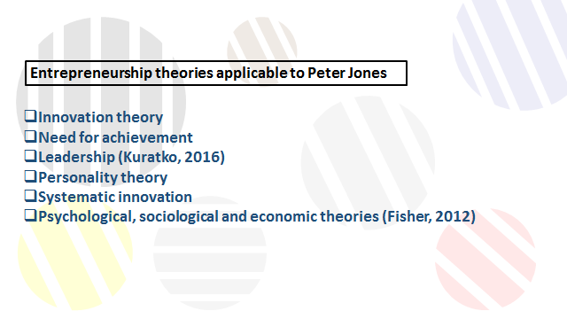
Speaker Note:
Peter jones has become popular through his new idea generation activities, which is a reflection of the innovation theory. Peter tried to become a multi-millionaire from the beginning. And he tried according to this. So, he has ultimate need for achievement. Peter manages a large number of employees in his different businesses. Managing these employees needs a good leadership skill. Peter belongs to a good personality with moral and social values. Peter always makes the proper utilization of the opportunities. He invests in several businesses. He has spread his areas of business through a systematic innovation. Peter determined to be a successful entrepreneur because, he observed his parents. His parents were hard working. As a result, Peter tried to be hard working. The society also provided proper support so that Peter could find out new opportunities (Fisher, 2012).

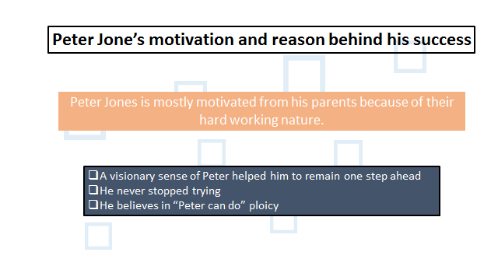
Speaker Note:
Peter can have a view of the future through his knowledge and expertise and can take decisions according to his assumptions. He tried several businesses. Sometimes, he failed. But he tried again and again to become established. He believes that he can do everything by putting efforts. That’s why he tried again and again and became a successful entrepreneur (Peterjonesfoundation.org. 2020).

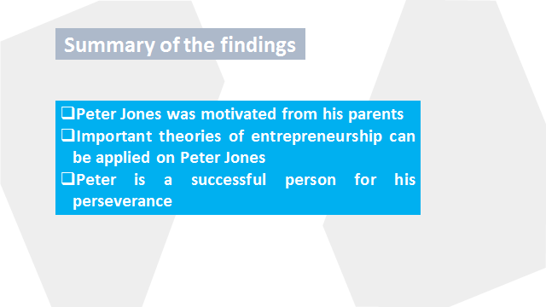
Speaker Note:
A hardworking life of Peter’s parents motivated Peter mostly. Peter's parents worked for a long time of their life.
Innovation theory, achievement theory, leadership theory and other important theories are reflected on Peter’s life. The economic theory, the social theory and the model personality theory is related to him.
Peter never stopped trying. Failure has made him stronger. As a result he has been able of expanding his business into different categories.

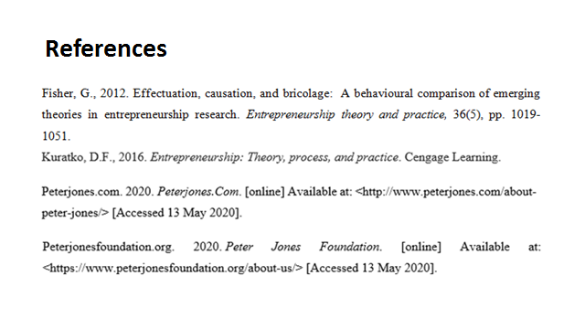
Speaker Note:
These references have been used for the presentation part.


Speaker Note:
Thank you all for your patience and time.

