ESSENTIAL SKILLS FOR STUDY AND EMPLOYMENT
What are essential learning skills? And how can the skills that are learnt in further education be transformed into those valued by future employers? Cottrell [1] details 5 transferable essential skills (see Fig-1) that the student can learn and can take forward into their chosen career. Though she does iterate that every one’s learning curve is different and each individual will need to take charge of their own study plan and make the effort and take time to find the skill set that works best for them
Fig-1
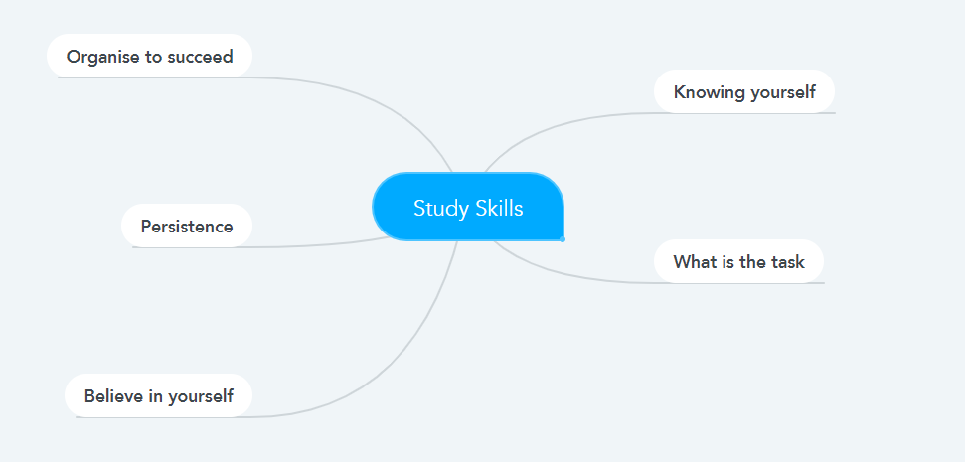
One of the most frequently asked questions in the academic world is whether academia is truly equipping their students with the essential skills they need to succeed within their chosen career path. Suleman [2] has observed that the top three essential skills that employers would like their prospective employees to have is ‘problem solving’, ‘attitudes towards work’ and ‘willingness to learn’. Which we can link into our 5 essential study skills. (see Fig-2)
Fig-2
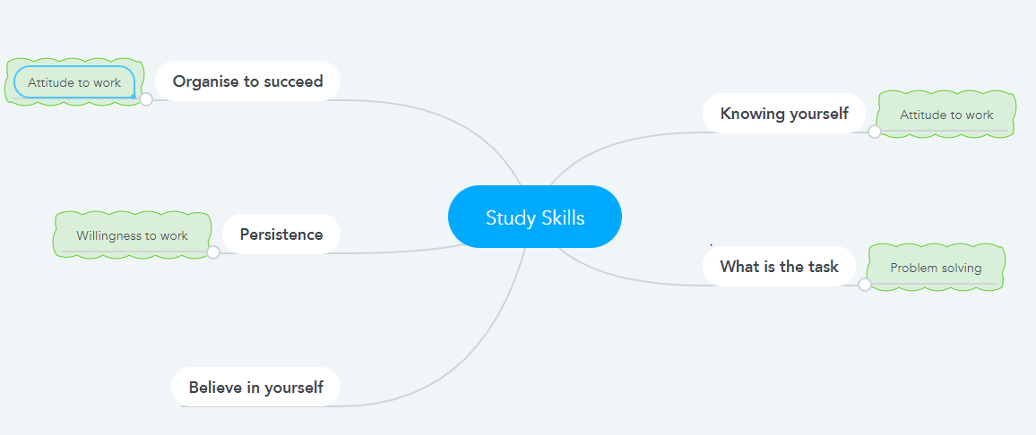
Fig 3 [3]

Recent research [4] has backed up Suleman’s study; detailing how it is apparent that study skills are not just for students but can be used far beyond the realms of higher education and into employment. As what employer would not want a future candidate that was bright, organized, dedicated and self-disciplined.
Smith [5] concludes that as the world around us changes so does the challenge to academia to continually change to ensure that students now and in the future have the essential skills they require for success.

Reference List
[1] S Cottrell, The Study Skills Handbook, 5th ed., London: Red Globe Press, 2019,ch.1,pp.24-28
[2] F Suleman, “The employability skills of higher education graduate: insights into conceptual frameworks and methodology”, High Ed, Vol.76,pp.263-278,Aug. 2018
[3] B Waugh,” Shutterstock_39098137”,3 ways a student system can help increase student retention and success rates ,Dec. 2013, [Online], https://www.vevox.com/3-ways-a-student-response-system-can-help-increase-student-engagement
[4] Skills you need, “Study Skills”, 2011-2020 SkillsYouNeed.com, 2017, [Online], https://www.skillsyouneed.com/learn/academic-referencing.html, [Accessed Oct. 12, 2020]
[5] C Smith, Skill Demands and Developments in the Advanced Economics, Oxford Handbooks Online, p.1, Mar. 2017, [Online], DOI: 10.1093/oxfordhb/9780199655366.013.23, [Access Oct. 12, 2020]

