
international business communication
Konstantina Malamova
BABM Level 6 Term 1
Assignment 1


Contents
Introduction 2
Background of Tesco Plc 2
Theoretical principles of international and intercultural communication referring to Tesco Plc 3
Discussion on cultural sensitivity referring to workplace diversity of Tesco Plc 5
Communication barriers witnessed by diverse workforce of Tesco Plc 7
Recommendation for communication strategies 10
Conclusion 12
References 13

Introduction
Communication is all about transmission of information from sender to receiver via a transmission channel or a medium. Hence, the conceptual background of British business communication is a projection of the effective communication process evident within the business organisations of the United Kingdom. It is also observed as usually the people of Britain prefer to communicate using verbal modes of communication which is often an indirect one. Non-verbal communication including eye contact and body gestures are not preferred by the British people. As evidenced the population of Great Britain are indirect communicators as they want to bypass involving into a conflicting situation. Moreover, the corporate professionals of the United Kingdom are very polite about prefer entering discussion rather than into conflicts. Courtesy, politeness, discipline, and punctuality are foundation pillars of the British Communication process (Guffey and Loewy, 2022).
Referring to the provided case study a report to be drafted exploring different aspects related with communication applicable within the corporate sectors of UK. Tesco Plc has been cited as an organisational example to elaborate on major theories of international and intercultural communication followed with an analysis of the cultural diversity and different communication barriers that are likely to be witnessed by the employees of Tesco Plc. The latter part of this report shall focus on formulating relevant communication strategies and recommendations enabling Tesco Plc. to embed a positive business environment promoting effective communication at an organisational level.

Background of Tesco Plc
Funded long back in 1919 by Jack Cohen, Tesco Plc is a British multinational grocery supermarket business with its company headquarter located in Walwyn Garden City of the United Kingdom. At present Tesco is enlisted as the third largest retailers in the world with respect to gross revenue generated and 9th largest in terms of revenues. The grocery multinational is having its actively operating stores in various locations of Ireland, United Kingdom, Czech Republic, Hungary, Slovakia. Tesco Plc has dominated a significant portion of grocery market share and operational as market leader in the grocery business sector. the company has successfully expanded in 11 nations and has a strong product portfolio embedding diversification strategy. The company has been also listed on the London Stock Exchange and a part of the FTSE 100 Index (Tesco Plc, 2023).
According to the company annual report published in 2022, Tesco has generated a revenue amounting to 61.344 billion pounds and an operating income of 2.825 billion pounds. The net income earned by Tesco Plc. in 2022 was 1.483 billion with a total asset worth 12.189 billon. The company has a huge employee base of 354, 744 as of the last year. The major business divisions of Tesco Plc are Tesco Stores Ltd, Tesco Bank, Tesco Mobile, Tesco Ireland, Tesco Family Dining Ltd., Spenhill and Booker Group. The present business success of Tesco Plc. is reflected through its successful diversification strategy that has further contributed to Tesco business expansion strategies. The corporate aim of Tesco is to serve its customers everyday with affordable, healthy, sustainable food items thereby enabling them to live a better quality of life (Tesco Plc, 2023).

Theoretical principles of international and intercultural communication referring to Tesco Plc
The concept of intercultural communication indicates communication incident between people belonging to varied cultural backgrounds while international communication is the global communication process as its evident within the international borders. The gradual dominance of globalisation in business sought to increase the demand for intercultural and international communication. Therefore, the success and long run viability of adverse working force is significantly influenced by intercultural and international communication process. Referring to the example of Tesco Plc. Its multinational level of business operations reflect formation of a diverse working force wherein intercultural communication effectiveness is favourable for developing a diverse working force (Arasaratnam, 2015).
Aligning with the given topic, Hofstede model of intercultural communication has been embedded which is identified as a popular framework for evaluating cultural variations. The model was designed by Geert Hofstede based on the different cultures present between nations and included five different dimensions of communication. Power distance, masculinity vs femininity, long term orientation vs short term thinking., individualism vs collectivism and uncertainty avoidance are the five dimensions of this model. Hofstede model appears to be a comprehensive oner capable to treating the cultural sensitivity to communication at a corporate level (Bennett and Hammer, 2017).
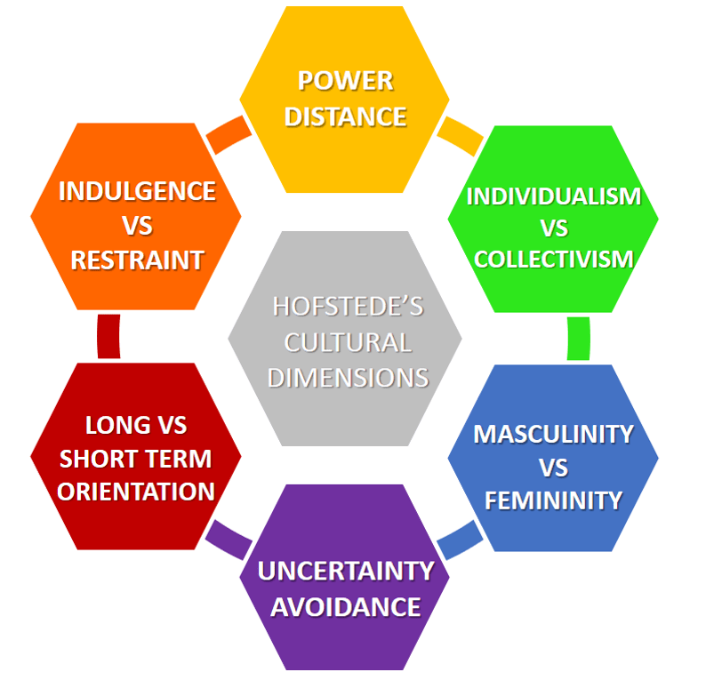
Source: (Bennett and Hammer, 2017).
Implementing this communication model, power distance dimension can be referred in order to evaluate the extent to which corporate hierarchy dominants in the grocery retail sector. Interesting to add, applying the dimension of individualism vs collectivism it is possible to focus on assimilation of the outcome that its employees located in UK are individualistic compared to the staffs of this business located in Asian nation. Therefore, incorporating the cited mode it has been possible for Tesco Plc to develop a culturally strong and competent background (Klyukanov, 2020).
Referring to the published book written by Larry A Samovar communication among different cultures indicate the need for acquiring significant knowledge of various cultures in order to strengthen the communication process particularly within the culturally sensitive working place. It was further state that a promotion to intercultural communication embed four different principles namely language, culture, and intercultural mediation. Also, the communication channels used have been considered as the subconscious elements in the existing communication process. Therefore, aligning with this theoretical principle, it is vital for the HR managers of Tesco Plc to incorporate intercultural and international communication by acquiring knowledge on the cultural background and the colleagues in order to address the intercultural sensitivity within the same (Samovar et al., 2016).

Discussion on cultural sensitivity referring to workplace diversity of Tesco Plc
Cultural sensitivity is defined as an awareness towards cross cultures and is also considered as the ability to accept other cultures. Cultural sensitivity is important as is positively contribute in widening the market reach and to enhance the degree of audience engagement through effective collaboration. Considering the professional domain, cultural sensitivity is significant as it helps in accumulation of different perspectives and contribute in spreading awareness of diverse culture and identities. This further help a corporate entity in reducing biased attitude while execution of staff hiring, selection and promotion process. Understanding the core background of cultural sensitivity, the same can be aligned with a diverse working place. Presence of a diverse workplace within a multinational company like Tesco Plc has strongly reflected prevalence of cultural sensitivity within its employees (Cai, 2016).
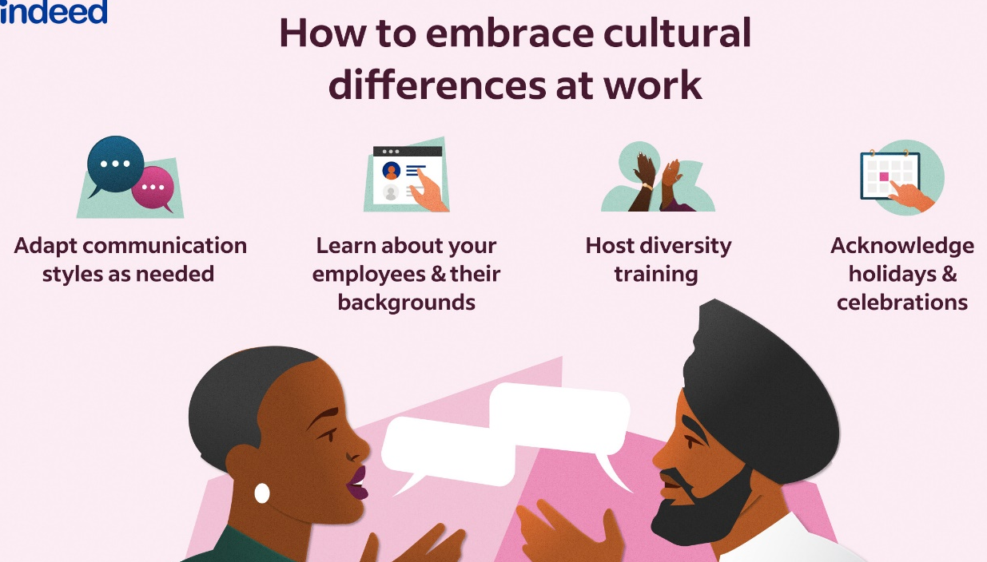
Source: (Cai, 2016).
To further understand the importance of cultural sensitivity in relation to successful operation of a diverse working place it is important to explore the overall work culture of the country. A relaxed and social ambience is evident within the work culture of the UK based business and employee considering their respective works by taking few breaks in between.
Referring to the example of Tesco Plc it has a huge and diverse working base that further reflect workplace diversity and inclusion practises within the concerned organisation. Hence within the organisational premises of Tesco employees belonging to different cultural background and of varied ethnic background indicate enormous amount of cultural diversity Therefore formulation of relevant policies and procedures are vital to successful manage the culturally diverse employee base of Tesco Plc (Ilie, 2019).
Addressing the issue of cultural diversity, the employees of Tesco are evident to inherit four core values namely respect, integrity, service, excellence, and stewardship. Moreover, the HR department of Tesco Plc has focused on developing an inclusive work environment and has encouraged recruitment of people of varied background and ethnic origin. Therefore, the inclusion policies and procedures within Tesco has been highly favourable to promote cultural diversity and cultural sensitivity within the employee of this British retailer (Shepherd, 2019).
In course of embedding high degree of cultural sensitivity the HR managers of this organisation has considered strengthening units diverse, equitable, and inclusive work culture thereby forming a competitive employee base. The company’s inclusion policy is evident to focus on formation of high performing teams that are culturally diverse. Tesco’s successful inclusive work environment has been able to attract the best talents to develop a high performing team. Also, the company’s HR managers are dedicated to share voces to support cultural sensitivity and awareness thereby directly contributing to the company’s workforce retention.
The present issues related to cultural sensitivity within the cited organisation has been responded by its HR department indicating the demand for embedding cultural awareness. This have helped Tesco’s employees to present themselves as well informed professionals with a positive ad confident body language, etiquette, overall behavioural attributes (Ilie, 2019).
Focus is also given to incorporate mutual trust within the diverse employee pool which can be assure by incorporating a relationship-based trust. Therefore, at Tesco Plc. its senior HR managers has considered communication to be a major factor to eliminate cultural sensitivity. along with assuring incorporation of a strong communication platform.

Communication barriers witnessed by diverse workforce of Tesco Plc
The factors that contribute in restricting or lowering the overall efficiency of a communication process are identified as barriers to communication and impose an adverse effect over the corporate productivity of the same. Referring to the example of Tesco Plc the presence of culturally diverse working force has made the company vulnerable to several communication barriers. Hence issues like employee grievances, uncertainty in corporate world, stereotype attitude and ethnocentrism are major barriers of communication. The emergence of identified communication barriers is mainly due to absence of adequate knowledge and information about the intercultural communication skills within the employees (Yusof and Rahmat, 2020).
Discussed below some of the primary barriers affecting the communication of diverse employee base of Tesco:
Different speaking languages – in a diverse workplace like that of Tesco the employees come from different socio-cultural and ethnic background indicating variation in their speaking languages. Practises of interacting in different languages within a diverse workplace like Tesco tend to act as a major barrier of communication creating a gap of understanding within the employees. Therefore, understanding the complicated situation resulted due to use of multipole languages for employee level interaction, English has been identified as a common and universal language to interact in the workplace thereby assuring effective communication of information (Yusof and Rahmat, 2020).
Evidences of improper and hostile stereotyped attitude- this is considered as another barrier to communication within the employees of a diverse workplace like Tesco Plc. Presence of stereotype nature within the business managers and executives tend to hamper with the flow of information resulting to incidents of conflict of interests. Therefore, at Tesco in course of its diverse workforce, presence of stereotype attitude appears to be a negative one affecting the entire organisation communication process which can be addressed by making the employee culturally informed (Rani, 2016).
Variation in attitude – The diverse workplace of Tesco is vulnerable to experience different behavioural outcomes from its staffs which in turn act as a communication barrier. Evidences of varied behaviour is acausal agent towards conflict of interest and gaps in internal communication. The cross-cultural communication efficiency within Tesco is immensely affected by the identified barrier.
Emotional unbalance- the extent of emotion reflected by the staffs of Tesco act as a potential barrier of communication. Citing the example of Tesco, the staffs belonging to diverse background tend to reflect either excessive or least amount of emotion. To mention the staffs belonging to some culture exhibit anger, fear and anxiety at workplace which is not the case with other employees. Hence employee coming from similar cultural background is expected to project similar behavioural outcomes (Jelani and Nordin, 2019).
Ethnocentrism- the phenomena of ethnocentrism is recognised as a vital barrier to communication particularly within a culturally diverse workplace. Evidences of high extent of ethnocentrism within staffs tend to affect their intention to communicate. Therefore, within a corporate domain, employees with an ethnocentric attitude usually do not prefer to interact with staffs coming from another ethnic background. Lack of willingness to communicate with culturally diverse employees is a major communication barrier and may lead to unmotivated attitude within the staffs (Campbell, 2016).
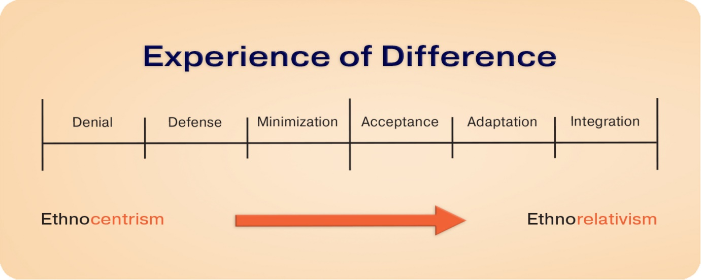
Source: (Campbell, 2016).
Psychological barrier- referring to the organisational example of Tesco Plc its concern to manage the culturally diverse team is likely to come across psychological barrier of communication. To note a difference in individual level of psychology is likely to widen the communication gap within its staffs. For example, the culture practised in France is to provide feedback and stay focussed which is different from that of the approach initiated in the United Kingdom (Jelani and Nordin, 2019).

Recommendation for communication strategies
Aligning with the previously developed content effective communication is vital for an organisation to thrive amidst intense competition. Referring to the example of Tesco Plc. and its culturally diverse employee base it is important to focus on formulating effective communication strategies. Hence as a culturally diverse workplace is prone to witness conflicts of interests and gaps in communication it is advisable for the organisation to incorporate a positive and transparent organisational culture assuring effective flow of information coupled with clarity of the same (Guffey and Loewy, 2022).
Also, the line managers of this retail supermarket are recommended to restore a professional etiquette and consider using a single language o communicate. The company need to initiate strict rules on restraining its employees to verbalise bad words and should be concerned about their word selection while interacting. It is highly suggested for the staffs of Tesco to use simple words and verbalise short sentences assuring effective understanding of the information conveyed (Alyammahi et al., 2021).
The existing communication of Tesco Plc can be further improved by application of open-door policy assuring that staffs are able freely communicate. Furthermore, the HR department of Tesco Plc are suggested to make the employee interact directly by keeping an eye-to-eye contact. Organising meeting and group discussion within the premises of Tesco Plc. are advised helping the staff to convey their perspectives (Holmes, 2017).
Intending to develop strategic communication practise the HR managers of Tesco are recommended to become an active listener and to develop the skill of patience listening which shall further contribute in narrowing the existing communication gap within the cited business. It is also suggested for the employees of Tesco to acquire the skill of reflective listening and to incorporate an optimistic mindset and become able to include other cultures (Doyle, 2017).
Understanding the need for developing effective communication strategies the HR department of Tesco are recommended to incorporate certain skill development sessions wherein the staffs can be trained to improve their respective communication skill. The employees of this business need to keep themselves away from any conflicting situation and should focus on discussing the concerned issue.
Intending to enhance the overall communication process within Tesco the front-line managers of this business are advised to strengthen the communication skill subsequently improving employee morale and assuring employee engagement thereby promoting an inclusive workplace culture (Doyle, 2017).

Conclusion
Adhering with the report it can be concluded that communication at an organisational level is highly demanded to assure its viability., I this context the role of communication managers is vital. Tesco by embedding a strong communication ground is expected to restore its culturally diverse working place. Moreover, it is important for the managers of Tesco to become aware of the cultural variation thereby resulting to cultural sensitivity. Last but not the least the diverse work culture of Tesco Plc. is expected to improve in presence of a strong communication platform.

References
Alyammahi, A., Alshurideh, M., Kurdi, B.A. and Salloum, S.A., 2021. The impacts of communication ethics on workplace decision making and productivity. In Proceedings of the International Conference on Advanced Intelligent Systems and Informatics 2020 (pp. 488-500). Springer International Publishing.
Arasaratnam, L.A., 2015. Research in intercultural communication: Reviewing the past decade. Journal of International and Intercultural Communication, 8(4), pp.290-310.
Bennett, M.J. and Hammer, M., 2017. A developmental model of intercultural sensitivity. The international encyclopedia of intercultural communication, 1(10).
Cai, D.Y., 2016. A concept analysis of cultural competence. International Journal of Nursing Sciences, 3(3), pp.268-273.
Campbell, N., 2016. Ethnocentrism and intercultural willingness to communicate. Journal of Intercultural Communication, 40(1), p.1.
Doyle, A., 2017. Communication Skills for workplace success. The Balance Careers.
Guffey, M.E. and Loewy, D., 2022. Essentials of business communication. Cengage Learning.
Holmes, J., 2017. Intercultural communication in the workplace. The Routledge handbook of language in the workplace, pp.335-347.
Ilie, O.A., 2019, June. The intercultural competence. Developing effective intercultural communication skills. In International conference Knowledge-based organization (Vol. 25, No. 2, pp. 264-268).
Jelani, F. and Nordin, N.S., 2019. Barriers to effective communication at the workplace. Journal of Modern Language and Applied Linguistics, 3(2), pp.7-18.
Klyukanov, I., 2020. Principles of intercultural communication. Routledge.
Rani, K.U., 2016. Communication barriers. Journal of English Language and Literature, 3(2), pp.74-76.
Samovar, L.A., Porter, R.E., McDaniel, E.R. and Roy, C.S., 2016. Communication between cultures. Cengage Learning.
Shepherd, S.M., 2019. Cultural awareness workshops: limitations and practical consequences. BMC Medical Education, 19(1), pp.1-10.
Yusof, A.N.A.M. and Rahmat, N.H., 2020. Communication barriers at the workplace: A case study. European Journal of Education Studies, 7(10).

