MODULE; Digital skills and research methods
Student name: Miroslav Farbar
STUDENT:ID (2021204521)
MODULE: CODE(BMSW4003)
LECTURE NAME: Abdi Rahman

Contents
Abstract 3
Introduction 4
Research objective 4
Research question 4
Existing Literature Review 4
Research Design 5
Introduction 5
Research Methods 5
Data collection procedures 6
Ethical consideration 6
Data analysis 6
Results 6
Discussions 10
Conclusion 10
References 12
Appendix 13

Abstract
The emergence of digital technologies and skills in educational sector began in 1990s and it is spreading continuously. In order to make the students profession, the university teachers and staffs should form, support and improve the digital skills of the students. To perform in the workplace better today’s students and learners get the skills and information primarily from their schools, colleges, universities and from friends of them during their student life. Digital skills also described as the cognitive skills of the students. It includes the knowledge, skills and relationship. It is described as confident, critical and creative use of technologies in their education sectors, leisure and workplace etc. A mixed methodology was used for answering the research question whether the students and staffs of UWTSD feel confident in utilizing technologies to collaborate with each other or not. After collecting and analyzing the data the respondents are positive in this regard. Staffs and teachers are very dedicated to improve the digital skills of the students.

Introduction
The present world around us is constantly moving towards from traditional ways of doing our daily work to digital ways of doing our work. The whole world is in the hand of people due to the blessings of modern science and their technological inventions that are used in our daily works. The modern world of today’s is the world technological world (Pagani et al. 2016). Every aspect of our life and in every field of our daily life are directly related with the touch of modern technologies. The educational sector is fully dependent on the technologies, digital devices and the skills related with digital technologies (Kuhn et al. 2020). After introducing the corona virus worldwide, the use of digital devices and technologies in the educational sector was remarkable all around the world and still are using. But to use these digital technologies and devices some essential skills are needed to make the workplace efficient and make the students and staffs of schools, colleges and universities efficient in their activities (Jackman, Cho and Park 2021). As, all of the students and staffs of different educational institutions are constantly using digital technologies and devices for their day-to-day activities and official activities, rigorous research will be needed to explore the matter whether the students and staffs of university of Wales Trinity St David feel confident in utilizing technologies to collaborate with each other.

Research objective
The main objective of the research is to know the level of using technologies among students and staffs of UWSTD and encourage them to collaborate using technologies in daily activities.
- To explore whether the students and staffs are confident is using technologies to collaborate or not.

Research question
- How do the students and staffs maintain collaborating relations using technologies in the university life?

Existing Literature Review
The emergence of digital technologies and skills in educational sector began in 1990s and it is spreading continuously. In order to make the students profession, the university teachers and staffs should form, support and improve the digital skills of the students (Pirzada and Khan 2013). Digital skills are the abilities and capabilities of using digital devices and technologies in practical life, to use them in communication systems, to manage the data and information and to get the access of data and information by using the digital devices and technologies (Bastos et al. 2019). The skills of using digital devices in our practical life means to use different devices, apps, websites and know how to use them in our life, how to collaborate with different tasks and different persons (Handley 2018).
Digital skills of the students are identified as knowledge, abilities, attitudes, subjects, technologies, theories, context and educational process of interacting with the teachers and staffs in their daily activities (Had and Rashid 2019).
The digital skills of the students of educational institutes are to communicate with their teachers, officials using email or their educational webpages, learn how to get different textbooks, guidebooks, journals, articles and publications from their institutional webpages and use them in their practical life. And the officials and staff of the educational institutes collaborate these actions of the students to allowing them to get these facilities using their technologies and protocols (Leahy and Wilson 2014).
The educational sector is fully dependent on the technologies, digital devices and the skills related with digital technologies. After introducing the corona virus worldwide, the use of digital devices and technologies in the educational sector was remarkable all around the world and still are using. But to use these digital technologies and devices some essential skills are needed to make the workplace efficient and make the students and staffs of schools, colleges and universities efficient in their activities (Garcia et al. 2021).
To perform in the workplace better today’s students and learners get the skills and information primarily from their schools, colleges, universities and from friends of them during their student life. Digital skills also described as the cognitive skills of the students. It includes the knowledge, skills and relationship. It is described as confident, critical and creative use of technologies in their education sectors, leisure. Workplace etc. (Eynon, R., 2021).

Research Design

Introduction
In this section of research design, I’ll discuss the methodology which a I applied in this research, data collection procedures and instruments, ethical standard of the research and the analysis system of the data analysing.

Research Methods
To conduct research there are three types of research methods. Qualitative research stresses only on the opinions, experiences and feelings of the respondents and quantitative method stresses only on the numerical data (Nayak and Singh 2021). In this research I used mixed methods because it allowed me to know the numerical evidence and also the opinions and experiences of them to present the findings well.

Data collection procedures
27 students, teachers and official staffs of UWTSD were chosen for collecting the data. As I chose mixed method, I made a survey question and conducted in-dept interviews for collecting the relevant information and evidence.

Ethical consideration
Research ethics is the set of standards that are followed by the research to show respect the respondents (Vlahou et al. 2021). During conducting the study, I maintained the ethical standards. I took the permission from the university authority and collected the data without harming others.

Data analysis
The collected data were analysed with different graphs and charts with existing literature.

Results
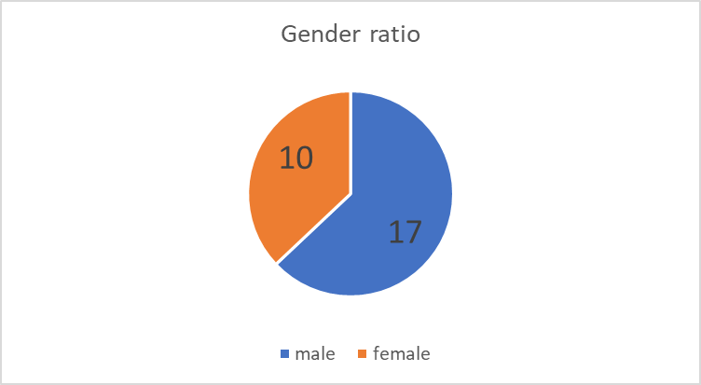
Among the respondent’s male are 17 and female are 10.
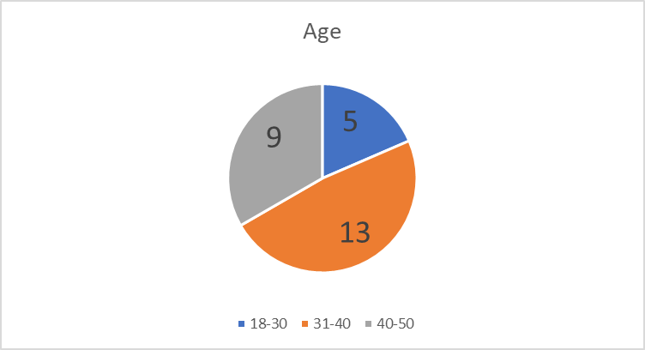
Amon the participants 9 people are age of 40-50 years, 13 people are age of 31-40 years and 5 people are age of 18-30 years
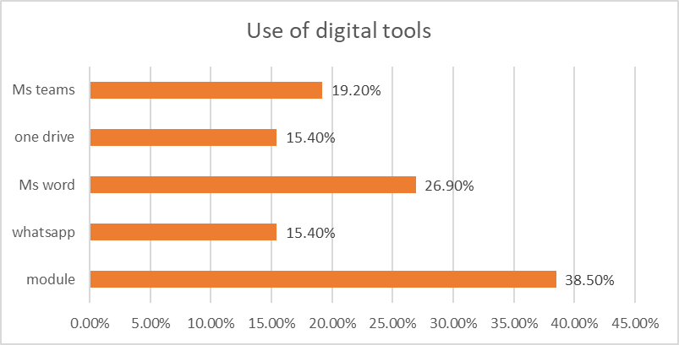
When the students were asked Which applications do you use and how frequently use them to collaborate with others? They replied they use all of these to collaborate but they used mostly the module (38.50%).
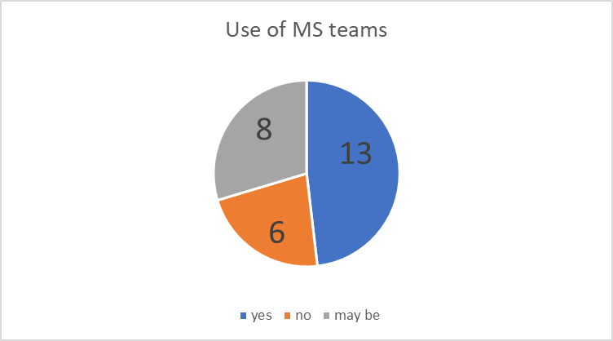
When the students were asked Do you use MS teams more than other tools to work with your colleagues and peers? 13% of them replied yes and 6% replied negative.
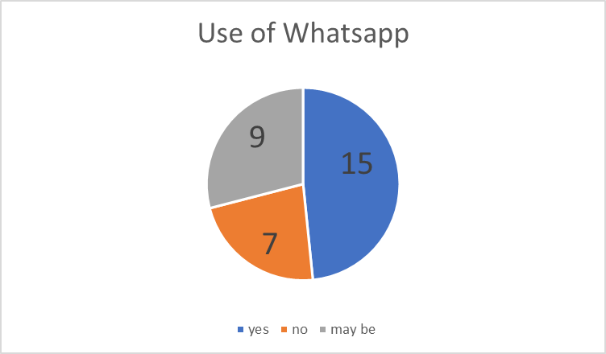
When the students were asked Do you use WhatsApp more than other tools to work with your colleagues and peers? 15% of them replied yes and 7% replied negative.
When the teachers and official staffs were asked whether the students of the university get enough facilities to improve their digital skills or not? To answer the question one of teachers said,
“University is the highest step to form and improve the skills of the students. And here we the authority and staffs provide all the facilities to form and foster their digital skills. We have the sophisticated e-library and websites, laboratories, research instructions with full of modern technologies. All the students are getting these chances from collaborating with our staffs.” (KII 2, Personal Communication, March 20, 2022).
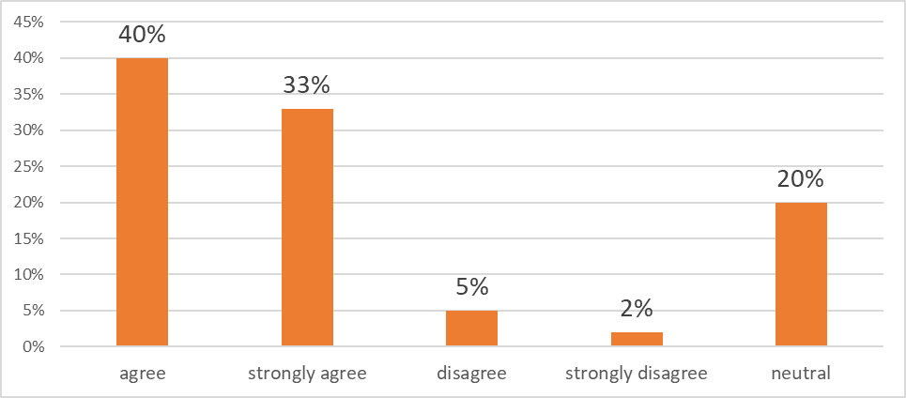
When the students of the university were asked “Do you get all the technological facilities from university authority?” in this question 73% of the students answered yes, 7% of them disagreed and the rest of them remained neutral.
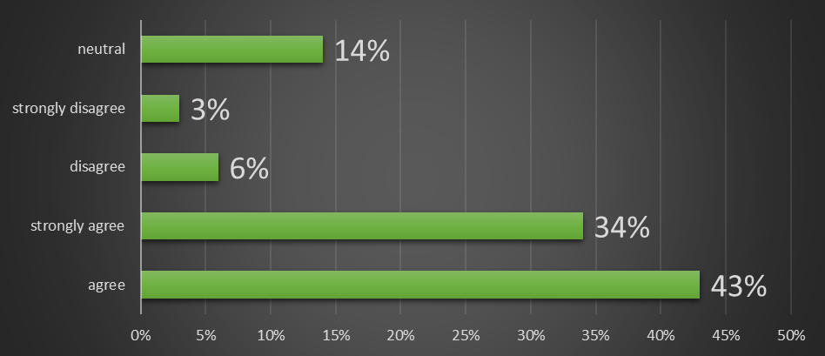
When the students of the university were asked “Do you feel confident while using technologies in case of your need and do you think the staffs and teachers are collaborative in technological using with you?” in this question 77% of the students answered that the staffs and teachers provide us the technological support to solve our problems, make models, doing coding making communicate with them and we fell confidence while we use digital devices in our activities. The staffs also collaborate us using technologies we pay all the fees through online and inform them with email. They are skilled and collaborated these tasks with us, 9% of them disagreed and the rest of them remained neutral.

Discussions
The findings of the research are somewhat linked with the existing literature. The digital skills of the students of educational institutes are to communicate with their teachers, officials using email or their educational webpages, learn how to get different textbooks, guidebooks, journals, articles and publications from their institutional webpages and use them in their practical life. And the officials and staff of the educational institutes collaborate these actions of the students to allowing them to get these facilities using their technologies and protocols (Leahy and Wilson 2014).
The teachers and staffs of UWTSD said that University is the highest step to form and improve the skills of the students. And here we the authority and staffs provide all the facilities to form and foster their digital skills. We have the sophisticated e-library and websites, laboratories, research instructions with full of modern technologies. All the students are getting these chances from collaborating with our staffs. 77% of the students answered that the staffs and teachers provide us the technological support to solve our problems, make models, doing coding making communicate with them and we fell confidence while we use digital devices in our activities. The staffs also collaborate us using technologies we pay all the fees through online and inform them with email. They are skilled and collaborated these tasks with us.
To perform in the workplace better today’s students and learners get the skills and information primarily from their schools, colleges, universities and from friends of them during their student life. Digital skills also described as the cognitive skills of the students. It includes the knowledge, skills and relationship. It is described as confident, critical and creative use of technologies in their education sectors, leisure. Workplace etc. (Eynon, R., 2021). 73% of the students agreed upon that their teachers and staffs of the university provided all the facilities to improve their digital skills in the workplace, educational sectors and in communication.

Conclusion
Increasing the students' digital literacy relies on a variety of factors. One of the issues might be an absence of desire among young students to continue to enhance their gained knowledge and abilities. It's critical to guide pupils through problem-solving exercises with the goal of linking information from many disciplines. Integrating theoretical knowledge into practical skills allows for a more in-depth investigation of possible security concerns, report reliability, and data relevancy. It is critical to concentrate on the more precise features and broader circumstances of security dangers that emerge in the internet world, and preserving privacy via adequate security. The opinions of participants and the findings of this survey show how the educational procedures of collaborating with students and staffs improved in the future.

References
Bastos, S., De Oliveira, H., Silva, M. and Azevedo, L., 2019, November. Soft
-
digital skills in
higher education curricula. In

Proc. 18th Eur.
Conf. E
-
Learn
.

(p. 70)
.

Eynon, R., 2021. Becoming digitally literate: Reinstating an e
ducational lens to digital skills
policies for adults.

British Educational Research Journa
l
,

4
7
(1), pp.146
-
162
.

Garcia, K.R., Rodrigues, L., Pereira, L., Busse, G., Irbe, M., Almada, M., Christensen, C., Midão,
L., Dias, I., Heery, D. and Hardy, R., 2021. Improving the digital skills of older adults in a
COVID
-
19 pandemic environment.

Educa
tional Gerontolog
y
,

4
7
(5), pp.196
-
206
.

Had, M.Z.C. and Rashid, R.A., 2019. A Review of Digital Skills of Malaysian English Language
Teachers.

International Journal of Emerging Technologies in Learnin
g
,

1
4
(2)
.

Handley, F.J., 2018. Developing Digital Skills and Literacies in UK Higher Education: Recent
developments

and a case study of the Digital Literacies Framework at the University of
Brighton, UK
.

Jackman, J.A., Gentile, D.A., Cho, N.J. and Park, Y., 2021. Addressing the digital skills gap for
future education.

Nature Human Behaviou
r
,

5
(5), pp.542
-
545
.

Kuhn, S., Müller, N., Kirchgässner, E., Ulzheimer, L. and Deutsch, K.L., 2020. Digital skills for
medical students
–
qualitative evaluation of the curriculum 4.0 “Medicine in the digital
age”.

GMS journal for medical educatio
n
,

3
7
(6)
.

Leahy, D. and Wilson, D., 2014, July. Digital skills for employment. In

IFIP Conference on
Information Technology in Educational Managemen
t

(pp. 178
-
189). Springer, Berlin,
Heidelberg
.

Nayak, J.K. and Singh, P., 2021.

Fundamentals of research methodology problems and prospect
s
.
SSDN Publishers & Distributors
.

Appendix
Questionnaire
1. Name:
2. Gender: ☐Male ☐Female
3. Age: ☐18-30 ☐31-40 ☐ 40-50
4. Which applications do you use and how frequently use them to collaborate with others?
☐Yes ☐No ☐ May be
5. Do you use MS teams more than other tools to work with your colleagues and peers?
☐Yes ☐No ☐ May be
6. Do you use WhatsApp more than other tools to work and collaborate with your colleagues and peers?
☐Yes ☐No ☐ May be
7. whether the students of the university get enough facilities to improve their digital skills or not?
☐Strongly agree ☐ Agree ☐ Neutral ☐Disagree ☐Strongly disagree
8. Do you get all the technological facilities from university authority?
☐Strongly agree ☐ Agree ☐ Neutral ☐Disagree ☐Strongly disagree
9. Do you feel confident while using technologies in case of your need and do you think the staffs and teachers are collaborative in technological using with you?
☐Strongly agree ☐ Agree ☐ Neutral ☐Disagree ☐Strongly disagree

