

Introducing the Modern Workplace (LCBB4003)

Business report: Relationship of organizational structure and culture
with organizational performance.

Module Lecturer’s Name: Rexon Nting

Student Name: Manuela Hristova Manoloova
Student ID: 2018271

- About this report……………………………………………………………………3

- BMW Group introduction………………………………………………………….3

- What is Organizational Structure……………………………………………..…4

  - Types of Organizational structure…………………………………………..4

- What is Organizational Culture…………………………………………………..6

  - Types of Organizational Culture……………………..………………………7

- How organizational structure can influence on organizational performances in BMW Group?.......................................................................8

- How organizational Culture influence on organizational performances of BMW GROUP……………………………………………………………………….9

- Factors which can influence on individual behavior at work place…......10

- Recommendations………………………………………………………………..11

- Conclusion…………………………………………………………………………11

- Reference List……………………………………………………………………..12

- About this report
This is a business report that represents the relationship between organizational structure and culture with organizational performance in the BMW Group.It is important to begin by briefly describing a history, product and market share of the BMW Group and discussion about its organizational behavior. Next is to show and describe with images, figures and graphs the definition and different types of organizational structure and culture. It is explained the impact of organizational structure on organization performance and analyzed how organizational culture can influence on organizational performance in the BMW Group. The different factors that influence on individual behavior at work place like leadership, work environment, effective communication and self-perception are also listed. There is focus of the recommendation for improving performances by using organizational structure and culture: grow the company, engage people, leverage high impact leadership practices, use training and development strategically. At the end there is a reference list with published literature.

- BMW Group Introduction
BMW is a German corporation, founded on 07 March 1916 that produce vehicles and motorcycles by brand BMW, Rolls-Royce, Mini, BMW Motorrad. BMW is headquartered in Munich but the company produces motor vehicles not only in Germany, but in a lot of different countries all over the world like United States, South Africa, Mexico, China, South Africa, the United Kingdom and Brazil. The organization has a large history in touring and sport cars for Formula 1 and can be proud of being fourteenth biggest producer of vehicles for 2017. At the beginning the company used to produce aircraft engines, but then in 1932 is created the first vehicle of BMW. Today we still use the created in 1917 year white and blue round emblem of BMW.
BMW receive the title “Most Attractive Employers” by Universum agency survey and it is the best employer in Germany. The company use motivation and working in team to create a strong culture.

- What is organizational structure?
It is the management system that defines interconnectedness of the department heads, the responsibilities, power and role of the staff. It helps the organization to be successful and organize the employees. Choosing the right organizational structure should be priority for the company, because it will help to achieve its goals. The next step is to find which type is the correct one.
“Inaccurate organizational structure affects organization performance negatively. An efficient organizational structure would facilitate the work relationships between sections, and enable the organization to keep the order while developing flexibility and creativity.”
“Just what is organizational structure? It is how job tasks are formally divided, grouped, and coordinated within an organization.“ (Robbins ,2016))

3.1Types of organizational structure?

  - Simple structure-It is used for small business organizations. One person is reliable for all the tasks and take all decisions, which leads to decrease in the quality ot the work. There is not any departments .The owner of the company has full control of the business. Career opportunities are few.

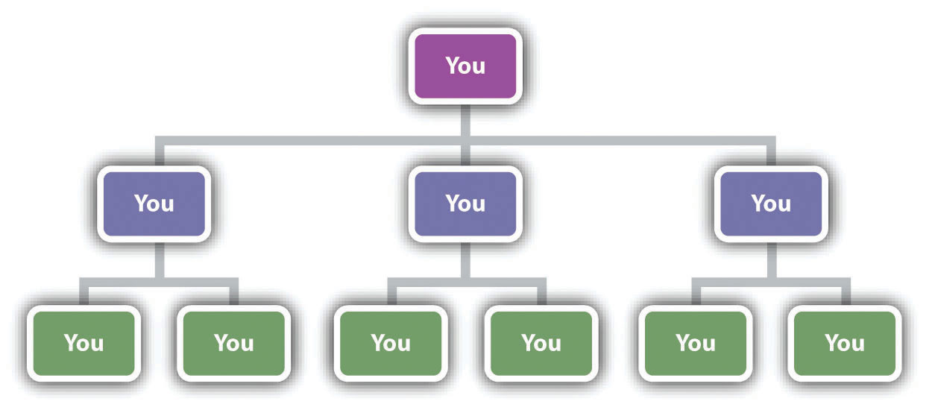

If there are more than one employee, all tasks are distributed equally among all.
“Simple structure is not designed precisely, it has little complexity, monitoring is performed directly and mandates are centralized.” (Ebrahimi,2014,p.96-106)
- Functional structure – There are a different departments such as human resources, marketing, information technology and all of this areas have a manager. The role of the manager is to organize and coordinate the employees, who are grouped by their skills and knowages. In the common structure managers are well specialized in only one area, which give the opportunities for professional development and increasing competitiveness.

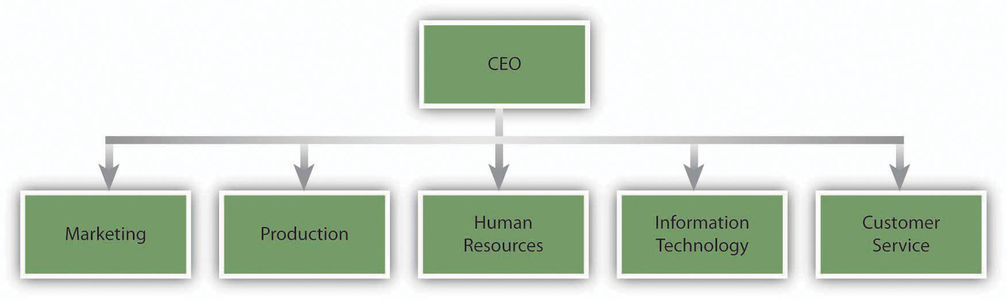

- Multidivisional structure – Depends on the product and/or geographic area the employees are divided in the departments and the firm is separated on divisions. This structure is used by large company with a big variety of services and products. It make the business flexible.

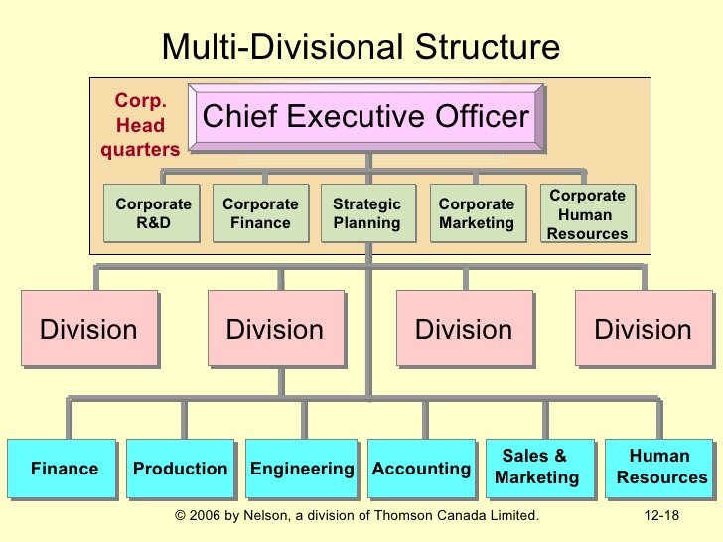

The cons here is that the communication and share information between the divisions are hard.

- Matrix Structure – it is a combination of several types of organizational structures. The reason for that is to give them a balance, more strength and less weakness. There are two managers that are connected to a team. This structure give an opportunity two different product to be produced at the same time. It is very good for managing a big projects.
The process of decision making is hard and the work can be too much.
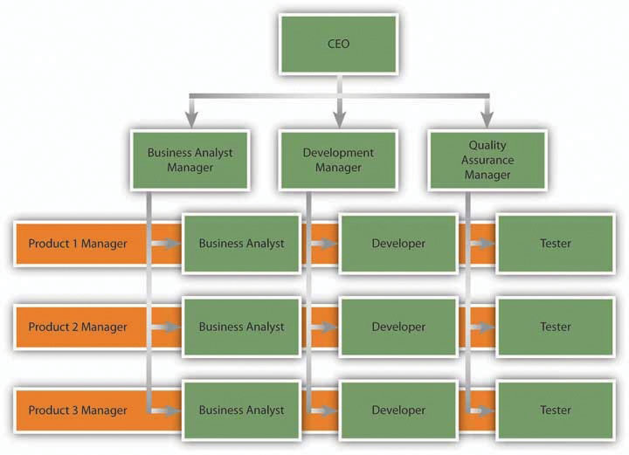

- What is organizational culture?
This means the culture and personality of the company - the same thinking, beliefs, norms, values and attitudes of organizational members and current behaviors.
“Organizational culture is defined as a set of beliefs, values, and assumptions that are shared by members of an organization (Schein, 1985). These underlying values have an influence on the behavior of organizational members, as people rely on these values to guide their decisions and behaviors (Schein, 1985).” (Brian,2009, p. 673-679)
The level of organizational culture depends on the relationship between culture and leader. At the first level is what people believe in, at the second level principles, goals and standards are shared, and at the third level - visible aspects of organizational culture. Some companies follow the rule that happy managers and employees can benefit the organization. That's why they include company picnic meetings and billiards games.

4.1 Organisational culture can be:
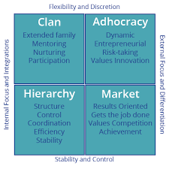
- Clan Culture
Less-structured and the goal is to make employees feel as a part of big and warm family, to feel engage with the company problems and success. There is very good team-working and communication with a leader who is like a mentor. Different ideas are very welcome, but employees should remember that the boss is not their best friend.

- The Adhocracy Culture:
It is focused on the new ideas, innovation and creativity.The energy, dynamic and freedom to do an experiments are based in this type of Culture.People take risks and meet new challenges. Example for this is Google or Apple, doing what was not done before. It is very common in the information technology sector.

- The Market Culture: Being number one is the moto of this type of culture. The environment is competitive and the company should be the best. The employees are very ambitious, profit is the most important thing. Fast reactions on any changes. It is used by the large companies that are already leaders on the market. Disadvantages of this culture are its aggressive nature, the toxic environment and employees can be also against each other.

- The Hierarchy Culture: The attention here is focused on mechanical processes, control and structure.The process is predictable and smooth. There are formal rules and polices and low costs. The higher control stops creativity and innovations of the employees. This kind of culture can be founded in the fast food restaurant like Burger King, government agencies.

5.How organisational structure can influence on organisatonal performances in BMW Group?
"Failure to understanding organizational objectives, the environment it operates in, the markets, how it does its business, how it’s structured and all the elements of an organization leads to faulty assumptions of performance" (Bedeian A.G, 1986).
To choose the right organisational structure the company should know what expect from the employees, what goals they need to achieve and how, what attitude and how should they act on the workplace. Respond to this questions will lead to implement the correct structure for increasing the efficiency of the processes and performance.

- BMW has a hierarchy leadership organizational structure, that is massive and looks like a pyramid. On the top of the structure is BMW AG Supervisory Board that contain 20 members in 4 committees.They organize meetings for set of questions and important decisions.
-First level are Vice President, Secretary, Treasurer and Directors.
-Second level is Executive Director who design and develop strategic plans.
-Tthird level Office Manager, Accountant, Managing Editor, Art Director, Advertising Director,and Volunteer staff. In BMW works are managers, who are six of the best European managers.
-On the fourth level is Receptionist Membership

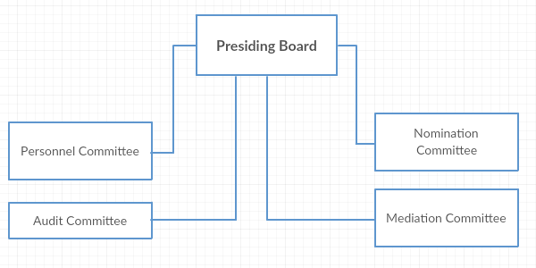

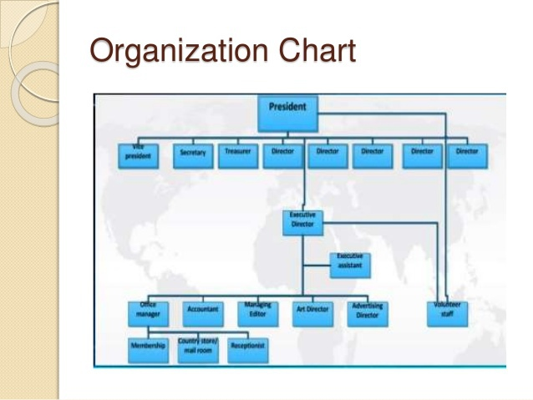

Above that the company results are not so good as the performance deviating from the expected. There are several performance gaps:
- not able to compete in the growing automobile industry- Audi and Honda are some of the biggest competitors of BMW. The problem is that BMW employees are probably not enough motivated to do innovations and to be better at technologies. The company is not able to produce a competitive goods that was in 2012 the profit fall by 28%
- not able to reach 50% reduction carbon emission from the vehicles manufactured- the customers know the bad effect of the emissions, that is the reason they don’t want to buy cars with high emissions.

6. How organizational Culture influence on organizational performances of BMW GROUP
- There is a relationship between a strong organisational culture and higher organisational performance. If the company is performing well there are shared values, principles and traditions. All of the employees know the right way to deal with the task and there are less disagreement between them. People work as a team and everyone knows what is respond for. This is the way how the culture contributes for organizational success.

- BMW has a Role culture. The business is separated by different hierarchal functions and the big attention is on the personality of the person who occupies the given position. Managers have to interact with the employees. Together they should analyze personal performances related with the goals of the company each year, then they define it for the next year. They identify the methods of training, learning and knowledge, requiring development. The focus is on decreasing weaknesses and develop strengths. BMW show that their employees are the most valuable and important part concerning Human Resources. BMW always encourage its members to become better and to offer better product with very positive and strong spirit. They are motivated, satisfied, respect and help each other. BMW has a diversity of employees form different countries and all of them are treated equally. That bring the firm more innovation ideas and employees are called upon to implement elements of corporate sustainability in their area of responsibility. This culture stimulate professional development and success.

The problem here is that BMW has an aging workforce that might require replacement in the future so the need is to be trained and developed new talents. The company's training program is still trying to achieve this goal. It is been invested €352 million in further training programs and education in 2015 and hire 4 700 young people.
BMW boasts a very strong and successful culture.

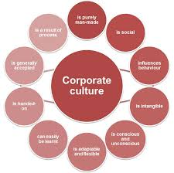

7. Factors which can influence on individual behavior at work place
It is a big specification of factors that influence on the individual behavor on the workplace. Some of them are:
- Leadership - the secret of the success is a big and powerful leader that can lead and motivate his team. An effective team leader inspire the employees to take challenges, show the best of them and help the company to achieve its goals.

- Work environment - it is easy to work in a positive and safe environment. Before hire an employees the company should run from the negative influences as this can have bad consequences by reducing the willingness of workers to perform their duties and to show their skills and potential.

- Effective communication- The effective communication ensures the timely flow of the information. Managers need to communicate with the employees and give them a feedback of their progress. In this way an employees do not lose interest and they hark harder to achieve a positive feedback.

- Self-perception –the employees can be introverts or extroverted, emotional or to hide their emotions, take challenges or do not like risks. Company should provide positive environment so the people feel free to be themselves and to create. Then they will love their job and feel like this is the exactly place they belong to.

8. Recommendations
Here are some recommends for improving overall performances by using organizational structure and culture.
- Listen to your Employees - listen for ideas, try to ease conflict and this will help to create an even better company culture. This is the way to earn your employees trust and support.
- Show the employees that are special, supported and their needs are important. Honesty and positive attitude about them and their needs.
- Engage the employees with the mission of the company. Educate them on the organisational purpose include them on the projects and give an information for the company progress and results.

9. Conclusion
To manage a group of people it is necessary to know their culture, values, traditions and shared views. In this way you will be able to motivate them and make them perform their tasks conscientiously and correctly. This knowledge makes it possible to choose the most appropriate organizational structure for the distribution of tasks among employees in the enterprise. This makes the work process easy, fast and enjoyable as well as makes it easier for managers to make important decisions. Helps achieve the goals of the organization, increases profits and reduces losses. This connection between organizational culture and structure is the formula for successful organizational performance.

10. Reference List

- Mullins, Laurie J. ( 2016) Management and organisational behavior.11ed. Harlow:Pearson

- Mullins, Laurie J. (2019) Organisational behaviour in the workplace.12 ed.Harlow: Pearson

- Stephen P. Robbins (2016) Fundamentals of Management: Essential Concepts and Applications.10 ed.

- Brian T.(2009) ‘Organizational culture and effectiveness: A study of values, attitudes, and organizational outcomes’ Journal of Business Research,62(7),pp.673-679

- Ebrahimi, M.(2014) ‘Business and Management’ Arabian Journal of Business and Management Review; 4(1), pp.96-106)

- BMW GROUP
Avaliable at: https://www.bmwgroup.com/en.html
(Accessed: 06 April 2021)

- Wikipedia, the free encyclopedia(2001)
Avaliable at: https://en.wikipedia.org/wiki/BMW
(Accessed: 05 April 2021)

