
Module Name: International Business Concepts
Module Code: LCMB7034
Lecturer Name: Jean Wang
Student ID: 2431869
Student Name: Syed Tahbib Baksh

Table of Contents
Introduction 3
2. Benefits and Challenges of PRAN’s International Challenges 5
2.1 Designation as MNC/TNC 5
2.2 Nature of PRAN’s Global Operations and Value Chain Aspects 6
2.3 Entry Modes in International Markets 8
2.4 Key Benefits from International Operations 9
3. OLE Analysis on PRAN’s UAE Market Entry Strategy 11
3.1 Ownership Advantages 11
3.2 Location Advantages 13
3.3 Internalisation Advantages 15
4. Influence of Culture Bangladesh (Home) vs UAE (Host) Market Entry Strategy: Market Entry Strategy and Potential for Success 16
4.1 Cultural Framework 16
4.2 Consumer Preferences in Price Sensitivity, Tastes & Channel Preferences 18
5. Suggested Adjustments to PRAN’s Standard Operating Procedures (SOPs) for UAE : Considering OLI and Cultural Insights 20
5.1 SOP Adjustment 1: Regulatory and Quality Compliance System. 20
5.2 SOP Adjustment 2: Cultural and Workforce Integration Protocol 20
5.3 SOP Adjustment 3: Digital Marketing and Distribution Automation 21
Conclusion 22
References 23

Introduction
PRAN (Program for Rural Advancement Nationally) is a well-known Bangladeshi-based food and beverage conglomerate that operates under PRAN-RFL Group. Founded in 1981, PRAN is now one of the top agro-processors and exporters in the South Asian region, with its operations serving more than 145 countries and a diverse portfolio of products. Pran-RFL Group provides more than 8,000 products spanning 100 brands. The Business Standard report (2025) indicates that from October to December, revenue surged by more than 16%, reaching Tk90 crore. Despite this, net profit decreased by 2.17%, totalling Tk 1.35 crore compared to the prior year. Today, the company's share price settled at Tk 201 on the DSE, reflecting a decline of 1.71% compared to the previous session (Dhaka Stock Exchange, 2025). PRAN has built a reputation for delivering superior products at affordable prices, enabling the company to secure a robust foothold across multiple sectors. This essay aims to critically evaluate PRAN's global operations in the food and beverage industry, its strategy, issues, and success with respect to the growing market in the UAE.
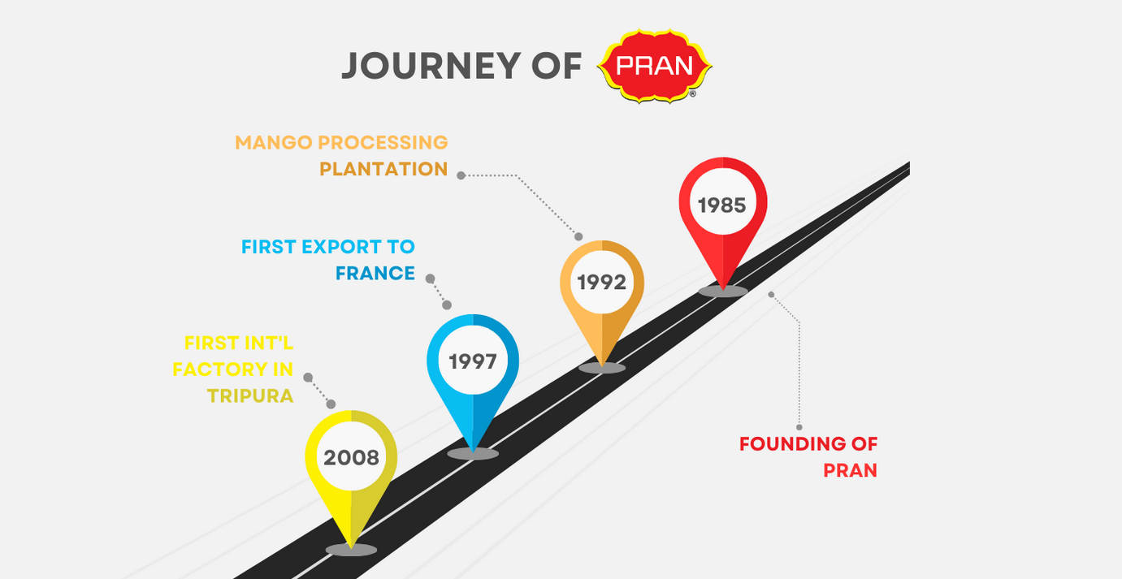
Figure: A journey of PRAN (PRAN, 2025)
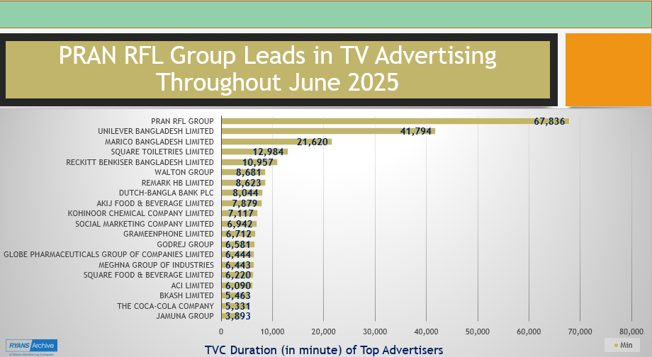
Figure: PRAN RFL Group dominate TV advertising through 1st part of 2025 (News Shell, 2025)
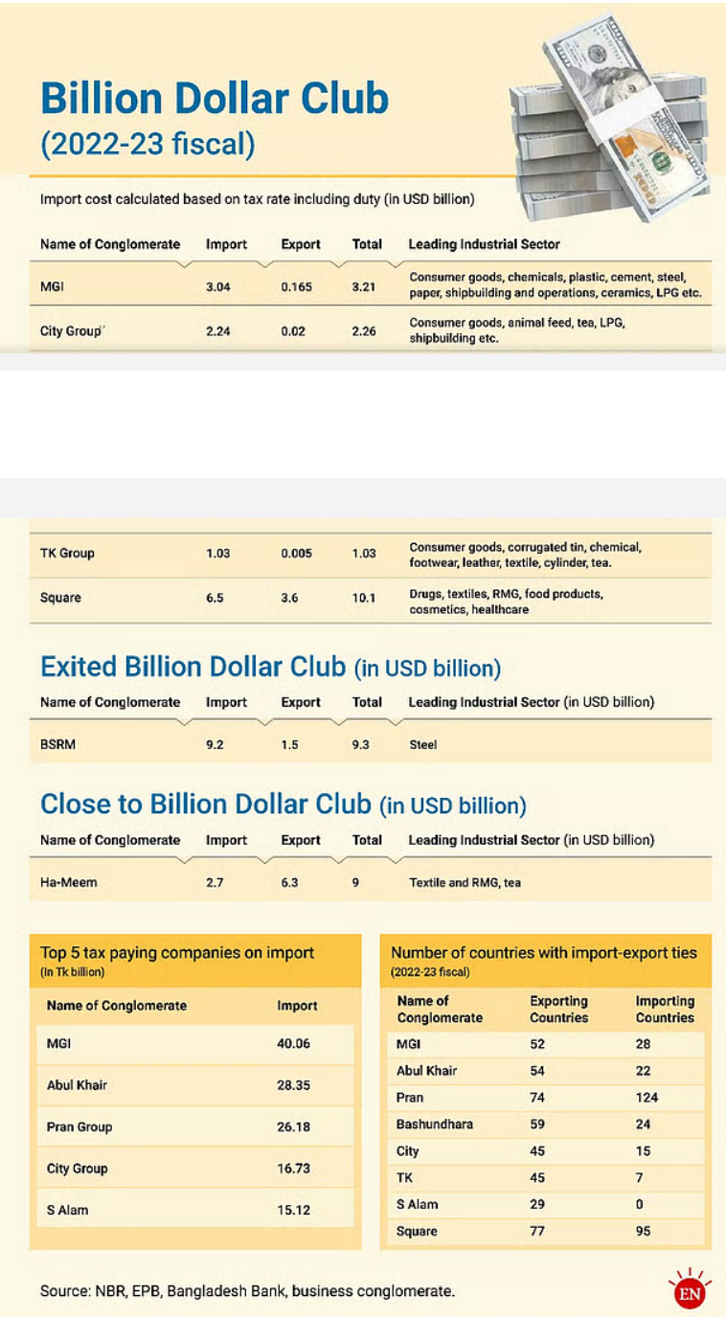
Figure: Business conglomerate entering billion-dollar club (Milad, 2023)

2. Benefits and Challenges of PRAN’s International Challenges

2.1 Designation as MNC/TNC
PRAN is a clear example of a multinational/transnational company. PRAN exports to approximately 145 countries globally, indicating its widespread global presence (PRAN, 2025), and the UAE is among them. To reach the world markets, the company has sales and distribution networks consisting of offices, warehouses and a production facility in India (Roxy and Rahman, 2023). PRAN firm supports the high standards with the ISO 9001, HACCP, HALAL and compliance with Good Manufacturing Practices (GMP) certifications and, thus, allows penetrating sensitive markets and increasing the quality of the products (PRAN Frooto, 2025). To add, the multiple product offering of the company (including beverages, snacks, confectionery, dairy and more) and the high level of vertical integration (including contract farming all the way to processing) demonstrates the complex global operations of multinational companies (Globixo, 2025). As per a report from Easy Build (2025), PRAN-RFL boasts an excess of 100,000 employees across the globe. This implies an operation scale which is beyond a domestic or a small exporter company. Setting up an overseas plant in India in 2008 was a major leap for PRAN (Azim, 2016) for boosting an MNC company.
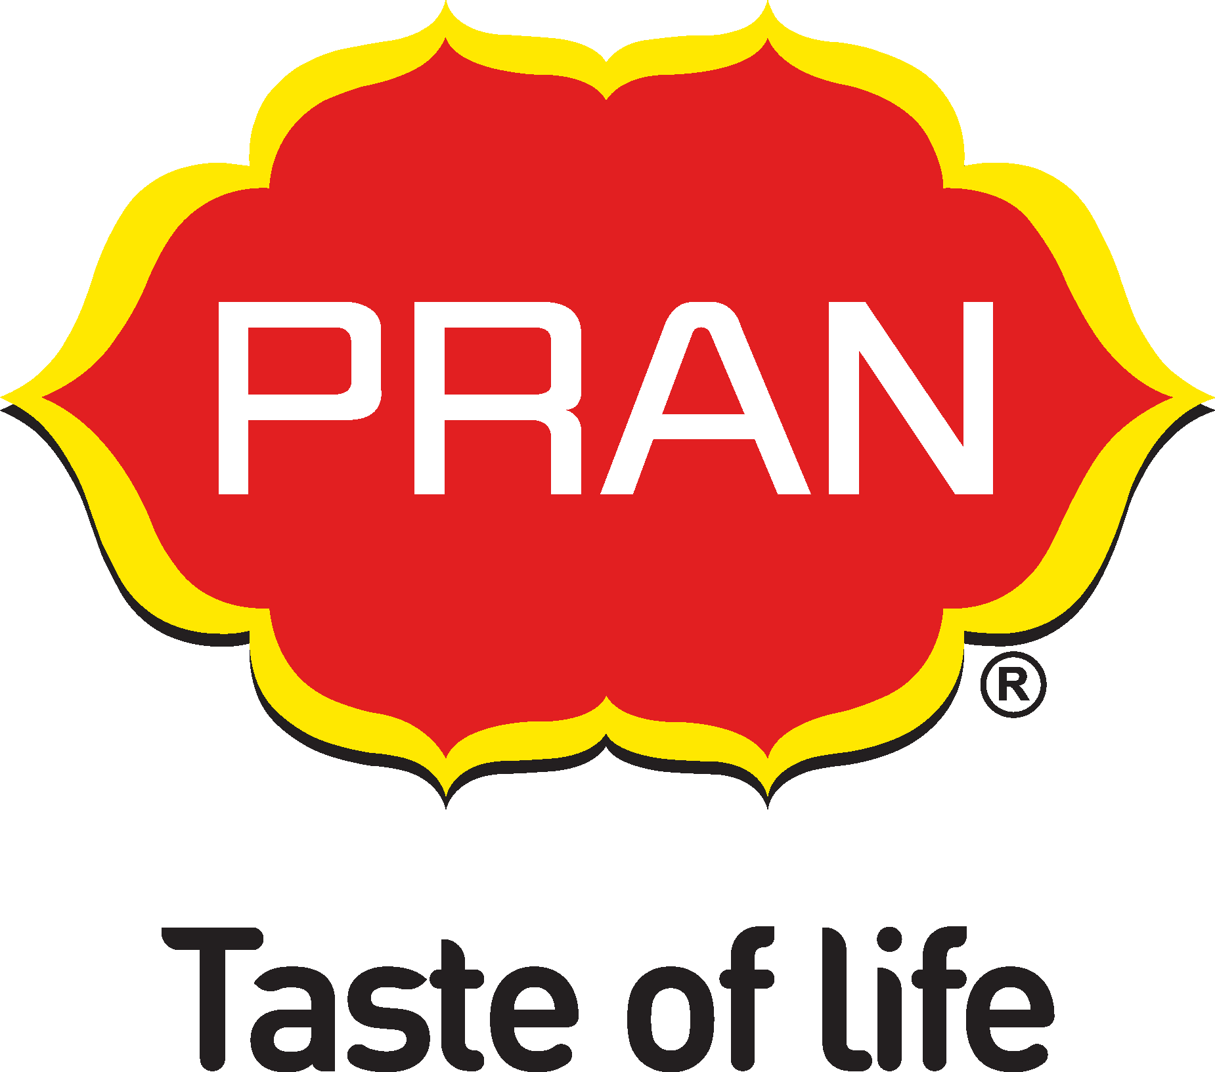

2.2 Nature of PRAN’s Global Operations and Value Chain Aspects
Research and Development: Global business strategy of PRAN-RFL means that the group is flexible in its product mix and marketing strategy to suit various international markets. This implies that at least, PRAN does a market-based product development, trying to adapt flavours, packaging, and product lines to the needs of international consumers and the demands of regulatory bodies such as Halal certification, where necessary (Roxy and Rahman, 2023). According to the report from The Daily Observer (2024), PRAN has used its research and development units in Dhaka and Natore to continue innovating its products. The firm modifies the sugar content and packaging of its products to suit the Middle Eastern and European markets to comply with the international regulatory requirements, as well as satisfy the local markets (Amin and Zaman, 2022). Yet, the specifics of the process or the underlying innovations of these adaptations are only slightly visible to the public and restrict the openness of the innovation pipeline of the firm.

Sourcing: The PRAN company obtains raw materials via a contract-farming system comprising more than 100,000 farmers in Bangladesh, which guarantees regularity of supply and contributes to the rural farmers (Daily-Sun, 2025). This farm-to-final product vertical integration is a key competitive strength and helps PRAN to serve a variety of markets at scale. Though contract farming may be helpful in the livelihoods of rural people as it gives farmers a stable income and access to the market, it can result in dependencies (Tuyen et al., 2022). The farmers would find themselves dependent on PRAN as a main or even the only purchaser, and thus their bargaining power may be diminished as they can be exposed to changes in the terms of the contract or prices of the company. To mitigate logistical challenges, PRAN has established export-oriented industrial complexes in Narsingdi and Habiganj with dedicated quality control labs and storage facilities adhering to ISO and HACCP standards (Deen, 2022).
Production: PRAN has 25 manufacturing plants in Bangladesh and a few outside the country, in India, Nepal, and Ghana. According to Roxy and Rahman (2023), PRAN has diversified its production so that it bounces back against regional trade barriers and fluctuation of exchange rates. However, since proximity to markets contributes towards the reduction of tariffs, it also subjects PRAN to the volatility of the regional economies, political instabilities, and local changes in regulations, which may weaken the very cost reduction that is sought through diversification (PR Newswire, 2025).
Sales: According to Yan and Yu, (2021), the company has excellent distribution relationships with other companies like Lulu Hypermarket (in the UAE) and Carrefour (in Saudi Arabia), which enable it to enter the established retail chains effectively. Noyon (2024) reported that PRAN products are sold in virtually every major shop in the UAE, such as Dubai, Abu Dhabi and Sharjah. Even Halder (2025) clarified that in the past year, PRAN has achieved good sales of over 265 million or approximately Tk3,000 crore through its offerings in the oil-rich products. Yet, the result of this success is increasing susceptibility to macroeconomic issues like as currency volatility, regional rivalry, and altering customer preferences (Amit and Kafy, 2024). Alom (2024) stated that PRAN goods are available in 28 Indian states; in fact, its annual sales, as per Noyon (2024), are more than 60 million dollars (Tk700-750 crore). However, the evaluation of the sales distribution can be uneven or concentrated on a few regions, and this may expose PRAN to regional market volatility and competition.

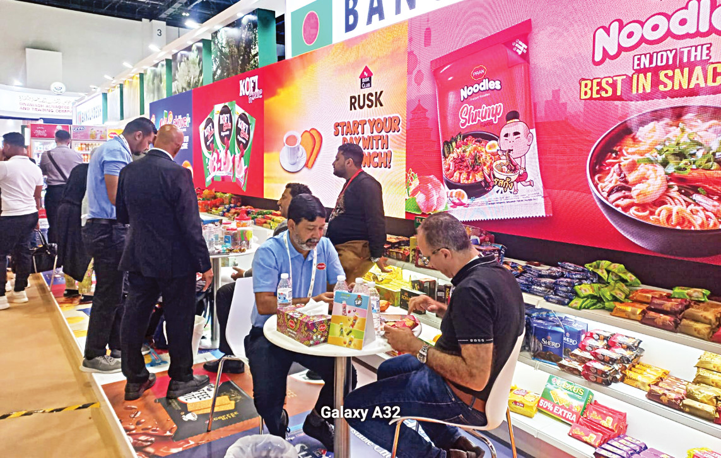
Figure: PRAN RFL showcasing products at Dubai Gulf Trade Fair (Halder, 2025)
Financing and Investment: Export revenues, concessional loans by development banks and retained profits are used to finance the international activities of PRAN. The company enjoys the drawbacks of duties and export incentives under the Export Promotion Policy of Bangladesh. Nonetheless, the method can be prone to governmental interventions or economic crises in the world, so making it less useful in uncertain situations. Additionally, PRAN takes advantage of the capital markets in the host countries and the reduction of currency risks and political instabilities by establishing joint ventures in the region (Kanungo and Kanungo, 2012). Halder (2025), in his latest report, has mentioned that goods and items valued at $377 million were exported by the firm in the year 2024. Not only that, but the Business Standard (2022) also revealed that the PRAN organisation has set a target of reaching $2 billion in exports by the year 2030. However, Coveillo et al (2024) argued that achieving this growth requires aggressive scaling both in terms of market presence and production capacity, which may affect the quality of the product

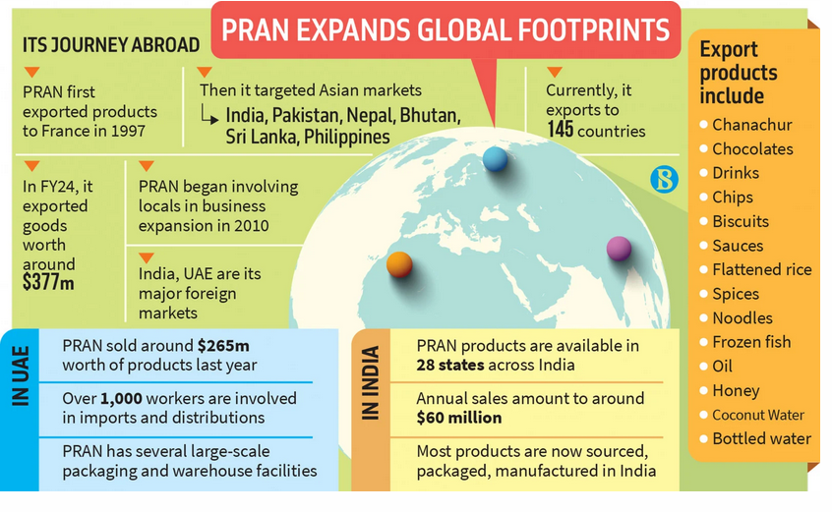
Figure: Global operations in a nutshell for PRAN (Noyon, 2024)

2.3 Entry Modes in International Markets
The global expansion strategy of PRAN presents a broad range of entry mode that illustrates the capacity of the company in adapting and reacting well to the local market dynamics. It then established strong sales and distribution networks in other parts of the world, the USA, the Australian market, the UAE and Saudi Arabia, Qatar, India, Oman, Malaysia, Singapore and Somalia, with offices, warehousing and logistics (Deen, 2022). Then, PRAN began its abroad operations via indirect exporting (Roxy and Rahman, 2023). This shifted to direct exporting as time went on, with offices being set up in India, the UAE, and Africa, with the intention of having increased control of branding and logistics, as stated by Alom (2024). To overcome trade regulations and adaptation to the local markets, PRAN embraced contract manufacturing and local sourcing, e.g. in India, it has five factories and in the UAE sources and packages products locally under its brand (Noyon, 2024). In order to circumvent regulatory limitations in the host countries, PRAN entered into joint ventures, especially PRAN Beverages India Pvt. Ltd. and PRAN Ghana Ltd (Opu, 2024). PRAN opened wholly owned subsidiaries in the emerging economies and especially in India and Nepal, enabling the firm to exercise complete control over the work and localise the products (Alom, 2024). A report from Daily-Sun (2023) indicated that PRAN also uses franchising by licensing its brand to local distributors and retailers to maximise market penetration, but reduce risks of capital investment in unstable markets such as Nigeria and Kenya. On a different side, PRAN is actively trying to increase its global FDI by acquiring a working capital credit of $30 million from the IFC, which is a subsidiary of the World Bank Group (Frank, 2024). Such an accord provides foreign investment to enhance exports, availability of foreign currency and employment assurance for about 30,000 jobs. The first move of PRAN towards foreign direct investment was the setting up of a subsidiary in the UAE in 2003, which was its first move into international expansion through the establishment of a localised corporate presence. In 2008, PRAN also declared it was going to construct a production plant in Tripura, India, when the ban on Bangladeshi firms investing in India was removed as an example of planned outward FDI. According to Ria (2025), PRAN plans to establish a plant in Saudi Arabia as a process FDI entry method, as Saudi Arabia has attracted approximately SAR 119 billion (US$31.7 billion) in FDI, with the manufacturing sector accounting for nearly 29% of total inflows (Rizvi, 2025), indicating a favourable environment for new manufacturing ventures through FDI. As Pierrine Consulting (2024) finds that 53.9% of Nigerian customers drink fruit juice, smoothies, and other beverages, the business is considering building a beverage production factory in Nigeria to boost foreign direct investment.

2.4 Key Benefits from International Operations
PRAN is a winner of 21 National Export Trophies, and this has been achieved because of an outstanding export history that has been unmatched by any other company in Bangladesh (Daily-Sun, 2025). The firm made its products conspicuously visible in the shelves of the major retail players worldwide, including Walmart, Carrefour, Tesco, Poundland, Reliance Fresh, and Giant (Roxy and Rahman, 2023). Mass scale production and automation allow cost savings- e.g. in poultry production, the automated production facilities at PRAN help ensure the consistency of production, and also low unit costs, as compared with small farmers. On the opposite side, foreign product restrictions contribute to forcing PRAN to depend on domestic production and alliances, which adds complexity to supply chains. The global operations of PRAN contribute to over 40% of the total company revenue, which cushions it against fluctuations in the local market. Such diversity leads to the sustainability of businesses and shareholders. The Made in Bangladesh trademark of the company has been identified with the cost and quality in emerging countries. This growing image not only helps PRAN but also the national image of the exports of Bangladesh. However, managing a diverse network of contract farmers, manufacturing plants, warehouses, and logistics across continents increases operational and administrative challenges. On the flip side, since the company is a family-based conglomerate that has been developing into a global corporate body, the company may experience shortages in managerial capacity in its international subsidiaries, which often lead to inefficiency in cross-cultural leadership (Zaidi, Waqas and Mahmood, 2024).
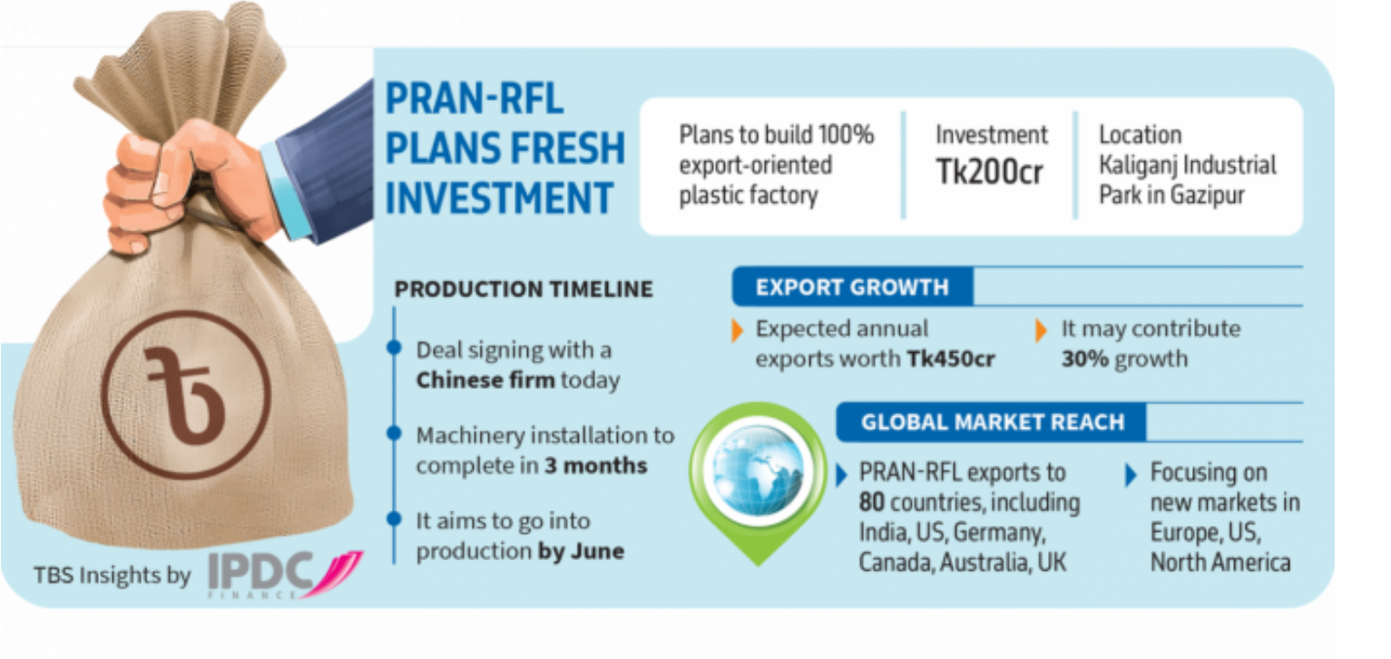
Figure: New fresh export investment for PRAN (Invest Bangladesh, 2025)

3. OLE Analysis on PRAN’s UAE Market Entry Strategy
The OLI Framework implies that three interrelated advantages, internalisation (I), ownership (O), and location (L), are required so that a company can expand on a global scale (Luo, 2021). The strategic interplay of these factors is probably the reason why PRAN decided to establish wholly owned subsidiaries and conduct direct export activities as it ventures into the UAE market.

3.1 Ownership Advantages
PRAN has considerable recognition, especially in the food and beverage industries in Bangladesh, Pakistan, and the whole South Asian population. This gives brand value of culture and diaspora that is not limited to Bangladesh. The benefits of ownership of PRAN are based on its intellectual property, brand name, and vertically integrated agro-industrial ventures. The company is certified by ISO 9001 and HACCP, which proves the high efficiency and quality attainment of its operations (Roxy and Rahman, 2023), which is needed to enter such a market as the UAE, where the stringent food safety requirements are imposed under the UAE Food Law No. 10 of 2015 (Alfzari and Omain, 2022). Though these benefits can be questioned by emerging competition of international players like PepsiCo, Coca-Cola and local brands like Rani in beverages and Indomie and Maggi in noodles. The brand reputation of PRAN as the provider of affordable, halal-certified food products can be used to compete in Muslim dominant countries (Ovi, 2025). Out of the 9.6 million population residing in the UAE, with more than 85% being expatriates (Primal Alliance, 2025), a huge diaspora market in South Asian cuisine is created. Nonetheless, the fact that PRAN targets a particular group in the demographic market segment puts it at a disadvantage: the change in customer preferences or modification of the retail relations may jeopardise the market share and the buyer power of the organisation.

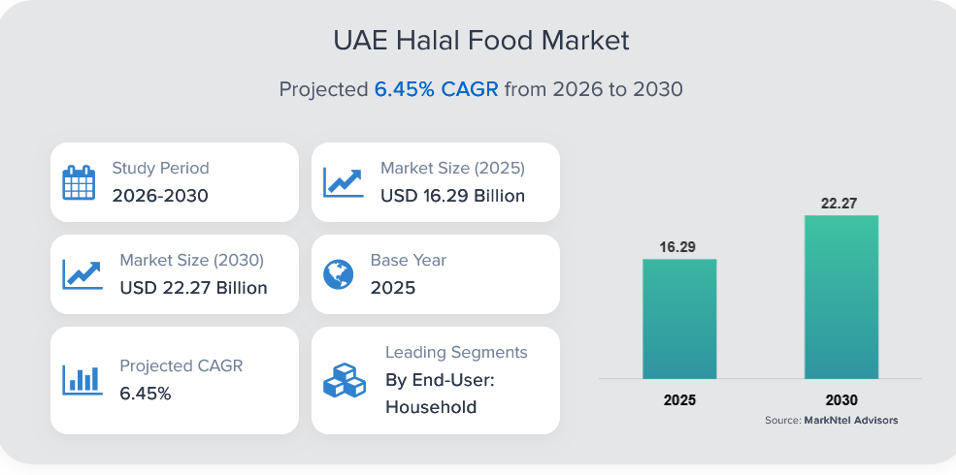
Figure: UAE Halal Food Market Growth (Markntel Advisors, 2025)
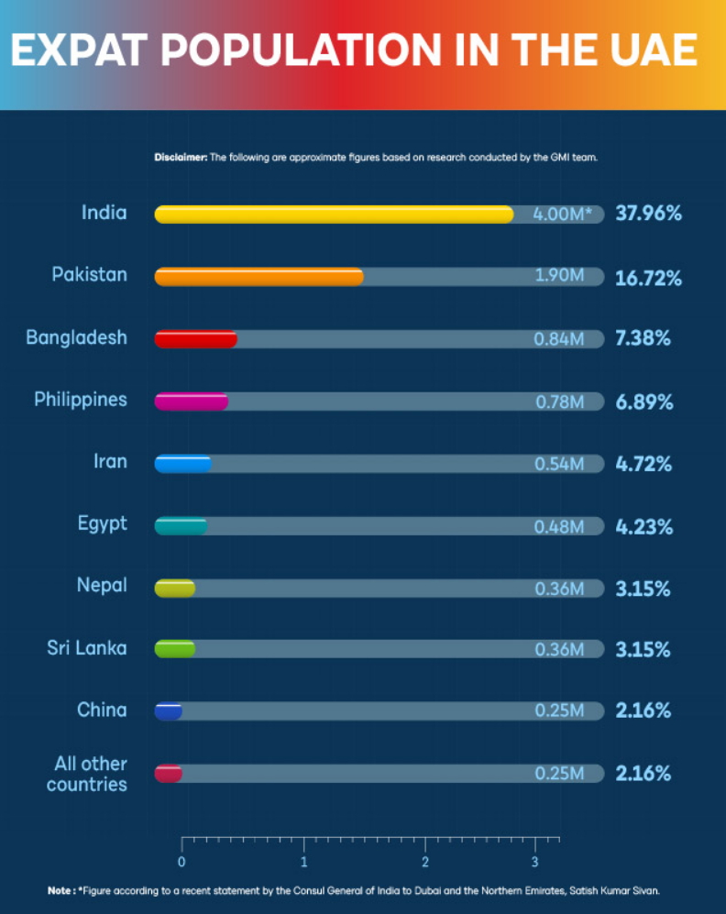
Figure: Expat populations in the UAE (GMI Research Team, 2025)
The economies of scale and the successes of adapting to the market through having over 2000 product SKUs and having well-developed distribution networks across 145 countries allow PRAN to achieve economies of scale (Alom, 2024). Managing however 2,000 or more product SKUs, and a wide distribution network in 145 countries can also result in operational inefficiencies and increased overhead costs, which can undermine the very economies of scale that PRAN seeks to attain.

3.2 Location Advantages
The UAE is a logistical hub with a diverse population and strong purchasing power. PRAN's 2003 subsidiary in the UAE and local manufacturing suggest that it recognises such benefits. PRAN's Middle Eastern distribution centre in the UAE increases its reach. The Dh110 million Abu Dhabi manufacturing plant would allow efficient supply to the UAE and surrounding markets and reduce lead times and tariff risks (Gulf News, 2023). Despite enhancing its local presence, it presents the operational risks of capital intensity, regulatory turbulence, and economic instability in the region, which can, in turn, impact on returns. The prime locations, such as Jebel Ali and renowned free trade zones such as JAFZA, have enabled the UAE to be ranked the 11th most favourable region worldwide (Ahmed, AL Amiri and ABudaqa, 2021). Moreover, the foreign ownership and profit repatriation are 100% in these zones, which have a significant positive effect on the export-oriented industrial strategy of PRAN because of the unique geographic position of the UAE as a commercial hub between Asia, Africa, and Europe. PRAN exports about 45 % of its exports to the Gulf region through the middlemen in the UAE to Saudi Arabia, Oman and Kuwait (Alom, 2024). This arrangement, however puts PRAN at risk due to the policy changes, congestion of infrastructure or even geopolitical tensions that would traverse this very important transit path.
The United Arab Emirates depends significantly on food imports due to its arid climate and little local agriculture. International food corporations have strategic potential inside the UAE food industry, as shown by Green (2025), due to the sector's continued dependence on imports. Furthermore, the United Arab Emirates has a high-income economy, with a projected GDP exceeding 51,000 USD in 2025 (John, 2024), hence providing its residents with increased disposable income for premium ethnic food, convenient packaged products, and foreign groceries.
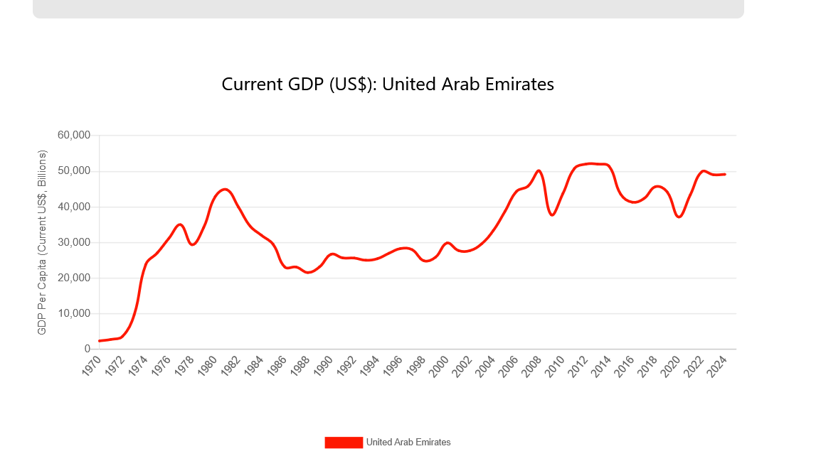
Figure: Current GDP of UAE (World Economics, 2025)
However, imported food goods must be both economical and compliant with rigorous requirements of quality, safety, and freshness, since the food and beverages in Bangladesh can include inferior substances. According to Kamruzzaman (2022), obesity is increasing in Bangladesh due to the consumption of junk food, with students consuming 79.8% of their beverages and food items as junk food, as reported by Akter et al. (2025). According to Bandyopadhyay (2024), the growing FMCG market in the UAE presents promising opportunities for PRAN's packaged beverages, snacks, and milk. However, Danzier (20220 argued that the demand for both value-based and luxurious goods compels companies to diversify their portfolios, but at a cost-efficient and quality. Besides, cultural, culinary similarities, particularly between the patrons of Bangladeshi and Indian backgrounds, who represent 38% of the UAE labour force (Benuyenah, 2024), provide a natural consumer segment.

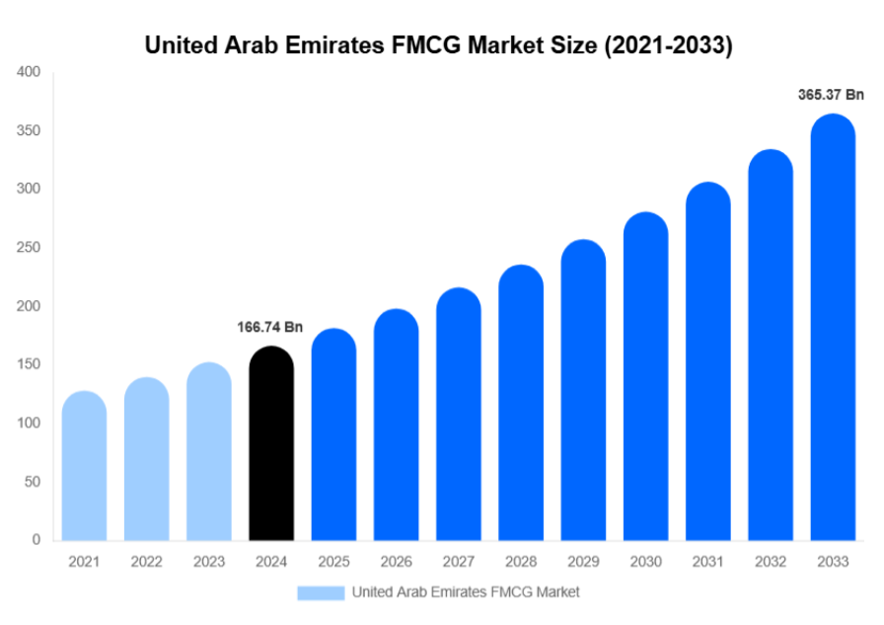
Figure: UAE FMCG market size (Morgan, 2025)

3.3 Internalisation Advantages
Medialinks (2025) state that PRAN has centralised key services combining distribution, marketing and retail management through such organisations as Emerging World FZC, which deal with logistics and sales in the Middle East. This internalisation decreases the reliance on partners and secures the brand identity. The premise of the hybrid retail strategy of PRAN in the domestic market, which combines company-owned outlets with franchising, shows the advanced level of managerial skills and adaptability (Riya, 2023). A critical fact to notice: on the one hand, internalisation makes it easier to conduct strategic control over the supply chain and customer experience, but it, at the same time, increases the complexity of administration and requires significant local expertise (Forsgren and Holm, 2022). PRAN saves money on logistics through transport, customs, and delivery, as all products are produced in the UAE. By bringing together its components and processes into one location, it has been able to achieve significant savings in production costs and decrease time to market. However, managing a wholly owned facility in another country adds levels of complexity related to international business regulations and cultural differences (Sagedar and Feldbauer-Durstmüller, 2019).
PRAN's UAE entrance strategy is an export-oriented hybrid internalisation model based on ownership-based cost benefits and the UAE's trade-friendly location.

4. Influence of Culture Bangladesh (Home) vs UAE (Host) Market Entry Strategy: Market Entry Strategy and Potential for Success
Cultural factors, in addition to economic and logistical motivations, will play a major role in determining the success of PRAN entering the UAE market based on cultural differences between the home country (Bangladesh) and the destination country (UAE).

4.1 Cultural Framework
Utilising Hofstede’s Cultural Dimensions, a clear distinction can be made between Bangladesh (home) and the UAE (host) that significantly impacts PRAN’s market entry and operational effectiveness.
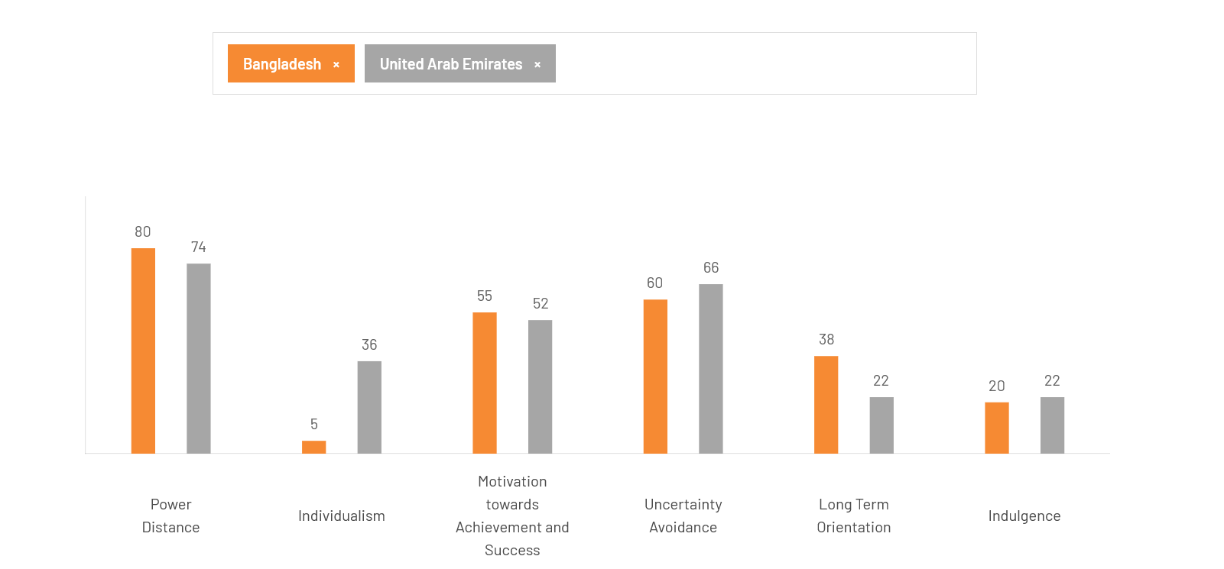
Figure: Cultural differences between Bangladesh and the UAE (Culture Factor, 2025)
Power Distance: According to Culture Factor (2024), Bangladesh and the United Arab Emirates have a significant power distance with the scores of 80 and 74, respectively, which imply a hierarchical organisational culture. However, Emirati business culture focuses on formality and local representation (Ergalieva, 2024), despite the fact that PRAN's family-run management structure fits this pattern. Thus, without introducing Emirati citizens into the leadership or compliance positions, which is both a legal and cultural requirement as per the policies of Emiratisation in the UAE, the reliance of foreign management on local distribution agreements may limit the access of PRAN to local distribution agreements. Uddin's (2025) study highlights the substantial impact that social media and family/peer relationships have on how consumers in the UAE consider their purchasing decisions. Recommendations and referrals serve as an impetus to influence consumers' buying behaviours and foster a community-based consumer experience. PRAN could capitalise on this opportunity through partnerships between influencer groups in South Asian and Emirati communities, the leveraging of community leader relationships and implementing 'organic' marketing strategies. However, failure to establish social trust or cultural/normative misunderstandings regarding the process of referral/networking may impede acceptance of the brand and impede progress.
Individualism and Collectivism: Bangladesh and the UAE emphasise the importance of cultivating robust connections in their business dealings, showcasing their shared cultural values of collectivism. This cultural bond enhances PRAN, which usually establishes collaborations through conversations grounded in trust. The UAE's vibrant workforce, comprising more than 200 nationalities (Lew, 2025), demands a deep comprehension of cross-cultural dynamics in human resources and marketing communications. In a different report, Qomariyah et al (2022) stated that expatriates tend to bring their cultural characteristics into the country, which leads to disintegrated organisational cultures of companies. PRAN needs to establish a cohesive organisational culture that could be achieved by means of effective onboarding, bilingual packaging (Arabic-English), cross-cultural training, and inclusive leadership and culturally relevant advertising to expand its reach beyond South Asian consumers. However, the same identity will not necessarily be attractive to Emiratis or other expatriates. Unless there is specific positioning and product differentiation, PRAN will be viewed as a niche brand in the ethnic category that will not be so appealing to the wider market (Verkeer, 2025)
Uncertainty Avoidance: The UAE is more cautious than Bangladesh, which is a sign of strong adherence to regulations, precise filing and high quality control. The informal market capacity of PRAN in African and South African exports is not easy in the UAE. They should be certified with ESMA, Halal and compulsory traceability audits. The lack of enough procedural alignment can hinder the clearance of customs and destroy brand image. According to a recent article published by The Dubai-Biz Directory (2025), the halal certification of PRAN is completely in line with the Islamic dietary laws, which increases its attractiveness among the Muslim population of the UAE. Religion plays a major role in buying decisions, especially in the food industry, where adherence to the halal requirements is mandatory and irrevocable (Sustainability Directory, 2025). According to Domat (2024), the UAE is a Muslim nation with 95% Muslims, and it maintains Sharia-compliant business practices. The halal certification by PRAN is very appropriate, but it is necessary to think in terms of ethical marketing and avoid any images of non-halal eating or gender insensitivity. Further, it is important to adhere to Ramadan marketing rules and do community sponsorships, as this will enhance brand credibility in this cultural context. However, failing to adjust marketing messages to the Emirati cultural values (e.g. modesty, Arabic language, or a campaign specific to Ramadan) may hinder the brand affinity, particularly among native Emiratis (Ergalieva, 2024).

4.2 Consumer Preferences in Price Sensitivity, Tastes & Channel Preferences
According to Arabian Business (2024), 72% of consumers in the UAE are willing to pay more money for better quality. This indicates that consumers are aware of brands and prefer to purchase brands based on their reputation for quality and customer service. At the same time, consumers are very responsive to special offers from retailers and are looking for value when purchasing. PRAN's pricing strategy is positioned to capture the attention of price-sensitive international workers. However, it will be important for PRAN to provide value in its products while also maintaining quality standards. If PRAN's products fail to meet the high expectations of sophisticated Emirati consumers or if its marketing strategies do not properly target Emirati consumers, they may have difficulty establishing brand loyalty across market segments. In the UAE, malls are used as lifestyle destinations and continue to dominate the traditional retail space (Krawchuk and Gurrapu, 2025).
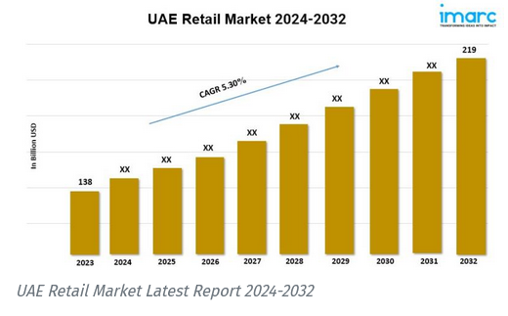
Figure: UAE retail market report 2024-2032 (IMARC Group, 2024)
However, consumers are now quickly adopting digital convenience and multichannel purchasing methods (Uddin, 2025). To remain competitive, PRAN needs to invest in developing seamless digital integration (including click-and-collect, home delivery, etc.) and in-store visibility (via product sampling or experiential displays). If PRAN ignores any of these channels, it will hinder its ability to penetrate the UAE market, as consumers will lose trust in PRAN if the company does not meet the UAE's rigorous standards for service and convenience.
UAE Health awareness is on the rise as customers are becoming frustrated with Uber-processed food and are demanding a healthier and fresher option (Sapience, 2025). The product lines of PRAN can have high-sugar levels or processed foods that cannot be compatible with these increasing desires. PRAN might not be able to keep up with the long-term trends in the market without innovation in healthier formulas, labelling, or the high-end brands of natural products, as the company may become irrelevant.

5. Suggested Adjustments to PRAN’s Standard Operating Procedures (SOPs) for UAE : Considering OLI and Cultural Insights
In order to maintain competitiveness and compliance within the UAE, PRAN needs to standardise and localise its Standard Operating Procedures (SOPs) with the guidance of the OLI and cultural analysis. SOPs should cover the three pillars of strategy, which are regulatory alignment, cultural integration, and digital transformation.

5.1 SOP Adjustment 1: Regulatory and Quality Compliance System.
The UAE enforces stringent laws that regulate the import and labelling of food. Compliance with ESMA certification, the display of shelf-life information, and labelling in Arabic are mandatory requirements. The failure to meet these requirements results in the rejection of imports (Dubai Municipality, 2023). A special Regulatory Affairs Unit was created in PRAN Dubai, tasked with the registration of products and compliance documentation (Alom, 2024). The aim is to integrate the ISO 22000 food safety management system with the local ESMA requirements. A halal certification and origin check traceability through Blockchain-based traceability is set to become a new standard under the UAE Food Security Strategy 2051 (Ahmed, Al Amiri and Abudaqa, 2024). The system enhances the brand's trustworthiness, accelerates the clearance process, and positions PRAN as a reliable halal brand. The internalisation advantage is also realised through the institutionalisation of cross-border quality control. Nonetheless, the success will rest on training on a regular basis, accountability, and internal audits. The SOP should cover resource allocation (e.g. staffing, budget), integration with production and export teams, and the mechanisms of keeping up with the changes in regulations. In the absence of such safeguards, even a well-designed system can end up being bureaucratic and out-of-date.

5.2 SOP Adjustment 2: Cultural and Workforce Integration Protocol
Cultural misalignment and lack of participation by Emiratis may limit the legitimacy of a business (Arabian Business, 224). Sarker and Rahman (2020) state that the representation of local people in managerial posts must be addressed as per the Emiratisation principles. Changing business laws are also a challenge to businesses in the UAE, particularly those related to data protection and compliance systems (centresystemsgroup.net). In this regard, it is suggested to make regular audits, checklists of compliance (e.g. Halal, HACCP, ISO), review of documentation, and training of staff about UAE-specific regulations. This will make the products of PRAN up to the mark in terms of quality and compliance with the law. Moreover, the Emirati liaison officers are to be enlisted under the governance system of PRAN Dubai. The dimensions of Hofstede should be used to conduct cross-cultural training to overcome communication barriers between the managers of Bangladesh and partners in the UAE. HR policies must be restructured to ensure the practices of multicultural inclusiveness, which should consider the language differences, religious beliefs, and gender sensitivity.
The adaptations lead to cultural synergy, adequate local reputation and expansion of the negotiating ability of the company. The operationalisation of the ownership advantage, which PRAN has, is the incorporation of cultural intelligence into human capital.

5.3 SOP Adjustment 3: Digital Marketing and Distribution Automation
Most of the e-commerce is digitalised, and e-commerce is estimated to be 23% of the total FMCG sales in the UAE, according to Statista (2024). The conventional distribution model of PRAN, with the focus on physical stores, does not allow the company to scale in the market. The demand forecasting based on AI should be implemented in managing inventory in the UAE market. They must also become part of the UAE e-commerce powerhouses, including Noon and Carrefour online, via B2B digital alliances. According to Srivastava (2025), social media analytics has helped localise marketing, and the Arabic influencers are used to foster brand trust. The adjustment enhances location benefits by maximising the last-mile logistics and data-based marketing. It makes sure that PRAN can be competitive in the UAE technology-driven retail market. However, UAE organisations' ERP installation issues demonstrate the necessity of cross-functional alignment and tailored training that includes inadequate training, translation, and unrealistic timeframes (Jazairy, Shurrab and Chedid, 2025).

Conclusion
The entry of RAN in the UAE market is a good example of a planned yet culturally complex expansion. The OLI framework explains the way in which the PRAN benefits of ownership, i.e., cost-effective production, strong brand recognition with a strong halal certification, and a well-tuned supply chain, provide the company with a competitive advantage in the industry that values affordability and authenticity. The geographical advantage of the UAE, and that is; good logistics, free-zone, and a high population of South Asians, complements the hybrid strategy that PRAN pursues; that is, exports, domestic distribution, and partial manufacture. Internalisation will ensure a higher quality and brand consistency control, which will meet customer expectations and the strict food safety standards in the UAE.
The cultural adaptation and structural advantages are important in achieving success in the UAE. A study of cultural differences between the UAE and Bangladesh suggests that PRAN will need to change its leadership, marketing, and operations strategies to correspond to Emirati business etiquette, collectivist, and religious factors. Emiratization, halal standards and ethical marketing are not only legislative but also strategic needs to ensure a sense of legitimacy and long-term brand confidence.
These findings are translated into realistic frameworks through strategic SOP improvement, such as the digital transformation, the native integration of the workforce in the UAE, and regulatory compliance automation. Through these strategies, PRAN can evolve to no longer be an exporter that is price-driven, to a culturally sensitive, innovation-based international company. The UAE market will provide the PRAN with the access to a lucrative customer base and can be regarded as a test ground to develop into a significant South Asian brand that is both cost effective, culturally effective, and sustainable with regard to its global growth.

References
Ahmed, I. and Noyon, A.U. (2022) If Coca-Cola & Unilever can do it, we can too: Pran RFL chairman on its global ambitions, The Business Standard. Available at: https://www.tbsnews.net/features/panorama/if-coca-cola-unilever-can-do-it-we-can-too-pran-rfl-chairman-its-global-ambitions (Accessed: December 13, 2025).
BSS (2024) IFC to invest US$30m in Pran Dairy, BSS. Available at: https://www.bssnews.net/business/182898 (Accessed: December 13, 2025).
Ergalieva, D. (2024) Cultural insights: Mastering Business etiquette in the UAE, Anika Property. Available at: https://anika-property.com/cultural-insights-mastering-business-etiquette-in-the-uae/ (Accessed: December 9, 2025).
Forsgren, M. and Holm, U. (2022) “Controlling without owning-owning without controlling: A critical note on two extensions of internalization theory,” Journal of International Business Studies, 53(8), pp. 1734–1746.
Frank (2024) IFC invests US$30M in Pran Group to boost Bangladesh’s private sector, job creation, Dairybusinessmea.com. FW Africa. Available at: https://dairybusinessmea.com/2024/04/09/ifc-invests-us30m-in-pran-group-to-boost-bangladeshs-private-sector-job-creation/ (Accessed: December 13, 2025).
Globixo. (2025) Agricultural marketing co. Ltd. - Beverages, Snacks, Globixo.com. Available at: https://www.globixo.com/agricultural-marketing-co-ltd (Accessed: December 7, 2025).
GMI Research Team (2025) United Arab Emirates (UAE) population Statistics 2025, Official GMI Blog. Global Media Insight. Available at: https://www.globalmediainsight.com/blog/uae-population-statistics/ (Accessed: December 8, 2025).
Green, M. (2025) Cbre.ae. Available at: https://www.cbre.ae/insights/viewpoints/uae-food-sector-report-h2-2024? (Accessed: December 8, 2025).
Gulf News (2023) “Bangladeshi F&B brand Pran to build Dh110m manufacturing hub in Abu Dhabi,” Gulf News, 24 January. Available at: https://gulfnews.com/business/markets/bangladeshi-fb-brand-pran-to-build-dh110m-manufacturing-hub-in-abu-dhabi-1.1674545870413 (Accessed: December 8, 2025).
Halder, S. (2025) Pran’s journey in the UAE, The Daily Star. Available at: https://www.thedailystar.net/business/news/prans-journey-the-uae-3828901 (Accessed: December 8, 2025).
IMARC Group (2024) UAE retail market 2024-2032: Industry growth, share, size, trends analysis and future forecast report, openPR. Available at: https://www.openpr.com/news/3704276/uae-retail-market-2024-2032-industry-growth-share-size (Accessed: December 9, 2025).
Invest Bangladesh (2025) PRAN-RFL export-oriented plastic factory, Invest Bangladesh. Available at: https://investbangladesh.co/news/pran-rfl-export-oriented-plastic-factory/ (Accessed: December 8, 2025).
Jazairy, A., Shurrab, H. and Chedid, F. (2025) “Impact pathways: walking a tightrope—unveiling the paradoxes of adopting artificial intelligence (AI) in sales and operations planning,” International journal of operations & production management, 45(13), pp. 1–27. Available at: https://doi.org/10.1108/ijopm-07-2024-0582.
John, I. (2024) “UAE’s per capita GDP to hit $52,407 this year,” Khaleej Times, 3 January. Available at: https://www.khaleejtimes.com/business/uaes-per-capita-gdp-to-hit-52407-this-year (Accessed: December 8, 2025).
Kamruzzaman, M. (2022) Obesity on rise in Bangladesh children owing to junk food, unhealthy lifestyles, Com.tr. Available at: https://www.aa.com.tr/en/asia-pacific/obesity-on-rise-in-bangladesh-children-owing-to-junk-food-unhealthy-lifestyles/2525269 (Accessed: December 8, 2025).
Kanungo, A.K. and Kanungo, D. (2012) “FDI inflows into south Asia: A case study of India’s investments in Bangladesh,” SSRN Electronic Journal [Preprint]. Available at: https://doi.org/10.2139/ssrn.2140737.
Krawchuk, W. and Gurrapu, P. (2025) Dubai retail market enters next phase of evolution as supply, spending, and experience expand, Cushwake.ae. Available at: https://www.cushwake.ae/en/news/dubai-retail-market-enters-next-phase-of-evolution-as-supply-spending-and-experience-expand (Accessed: December 9, 2025).
Lew, M. (2025) “Diverse culture of the UAE with 200+ Nationalities,” Internationalschooling.org. International Schooling, 13 May. Available at: https://internationalschooling.org/blog/diverse-culture-of-the-uae (Accessed: December 9, 2025).
Luo, Y. (2021) “New OLI advantages in digital globalization,” International business review (Oxford, England), 30(2), p. 101797. Available at: https://doi.org/10.1016/j.ibusrev.2021.101797.
Markntel Advisors (2025) “UAE Halal Food Market research report: Forecast (2026-2030).” Available at: https://www.marknteladvisors.com/research-library/halal-food-market-uae.html (Accessed: December 8, 2025).
Medialinks (2025) Emerging World Group (PRAN-RFL Group), Medialinks. Available at: https://themedialinks.com/ewg-pranfoods-digitalmarketingagency-ajman/ (Accessed: December 8, 2025).
Milad, M. (2023) 8 local business conglomerates enter billion-dollar club, Prothom Alo English. Available at: https://en.prothomalo.com/business/local/y16ksbofmp (Accessed: December 7, 2025).
Morgan, A. (2025) United Arab Emirates FMCG Market size, share report by 2033. Deep Market Insights.
News Shell (2025) PRAN RFL Group dominates TV advertising in June 2025, Newsshell.com. Available at: https://newsshell.com/blog/139 (Accessed: December 7, 2025).
Noyon, A.U. (2024) Bangladeshi agro brand expands abroad with local sourcing, The Business Standard. Available at: https://www.tbsnews.net/economy/stocks/pran-expands-major-brand-abroad-local-sourcing-953826 (Accessed: December 6, 2025).
Opu, M.F.A. (2025) Factors Influencing Supply Chain Management towards FMCG Sector: A Study on Pran-RFL Group.
Ovi, I.H. (2025) Pran clinches $1.5m orders at Malaysia’s halal products fair, eyes deeper ASEAN market, jagonews24.com. Available at: https://www.jagonews24.com/en/business/news/85751 (Accessed: December 8, 2025).
PR Newswire (2025) Global Markets at a Crossroads: Navigating Uncertainty, Tariffs, and shifting sentiments, Financialcontent.com. Available at: https://markets.financialcontent.com/prnews.investoruprising/article/marketminute-2025-8-6-global-markets-at-a-crossroads-navigating-uncertainty-tariffs-and-shifting-sentiments (Accessed: December 8, 2025).
Pierrine Consulting (2024) Understanding the market trends in the carbonated soft drinks segment in Nigeria, Pierrine Consulting. Available at: https://www.pierrine-consulting.com/drinks-trends-in-nigeria/ (Accessed: December 13, 2025).
PRAN (2025) Global reach, Pranfoods.net. Available at: https://www.pranfoods.net/global-reach (Accessed: December 6, 2025).
PRAN Frooto (2025) PRAN Frooto, Pranfrooto.com. Available at: https://www.pranfrooto.com/about.php (Accessed: December 7, 2025).
Primal Alliance (2025) Diversity of expats in the UAE, Primalalliance.com. Available at: https://www.primalalliance.com/expats-in-the-uae/ (Accessed: December 8, 2025).
Qomariyah, A. et al. (2022) “The effects of expatriate’s personality and cross-cultural competence on social capital, cross-cultural adjustment, and performance: The context of foreign-owned multinational firms,” SAGE open, 12(3). Available at: https://doi.org/10.1177/21582440221126689.
Ria, A. (2023) A brief history of PRAN, Future Startup. Available at: https://futurestartup.com/2023/11/28/a-brief-history-of-pran/ (Accessed: December 7, 2025).
Rizvi, S. (2025) Saudi Arabia attracts $32bn in FDI inflows, Investment Monitor. Available at: https://www.investmentmonitor.ai/features/saudi-arabia-attracts-32bn-in-fdi-inflows/ (Accessed: December 13, 2025).
Roxy, M.A.H. and Rahman, M.M. (2023) Global business strategies and growth of PRAN-RFL group Bangladesh.
Sageder, M. and Feldbauer-Durstmüller, B. (2019) “Management control in multinational companies: a systematic literature review,” Review of managerial science, 13(5), pp. 875–918. Available at: https://doi.org/10.1007/s11846-018-0276-1.
Sapience (2025) The rise of health & wellness spending in the UAE, Sapience. Sapience Consultancy. Available at: https://www.sapience.ae/the-rise-of-health-and-wellness-spending-in-the-uae-trends-driving-consumer-choices-in-2025/ (Accessed: December 9, 2025).
Sarker, A.E. and Rahman, M.H. (2020) “Social engineering and Emiratization in the United Arab Emirates,” Public Administration and Policy An Asia-Pacific Journal, 23(2), pp. 173–186. Available at: https://doi.org/10.1108/pap-02-2020-0009.
Srivastava, A. (2025) Social media in UAE: Popular trends and strategies, Sprinklr.com. Sprinklr. Available at: https://www.sprinklr.com/blog/social-media-in-uae/ (Accessed: December 9, 2025).
Sustainability Directory (2025) How does religion influence consumption choices?, Lifestyle → Sustainability Directory. Available at: https://lifestyle.sustainability-directory.com/question/how-does-religion-influence-consumption-choices/ (Accessed: December 9, 2025).
The Business Standard (2022) Pran-RFL eyes $2bn exports by 2030: CEO Ahsan Khan Chowdhury, The Business Standard. Available at: https://www.tbsnews.net/economy/corporates/pran-rfl-targets-2b-export-2030-464226 (Accessed: December 7, 2025).
The Business Standard (2025) Two listed PRAN-RFL firms post revenue, profit growth in H1, The Business Standard. Available at: https://www.tbsnews.net/economy/stocks/two-listed-pran-rfl-firms-post-revenue-profit-growth-h1-1059236 (Accessed: December 7, 2025).
The Culutre Factor (2025) Country comparison tool, Theculturefactor.com. Available at: https://www.theculturefactor.com/country-comparison-tool?countries=bangladesh%2Cunited+arab+emirates (Accessed: December 9, 2025).
The Daily Observer (2025) PRAN-RFL to set up another industrial park in Natore, The Daily Observer. Available at: https://www.observerbd.com/news/463012 (Accessed: December 7, 2025).
The Dubai-Biz Directory (2025) Understanding consumer behavior in the UAE’s retail market, Thedubaibizdirectory.com. Available at: https://thedubaibizdirectory.com/2025/05/31/understanding-consumer-behavior-in-the-uaes-retail-market/ (Accessed: December 9, 2025).
Tuyen, M.C. et al. (2022) “Perceptions, problems and prospects of contract farming: Insights from rice production in Vietnam,” Sustainability, 14(19), p. 12472. Available at: https://doi.org/10.3390/su141912472.
Uddin, A. (2025) Key differences in consumer behaviours across the UAE, UK and US - How to target UAE consumers, Anees Uddin. Available at: https://www.aneesuddin.com/journal/key-differences-in-consumer-behaviours-across-the-uae-uk-and-us-how-to-target-uae-consumers (Accessed: December 9, 2025).
Verkeer (2025) Understanding consumer behaviour in the UAE’s online market, Verkeer. Available at: https://www.verkeer.co/ae/insights/understanding-consumer-behaviour-in-dubai (Accessed: December 9, 2025).
World Economics (2025) World Economics: United Arab Emirates GDP per Capita: $49,144 GROSS DOMESTIC PRODUCT PER CAPITA (MARKET PRICES), World Economics. Available at: https://www.worldeconomics.com/Processors/Public-GDPSize-PerCapita-Current.aspx?Country=United%20Arab%20Emirates (Accessed: December 8, 2025).
Yan, H.-D. and Yu, F.-L.T. (2021) “South Asia: Bangladesh, India, Nepal, and Pakistan,” in The Routledge Companion to Asian Family Business. 1st Edition. London, England: Routledge, pp. 425–493.
Zaidi, S.Y.A., Waqas, M. and Mahmood, F. (2024) “Exploring challenges forefront to family business leaders: A perspective of family business owners,” International Journal of Management Research and Emerging Sciences, 14(1). Available at: https://doi.org/10.56536/ijmres.v14i1.545.
Zawya (2023) Emerging World FZC signs land lease agreement with KEZAD Group to establish PRAN manufacturing plant, Zawya. Available at: https://www.zawya.com/en/press-release/companies-news/emerging-world-fzc-signs-land-lease-agreement-with-kezad-group-to-establish-pran-manufacturing-plant-g1lsw7jw (Accessed: December 8, 2025).

