Problem Solving and Decision Making.

Student Name | Rose – Ann Messam
Student Number | 2010302
Module Number | BMSW4004
Module Title | Problem Solving and Decision making in the workplace
Lecturer | Mary March
Submission Date | 15 September 2021

Contents
Introduction 3
Problem definition and scope 3
Head of the fish 3
Environment 4
Student 4
Parent 5
Lecturer 5
Therapist: 5
Nurse 5
Support staff/carer 6
Discussion – Discuss the impact of the problem on all the stakeholders 6
Analysis of the decision-making process including the relevant legislation 7
Recommendation / Alternative solutions – Propose a range of alternative solutions to the problem. Plus - to alternative solutions 8
Staff respecting each other 8
Regular Team Meeting 9
Minus – to alternative solutions 9
Staff not treating each equally 9
Interesting 9
Team progression 10
Everyone is in the know 10
There is stronger legal protection for more sensitive information, such as: 10
Conclusion 11
Fishbone 13
Reference 14

Introduction
Oval college is a specialised, accredited independent further education college for learners with moderate to profound physical and intellectual disabilities, spanning from 19 to 25 years old. This report will identify three problems in health care/Oval college, but only focus on one problem which is the miscommunication between different departments within the college. Concerns were raised regarding poor working relationships amongst staff, hence not meeting the needs of students in their care. Analysis such as the Fishbone method will be applied to diffuse work-related issues along with the PMI analysis to identify an alternate solution to issues raised.

Problem definition and scope
The health care industry has been battling with multiple challenges they face daily, such as lack of staff since the covid 19, the health care industry has been seriously under staff, this has put a strain on the NHS, lack of personal protective equipment (PPE) since the pandemic left the health care industry struggling to keep up with the demand for (PPE). Communication have been a big problem within the health care industry for many years, miscommunication of vital information about a patient’s symptoms or condition, as well as inadequate documentation of patient information, are the most prevalent communication failures among health care professionals. This can cause patient to receive wrong treatment due to miscommunication between Health care professionals which can accord at any time during patient care. According to HIPAA journal “Medical safety experts at CRICO strategies investigated 23,000 medical malpractice lawsuits and found more than 7,000 of those lawsuits could be attributed to communication failures. Those communication failures resulted in $ 1.7 billion in malpractice costs and almost 2,000 preventable deaths. A study conducted by the joint Commission found 80% of serious medical errors were the result of miscommunication between caregivers during patient handover” (HIPAA journal 2021). “Communication is about giving, receiving, and exchanging information, such as writing, listening, and reading. Good communicators pay attention to what others are saying, speak or write clearly, and respect others’ opinions” (common sense media.org.).
The Fishbone diagram is used to define the problem because the problem is internal and not external. For this reason, the PESTEL is not appropriate because it is external (cipd.co.uk 2020).

Head of the fish
Communication is essential in the workplace, especially when working with SEND students, also you are caring for others. Using the fishbone analysis to examine the problem of lack of communication between staff from a different department at Oval College when caring for David who is a student could have led to the student being harmed.

Environment
The Oval college supports students who are challenged with a range of disabilities and complex medical needs. The college was established in 1960 it currently houses 90 students, and it is located on the outskirt of SE London. Flexible learning programmes are tailored to the needs of each learner and courses are available full or part-time. in addition to this, are the highly specialised teams of educators, caregivers (support workers), therapists and nurses who provide a range of services. Oval has earned Autism Accreditation and is recognised for its outstanding services. Ofsted awarded Oval College with an outstanding report for excellence in areas in 2019. Each student with special education needs and disabilities (SEND) have an education health care (EHC) plan. This plan is for children and young people aged up to 25, who need more support than is available through special educational needs support. This care package is arranged by the local authority which also benchmarks a financial budget to support each student’s needs, from the borough in which the student resides (GOV.UK 2021).

Student
David was born a normal child who developed a neurological disease at the age of 7 which causes him to slowly deteriorate. He is now 21-year-old, 5ft 11 inches,180 pounds and is confined to a wheelchair. He has lost 60 percent of his sight and 40 percent of his hearing, and his speech is also altered. He can only walk with the assistant of Meywalker whilst being supported by a staff member. David also showed some signs of dysphagia and suffers from a wide range of seizures such as atonic (drop attack) seizures. These atonic seizures also known as a drop occurs when a person’s muscles spontaneously relax and become floppy. Persons can sometimes fall, usually forwards, and can damage the front of their head or face if they are standing. Atonic seizures are usually brief and may occur without warning. Apart from potential complications, people recover easily. This disease has a great impact on his daily activities, hence reducing his recommended activities of daily living (ADL) score (Epilepsy Society,2018).

David is very energetic, eager to learn and try new things which are not always in his best interest because he has limited cognition of direction or limitation. One of the main criteria on his education health care plan (EHC), is to maintain his mobility to hinder the progression of the disease. David started attending college in February after the spring break, so all staff know about him based on his previous care plan given to them from the previous school that he attended; and, from information provided by his mother.

Parent
David’s mother informed the team who are allocated to care for him regarding his past injuries; which include several incidents of the broken jaw; of which she expresses great concern. The doctor has informed her that they will not be able to fix his jaw if this should happen again.

Lecturer
The lecturer designs the academic plan for David to achieve his set target. The lecturer and the support staff work together to achieve David’s targets.

Therapist:
Occupational therapists (OT)- work with adults and children of all ages to maintain their independence. They also work with people who have mental health illnesses, physical or learning disabilities. They work in all setting such as health organisations, social care services, housing, education, voluntary organisations, or as independent practitioners OT delivers practical support and empower to aid with recovery to overcome barriers preventing from the activities the enjoys doing (Regis College, 2021).
In David’s case, the OT is responsible for maintaining his upper body strength and fine motor skills. For example, David loves to draw, and he is an excellent artist, but lately, he is having a hard time maintaining his grip on the pencil or a paintbrush for long periods (Royal College of Occupational Therapists 2021).

Physiotherapist (physio) – Physiotherapy helps to maintain function and movement for people who are being affected by injury, illness, and disability. The physio is responsible for arranging exercise to maintain David’s mobility (NHS.UK 2018)

Nurse
The nurses are responsible for all David’s medical needs, and they are always ready to administer care and treatment when needed.

Support staff/carer
The support staff duties are to support students, to ensure that they meet his learning outcome target. David’s medical needs, require that he is always supported by two support staff who are highly trained to meet his education and medical needs, as he suffers from spontaneous seizures. The support staff gets to know David very well since they are always with him when he is in college. The support worker and the lecturer come together and discuss approaches to enable David to meet his target, and this involves support workers assisting David during the lesson based on the lesson plan formulated by the lecturer, to help him achieve.
Physiotherapists and OT’s work with David and his support staff during therapy, so that the support staff will be able to work with him on their own doing the exercise provided for him. However, some exercises may seem challenging, therefore, support staff will report issues to the OTs to review the exercise care plan. Considering David suffers from an atonic (drop) seizure that can happen suddenly without any warning which can cause him serious injury
Sometimes, David’s support staff are not happy with his exercise plan, which includes lunges, squats and stepping on a three-block step because David’s balance is not good, so, he will be needing more support than was initially planned and this would delay his independence by far. The support staff had a conversion with the physio and occupational therapist at the end of the session to highlight their concerns that they are not comfortable with the choice of the exercise was chosen for David and of the potential danger this poses for him. The physiotherapist pointed out that if he is wearing his helmet and mat were place on the floor, he would be alright in event that he had a fall. The support staff remind the physio of the college protocol for when a student is having a seizure, which states that, “if a student is having a seizure, they must be allowed to fall safely; because if trying to stop the fall, one can acquire serious injury to ones-self and the student”. There is no way of predicting when and how the student will fall or when the seizure will occur. It could be during one of his exercise routines when he is stepping up on the stepping block and have a seizure and fall and hit his face on the step block which can result in a broken jaw again. One challenge is the failure of the physio and occupational therapist to recognise that the support staff spend more time with David, so they are more aware of the dangers and challenges that affect him.

Discussion – Discuss the impact of the problem on all the stakeholders
The Lack of communication regarding David’s care is unprecedented. If David has a fall and breaks his jaw whilst doing an exercise. The support staff will have to notify their line manager about the accident and fill out a detailed form and a cause for concern form, which the college will have to use to conduct an internal investigation as to what went wrong. They would have to look at the exercise plan to determine if the exercise plan is appropriate and if it were carried out appropriately and check that all the necessary precautions were put in place to make sure David was safe. Under the Health and Safety Act at Work 1974. the employer must protect the health, safety, and welfare at work of all their employees, as well as others on their premises. (Work Smart 2021).

The college will also have to inform the authority duty of candour who will also do their investigation as to how and what had happened to cause his injury. The duty of Candour has legal responsibility to schools and healthcare services to open and honest when an unexpected incident happens, which cause harm. (Royal College of Nursing 2021).

Staff sometimes do not follow the Care Act (2014) when it comes to safeguarding David. According to the Care Act 2014, it states “to assess anyone who appears to need care and support, regardless of whether they are likely to be eligible for state-funded care or not; and this was not applied to David’s needs at times.

The assessment focus must be on the person's needs and how it affects their wellbeing, as well as the outcomes they want to achieve. The physio and occupational therapist sometimes fail to listen to any of the concerns that were raised by the support staff or reassess David to find another alternative. This can pose a bad image for the college, which could lead to closure from the Local authority, which could further lead to job loss and/or staff faced with criminal charges. In addition to this, David’s parents may decide that the college did not do enough to safeguard their son and pursue a rigorous lawsuit against the college for not making sure David was safe.

Depending on their findings, two things can happen, for example, the support staff can be blamed for negligence for not doing enough to support him and making sure he is safe. Or the authority can say the college did not do enough to protect David based on its ineffective policies or lack of staff training.

Analysis of the decision-making process including the relevant legislation
Firstly, Oval college would need to conduct an internal investigation to find out what happened and if anyone is to be blamed for the accident. The support staff would follow the college protocol for whenever an accident occurs, which is to fill out an accident form with the details of what happened and to specify the time of the accident. They will also be required to fill out a cause for concern form which would detail concerns leading up to the time of the accident. This would include conversations between the physiotherapist, occupational therapist and all staff involved in David’s care. According to the Health and Safety Act 2008-2014 which state that “providers must take to ensure that each person receives person-centred care and treatment based on an assessment of their needs and preferences (Care Quality Commission 2021). Also, under the Mental Capacity Act 2005 providers must ensure they include and consult others such as carers (Care Quality Commission 2021). The Mental Capacity Act of 2005 establishes a legal framework to empower and protect vulnerable people who cannot make their own decisions. It specifies who has the authority to make decisions, in what circumstances, and how they should do so. It enables people to plan for the possibility of losing capacity. The Code of Practice will guide the Act. Individuals who have been assigned”
(Rotherham Doncaster 2021).

The safe grading officer would have to contact David’s mother and informed her of the accident also depending on the severity of his injuries they would have to notify the local authority. The Health and Social Care Act 2008 – 2014 Regulation 20 state that the Duty of Candour must be open and honest with all parties involved concerning their care. The local authority will do their investigation as to what went wrong. (Care Quality Communication2021).

Recommendation / Alternative solutions – Propose a range of alternative solutions to the problem. Plus - to alternative solutions
Training – the college can offer staff up-to-date training on communication and teamwork. Good communication is an essential tool to maintain a strong working relationship in any working environment. To achieve desired results, teamwork necessitates such as cooperation, coordination, and communication among team members must. Be enacted. Effective teamwork has shown to achieve team goals becoming successful and efficient, with fewer errors within industries with high degrees of risk, such as in health care. Training can also improve relationships between management, staff, 5and service user (Nursing Standard 2021).

Staff respecting each other
Training can ensure that staff learn to respect and value each other’s opinions. According to a 2014 survey conducted by the Society for Human Resources Management (SHRM), 72 per cent of those polled, rated respectful treatment of employees at all levels as important. Making it the top contributor to overall employee job satisfaction. The survey further revealed that employees are more likely to work harder and stay productive in a respectful work environment; and that those employees report more conflicts and misunderstandings in workplaces where there is little or no respect, and this encourages lower attendance and engagement on the job (SYNDEO 2018).

Regular Team Meeting
Having regular team meetings helps to share information and encourages open discussions and feedback as this strengthens relationships within the team by ensuring the team is aligned, showcasing leadership and the motivation of fellow teammates (fellow. 2019).

Minus – to alternative solutions
Meeting - Some staff might not attend the meeting if they feel that there is no need for communication training because they have excellent communication skills. This could be damaging as there is always room for improvement (Industry Week, 2021).

Staff not treating each equally
Within the working environment, there are people from different cultures and ethnicity. According to the Equality Act (2010), people are protected by law from discrimination or unfair treatment within the workplace. The act establishes a legal framework to protect individuals' rights and promote equal opportunities for all. It emphasises the guidelines by which private, public, and non-profit sectors must work to ensure that people with protected characteristics are not disadvantaged. The act cover discrimination against, age, disability, gender reassignment, race, religion or belief, sex, sexual orientation, marriage and civil partnership and pregnancy and maternity (Levelplayingfield.org.uk 2021).

Not knowing what to do – staff not attending meetings result in team members not having enough information to carry out their duty effectively or team members not communicating with each other which can result in malpractice and errors.

Interesting
Learning to communicate better – Effective communication skills are essential for achieving success in all areas of life. All working environment requires excellent communication skills to enhance growth and service satisfaction provisions. People who are good communicators usually have better interpersonal relationships with others. Effective communication is necessary for the use of critical interpersonal skills. Additionally, learning how to improve communication has numerous advantages, even though some people find communication difficult. Persons should identify their communication needs using measurable communication tools. However, after identifying their communication issues and how to improve communication in the work environment, they manage to implement what they have learnt from the training to improve the performance of the team (skills you need 2021).

Team progression- Most people believe that success comes from surrounding themselves with people of their stature. However true, success and breakthrough innovation necessitate discomfort which force evolve in a person’s life, and this is where experience, opinion, and perspectives diverge. Diversity is a well-documented path to discovering new opportunities, overcoming new challenges, and gaining new perspectives (Atlassian 2019).

Everyone is in the know – Staff will be open with their team about how to care for their student while maintaining confidentiality. According to the Data Protection Act (2018), controls on how your personal information is used by organisations, businesses, or the government is protected by law. Everyone responsible for using personal data must follow strict rules under the data protection to make sure the information is:
- Used fairly, lawfully, and transparently
- Used for specified, explicit purposes
- Used in a way that is adequate, relevant, and limited to only what is necessary
- Accurate, where necessary, and kept up to date
- Kept for no longer than is necessary
- Handled in a way that ensures appropriate security, including protection against unlawful or unauthorised processing, access, loss, destruction, or damage

There is stronger legal protection for more sensitive information, such as:
- race
- Ethnic background
- Political opinions
- Religious beliefs
- Trade union membership
- Genetics
- Biometrics (where used for identification)
- Health
- Sex life or orientation (gov.uk. 2018)
- By following the data protection act staff can make sure David remain the centre of his care.

Conclusion
The focus of this report was to identify a problem within the workplace and to produce a reasonable solution to the problem. Lack of communication seemed to have been a major problem between staff and their model of care, which could have led to a student being seriously harmed. Communication is an important aspect of all business and is relevant through ought life and is recognised as an essential tool when building relationships between colleagues and service users. Whilst communication is an inherent part of the human experience, it is critical to consider how one will communicate positively and effectively which is consistent with their responsibilities and reputation as professionals.

Appendix

PMI

Plus | Minus | Interesting
Up to date training (+5) | Staff not turning up (- 6) | Learning to communicate better (+3)
Staff respecting each other (+5) | Not treating each other equally ( -3) | Team progression (+2)
Regular team meeting (+3) | Not knowing what to do (- 9) | Everyone one is in the know  (+1)

Fishbone
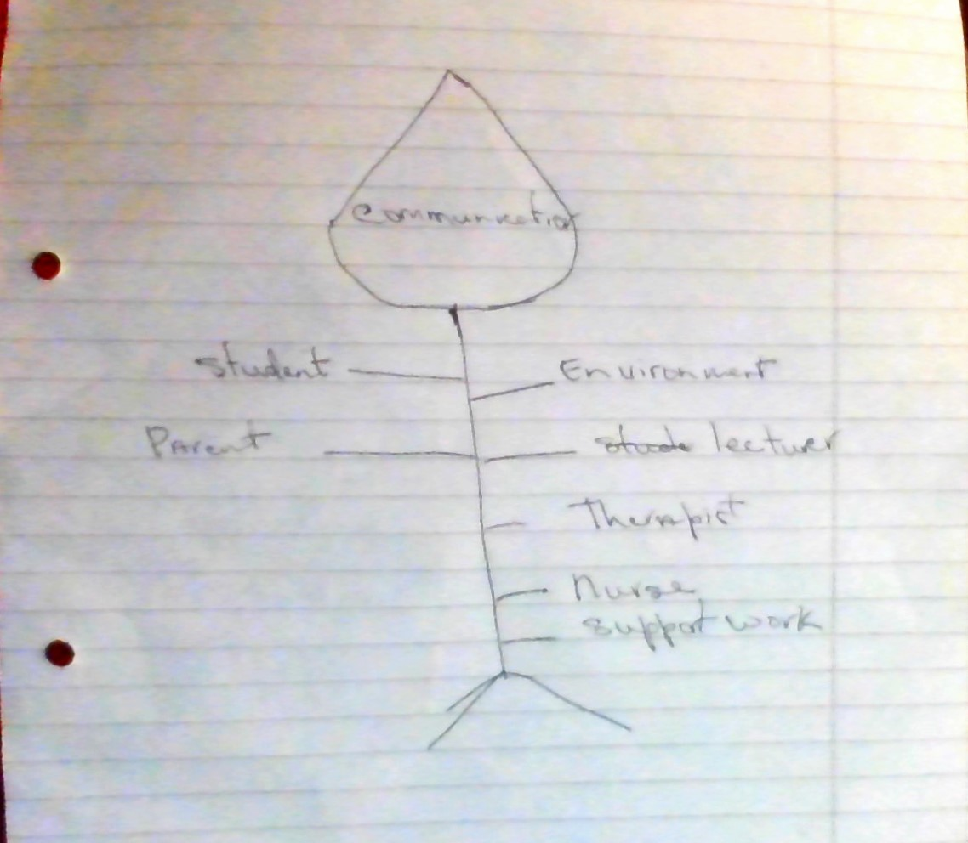

Reference

Atlassian (2021) The importance of teamwork: Available online at: https://www.atlassian.com/blog/teamwork/the-importance-of-teamwork [Accessed 31July 2021]

CIPD (2020) PESTLE analysis. Available online at: https://www.cipd.co.uk/knowledge/strategy/organisational-development/pestle-analysis-factsheet#gref [Accessed 10 July 2021]

Epilepsy society (2018). Tonic and atonic seizures. Available online at: https://epilespysociety.org.uk/about- epilepsy/epileptic-seizures//atonic-seizures

Fellow. (2019) The 5 Crucial Benefits of a Well-run Team Meeting/https://fellow.app/blog/meetings/the- 5 -crucial- benefits -of- a well- run -team- meeting [ Access 22 July 2021]

GOV.UK. (2021) Children with special educational needs and disabilities SEND. Available online at: https://www.gov.uk/children-with- special- educational - needs/ extra- SEN- help [ Accessed on 15 July 2021}

HIPAA Journal (2021) Effects of Poor Communication in Healthcare. Available online at: https://www.hipaajournal.com/effects-of-poor-communication-in-healthcare/ [Accessed: 14 September 2021]

Industry Week (2021). Employee Engagement: Room for Improvement. Available at:
https://www.industryweek.com/talent/engagement/article/21958333/employee-engagement-room-for-improvement[Accessed: 1 July 2021]

NHS (2018). Techniques Physiotherapy. Available online at: https://www.nhs.uk/conditions/physiotherapy/how- it- works [Accessed:3 August 2021]

Nursing Standard (2021) Effective communication and teamwork promotes patient safety. https://journals.rcni.com/nursing-standard/effective-communication-and-teamwork-promotes-patient-safty-ns.29.49.50.e10042[3 August 2021]

Regis College (2021). What is an Occupational Therapist? Available at:
https://www.regiscollege.edu/blog/occupational-therapy/what-does-occupational-therapist-do-roles-and-responsibilities [Accessed: 1 July
2021]

Rotherham Doncaster (2021) Mental Capacity Act 2005.
https://www.rdash.nhs.uk/wp-content/uploads/2016/12/Mental-Capacity-Act-2005-leaflet.pdf [Accessed 31 July 2021]

Royal College of Nursing (2021). Duty of candour: Available online at: https://www.rcn.org.uk/get -help/rcn-advice/duty-of-candour [Accessed:10 August2021}

Royal College of Occupational Therapists (2021) What is occupational therapy? Available online at: https:// www.rcot.co.uk/about–occupational-therapy/what -is- occupational -therapy [Accessed 4 July 2021]

Skills You Need (2021) Improving Communication: Available online at: https://www.skillsyouneed.com/ips/improving-communicatio.html [Accessed 12 August 2021]

SYNDEO (2021) How and why to Demonstrate Respect in the Workplace: Available online at: https:// syndeohro.com/demonstrate-respect-workplace/ [Accessed: 7 August 2021]

Work smart (2021). What is the Health and Safety at work Act? Available online at:
https://worksmart.org.uk/health- advice/health-and-safety/employer-duties/what-health-and-safety-work-act [Accessed:3 August 2021]

