Data Handling & Business Intelligence

Table of Contents

Introduction 1
Part 1 2
1.1 Decline in Sales 2
1.2 Evaluation of Excel for pre-processing, analysing and visualising the data 9
Part 2 9
2.1: Frequency of Students who like vanilla flavour of ice-cream 9
2.2: Male and Female Student Frequency 11
2.3: The Mean and Median of participants who likes chocolate and strawberry flavour ice-cream 12
2.4: Clustering using SPSS 15
2.5: The most common data mining and text mining methods 16
2.6 Advantages and disadvantages of using SPSS and Excel 17
Conclusion 19
Reference 20

Introduction
Data management and handling is a critical task that requires careful recording and processing of useful data. Data analytics helps to transform raw data into useful information which can be used to make informed decisions and changes in the operational systems of a business (List, 2020). The following report attempts to analyse data in both MS Excel and SPSS software using multiple formulae and statistical tools make sense of them and understand the findings by interpreting them accordingly. The report has been segregated into two parts – part 1 and part 2. Part 1 examinees the use of the MS Excel spreadsheet software to store and analyse the data, whilst part 2 focuses on SPSS data analytical functions and representations.

Part 1
This part is dedicated to using MS Excel to sort and use respective formulae to determine the changes in the sales of the company.

1.1 Decline in Sales
The file of the Superstore sales have been extracted in Excel. For sorting the data from the spreadsheet in a simpler manner, few of the variables have been taken such as Order Date, Order Quantity, Unit Price, Sales, Discount, and Profit. These variables have been firstly selected and copy pasted in a new spreadsheet. Then the data range is selected and the customer sort option in the Task Bar, from the Sort and Filter option has been chosen. Then the data has been sorted using the ascending order of the order date by selecting ‘Order Date’ in the sort by criteria, and ‘A to Z’ in the ‘Order’ criteria. After clicking OK, the dataset would be rearranged in the ascending order of the date. The following figure illustrates how the customer sort function is used and the final outlook of the dataset have been shown.
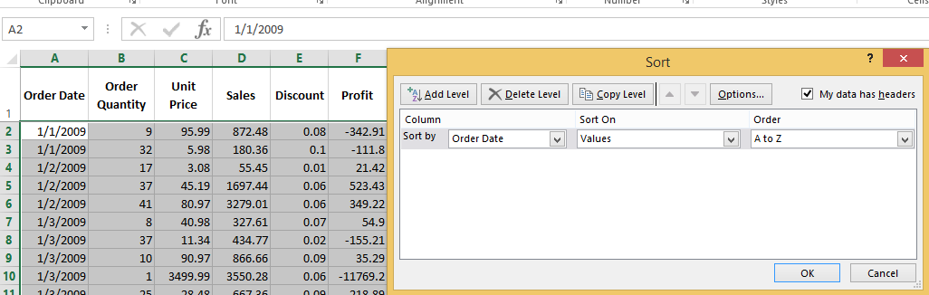
Figure 1: Custom Sort
Afterwards, the Order Date and Sales value data ranges had been selected and the option of creating charts in the ‘Insert’ option in the Task Bar had been selected. The line graph is selected as it shall provide the illustration of the sales dynamics throughout the years. However, as the Excel software is outdated, the sorting of such large amounts of data cannot be done properly or effectively. This has resulted in an unsorted dataset and graph that has been provided below.
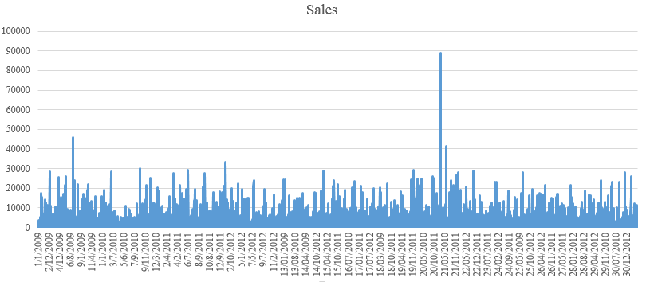
Figure 2: Changes in Sales
The above figure illustrates the graph that provides the changes in the sales throughout the years. It can be observed that the sales have been fluctuating over the years drastically. Such drastic changes can be observed as the order qualities and sales revenues have been different and fluctuating with every order. However, an outlier of sales data can be observed in 2010 to be unusually high relative to the other sales values. However, it can be said that majority of the sales values are below 35,000 in value. However, it can be said that sales have spikes seasonally when customer used to order more of the products relative to the other times of the year.
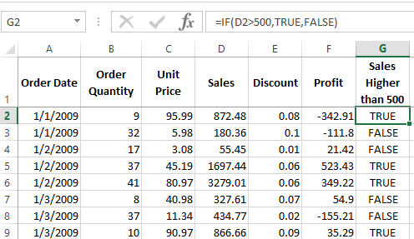
Figure 3: Using IF Formula
Next, the dataset was then used to identify the sales which were higher than 500 in value. The IF function had been used for this, as shown in the figure above. The condition for the formula was that the value must be higher than 500 to be considered as true, indicating that the sales were higher than 500 in value. Otherwise, if the value is less than 500, the result would be false. So, the formula was used to identify whether the sales were higher than 500.
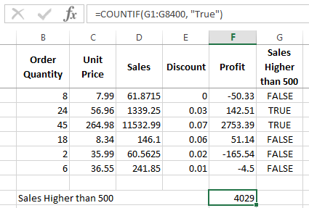
Figure 4: CountIF Formula
The COUNTIF formula has been used to identify the frequency of the sales which were higher than 500 in value. The condition set for the formula was used upon the G column having Sales Higher than 500 with the IF formulae. The column had identified whether the sales were higher than 500 or not, so, the count if formula used the consider to be counting the cells having the word ‘True’, to determine the frequency of sales that were higher in value of 500. Thus, it was deduced that around 4,029 times the sales had value more than 500.
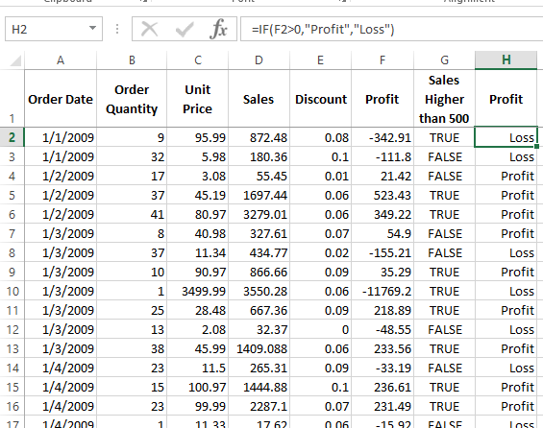
Figure 5: Using IF Formula in Profit
Next, the IF formula was used in the Profit column to identify if the order generated profit or loss. In order to return the terms ‘Loss’ and ‘Profit’, the formula included the condition of profit cell to be greater than 0 and the term had been stated in speak marks. So, beside every order, the column reveal whether the sales had generated profit or loss.
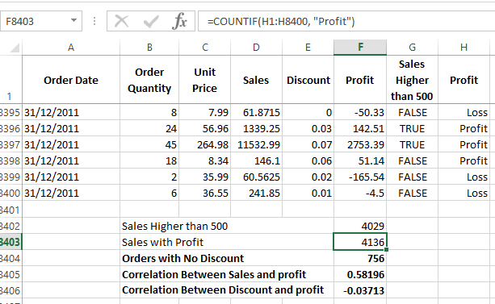
Figure 6: CountIF to Count Profit Frequency
Furthermore, the COUNTIF formula had been used to identify the frequency of orders that had generated profit. The formula had used the data range of the Profit or Loss column, H, with the condition being “Profit”. This had produced the result stating that 4,136 orders had generated profits within the dataset.
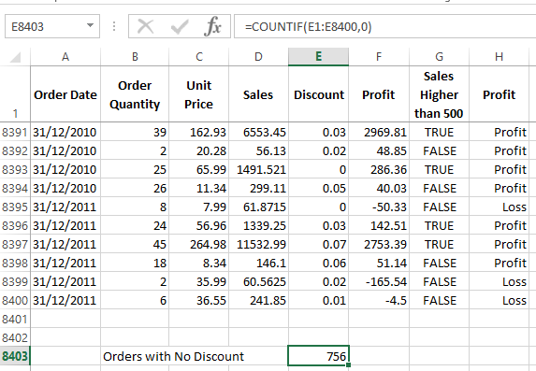
Figure 7: Using CountIF Formula
Then the COUNT function had been used to determine the number of orders which had not applied any discounts to. The formula had used the discount column, E, and the condition of the respective cells having the value of 0. This deduced that around 756 orders had no discounts applied to it.
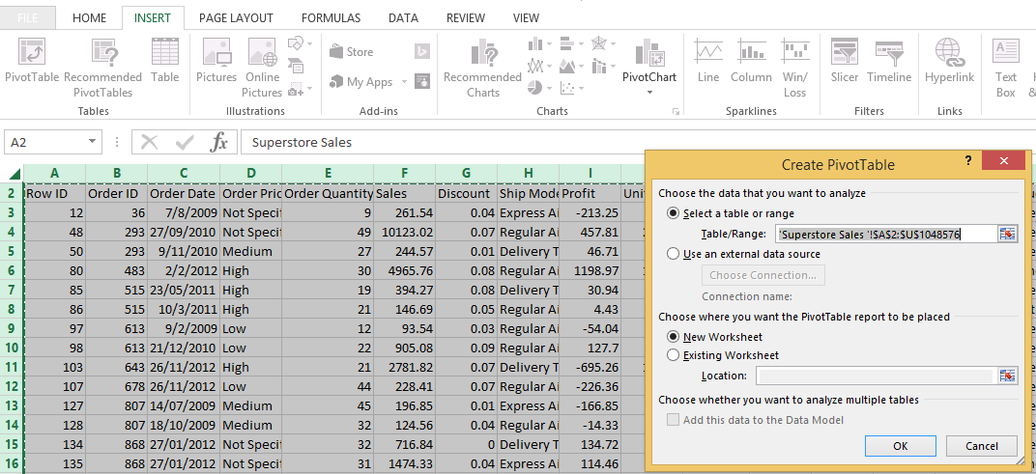
Figure 8: Pivot Table Creation
Afterwards, a pivot table had been produced by using selective columns of data. As the figure below illustrates, the entire spreadsheet had been selected and the option of creating a Pivot Table had been chosen from the Insert tab. A command box had appeared showing the data cell range. The pivot table was to be created in a new worksheet so that option was selected and the OK button was pressed.
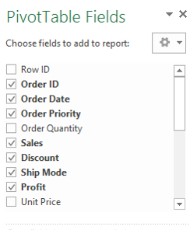
Figure 9: Pivot Table Field Selection
Next, the desired variables were selected to be in the Pivot table as shown in the figure above. The Order ID, Order Date, Order Priority, Sales, Discount, Ship Mode, and Profit were selected to be in the pivot table. Whilst selecting the variables, the pivot table had updated itself to be as shown in the figure below.
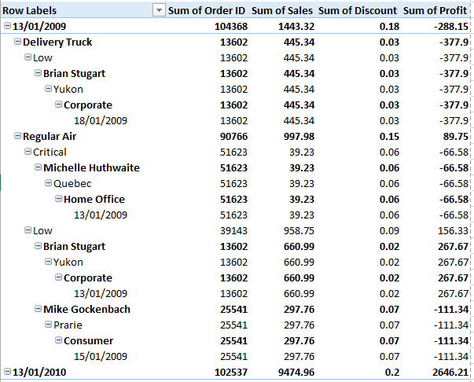
Figure 10: Pivot Table for Selected Items
It can be observed that Pivot table provides a better illustration and representation of the dataset as cross-sectional manner. The tables helped top understand the details of every order and determine the sum of sales, sum of discounts, and sum of profit, which was a loss.
Table 2: Correlation Values
Orders with No Discount | 756
Correlation Between Sales and profit | 0.58196
Correlation Between Discount and profit | -0.03713
Next, the correlation function had been used to determine whether the sales value had an impact on the profits or the discounts had an impact on the profit. The CORREL formula would a core indicator to identify any sort of relationship that exists between them. The table above provides the summary of correlation values extracted from the Excel file.
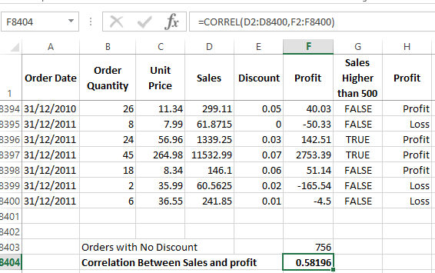
Figure 11: Correlation Formula being Used
It was found using the CORREL function between Sales and Profit that the correlation was 0.582 which indicated moderately strong positive correlation between the variable, as shown in the figure above. It meant that when the sales value were higher, there is a moderately high chance that the profit would be generated. However, the results of correlation between discounts and profits revealed that they were poorly yet negatively correlated, producing -0.03717 as shown in the figure below. This indicated that there may be an insignificant negative relation between them, stating when the discounts are higher, the value of profits can be lower but it is statistically insignificant.
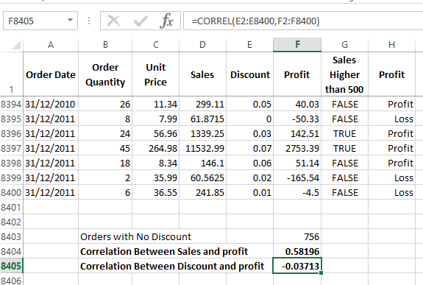
Figure 12: Correlation Formula being Used
So, it can be said that Excel can be used to conduct several data manipulation and analysis over the structured data. However, the evaluation of the Excel software shall be done below.

1.2 Evaluation of Excel for pre-processing, analysing and visualising the data
The spreadsheet software, MS Excel, helps to sort and manipulate data is an easy and systematic manner. It allows very practical and simple interface for the users to easily work and sort out data according to their desire. The software also allows non-programmers to easily sort and analyse data without much hassle. The software has sufficient functions and techniques that helps to record and clean data easily (Todorova, 2019). The software allows the users to identify trends and patterns within the data set by organising and sorting the data into meaningful segments. The pre-processing stage of the Excel software helps to clean, integrate, transform, reduce, and create discretion of the data. During the processing stage, the software has several functions to sort and analyse the data, ranging from statistical measures of tendency, dispersal, etc. (Cleff, 2019). Some of these functions may seem overwhelming to many but the formula can be used to manipulate data to extract useful outcomes. Moreover, the software has provision to construct graphs and charts which allow to interpret the data better. They allow to identify the trends and pattern of the data development. Also, the software provides provision for data to be illustrated through different types of charts and graphs along with the simplified versions of analytical outcomes (Anderson et al., 2020).

Part 2
This part involves the assessment of data using Excel and SPSS by using several functions and measures to manipulate data and determine the outcomes. For the first few parts, the Excel software has been used to sort, analyse, and yield in data outcomes. For the second part, SPSS software had been used to conduct certain tests and yield in data results.

2.1: Frequency of Students who like vanilla flavour of ice-cream
The frequency of the students who like vanilla flavour of ice cream can be deduced by using the count function. The function requires to state a condition which shall be 1 for denoting the vanilla flavour. The following figure illustrates the use of the function on the Ice Cream column, C, by using the exact formula of =COUNTIF(C2:C201,1).

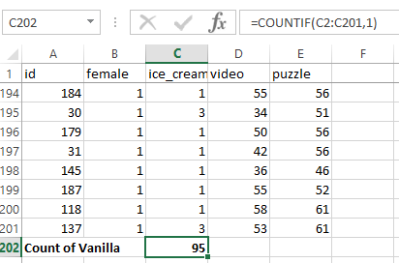
Figure 13: COUNTIF Function
It can be determined using the COUNTIF formula that 95 students voted to like the vanilla flavour of ice cream. So, 95 out of 200 students prefer vanilla over other flavours. The following chart illustrates the graphical representation of the findings on the flavour preferences of the students.
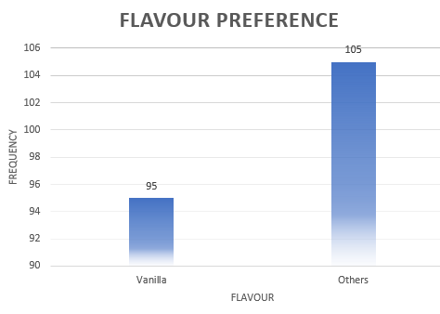
Figure 14: Flavour Preference of the Students

2.2: Male and Female Student Frequency
The frequency of students who are male and female can be determined by using the COUNTIF formula in Excel. For identifying the frequency of male students, the condition used in the formula would consist ‘0’, while to identifying the frequency of female students would consist of the condition of ‘1’.
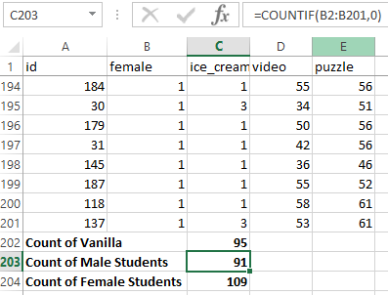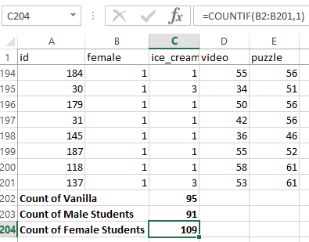
Figure 15: COUNTIF Formulae Used
The figures above illustrates that the formula used to determine the frequency of male student is =COUNTIF(B2:B201,0), and the formula used to determine the frequency of female student is =COUNTIF(B2:B201,1). It was found that there were 91 male students and 109 female students. This has been represented in a bar chart below. Around 55% of the total students were male while the remaining 45% were female students.
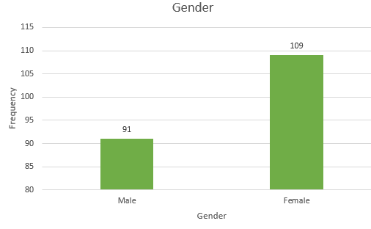
Figure 16: Gender Frequency

2.3: The Mean and Median of participants who likes chocolate and strawberry flavour ice-cream
The mean and median of the participants who like chocolate and strawberry can be determined by identifying the students who like chocolate and strawberry ice cream flavour first by using the IF function. The IF formula used is =IF(C2>1,B2,""), which shall identify the male or female participants if they prefer either chocolate or strawberry only, in respective cells in the ice cream flavour column, C; or else, the cell in the F column would be blank, as the condition is set using “”; as shown in the figure below.
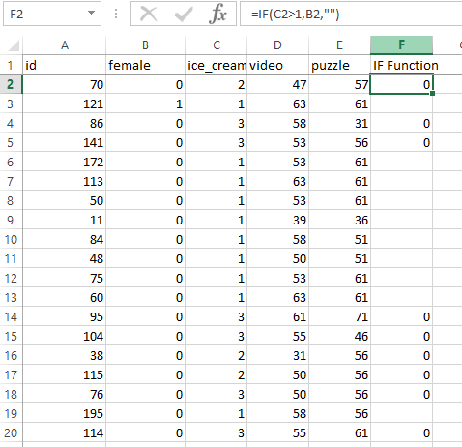
Figure 17: IF Function
Next, the mean can be deduced by using the AVERAGE function on the column F by using the respective formula =AVERAGE(F2:F201). The mean for the students referring the respective flavours is 0.580952381, as shown below. If this value is rounded off, the mean shall be 1, which indicates that the average participant who likes chocolate and strawberry is female.
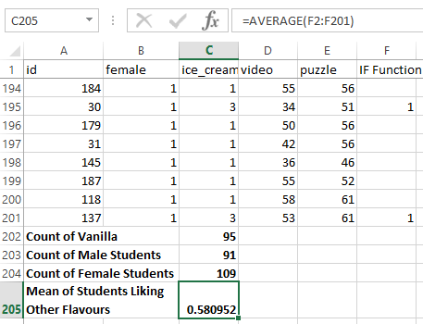
Figure 18: Average Formula
Similarly, the median is deduced by applying the MEDIAN formula on column F as shown below. It can be seen that the median value is 1, which indicates that more than half of the female students either like chocolate or strawberry flavoured ice cream.
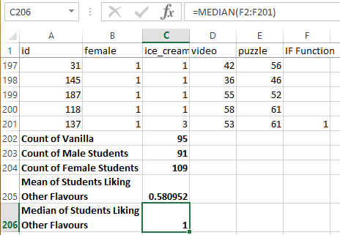
Figure 19: MEDIAN Function

2.4: Clustering using SPSS
Using the dataset Ice_cream_csv provided in conjunction with SPSS, a specific example of clustering that is K-Means clustering has been performed and shown below.
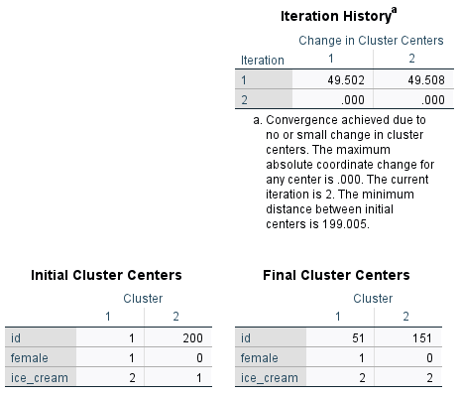
Figure 20: K-Means Clustering
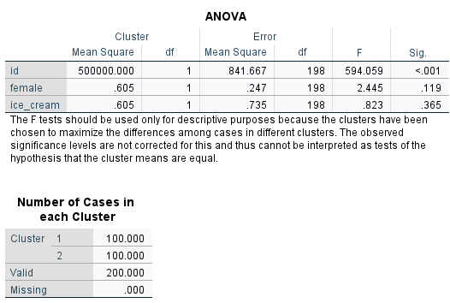
Figure 21: ANOVA Findings

2.5: The most common data mining and text mining methods
There are several methods that can be used for data mining and text mining. However, there are certain methods which are more commonly used than others due to their simplicity and efficiency. The most common data mining and text mining methods have been identified and described below.
- Association – this method helps to determine the relationships between different sets of variables. The data mining can be performed using either single dimension association or multi-dimension association. This may be applicable for convenience stores to identify the repeat customers based on their demographic characteristics (Tao, Yang and Feng, 2020).
- Data Visualisation – this method consists representing and illustrating data in graphical or chart forms for better interpretation. It helps the users and stakeholders of businesses to make informed decisions based on the findings that are represented though these methods.
- Classification – this method involves storing data in clusters or cross-sectional forms consisting of demographic characteristics to conduct comparative and critical analysis like logical regression, K-nearest neighbours, decision trees, etc. Such methods are often used by financial institutes to segregate and sort their clients and customers according to their service purchased (Tao, Yang and Feng, 2020).
- Prediction – this method is often used by financial managers and head of departments to forecast future trends through meticulous data analysis. This helps to make reliable business and investment decisions which shall yield in profitable ventures.
- Neutral Networks – this method involves the database to mimic human intelligence by using three stage process of input, hidden, and output (Saura and Bennett, 2019). This is often used by businesses to identify changes in the customer preferences and changes in the trend in the market.
- Information Extraction – this method involves extracting only the useful information amidst the vast array of data. This helps to identify the most vital information regarding characteristics, trends, and other criterions which may be useful for the user. This is essentially useful for researchers who study vast array of literature (Ferreira‐Mello et al., 2019).

2.6 Advantages and disadvantages of using SPSS and Excel
Excel and SPSS are useful tools which can be used to record, store, manipulate, extract important information, and present them in charts and graphical formats. However, both the software have their own sets of advantages and disadvantages; that have been identified the tables below.
ADVANTAGES
EXCEL | SPSS
- The spreadsheet allows to record large amounts of data.  - The software is available and compatible to use in every type of device.  - The Excel can work well with other software within the MS Office.  - The software is simple and easy to use (Opie, 2019). | - It is a quick and versatile software to work with.  - Every data can be stored in a detailed manner without much effort.  - Large amounts of data can be easily stored in the software.  - The interpretation of results can be done easily (George and Mallery, 2019).  - It has a better interface and outlook of the spreadsheet.

DISADVANTAGES
EXCEL | SPSS
- Using the old model can restrict from utilising the functions of the software on large amounts of data effectively.  - Some formulae and functions can be complicated to use.  - Understanding and learning the full potential of the software takes time and regular practice (Guerrero, 2010).  - The purchase price of the official and professional version of the software can be pricey for individuals.  - Human errors cannot be detected by Excel which may result in faulty outcomes. | - The software is very similar to MS Excel.  - The presentation of graphs in SPSS can be complicated to do.  - It is considered to be one of the most expensive software to purchase (Opie, 2019).  - The software has limited functions to use and they are all shown in the panel on the top of the spreadsheet.

Conclusion
The report has successfully completed both the tasks by using the software of MS Excel spreadsheet and SPSS. The data provided in the spreadsheet have been used to identify and sort information according to make the interpretation of the information better. The SPSS software has been used to examine the various nodes of statistical tools and representative measures to present data into graphical formats for better interpretations.

Reference
Anderson, D. R. et al. (2020) Modern business statistics with Microsoft Excel. Cengage Learning.
Cleff, T. (2019) Applied statistics and multivariate data analysis for business and economics: A modern approach using SPSS, Stata, and Excel. Springer.
Ferreira‐Mello, R. et al. (2019) ‘Text mining in education’, Wiley Interdisciplinary Reviews: Data Mining and Knowledge Discovery, 9(6), p. e1332.
George, D. and Mallery, P. (2019) IBM SPSS statistics 26 step by step: A simple guide and reference. Routledge.
Guerrero, H. (2010) ‘Excel data analysis’, Modeling and simulation.
List, J.-M. (2020) ‘Improving data handling and analysis in the study of rhyme patterns’, Cahiers de linguistique Asie orientale, 49(1), pp. 43–57.
Opie, C. (2019) ‘Using excel/spss in your research’, Getting Started in Your Educational Research: Design, Data Production and Analysis, 309.
Saura, J. R. and Bennett, D. R. (2019) ‘A three-stage method for data text mining: Using UGC in business intelligence analysis’, Symmetry, 11(4), p. 519.
Tao, D., Yang, P. and Feng, H. (2020) ‘Utilization of text mining as a big data analysis tool for food science and nutrition’, Comprehensive reviews in food science and food safety, 19(2), pp. 875–894.
Todorova, S. (2019) ‘Statistics for data analysis using Microsoft Excel’, Izvestia Journal of the Union of Scientists-Varna. Economic Sciences Series, 8(2), pp. 68–74.

