

A Study on Web Usability
to enhance the user experience

By
Shannon Cranfield

Supervisor: Michael Dacey
Second Marker: Dr Kemi Ademoye

Project submitted as part of the requirements for the award of
BSc (Hons) Web Development

May 2019

DECLARATION FORM AND FORM OF CONSENT

DECLARATION

I, Shannon Cranfield, declare that I am the sole author of this Project; that all references cited have been consulted; that I have conducted all work of which this is a record, and that the finished work lies within the prescribed word limits.

This work has not previously been accepted as part of any other degree submission.

Signed: Ms SJ Cranfield

Date: 01 May 2019

FORM OF CONSENT

I Shannon Cranfield hereby consent that my Project, submitted in candidature for the B.Sc.(Hons) Web Development degree, if successful, may be made available for inter-library loan or photocopying (subject to the law of copyright), and that the title and abstract may be made available to outside organisations.

Signed : Ms SJ Cranfield

Date : 01 May 2019

Abstract
This study investigates the importance of Web Usability and how it can improve a users’ experience of a Website. The approach used was an inductive, qualitative research design used to better understand the importance of Usability in improving the User experience. Research was conducted initially in the form of a literature review which provided guidelines for the development of a website. Convenient sampling was used to obtain participants for the study, and two tests were used on the participants while being observed doing the tests. These tests yielded invaluable feedback which could be translated in to user requirements for the new design of the website. A Usability test has been undertaken to investigate the usability problems which includes users in the gathering of data to influence the redesign of the website. Structured methodologies were followed, specifically using the waterfall methodology together with the software prototyping methodology to develop a redesign prototype of a website based on the usability data received from users. The main objectives of this study therefore is to provide a critical analysis of an existing website that focuses on Web Usability issues.

The results of the study suggest that the users experience of the new redesigned website, showed an improvement as compared with the original website, and the SUS test score improved. These results reflect that the main aim of the research study was achieved, that is to better understand the importance of the Usability to the User experience.

Keywords: Usability, web, usability testing

Table of Contents

DECLARATION FORM AND FORM OF CONSENT 2
Abstract 3
Table of Figures 5
Table of tables 5
Chapter 1: Introduction 6
1.1.Aims 6
1.2.Objectives 6
Chapter 2: Research and review of Literature 7
Chapter 3: Research and development methodology 12
Chapter 4: Usability testing of website data collection 18
Chapter 5: Design of Prototype 24
CHAPTER 6: Implementation of the Prototype 25
CHAPTER 7: Analysis of Prototype Testing 27
CHAPTER 8: Overall conclusions & recommendations 30
CHAPTER 10: Reflection 31
Chapter 11 References 32
Appendix A – Scenario Task Results 34

Table of Figures
Figure 1: Research Process 12
Figure 2 Research Design 16
Figure 3: Usability Testing - System Usability Score Questionnaire Results 21
Figure 4 Redesign System Usability Chart 28

Table of tables
Table 1 System Usability Scale questionnaire 15
Table 2: SUS Score Interpretation 22
Table 3: SUS Score obtained 22

Chapter 1: Introduction
In 1989 when Tim Berners-Lee created the world-wide web, it brought excitement and curiosity, with the initial purpose of spreading information over the internet through a flexible and easy to use format [1]. Nowadays, if users land on a page and the website is not easy to use they will leave. Effective Websites are not only about the creation of the code and how well written they are but the efficiency of the ease of the website for the user. With a website having poor usability, websites will lead to completion of goals to be slower and painful leading to negative emotions from users that are interacting with the users. Usability plays a fundamental part of the effectiveness of websites as it plays a central part in the interaction with users.

However, in this study the focus is to investigate techniques to solve common usability problems and how important it is for usability of a website to be thorough to enhance the user experience, this study will provide and evaluation of an existing University website, so that a prototype can be implemented to try and solve some problems discovered.

Aims
The main aim of this project is to
‘Investigate the significance of web usability and how it improves a user’s experience’

Objectives
The objectives of this research project are to:
- Provide a critical literature review of the importance of web usability
- Explain how usability enhances a user’s experience
- Provide usability tests to try and solve usability problems by implementing a website.
- Provide a critical analysis of a website focusing on key point points discussed in the literature review

Chapter 2: Research and review of Literature
2.1 Defining Usability
Over a period, many researchers have defined the word ‘usability’ with different people using the word in diverse ways. The word usability formally originated from the word user friendly, this was a misdirected term and in 1995 Dr Bevan replaced that word and defined usability as the quality in use. The International Organization for Standardization has defined Usability as the degree of which a product can be used by users to successfully reach their goals with effectiveness, efficiency and satisfaction in a clearly identified context of use [2].

A usability consultant, Jacob Nielson defines usability to be characterized by five components also known as attributes: 1. Learnability, how easy the users are able to undertake tasks which are basic the first time they interact with the design; 2: Efficiency, how easily users perform the task when they have developed an understanding of the design; 3. Memorability, how easily users regain the ability to use the design after not using it for a length of time; 4. Errors, how many errors does one user make, what level of severity are those errors and how effortlessly they recover from the errors; 5. Satisfaction, how one user finds the design in terms of its aesthetics [3]. Overall he has described usability as a measurement of quality that the user is experiencing when interacting with a design. He has undoubtedly played a large role in usability [4]. The global concept of usability is that it is about making a task stress-free and innovative, it is also about taking away barriers and reducing stages. It is about what users do and how they do them than how they feel. Usability is just one of many levels that effects a good user experience [5]. Usability is an important characteristic of what makes a good User Experience

2.2 Defining Web Usability
Web usability is defined as how efficient and effective a website is and how easily a user can access information on the website [6]. Web Usability refers to the ease of use of the website in question and addresses the question of how user friendly a website is [4]

2.3 Comparing User Experience and Usability
User Experience is a term that often gets mixed up with usability. So what is the difference between these two terms? The aim of usability is to ensure that the website is easy to use, additionally, usability looks at the creation of an interface that allows users to easily understand the design and how to intuitively use it to achieve goals [7]. User experience, however, looks at how the user engages with the website on an emotional level [8]. Its more about the emotional connection to the website. The best websites take into consideration an approach to both usability and user experience. It concentrates on making the task more meaningful and valuable by creating an emotional connection [5].

Don Norman the creator of the word “user experience” devised the word as he thought human interface and usability was too constricted, he wanted to ensure that all qualities of a person’s interaction with a system was covered [9].

There are several factors that impact or influence a user’s experience of a website. Usability is one of these factors that can have an influence or impact the user’s experience. For this project usability, will be the focus of the research and how it impacts on the user’s experience. A websites functionality is essential to the experience of a user, as a user will use a website for its functionality.

2.4 Comparing Accessibility and Usability
Another term linked with usability is web accessibility. Tim Berners has said that the power of the web is in its universality and that it should be retrieved by everyone irrespective of disability [10]. Web Accessibility refers to the ability of the website being available for everyone [11]. It ensures that people with disabilities have an equal opportunity as everyone when using the website. In order for a website to be operational it has to be accessible, however, it does not need to be usable to be accessible [12].

2.5 Web Usability Issues

2.5.1 Navigation Issues
Several Navigation Issues exist:
- Broken links: There are typical web usability problems that occur quite regularly. One such web usability issue is Navigation. Navigation is a problem when there are broken links or the links are not layered clearly, and this in turn will aggravate users and stop them from returning to the website [13].
- Excessive Clicks: When there are excessive clicks and submenus, more than three clicks to get from one page to the next [13] , this can present as a usability issue for users.
- Overloaded or unclear navigation: When the website is overloaded with information and does not provide a clear path to the different pages, not having a clear site map [13].

    - Inconsistency Issues:
Luke Downing contends that when the website does not have the same design throughout
each of the pages this creates confusion and affects the user experience [13].

    - Memorability Issues:
If a website does not allow users to become accustomed with the site, then this is a problem,
for example, an e-commerce site if a user wants to buy an item, the website must allow users
to move through the sequence of actions to buy an item quickly. Furthermore, the website
should be easily picked up again if a user wants to buy another item, learning from the first
time and using the site the second time just as easily [14].

2.6 Importance of Usability
Web usability gauges the quality of a visitor's experience while interacting with the website.
It is important for websites to employ certain usability principles as it can assist with making
useful and appealing Web content, it also ensures that the target audience is
suited and that it helps combat user dissatisfaction and enhances user experience [15].

2.7 Usability Guidelines and Frameworks
Several guidelines and frameworks exist to help developers design a better website with the aim to enhance the usability of a website. There are too many to list here, however, the most important ones have been selected and will be discussed below:

2.7.1 Navigation
The aim of a navigation mechanism is to link pages together allowing users to browse information and perform actions therefore good navigation is the key to making the experience enjoyable and efficient as users will be guided around the site easily, also knowing where they have been and where they can go next. Website navigation has been compared to a roadmap. [16] [17] [18].

2.7.2 Display of information
Another is how information on the page is displayed to the user. Research has shown that most individuals who visit a website scans through the page. Such things like Headings, Links, Bold text, Bulleted lists are features of a website that attracts the user’s eye first. A website that has been designed with usability in mind will provide users with information that they need quickly and efficiently [16] .

    - Text
Users do a lot of scanning of the page rather than reading, headings and titles need to enable both. Each page needs to have a descriptive page title that is unique. It is advised that many headings should be used to enable users to find what they are searching for [19].

    - Media Use
The use of media is one way to make a website more interesting and to make it stand out. When used correctly graphics / images can aid with learning. Unnecessary multimedia can disturb user’s attentiveness as some can be irritating. A company’s website logo for example is an important image to show on a website and should always be visible to users visiting the site. Background images that have a complex design tends to affect the readability of text, additionally it tends to slow the website pages loading time, thus the reason it is not advised to be used as an entire background [19].

  - Usability Testing and Evaluation
Usability testing refers to the act of checking how easily the system can be used by end users, it is a non-functional technique, which means testing aspects that are non-functional such as reliability, performance and usability. The reasons for usability testing of websites is to identify any problems as well as recognizing any dissatisfaction from the user. Additionally, it reassures that time spent in the development and design stage is not wasted, therefore saving time and money [20].

There are two main usability evaluating methods. One is the analytic method, which includes Usability Inspection, Expert review, Heuristic Evaluation, Cognitive walk through and GOMS analysis. The second method is Empirical Methods which includes Usability Testing, either field or lab or observation looking at problem identification. Controlled Experiment is also an empirical method, formal controlled scientific experiment or Comparisons, statistical analysis [21].

There are two approaches to evaluation. One approach involves the user providing data to the developer, however, this approach can be extremely expensive and slow. The other approach does not involve the users but depends solely on the tester’s knowledge [22].

  - Research Studies conducted
The area of usability arose in the 1980’s , Several Usability research studies have been undertaken over including articles in journals and books written on the topic. Jakob Nielson was one of the first to publish a book on the problems and solutions linked with poor designs. In 2000, a book by Steven Krug titled “Don’t make me Think” was released discussing usability testing, then eight years later the book titled “Measuring the user experience was published by tom Tullis and Bill albert, talking about measuring usability in a quantitative way [23].

Chapter 3: Research and development methodology
  - Introduction
In chapter 2 a literature review was presented providing a foundation of the key principles and aspects of web design that enhances the user’s experience. In this chapter research design, philosophy, research methodology and research methods for data collection and analysis will be explored and a process for how this study will be conducted presented. This chapter aims to justify the research design in order to achieve the objectives of the research.

  - Research Overview
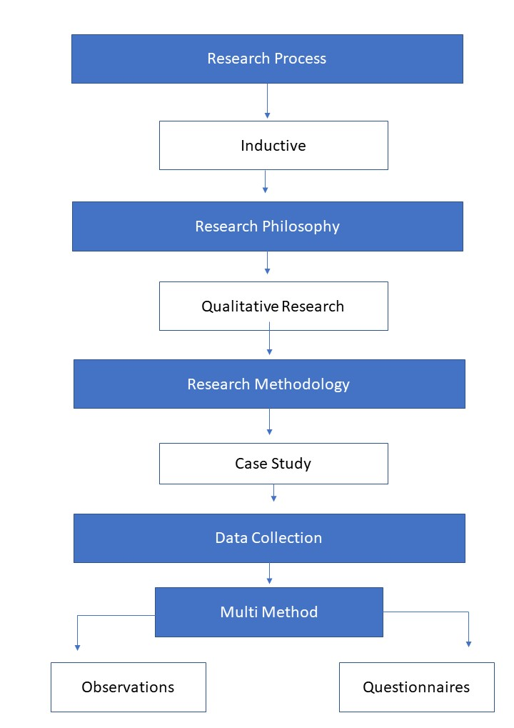
Figure 1: Research Process

    - Research Process
The aim of this research is to investigate the significance of Usability as a factor that can improve or influence the user experience of a web application. An Inductive Process was adopted, linked to interpretivism, which would allow for the exploration and improved understanding of usability as a factor to improve the user experience. This approach aims to generate meanings from the data set collected in order to identify patterns and relationships to build a theory, it is based on learning from experience. Observations were made and a survey used to understand patterns, resemblances and regularities in experience (premises) to reach conclusions [24].

3.2.2 Research Philosophy
A Research philosophy is a belief about the ways in which data about a phenomenon should be collected, analyzed and used[24]. It involves being aware and formulating beliefs and assumptions about a phenomenon. Each stage of the research process is based on assumptions about the sources and the nature of knowledge which will reflect the researcher’s important assumptions which serve as base for the research strategy [24]. Generally, research philosophy has many branches related to a wide range of disciplines.

    - Research Methodologies
Descriptive qualitative research methodology is used to describe the factors and issues of Usability. Research suggests that it is closely linked to observational studies, and is not limited with the observation data collection method only but other methods can be used with it as well, such as case studies and surveys can also be specified as popular data collection methods used with descriptive studies [25]. For this study therefore the University of Advancing Technology will be used as a Case to understand and evaluate, with the data collection occurring in two phases, a pre and post redesign data collection will be undertaken to understand the user experience and how the usability of the website affects the use experience.

    - Research Data Collection
Research is not complete unless one of its key components - data collection is carried out. Data collection can be carried out in a numerous amount of ways each for its own desired purpose. For the purposes of this research, observations are going to be used.

While using the Observation technique two questionnaires will be administered while participants are being observed:
- User Scenario Task Analysis questionnaire type based collection will be used. A template created by Dr Nik Whitehead will be used for this test [29]. Specifically, task analysis helps teams understand: Users’ goals, how users access the site or app, what users do within the site or app, how users’ personal, social, or cultural experiences influence the task, how users are influenced by their environment.
- System Usability Scale (SUS) will also be used to collect data, also under these observational sessions. A template will be used for this survey, which has been developed by USPTO [30]. The System Usability Scale (SUS) provides a quick reliable tool for measuring the usability. It consists of a 10-item questionnaire with five response options for respondents; from Strongly agree to Strongly disagree. Originally created by John Brooke in 1986, it allows you to evaluate a wide variety of products and services, including hardware, software, mobile devices, websites and applications. See figure for example
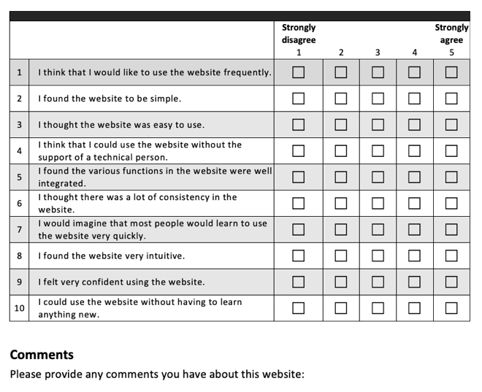

Table 1 System Usability Scale questionnaire [

Sampling
Convenience sampling (also known as availability sampling) is a specific type of non-probability sampling method that relies on data collection from the population who are conveniently available to participate in the study [24]. This type of sampling is most useful for pilot testing. Convenient sampling was used for this research study, with the sample size being 5 participants, each asked to participate in this usability testing session. Jakob Nielsen suggests that exactly five test users can find almost as many problems with usability as will be discovered using many more test participants [4].

    - Research Design
In order to achieve the aim of the research a plan is designed. This plan sets out the methods to investigate, analyse and to understand the phenomenon.

Figure 2 provides an overview of the Research Design components. It demonstrates the different aspects of the process undertaken to achieve the stated outcome.
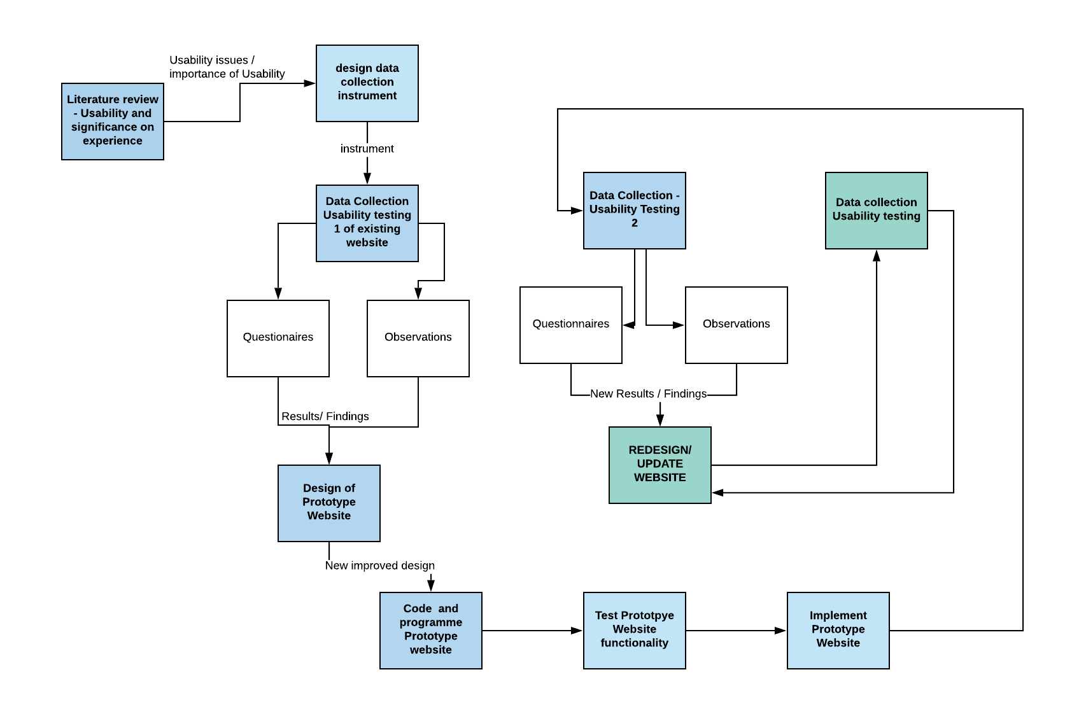
Observations
SUS
STA
Observations
SUS
STA
Figure 2 Research Design
    - Website Development Methodology
Developing new systems or applications is touted to be one of the toughest jobs to do [26]. Over the years the development process has changed and has moved from being more of a craft to a science, with new structure and methods included to ensure efficient and well-defined development processes. Over the years, several development approaches were introduced to include better programming discipline, make it more reliable with fewer errors, and to make more efficient use of resources [26]. But what is Software development? Software development is
“….the process of conceiving, specifying, designing, programming, documenting, testing, and bug fixing involved in creating and maintaining applications….” [26].

It is the process of writing and maintaining the source code, and includes all the processes from the conception of the desired software application to the final version of the software application in a planned and structured manner [25]. Several methodologies therefore exist to help developers with the process of developing fit-for-purpose applications, including, agile software development, lean software development, Kanban software development, software prototyping, and the waterfall methodology to mention a few.

Software Development techniques used
For this project, a combination of development techniques will be used to meet the requirements for the development. The waterfall methodology will be used broadly, in combination with the software prototyping methodology as follows:
- Firstly, the user requirements will be gathered by allowing users to answer two questionnaires which will help in shaping the Design of the prototype website redesign
- Secondly, the data from step 1 will inform the redesign of the website enabling improvements based on user input to be made
- Thirdly, the design will be coded quickly as a prototype using techniques like HTML, CSS, Javascript and Bootstrap
- Fourthly, the prototype functionality is tested to see that all aspects are working.
- The participants are then asked to evaluate the redesigned prototype website as a post-redesign evaluation process to better understand aspects of usability and further clarify and improve the usability of the website.
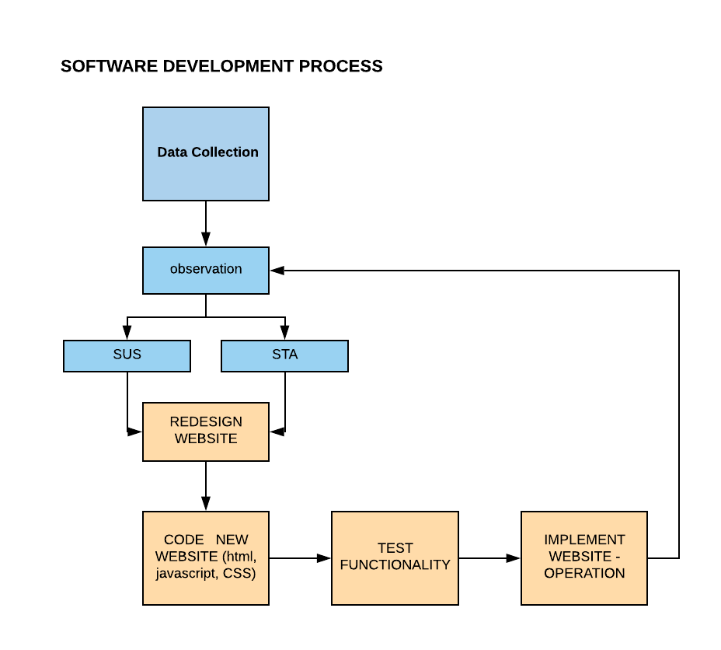
Figure 3 Software Development Process

Justification for the use of the development tools
Software prototyping: It was important for this project to be able to develop a working and functional version of the website quickly and efficiently that included most of the main features highlighted by the participants. This would allow them to interact with the website to provide valuable feedback and user experience with the website.

Waterfall Methodology – This structured methodology was loosely followed to provide a structure and discipline for the development of the website.

Programming languages: HMTL5, Javascript, Bootstrap and CSS (Cascading Stylesheets) were used to develop the website. Justification for each of these is provided in the section on implementation of the website (Section 6)

    - Research and Development Deliverables
The main output from the research and development of the study should be three-fold:
- Guidelines for the design of the website (from the literature review) – found in the Literature review section, Chapter 2
- Initial User requirements, based on data collection and testing (SUS and STA) – found in the Data collection section, Chapter 4
- The Website Prototype developed – found in the implementation section, Chapter 5
- Post-redesign improvements – found in Chapter 7
The guidelines helped to inform the design of the prototype, together with the user requirements based on the initial testing done on the website. The website prototype was then developed and was used to enable further data collection on the new website design which could be used as requirements for improvement of the User experience based on the Usability tests undertaken.

CHAPTER 4: data collection – user testing of website
The main aim of this study is to better understand the significance of Usability in relation to user experience of a website. One specific website was used as a case example to implement the research, namely, the University of Advancing Technology (UAT).

4.1 Testing Process
For this study five participants were selected to partake in testing the website. This number was chosen as Nielson suggest that 5 is the perfect number for usability testing [4]. Seeing that the type of website was a university site, the user base focused on the age range between 18-35.
Moderator/ observer was present in the room with participants to simply just observe their interaction with the website. The role of the observer during this testing session was to observe.
Before the testing session began one moderator/observer ensured that the environment was suitable for the participant, certifying that an iMac 21.5-inch was visible, this was used mainly to display the website and that also an iPad was present, this was used to let the participants respond to the user tasks as-well as the system usability score questionnaire.

While making sure that these were presented the moderator also conducted a run through of everything double checking that the electronical devices were running okay and to also see if the tasks and sus made sense.

At the start of the testing session participants were informed as to the purpose of the testing session and what they were going to be doing. Additionally, they were well-versed that this will help show how applicable the website is and how it be amended. Furthermore, participants were welcomed ensuring the participants were made comfortable with the session as well with the environment. Participants were told what the devices were going to be used for and then the moderator began the testing session.

Participants were asked to complete three scenario tasks at a time with no help from the oberserver.

The following were the scenarios and tasks asked.
- You are first year student wanting to view the facilities at the university of advancing technology. All you need to do is visit the website and find the information
Task: Find facilities at UAT
Step 1: Select campus UAT
Step 2: Select Campus Life
Step 3: Select See you at UAT Campus
- You are interested in attending the University of Advancing Technology next summer to study web development however you do now know much about this course at this university, therefore you would like to find out more about this web design course.
Task: Find details on the web design degree
Step 1: Select Advancing Technology Courses
Step 2: Select Web Design Degree
Step 1: Select Degree Summary

- You a mother of a future student and want to find out more about how your child will cope and fit It in the university.
Task: Find information for parents of students

Step 1: Select About UAT
Step 2: Select parents’ guide

These scenario tasks helped measure if features and functions within the website are successful. It helps unfold opinions around design and content, more importantly It apprehends usability problems. Results of these Scenario tasks will be discussed further on in the report.
Once a participant completed its user tasks. Participants were also asked to complete a system usability score questionnaire. This questionnaire displays 5 point Likert scale that ranges from strongly Disagree (1) to Strongly Agree (5).
This sort of questionnaire stimulates a way for participants to rate the overall experience using the website quickly.

Once the participant completed the system usability score questionnaire, the observer expressed gratitude towards the participant for partaking in the study. After the testing session, the observer had to remove all evidence from previous participant responses and a clean-up of the environment for the next participate took place.

  - Analysis of Results

4.2.1 Results obtained from Scenario Tasks

Scenario 1: the majority of the participants found that the controls needed to complete these tasks were easily seen however one participant did not find that these controls were easily found, more over this participant expressed that they would have not have known that this was a control unless they hovered over the item. Menu links did not immediately show and took some time to visually appear. Participants commented on the display and how understandable it is, they expressed that the course display page was too busy. The use of a transparent background of the menu distracted some participants as the background of the website came through therefore it was not clear. Therefore a solid background color was suggested.

Scenario 2:Participants through this scenario tasks found that the footer does not get displayed on this page described on the scenario task, only a grey box is shown at the bottom, which distracted some participants from the purpose of the page. Additionally, participants found also on this page words especially the title was overlapping.

Scenario 3: Participants found that the main menu bar when the page described in the scenario task questionnaire moves further down the page leaving the original menu just black with nothing displayed, additionally the new menu bar cuts out items leaving only half of the items visible.

4.2.2 Results obtained from System Usability Score Questionnaire

Figure 1 shows the results obtained from the five participants, most of the participants did not agree or disagree with the website being simple. 70% of the participants did not agree that the website had great integrated functions. Most the participants strongly disagreed with the statement that the website was intuitive.

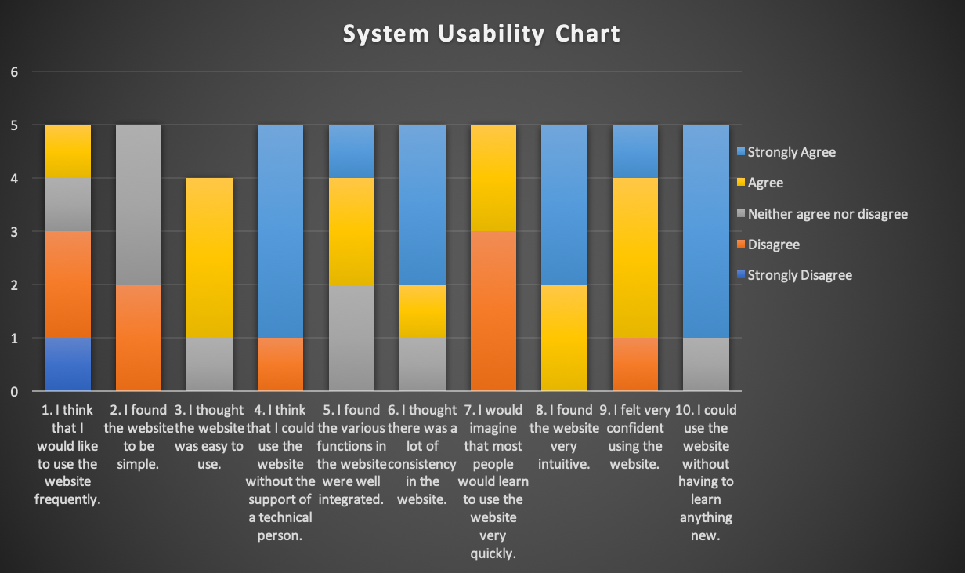
Figure 4: Usability Testing - System Usability Score Questionnaire Results

Following this system usability questionnaire, participants could talk freely about their experience and thoughts about the website. Most of the participants stated that the navigation bar at the top of the page was hard to read as a use of gradient colour was used behind a light grey text, making readability of the items quite poor. Additionally, one participant pointed out that a bar at the side of the page does not entirely fit on the page and therefore the last option cannot be read or functional. Furthermore, they discussed the use of images within the website, focusing on one element of the website, the footer, the footer displays a map which was quite hard to read leading the participants to suggest that these images should be made bigger. Some participant brought up the fact that text on this website was hard to read due to that there is a grey on grey effect going. The use of the colour breaks up the greyness of the page. Moreover, some stated that when looking for a course a qualifications page that the uni needed for applications was not easily visible or wasn't viable at all, making users unaware if they can apply for the course.

Some participant took it one step further and made suggestions towards the website, and talked about how content on the page should be made better one example namely mentioned was within the page of the degrees, the degree description along with objectives could be placed at the top of the page as these are the most important things that a person would want to know.

4.2.3 The System Usability Score
The System Usability Scale does not prove a diagnostic on the pin point problems the website faced but gives a red or green light to know how good or bad the usability on the site is. Studies show that the System Usability scale average score is 68. If the website scores anything under that score then the website has a serious problem with their usability, on the other hand if the System Usability scale scores above 68 then the website’s usability for the time being does not need any work. Table 1 shows an overview of how the scores are measured.
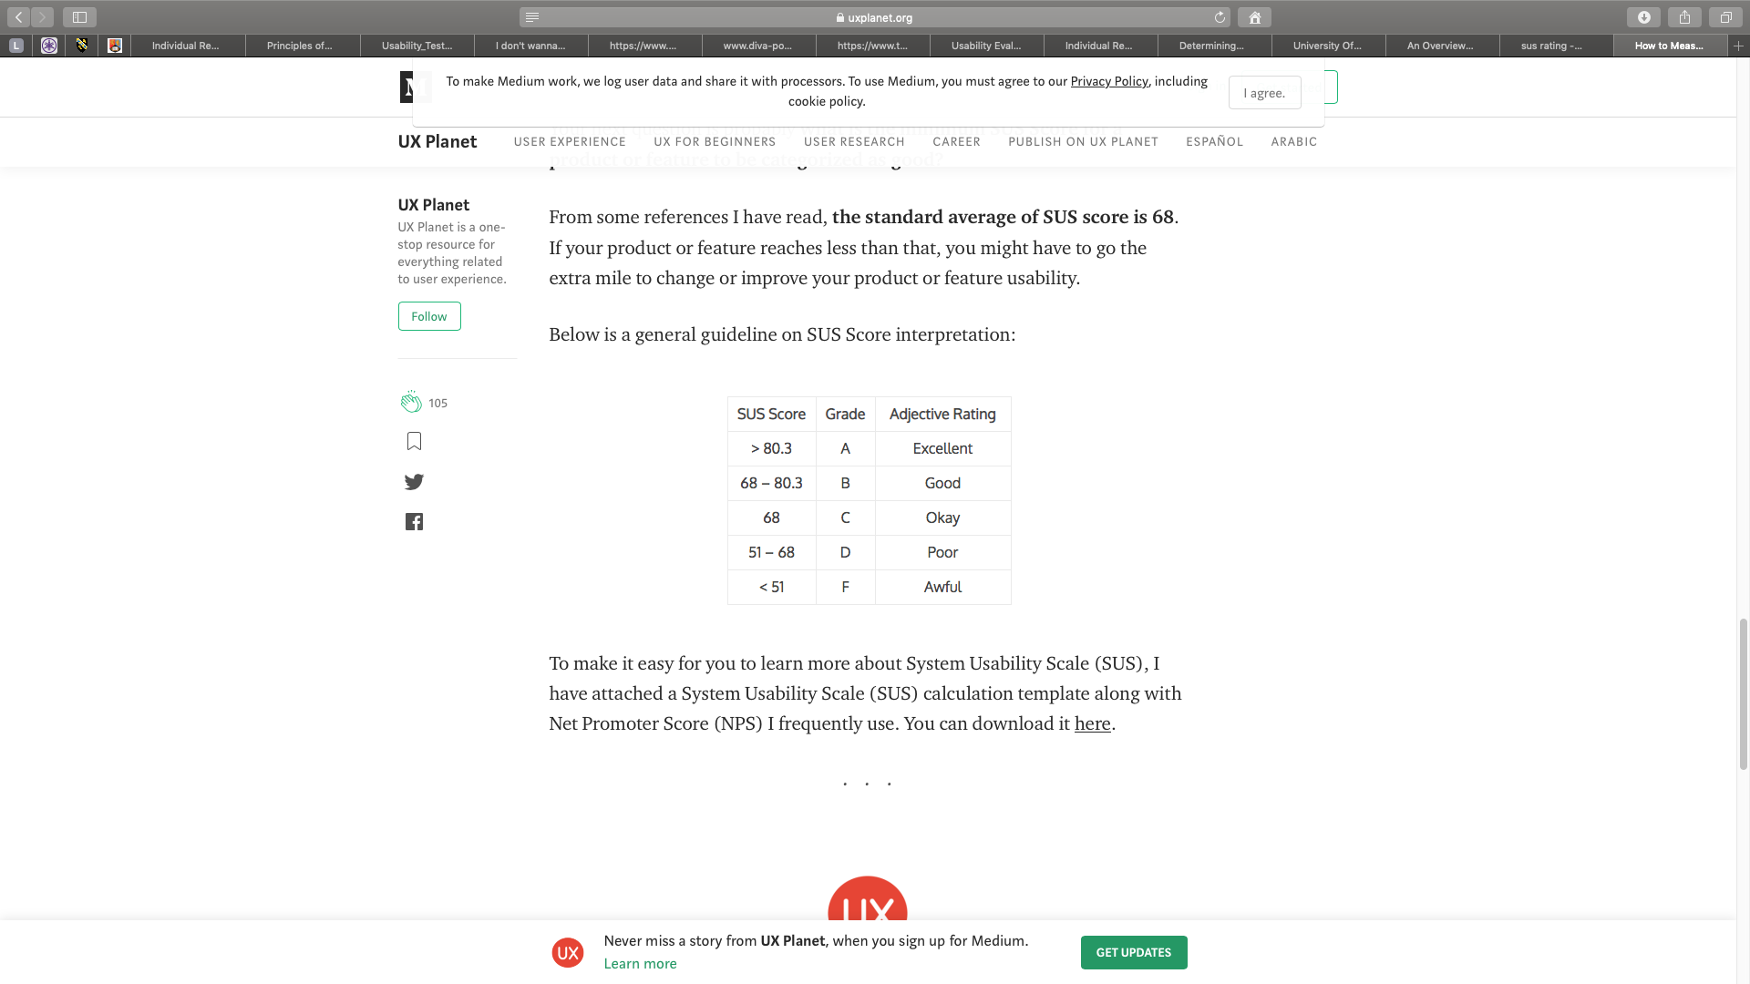
Table 2: SUS Score Interpretation

For this study the overall score shown in table 2 obtained was a 37.5, as evident in table 1, this would give a rating for the university of Advancing Technology a grading of F which is awful. Furthermore, this meant that lots of work needed to be done on this website.

SUS SCORE | 37.5
Table 3: SUS Score obtained

4.6 Summary of Initial Study
Participants of the study provided valuable feedback which lead to user requirements for the redesign of the website. These are summarised below:
- Navigation not clear
- Incorrect use of Text
- Bad use of Colour
- Images not clear
- Simplicity of design and layout
- Distracting animation
- Awful Usability score obtained (F)

The feedback obtained through observations and testing, allowed the researcher to develop and redesign the website based on the actual feedback received as well as best practices in designing of websites.

A prototype of the website was redesigned very quickly to enable the participants to interact with a working and live version of the website. This process provided further observations and feedback, which was not taken into account for a further redesign of the current website, but will enable future improvements.

CHAPTER 5: Design of Prototype
Based on the feedback provided from the participants, a list of requirements has been developed to improve on the usability for the original website.

51 Original Design of website (Home page)
The homepage for the original website is displayed below.
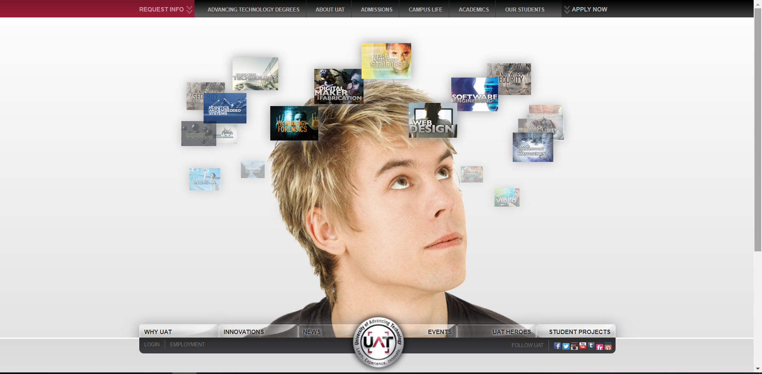
Figure 5 Original Main page of Website - University of Advancing Technology

5.2 New Redesign of Website Requirements
The redesign of the website included the observations from the participants, developed into requirements as set out below:
- Navigation:
  - Clear navigation
  - Simple and few clicks to navigate through pages
- Text:
  - Correct the sizing of text on the website
  - Clear Fonts used
  - Simple design and use of text, not too much text on each page

- Colour: Use appropriate colours, both background and foreground, that work well together and provides clear and easy reading of text ad images
- Images: Ensure images are readable, and clear
- Simplicity of design and layout
  - Ensure the layout is easy to follow and users are able to quickly find what they looking for
  - Ensure the lost in their click journey,
- No distracting animation
- Improve Usability score obtained: Ensure that the Usability features are such to improve on the score achieved before.

5.3 Redesign of Website (screenshots)
The design of the website can be seen below with 4 different screenshots showing the full Home page.
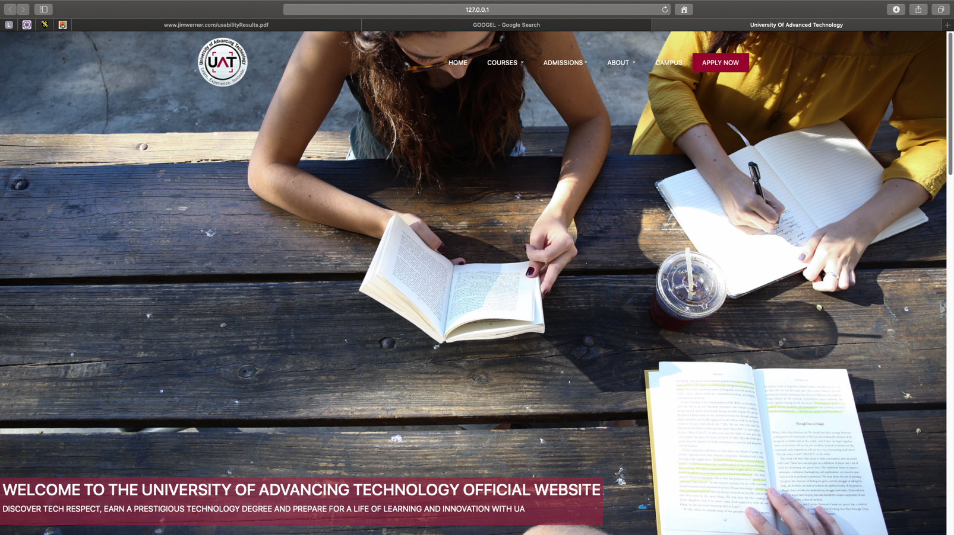
Figure 6 Home page section of redesigned website

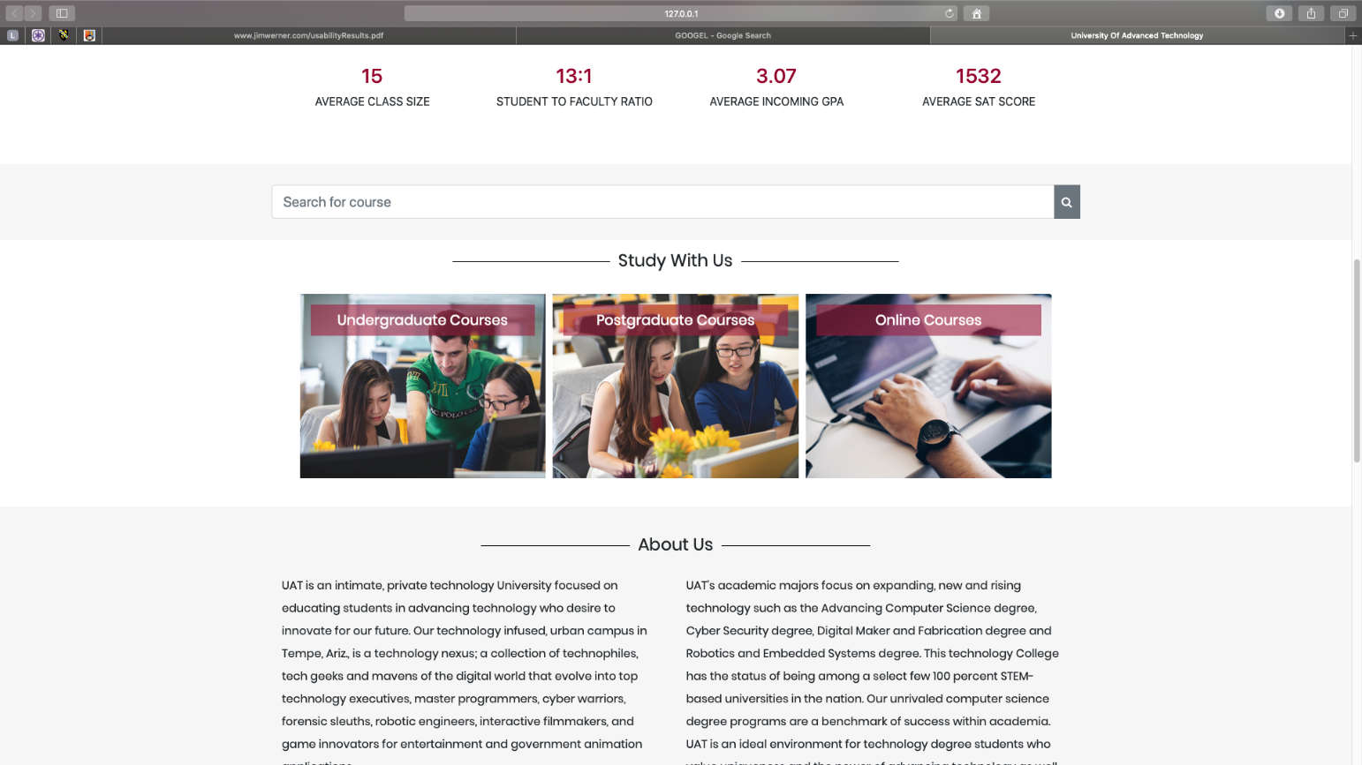
Figure 7: Homepage section of redesigned website
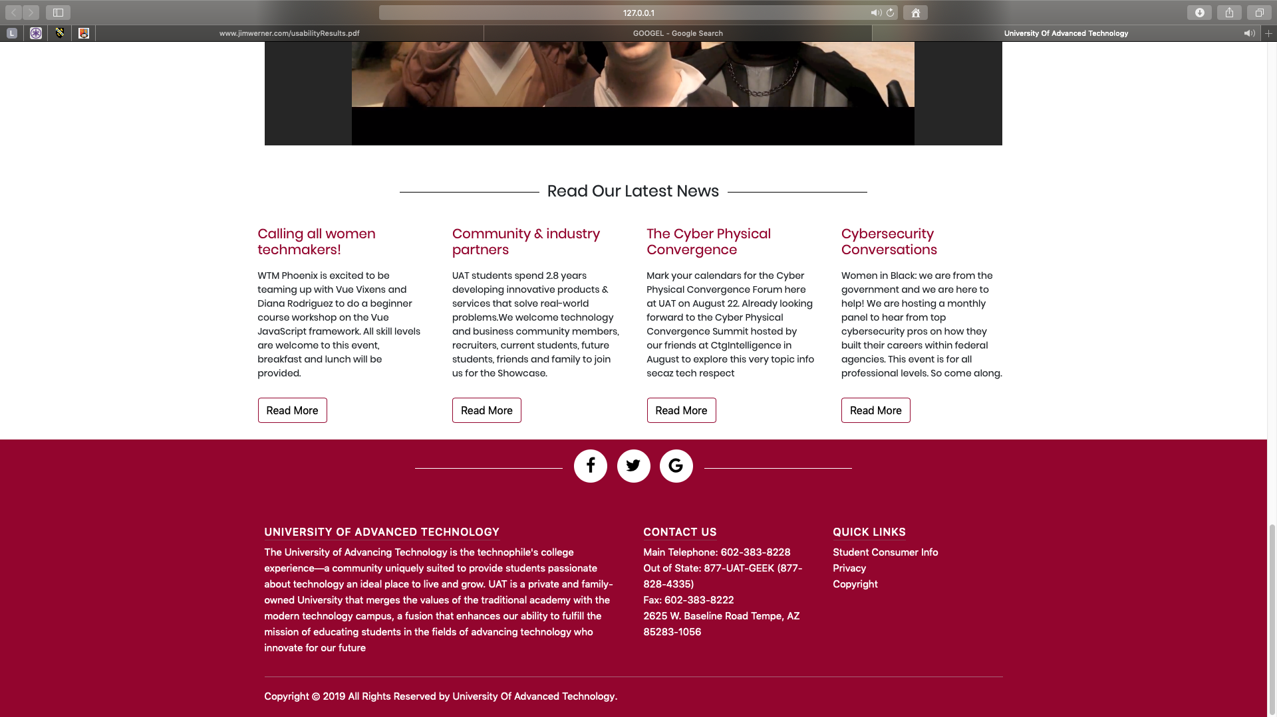
Figure 8: Homepage section of redesigned website
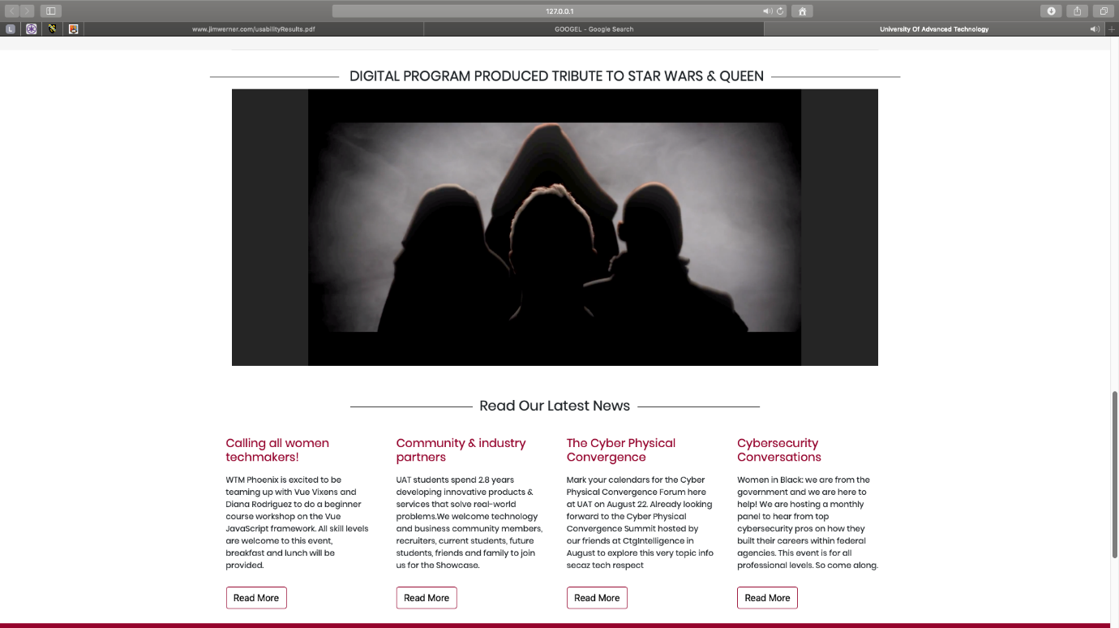
Figure 9 Homepage of redesign section 4

CHAPTER 6: Implementation of the Prototype
6.1 Introduction
For the implementation of the prototype redesign, several programming languages were used, these are discussed below with the advantages and reasons for choosing each of the languages briefly discussed.

6.2 Programming languages used
One language used to create the website was Hypertext Mark-up Language (HTML5), HTML5 is the latest version and offers support to all browsers such as Safari, Chrome, Internet Explorer and Firefox, thus the reason for it being the latest version. HTML5 has many technical enhancements that help improve features for the web, with the help of html5 dynamic websites and better web applications can be used that result in better usability [27]. Cascading stylesheets were also used to style the appearance of the website, just like using the latest version of html, CSS3 is the latest standard for CSS language. In addition, JavaScript was used, JavaScript is a language which is mostly used for creating pages on the client side, one of its key purposes is to add dynamic behaviour to a website [28].

Furthermore, bootstrap was also used to implement the website. Bootstrap is a front-end framework that combines HTML and CSS. Bootstrap 4 is the latest version that holds new components faster stylesheets and more responsiveness. The main reason for the use of bootstrap is that it speeds up development while creating a well-designed website. The purpose of using Bootstrap was to provide development components which assisted in the development process, enabling the researcher to develop the prototype quickly without needed to start the development of different components from scratch [28]. These components were partially created to support the development of more specific elements of the website.

  - How the requirements were implemented
6.3.1 How navigation was integrated in the new website
The use of bootstrap navbar component enabled for a easy creation of a navigational bar.
<nav class="navbar navbar-light bg-dark">

Navbars are Meta components which are responsive these act as a navigation header. With the use of this implemented in the website, consistency with the navigation will be good.

6.3.2 Text
Different layers of HTML heading Tags were used to appropriately display headings, paragraphs were displayed at a lower level as headings. Subheadings were displayed. Paragraphs of text was enlarged to ensure readability and better usability. The Font family POPPINS, SANS-SERIFF text was used throughout.

6.3.3. Colour
The appropriate use of colors, both background and foreground as well as text was changed to improve the readability providing clear and easy reading of text and images. From the analysis of the existing website colour contrast was a huge downfall. For this reason, a solid dark grey background of the navigation bar has been selected with a choice of white text for the menu, users of the website must be able to see information without any sense of struggle. Displayed alongside this navigational bar is the university logo. The drop-down menu was changed from the original background transparency to a solid colour, as participants from the testing session pointed out that this was a distraction.

The background was changed from grey to white and cream, with black text used. The house style of the website is therefore consistent throughout the pages making sure that the user experience of the website is improved.

6.3.4 Images
The images used on the new website were changed to better reflect the objectives of the University. See appendices and website for these changes.

6.3.5 Simplicity of design and layout
Ensure the layout is easy to follow and users are able to quickly find what they looking for
Ensure the lost in their click journey, all distracting animation was removed from the website.

6.3.6 Improve Usability score obtained:
The Usability test was conducted which showed an improvement in the score from 37 to 60.

6.4 Issues encountered
The redesign of the website was accomplished, with most of the suggested features from the data collection of the usability test include and implemented, however, one of the suggestions was not included as a functioning aspect of the redesign. One participant suggested that a search function be incorporated into the website where users can search for a course to reduce the amount of searching and clicking

CHAPTER 7: Analysis of Prototype Testing
7.1 Usability Testing of Prototype
7.1.1. Testing Process
Similarly, to the study of the Usability of the Existing University website seen in chapter 4, the same participants were selected to participate in the usability testing of the prototype. The exact same process was followed which included observation and two tests (SUS and STA) being performed with the participants while being observed.

As such, before the testing session began one moderator/observer ensured that the surroundings was suitable for the participant, certifying that an iMac was visible, this was used again to display the website and a iPad was present, this was used to let the participants respond to the user tasks as-well as the system usability score questionnaire. While making sure that these were present the moderator also conducted a run through of everything double checking that the electronical devices were running okay and to also see if the tasks and sus made sense.

In the same way the previous usability testing session happened, during this testing session participants were welcomed again and participants were made comfortable with the session as well with the environment. Additionally, participants were told again what the devices were going to be used for and then the moderator began the testing session. Participants were asked to complete three user tasks at a time with no help from the oberserver. Moderator/ observer was present in the room with participants to simply just observe their interaction with the website. The role of the observer during this testing session was to observe. Once a participant completed its user tasks and completed its system usability score questionnaire, the observer expressed gratitude towards the participant for partaking in the study. After the testing session with one participant the observer had to remove all evidence form previous participant responses and a clean-up of the environment for the next participate took place.

7.2 Evaluation of the Redesign
Due to the changes in the website design, different subtasks to complete the scenario tasks needed to be developed and set. Below is the feedback received from the participants.

Figure 10 Redesign System Usability Chart
Some of the main positive feedback received after the SUS testing is presented below:
- Three out of the six participants agreed strongly that they thought the website was simple.
- Five out of the five participants felt strongly that the website was intuitive.
- Five out of the 5 participants agreed that functions within the website were integrated well.
- Participants emphasized that the colour scheme through-out the website really co-operates the house style and ethos of Advancing Technology University.

Feedback obtained from the Scenario Tasks

Scenario 1: Participants stated that the colour contrast works well. A few participants said that although the text “parents” is displayed they thought it was just an image placed on the website and did not now that the image was clickable until they hovered over it

Scenario 2: Video tour displayed and clearly displayed images of campus is shown with description. Participants expressed that the heading of the page be made bigger.

Scenario 3: Participants found controls easily. They also commented on how the view course link was just displaying in the middle, when it would have been more convenient to place it with the rest of the text layout. Participants also found that there is a search bar that has no functionality, thoughts were conveyed on this as this would have made looking for a course much easier than scrolling

CHAPTER 8: summary, CONCLUSIONS & recommendations

Summary
This study investigates the importance of Web Usability and how it can improve a users’ experience of a Website. The approach used was an inductive, qualitative research design used to better understand the importance of Usability in improving the User experience. Research was conducted initially in the form of a literature review which provided guidelines for the development of a website. Convenient sampling was used to obtain participants for the study, and two tests were used on the participants while being observed doing the tests. These tests yielded invaluable feedback which could be translated in to user requirements for the new design of the website. A Usability test has been undertaken to investigate the usability problems which includes users in the gathering of data to influence the redesign of the website. Structured methodologies were followed, specifically using the waterfall methodology together with the software prototyping methodology to develop a redesign prototype of a website based on the usability data received from users. The main objectives of this study therefore is to provide a critical analysis of an existing website that focuses on Web Usability issues.

The results of the study suggest that the users experience of the new redesigned website, showed an improvement as compared with the original website, and the SUS test score improved. These results reflect that the main aim of the research study was achieved, that is to better understand the importance of the Usability to the User experience.

Conclusion
The main outputs of the research were:
- Design Guidelines
  - Web Usability Issues: The main issues uncovered were Navigation issues, inconsistency issues, and memorability issues. These issues were used as a guide to improve the design
  - The importance of Usability to the User experience
  - Frameworks:
    - Navigation
    - Display of Information
    - Text
    - Media Use
- Initial User requirements (from testing)
  - Navigation
  - Text
  - Colour
  - Use of visual aids (media / images etc)
  - Simplicity of Design and layout
  - Improve Usability Score
- Website prototype
- Post-redesign user requirements (from second testing)

The research process followed and the development process implemented provided a structured way in which to undertake this research study. The user tests yielded valuable insights into the Usability factors, some of which tied in with the research and guidelines uncovered during the literature review. The website prototype yielded a higher SUS score and hence suggesting that the guidelines and feedback provided, enabled the improvements to be made to the design which yielded better User experience of the website.

Recommendations for Further Research
The research that has been conducted has many possibilities for further research, however, the most significant would be to undertake analysis to better understand the relationship between the Usability factors and the impact of each of the factors on the User experience, to understand the relationship of each and the impact on the User Experience.

CHAPTER 9: Reflection
This section discusses to what extent the aim and objectives of this research has been achieved, and reflects on how well the objectives have been achieved and what could have been done to address any shortcomings.

9.1 Individual reflection on progress and conduct
This research study presented me with some challenges in conceptualizing the structure and flow of the research design. As the research used an existing website, which was used as part of the data collection phase to provide requirements for the new design, I found this challenging to structure the report against the template provided. This took an exceptionally long time to get to understand and conceptualize. I did not anticipate this challenge, and as a consequence it delayed my progress substantially. In future, I will make sure that I have a framework first, which is thoroughly discussed with my supervisor to ensure any difficulties are uncovered early on. Additionally, being able to balance my time effectively between developing and implementing the software application or project and writing up the report needs to be given careful consideration as I spend too much time on the implementation and coding and ensuring all aspects are perfect, but then the writing up of the report and collating all the research and gathering the evidence of analysis and collection takes much longer than anticipated.

9.2 Reflection on achievement of aims and objectives

The aim of this research was to investigate the significance of web usability and how it improves a user’s experience. A set of objectives were set to support achieving the aims of the project:
- Provide a critical literature review of the importance of web usability: A good critical review of the Usability and User experience literature was provided, which yielded a set of Usability guidelines which could be considered for the design of a website.
- Explain how usability enhances a user’s experience: This objective was covered in the literature review as well as throughout the document, in the design and testing sections.
- Provide usability tests to try and solve usability problems by implementing a website: A prototype website was designed as an improvement of the University of Advancing Technology website. The SUS score improved and feedback provided by participants were positive.
- Provide a critical analysis of a website focusing on key point points discussed in the literature review: The original website was evaluated, using two different tests while being observed by the researcher. This process yielded a critical analysis of the original website, to provide a new and improved website design. The key points discovered in the literature review provided a guideline to the design of the new website and supported some of the feedback from participants.

The one aspect that could have been undertaken was the implementation of the second set of user requirements obtained from the second round of testing on the website prototype, this would have yielded and much better and much improved website, with all of the Usability issues taken into account.

Chapter 11 References

[1] S. Lawrence and C. L. Giles, “Searching the world wide Web,” Science, vol. 280, no. 5360, pp. 98–100, Apr. 1998.
[2] ISO-9241-11, “Iso 9241-11,” vol. 1998, 1998.
[3] P. Parsons, “Making Your Gateway Easy and Pleasant To Use,” 2017.
[4] J. Nielsen, “What Is Usability?,” User Exp. Re-Mastered, no. October, pp. 3–22, 2010.
[5] R. Nilsson, “Usability vs. User Experience (UX),” 2010.
[6] “Web Usability: Standards &amp; Definition.” [Online]. Available: https://study.com/academy/lesson/web-usability-standards-definition.html. [Accessed: 25-Dec-2018].
[7] “The purpose of usability testing.” [Online]. Available: https://bugwolf.com/blog/the-purpose-of-usability-testing. [Accessed: 21-Nov-2018].
[8] J. Mifsud, “Difference (and Relationship) Between Usability And User Experience.” [Online]. Available: https://usabilitygeek.com/the-difference-between-usability-and-user-experience/. [Accessed: 20-Nov-2018].
[9] P. Merholz, “Peter in Conversation with Don Norman About UX &amp; Innovation | Adaptive Path,” 2017.
[10] W3C, “Introduction to Web Accessibility.” [Online]. Available: https://www.w3.org/WAI/fundamentals/accessibility-intro/. [Accessed: 03-Jan-2019].
[11] L. McGrath, “How to Meet the Web Content Accessibility Guidelines 2.0 - Luke McGrath - Google Books,” Lulu, 2015. .
[12] L. McGrath, “What’s the difference between web accessibility and usability?” 2015.
[13] L. Dowding, “20 Common usability issues to look out for,” 2018. [Online]. Available: http://lukedowding.com/20-common-usability-issues-look/. [Accessed: 25-Nov-2018].
[14] M. Soegaard, “A part of the User Experience.”
[15] A. De Schrijver, “Importance of Web Usability.” [Online]. Available: https://smallbusiness.chron.com/importance-usability-44946.html. [Accessed: 25-Nov-2018].
[16] S. Krug, Don’t Make Me Think! A Common Sense Approach to Web Usability, 2nd ed. New Riders, 2006.
[17] “Best Practices for Enhancing the User Experience on Your Website.”
[18] Webcredible, “Web Usability Guide,” 2004.
[19] M. O. Leavitt and B. Shneiderman, “Research-Based Web Design &amp; Usability Guidelines.”
[20] A. Training, “Manual testing 21 - What is Usability testing? How to do usability testing? Why usability testing?,” 2018.
[21] C. North, “Usability Evaluation.” .
[22] N. Whitehead, “UXD Lecture 17 - Evaluation I.” p. 22, 2018.
[23] D. Boyts, “Usability,” 2015. [Online]. Available: http://usability.danboyts.com/. [Accessed: 22-Nov-2018].
[24] “Research Philosophy.” [Online]. Available: https://research-methodology.net/research-philosophy/.
[25] Shod hgnagna, “CHAPTER 3 - RESEARCH METHODOLOGY.”
[26] S. and B. McNurlin, Information Systems Management, Pearson. 2009.
[27] “Why we should develop websites using HTML5?” [Online]. Available: https://www.graycelltech.com/why-use-html-5/. [Accessed: 01-Apr-2019].
[28] M. Krishna Patel, “HTML, CSS, Bootstrap, Javascript and jQuery.”
[29] Dr Nick Whitehead. Usability tasks, 2019
[30] USPTO, Software Usability Scale, 2019,

Appendix A –exisiting Scenario Task Results
Response 3: A
You a mother of a future student and want to find out more about how your child will cope and fit It in the university.
Task: Find information for parents of students

Select About UAT | Successful? | Comments?
Does the user know what they want to do? | y
Can they see a control that will do the job? | y
Is it clear how to operate the control? | y
Is the immediate feedback understandable? | y

Select parents guide | Successful? | Comments?
Does the user know what they want to do? | y
Can they see a control that will do the job? | y
Is it clear how to operate the control? | y
Is the immediate feedback understandable? | y | Menu bar is not consistent as it moves further down the page leaving the original menu just black,the new menu bar cuts out items leaving only half of the items visable.

Response 3: B
You a mother of a future student and want to find out more about how your child will cope and fit It in the university.
Task: Find information for parents of students

Select About UAT | Successful? | Comments?
Does the user know what they want to do? | y
Can they see a control that will do the job? | y
Is it clear how to operate the control? | y
Is the immediate feedback understandable? | y

Select parents guide | Successful? | Comments?
Does the user know what they want to do? | y
Can they see a control that will do the job? | y
Is it clear how to operate the control? | y
Is the immediate feedback understandable? | y | Footer of website does not get displayed, only a dark grey box is shown.

Response 3: C
You a mother of a future student and want to find out more about how your child will cope and fit It in the university.
Task: Find information for parents of students

Select About UAT | Successful? | Comments?
Does the user know what they want to do? | y
Can they see a control that will do the job? | y
Is it clear how to operate the control? | y
Is the immediate feedback understandable? | y

Select parents guide | Successful? | Comments?
Does the user know what they want to do? | y
Can they see a control that will do the job? | y
Is it clear how to operate the control? | y
Is the immediate feedback understandable? | y | Words overlapping in heading

Response 3: D
You a mother of a future student and want to find out more about how your child will cope and fit It in the university.
Task: Find information for parents of students

Select About UAT | Successful? | Comments?
Does the user know what they want to do? | y
Can they see a control that will do the job? | y
Is it clear how to operate the control? | y
Is the immediate feedback understandable? | y

Select parents guide | Successful? | Comments?
Does the user know what they want to do? | y
Can they see a control that will do the job? | y
Is it clear how to operate the control? | y
Is the immediate feedback understandable? | y | Images could be made bigger  Text could be made bigger

Response 3: E
You a mother of a future student and want to find out more about how your child will cope and fit It in the university.
Task: Find information for parents of students

Select About UAT | Successful? | Comments?
Does the user know what they want to do? | y
Can they see a control that will do the job? | y
Is it clear how to operate the control? | y
Is the immediate feedback understandable? | y

Select parents guide | Successful? | Comments?
Does the user know what they want to do? | y
Can they see a control that will do the job? | y
Is it clear how to operate the control? | y
Is the immediate feedback understandable? | y | Title of page not showing correct as it overlaps with words overlapping in heading

Response 2: A

You are first year student wanting to view the facilities at the university of advancing technology. All you need to do is visit the website and find the information
Task: Find facilities at UAT

Select Campus Life | Successful? | Comments?
Does the user know what they want to do? | y
Can they see a control that will do the job? | y
Is it clear how to operate the control? | y
Is the immediate feedback understandable? | y | Images are displayed nicely  And nice video of tour of uni

Response 2: B

You are first year student wanting to view the facilities at the university of advancing technology. All you need to do is visit the website and find the information
Task: Find facilities at UAT

Select Campus Life | Successful? | Comments?
Does the user know what they want to do? | y
Can they see a control that will do the job? | y
Is it clear how to operate the control? | y
Is the immediate feedback understandable? | y

Response 2: C

You are first year student wanting to view the facilities at the university of advancing technology. All you need to do is visit the website and find the information
Task: Find facilities at UAT

Select Campus Life | Successful? | Comments?
Does the user know what they want to do? | y
Can they see a control that will do the job? | y
Is it clear how to operate the control? | y
Is the immediate feedback understandable? | y

Response 2: D

You are first year student wanting to view the facilities at the university of advancing technology. All you need to do is visit the website and find the information
Task: Find facilities at UAT

Select Campus Life | Successful? | Comments?
Does the user know what they want to do? | y
Can they see a control that will do the job? | y
Is it clear how to operate the control? | y
Is the immediate feedback understandable? | y

Response 2: E

You are first year student wanting to view the facilities at the university of advancing technology. All you need to do is visit the website and find the information
Task: Find facilities at UAT

Select Campus Life | Successful? | Comments?
Does the user know what they want to do? | y
Can they see a control that will do the job? | y
Is it clear how to operate the control? | y
Is the immediate feedback understandable? | y | Page and text displayed readable

Response 1: A
Scenario 1 : You are interested in attending the University of Advancing Technology next summer to study web design however you do now know much about this course at this university, therefore you would like to find out more about this web design course.
Task: Find details on the web design degree
Select Advancing Technology degrees | Successful? | Comments?
Does the user know what they want to do? | Y
Can they see a control that will do the job? | n | Wouldn't know it was a control until you use mouse to hover over it
Is it clear how to operate the control? | y
Is the immediate feedback understandable? |  | Yes, however the loading of the menu links did not display immediately took some time to display.

Select Web Design Degree | Successful? | Comments?
Does the user know what they want to do? | y
Can they see a control that will do the job? | y
Is it clear how to operate the control? | y
Is the immediate feedback understandable? | y

Select Degree Summary | Successful? | Comments?
Does the user know what they want to do? | y
Can they see a control that will do the job? | y
Is it clear how to operate the control? | y
Is the immediate feedback understandable? | y | Choice of colour, grey text over grey background not a great choice.
Response 1: B
Scenario: You are interested in attending the University of Advancing Technology next summer to study web development however you do now know much about this course at this university, therefore you would like to find out more about this web design course.
Task: Find details on the web design degree
Select Advancing Technology degrees | Successful? | Comments?
Does the user know what they want to do? | Y
Can they see a control that will do the job? | y
Is it clear how to operate the control? | y
Is the immediate feedback understandable? | n | Text too small

Select Web Design Degree | Successful? | Comments?
Does the user know what they want to do? | y
Can they see a control that will do the job? | y
Is it clear how to operate the control? | y
Is the immediate feedback understandable? | n | Transparent background of this control distracts as the background of the website is coming through, not clear for users cause of this

Select Degree Summary | Successful? | Comments?
Does the user know what they want to do? | y
Can they see a control that will do the job? | y
Is it clear how to operate the control? | y
Is the immediate feedback understandable? | y | Page displayed is not simple, too busy

Response 1: C
Scenario: You are interested in attending the University of Advancing Technology next summer to study web development however you do now know much about this course at this university, therefore you would like to find out more about this web design course.
Task: Find details on the web design degree
Select Advancing Technology degrees | Successful? | Comments?
Does the user know what they want to do? | Y
Can they see a control that will do the job? | y
Is it clear how to operate the control? | y
Is the immediate feedback understandable? | y | clear

Select Web Design Degree | Successful? | Comments?
Does the user know what they want to do? | y
Can they see a control that will do the job? | y
Is it clear how to operate the control? | y
Is the immediate feedback understandable? | y | Text is visible

Select Degree Summary | Successful? | Comments?
Does the user know what they want to do? | y
Can they see a control that will do the job? | y
Is it clear how to operate the control? | y
Is the immediate feedback understandable? | y

Response 1: D
Scenario: You are interested in attending the University of Advancing Technology next summer to study web development however you do now know much about this course at this university, therefore you would like to find out more about this web design course.
Task: Find details on the web design degree
Select Advancing Technology degrees | Successful? | Comments?
Does the user know what they want to do? | Y
Can they see a control that will do the job? | n
Is it clear how to operate the control? | y
Is the immediate feedback understandable? |  | Bigger menu bar  Bolder text is needed

Select Web Design Degree | Successful? | Comments?
Does the user know what they want to do? | y
Can they see a control that will do the job? | y
Is it clear how to operate the control? | y
Is the immediate feedback understandable? | y | Bolder text  Transparency solid color

Select Degree Summary | Successful? | Comments?
Does the user know what they want to do? | y
Can they see a control that will do the job? | y
Is it clear how to operate the control? | y
Is the immediate feedback understandable? | y

Response 1:E
Scenario: You are interested in attending the University of Advancing Technology next summer to study web development however you do now know much about this course at this university, therefore you would like to find out more about this web design course.
Task: Find details on the web design degree
Select Advancing Technology degrees | Successful? | Comments?
Does the user know what they want to do? | Y
Can they see a control that will do the job? | Y
Is it clear how to operate the control? | y
Is the immediate feedback understandable? | y | Menu links could be categorized so that only the headings are displayed and not the courses

Select Web Design Degree | Successful? | Comments?
Does the user know what they want to do? | y
Can they see a control that will do the job? | y
Is it clear how to operate the control? | y
Is the immediate feedback understandable? | y

Select Degree Summary | Successful? | Comments?
Does the user know what they want to do? | y
Can they see a control that will do the job? | y
Is it clear how to operate the control? | y
Is the immediate feedback understandable? | y | Page text small  Color contrast not good

Appendix b – exisiting sus questionaire Results
Used from template.

Appendix C – new protype SCENARIO TASKS results
Response 3: A
You a mother of a future student and want to find out more about how your child will cope and fit It in the university.
Task: Find information for parents of students

Select admissions UAT | Successful? | Comments?
Does the user know what they want to do? | y
Can they see a control that will do the job? | y
Is it clear how to operate the control? | y
Is the immediate feedback understandable? | y

Select parents | Successful? | Comments?
Does the user know what they want to do? | y
Can they see a control that will do the job? | y
Is it clear how to operate the control? | y
Is the immediate feedback understandable? | y

Response 3: B
You a mother of a future student and want to find out more about how your child will cope and fit It in the university.
Task: Find information for parents of students

Select admissions UAT | Successful? | Comments?
Does the user know what they want to do? | y
Can they see a control that will do the job? | y
Is it clear how to operate the control? | y
Is the immediate feedback understandable? | y

Select parents | Successful? | Comments?
Does the user know what they want to do? | y
Can they see a control that will do the job? | y
Is it clear how to operate the control? | y
Is the immediate feedback understandable? | y

Response 3: C
You a mother of a future student and want to find out more about how your child will cope and fit It in the university.
Task: Find information for parents of students

Select admissions UAT | Successful? | Comments?
Does the user know what they want to do? | y
Can they see a control that will do the job? | y
Is it clear how to operate the control? | y
Is the immediate feedback understandable? | y

Select parents’ guide | Successful? | Comments?
Does the user know what they want to do? | y
Can they see a control that will do the job? | y
Is it clear how to operate the control? | y
Is the immediate feedback understandable? | y

Response 3: D
You a mother of a future student and want to find out more about how your child will cope and fit It in the university.
Task: Find information for parents of students

Select About UAT | Successful? | Comments?
Does the user know what they want to do? | Y
Can they see a control that will do the job? | y
Is it clear how to operate the control? | y
Is the immediate feedback understandable? | y

Select parents guide | Successful? | Comments?
Does the user know what they want to do? | Y
Can they see a control that will do the job? | Y
Is it clear how to operate the control? | Y
Is the immediate feedback understandable? | y | Contrast of colours work well together

Response 3: E
You a mother of a future student and want to find out more about how your child will cope and fit It in the university.
Task: Find information for parents of students

Select admissions UAT | Successful? | Comments?
Does the user know what they want to do? | y
Can they see a control that will do the job? | y
Is it clear how to operate the control? | y
Is the immediate feedback understandable? | y

Select parents | Successful? | Comments?
Does the user know what they want to do? | y
Can they see a control that will do the job? | y | Text “parents is displayed”
Is it clear how to operate the control? | n | Thought it was just an image, until hovered over and saw it was clickable
Is the immediate feedback understandable? | y

Response 2: A

You are first year student wanting to view the facilities at the university of advancing technology. All you need to do is visit the website and find the information
Task: Find facilities at UAT

Select campus UAT | Successful? | Comments?
Does the user know what they want to do? | y
Can they see a control that will do the job? | y
Is it clear how to operate the control? | y
Is the immediate feedback understandable? | y | Video tour displayed and clearly displayed images of campus is shown with description

Response 2: B

You are first year student wanting to view the facilities at the university of advancing technology. All you need to do is visit the website and find the information
Task: Find facilities at UAT

Select campus UAT | Successful? | Comments?
Does the user know what they want to do? | y
Can they see a control that will do the job? | y
Is it clear how to operate the control? | y
Is the immediate feedback understandable? | y

Response 2: C

You are first year student wanting to view the facilities at the university of advancing technology. All you need to do is visit the website and find the information
Task: Find facilities at UAT

Select campus UAT | Successful? | Comments?
Does the user know what they want to do? | y
Can they see a control that will do the job? | y
Is it clear how to operate the control? | y
Is the immediate feedback understandable? | y

Response 2: D

You are first year student wanting to view the facilities at the university of advancing technology. All you need to do is visit the website and find the information
Task: Find facilities at UAT

Select campus UAT | Successful? | Comments?
Does the user know what they want to do? | y
Can they see a control that will do the job? | y
Is it clear how to operate the control? | y
Is the immediate feedback understandable? | y | Title of page could be bigger

Response 2: E

You are first year student wanting to view the facilities at the university of advancing technology. All you need to do is visit the website and find the information
Task: Find facilities at UAT

Select campus UAT | Successful? | Comments?
Does the user know what they want to do? | y
Can they see a control that will do the job? | y
Is it clear how to operate the control? | y
Is the immediate feedback understandable? | y | title size could increase

Response 1: A
Scenario 1 : You are interested in attending the University of Advancing Technology next summer to study web design however you do now know much about this course at this university, therefore you would like to find out more about this web design course.
Task: Find details on the web design degree
Select courses | Successful? | Comments?
Does the user know what they want to do? | Y
Can they see a control that will do the job? | y
Is it clear how to operate the control? | y
Is the immediate feedback understandable? | y

Select undergraduate | Successful? | Comments?
Does the user know what they want to do? | y
Can they see a control that will do the job? | y
Is it clear how to operate the control? | y
Is the immediate feedback understandable? | y

Select web design | Successful? | Comments?
Does the user know what they want to do? | y
Can they see a control that will do the job? | y
Is it clear how to operate the control? | y
Is the immediate feedback understandable? | y | Search function does not work  This could have made the process of finding the course more easy

Response 1: B
Scenario: You are interested in attending the University of Advancing Technology next summer to study web development however you do now know much about this course at this university, therefore you would like to find out more about this web design course.
Task: Find details on the web design degree
Select courses | Successful? | Comments?
Does the user know what they want to do? | Y
Can they see a control that will do the job? | y
Is it clear how to operate the control? | y
Is the immediate feedback understandable? | y | Text too small

Select undergraduate | Successful? | Comments?
Does the user know what they want to do? | y
Can they see a control that will do the job? | y
Is it clear how to operate the control? | y
Is the immediate feedback understandable? | y

Select web design view course | Successful? | Comments?
Does the user know what they want to do? | y
Can they see a control that will do the job? | y
Is it clear how to operate the control? | y
Is the immediate feedback understandable? | y | Heading of page could be bigger  View page link just floating in middle

Response 1: C
Scenario: You are interested in attending the University of Advancing Technology next summer to study web development however you do now know much about this course at this university, therefore you would like to find out more about this web design course.
Task: Find details on the web design degree
Select courses | Successful? | Comments?
Does the user know what they want to do? | Y
Can they see a control that will do the job? | y
Is it clear how to operate the control? | y
Is the immediate feedback understandable? | y

Select undergraduate | Successful? | Comments?
Does the user know what they want to do? | y
Can they see a control that will do the job? | y
Is it clear how to operate the control? | y
Is the immediate feedback understandable? | y | Text is visible

Select web design - view course | Successful? | Comments?
Does the user know what they want to do? | y
Can they see a control that will do the job? | y
Is it clear how to operate the control? | y
Is the immediate feedback understandable? | y | View course just wondering in the middle of the course sections

Response 1: D
Scenario: You are interested in attending the University of Advancing Technology next summer to study web development however you do now know much about this course at this university, therefore you would like to find out more about this web design course.
Task: Find details on the web design degree
Select Advancing Technology degrees | Successful? | Comments?
Does the user know what they want to do? | Y
Can they see a control that will do the job? | y
Is it clear how to operate the control? | y
Is the immediate feedback understandable? | y

Select Web Design Degree | Successful? | Comments?
Does the user know what they want to do? | y
Can they see a control that will do the job? | y
Is it clear how to operate the control? | y
Is the immediate feedback understandable? | y

Select Degree Summary | Successful? | Comments?
Does the user know what they want to do? | y
Can they see a control that will do the job? | y
Is it clear how to operate the control? | y
Is the immediate feedback understandable? | y

Response 1: E
Scenario: You are interested in attending the University of Advancing Technology next summer to study web development however you do now know much about this course at this university, therefore you would like to find out more about this web design course.
Task: Find details on the web design degree
Select courses | Successful? | Comments?
Does the user know what they want to do? | Y
Can they see a control that will do the job? | Y
Is it clear how to operate the control? | y
Is the immediate feedback understandable? | y

Select undergraduate | Successful? | Comments?
Does the user know what they want to do? | y
Can they see a control that will do the job? | y
Is it clear how to operate the control? | y
Is the immediate feedback understandable? | y

Select web design – view course | Successful? | Comments?
Does the user know what they want to do? | y
Can they see a control that will do the job? | y
Is it clear how to operate the control? | y
Is the immediate feedback understandable? | y | Bigger heading

APPENDIX D – NEW PROTOYPE SUS QUESTIONAIRE RESULTS

APPENDIX E - PROJECT PLAN


