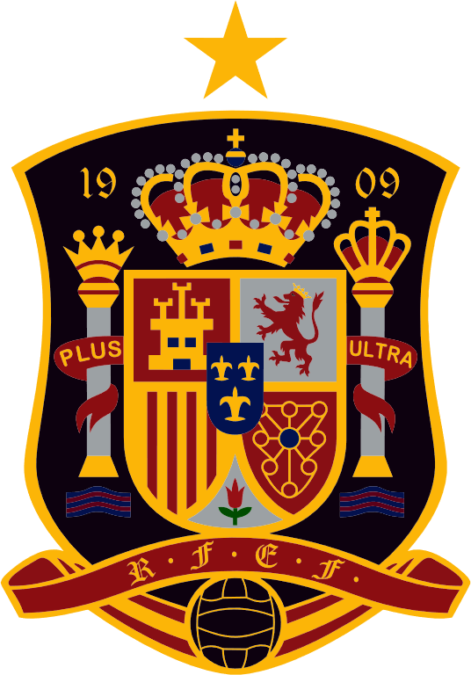

The National football team of Spain
Road to success

In the following presentation I will try to talk to you about the National football team of Spain and about its resounding success in the past decade. I will also bring into topic Tuckman’s theory, and I will also mention notions such as groups and teams, group dynamics, and in the end I will speak about reward and recognition.
Would you be surprised to find out that there are several steps that must be taken in order to create a team? Well, I must admit I was. Before joining the Effective Team Working and Communication course I thought a team is just a bunch of people. Only after that I realised that a team is much more than this, that a team is a group of people with a full set of complementary skills required to complete a task, job, or project. (Business dictionary, 2018)
The group and the team are considered to be very similar, but in fact they are so different. This is why it is very important to make a distinction between these terms in order to define them properly. A group is usually formed out of two to four members who work in close connection, but have an individual responsibility to fulfil a task. A group is led by a leader.
The team is formed by seven to twelve individuals who work interdependently and share responsibilities in order to reach the common goal. Usually they do not need a leader to guide them, on the contrary they help each other to develop new abilities in order to increase performance. As a conclusion we have to understand that a group is a number of individuals forming a unit for a reason or cause, and a team is a collection of accomplished people coming together for a common goal that needs completion. (Study.com, 2018)
Bruce Tuckman studied teams from formation to completion of a task and noticed some crucial stages in a team’s life cycle. (Belbin, 2018)
Initially he identified 4 stages which he named : forming, storming, norming and performing. Later on he added a fifth one called adjourning and transforming, to cover the completion of a task. (Team Building, 2018)
Differences between groups and teams
- A group is easier to control and can give excellent results in a short period of time.
- A team is more efficient in long term projects because they work together as a whole.
- In a team trust and respect are fundamental.
- In a group trust can be developed only between some members.
- Common goals- in a team its members work together to reach the common goal. In a group individual agenda is the one that matters the most.
- Leadership is vital in a team as all the members are informal leaders. In a group we find a bunch of strong personalities fighting for domination.

Characteristics of effective teams

- Commitment and Trust - Trust is essential to an effective team, because it provides a sense of safety. When your team members feel safe with each other, they feel comfortable to open up, take appropriate risks, and expose vulnerabilities. (Mind Tools, 2018)
- Communication -is very important for the evolution and progress of the team.
- Diversity of Capabilities
- Adaptability-“Adaptability is becoming a hallmark of effective performance at all levels and types of organizations. Individuals within both public and private organizations are having to adapt to technological changes and the tempo of operations in dynamic, competitive environment.” (Burke et al, 2006)

- Creative Freedom

Adair states that “The power of a team to accomplish its mission is directly related to how well the leader selects and develops its members.”(Adair, 1987)

According to his statement it is up to the team leader to identify the set of skills that each team member has. By doing so the team leader can assign a task to the individual in his team that has the required skill to solve it. However, I strongly believe that a good team member can change to any situation that called for a team role he did not have and he will still be able to be effective. (Belbin et al, 2010)

Every single football fan heard about the tremendous success obtained by Spain national football team between 2008 and 2012. It all started in 2006, when Luis Aragones was named as new head coach of the Spanish team. On taking over the national team, he made changes to the team, dropping experienced players such as Míchel Salgado and Raúl, two iconic players who were too old to keep up with the requirements of the modern times and the fast pace of the matches. The coach brought some fresh blood and gave the chance to young players to prove them worthy to wear the national t-shirt. Using the training grounds of the city of football Las Rozas, Spain national football team began the campaign for EURO 2008. Deliberately or by mistake he introduced into the training grounds the brainstorming technique, allowing his players to express themselves freely during the training sessions. The golden rule is that there should be no critique or evaluation of anyone else’s idea.(Morgan,2017) It was a clever move as through this technique the players started to know each other better, understand and agree upon the same game tactics that the coach explained to them. The rest is written in the history pages as Spain became European champion, defeating in the final the national football team of Germany with a 1-0 win thanks to Fernando Torres.
Reward and recognition
Spain, the winning team, received from UEFA a cash prize of 23 million euros each player taking home somewhere around 300.000 euros. Another financial reward for the Spanish team came from TV rights and official partners. The players market value grew up rapidly as well. After the European championship the national team of Spain also known as “La Furia Roja” (ESPN, 2018) played several friendly matches which brought some good money in the Spanish Football Federation accounts.
From a non-financial point of view one of the biggest reward is the joy they brought to the Spanish people and football fans around the world. Spanish players began to gain fame and millions of fans on their social media platforms as well.

REFERENCES

- Adair, J.E., 1987. Effective teambuilding : how to make a winning team, London: Pan. , page 143
- Belbin, R. Meredith & Belbin, R. M, 2010. Management teams : why they succeed or fail 3rd ed., Oxford, U.K.: Butterworth-Heinemann. (pg121)
- C. Shawn Burke, Linda G. Pierce, Eduardo Salas (ed.)2006, Understanding Adaptability: A Prerequisite for Effective Performance within Complex Environments (Advances in Human Performance and Cognitive Engineering Research, Volume 6) Emerald Group Publishing Limited,
- http://en.espn.co.uk/football/sport/story/198554.html (Accessed 02/11/2018)
- http://www.businessdictionary.com/definition/team.html (Accessed 01/11/2018)
- https://study.com/academy/lesson/the-difference-between-groups-and-teams-definition-contrasts.html (Accessed 31/10/2018)
- https://www.belbin.com/resources/blogs/belbin-and-tuckman/ (Accessed 01/11/2018)
- https://www.mindtools.com/pages/article/building-trust-team.htm (Accessed 30/10/2018)
- https://www.teambuilding.co.uk/theory/Forming-Storming-Norming-Performing.html (Accessed 02/11/2018)
- Morgan, P., 2017. Business student's guide to study and employability, London: Sage Publications Ltd. , pp306

