Stela Georgieva Student ID: 2128350
Yoanna Chalkiyan Student ID: 2120501
Lavinia Beliga Student ID: 2124260

Introduction to the Modern Workplace
(LCBB4003_BRM)

Assignment Component 2

Uju Ugochukwu

06.04.2022

“GUCCI GROUP”
INTRODUCTION
Gucci is a luxury fashion house with headquarters in Florence, Italy. Guccio Gucci founded the company in 1921, and it was valued at $12.1 billion in 2020. Its sales exceed $4.7 billion, putting it in 31st place on Forbes' list of the World's Most Valuable Brands. Its brand is worth $22.6 billion, with $10.8 billion in revenue generated globally (Forbes, 2020).
Gucci is a well-known Italian fashion and leather firm owned by Kering. Gucci is known for its high-end luxury clothing and leather items. It has been likened to regular sites across the world, and the merchandise is marketed through franchise or luxury department shops. Branding has evolved into a kaleidoscope of platforms., consumer information, and interactive and social components, and is no more a hub-and-spoke approach. A critical part is the Web channel. Gucci has evolved from a small leather goods company to become one of the most sought-after names.
Despite its Italian origins, the company has opened more than two hundred outlets in developing markets, compared to less than one hundred in Western Europe. According to (Statista 2020), they have the most stores open internationally compared to other luxury brands, showing that they have a significant international market presence. Gucci has carefully positioned it by separating itself from the competition. The concept is smart, high-class, and classic all at the same time.
The Gucci company has once again become a leader in the fashion world, thanks to de Sola's successful economic policy of taking away licenses, investing the profits in expanding the business and buying the most well-known fashion houses, as well as the talent of Tom Ford, whose designs have always been successful. Tom Ford was selected best fashion designer in 1995/96 for his "Jet Set" collection. The Italian brand's lost reputation is not only restored but also increased severalfold. The Gucci Group, which forms well-known firms such as Yves Saint Laurent, Balenciaga, Alexander McQueen, Sergio Ros, and many more, was founded in April 2004. Each of the brands that make up the Gucci Group is run individually.
However, focused on every brand's financial success, there seems to be a common notion of brand management. The Gucci Business made $2.285 billion in sales in 2020, with 60% of revenue coming from the Gucci brand, 20% from YSL Beaute (perfumes and cosmetics), and 4% from the Yves Saint Laurent brand, and 10% from the rest of the company.
In 2020, the company was the most important component in the Gucci Group, with Yves Saint Laurent coming in second. Boucheron, Bottega Veneta, Bedat & Co Sergio Rossi, and design houses, Alexander McQueen, Balenciaga, and Stella McCartney are all candidates.

ORGANIZATIONAL CULTURE
“Organisational Culture tends to be more straightforward and precise to measure than National Culture” (Hofstede 2019) The word "organisational culture" refers to a system of policies that give people direction and guidance. It is a complicated system made up of shared concepts, beliefs, and assumptions that direct employee behaviour within the company. Gucci's organisational culture Due to the obvious underlying assumptions, ideas, and values, the psychological and social surroundings are unique and structural. According to (Schein 2017), a corporate culture model in which fundamental assumptions shape values, which then shape practises and behaviour, which are the visible features of culture. Organizations do not generate a culture overnight; rather, they learn from previous experiences and continue to accept it on a regular basis, culminating in the formation of workplace culture.

GUCCI’S ORGANIZATIONAL CULTURE
Gucci's mission is clear. This shows that the firm hasn't communicated its position and posture to the public and key stakeholders using a range of languages and conversations. To assist stakeholders to understand the company's business strategy and purpose, the vision and mission must be clear and comprehensive, reflecting the company's underlying principles and ambitions. “Organisational Culture is spoken about in very different ways, depending on the source.” (Hofstede 2019)

GUCCI’S ORGANIZATIONAL CULTURE ARTEFACTS
The top layer of the organisational culture ring is made up of artefacts. Gucci's company culture is represented via tangible and visible artefacts. The open-door policy, workplace design, and official dress code for staff are all artefacts. Even though the Gucci cultural artefacts are visible to the public, they are tough to comprehend.

GUCCI’S ORGANIZATIONAL CULTURE VALUES
It's difficult to see the main ideas. Gucci's core values are its shared aims, beliefs, and standards. Responsibility, creativity, quality, cooperation, excitement, honesty, and leadership are all vital values. Gucci's management recognises the need of expressing the company's basic principles so that each employee may embrace them and adjust their behaviour appropriately.

GUCCI’S ORGANIZATIONAL CULTURE ASSUMPTIONS
Gucci's corporate culture is founded on assumptions, or long-held beliefs and attitudes. Employees, although playing a critical role in the creation of observable behaviours and significant values, are frequently oblivious of assumptions.

IMPORTANTANDS OF UNDERSTANDING THE ORGANIZATIONAL CULTURE.
Understanding organisational culture is crucial since it is necessary for gaining a competitive advantage in today's business climate. Gucci's corporate culture ensures that all workers are working for the same goal, which relates to the company's overall goal. Because Gucci's behaviour, aims, and firmly held principles are all in harmony, the employees can focus their energies on the proper direction, offering their best performance, and assuring great commitment to the company.” Not only organizations are culture-bound; theories about organizations are equally culture-bound.” (Hofstede, Minkov 2005).
The person and the rules (the legislation) are both sources of power in Fayol's view. We perceive the organisational model as a hierarchy of individuals with personal authority and formal norms as coordination principles. The actual authority, according to Weber, is found in the rules. These rules tightly restrict the ability of the officials. We see the organization's model as a good working engine that operates according to the rules.

MANAGEMENT ENVIRONMENT

It is an important way to learn the theory behind your business's network and how the operation mechanism works. In summary, the execution environment includes all application and server components that will allow your business to handle on-demand work requests. There are two management environments: external and internal. Within the organization, the internal environment describes the factors and conditions that have an impact on it. Depending on the organization's goods or services, the external environment may influence success.

PLANING

Time management and undertaking management are two of the most essential processes for success. The process of planning involves laying out a plan for attaining specific goals. Whether it is an organization or a person, they can reduce the time and effort necessary for achieving their goals by doing it effectively. Making plans is like making maps. It is always possible to tell how far a project has progressed and how much effort has been put into it so far. Considering Gucci's need to achieve profit through a bottom-up decision-making process, everyone within the organization needs to contribute to the decision-making process. This extends to the entire organization. Their importance can be felt, and their humble opinions can motivate them to contribute to the growth and development of the organization, motivating them to work there. Gucci's new chief executive officer, Robert Polet, remained committed to his plan: focus on the employees, build up a plan with them together, and provide a statistical analysis of the client's preferences to dictate the trends. Purchasing struggling brands, repositioning them, and directly operating them.

ORGANIZATIONAL STRUCTURE
An organizational structure is a system that outlines how certain activities are directed in order to achieve the goals of an organization. Roles, responsibilities, and rules can all be included. Information flow between employees is also impacted by the organizational structure. When an organization is decentralized, the decision-making power is distributed among multiple levels as opposed to being centralized from the top. Companies can remain efficient and focused with an organizational structure in place. Organizational structures are heavily used by companies of all sizes. Within organizations, they describe the hierarchy. It is important for the organizational structure to clearly distinguish the roles and responsibilities of each employee. In a nutshell, the organizational structure determines who does what so the company will be able to succeed.

Using this grouping, a company can see how it is structured, and how it will be able to attain its goals in a more effective manner. It is common to visualize organizational structures in charts and diagrams like pyramids, in which the most powerful members of the organization sit at the top and the least powerful members at the bottom.

Certain organizations may have difficulty operating without a formal structure in place. Staff may not know what their role is without a formal structure. Consequently, there may be confusion regarding who is responsible for what in the organization.

By providing structure, everyone at every level is able to be more efficient and clearer. Additionally, this can mean higher productivity as departments are likely to be more focused on time and energy.

Danny & Daft Management (2009, p. 371) define organizational structure as such: "The framework within which the organization determines how tasks are distributed, resources are assigned, and departmental policies are taken". In the following chart, Gucci's organizational chart is briefly described.

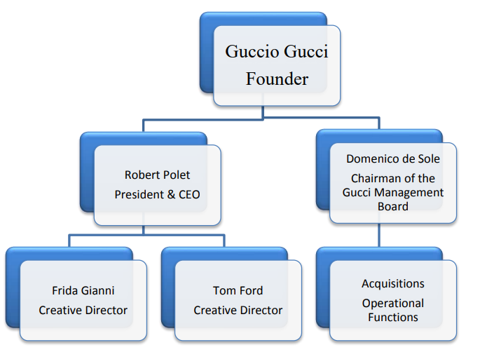

ORGANIZATIONAL STRUCTURE OF GUCCI GROUP
The Gucci Grouping organization is made up of operational arrangements where duties are assigned according to their specialties, for instance finance, manufacturing, and merchandising. A structure that discourages the evolution of different action as strategic business entities may be necessary for the development of a contemporary operation approach. A style of the organization is that it endeavours to install its culture into its members, including the values, beliefs, and norms shared within.

EMPLOYEES PERFORMANCE, MOTIVATION AND ENGAGEMENT

Benefits of employees working at Gucci:
Employees at Gucci earn $50,000 annually, or $24 per hour, which represents a 28% reduction in wages compared to the national salary average of $66,000. Data indicates that the highest paying job at Gucci is a Selling Supervisor, making $60,000 annually, while the lowest paying job at Gucci is an Intern, making $25,000.

Gucci is providing for their employees the next benefits:
– Health Insurance
– Dental Insurance
– Vision Insurance
– Life Insurance
– Supplemental Life Insurance

Also, the employees are getting 50% off everything in store and 30% off other Kering house brands.

The Italian clothing, footwear, and accessories company Guccio Gucci S.p.A. reported 947 employees in 2017; it is renowned worldwide for its luxury feminine and men's clothing, footwear, and accessories. As an example, the number of employees in the third year on the graph increased by almost 200 units compared with the first year. However, the most remarkable thing was that Gucci hired 133 new employees in 2017, which was the greatest increase in its workforce.

Several different racial and ethnic groups are represented in the Gucci staff. Women account for 54.4% of the company's workforce, while ethnic minorities make up 50.1%. Even though it has great demographic diversity, Gucci notably lacks in political diversity. A high percentage of its workers are Democrats, at 92.0%. Workers at Gucci tend to have relatively short tenures, however, despite sharing the same political views. The company's average employee tenure is 2.9 years. On average, Gucci employees earn $28,662. Compared to some of its highest-paying competitors, such as Prada USA, Crabtree & Evelyn and Hermes of Paris, Gucci pays substantially less than those firms.

The employees at Gucci are pleased with the company's rapid growth, evaluating it 90/100 for growth. 89% of Gucci's employees approve of the work they do, and the executive team directly impacts Gucci's growth. Culture metrics are a good indicator of Gucci's growth. According to employee ratings for each company, Gucci comes in fourth behind CHANEL and Bottega Veneta.

Brands need to maintain a positive image when their products range in price from hundreds of dollars to thousands. As a result of expanding luxury markets in various geographic areas, there is a need for luxury professionals who are familiar with the nuances of the luxury business. As brands strive to provide an omni-channel experience, they need employees who have the ability to handle many different situations. Besides being familiar with how to click images for social media, retail managers should also understand consumer patterns offline. Thus, it is crucial for a brand to hire the right employees who embody its ethos.

Being able to clearly differentiate between luxury goods, designer goods, super-premium goods, and premium goods is one of the key aspects to working in the luxury industry. It is imperative to have the appropriate combination of academic excellence and professional experience when breaking into and working in the luxury industry. Luxury retail professionals are required to provide an exclusive ambiance that reflects the brand's ethos and reinforces it. The skills necessary to create such beautiful products require you to understand innately the importance of time and sheer labour. As a result, understanding every detail of the product is essential for all employees. A luxury store's shopper experience is highly critical as a product expert. Employees become brand custodians, product experts, and fashion or lifestyle consultants.

There are no tolerances in the luxury industry. It is vital that luxury companies hire practitioners who have a thorough understanding of their customers' needs. In order to follow the luxury market well and have personal aspirations for the products, one must have a keen interest in the industry. Furthermore, empathy is crucial, as is the ability to establish a good rapport. To be successful in this industry, one must be attentive to details, dynamic, have excellent customer service capabilities, be aware of the latest trends in the industry, have a natural flair for interpersonal interactions, and have excellent communication abilities.

The customer expects exceptional service from luxury brands. Your shop floor must be outstanding! It is crucial to know the things you are selling, as well as the brand you're working for, in order to engage customers knowledgeably. The most successful luxury brands need to provide their customers with an experience they're drawn to, something they want to repeat time and time again.
In addition, no luxury brand identity can forget the importance of supporting its product with exceptional service. If you are unable to contact a person or wait two weeks for a response to a complaint, you will seriously devalue your brand in the minds of your customers. Luxury is associated with high levels of service.
Customers and brands can also form a relationship through this. Positive experiences create brand loyalty. It's important to get in touch regularly instead of just when something goes wrong. There are more opportunities available to reinforce this when everything is going well.
Those who live in the luxury sector don't shy away from pampering themselves, and they expect their favourite brands to do the same. Consumers who feel the same way as brands are critical to luxury brands. Whenever a luxury brand carries out its social responsibility in a good way and improves the communities they serve, their customers feel comfortable supporting them.

It is an absolute pleasure to work for Gucci, the best luxury brand in the world! Gucci is devoted to providing extraordinary benefits and compensation programs, in addition to extensive training programs. 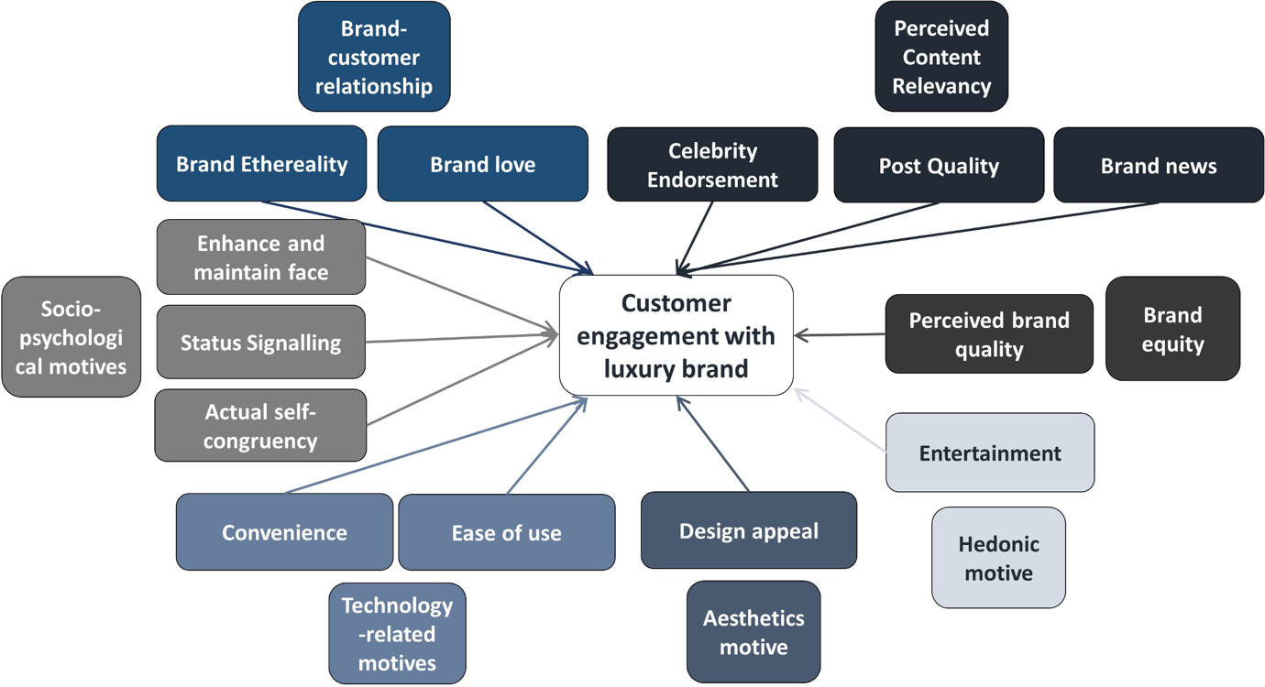

RECCOMENDATIONS TO ENHANCE BUSINESS GROWTH IN THAT COMPANY
If the Gucci Group wants to achieve its diminutive and continued designation purposes, they must change their management style to one that is more democratic, so the company can achieve its objectives by participating in the decision-making process. Organizations such as Zara require attaining from the organization as well in terms of policies and a great deal of quality within the or to learn new behaviours and behaviour substitutions within an organization and to use those desires to increasing of their profit.

In order to grab a larger share of the young adult market, Gucci began targeting a new customer segment. Their clothing and accessories were not only redesigned, but also their narrative was revised on an emotional level to connect with millennials. Role models and Instagram were used instead of traditional runway shows.

Gucci began targeting a new customer segment to capture a larger market share among young adults. As well as redesigning clothing and accessories, the brand revision its narrative to connect with millennials on a deeper level. Rather than traditional runway shows, role models were used.

Blockbuster stories about a successful brand transformation are common in the fashion industry. In direct proportion to the millennial generation, Gucci is currently selling 50% of its products to them.

In order to align with the brand image even better with millennials, the brand is working to build even stronger relationships with them. AI is now being implemented in a variety of areas at the fashion house.

Their retail outlets use it to predict sales, but most importantly, their tech-savvy audience uses it to collect data. Gucci predicts fashion's future based on its understanding of its customers' behaviour.

WHY “GUCCI”?
The hardest challenge Gucci had to overcome in order to be successful and unique was to tell a different and compelling brand story. As soon as Bizzarri began working with Gucci, the company focused on building brand equity. Luxury brands are the only ones that have mastered storytelling as one of the key drivers of greatest value creation.

The departure of Tom Ford and Pizzarri resulted in Gucci's position in the market becoming too vague and comparable. The situation has altered recently. With artistic mastery, advertising, and in-store experiences there's now a clear, cohesive brand attitude expressed through artistic expression.
For Chinese consumers, especially, this helps create a unified brand message because the brand personality Gucci has created appeals to them much more than similar brands in other regions.

The importance of the story behind the product is often ignored by brands that focus too much on the product. Its creation, definition, and execution. It is a challenge for brands to focus on storytelling without becoming vulnerable to 'one-hit wonders'.

In the history of brands, Gucci was the first to make their story as important as their product. As a result, all the big brands began copying Gucci's example because it is unique.

REFERENCE LIST
Forbes, (2020). Gucci [online]. | Forbes
Schein, E.H. and Schein, P. (2017) Organizational culture and leadership. Fifth edition. Hoboken, New Jersey: Wiley.
Statista (2020). Topic: Gucci. | Statista
Hofstede Insights (2019). Organizational Culture. Available at: https://www.hofstede-insights.com/models/organisational-culture/
Hofstede, G., & Minkov, M. (2005). Cultures and organizations: Software of the mind (Vol. 2). New York: Mcgraw-hill.
Danny & Daft Management (2009, p. 370)

