1402171
Lauren Jane Boswell
ECAY6005
Assessment 2
Portfolio

Identify 4 images which represent families in the 21st century. Then compare and contrast these images to explore, in depth, how social media can influence current representations of family within society.

Table of Contents
How does Social Media influence current representations of family within society? 3
Appendix 1 (Image 1) 4
Appendix 2 (Image 2) 5
Appendix 3 (Image 3) 6
Appendix 4 (Image 4) 7
Reference List 8

How does social media influence current representations of family within society?
Within this assignment, we will explore the influence that social media has on the family unit within society, and how it has arguably shaped us into a new realm of reality. We will look at four different pictures of ‘family’, and compare and contrast them to each other, viewing how social media has influenced them in different ways. The first image (appendix 1) is a family at the dinner table, where the use of technology and social media is evident at the dinner table and the child is sat there. The second image (appendix 2) is the entire family sat on their phones. The third image (appendix 3) is a child gaming excessively, and the fourth (appendix 4) is a child in distress being videoed by their parents producing blogging videos online. We will explore, in depth, how each family member may have been affected, how it affects them with evidence, and compare and contrast each picture.
Firstly, the meaning of ‘family’ is a social construct, and has a different meaning to each individual for various reasonings and factors of which contribute. Diverse family structures are now evident, due to several factors. And each era legitimises a particular version of family. If we delve into the history of family, it has been demonstrated by researchers that we as a society move with the social ideologies of family that are forever changing. Trask, B (2010) argues that ‘when it comes to the study of families, we need to acknowledge that conceptions of space and time are in the process of transformation and that this influences our understanding of family processes’.
Furthermore, it’s very surreal to think what humans would be doing currently without the internet and social media. It has been integrated into our daily lives, and for most of us, it is a vital aspect of their life. Maryville University (2020) states that ‘the evolution of social media has been fuelled by the human impulse to communicate and by advances in digital technology. It is a story about establishing and nurturing personal connections at scale’. It is understandable that society will make use of social media for communicating with others whilst impossible to otherwise see each other for geographical reasons. For example, video chatting with family if they are too far away at that moment in time. Merriam-Webster Dictionary (2024) also states that ‘forms of electronic communication (such as websites for social networking and microblogging) through which users create online communities to share information, ideas, personal messages, and other content (such as videos). Within the 21st century, the use of the internet and social media has become of use daily for a lot of us. Forbes (2023) states that ‘The average person spends about 145 minutes on social media every day’ and that ‘time is a precious commodity. So, it’s significant that the average person globally spends a significant portion of their day—about 145 minutes—on social media. Interestingly, Americans fall slightly below this average, clocking in at 2 hours and 7 minutes daily’. Research shows that that the statistics of internet and social media usage is higher in the United Kingdom than in the USA. Social media can be used in a positive way to promote a business, raise awareness of mental health, and provide a community for those that don’t feel as though they have a voice, or are alone and/or vulnerable; but it can also be overused, and used to the advantage of individuals with ill intentions.
Firstly, within the first image (appendix 1), you can see a mum and a dad with their child sat at the table. Both parents are using their mobile phones for, albeit we expect the usage of social media and the internet. The child has seemed to have no obvious facial expression, which could suggest that he is very aware and used to this dynamic – even at the dinner table. This dynamic of suggested neglect could have a severe detrimental effect on a child’s mental health and wellbeing. This addiction could take over their personalities and have an impact on everything that they do. This also applies to image two, and four (appendices 2&4), although in different ways, the effects would arguably be the same. Forbes (2023) argues that ‘It’s time we stopped trying to make a profit on kids’ developing brains. For the first time in human history, we have given up autonomous control over our social relationships and interactions, and we now allow machine learning and artificial intelligence to make decisions for us.’ This is the state of society now and would never have been evident prior to the epidemic of social media.
Furthermore, for arguments sake, we can presume that this dynamic is apparent throughout the evening, therefore, displays that the parents are only interested in their phones, and not the child. The child may well feel lonely and have low self-esteem issues, and not feel as though he fits into his own family dynamic. This could have a direct impact on his childhood and leave him feeling withdrawn. The American Psychological Association (2022) argues that ‘As children and teens increasingly go online for entertainment and connection, parents, scholars, and policymakers are concerned that young people’s biology is making them particularly vulnerable to and in some cases, even exploited by social media’.
In comparison, image 2 (appendix 2) shows all family members are using their mobile phones. It would have been taboo for a child of that age to own a mobile phone at that age when most of us were young, but it is most children now own or have access to mobile phones, the internet and social media. Similar effects in images 2 and 4 (appendix 2 & 4) will be apparent regarding mental health from social media usage, or the backlash of extreme usage. If the children are using the internet, they can also become addicted to usage, alike adults. Further research shows how this biological vulnerability plays out in the lives of children and teens. ‘Younger social media users are more likely than older ones to have body image issues, while kids who use Instagram or Snapchat before age 11 face a higher risk of online harassment.’ Saiphoo, A. N & Vahedi, Z (2022). As children will aspire to be like their parents, therefore resulting in a learned behaviour. This is the future. Alike the first image (appendix 1), the child could also be feeling alone and neglected but mirroring her parents’ behaviours to fit into the family dynamic and not feel like an outsider.
Furthermore, whilst the child in the first image (appendix 1) has security and innocence, the child in the second picture (appendix 2) may not have her internet usage monitored and therefore be susceptible to online scams and sexual predators. This could be apparent to all four images provided. The Innocent Lives Foundation (2024) states that ‘we explained the connection between connecting anonymously through gaming sites and how predators hide behind false identities to groom children. It is shocking and utterly repulsive, but that is not the only place it happens. Predators do the same thing on social media. Some of the most popular social media sites including YouTube, Snapchat, Instagram, and WhatsApp are not immune to predators. Each outlet offers different services, but they all present different opportunities for dangerous activity’. This could also be evident in image 3 and 4 (appendices 3&4), as it is easy for online predators to engage with vulnerable adults and children by making fake profiles and presenting themselves as a child.
Additionally, image 1 and image 2 (appendices 1&2) displays the social norms of daily life today. In previous years, prior to the 21st century, social media or the internet were not yet invented, and this setup, or dynamic at the dinner table would not be evident. Apparent to social norms, a family would sit and have dinner together and discuss most things, and more common questions like, ‘how was your day?’. We as a society have become addicted to our mobile phones, and therefore displays a vision of the dark side of social media.
The effects on the parents’ mental health could also be evident. Extreme usage of social media and the internet can lead to very unpleasant symptoms. Ivanova, V (2024) argues that ‘the signs and symptoms of social media addiction include excessive time spent online, preoccupation with social media, anxiety or irritability when unable to access online content, using digital platforms as a coping mechanism, loss of control over internet usage, constant need for validation, spending less time on hobbies and activities, neglecting time with others to stay online, and allowing social media to interfere with life responsibilities. The causes of social media addiction are instant gratification, low self-esteem, loneliness and isolation, fear of missing out (FOMO), and algorithm-driven engagement.’ This could then lead to a continuous cycle where the children will learn the same behaviours and see it as a ‘norm’.
Furthermore, image 3 (appendix 3) shows a boy playing a games console in his room, hibernating from his family, and isolating himself. This could be the same as the child in image 1 (appendix 1), meaning they are isolated. ‘Video game addiction (internet gaming disorder) is characterised by severely reduced control over gaming habits, resulting in negative impacts on daily functioning, including personal, social, educational and occupational responsibilities. While millions of people play video games, only a small percentage develop video game addiction.’ Cleveland Clinic (2024). It is also suggested that ‘researchers estimate that video game addiction affects between 1.7% and 10% of the U.S. population. The estimated range is large because many researchers disagree on the diagnostic criteria for internet gaming disorder.’ Cleveland Clinic (2024). It seems in this image (appendix 3) that his parents don’t understand what is happening, and it shows that the boy is spending all his time in his room, and the parents are looking through his window to check on him. Cleveland Clinic (2024) states that ‘Video game addiction can affect children, teens and adults, although adults are most likely to have this condition. People assigned male at birth are more likely to have video game addiction than people assigned female at birth.’ This is interesting in comparison to image 2 (appendix 2) as a young girl is also playing on her mobile phone, or even playing a game. Research shows that a gaming addiction is a real recognised illness, and that there is treatment available for those that inherit this diagnosis. Willacy, H (2023) argues that ‘there is currently a lack of very strong evidence on the best treatments for gaming addiction. The most widely used psychological help has been cognitive behavioural therapy. Other approaches, including family therapy and motivational interviewing, have also been used. Treating gaming addiction is based on an assessment of each individual person and the severity of their gaming addiction. The aim of treatment is usually to help the person completely avoid gaming because even a small amount of gaming may steadily increase back to a problem in a person who is susceptible to gaming addiction.’
Next, image 4 (appendix 4) represents a distressed child that is being filmed online by his parents. This parenting style is questionably unethical and is also questionable whether the child should be able to give consent when placed in a vulnerable position online. Obviously, a baby can’t speak yet, let alone give consent, so who is responsible for this? Given it is of the parent’s discretion whether they decide to post videos or pictures of their child online, but who says that this circumstance is ethical or morally right? This image seems to be exploiting a child and their rights to a happy childhood. As a parent, their job is to protect their children and keep them safe from risk and harm of others. This image certainly isn’t a display of protection. Babies and children that are posted online are not able to consent for themselves whether they want to be posted online or not, and they are very vulnerable and could be susceptible to abuse and paedophilia. NSPCC (2024) states that ‘if safe processes aren't in place, photos and videos may be shared outside of your organisation or posted online without prior consent from children and families. This could lead to safeguarding risks such as: images being modified or misused out of context, for example to create child abuse images, a child being identified for the purpose of future grooming and abuse, a vulnerable child being identified by an existing perpetrator of abuse.’ It is very clear that parents are arguably more interested in the money-making scheme of social media and the internet, rather than the safety and wellbeing of their children. Social media can be used in a positive way to make money and create a successful and comfortable life for your family, but at what cost? In image 1 (appendix 1), the parents look successful, although the child still does not look happy. Creating this kind of content fundamentally alters the child’s relationship with their parents. It isn’t the kind of dynamic that is the social norm. Arguably, today, this is a social norm, and that technology is the way forward to provide better things. Referring to image 1 (appendix 1), this child does not look happy and probably doesn’t have a great relationship with his parents – is this realistically better? Being involved in a ‘day in the life’ vlog as a child can be extremely exhausting and could be seen as a job that they didn’t even agree to. Reilly, M (2023) states that ‘other family vlogging channels have taken their exploitation a step further by taking advantage of their children’s hardships. One of the most infamous examples of this phenomenon is 31-year-old family vlogger Jordan Cheyenne; after finding out that their dog was severely sick, Cheyenne recorded a video of herself and her son in the car as she tried to comfort him. She then proceeded to accidentally upload the raw footage of this video, which shows her trying to make her son pose for a thumbnail as she pretends to be crying. When she tells him to pretend to be crying, he responds “Mom, I’m actually, seriously crying,” as she continues to find the right angle for the thumbnail of her video.’ This demonstrates how blurred the lines are between parents and employer.
To conclude, we have established that social media represents the current representation of families in many ways. Single mothers that vlog and are involved in the monetary use of the internet to provide for their children. Parents that are successful business owners, promoting and sharing their business online for new ventures and opportunities. And a child that can sing and wishes to be the next talented star. All of these examples are valid, but the dark side of the internet and social media has taken over to the extreme. Any person is able to gain access to use these platforms to financially gain from abuse of their children, or wrongfully begging. Dangerous people can make fake profiles posing as children to try and exploit and abuse vulnerable adults and children. When parents are too invested in social media and are neglecting their children, or people using the internet to hibernate or isolate from bullying. All the reasonings above display that we as a society use social media and the internet as a false reality to hide and feel safe behind a computer. Research has shown that extreme use and addiction can cause a lot of mental health issues and can have a colossal impact on not on the individual, but on the family unit. Social media can be seen to push the family ideology backwards often, rather than forwards.

Appendix 1 (Image 1)

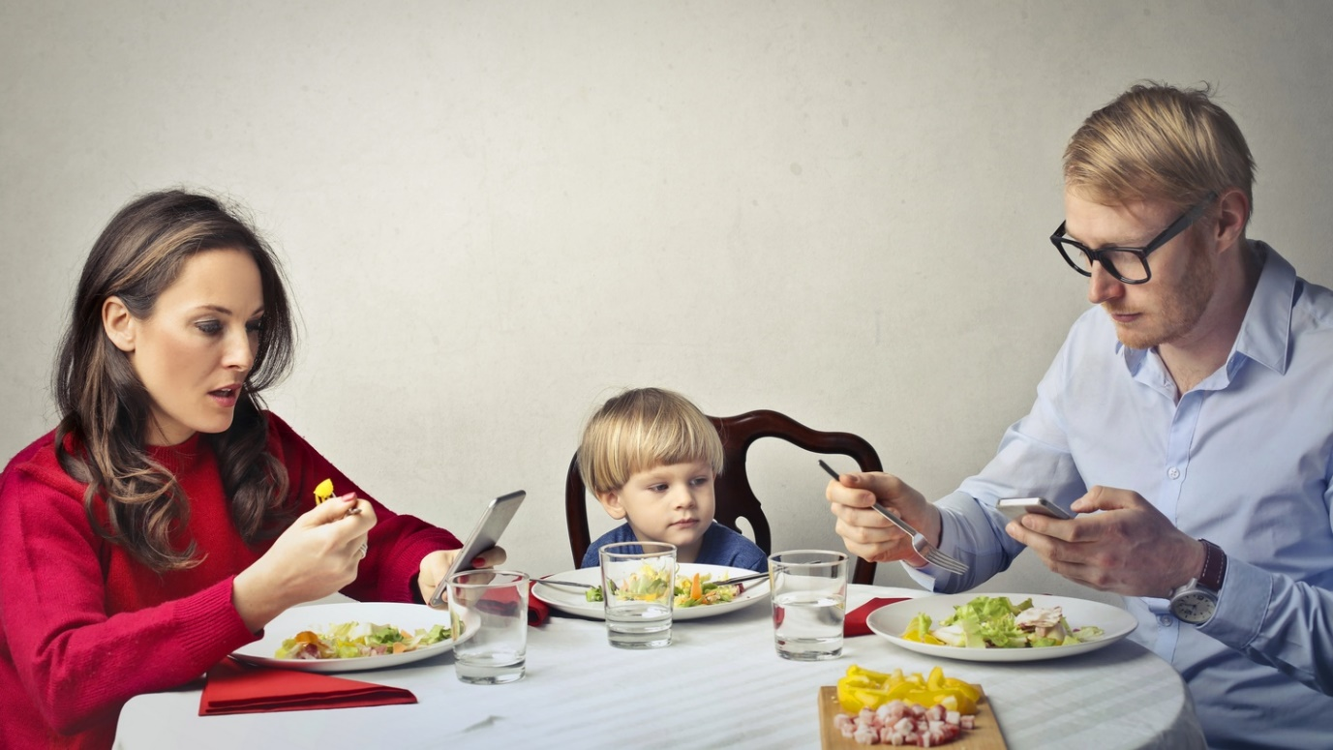
The Irish Times (2018)

Appendix 2 (Image 2)


Spencer, C (2024)

Appendix 3 (Image 3)


Shutterstock, (2020)

Appendix 4 (Image 4)

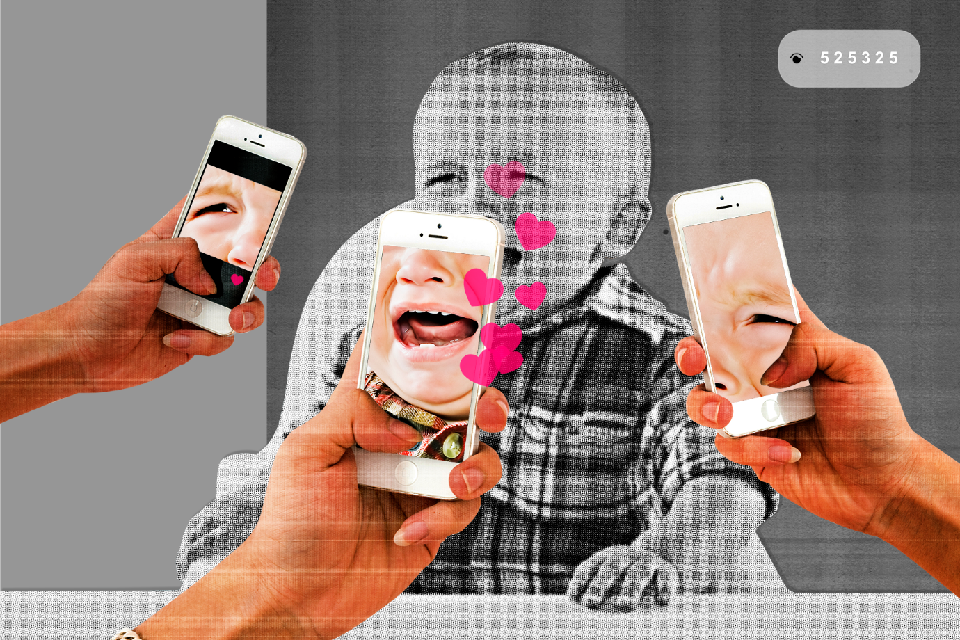
Latifi, F, Cosmopolitan, (2024)

Reference List

Abrams, Z. (2023). Why young brains are especially vulnerable to social media. [Online]. APA. Last Updated: 2023. Available at: Why young brains are especially vulnerable to social media [Accessed 19 December 2024].
Cleveland Clinic. (2024). Video Game Addiction. [Online]. Cleveland Clinic. Last Updated: 2024. Available at: https://my.clevelandclinic.org/health/diseases/23124-video-game-addiction [Accessed 19 December 2024].
ILF. (2024). How Predators Have Infiltrated Social Media. [Online]. Innocent Lives Foundation. Last Updated: 2024. Available at: https://www.innocentlivesfoundation.org/how-predators-have-infiltrated-social-media/ [Accessed 19 December 2024].
Ivanova, V. (2024). Social Media Addiction. [Online]. The Diamond Rehab Thailand. Last Updated: 2024. Available at: https://diamondrehabthailand.com/what-is-social-media-addiction/ [Accessed 19 December 2024].
Latifi, F. (2024). The Parenting Influencers Who Won’t Stop Posting Their Children. [Online]. Cosmopolitan. Last Updated: 2024. Available at: https://www.cosmopolitan.com/lifestyle/a60115669/why-family-influencers-post-children/ [Accessed 19 December 2024].
Maryville University. (2020). The Evolution of Social Media: How Did It Begin, and Where Could It Go Next?. [Online]. Maryville University. Last Updated: 2020. Available at: https://online.maryville.edu/blog/evolution-social-media/ [Accessed 19 December 2024].
Merriam-Webster Dictionary. (2024). Social Media Definition. [Online]. Merriam-Webster Dictionary. Last Updated: 2024. Available at: https://www.merriam-webster.com/dictionary/social%20media [Accessed 19 December 2024].
NSPCC. (2024). Photographing and filming children. [Online]. NSPCC Learning. Last Updated: 2024. Available at: https://learning.nspcc.org.uk/online-safety/photographing-filming-children#:~:text=If%20safe%20proce [Accessed 19 December 2024].
Quinlan, A. (2018). How technology and social media is undermining family relationships. [Online]. The Irish Times. Last Updated: 2018. Available at: https://www.irishtimes.com/life-and-style/health-family/parenting/how-technology-and-social-media-is [Accessed 19 December 2024].
Reilly, M. (2023). Family Vlogging: Blurring the Line Between Parent and Employer. [Online]. The Science Survey. Last Updated: 2023. Available at: https://thesciencesurvey.com/editorial/2023/01/18/family-vlogging-blurring-the-line-between-parent-a [Accessed 19 December 2024].
Shutterstock Images. (2024). Boy Addicted Gaming Playing Night Friends Stock Vector (Royalty Free) 1805850805. [Online]. Shutterstock. Last Updated: 2024. Available at: https://www.shutterstock.com/image-vector/boy-addicted-gaming-playing-night-friends-1805850805?conse [Accessed 19 December 2024].
Spencer, C. (2024). 6 Psychological Triggers Behind Social Media Addiction. [Online]. ARO. Last Updated: 2024. Available at: https://www.goaro.com/blog/6-psychological-triggers-behind-social-media-addiction [Accessed 19 December 2024].
Trask, B. (2010). Globalisation and Families. USA: Springer. pp.1-98.
Willacy, H. (2023). Gaming Addiction: Symptoms and Treatment. [Online]. Patient Info. Last Updated: 2023. Available at: https://patient.info/mental-health/gaming-disorder-gaming-addiction [Accessed 19 December 2024].
Wong, B. (2023). Top Social Media Statistics And Trends Of 2024. [Online]. Forbes. Last Updated: 2023. Available at: https://www.forbes.com/advisor/business/social-media-statistics/#social_media_usage_statistics_secti [Accessed 19 December 2024].

