Practical – Evidence
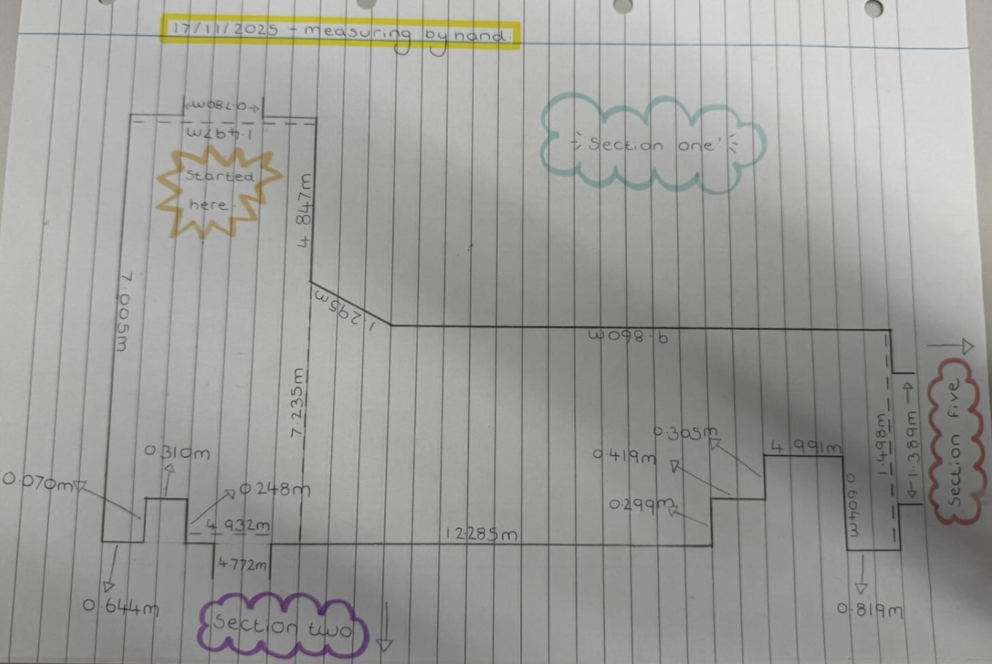

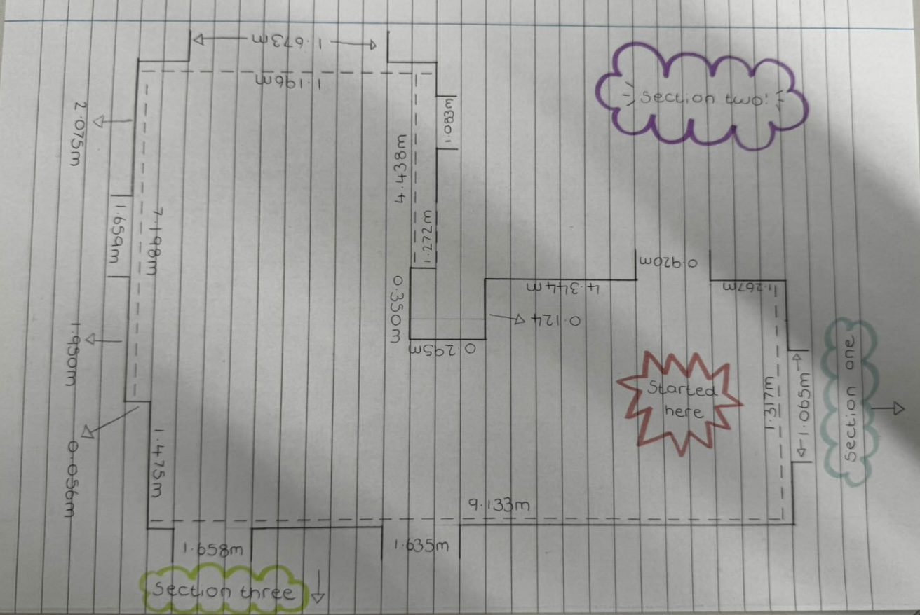

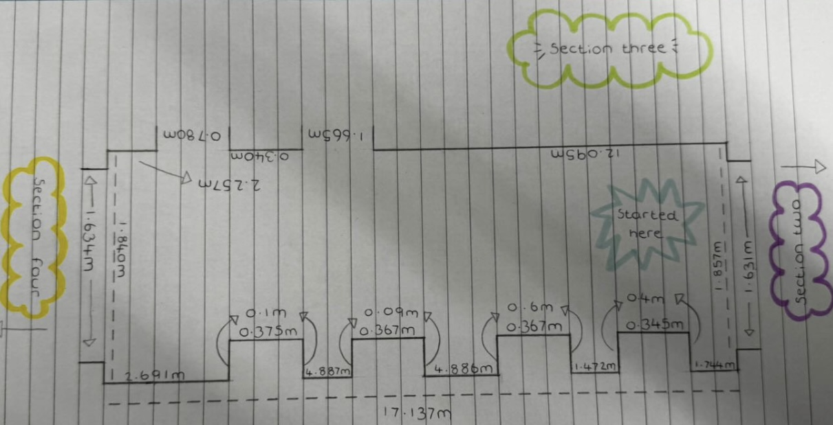

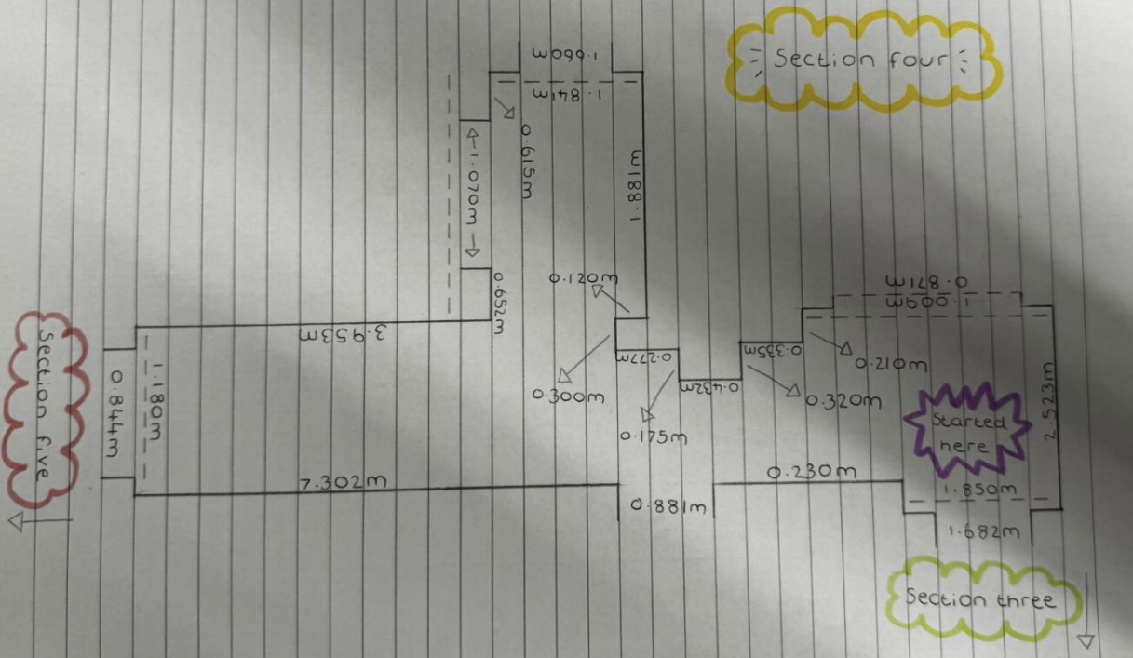
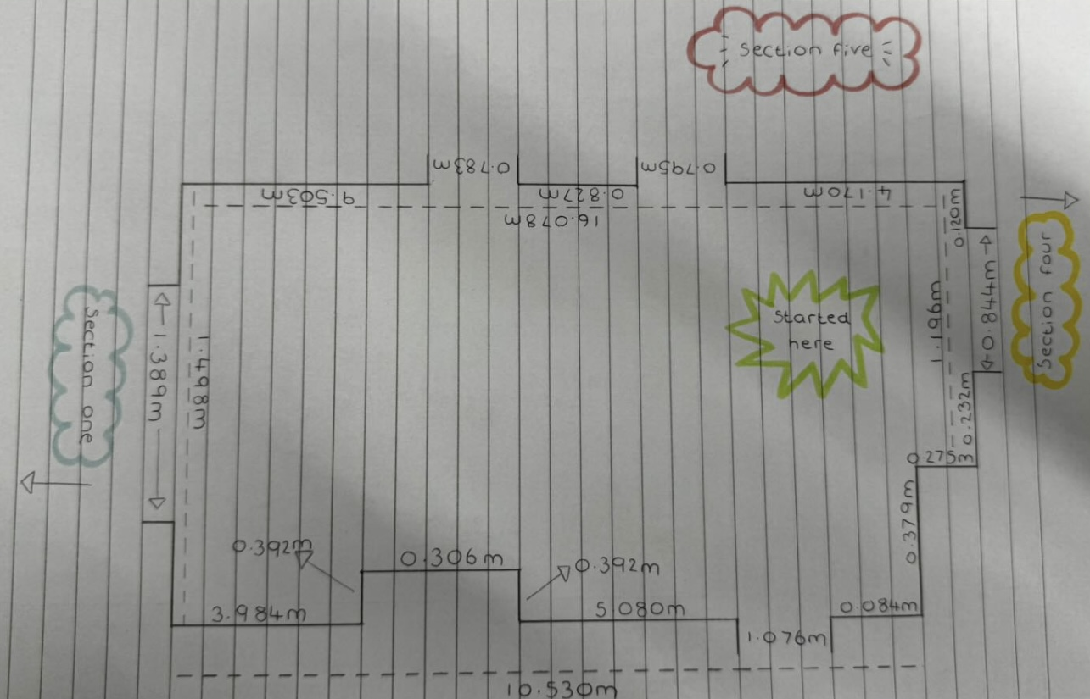

Survey Execution Summary
The survey using laser scanning went mostly to plan as we were able to scan the whole floor and obtain accurate measurements of the buildings interior which we can use to create an accurate floor plan and drawing of the buildings top floor. The time frame in which it took us to complete was as intended, as it took us roughly 1 hour 30 minutes to complete which was on schedule. However, I was not able to provide evidence of the scans and laser scanners in work, therefore I have also completed hand drawings which were done using hand measurements as another example of data and measurements of the top floor, though possibly not as accurate as the measurements which would have come from the laser scanners. We also had to change the number of scans we took to a higher amount to make sure that the pictures and measurements that we were receiving are up to a good standard and as accurate as possible.
There weren’t many major issues which occurred during the survey as it was mostly a straightforward task. One minor inconvenience was that there were other people using the top floor for other purposes. This lead to continuously having to ask people to get out of the way of the scanners or waiting for them to finish what they were doing as it would have affected the data, which as a result was causing a hinderance to both us and them as they were also trying to carry out their own activities, while also slightly slowing down the process. To try and counter this we tried to avoid the pedestrian’s path as much as possible to prevent our data being affected and to prevent the process from being slowed down too much as we would not have had enough time to complete it otherwise. On the other hand, the hand measurements didn’t encounter as many hinderances, however the process did take significantly longer overall in comparison to using the laser scanners as each wall, window, door, out cove etc had to be measured individually with a lot more room for error.
Overall, the process was a success as a whole and we were able to obtain accurate and detailed data and measurements of the top floor of the Dylan Thomas Centre in Swansea which allows us to create detailed and accurate drawings which include accurate measurements; therefore, the practical was an overall success.

