

Professional Career Development

Mohammad Anamul Haque

Student Id:
1706731
Teacher name: Sylvia Hoffmann

Table of Contents
Introduction 1
Self-evaluation review 2
Personal development planning 5
Personal strengths and weakness 5
Johari window model 7
SMART objectives 9
Review of your understanding and expectations of the world of employment 11
Career ambitions and aspirations 13
Personal Development Plan 14
Relevant procedures and employment legislation 17
Employment procedures 17
Employment legislation 18
Conclusion 20
Reference 21

Introduction
After completing graduation, I was seeking a job that will develop my professional skills and now I am an assistant manager of an organisation. My family and teacher supported me to get my expected job. I was thinking about what to do next when I graduated. Then I consider the lifeline exercise which helped me to think about what I did in the previous job and why I was unsuccessful. I draw my own lifeline where I included my first grade, summer job, the reason of unsuccessful etc. I founded that I needed some development in my professional career which can help me in future employment. Here I will discuss my strength, weakness, development planning, career ambition and aspiration, self-evaluation, employment legislation and procedures.

Self-evaluation review

Self-motivation: Becoming a successful person need personal and professional career development where motivation is needed, discussed by Appavou (2014). Sometimes, I felt that success will not come in my life and then I find motivation from me, my family and other people. Deci and Ryan developed a self-determination model which helps to get three basic needs of human life.
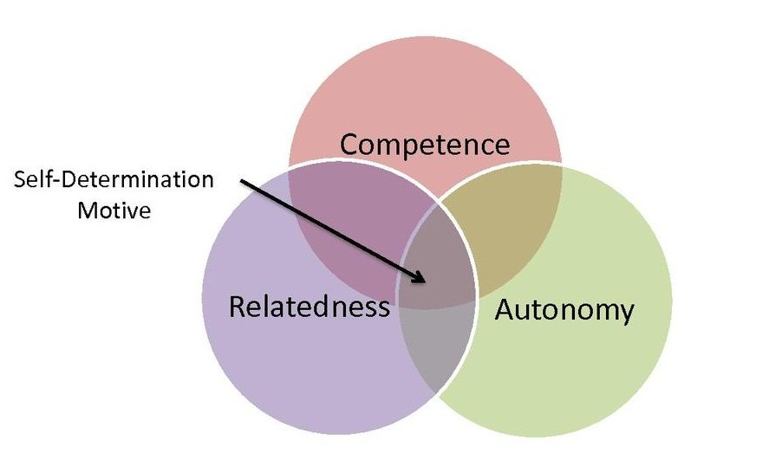
Figure 1 Self-determination model of motivation
Source: (Selfdeterminationtheory.org, 2018).
Autonomy: I also felt independent when I was working and controlling my behaviour. As an assistant manager, I was able to make my own decision and controlling employee. This helped me to make a decision in a critical situation independently. This motivated me to learn something new from the workplace and employee about how to control myself behaviour and making a decision in the different situation.

Competence: I was able to develop my skill while working and learning from school. Developing supremacy over task and building competency was important to me. So, I learnt from the working situation and made my achievement. When several unfavourable situations came, I was feeling like lost the path. But with the skill and determination, I solved the entire problem in my career development. This increased my knowledge and achievements. Now, I am able to control the outcomes of working activities that is needed in my professional career development.

Relatedness: Bérard (2013) discussed that every people should care about other so that they can be connected and share their experience. I also have connectedness with the employee and other people related to my life. They influence me to develop myself and my professional behaviour. I am concern about making a connection with other people because I know that each people may need in my life in the future. Making good relation with every people is difficult is the workplace. I treated them with cordially and this helped to have a good impression of them toward me.

Learning styles: I get the chance to learn new things from my workplace while operating the organisational activities. Mainstone (2012) the learning style is different for each situation. I learnt using the Kolb learning style model where four learning style has been referred. According to him, the person behaviour depends on their experience and background as well as the learning style is not same.

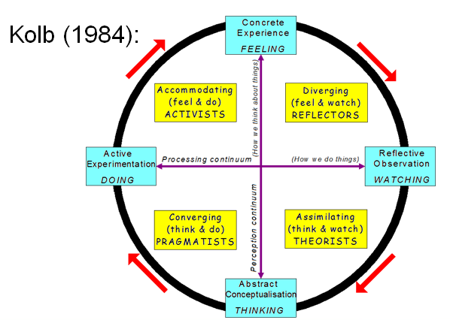
Figure 2 Kolb's theory of learning style
Source: (Verywell Mind. 2018)
Diverging: These kinds of people view the concrete situation and observe other perceptions. I learned from an imaginative approach as well as get learning from experience and other’s feelings. I observed the situation as what the group members think about me. I like brainstorming about any problem and cooperative work. I was responsible for making a decision and I have to manage the conflict. I learn to manage time properly, decision making, being responsible and managing people.

Assimilating: These types of learners are skilled in reflective observation and creating model and theory. I observed the different situation and made the judgement which was interested in me. I also did some experiment on the different situation which leads me to a successful project. I tried to being concerned about practical theories. Typically, I like math which leads me to be an assimilator and planning for the project.

Converging: This learning style allows to practice on the practical application of problem-solving. I had to make a decision, solve the problem and innovating ideas which need experiment and conceptual ability. I find the best solution to the problem by practising practical application and analysing the ideas.

Accommodating: This learning style helps to have the ability to influence people and taking the risk. I take the risk while completing the project and making a decision. I used a trial and error approach while solving any problem. As a manager, I had to observe the sales and marketing department as well as making the decision for them. So this learning style helped me a lot as this is action based and active experimental. When need to change any situation, I used this learning style to adapt to the situation.

Personal development planning
Moore (2017) defined that personal development planning helps to develop a professional career which is much needed in future life. For personal development planning, the strength, weakness and setting objectives is crucial. They are discussing below-

Personal strengths and weakness
While working in the organisation with the team, I found some strength and weakness of mine. After evaluating them, I felt that I should work on my weakness and hold the strength. The weakness and strength that I found while working it showing below-

Strength:

Technological skill: I have some skill like computer skill, MS Word, Excel, Access; projector operating, IT, tools etc. These skills helped me a lot to work with other employees within the organisation. This is the strength of mine as well as will give an advantage in future career.

Communication skill: This is the most crucial skill that is needed to communicate with people. I can communicate with other employees effectively by sharing the information and personal feelings. This skill worked for me as a strength because to control and working with employee proper communication need.

Motivation: As a manager, I also have to work as a motivator for my employee. Some employees worked with enthusiasm and some employees were not giving their full effort at work. So, I had to motivate them to work to achieve the objectives. The motivation techniques were depending on employees demand and need.

Leadership: I have to work as a leader also because the employee was working on my guideline and leading. I am able to control and lead people knowing their perception and need. I practised different leadership style and finally, I know that how to delegate people well.

Weakness:

Time management: I have less ability to manage time while working or projecting. But this is the most important skill that is needed otherwise hard work can be lost in vain. This is my weakness that I have to improve to use the time in an efficient way.

Conflict management: while working with group or team several problems came in a different way. I solved the entire problem but I think that I have to lack this skill. Because the decision that I was made, taking a long time. That led to increasing the conflict among group member.

Deal with changes: Every situation comes with some changes in the working area and this should be adaptable by the employee, elaborated by Rogers (2007). But I have not much adaptability to deal with changes. I think this is my weakness that I have to recover.

Negotiation: This is a strategic decision to resolve an issue that will accept as well as benefit both parties. In this case, I am not able to make this kind of decision and I was taking help from seniors. So I should recover this weakness through training from seniors.

Johari window model
Borg et al. (2010) discussed that Johari developed a model of enhancing the individual perception that consists of two ideas of trust and learning. In the Johari model, two parts represent the unknown to others and self. Other two parts represent the known to others and self. Using this model, my learning style can be reviewed. I shared the information with group members through mutual trust achieving socialisation and feedback from other.
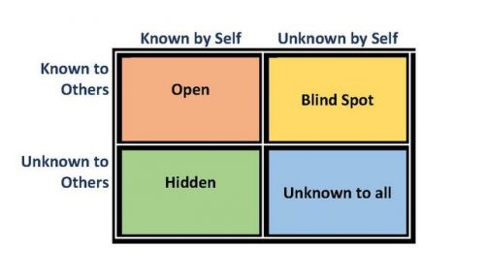
Figure 3 Johari Window model
Source: (Verywell Mind. 2018)
Open arena: in this area, I was able to know the information of the behaviour, skills, feelings, attitude of mine and by others. Here, the communication among me and other member occurs and the relationship becomes dynamic and effective. I got feedback from other through socialisation and feedback process. This was most effective learning style in my workplace sharing everyone’s feelings.

Blind spot: Here, my group members were known about me but I was unaware of it. Some members treated me differently and that was unexpected to me. Sometimes, their behaviour hurt and surprised me and I was leaving in dark. In a positive sense, this leads me to develop my behaviour because I accepted it as a gift and strength. I reduced blind spot with proper communication and getting feedback from others.

Hidden area: This is the situation where the information was known by me but unknown to others. This information was personal information as feelings, secrets, fear and past experience. Typically people want to keep secret about their personal information and feelings because they feel reluctant to share, discussed by Martin (2016). Sometimes, this was good for me to keep secret as like password and secret information that should not share with others. But this leads me the causes of poor communication, embarrassment etc. I solved this problem by sharing information with others which was sharable.

Unknown area: This is the area where I did not know about the information, talents, capabilities, personality, feelings etc. I was unaware of these because of past experience or event. Before discovering the abilities and quality, I was remaining unaware of it. I discovered the weakness and strength of by sharing the information and effective communication with others.

SMART objectives
For personal development, I determined some SMART objectives which are essential for my future career. I need to develop some skills as negotiation skill, time management skill, conflict management,

skill or ability area | specific task | measures | agreed | realistic | timings | comments/  actions
Time management | Developing time management skill | The improvement in performance will be measure in parameters measurement approach. | Yes | Yes | 6 month | I am participating in different project and trying to complete the project within time, taking appropriate decision.
Conflict management | Increase ability to manage critical conflict | The conflict management will be standards measurement | Yes | Yes | 3 month | I am working within a team and taking training about how to develop the conflict management skill.
Negotiation | Become a good negotiator that will benefit both party | To measure the improvement of this skill, there need standards measurement. | Yes | Yes | 3 month | I will participate in development program soon to develop this skill
Leadership | Becoming a good leader | To measure this skill, there need standard measurement method. | Yes | Yes | 1 year | Getting development program and working with team will help to improve this skill.

Review of understanding and expectations of the world of employment
After completing graduation, the main target becomes finding a suitable job that will fulfil the human basic needs giving recognition in society. After the internship program, I also had that expectation in my life. I did an internship program from a reputed organisation and benefited a lot from my professional development. After that, I was looking for a prestigious job which will improve my personal skill and benefit me financially. With my skill and ability, I become the manager of an organisation as I was expected.

While interviewing in a different place, I found that there is lots of employee with their ability and skill in finding a job like me. Then I realised that how tough the employment world is. I applied to several organisations and invited for an interview. But in some organisation, I shorted out because of competition in the employment market. All unemployed people want a prestigious job and they are fighting with their ability and skill in having a good position in the job market.

I found that several organisations discriminating with the applicant when interviewing. Most of the organisation were selecting employee based on a recommendation, not analysing the skill. Some organisation’s viva board were hard on applicant because of shorting list. They were taking experienced as well as the skilled employee who worked around 2/3 years as a corporate employee. As I was new in the job market after internship and a part-time job, I rejected by many organisation not being qualified.

Finally, an organisation selected me as an assistant manager seeking my skill, ability and qualification. I needed some skill to reach in that position and they are-

Delegation skill: While doing an internship program and working in a team, I got a chance to developed my delegation skill. This helped me in my interview while having a conversation with judges. The interviewer team noticed my skill when communicating with them.

Communication skill: This is the most crucial skill that is needed in every aspect of life as well as in professional life. I was able to properly communicate with the judges on the interview board. Proper communication skill helped me to express my feelings and thoughts to judges.

Problem-solving skill: This skill needs in personal and professional life and also in my interview. The judges gave me a situation and asked what I could do. I gave an appropriate answer to the judges considering the situation because of my problem-solving skill.

Interpersonal skill: This is needed skill for any person who wants to be a HR manger. The interpersonal skill helps to have a good impression of judges. These skills are a positive attitude, showing appreciation, body language, self-confidence, listening etc.

Leadership skill: To become a manager this is the most important skill because a manager has to lead employee. Appavou (2014) discussed that the manager has to give guidance and an outline of the path to the employee. Leadership skill helps to lead an employee based on their preference, culture and need.

Career ambitions and aspirations
I choose to become a Human resource manager in my career because of some reason. Bérard (2013) discussed that the HR manager gets opportunities to develop their skill more than other employees. They are able to do different initiative and things that will help me to improve my skill and knowledge. They are more responsible to recruit, select, appointing and train employee. HR manager control other employee and evaluate their performance. All the employees work and treat other in a professional way which is the most attracting things to me. The organisation ranks the employee performance and gives the reward to the best employee. Because of this, the employee can recognise their performance.
HR manager work as motivator to employees which helps to innovation new things and performance better to get the best employee reward. The employee can learn from the HR manager as how to work with full dedication. The HR manager knows the value of work and influences other working as leader which helps to develop career more. The HR manager knows how to work hard and develop the career that is why my ambition and aspiration is becoming a HR manager.

Personal Development Plan
As my ambition is being a HR manager, I need personal and professional development to achieve my objectives. I in a reputed organisation as an assistant manager and did my internship program. From that, I learnt lots of thing about professional life as well as get a chance to develop my skill. I made an action plan that will help to improve my weakness.

What do I want/need to learn? | What will I do to achieve this? | What resources or support will I need? | What will my success criteria be? | Target dates for review and completion
Time management | Improving this skill, I will participate in different project as well as will try to finish the project in appropriate period. | Getting chance of project management, guidance from seniors and dedication. | Record keeping and analysing, getting feedback from seniors | 6 month
Conflict management | I will develop this skill through working with team and training. | Training program, team members and seniors support | Group performance and feedback collection | 3 month
Deal with changes | I will practise on different theory on how to deal with changes and receive development program. | Guidance from senior, training program and continuous measurement. | Getting feedback | 6 month
Negotiation | Through training and participating in development program, negotiation skill needs to develop. | Need change to deal with parties and development program. | Performance measurement | 3 month

Recommendation
Personal development helps to develop the personal skill and ability as well as professional development. There have some findings of personal skill gap that need to recover. Becoming a HR manger, the leadership, negotiation, problem-solving and deal with changes much important. Training program should take to enhance the skill that has been identified. Personal development action plan will help to develop the skill within a specific period.
The employee legislation and procedures also have to know by the employee to get their right. Practising practical application in working place will help to develop personal and professional skill. Every personal development plan should consist of a specific period, realistic thought and dedication to improving the skills and ability. Borg (2010) discussed that the employee should have strong interpersonal skill so that they can get a good impression from others.

Relevant procedures and employment legislation
The employment procedures and legislation that an organisation have to follow is discussing below-

Employment procedures
For employment in an organisation, there need to follow some procedures by a manager. Their employment procedures are given below-

Requirement: At first, the manager has to prepare a required form for the applicant. In the requirement form, the manager has to include the responsibility and specification of the job. The manager has to analyse the job to find the job requirement.

Analysing applicant qualification: After job specification and requirement, a lot of applicants will apply for the vacant position, discussed by Mainstone (2012). All of them will be not qualified for the job post and some of them will have the high qualification. Analysing the qualification of applicants, the manager has to select an applicant for an interview.

Interview: This is the stage of communicating face to face with interviewer and candidates. Through interview of the candidate, most of the candidates will be rejected because of short out process. Only smart, skilled and experienced employee will be taken by the organisation for the next test.

Selection: After taking the interview, the candidates will be selected for the physical and another test if needed. By analysing the result and recommendation, the candidates will be selected. The candidates also have to experience for the job and they will be given priority most by the organisation.

Appointment: after final selection, the organisation will send an appointment letter. In that letter, there will be some offer for the candidates that will give benefits to both candidates and organisation. The candidates also need to send a confirmation letter within a specific time. Otherwise, the appointment letter will count as invalid to the applicant.

Orientation: after appointing the employee, the organisation gives orientation to the employee to inform about the organisation’s culture and ethics. Every organisation has some rules and regulation that an employee has to maintain, mentioned by Moore (2017). In orientation, the assistant manager introduces their rules and regulation to the employee.

Training: This is the program that given to an employee if they need any skill related to their work. This program helps to develop the skill and ability to perform their job. The organisation provides a training program to the employee analysing their performance gap or lacking skills.

Employment legislation
In an organisation, there need to follow some legislation in the case of employment. These legislations are-

Health & Safety at Work Act 1974: this act refers that the organisation will ensure the employee safety, health and welfare at work. According to Rogers (2007) the employee will get protection from risk and organisation will be aware. This law established to keep control over working place preventing dangerous circumstance.

Employment Rights Act 1996: This law established for ensuring employee rights in 1996. The employee will know the reason for dismissal and the organisation cannot dismiss without reason. Redundancy payment, wage, timing of work etc. is the considering issue of this act.

Data Protection Act 1998: According to this act, the personal data employee will be secured and secret by the organisation on the computer through the filling system. One employee cannot use other employee’s data without their permission.

National Minimum Wage Act 1998: According to this act the employee will get at least minimum wage in the UK. The minimum wage from April 1, 2018, is per hour 7.83$ for that worker who is over 25 age, mentioned by Selfdeterminationtheory.org. (2018). For 21-24 aged workers, the wage is 7.38 per hour and for 18-20 aged workers, the wage is 5.90 per hour.

Human Rights Act 1998: This act reflects theta the employee and candidates will get right as a human. They will be not discriminated because of their gender, culture, nations and colour by the organisation and workplace.

Employment Act 2002: This act reflects that the employee will get leave rights and the workplace will be the family-friendly working place. The employee will get six months and the payment will be the same as standard paying for the maternity leave.

Employment Relations Act 1999/2004: According to this law in 1994, the employee will get grievance hearings, rights of individuals and leave for domestic and family reason. The employment relation act 2004 reflects that the employee will get minimum waged according to legislation and all the facilities that trade union announced.

Equality Act 2010: This act reflects that the employee will get equality to form the organisation and will not discriminate. The organisation will give same facilitates to all employee, not discriminating by gender, disability, race or colour of employee.

Conclusion
For professional career development, the personal skill needs to improve as it helps in personal career development. The action plan is a process of including lacking skill and a specific period to improve these skills. The employment procedures help an organisation to find an appropriate employee. The legislation of employment reflects the right and organisation’s behaviour toward the employee. In this report, self-evaluation, Deci and Ryan self-determination model, Kolb's theory of learning style, personal strengths and weakness, Johari window model, career ambitions and aspirations, Personal Development Plan, procedures and employment legislation has been discussed.

Reference
Appavou, A. (2014). Effectiveness of selection committees in making employment equity appointments at the Health Science Faculty. University of Cape Town.
Bérard, J. (2013). Accelerating leadership development. Mississauga, Ont.: John Wiley & Sons Canada.
Verywell Mind. (2018). Kolb's Theory of Learning Styles. [online] Available at: https://www.verywellmind.com/kolbs-learning-styles-2795155 [Accessed 14 Jul. 2018].
Mainstone, J. (2012). Personal development and work experience guide. Cambridge Occupational Analysts.
Moore, J. (2017). Setting SMART objectives. Headteacher Update, 2017(6), pp.14-14.
Ontario labour & employment legislation. (2014). Toronto, Ontario: Canada Law Book.
Rogers, J. (2007). Career Stories. University Park, Pa.: Pennsylvania State University Press.
Self-Awareness. (2018). Self Awareness. [online] Available at: http://www.selfawareness.org.uk/news/understanding-the-johari-window-model [Accessed 14 Jul. 2018].
Selfdeterminationtheory.org. (2018). selfdeterminationtheory.org - An Approach to human motivation & personality. [online] Available at: http://selfdeterminationtheory.org/ [Accessed 14 Jul. 2018].
THE CITY LAW SCHOOL. (2014). Employment law in practice 11e. Oxford: Oxford higher education.
Borg, H. and Ohlsson, H. (2010). Career development. New York, NY: Nova Science Publishers.
Eliason, G. and Patrick, J. (2008). Career development in the schools. Charlotte, NC: IAP.
Martin, T. (2016). Career Development. Hauppauge: Nova Science Publishers, Inc.

