MBA- Masters of Business Administration
LCMB7013
Name: Nkechi Jefia
ID No: 1714551
Module : Managing Performance
Lectuer: Rexon Nting
Date: 09/09/2022
Table of contents
Introduction 4
Overview of SainCo case 4
What is performance management?.....................................................................................5
Traditional and Modern method..........................................................................................5
New performance management approaches for the company 5
The commitment of senior leadership toward the new approach 5
Having recurrent check-ins for exchanging feedback, discussing the goals, and charting the development prospects 5
Leadership development must be for managers to boost their engagement and improve their teams 6
Investing in software and systems for delivering the needful data and insights 6
Building a performance-based culture 6
Examples of different companies adoption of new performance management approaches 6
Theoretical framework 11
Organisational and Employee Concerns 11
Depending upon outdated performance review ways 12
Emphasizing convincing the boss rather than improving the overall performance 12
Technology dependent 13
Role of Human Resource Management in managing and improving employee engagement and employee involvement 13
Engaging Employees Through Motivation and Inspiration 14
Appreciating Employees 15
Practices to support, improve and achieve competitive advantage and high performance 16
Recommendations 17
Conclusion 19
References 21

Introduction
This report is based on a case discussed with regards to the retail organisation, namely, SainCo. The report discusses improving the performance management of the company. It has hired a Human Resources Consultant to get outsourced Human Resource solutions regarding staff performance management. This report is based on identifying and critically analyzing the role of Human Resource Management in managing and improving employee and organisational performance. Moreover, the discussion involves the available practices for supporting, improving, and achieving the competitive advantage as well as high performance in SainCo.
Being a line manager, the company expects to introduce a new performance management approach for SainCo, which may address its concerns and offer a new performance management approach. In this regard, performance development planning, performance management, performance and development, and trust, manageability, and control in the company are explicitly discussed while adding supporting theoretical frameworks. These will help in justifying all the arguments.

Overview of SainCo case
SainCo tends to have an employee force that includes 2000 members. These work at ten locations. SainCo is a family-run as well as a highly traditional company that has an autocratic style of management. Moreover, to be competitive in the market, this company has recognised that there is a need to embrace modern concepts and practices with regard to performance management. Thus, the CEO of SainCo has come from a conference based on performance management instead of appraising the employees. It made her think of making changes in the company’s HRM practices whose impact could be seen influentially on the company’s performance management. Thus, she was convinced that improving performance management can be a way to enhance organisational performance and employee engagement. Verily, the CEO of SainCo thought of approaching the Consulting firm to get advice on the new performance management approach for the company, keeping in mind the present business environment as well as the goals of the company.

What is performance management?
According to,(Franco‐Santos and Otley, 2018) performance management refers to a continuing process of the communication among a supervisor as well as an employee which happens all over the year, supporting the accomplishment of the strategic objectives of the company.

Traditional method, there were no such effective performance management techniques to improve employee evaluation. The sainco company was so autocratic, and outdated. It appears to be a weak area of the bussiness. which is why CEO of sainco considered seeking assistant from the consulting firm. Employees are subjected to relative comparisons, Employees are subjected to relative comparisons, for instance, and after the comparisons, each employee is given a rank based on his standing.while
The modern method is built on encouraging employees, involving them in decision-making and planning, providing them with quality training and feedback, paying close attention to their development and been democratic.

New performance management approaches for the company
Performance management requires effective monitoring and evaluation so that things seem to be functional in a better way. However, the classic performance review is highly reviled. The employees and managers do not want it since it requires much time and energy. A CEB study discovered that, on average, managers spend 210 hours per year compiling and delivering performance feedback (Rezaei and Ortt, 2018). The ROI on such time investment seems to be minimum. The reviews are even considered castigatory or incompetent to reflect the rapid pace of business. Hence, the companies like GE, Deloitte, Gap, and Accenture realised that performance management could be combined with employee engagement (Pugna, Dutescu, and Stanila, 2018).
The best organizations have transformed their performance management while paying heed to engage and developing their workforces instead of sorting and assessing them. SainCo must learn that the performance management must be aligned with employee engagement, which tends to affect the revenue growth, level of productivity, and customer satisfaction (Helmold and Samara, 2019). This approach is inclined in some ways,

The commitment of senior leadership toward the new approach
Senior leaders must champion a continuing approach that places much focus on the alignment of the goal, development of the employees, and coaching. The leaders may progressively position the new approach to the performance management while keeping the performance management as well as employee engagement on the plan and daily discussion on them (Mone and London, 2018). It is important to invest in leadership development training for the managers in the organization for effective performance management. On their performance, they must be given bonuses on priority.

Having recurrent check-ins for exchanging feedback, discussing the goals, and charting the development prospects.
The highly characteristic feature of the new approaches to performance management is the fundamentally transformed time frame. The companies do not look to a single yearly review as per which they can discuss the performance and map the goals. Instead, they need to adapt the management models dependent upon recurrent check-ins that can respond in a better way to rapidly change the priorities of the business (Tadić and Mihajlović, 2020).

Leadership development must be for managers to boost their engagement and improve their teams
The managers themselves must get engaged,which tends to increase the chances of higher performance. Leadership development is needed to drive the organization in the right direction. In this regard, training on coaching, communicating the obvious expectations and encouraging the level of growth and development are important (Schleicher et al., 2018).

Investing in software and systems for delivering the needful data and insights
Effective performance management does not only enhance through training but also needs the data and tools for being proactive. As performance management and employee engagement are typically rooted in distinct parts of the organization, they usually require various data, systems, and individuals (Bhalla et al., 2018). It is needed to have the data for understanding the motivational and engaging factors of the employees.

Building a performance-based culture
It is needed that SainCo tends to have shared values as well as cultural alignment. A sense of mutual values and beliefs, along with the level of expectations amongst the employees, develop a more pleasant workplace to work in (Franco‐Santos and Otley, 2018). The employees must be committed to attaining the values and objectivesthe top management exemplifies.

Examples of different companies adoption of new performance management approaches
Google is shown on a list of firms that tends to use new and innovative ways of management. The company has been an innovator. Thus, its performance management relies on data and analysis, ensuring that employees are well trained. To assessits performance management system, Google has launched a project dedicated to assessingits managers (Perform Yard, 2022). It has resulted in a systematic training and future development procedure which tends to set the managers and employees for success. Similarly, SainCo may use a system to set the goals just like Google considering the OKRs system, that is, the Objectives and Key Results system (Knowledge Hub, 2022). Ithelps reframe the goal-setting procedures with the attainment of better results.
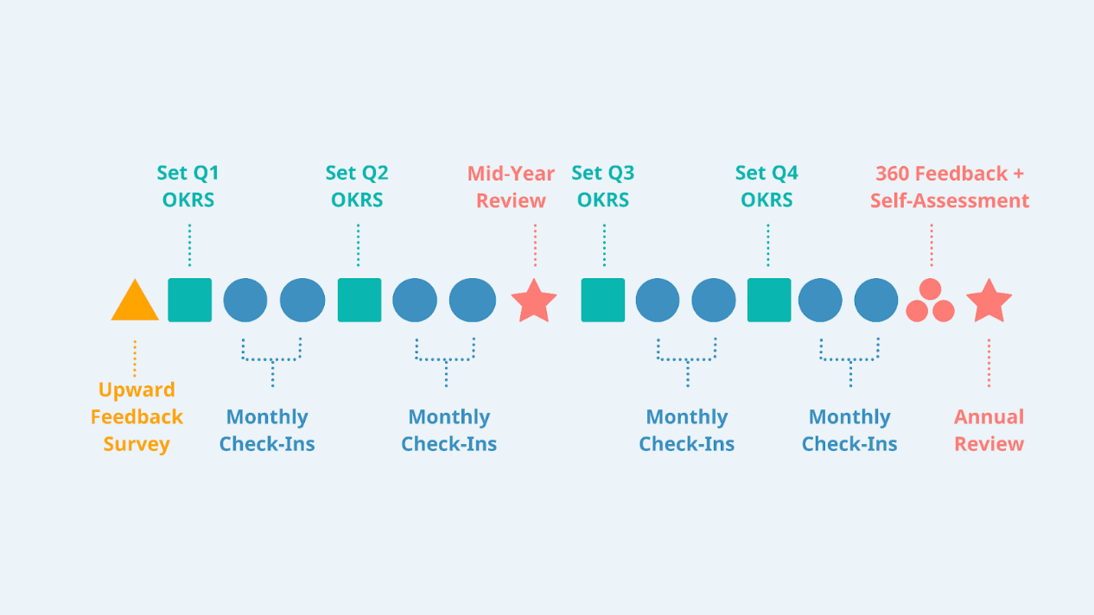
Figure 1 Performance management practices in Google
Source: Perform Yard, (2022)

Another company is Facebook which uses the performance management process and tends to focus greatly on peer-to-peer feedback. Moreover, in the semi-annual reviews, the managers use the feedback to see how finely the teams performed and understood the collaborative work (Knowledge Hub, 2022). They even made an internal software for providing continuous, real-time feedback. It is helpful for the employees in terms of solving the issues before they turn out to be problematic.
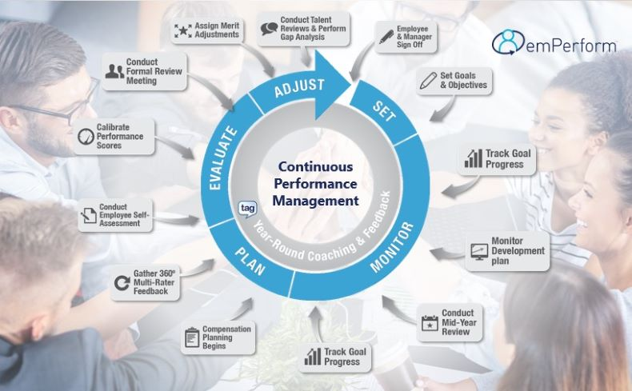
Figure 2 Continuous Performance Management
Source: Williams and Beck (2018)
Cargill refers to a Minnesota-related foodproducer and distributor with above 150,000 workers (Nikila, 2020). They tend to demonstrate that all big companies may ditch awkward performance appraisals while instituting a new system. Following the newest research on the disappointment of the management having the outdated performance management process, Cargill made their ‘Everyday Performance Management’ system (Tziner and Rabenu, 2018). Such a system is continuous, based on an effective employee-manager link, having regular activity and feedback that incorporates the conversations that tend to solve the problems instead of repeating the past actions. The Everyday Performance Management system had prodigiously constructive results, with 69 percent of the employees stating that they get feedback that was effective for their professional development. Whereas 70 percent reported that they are valued through the continuous performance deliberations with the manager (Knowledge Hub, 2022).
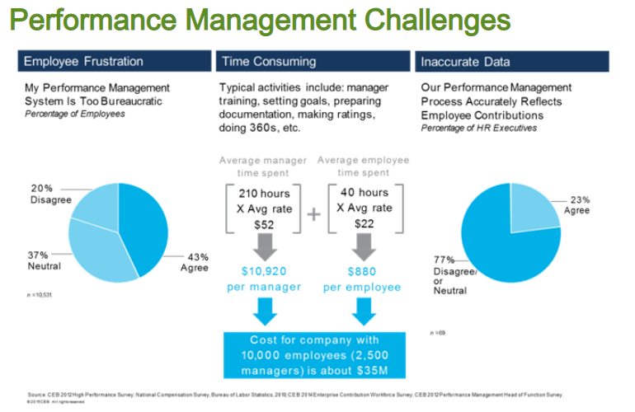
Figure 3 Performance management challenges in Cargill
Source: Tziner and Rabenu, (2018)
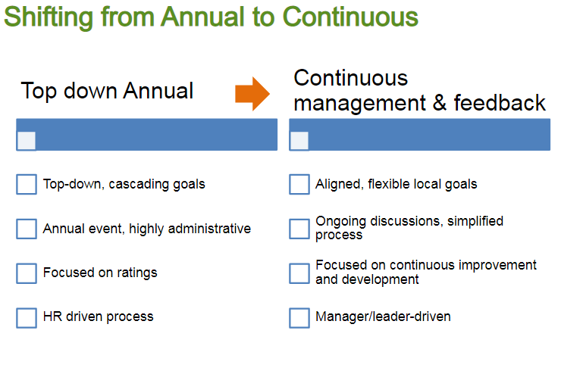
Figure 4 ‘Everyday Performance Management’ system
Source: Tziner and Rabenu, (2018)
Adobe has considered that the managers spend almost 80,000 hours per year on performance reviews just to have the employee’s reports. They left such reviews dejected. Hence, the rate of turnover rose. As per this system, negativity spread. The leadership team of Adobe resulted in a brave leap in the performance management system, which focused on training the managers regarding effective performance through frequent check-ins (Chiriță, Vișan and Popescu, 2020). The company offered actionable direction in this regard.
Accenture is a big company that has above 330,000 individuals. Thus, changing their systems refers a major effort. If they transferred to their new system, they would discard 90 percent of the preceding procedures (Knowledge Hub, 2022). The company uses a highly fluid performance management process in which the employees get continuing, timely feedback from the management. It is paired with a transformed focus on instant employee development with an internal app to communicate the feedback.
There are some examples with regard to the new performance approaches that various companies have adopted. SainCo may learn a lot more from them and realise that one size may not fits all instead, newness is needed.

Theoretical framework
AMO is helpful that can be applied for ensuring performance management in the company. It refers to s a function of the ability that includes training and selection, increasing motivation by incentives provision and feedback, as well as giving opportunity through constructive environment (Waeyenberg and Decramer, 2018). All three factors have a significant impact on the employee performance. SainCo may apply it as per which it will be able to have better productivity of the employees as well as enhanced output for the company.
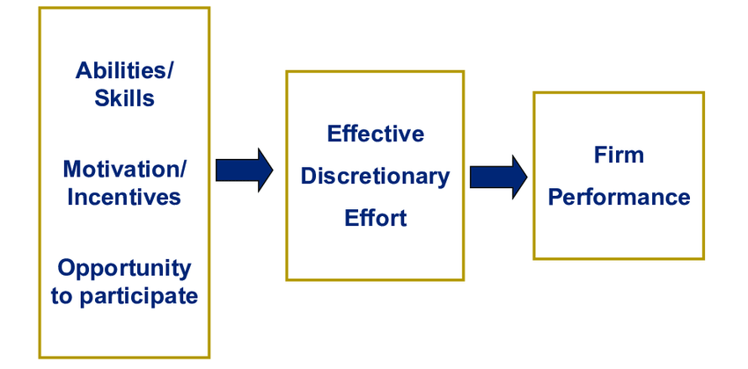
Figure 5 AMO Model
Source: Waeyenberg and Decramer, (2018)

Organisational and Employee Concerns
Organisations are mainly concerned with their growth and reputation in the market because it reflects the organisation’s progress. Therefore, organisation leaders ensure that the organisation performance must always be up to the mark and the employee’s performance for the organisation. An organisation has its major concerns over the productivity of employees and innovation and teamwork (Chanana, 2021). As per Alzoubi and Inairat (2020), organisations also have a big concern with the demand of customers to provide them satisfactory products and services to keep healthy relationships with customers. All these major concerns lead to a good management system within the organisation that specifies the roles of the employees and accordingly increases the performance of employees and provides them with a better workplace environment which decreases the employee turnover rate significantly.
According to Diamantidis and Chatzoglou (2018), in an organisation, the employee’s concerns are also an important factor that can affect the organization’s performance. The major concerns of the employees are safety issues, discrimination and harassment by the superior in the organisation. Harassment and safety issues raise a big concern which decreases the overall motivation of the employees, ultimately affecting the organization’s reputation. Interpersonal conflict and extra hours of working with no wages and the leave issues that employees faced in the organisation also increased the concerns about the well-being of the employees.

Depending upon outdated performance review ways
One of the concerns of the organization as well as employees is that they tend to rely upon the outdated performance review ways as per which the level of productivity cannot be identified. Today as well, the outdated annual performance review questions are asked in which no one is interested, and it does not give any authentic output (Shahi et al.,2020). Instead, it seems to be a time waste. Employees get concerned since they feel the evaluation process is weak, whereas organizations cannot identify suitable employees who can be promoted based on weak performance evaluation.

Emphasizing convincing the boss rather than improving the overall performance
Most performance reviews tend to focus on convincing someone but on the cost to others. A boss-related appraisal system tends to run the risk of focusing on attaining the employees’ attention while pleasing the boss for getting some of the other needed goals. Thus, the employee behaviorthat may eventually harm the company can be rewarded through an appraisal system that does not get vital information. Furthermore, such performance review can invade the rights of the employees to do what they consider a practical benefit for the company instead of achieving the boss’s approval (Diamantidis and Chatzoglou, 2018). Therefore, the top employers develop strategic plans for aiding their employees to use their agency and level of creativity to work out solutions.

Technology dependent
Technology is vitalizing and reinventing the management ways of performance for betterment. However, it is not sufficient for all. Technology can be a benefit as well as a curse concerning effective solutions to performance management. The curse is that the technology can turn out to be a support or something that the managers, as well as supervisors, hide behind to avoid meaningful interaction. The employees may use the company’s messaging platform or call colleagues to communicate with them.Everyone does not effectively use technology. At times, companies impose their usage without training,which becomes a concern for the employees (Islami, Mulolli, and Mustafa, 2018). On the other hand, employees use technology in the company that does not help meet the level of innovation but only speed. All these concerns cannot be denied while considering performance management tactics to be applied in SainCo.

Role of Human Resource Management in managing and improving employee engagement and employee involvement
Human resource management is a crucial part of the organisation that manages all the operations that are running. Human resource management also manages the organization’s decision-making and ensures its implementation effectively. Human resource management is considered one of the organization’s assets, providing solutions to the general problems that the organisation faces. Human resource management also involves managing employee involvement in the organisation by organising several engaging activities from which employees stay connected with the organisation. These activities also increase employee involvement and motivation to complete the task on time. Employees also feel comfortable because they realize that the organization values their feelings and morals (Saks, 2022).
Moreover, according to Johansen and Sowa (2019), employee engagement is the major responsibility of human resource management for the sake of stakeholders and organisational performance. The major responsibility of human resource management is to understand and have a keen insight into the multiple areas that can directly cause an impact on the engagement of employees. Human resource management should also report all these factors that can affect the engagement of employees and ensure to address all of them successfully so that leaders can provide better suggestions about engagement. Although, these factors can have a significant impact on the employee’s performance. All the top-performing organisations have employee engagement strategies that support them to increase their focus on work and ultimately increase the organization’s performance.
As per Salas‐Vallina, Alegre, and López‐Cabrales (2021), human resource management also provides support while motivating and inspiring the employees toward work and ensuring that they will not have any difficulty in their work and workplace. Human resource management also ensures that the employee must have the right skill, environment, and tools to perform their tasks properly with the proper understanding and best of their ability. Human resource management needs to manage employees in a way that they stay engaged with their work and workplace in any activity. Human resource management can engage employees through professional skill development programs, special training, succession plans, celebrations, and many other activities.

Engaging Employees Through Motivation and Inspiration
Human resource management tries to engage employees through inspiration which also motivates them in the workplace. Arranging training programs should be the first step to engaging employees and teaching them new skills that can be used in several situations. These training programs can promote the organization’s cultural values, which would only engage employees in the workplace. Leaders of the organisation have to adopt these motivational and inspirational techniques to enhance the organization’s performance. The organisation SainCo can adopt these techniques in their human resource management to increase the employees’ effectiveness (Singh et al. 2020).
According to Ali and Anwar (2021), human resource management can increase the motivation of the employees by thanking them personally after completing the task successfully. They can inspire employees by listening to them, caring about their suggestions and issues, and responding to their concerns accordingly. Human resource management has the details of all the employees. They can provide constructive feedback on their performance one after another to increase their motivation. They can also assign the task to the individuals and give them responsibility while encouraging them to use their initiatives and effective ideas to complete the task successfully. Human resource management has the major responsibility to provide support to the employees while keeping all of them up to date about the policies and the growth and development and informing employees about the organization’s current situation. It increases motivation and inspires employees to work effectively in the workplace (Stone, Cox, and Gavin, 2020).
SainCo can also implement these strategies to motivate their employees to enhance their involvement and engagement with the organisation. Implementing these techniques can also provide support to the organization’s performance management while understanding the preference of the employees in the workplace. It would also support the SainCo while sustaining their current business environment and increasing organisational performance.

Appreciating Employees
Appreciation seems to be a major factor that can increase employee engagement in the organisation. Employees want their leaders to recognise their efforts towards the organisation and appreciate them properly for all their efforts. Employee recognition seems to be a major factor in the engagement and involvement of the employees. Employees valued and appreciated tend to develop a strong emotional connection with their co-workers. These emotions show the engagement of employees with the work rather than just satisfaction with their work (Meng and Berger, 2019).
According to Saeed et al. (2019), human resource management has been introduced for formal recognition of the employees while providing them support in the workplace. When an employee works outstanding and contributes a lot to the organisation, he should be appreciated and well recognised among other employees to motivate them to show their full potential for the organisation. These outstanding performances and contributions of the employees earn them much appreciation from their leaders. Human resource management should also organise some personal benefits for these outstanding performers. Human resource management can also introduce a reward system for these outstanding employees which provides them personal benefits that force other employees to work hard and get appreciation from the organization’s leaders. Rewards can also be a promotion for specific employees to increase their motivation for the organisation.
Similarly, as per Ely and Thomas (2020), rewarding outstanding employees sends a clear message to all the employees about the value of the workforce that an organisation realise. Organisations also require outstanding employees to increase their productivity as well as effectiveness. These rewards do not have to be expensive, they can be cheap as well, but the effectiveness of the reward system is the most effective thing that can easily increase the overall performance of the organisation and boost other employees to compete to get the reward. However, SainCo can also implement this appreciation and reward system that can benefit both the organisation and employees.

Practices to support, improve and achieve competitive advantage and high performance
Although performance management may seem to be an easy task, it is not. The procedure itself is difficult, despite having just four processes mentioned above. It is why the list of recommended practices for the performance management of SainCO is presented. Here are the basic components of performance management that will ensure that the SainCo employee performance management system is functioning properly (Aguinis, 2019).As SainCo develops a performance management program, it must first determine its goals. It must evaluate if greater productivity is important to SainCo, if it plans on finding and developing leaders from inside, ifSainCo wishes to simplify the fair and proper evaluation, and if SainCo attempts to increase staff retention or involvement (Buckingham and Goodall, 2015). SainCo will find it better to create their program if they know what they want it to achieve.
The position needs to be clarified. It is far more difficult for employees to succeed if they do not understand what is required of them, how they should go about it, and what the end outcome should be (Van Dooren, Bouckaert, and Halligan, 2015).Develop a performance strategy to go along with SainCo’s aims. Year-long objectives frequently fail because they are too broad, and employees might get exhausted before they even begin. A performance plan assists individuals in understanding their journey, increasing the likelihood that they will reach their objective.Examine critical performance indicators. Use statistics and metrics to SainCo’s advantage, analyzing how goals are developing so that solutions can be implemented as soon as possible if required.
The goal of training is to assist in identifying and resolving issues when they’re too large. It won’t help if it isn’t done frequently. Meetings should be conducted quarterly to keep staff on the course (Schleicher et al., 2018).As part of the initial step of the performance management process, instructions for every function should be developed. These regulations and guidelines should identify or prohibit potential opportunities, investigations, and innovation. Workers are more productive when they have clear rules to follow.Verify that the SainCo company has common values and is culturally connected. Employees who share interests, ideas, and organizational commitment have a more peaceful and enjoyable workplace. Employees should be dedicated to the ideals and goals outlined and shown by senior management.
Conduct cross-functional workshop helps employees and managers understand what other teams do, how people operate, and what their advantages and disadvantages are. They can learn something new and make new contacts that will aid them in their future employment.Difficulties might occur during these training sessions if feedback is not provided in a healthy, practical manner. It is not necessary to look back and point fingers; instead, management should assist people in future achievements.Delivering less criticism is difficult for management and workers, which is one of the causes performance assessments are the less liked tasks. Managers must ensure that feedback is professional and that the emphasis is on conduct rather than qualities.
For example, noting that Peter frequently handed in key reports late is behavior feedback. Acknowledging that Peter is lazy and that this is why the files are regularly late is feedback on a characteristic. All these can help employees recognize their role in a program’s success or failure, while the others might make them defensive.
Management should also be trained to teach, and providing constructive criticism is difficult. That’s why there are many professional instructors available. Managers must be trained in such skill sets to be effective leaders (Boyne, 2010).Request that staff provides comments to one another. It will provide management with a more comprehensive perspective of employee performance, allow them to understand better the problems that teams face, and allow them to provide effective feedback.Whereas the review process is essential, it is only one component integrity of the entire system. Employees must be planned for, coached, and rewarded as part of the system.It is logical to presume that troubles are always employees’ fault, but this is not true. External variables such as supply availability, internal procedures producing troubles, or corporate policies can cause problems. To solve issues, try to identify their cause as clearly as possible.Workers cannot be expected to remain inspired if they are not rewarded, yet many businesses miss this critical step. Ensure that staff is rewarded and acknowledged for their efforts, and they will keep producing for your company (Forrester, 2011).

Strength
- Human resource management should display the integrity and honesty in their action.
- Human resource managers must be expert in both technical and social aspect of life.
- They should solve the problems and analyse the issues by using their expertise.
- Human resource managers must be innovated.
- They must practice self-development and get better results as well.
- The focus of human resource management must be on getting better results for the organisation.
- Human resource management must take initiatives for the greater good of the organisation.
- The verbal and written communication of the human resource management must be efficient and accurate.
- Human resource management must be well time managed and goal oriented (Alfes et al. 2019).
- Human resource management must be able to discuss the conflict in the constructive way and try to resolve issues.
- Human resource management must have a broad vision while organising the organisations and making the decisions for them.

Weakness
- Frequently hiring and frequently firing shows the weakness in the human resource management system where the system is not good enough to hire eligible individuals.
- Human resource management must not have the hiring onboard for too long.
- Human resource management must be financially oriented.
- Human resource management should have focus on the strategies of the organisation.
- Poor relationship with employees as well as with customers is harmful for human resource management (Kraev and Tikhonov, 2019).

Recommendations
It is a fact that the thinking process cannot be evolved overnight. Here are some of the recommendations to improve the process of performance management.
- A new system should be tried that will be driven by several goals specific to one department and function of business such as IT or finance. This will be better than assigning the new assessment processes to everyone simultaneously. Working on one function will provide the key learnings and improve the existing performance system with a new one before introducing it in the other departments. With time, the system will be used by all the departments of the company that should be working well (Franco‐Santos and Otley, 2018.).
- Google spreadsheet is not only the way to track the responsibilities of people. It is recommended that a simple and intuitive tool should be used for the performance tracking that has easy access and broad validity and visibility for everyone so that small seconds will be utilized for completing and modifying the goals. Ideally, if a company starts a department in mid-year in which changes are more obvious in the objectives, so this will provide the chance to test the technology in the situation of real-world.
- If the continuous performance system is used for the management a company should be ensured that it has leveraged its power within the time and place where it has some value. The review time for the performance management is at the end of the year. The system can be used to report and inform the evaluations of the employees, and compare the performance and experience with the process of review a year before. The deficiencies and the betterment in the performance were evaluated.
- It is recommended that the management systems should be initiated with a simple goal template which can then further be modified according to the needs of each department. Using the latest performance management systems efficient goals templates can be made that are almost complete and make it easier for others to adjust and utilize it efficiently (Helmold and Samara, 2019).
- It is also important to actively listen to the team members, employees, and executives in the company. It is important as it helps in finding the perception and opinions of others regarding the new system. It helps me find whether the new performance management system is effective in making the jobs easier for the employees. HR metrics that can analyze the performance of the new system can also be sued.
- Technology can be used to implement an advanced scanning feature that reviews the performance management and issues in this system can be identified. Technology can be used to develop insights about the system and legal disputes can be resolved.
- Do not consider which divisions or functions will receive a faster performance management approach next. Consider how SainCo will enhance the performance management process with internet services to increase productivity and efficiency, Including learning and skilling solutions. This would enable SainCo to include a stronger performance management approach into a larger HR strategy that delivers both a better vision of the business and a better outcome for employees.
- Managers are the new process’s controllers. Employees will not buy into the new system if they do not buy into it and explain its worth. Management and their employees must be able to quickly integrate the new system into their normal activities, and also have faith in the benefits it will provide. That is why executive sponsorship is essential (McKenna, Richardson, and Manroop, 2011.).
- An effective performance measurement system should provide no room for doubt about how performance is connected to compensation or acknowledgment. And, over time, HR should assess if it is accurate in terms of who gets awarded in which ways and how frequently. For people to accept the process, it must be fair.
- The performance evaluation will never be flawless, therefore look at the statistics and talk to individuals about what worked and what didn’t, then make modifications as needed. The more SainCo works to improve the system, the more employees are likely to become motivated and involved with the process and their job.
Upgraded thinking and the adoption of a new, successful, agile procedure necessitate the use of a platform that can assist it. Using obsolete, ineffective, and wasteful processes - or doing nothing is also not a realistic choice. Companies that can link a superior performance management system to improved business results will soon distinguish themselves from those that prefer comfort to the current system (Mone and London, 2018).

Conclusion
From this empirical study about the effectiveness of the performance management in the SainCo organisation, it can be concluded that performance management can be improved and increased by following several new approaches to performance management which provides diversity to the leaders of the organisation. These new effective approaches can increase the effectiveness of the organisation as well as the organisational performance. This report stated the importance of the organisational concerns as well as the employee concerns in detail which can affect performance management in a way that would be more effective.
Furthermore, the role of human resource management is very essential for employee engagement with the organisation. This study provided an idea of appreciation in order to increase the involvement of the employees with SainCo. A system of appreciation increases the inspiration of the employees as well as the motivation and effectiveness of work for SainCo. Several practices can also be adopted to improve and support the performance of the employees while providing them with a competitive environment for work. SainCo can achieve its objectives easily while implementing new strategies of working in the organisation which increases the effectiveness of the performance management. The recommendation about increasing the performance management is also reflected in the growth of the SainCo. These recommendations provided the short-term goal that can be achieved by enhancing the effectiveness of the organisation. Long-term objectives and goals are also reflecting towards the long-term growth of the organisation through the effectiveness of the performance management.

References
Aguinis, H., 2019. Performance management for dummies. John Wiley & Sons.
Alfes, K., Shantz, A.D., Bailey, C., Conway, E., Monks, K. and Fu, N., 2019. Perceived human resource system strength and employee reactions toward change: Revisiting human resource's remit as change agent. Human Resource Management.
Ali, B.J. and Anwar, G., 2021. An empirical study of employees’ motivation and its influence job satisfaction. Ali, BJ, & Anwar, G. (2021). An Empirical Study of Employees’ Motivation and its Influence Job Satisfaction. International Journal of Engineering, Business and Management.
Alzoubi, H.M. and Inairat, M., 2020. Do perceived service value, quality, price fairness and service recovery shape customer satisfaction and delight? A practical study in the service telecommunication context. Uncertain Supply Chain Management.
Bhalla, V., Caye, J.M., Lovich, D. and Tollman, P., 2018. A CEO’s guide to Talent Management today. Boston Consulting Group. Retrieved.
Boyne, G.A., 2010. Performance management: Does it work. Public management and performance: Research directions, pp.207-226.
Buckingham, M. and Goodall, A., 2015. Reinventing performance management. Harvard Business Review, 93(4), pp.40-50.
Chanana, N., 2021. Employee engagement practices during COVID‐19 lockdown. Journal of public affairs.
Chiriță, N., Vișan, A. and Popescu, M., 2020. Measuring Adobe Company performance from the perspective of a Complex Adaptive System. Theoretical & Applied Economics, 27(4).
Diamantidis, A.D. and Chatzoglou, P., 2018. Factors affecting employee performance: an empirical approach. International Journal of Productivity and Performance Management.
Diamantidis, A.D. and Chatzoglou, P., 2018. Factors affecting employee performance: an empirical approach. International Journal of Productivity and Performance Management.
Ely, R.J. and Thomas, D.A., 2020. Getting serious about diversity. Harvard Business Review.
Forrester, G., 2011. Performance management in education: milestone or millstone?. Management in education, 25(1), pp.5-9.
Franco‐Santos, M. and Otley, D., 2018. Reviewing and theorizing the unintended consequences of performance management systems. International Journal of Management Reviews, 20(3), pp.696-730.
Franco‐Santos, M. and Otley, D., 2018. Reviewing and theorizing the unintended consequences of performance management systems. International Journal of Management Reviews, 20(3), pp.696-730.
Franco‐Santos, M. and Otley, D., 2018. Reviewing and theorizing the unintended consequences of performance management systems. International Journal of Management Reviews, 20(3), pp.696-730.
Helmold, M. and Samara, W., 2019. Progress in performance management: Industry insights and case studies on principles, application tools, and practice. Springer.
Helmold, M. and Samara, W., 2019. Progress in performance management: Industry insights and case studies on principles, application tools, and practice. Springer.
Islami, X., Mulolli, E. and Mustafa, N., 2018. Using Management by Objectives as a performance appraisal tool for employee satisfaction. Future Business Journal, 4(1), pp.94-108.
Johansen, M.S. and Sowa, J.E., 2019. Human resource management, employee engagement, and non-profit hospital performance. Non-profit Management and Leadership.
Knowledge Hub, 2022. Performance Management. [Online] Available at https://www.valamis.com/hub/performance-management. [Accessed on 13th July 2022].
Kraev, V.M. and Tikhonov, A.I., 2019. Risk management in human resource management. TEM Journal.
McKenna, S., Richardson, J. and Manroop, L., 2011. Alternative paradigms and the study and practice of performance management and evaluation. Human Resource Management Review, 21(2), pp.148-157.
Meng, J. and Berger, B.K., 2019. The impact of organizational culture and leadership performance on PR professionals’ job satisfaction: Testing the joint mediating effects of engagement and trust. Public Relations Review.
Mone, E.M. and London, M., 2018. Employee engagement through effective performance management: A practical guide for managers. Routledge.
Mone, E.M. and London, M., 2018. Employee engagement through effective performance management: A practical guide for managers. Routledge.
Nikila, N., 2020. An Organization Study On Cargill (Doctoral dissertation, CMR Institute of Technology. Bangalore).
Perform Yard, 2022. Google’s Performance Management Playbook: Inspiration for Your Organization. [Online] Available at https://www.performyard.com/articles/googles-performance-management-playbook [Accessed on 13th July 2022].
Pugna, I.B., Dutescu, A. and Stanila, G.O., 2018, May. Performance management in the data-driven oragnisation. In Proceedings of the International Conference on Business Excellence (Vol. 12, No. 1, pp. 816-828).
Rezaei, J. and Ortt, R., 2018. Entrepreneurial orientation and firm performance: the mediating role of functional performances. Management Research Review.
Saeed, B.B., Afsar, B., Hafeez, S., Khan, I., Tahir, M. and Afridi, MA, 2019. Promoting employee’s pro-environmental behaviour through green human resource management practices. Corporate Social Responsibility and Environmental Management.
Saks, A.M., 2022. Caring human resources management and employee engagement. Human Resource Management Review.
Salas‐Vallina, A., Alegre, J. and López‐Cabrales, Á., 2021. The challenge of increasing employees’ well‐being and performance: How human resource management practices and engaging leadership work together toward reaching this goal. Human Resource Management.
Schleicher, D.J., Baumann, H.M., Sullivan, D.W., Levy, P.E., Hargrove, D.C. and Barros-Rivera, B.A., 2018. Putting the system into performance management systems: A review and agenda for performance management research. Journal of management, 44(6), pp.2209-2245.
Schleicher, D.J., Baumann, H.M., Sullivan, D.W., Levy, P.E., Hargrove, D.C. and Barros-Rivera, B.A., 2018. Putting the system into performance management systems: A review and agenda for performance management research. Journal of management, 44(6), pp.2209-2245.
Shahi, T., Farrokhsheresht, B., Taghipourian, M.J. and Aghajani, H.A., 2020. Behavioral Factors Affecting Talent Management: Meta-Synthesis Technique. Iranian Journal of Management Studies, 13(1), pp.117-137.
Singh, S.K., Del Giudice, M., Chierici, R. and Graziano, D., 2020. Green innovation and environmental performance: The role of green transformational leadership and green human resource management. Technological Forecasting and Social Change.
Stone, R.J., Cox, A. and Gavin, M., 2020. Human resource management. John Wiley & Sons.
Tadić, J. and Mihajlović, M., 2020. INTEGRATED PERFORMANCE MANAGEMENT MODEL OF COMPANY USING AN ANALYTICAL HIERARCHY PROCESS. Poslovnaekonomija, 17(1), pp.1-19.
Tziner, A. and Rabenu, E., 2018. Performance appraisal: The outlook and future directions. In Improving Performance Appraisal at Work. Edward Elgar Publishing.
Van Dooren, W., Bouckaert, G. and Halligan, J., 2015. Performance management in the public sector. Routledge.
Van Waeyenberg, T. and Decramer, A., 2018. Line managers’ AMO to manage employees’ performance: the route to effective and satisfying performance management. The International Journal of Human Resource Management, 29(22), pp.3093-3114.
Williams, G. and Beck, V., 2018. From annual ritual to daily routine: continuous performance management and its consequences for employment security. New Technology, Work and Employment, 33(1), pp.30-43.

