HND Electrical and Electronic Engineering
Computer engineering and Microprocessors

Buthaina Al-Jarrah
2018-2019
Gower College Swansea

(computer engineering , 2019)

Table of Contents
HND Electrical and Electronic Engineering 1
Explaining my flowchart 5
My Arduino program 5
Defining the pins 9
My Arduino programming for the car park 10
Conclusion 13
References 13

Introduction
As I am part of HND students, in this assignment I was asked to write 2 programs
In the first question I was asked to do a program to control a motor using an operator interface. In this task I am going to use Arduino to write and check the program. Then I am going to write a report of how I done the program.
In the second task, I was asked to write a program in Arduino controlling the traffic of car park.
Also, I am going to include flow charts for both programs and include the Arduino programs.

Task 1

Motor control

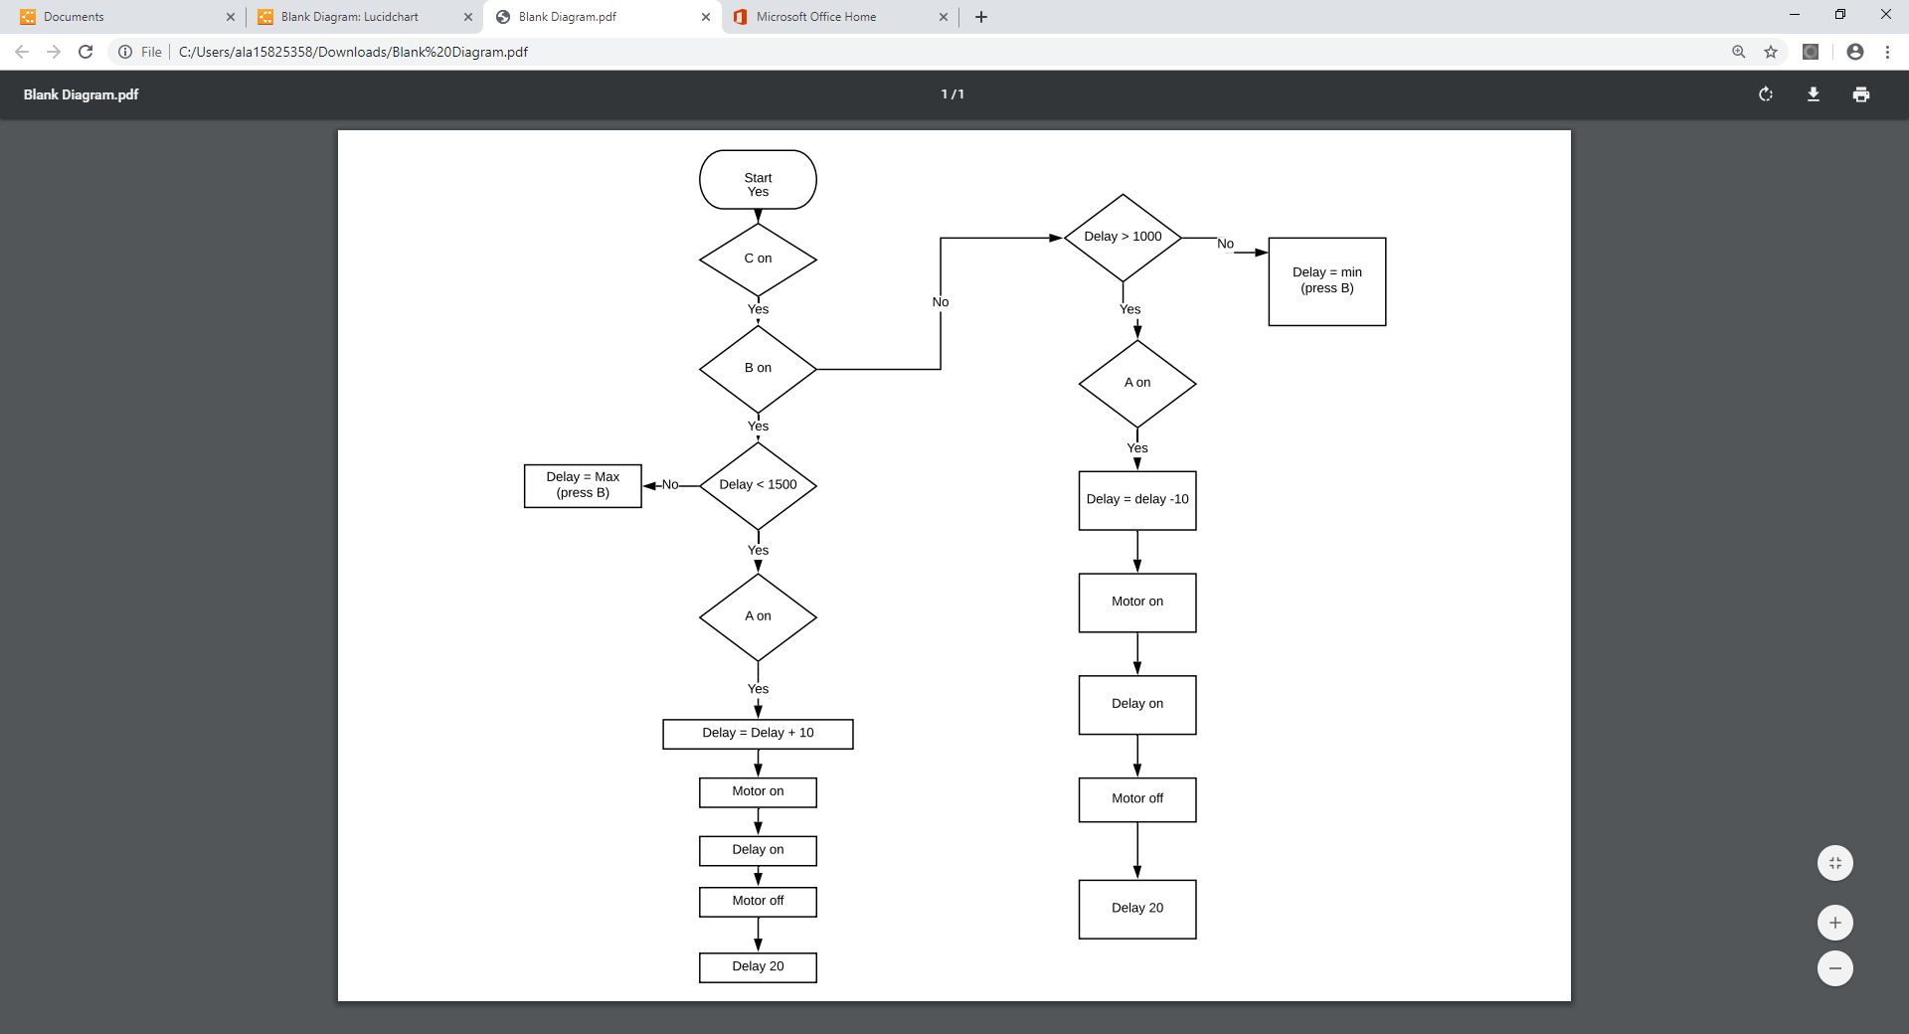

As I mentioned, I am tasked to write a program in Arduino to control a motor. I am required to write a program that control the motor using an operator interface.

Explaining my flowchart
First of all, checking if switch C was on if yes check whether switch B is on.
On one hand, If switch B was off and the delay is not > 1000 then press B. Otherwise, we going to see if switch A is on then the delay = -10, the motor going to be on as well as the delay then the motor will go off and there will be a delay 20.
On the other hand, if switch B was on and the delay was < 1500 then switch A going to be on and the delay will be delay +10. The motor will be on in at this point and the delay will be on. In addition the Motor will go off and the delay 20.

My Arduino program
const int s1= 2;
const int s2= 3;
const int s3= 4;
const int enable=10;
const int pin13 = 13;
int s1state1;
int s1state2;
int s2state1;
int s2state2;
int s3state1;
int s3state2;
int delay1 = 1500;
int delaymax = 2000;
int delaymin = 1000;
int s2default = LOW;
int s3default = LOW;
void setup() {
// put your setup code here, to run once:
Serial.begin(9600);
pinMode(s1,INPUT);
pinMode(s2,INPUT);
pinMode(s3,INPUT);
pinMode(pin13,OUTPUT);
pinMode(enable,OUTPUT);

}
void loop() {
// put your main code here, to run repeatedly:
int s3state1 = digitalRead (s3);
if (s3state1 == LOW){
delay(100);
//s3state2 = HIGH;
//s3default = !s3default;
Serial.print("SWITCH C ");
Serial.println(s3state1);
digitalWrite(enable,s3state1);}
int s1state1 = digitalRead (s1);
if (s1state1 == HIGH){
delay(1000);
s1state2 = HIGH;
Serial.print("SENSOR 1 STATE IS ");
Serial.println(s1state2);}

int s2state1 = digitalRead (s2);
if (s2state1 == HIGH){
delay(100);
//s2state2 = HIGH;
//s2default = !s2default;
Serial.print("SWITCH B ");
Serial.println(s2default);}
s3state1 = digitalRead (s3);
if (s3state1 == HIGH){
delay(100);
//s3state2 = HIGH;
//s3default = !s3default;
Serial.print("SWITCH C ");
Serial.println(s3default);
digitalWrite(enable,s3default);}

if (s3state1 == HIGH){
if (s2state1 == HIGH){
if (delay1 < delaymax) {
if(s1state2==HIGH) {
delay1 = delay1+10;}
Serial.print("delay1 is ");
Serial.println(delay1);
digitalWrite(pin13,HIGH);
delayMicroseconds(delay1);
digitalWrite(pin13,LOW);
delayMicroseconds(20000);
s1state2 = LOW;
}
else {
Serial.println("max ");}
}
else{
if (delay1 > delaymin){
if(s1state2==HIGH){
delay1= delay1-10;}
Serial.print("delay1 is ");
Serial.println(delay1);
digitalWrite(pin13,HIGH);
delayMicroseconds(delay1);
digitalWrite(pin13,LOW);
delayMicroseconds(20000);
s1state2 = LOW;
}
else {
Serial.println("min ");}
}
}
}

Task 2
Car park
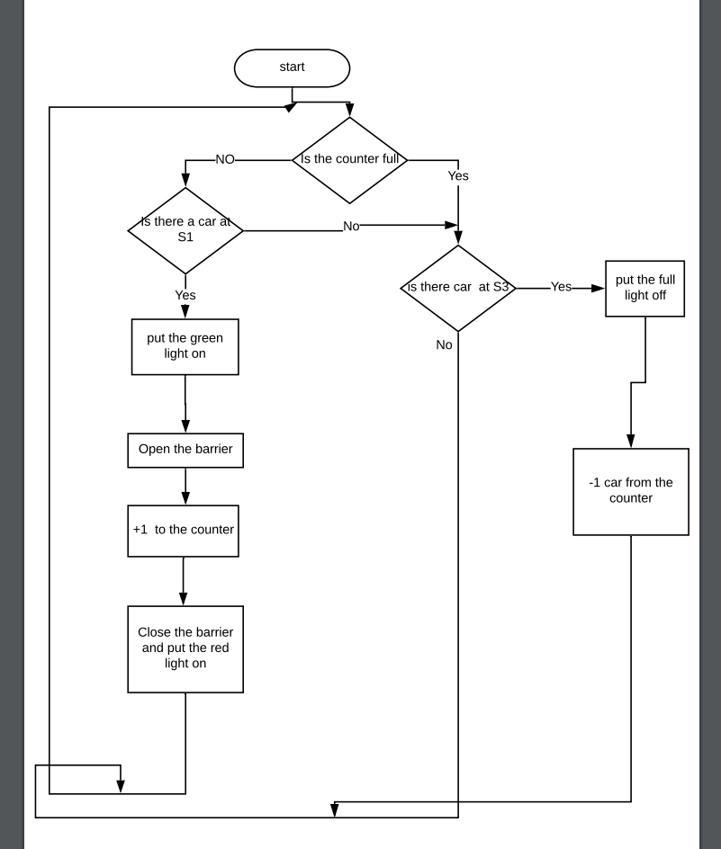

Defining the pins
Sensor 1 = pin 2
Sensor 2 = pin 3
Sensor 3 = pin 4
Red = pin 5
Green = pin 6
Carpark full = pin 7

I was asked to do when the car park is full to light up the “Car park” sign and no more cars will be allowed to enter. Also, to rise a green light when the barrier open and allow cars to go through. Then raise the red light after the car has enter and the barrier closed, so there will not be a car allowed to go through. In my program there will be 3 sensors.
The first sensor which is sensor 1 where it is going to be in the entrance of the car park checking if there is car.
The second sensor which is connected to pin 3, it is there watching if the cars have passed through the barrier.
The third sensor which is connected to pin 4, is placed in the exit of the car park checking if there is any car going.

Explaining my flowchart
Beginning with checking whether the car par is full or not. If it was full then sensor 3 going to check if there is any car leaving. If there was a car leaving then the “full car park” light will go off and the counter –1 car. If there was no car leaving then it will delay for 2 seconds and go back to the “full car park” sign and go back to the beginning and do all the procedures that mentioned above.
If the car park was not full, sensor 1 going to check if there was a car at the entrance if there was no car so it is going to sensor 3 checking whether there is a car leaving.
if there was a car at sensor 1 there will be a delay for 1 second and then the barrier will open and the green light will raise allowing the car to enter. After checking that the car has entered by sensor 2 the counter will +1 car.
After that, the barrier will close and put the red light on then go back checking if the car park full and do all what mentioned above.

My Arduino programming for the car park
const int spin1 = 7;
int spin1status = 0;
const int spin2 = 2;
int spin2status= 0;
const int spin3 = 3;
int spin3status = 0;
const int rpin = 4;
const int gpin = 5;
const int cppin = 6;
int counter;
const int full = 5;
int s3old = 0;
#include <Stepper.h>
const int stepsPerRevolution = 200;

Stepper myStepper(stepsPerRevolution, 8, 11, 12, 13);

int motorspeed=60;
int times;
int newstep = 50;
const int enablepin1 =9;
const int enablepin2 =10;

void setup() {
// put your setup code here, to run once:
Serial.begin (9600);
pinMode (spin1, INPUT);
pinMode (spin2, INPUT);
pinMode (spin3, INPUT);
pinMode (rpin, OUTPUT);
pinMode (gpin, OUTPUT);
pinMode (cppin, OUTPUT);

pinMode(enablepin1,OUTPUT);
pinMode(enablepin2,OUTPUT);
digitalWrite(enablepin1,HIGH);
digitalWrite(enablepin2,HIGH);

}

void loop() {
spin1status = digitalRead(spin1);

spin2status = digitalRead(spin2);

spin3status = digitalRead(spin3);
Serial.print("counter = ");
Serial.println(counter);

// put your main code here, to run repeatedly:

if (spin3status == HIGH) { //see if a car is leaving
s3old =HIGH; // s3old = 1

}
else {
Serial.print("sp3 status = ");
Serial.println(s3old);
delay(2000);

if (s3old == HIGH){
Serial.print("s3old = ");
Serial.println(s3old);
counter--;
digitalWrite (cppin , LOW);
s3old = LOW;

}

}
if (counter == full) { // car park is full
Serial.print("car park full sensor3 = ");
Serial.println(spin3status);

}

else {
Serial.print("spin1 = ");
Serial.println(spin1status);
if (spin1status == HIGH) { // is thereacar commminnng innnn

delay(1000); // waits for 1 seconds
Serial.println("greenon = ");

myStepper.step(newstep);
counter = counter +1;
digitalWrite (gpin , HIGH);
digitalWrite (rpin , LOW);
Serial.print("counter = ");
Serial.println(counter);
delay(1000); // waits for 1 seconds
// Serial.print("sp2 statussssss = ");
// Serial.println(spin2status);
do {
spin2status=digitalRead (spin2);
//Serial.print("sp2 status = ");
//Serial.println(spin2status);
}while (spin2status==LOW);
Serial.println("down");
myStepper.step(-newstep);
digitalWrite (gpin , LOW);
digitalWrite (rpin , HIGH);
delay(1000); // waits for 1 seconds
}
}

}

Conclusion
I have done 2 tasks about creating 2 programs in Arduino one of them was about controlling a motor and the other one was about car park traffic.

Also, I have included a picture of my flowchart that I have done by using lucid chart.
In addition, I have included the program that I wrote in the in Arduino.

References
computer engineering . (2019, 05 21). Retrieved from computer engineering : https://www.bing.com/images/search?view=detailV2&id=B01487BD7563E2199338525BCEBF9A5D1DC81920&thid=OIP.PnURrMMubdomOp1kNRUs5wHaEK&mediaurl=http%3A%2F%2Fdig100aexperienceinterfaceinteraction.files.wordpress.com%2F2014%2F08%2Fcomparison-between-microprocesso

