Resonance

Electrical & electronic principles
ACDA4006
BEng Embedded
Electronic Systems

Samuel Hunt, 2315404

0.0 Table of contents
Contents
0.0 Table of figures 3
0.0 Table of tables 4
0.0 Introduction 5
0.1.0 Abstract 5
0.2.0 Introduction 5
1.0 Simulation 6
1.1.0 Building 6
1.2.0 Testing 7
1.3.0 Calculating resonant frequency 8
2.0 Practical 9
2.1.0 Building 9
2.2.0 Testing 10
3.0 Results 11
3.1.0 Quality factor 11
3.2.0 Simulated 12
3.3.0 Practical 13
3.4.0 Discussion 14
3.4.1 Frequency response 14
4.0 Solutions 17
4.1.0 Improved circuit design 17
4.2.0 Improved graph and comparison 18
5.0 Conclusion 19
6.0 References 20
7.0 Appendix 21

- Table of figures
Figure 1: RLC tank circuit 5
Figure 2: Manual testing circuit 6
Figure 3: Automated testing circuit 6
Figure 4: Manual testing setup 7
Figure 5: Attenuation calculations 8
Figure 6: Practical circuit 9
Figure 7: Testing setup 10
Figure 8: Calculating Q factor 11
Figure 9: Simulated results graph 12
Figure 10: Automated simulation graph 12
Figure 11: Practical results graph 13
Figure 12: Inductor equivalent circuit [6] 14
Figure 13: Comparison graph 15
Figure 14: Capacitor tolerances 15
Figure 15: Resistor tolerances 16
Figure 16: Equivalent components 17
Figure 17: Improved circuit 17
Figure 18: Corrected circuit graph 18

0.0 Table of tables
Table 1: Simulated results 21
Table 2: Practical results 22

0.0 Introduction

0.1.0 Abstract
In this document, a tank circuit will be tested for its frequency response, which will be achieved through a simulation package and a practical circuit. In which the results will be compared and it will be established that the data doesn’t match for various reasons, such as, parasitic properties that affect the characteristics of some components. Namely, the capacitance and resistance due to the wire within the inductor. This will be rectified and allow for a more accurate simulation to be created through adding equivalent circuits that correct the forces within the circuits.

0.2.0 Introduction
Tank circuits are commonly used in conjunction with a resistor to create a band pass filter, as seen in this application. Commonly used in combination with a resistor they form a voltage divider, due to voltage dividing across components in series and staying constant across components in parallel [1, pp. 52-53]. To make this a filter, the ground is connected to the terminals of the inductor and capacitor, which means that at frequencies lower than the resonant frequency the inductor will conduct the signal to ground, hence, eliminating it. The same is applicable to the capacitor at higher frequencies. This is due to the reactance of an inductor or capacitor being tied to the frequency of the signal, as shown in the equations for reactance in a capacitor and inductor respectively [2] [3]:
$x_{c}=\frac{1}{2πfC}$ and $x_{L}=2πfL$
At the resonant frequency, the impendence across the inductor and capacitor will reach a point where it is the highest possible when combined, reducing the current being grounded.
This is commonly used in radio frequency (RF) applications, where a particular band needs to be selected for applications and all other signals ignored [1, pp. 52-53]. This is logical due to the theoretically high quality (Q) factor, which means that only a small band is selected, along with a very high attenuation outside of that band [4, p. 15]. Relative to other RC (resistor capacitor) filters, RLC (resistor inductor capacitor) filters offer sharper frequency response, which may be beneficial in applications where very narrow bands need to be selected, making it ideal for tuning into a specific frequency. However, due to both a capacitor and inductor being present the phase of the signal will shift depending on which component is predominantly conducting [1]. This will shift at the resonant frequency, where the voltage leading ahead of the current in the inductor will swap to the capacitor’s current leading voltage.
Figure 1 below shows the general form of a tank circuit with a resistor.
Figure 1: RLC tank circuit
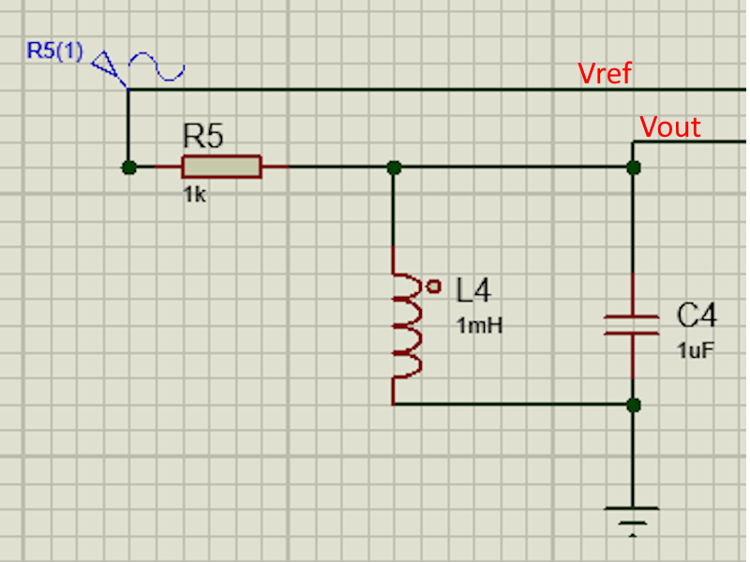

1.0 Simulation

1.1.0 Building
The circuit was replicated from the given schematic, which included a capacitor, resistor and inductor in addition to a power supply and oscilloscopes. This was achieved through using the inbuilt library, which contains the components, along with inbuilt test equipment such as an oscilloscope and signal generator, these would require the samples to be taken manually. The figure below shows the circuit that was built for manual measurements.
Figure 2: Manual testing circuit
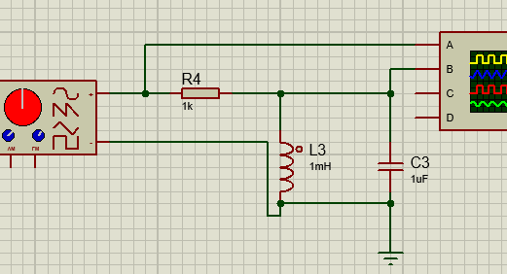
However, the manual testing circuit was adapted to include a different signal generator and oscilloscope which can export data as a comma separated variables (CSV) file. In addition to this a graph (showing the gain against frequency) was added to allow for easier diagnostics of the data if it was incorrect. This allowed for a higher volume of datapoints to be made, making for a higher resolution dataset accessible for comparison with the practical testing. Figure 3 below shows the automated testing circuit setup.
Figure 3: Automated testing circuit
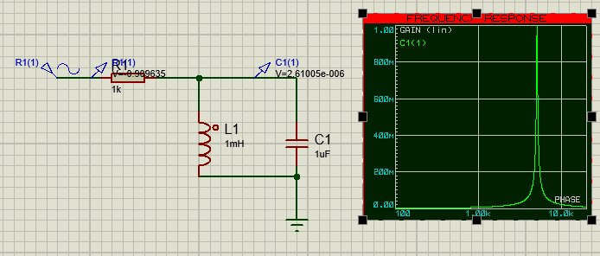

1.2.0 Testing
All of the circuits designed will be tested from 100Hz to 20kHz. To accurately test across this range manually the frequency that would be sampled increases exponentially. As a result, 8 samples were made initially. The samples were gathered through adjusting the frequency to the desired value then using the cursors on the oscilloscope to read and note the output values. A further 4 more samples were added to increase the accuracy around the resonant frequency.
Figure 4: Manual testing setup
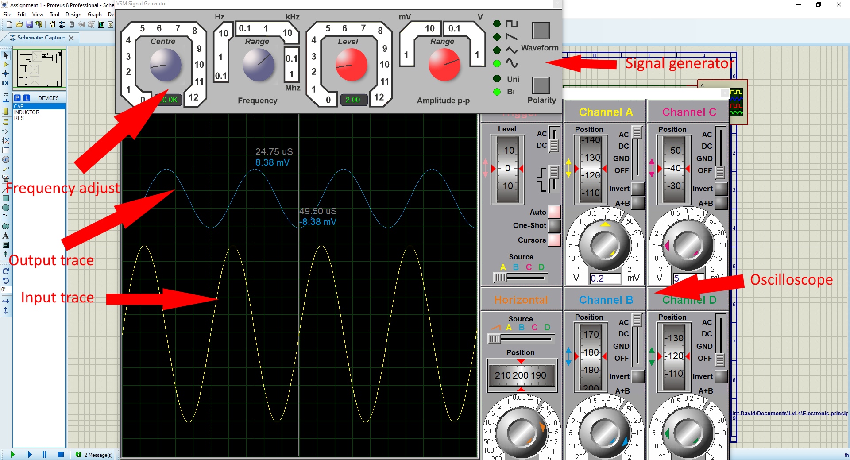
The automated circuit was simulated using Proteus’ probes to gather the voltages across the input and output of the Tank Circuit. This was then parsed into a graph, which used converted the results into Deci Bels (dB) and displayed them.
This yields a higher accuracy output than manually taking measurements, which results in a more accurate reading being given. The data was then captured in a CSV file and imported into excel, for use in obtaining the resonant frequency through the equation $A=20*log⁡(\frac{V_{out}}{V_{in}})$.

1.3.0 Calculating resonant frequency
The page below shows the process for calculating the theoretical resonant frequency of the circuit.
Figure 5: Attenuation calculations
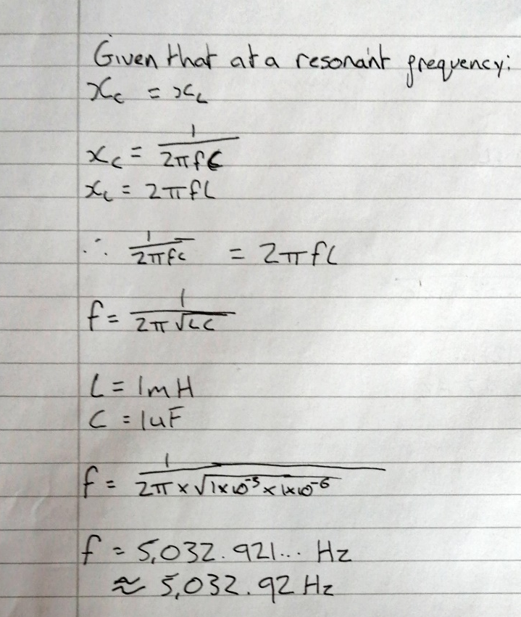

2.0 Practical

2.1.0 Building
The circuit was built on breadboard according to the simulation CAD model, this included adding in wires to allow for the connection of crocodile clips for input and output connections. In Figure 6 the setup is shown. The red crocodile clip connects the output of the signal generator, supplying the AC signal to the circuit. The black wire connects the ground output of the signal generator to the outputs of the capacitor and inductor.
Figure 6: Practical circuit
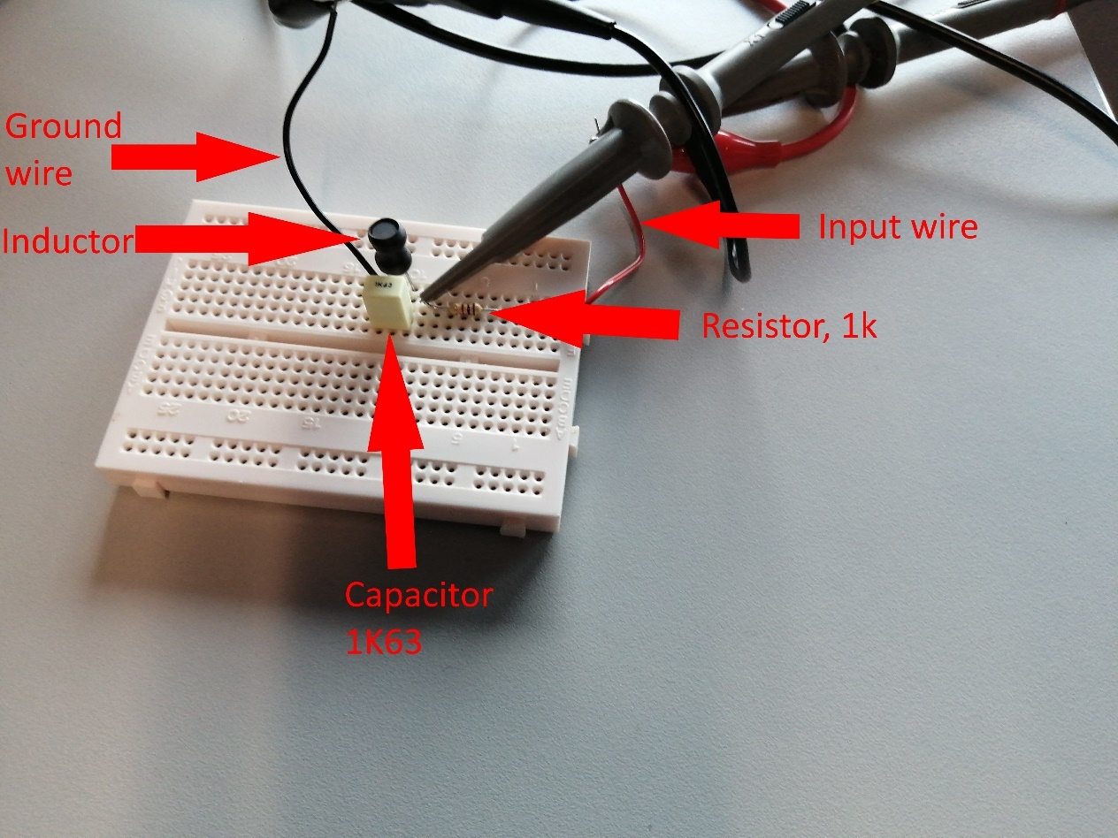
The red channel of the oscilloscope was connected to the input signal, allowing for an accurate measurement of the signal pushed into the circuit, which can be used to calculate the attenuation. The yellow channel was used to measure the voltage drop across the inductor and capacitor. This represents the impedance that occurs over the capacitor and inductor combined.
The signal generator was set to the initial sample frequency of 100Hz, and a voltage of 2V peak to peak (pk – pk).

2.2.0 Testing
The circuit was tested using the same frequencies as manual testing, allowing for direct comparison of the output. The inbuilt cursors were used to measure the pk – pk voltage. The sample was taken and the frequency increased accordingly. Figure 7 below shows the settings used for the oscilloscope (foreground) and signal generator (top of background). The data was stored in a similar excel page to that of the simulated testing, which is used to calculate the attenuation and Q.
Figure 7: Testing setup
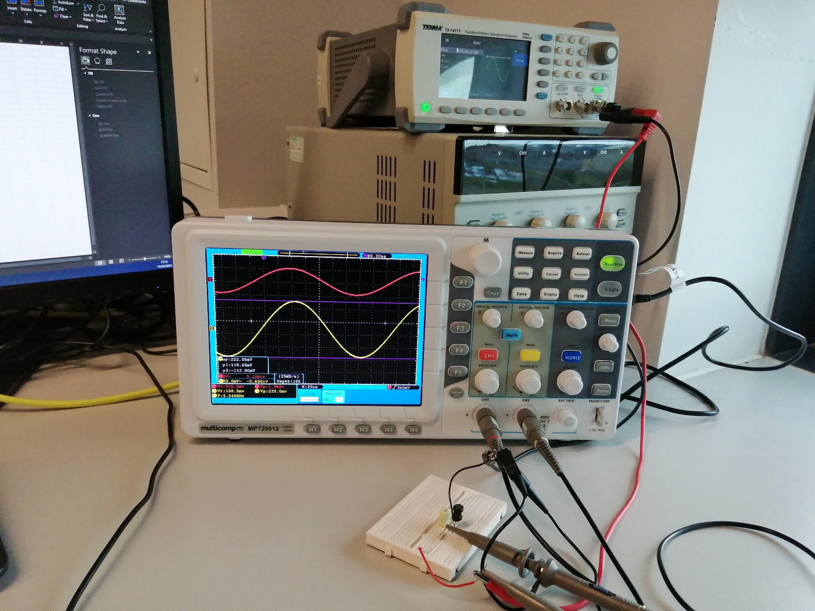

3.0 Results

3.1.0 Quality factor
The quality factor was calculated using the results on a graph, which helped find the central frequency, which is also the resonant frequency in this case. This was achieved through finding the bandwidth (BW) -3dB from the peak, the frequency which intersected with the peak -3dB was then noted. The BW is given by subtracting the lower value (fi) from the higher (fh). The Q factor was then calculated using $Q=\frac{fr}{BW}$ [5].
The straight lines (‘Q lines’) were used to simplify the process of finding the intersection points, making it easier to find intersections.
Figure 8: Calculating Q factor
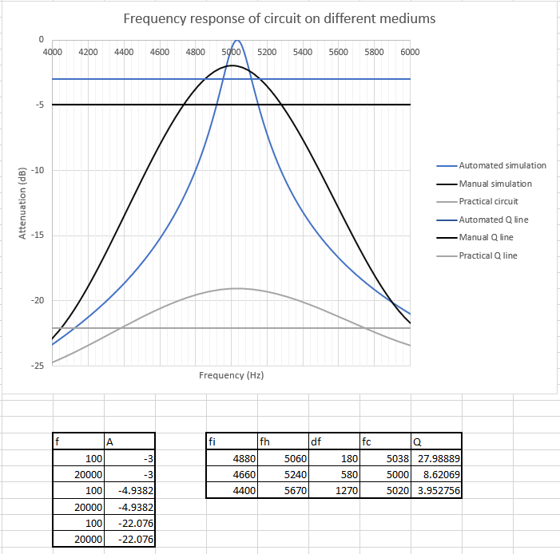
From Figure 8 it can be observed that the manually obtained results yield a significantly low Q factor relative to the automated circuit. As such, the accuracy of the peaks could be diminished by a small amount. However, this allows for a more accurate comparison to be formed from point to point. Also, it reduced the amount of time needed to collect all of the data points needed.

3.2.0 Simulated
In Figure 9, it can be seen that the gain is highest at approximately 5kHz, with the gain decreasing as the frequency increases or decreases away from it. As such, it displays the characteristics of a band pass filter, as expected from a tank circuit.
Relative to each other, the graph generally matches up, reducing the likelihood that an error has occurred. Although, the manually measured circuit does not peak as high and doesn’t peak as sharply and there is a miniscule mismatch in the resonant frequency.
Figure 9: Simulated results graph

Figure 10: Automated simulation graph

3.3.0 Practical
The practical circuit shows a relatively low gain and more gradual peaks, with no linear increases or decreases. The resonant frequency is at a lower frequency than that of the simulation and yields a lower gain. Compared to Figure 9, it seems to be asymptotic to a value in the low 40s.
Figure 11: Practical results graph

3.4.0 Discussion

3.4.1 Frequency response

3.4.1.1 Gain
In Figure 13, both circuits have been overlaid for easier comparison. The first notable difference is the amplitude of the peaks, with the simulated peaking far higher than the practical. A likely source of error regarding the gain could be a parasitic property attached to a component skewing the amount of reactance a specific component creates. On further research it is likely due to a factor not added into the simulation. This fact is further compounded by a report made by Texas Instruments (TI), which states the true factors that need to be accounted for within an inductor. As shown in Figure 12 the equivalent circuit of an inductor includes both the internal series resistance from the wire (R_{s}) and parallel capacitance (C_{p}) of the inductor [6]. Due to the increased resistance, the current will flow through the equivalent of a capacitor, which will decrease the overall reactance of the inductor. From this, it can be taken that the inductor itself acts like an RLC circuit with its own resonant frequency and different characteristics relative to the simulated circuit.
Figure 12: Inductor equivalent circuit [6]

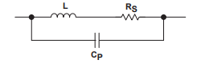
The tolerances of the resistor could also change the voltage divide across each, which could lead to a difference in gain too. However, due the relatively low tolerance of the resistor (1%), which would lead to a difference of ±10Ω. This would likely cause minimal changes to the output, as shown in 3.4.2.1 Resonant frequency.

3.4.2.1 Resonant frequency
A negligible change in the resonant frequency could be due to the fact that there is such a low number of datapoints that have been observed. Furthermore, the potential for tolerances within the components changing the resonant frequency can also affect specifically the manual circuit. For example, the 1K63 capacitor used has a tolerance of 10%, which as shown in Figure 14 can change the resonant frequency marginally.
Figure 13: Comparison graph

Figure 14 below shows the changes due to the maximum and minimum tolerances of the capacitor in the original circuit. The changes seem to be negligible relative to the scale of the frequencies tested, only changing the resonant frequency by ±200Hz at most. This is also applicable to the inductor, which in conjunction could also further change the resonant frequency. However, due to the tolerances of the inductor not being able to be reliably established they will not be tested. It can be established that both likely affected the physical circuit.
Figure 14: Capacitor tolerances

The linearity of the simulated circuit is likely due to the simulating software used (SPICE) using an equation, which will use the equations for calculating impedance whilst disregarding other potential interactions and interference. This will produce a linear line until V_{out} = 0.

3.4.2 Quality factor
As eluded to in 0.2.0 Introduction, the tank circuit should theoretically have an extremely high Q factor, as shown in the automated testing, which best represents the theoretically ideal tank circuit. However, due to inaccuracies in testing is not reflected in the manually simulated circuit. In the physical circuit this is compounded by potential extra losses in the circuit not modelled by Proteus. When solving this, it was found that modifying the internal resistance of the inductor would both reduce the gain and Q factor. The reduction is due to the internal resistance of the wire within the inductor not being modelled in Proteus, as such producing a much lower Q factor. To match the simulation, it is possible to add a “Q spoiling resistor [1]”, which will reduce the sharpness of the curve to better match the physical circuit.
According to external studies, a higher impedance source could be used, which would increase the Q factor of the circuit [1]. Hence, allowing the physical circuit to better match the simulation. However, in the physical circuit the highest impedance option was used hence, eliminating this factor.
The 1k resistor’s tolerances do marginally change the gain of the circuit, as shown in Figure 15. It has a 1% tolerance, which will change the circuit marginally over the frequencies.
Due to the affect the resistor has on the gain of the circuit it can be taken that the inductor is the most likely cause of the difference. However, the tolerances in the resistor and extra resistance from the inductor and capacitor could also feed the difference in Q factor.
Figure 15: Resistor tolerances

4.0 Solutions

4.1.0 Improved circuit design
Correcting the simulated circuit involved decreasing the overall impedance of the LC tank circuit and decreasing the Q factor. This was achieved through using the equivalent circuits provided by Texas Instruments [6], which account for all electrical forces that occur on a component, including forces that may occur on its connections. For example, the inductive force that occurs when a current is pushed through nearby wires. Figure 16 below, represents the circuit with new equivalent components.
Figure 16: Equivalent components
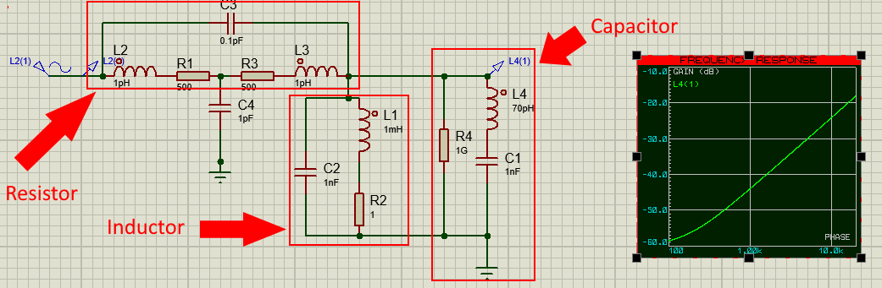
However, due to TI only providing ballpark estimates for values, and the error in C1, the circuit did not display the desired characteristics. This is due to the capacitance being far too low for C1, causing it to not function properly within the frequencies tested. Most likely, the inductor was only active and the capacitor was not filtering anything, hence, the lack of a peak and continuously increasing voltage due to the reactance of the inductor increasing, filtering less of the signal.
After some tweaking of the values for resistance in the inductor Figure 17 was produced, which shows far more ideal characteristics relative to previous simulations. Adding the extra resistance into the inductor has a two-fold affect; it spoils the Q factor, making it less ‘pointy’ whilst also decreasing the maximum gain. The lower gain was achieved through the increase in resistance in conjunction with a capacitor, which decreased the amount of current flowing through the inductor, which allows more current to flow through the capacitor reducing the voltage overall at resonance.
Figure 17: Improved circuit
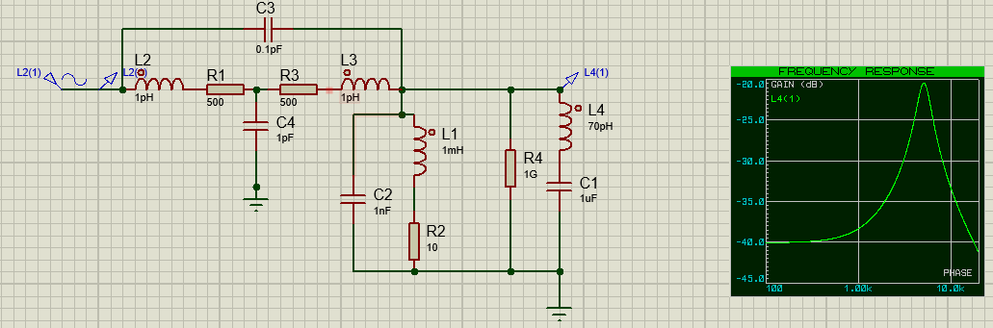

4.2.0 Improved graph and comparison
In Figure 18 the new frequency response and gain closer match the simulator circuit, however, could do with more fine tuning to match the simulator closer. This would likely include using large amounts of trial and error to get the outputs to match exactly.
Figure 18: Corrected circuit graph

5.0 Conclusion
Overall, in this experiment it has been determined that although a simulator cannot accurately simulate an RLC tank circuit without further improvement, which is due to some properties not being modelled. Furthermore, it was learnt that the tolerances on components has the potential to skew the physical results, making it harder to interpret and solve. Namely, the small difference in resonant frequency, which was due to the different tolerances between the inductor and capacitor, which yielded a slightly higher resonant frequency in the physical circuit.
As a result of the above conclusions, a new circuit design was created, which would more accurately reflect the true nature of the circuit. Including adding equivalent circuits provided by a reputable souce, which was retested to ensure that it would uphold the accuracy needed. After some further tweaking, the circuit successfully replicated the form of the graph of the physical circuit.

6.0 References

[1] | W. H. Paul Horowitz, The Art Of Electronics, Glasgow: Cambridge University Press, 2015.
[2] | ETech Media LLC, “AC Inductor Circuits | Reactance And Impedence -- Inductive | Electronics Textboook,” EETech Media, 2019. [Online]. Available: https://www.allaboutcircuits.com/textbook/alternating-current/chpt-3/ac-inductor-circuits/#:~:text=Inductive%20reactance%20is%20the%20opposition,just%20like%20resistance%20(R).. [Accessed 23 04 2024].
[3] | EETech Media LLC, “AC Capacitor Circuits | Reactance and Impedence -- Capacitive | Electronics Textbook,” EETech Media , 2019. [Online]. Available: https://www.allaboutcircuits.com/textbook/alternating-current/chpt-4/ac-capacitor-circuits/. [Accessed 23 04 2024].
[4] | A. Bohar, “Importance of tank circuits in electronics,” SOCH, vol. 10, no. 2, p. 230, 2006.
[5] | S. Mosey, Q factor, Swansea: UWTSD, 2016.
[6] | Texas Instruments, “Understanding Basic Analog - Passive Devices,” Texas Instruments, Dallas, 1999.

7.0 Appendix
Simulated results
Table 1: Simulated results
Freq | Vin | Vout | Atten | Db
100 | 1 | 0.00065 | 0.00065 | -63.7417
200 | 1 | 0.00125 | 0.00125 | -58.0618
500 | 1 | 0.0032 | 0.0032 | -49.897
1000 | 1 | 0.00665 | 0.00665 | -43.5436
2000 | 1 | 0.01525 | 0.01525 | -36.3346
3000 | 1 | 0.03013 | 0.03013 | -30.42
4000 | 1 | 0.072 | 0.072 | -22.8534
5000 | 1 | 0.8 | 0.8 | -1.9382
6000 | 1 | 0.0825 | 0.0825 | -21.6709
7000 | 1 | 0.045 | 0.045 | -26.9357
10000 | 1 | 0.0205 | 0.0205 | -33.7649
20000 | 1 | 0.00825 | 0.00825 | -41.6709

Practical results
Table 2: Practical results
Freq | Vin | Vout | Atten | dB
100 | 1.96 | 0.0168 | 0.008571 | -41.3389
200 | 1.96 | 0.0172 | 0.008776 | -41.1346
500 | 1.96 | 0.0184 | 0.009388 | -40.5488
1000 | 1.96 | 0.0196 | 0.01 | -40
2000 | 1.96 | 0.0328 | 0.016735 | -35.5276
3000 | 1.96 | 0.058 | 0.029592 | -30.5766
4000 | 1.96 | 0.1136 | 0.057959 | -24.7376
5000 | 1.96 | 0.218 | 0.111224 | -19.076
6000 | 1.96 | 0.132 | 0.067347 | -23.4336
7000 | 1.96 | 0.0816 | 0.041633 | -27.6113
10000 | 1.96 | 0.04 | 0.020408 | -33.8039
20000 | 1.96 | 0.0162 | 0.008265 | -41.6548

