Explore the work of two contemporary artists and analyse the relationship they have developed between their art practice and environment, place and space.

Sophie Harding
P149845

Word count: 2748

Table of Figures

Figure 1: Pipilotti Rist, Pixel Forest (2016) Installation view: “Pipilotti Rist: Dein Speichel ist mein Taucheranzug im Ozean des Schmerzes” [Your Saliva is my Diving Suit in the Ocean of Pain] 4

Figure 2: Pipilotti Rist, 4th Floor to Mildness from the Mildness Family, 2016, installation view, Pipilotti Rist: Pixel Forest, New Museum, New York. 5

Figure 3: Sophie Calle. Detail, Gotham handbook, 1994/2000. Collage with gelatin silver print, text, cibachrome print on plexiglas frame. Courtesy Galerie Emmanuel Perrotin, Paris & Miami. 7

Figure 4: Marcel Duchamp, Fountain 1917, replica 1964, Succession Marcel Duchamp/ADAGP, Paris and DACS, London 2019 9

Figure 5: William Anastasi (American, born 1933), Untitled (Six sites), 1966, Photography, 21.1 x 30.8 cm. (8.3 x 12.1 in.), Dwan Gallery, New York 10

There are several ways in which the terms place and space have been defined and studied. Although the two words interact in a dynamic relationship and tend to be used interchangeably, they each represent separate concepts. Referring to key thinkers; Eric O. Jacobsen, Yi Fu Tuan, Doreen Massey, Michel De Certeau and Brian O’ Doherty, this essay will delve into various theories of space and place, exploring how the two terms interact with each other. Discussion will focus on how space, place and environment have been utilised throughout multiple Art disciplines, such as, Installation, Conceptual and Photographic Art. Discourse will begin with an investigation into the ways in which contemporary artists such as Pipilotti Rist, Sophie Calle, Marcel Duchamp and William Anastasi have amalgamated or challenged notions of space, place and their environment within their Art practice. Evaluating how these artists have created innovative, engaging environments that blur perceptual boundaries, and confront conventional ideas of what we understand a space or place to be.

Eric O. Jacobsen describes place as a “context-specific, meaning-rich concept”. In other words, place is a context that occupies personal experiences, associations and memories of the things within it (Jacobsen, 2012). An example of this is your childhood home. It could never be entered without acknowledging your familiarity with it. Equally, when using place as a verb “to place”, the same applies. By placing something in a space we create an association or relationship between that object and its surroundings (Jen Jack Gieseking, 2014). Space, however, is an intangible concept, a physical location or blank slate, devoid of personal experience (Johnson, 2019). For example, a new house, consisting of the same bricks and interior, is purely a “space” we inhabit. Attaching experiences and memories to it, until It becomes our home, a “place” we value. We place our personal belongings into the house and become emotionally attached to the space, placing sentimental importance on it (Jen Jack Gieseking, 2014). While places are perpetually constructing and moulding our characteristics, spaces permit us to assess the identities which have been produced. “as a person lives life, one’s narrative begins to etch meaning on a particular space, causing it to become a place” (Jacobsen, 2012). Space is therefore something abstract, without any considerable meaning. While, a place is a space that has a meaning.

Like Jacobsen, Yi Fu Tuan explains how the distinctions between space and place can be described by the degree to which people give meaning to a particular area (Tuan, 1977). Tuan considers how significance can be derived or given to an area in two different ways; the first being in a direct and intimate way, through senses such as smell, hearing and vision. And the second; in an indirect and conceptual way, mediated by symbols and the Arts (Tuan, 1977). He describes space as a site which has no public relations to an individual. No significance has been given to the space (Tuan, 1977, pp. 164-165).

Pipilotti Rist manipulates the relationship between place, space and environment with her energetic, extensive installations. Rist’s abundant visual conversation of psychedelic, sensual experiences, consume the space and juxtapose the bizarre with the familiar. The artist completely changes the spectators experience of a once mundane space, by creating an entirely new atmosphere through what she places within it. Rist transforms spaces using a variation of visual elements, such as; lighting, moving image, sound, sculpture and furniture. Each component is strategically placed to create a unique sensory experience (The Solomon R. Guggenheim Foundation, 2019). She utilises every aspect of the space, creating an embodiment of her subject matter through her environment, rather than merely using it as an area of display. By doing so, Rist perplexes the perimeter of private and public space. Her artworks, concepts and personality become inimitably entwined within the space. Transforming it into an invented, artificial place for the public to enter and submerge themselves. Pixel Forest (Fig 1), is created using 3,000 LEDs hung on threads, resembling a movie screen that has shattered into the space (Hauser & Wirth, 2019). Ultimately, Rist is inviting viewers to take an immersive stroll through a 3-dimensional video (Lütgenau, 2016).

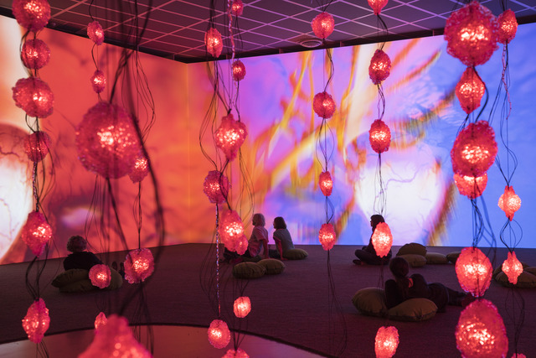

Figure 1: Pipilotti Rist, Pixel Forest (2016) Installation view: “Pipilotti Rist: Dein Speichel ist mein Taucheranzug im Ozean des Schmerzes” [Your Saliva is my Diving Suit in the Ocean of Pain]
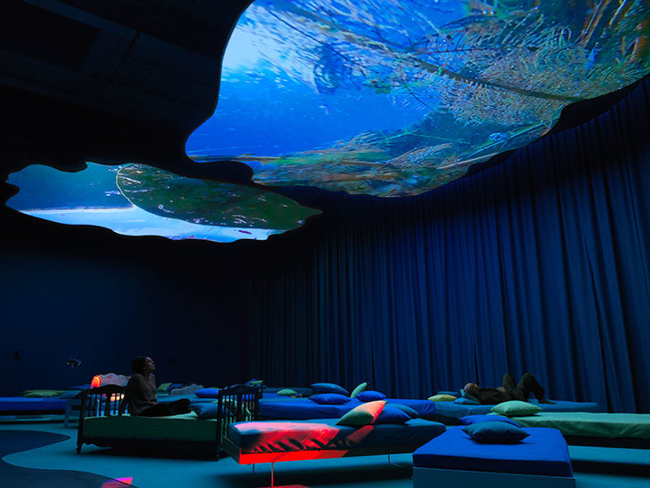

Figure 2: Pipilotti Rist, 4th Floor to Mildness from the Mildness Family, 2016, installation view, Pipilotti Rist: Pixel Forest, New Museum, New York.

The materials placed within the space forge a relationship with each other and the spectator. As seen in Sip my ocean (Fig 2), beds are placed around the space to consume the walkway, while the video projection placed on the ceiling informs the audience of how to view the moving image. The placement of each object dictates how we experience the environment (Hauser & Wirth, 2019). By introducing beds- an intimate object, into the space, the audience develops a connection to it through association with their own homes. Therefore, composition and the act of “placing”, become an essential concept (The Solomon R. Guggenheim Foundation, 2019). “Place is security, space is freedom, we are attached to the one and long for the other” (Taun, 1977). Rist unites the intimacy and security of a familiar place with the freedom of a detached and conjectural space, through her inauguration of a multidisciplinary ethereal environment.

Doreen Massey in For Space, similarly, exhorts us to reconsider several of our beliefs regarding space. Contradicting the aforementioned theories, she implies that space is not solely something we pass through. Massey “believes that an analysis of spatial relations between, for example, people, cities and jobs, is key to an understanding of politics and power” (Warburton, 2015). She see’s space not as an empty stage, but infused with all kinds of myriad stories, memories and events. Investigating the idea that space is not something stagnant and neutral, a static entity, but is something interwoven with time, thus ever changing (Massey, 2005). These ideologies are studied throughout many Art disciplines, not just installation. Michel De Certeau defines Art as a "way of making", by this Certeau means a method of imagining that is transmitted into a process of working, that affects methods of consumption (Certeau, 2011). Sophie Calle uses numerous techniques presented in De Certeau’s notions of 'making do'. Her work renovates our comprehension of municipal spaces, the operation of ordinary routines, the privileging of time throughout space, and the reclaim of recollection across the agencies that make viable mundane routines (Certeau, 2011). Instead of attempting to disturb the structures that control urban Spaces and paradigms, Calles emphasis on the everyday habits of living, highlight the strength of "making do" in her environment.

Place and space play a vital part in the everyday battles amongst the bureaucratic prerogatives that govern civilization, and the individuals who exist within its formations. Although the management of conduct is reliant on the allocation of leisure and work within specific allocated spaces, such as a home or an office. Transverse strategies do not comply with these regulations as they are not specified or characterised by them. These approaches can challenge the dominant arrangement of spatial associations. "They attempt to reduce temporal relations to spatial ones through the analytical attribution of a proper place to each particular element and through the combinatory organization of the movements specific to units or groups of units." (Certeau, 2011). Therefore, particular methods of operating within a space turn into a technique of diverting, exploiting and controlling spaces. Certeau compares this to a North African residing in Paris who integrates into the structures enforced on him, by the constraints of the French language and low-income accommodation, by constructing a means of living, recognisable to that of his indigenous home. "By creating for himself a space in which he can find ways of using the constraining order of the place or of the language...By an art of being in between, he draws unexpected results from his situation" (Certeau, 2011, p. 30).

This tactic is utilised in Calle’s, phone booth from Gotham Handbook (Fig 3), produced in collaboration with Paul Auster. Auster urges Calle to be aware of spaces and objects usually overlooked, "The small barely noticeable things standing right in front of our eyes" (Sophie Calle, 2013). Calle's understanding of this is to develop a mundane public space. Deciding upon a telephone cubicle, she adopts the public space designed for communal use and makes it personal.

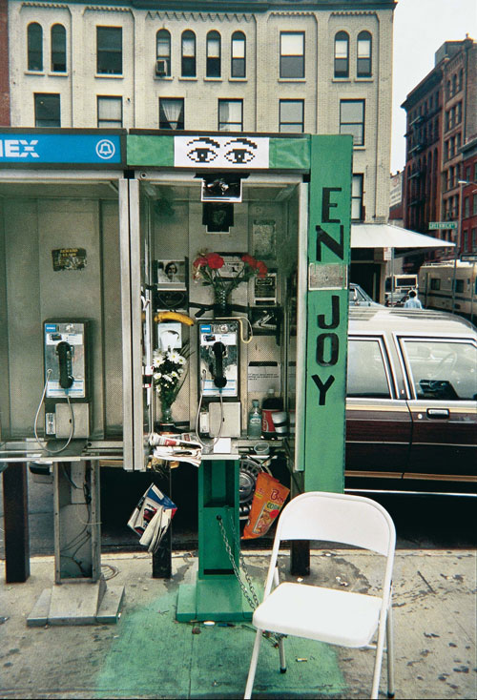

Figure 3: Sophie Calle. Detail, Gotham handbook, 1994/2000. Collage with gelatin silver print, text, cibachrome print on plexiglas frame. Courtesy Galerie Emmanuel Perrotin, Paris & Miami.

Calle decorates the booth with flowers, pictures and green paper, filling the space with an ashtray, notebooks, pens, a magazine and a foldable chair. When filling the space with objects from “the home” she occupies a similar approach as the North African living away from his native home. By employing an item of communal amenity, owned by no-one and everyone, Calle exposes the framing systems that appear in daily practices; which appoint specific spaces for specific duties, to be managed by specific individuals. Using manipulation and occupation as means, she reclaims the phone booth, not by threatening it but in making it noticeable and in interposing the “personal” into a space assigned for the anonymous “many” (Sophie Calle, 2013). Imposing the question of how the phonebooth should be perceived. Is it now a space or a place? Calle’s exploitation of the space changes its value and meaning from that of an insignificant functional space to a distinguished space/place. This confronts predetermined ideas of space and place and establishes a level of innovation in the contrived normative social order. “individuals derive or give meaning to the earths geography and use this to shape and organise the world around themselves” (Paul Cloke, 1991).
It is our perception of the world that influences our understanding of what “place” is. With so many juxtaposing ideas, the increase of information and accessibility of quicker transportation, the failure to cultivate space as a place, has risen exponentially. Jacobsen postulates that our culture suffers from the increase of “placelessness”. There is a disengagement from the idea of place, as it is now harder to identify ourselves by our places. This ensues a struggle to extricate space from place. We require a healthy quantity of the remoteness and privacy space offers. Without space, we may become devoured by our places. However, without place, we are perceptible to feeling a disillusion that emanates from a disproportionate extent of space. (Jacobsen, 2012)

In addition to altering the experience of a space by transforming its framework, certain spaces can impact the perception of the objects placed within it. It has been the virtuosity of our era to examine things in relation to their environment, to come to see the context as seminal on the thing. To see the environment as a thing itself. There are several discourses implanted in the curation of different spaces. Brian O'Doherty reconnoitres what the exceedingly controlled environment of the contemporary gallery does to the Art object, what it does to the viewing subject, and, how the context consumes the object, becoming it. The most apparent and key concern when exhibiting is the notion of dirty space. This space is not truly dirty, but it is loaded with pre-formed thoughts on how it should be, and what should be in it (O'Doherty, 2000). O’Doherty delves into the significance of the gallery space in White Cube (2000), foreseeing the white cube as a paradigm for modern Art. "The outside world must not come in, so windows are usually sealed off. Walls are painted white. The ceiling becomes the source of light… The art is free, as the saying used to go, to take on its own life” (O'Doherty, 2000, p. 15). Similar to that of a holy space, the artworks, like religious verities, are to appear unaffected by time and its vagaries. The white cube eradicates any historic or visual context that could be associated with the artwork. O'Doherty describes the modern gallery space as "constructed along laws as rigorous as those for building a medieval church." (O'Doherty, 2000, p. 15). As the artwork becomes revered due to this environment, it’s the environment that enhances the work in late modernism. “Art exists in a kind of eternity of display” (O'Doherty, 2000, p. 15). “This eternity gives the gallery a limbolike status; one has to have died already to be there." (O'Doherty, 2000, p. 15)

“Designed to accommodate the prejudices and enhance the self-image of the upper middle classes” (O'Doherty, 2000, p. 76) the white cube appears as a consequence of a commercial, capitalist approach to Art. It is the gallery space that enhances some of the most profound artistic actions in the 1970’s (O'Doherty, 2000). O’Doherty analyses Marcel Duchamp’s notorious works, stating that Duchamp was the first to make the gallery space the main material to be transformed by Art (O'Doherty, 2000). Regarding Duchamp’s Fountain (Fig 4), the context and critical thought is needed to see the exhibition space as something other than neutral. By exploiting a mundane urinal, an object designed for function, Duchamp, like Calle, utilises “the everyday”. However, rather than introducing objects into a space to modify how we value that space, Duchamp takes an object out of its original environment and places it within an entirely new formal context. Changing how we value the object. The urinal is modified by its new environment but also fundamentally impacts how we view the gallery space (Kaye, 2000).

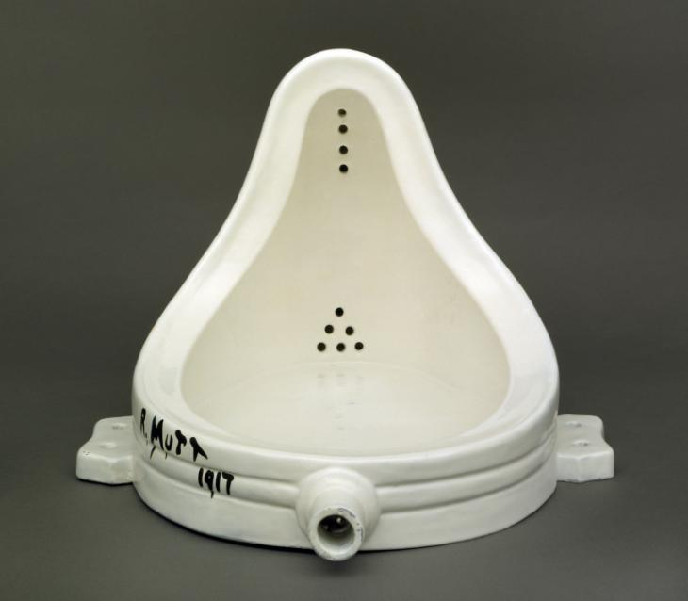

Figure 4: Marcel Duchamp, Fountain 1917, replica 1964, Succession Marcel Duchamp/ADAGP, Paris and DACS, London 2019

William Anastasi’s 1967 exhibition Six Sites (Fig 5), also challenges concepts of space, place and the gallery environment. Anastasi notably photographed the empty walls of the New York Dwan Gallery, exhibiting the photographs on the exact walls depicted (Artnet Worldwide, 2019). This action defies a photographs conventional purpose. Photography is a way of documenting and capturing moments within multiple spaces/places. It allows an individual to transport a place into an entirely new space, becoming a visual record or story. Anastasi, however, presents what you are already observing, the spatial narrative you are already stood within. He introduces no new place or story. Instead, the spectator discovers the aesthetic beauty of the bare white walls that surround them, noticing nuances they once disregarded. The space alters how we value the photographs and the photographs alter how we value the space.

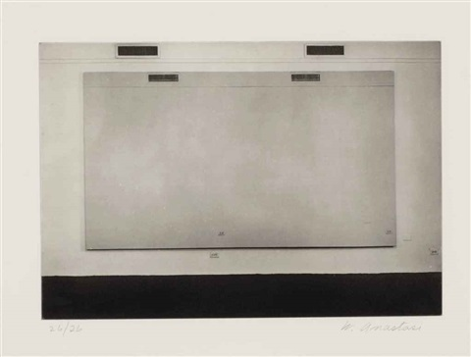

Figure 5: William Anastasi (American, born 1933), Untitled (Six sites), 1966, Photography, 21.1 x 30.8 cm. (8.3 x 12.1 in.), Dwan Gallery, New York

As illustrated in this essay notions of Space, place and environment have been explored throughout a profusion of Art practices. Whether by transforming a space into a designed place for the spectator or using a space to manipulate how we value an object, the boundaries between the two terms become blurred. Prompting us to question what we define a space or place to be. Jacobsen and Tuan’s theories of place and space are illustrated within Rist and Calle’s works. The more meaning a space contains the more we view it as a place. However, when analysing Duchamp’s work and the White Cube, the gallery is already somewhat seen as a place. It is the gallery environment that gives value to the objects placed within it. As Massey implies, the space is not just a static area we fill or pass through, it embodies a diversity of myriad stories, meaning and memories. Does this then make it a place? Are all spaces ultimately places? Or are all places just spaces? Has our inability to establish the difference between space and place created a sense of placelessness, as Jacobsen suggests? Perhaps the best way to approach the two terms are to see them as intertwined ideas.
If space, place an environment are interlinked, the act of defining them becomes a complex task. One that remains a stimulus for many ensuing theories and artworks. The presumption of place is that it has the ability to demand and structure personal objectives, experiences and events spatially (Sowers, 2008, pp. 43-51). However, without the conception of space there is no place, therefore, the connection between space and place should be preserved and not submitted as divided concepts. "place and space are dialectically structured in human environmental experience, since our understanding of space is related to the places we inhabit, which in turn derive meaning from their spatial context" (Relph, 2008).

Works Cited

Artnet Worldwide, 2019. william-anastasi. [Online]
Available at: http://www.artnet.com/artists/william-anastasi/
[Accessed 20 10 2019].

Certeau, M. D., 2011. The Practice of Everyday Life. 3rd Edition ed. s.l.:University of California Press.

Hauser & Wirth, 2019. Exhibitions: Pipilotti-Rist. [Online]
Available at: https://www.hauserwirth.com/hauser-wirth-exhibitions/3175-pipilotti-rist-2
[Accessed 20 11 2019].

Jacobsen, E. O., 2012. Space Between: A Christian Engagement with the Built Environment (Cultural Exegesis). s.l.:Baker Academic.

Jen Jack Gieseking, W. M. C. K. S. L. &. S. S., 2014. The people, place, and space reader. [Online]
Available at: https://peopleplacespace.org/toc/section-2/
[Accessed 11 10 2019].

Johnson, H. F., 2019. Space-constructing-intangible. [Online]
Available at: https://museum.cornell.edu/exhibitions/space-constructing-intangible
[Accessed 02 11 2019].

Kaye, N., 2000. In: 1st, ed. Site-Specific Art: Performance, Place and Documentation. s.l.:Routledge, p. 184.

Lütgenau, P., 2016. pipilotti-rist-pixel-forest. [Online]
Available at: https://www.artrabbit.com/events/pipilotti-rist-pixel-forest
[Accessed 05 10 2019].

Massey, D., 2005. For Space. s.l.:SAGE Publications Ltd; 1 edition.

O'Doherty, B., 2000. Inside the White Cube: The Ideology of the Gallery Space, Expanded Edition. Expanded Edition ed. s.l.:University of California Press.

Paul Cloke, C. P. a. D. S., 1991. Approaching Human Geography: An Introduction To Contemporary Theoretical Debates. 1st ed. s.l.:SAGE Publications Ltd.

Relph, E., 2008. Place and PLacelessnes. s.l.:Pion.

Sophie Calle, P. A., 2013. Sophie Calle: Double Game. 1st edition ed. s.l.:Violette Editions.

Sowers, D. S. a. J., 2008. Place and Placelessness, Edward Relph. In: R. K. G. V. Phil Hubbard, ed. Key Texts in Human Geography. London: SAGE, pp. 43-51.

Taun, Y. F., 1977. In: Space And Place: The Perspective of Experience. Minneapolis: University Of Minnesota Press, p. 4.

The Solomon R. Guggenheim Foundation, 2019. Pipilotti Rist - Sip my ocean. [Online]
Available at: https://www.guggenheim.org/artwork/5208
[Accessed 21 11 2019].

Tuan, Y. F., 1977. In: Space And Place: The Perspective of Experience. Minneapolis: University Of Minnesota Press, pp. 164-165.

Tuan, Y. F., 1977. In: Space And Place: The Perspective of Experience. Minneapolis: University of Minnesota Press, p. 6.

Tuan, Y. F., 1977. Space and Place: The Perspective of Experience. Minneapolis: University of Minnesota Press.

Bibliography

Artsy, 2018. pipilotti-rist-pixelwald-pixel-forest. [Online]
Available at: https://www.artsy.net/artwork/pipilotti-rist-pixelwald-pixel-forest
[Accessed 15 11 2019].

Bachelard, Gaston. 1994. The Poetics of Space. Boston, MA: Beacon Press.

Cooper Marcus, Clare. 1992. “Environmental Memories.” In Place Attachment, edited by Irwin Altman and Setha M. Low, pp. 87–112. New York: Springer.

Ferguson, S. C. a. R., 2000. Uta Barth in Between Places. s.l.:Henry Art Gallery,U.S.

Garage publishing program in collaboration with Ad Marginem press, 2019. Inside the White Cube: The Ideology of the Gallery Space. [Online]
Available at: https://garagemca.org/en/publishing/brian-o-doherty-inside-the-white-cube-the-ideology-of-the-gallery-space
[Accessed 12 11 2019].

Geography Ruhosting, 2012. Spave vs Place. [Online]
Available at: http://geography.ruhosting.nl/geography/index.php?title=Space_vs._place
[Accessed 10 10 2019].

Gioni, M., 2016. Pipilotti Rist: Pixel Forest. s.l.:Phaidon Press.

Heider, Fritz. 1967. On Perception, Event Structure, and Psychological Environment: Selected Papers. Madison, CT: International Universities Press.

Interartive, 2016. The-art-of-tactics-sophie-calle. [Online]
Available at: https://cultureurbanspace.interartive.org/the-art-of-tactics-sophie-calle
[Accessed 21 10 2019].

Janet Hand, Sophie Calles Art of Following and Seduction, Cultural Geographies 12 (Sage Publications, 2005), 470

Kitchin, P. h. a. R., 2010. Key Thinkers on Space and Place. 2nd ed. s.l.:SAGE .

Kitty Zijlmans, T. C. B. H. C. v. E. &. H. W., 2010. Take Place: Photography and Place from Multiple Perspectives. s.l.:Valiz.

massey, D., 1994. Space, Place and Gender. s.l.:Polity.

Mitchell, J. P., 2007. A fourth critic of the Enlightenment: Michel de Certeau and the ethnography of subjectivity*. [Online]
Available at: https://onlinelibrary.wiley.com/doi/abs/10.1111/j.1469-8676.2007.00001.x
[Accessed 04 10 2019].

Papastergiadis, "everything that surrounds," The Everyday, 70.

Social Science Bites, 2013. Doreen Massey on Space. [Online]
Available at: https://www.socialsciencespace.com/2013/02/podcastdoreen-massey-on-space/
[Accessed 20 10 2019].

Society of Control, n.d. INSIDE THE WHITE CUBE. [Online]
Available at: http://www.societyofcontrol.com/whitecube/insidewc.htm
[Accessed 30 10 2019].

Sophie Calle, quoted in Bice Curiger "In Conversation with Sophie Calle," in Sophie Calle: The Reader (London: Whitechapel, 2009), 50.

Simin Davoudi, I. S., 2008. Conceptions of Space and Place in Strategic Spatial Planning (RTPI Library Series). s.l.:Routledge.

Images

Anastasi, w. 1966. Six sites. [Online]. [Accessed 10 november 2019]. Available from: http://www.artnet.com/artists/william-anastasi/untitled-six-sites-pNi6-Yq6Ljw82jMh0zizDg2

Calle, S. 1994/2000. Gotham Handbook. [Accessed 8 November 2019]. Available From:
https://www.studiointernational.com/index.php/sophie-calle-talking-to-strangers

Duchamp, M. 1964. Fountain replica. [ACCESSED 8 NOVEMBER 2019]. Available From: https://www.tate.org.uk/kids/explore/who-is/who-marcel-duchamp

Rist, P.2016. Pixel forest. [accessed 6 November 2019]. Available from: https://www.mca.com.au/about-us/media-releases/media-releases/dive-mcas-summer-exhibition-pipilotti-rist-sip-my-ocean/
Rist, P. 2016. Sip my ocean. [accessed 6 November 2019]. Available From:
https://www.artslant.com/ny/articles/show/46867-pipilotti-rist-unleashes-the-comforts-and-

