

ACCB6025_BIRM
Cloud Computing Administration
Assessment 1 –
Aspire Retailers Cloud Management with Azure

Lecturer: Khadijah Hanga

Student:
Ivan Naydenov
Std. No: 2025312
Cloud Computing BSc

Contents
Introduction: 3
Cloud Computing Concepts, Principle and Benefits 4
Comparison between The Three Biggest Cloud Providers and Analysis of their Services 7
AWS (Amazon Web Service) 7
AWS Key Services and features: 8
Microsoft Azure 9
Azure Key Services and features: 9
Google Cloud 11
Estimate how much it would cost Aspire Retailers to manage their cloud spending based on given computing configurations 12
Discuss Azure AD and how it supports managing and Identities 17
Creating users in Azure AD and assigning roles to them 18
What is cloud governance strategy and how Microsoft Azure can help Aspire Retailer to secure access of cloud resources? 23
Suggest appropriate disaster recovery plan to the Aspire Retailers 24

Abstract

This, in depth analysis examines the benefits of cloud computing compares providers and ultimately suggests that Aspire Retailers should consider migrating to Microsoft Azure. The study delves into how leveraging cloud services such as servers, storage and databases can accelerate application development and deployment. It also covers load balancing techniques and highlights three top notch cloud service providers.
Furthermore, the research focuses on cost management in the cloud particularly emphasizing how moving Aspires infrastructure in North Europe to Azure could result in cost savings. It provides estimates for the cost of ownership (TCO) over a three-year period for both pay as you go and reserved instance setups.
Once migration is complete Aspire can benefit from utilizing Azure Active Directory to efficiently manage user accounts and group assignments within an environment. This includes enabling user creation and assigning roles to facilitate Bring Your Device (BYOD) practices.
The report introduces a cloud governance solution based on Microsoft Azure to address security concerns arising from work scenarios BYOD policies and the use of cloud applications. Lab activities are included to support these policies with the aim of helping Aspire ensure access to their resources.
Lastly the paper recommends implementing a disaster recovery strategy, for Aspire Retailers to safeguard their data and applications hosted in the cloud. This study assists Aspire Retailers in transitioning to the cloud by optimizing costs managing resources effectively enhancing security measures and building resilience.

Introduction:

Aspire Retailers is a well-known home improvement store that is on the verge of change. This is because the modern retail scene is always changing. The pandemic has presented the industry with a number of new difficulties and possibilities, such as a unique move towards digital platforms and the critical need to adapt to evolving consumer behaviour. In addition, there has been a distinct shift towards digital platforms.[1] Despite the fact that Aspire Retailers focuses in more traditional operations, the firm is having difficulty adjusting to the new combination of physical and online sales. This is a big duty for the business, and in order to make purchasing easier and more enjoyable for customers, they must completely reassess their current processes.
The retail industry is undergoing sped up change, which presents a number of technology challenges. Due to the development of hybrid methods, the use of augmented reality in product displays, the application of artificial intelligence in customised service, and the ever-increasing rate of mobile communication, retailers like Aspire have a lot on to do today. Aspire Retailers' current mission is to succeed in the contemporary, internet-based marketplace. One of the underlying principles of the present digital revolution is the use of cloud computing, which we will continue on to later.[2]
Aspire Retailers is set to make the smart choice to relocate its operations to the cloud, where they can be transformed more flexible, scalable, and reliable. This is due to current events and is an immediate result of them. Next, we'll look at how Aspire Retailers put Microsoft Azure's cloud computing resources to work for them. It presents the existing status of the company's technical infrastructure, assesses Azure's comprehensive range of solutions, such as load balancing, cost management, user account management, cloud administration, and disaster recovery, and analyses why a change is important.[3]
During the course of this journey, we will examine the difficulties that the organisation is now facing, investigate alternative solutions, and explain the consequences and tactics that are truly usable. By doing so, we intend to provide a methodical understanding of the ideas behind cloud computing, explain how those concepts may be used to create flexible solutions, and assess the application of fundamental cloud design principles in regard to standards set by the industry.

Cloud Computing Concepts, Principle and Benefits

Cloud computing is a relatively new paradigm in how people understand and utilise computer tools. Its main purpose is to let people use shared IT resources, both hardware and software, whenever the are need over the internet. Concepts such as Virtualisation, Infrastructure as a Service (IaaS), Software as a Service (SaaS), and Platform as a Service are renowned as Cloud Computing core provisions.[4]
As opposed to the physical environment, the method of virtualisation allows for creating a virtual one, hence, the abstraction layer created via this method separates virtual machines in a way that they “think” that they are the only operating system (or even single application), being hosted on a particular hardware. The term "virtualization" encompasses various system components, including equipment designs, operating systems, storage systems, and network resources, among others. The concurrent access to shared physical resources is an essential attribute that makes it a crucial element within the expanding field of cloud computing.
IaaS purpose is to provide users with on-demand access to virtualised essential infrastructure such as networks, servers and storage[5]. This Cloud Computing service grants users with the greatest control over their virtualised environment and allows them to manipulate and manage the operating systems, applications and data. The analogy with a rented house where the landlord is responsible for structural issue and their maintenance while the rentier is supposed to manage and maintain the interior gives an idea what is the level of control quite accurately.[6]
The model of PaaS provides another level of abstraction over the hardware going up and decreasing the level of control granted to the users but giving them the freedom of focusing only on the application development while the platform for it is provisioned by the Cloud Service Provider. Platform as a Service (PaaS) can be compared to the act of renting a fully furnished flat that includes all necessary appliances and furnishings. End-users are freed from concerns regarding the underlying infrastructure, enabling them to concentrate on the development, testing, and deployment of their applications.[4]
By hosting applications and delivering them to consumers via the Internet, software as a service (SaaS) is a method of distributing applications. All aspects of the infrastructure are managed and maintained by the service provider. Everything from the software itself to the server it runs on to the hardware it runs on to the data it stores and the network connection it maintains are all part of the software stack. SaaS, or "software as a service," refers to the delivery of software applications over the cloud. Comparable to a hotel room, complete with all the comforts of home. There is no need to think about repairs, cleaning, or finding assistance.[4]
The shared responsibility model is also an important concept that determines the level of resource management the users and respectively service providers are responsible for. Based on the cloud computing model that is currently used, namely SaaS, PaaS or IaaS, these responsibilities will differ for both customers and CSP (Cloud Service Providers) raging from hardware management, operating systems, middleware, runtime, data and applications.
The aforementioned service types could be provisioned to the end customers via three main deployment models.
The most common and wide-spread model currently is the Public Cloud. It is accessible by the all-internet users against paid subscription and hosts a wide range of information technology services and resources. These resources are owned usually by third-party CSP and provisioned over the internet. The biggest players on the market are Amazon AWS, Google Cloud, and Microsoft Azure.
On the other hand, private cloud provides IT resources and services to a single organisation and could be again hosted by a third-party provider or get accommodated at a private organisation’s site.
The hybrid cloud is the mixture between aforementioned two and allows data and applications to be shared between CSP and corporate user.[3]

So far, we discussed some of the key concepts characterising the Cloud Computing domain and described the core services and delivery methods to the customers.
With the increasing significance of cloud computing in the tech skyline, the set of benefits that this dominant resource means on the market seems to become undisputed. Every fast-growing company that needs quick deployment of its IT resources undoubtedly need to consider migrating its core IT assets to the cloud. The scalability, elasticity and load balancing offered by the Cloud Service Providers are powerful engine for every business model that want to keep up with the biggest players on the e-commerce market.
Cloud load balancing refers to the systematic distribution of workload and computing resources within a cloud environment, typically managed by a service provider. This distribution aims to ensure that cloud applications operate with improved efficiency and reliability. [7]
Companies like Aspire Retailers that need to expand their online services in the digital retail sector characterised with ever growing intricacy, benefit from hosting their digital resources on the cloud inevitably. Load balancing plays a big role in shortening response times and making software applications more resilient and reliable.[7]
While the traditional load balancing requires proprietary hardware, placed at a private company’s data centre and a team for implementation, maintenance and management, the cloud providers deploy easily this service in a timely manner with a great reliability and cost reduction for their customers. Cloud load balancing improves tremendously against its predecessor (hardware load balancing) model. [7]
In general, the allocation of the IT resources on multiple servers or nodes allows the requests to be fulfilled much faster. Thus, creating increased reliability and performance. One of the main features of cloud load balancing is that nodes are stacked in clusters that are platform and protocol independent.[8] This feature is critical when it comes to expected changes in demand of traffic like those Aspire Retailers might meet during seasonal or promotional peaks in online customer involvement.[9]
Scalability is another feature helping business respond to the surges in traffic in effective and efficient way by redirecting traffic to available or just more powerful servers that are capable to handle the load. The retail companies whose business is susceptible on such fluctuations during periods of surging customer activity benefit greatly by those services, as the are dynamically adjusted to the demand’s alterations.
The scaling of the resources which characterises with dynamical expansion whenever more resources are need in order to handle the increased load, could dynamically vertical or dynamically horizontal expansion of these resources. The difference is that when we have dynamically horizontal expansion more resources of the same are added by duplicating (usually a virtual machine/server, container etc.) the resource, while the vertical expansion means adding more computing power to existing resource helping it to meet the increase in the workload.[10]
Moreover, cloud load balancing offers flexibility and reliability, and these features are crucial for maintain steady performance as well as uninterrupted functioning of provisioned services and running applications. The servers (to be understood Virtual Machines) that don’t perform well-enough to meet the workload or have failed are relieved from the amount of traffic exceeding their capabilities. This helps CSP to provide maximum uptime high-quality of user experience. Aspire Retailers aim exactly this and keeping their customers shopping satisfaction at a high industry standard will give them advantage required to stay close with the market leaders.[11]
Migrating core services to the cloud not only provides smoothness of the hosted running applications but also cut extremely any upfront cost transforming the latter from capital (fixed) costs to pay-as-you-go (variable costs) yet keeping the traditional hardware-based load balancers reliability. This new paradigm in load balancing allows retail companies like Aspire Retailers to increase their flexibility shifting to the more manageable operational expenses model.
When it comes to vendor specific features of the load balancing cloud architecture, we can differentiate numerous functionalities that each provider can offer with regards to their customers specific needs. For example, Google Cloud Platform brings a set of different types of load balancing such as Application Load Balancer, Proxy Network Load Balancer or Passthrough Network Load Balancer., base on the available traffic type (determined by specific protocols like HTTP and HTTPS, TCP and UDP etc.)[12]. On the other hand, Microsoft Azure differentiates their Load Balancers’ option to public load balancer – those that provide the outbound traffic to customers Virtual Machines and internal (or private) load balancer – those assessed from an on-premises or hybrid networks.[13] The richness of options and extreme concurrency between the biggest Cloud Providers give the opportunity for every customer to choose the best service for them, one that covers their domain-specific necessities.

Comparison between The Three Biggest Cloud Providers and Analysis of their Services

According to some of the most popular vendors and experts, cloud computing resembles an outsourcing strategy where computing resources have been used out of the business infrastructure boundaries. This process is being referred as “computing in the cloud”. A company that specialises in cloud computing supplies its clients with restricted IT resources over the internet (cloud). The customers received coverage of their specific IT requirements by “renting” these resources from the aforementioned providers and pays only for the occupied capacity of the resources or even further just what it has used for a certain amount of time when these services have been active and operating. This gives smaller organisations to achieve their goals by using computational resources that were only available to larger enterprises before. Eventually, it enables organizations, from minor to enormous size, to advance utilizing an idea of modifying IT capabilities of the corporation on immediate basis using the Internet. Thus, the profit margin may be retained and grown with simplicity without paying significant costs in setting up from scratch a difficult IT system, educating new workers, and licensing new software. [14]
In order for the company to achieve high financial results in an effectively cost manner one should find the most optimal solution for their needs satisfying the best available market price and quality of service. All biggest Cloud Service providers have their strengths and weaknesses, and meticulous research should be done prior to choosing any of them.

AWS (Amazon Web Service)

Amazon Web Services (AWS) is usually acknowledged as the champion in the cloud computing area. They have been recognized them a winner in their unique sector for Infrastructure and Platform services for 10 years in a row. They have a varied service product, and organizations of various types employ AWS for their computer systems. For the most part, they earned good ratings from consumers in the assistance sector. Their support team is professional, talented, and makes advice to maximize the usability of the cloud setup for their customers. The main disadvantage is that their pricing structure is hard to grasp, leaving countless firms perplexed and dissatisfied.[15]
Founded in 2006 Amazon became quickly a market leader in by the time still new and unexplored domain of As-a-Service computing resource provisioning. During 2020 their financial results have skyrocketed surprising even the most positive expectation from their management body. They reported a 45 billion dollars revenue that has been a 30% growth in their income compared with the previous financial year.[16]

AWS Key Services and features:

- AWS Elastic Compute Cloud (EC2) - EC2 grants the customers with the ability to access virtual cluster of computers connected through the internet. The service provides smoothness of the running application and high availability. Customers receive powerful and of the highest quality computing capability. This includes the access to underneath hardware in terms of CPUs, GPUs, RAM and storage. The clients have options between multiple operating systems, establishing of system requirements and use pre-loaded configuration of stack of application services such as CRM, databases and webservers. Amazon itself is responsible for the global maintenance and back up of the service. As it was already mentioned above the costs are complex for calculation and accepts numerous parameters as a means for calculating the final expenses.[14]

- Amazon Simple Storage Service (S3) - For frequently accessed data, Amazon S3 Standard object storage delivers durability, availability, and performance. Due to its low latency and rapid data transfer, S3 Standard is ideal for cloud-based software, dynamic online platforms, content distribution systems, mobile and gaming apps, and large-scale data analysis. S3 Lifecycle management lets users set rules to automatically migrate things to the best storage class.[17]
Key features of this services are: high-throughput, low-latency performance; designed to last almost a hundred present of objects across numerous Availability Zones; resilient in case of incidents that might affect a whole Availability Zone; Availability is ensured by the Amazon S3 Service Level Agreement; SSL support for data in transit and encryption for data at rest; a S3 lifecycle management for migrating S3 object classes in an automated manner.[18]

- Database: Amazon Web Services offer a wide range of database management services such but not limited only to Amazon RDS, Amazon Dynamo DB, and Amazon Redshift: Amazon Relational Database Service (Amazon RDS) is a collection of managed services that simplifies the deployment, administration, and scalability of databases in the cloud. Select from seven prevalent engines; Amazon Dynamo DB supports scalable and high-performance applications, and plays a role of key-value, NoSQL database fully managed and also serverless; Amazon Redshift employs SQL and AWS-designed hardware and machine learning to analyse structured and semi-structured data from data warehouses, operational databases, and data lakes for the best price performance at any size. [19]

- Amazon Virtual Private Cloud (VPC) – the service lets customer manage their virtual networking environment, resource placement, connectivity and security. After the client creates their VPC they can add EC2 instances and define the communication rules and policies between accounts, Availability Zones and Aws regions.[19]

- AI and Machine Learning – The services involving AI and Machine learning technologies have grown to extent where they are becoming an enormous part of the Amazon portfolio and the tendencies show growth in exponential scale in the years to come. Amazone Augmented AI, Amazon CodeGuru, Amazon Forecast, Amazon Fraud Detector and also many more are just a fraction of the AI stack offered by the AWS.[20]

AWS isn’t only the market leader but simply the got the largest portfolio of services and research capabilities. In addition to already mentioned strength features the security implemented and maintained by the Web Services giant are undoubtedly onе of the best in the Cloud Computing field, usually highlighted as a weakness by the cloud computing critics.
Despite the aforementioned key strengths Amazon pricing and relatively high costs of their services brings a somewhat negative aspect to their business. Customers are tied up to their always optimizing services and transition to another providers seems to be a significant challenge for their customers. Another issue might be the level of utilisation of acquired services which turn out to be less than 20% and re-engineering and optimization often become time-consuming and difficult.[16]

Microsoft Azure

The response of Microsoft to the AWS was launched in 2010. Following the leadership of Microsoft most famous software product name Window, Azure Cloud built its strongest positions amongst the enterprise level of customers. The market share holds currently by Microsoft Azure gravitate around 20% mainly in the IaaS domain.
Overall, the number of services provided by Azure is tremendous (over 600). The growth during Covid time and post-covid adoption of Microsoft Azure services has surged significantly.

Azure Key Services and features:

- Azure Compute Services – Azure provides Virtual Machines that offers scalable computing resources, with Web Applications deployment that has been significantly facilitated by Azure App Service. With focus on customers in need of scalable and on demand resources the creation of Azure Virtual Machines executes in seconds. In addition to VMs, Azure offers AKS (Azure Kubernetes Services). It facilitates the management, deployment and scalability of applications running in containers and orchestrated by Kubernetes. The focus is primarily on customers who need to deploy and utilise container-based applications within microservices design pattern implementation.
Last but not least we should mention Azure Functions as the leading service providing even-driven platform for serverless computing. This service aim to fulfil developers need for cloud apps characterised with functions that are triggered by events.[21]

- Azure Networking Services – the services provide a set of capabilities and allows user to combine them in a full stack of services or use whatever they need on-demand. These capabilities could be summarised into Connectivity services, Application protection services, Application delivery services and Monitoring of the network. Each one of these sections offers specific services that fulfils strict requirements and has narrow set of functionalities provisioned so that clients can choose only those utilities that they are in need of. Some of the services covering this section are: Azure Virtual Network (VNet) – one of the building block that allows communication between Azure Resources; Azure Virtual Network Manager – used for managing service groups, also configures deploys and manages networks across subscriptions worldwide; ExpressRoute – provides the capability of extending on-premise networks into the cloud over a private connection eased by certain connectivity provider; VPN Gateway, Azure DNS, Virtual WAN, Virtual NAT Gateway and more.[22]
- Azure Storage Services - Azure Storage is Microsoft's contemporary data storage platform. Azure Storage is highly available, scalable, durable, and secure cloud storage for various data items. REST APIs provide global HTTP/HTTPS access to Azure Storage data objects. Azure Storage offers client libraries for.NET, Java, Python, JavaScript, C++, and Go developers. Developers and IT professionals may script data management and setup using Azure PowerShell and Azure CLI. Azure Storage Explorer and the Azure portal offer Azure Storage interfaces.[14] Some of the services are Blob Storage, File Storage, Queue Storage.[23]
- Azure Database Services – by paying for these services, Azure customers acquire the capability of fully-managed database systems in the cloud, implementing different database types. Some of the more popular are Azure SQL Database – a relational cloud database management system allowing auto-scale, service compatible and providing operating system level access.[24]
- Azure AI and Machine Learning Services – the competition in the AI field and Machine Learning in particular has pushed the leading software providers to the extreme in investment in Machine Learning Technologies as their utilising is practically limitless. Microsoft isn’t an exclusion as well. Recently they bought probably the most hyped at the moment company creating software called Generative Pre-Trained Transformer part of the Large Language Models family and built by the implementation of deep learning algorithms.[25]
- Azure Security Services - Managing the safety of an application or service might fall under a variety of different responsibilities, depending on the model of cloud computing currently used. Integrated features and partner solutions that may be included into an Azure subscription will give users the assistance they need to carry out these responsibilities. These capabilities are made available to you through the Azure Platform.[14]

To summarise all, the strength of Microsoft Azure Cloud Platform is determined by the above list of services, or with other words the diversity of option they provide for their customers. Not only the meticulous documentation and support but the partnership with key players on the Information Technology market such as Oracle, VMware and SAP place the company amongst the lead positions in cloud computing industry.
As a weakness we might point to the significant expenses one should expect when subscribing for Azure services. Moreover, the company does not guarantee any capacity even for those that have paid in advanced for the Cloud Provider’s products.[16]

Google Cloud

Google Cloud Platform was launched in 2011. It is the third biggest cloud provider nowadays and has in its portfolio some most of the common cloud services but emphasize mainly on data analytics and machine learning. Recently the platform has increased its hybrid, multi-cloud workload and provides its users with the option to manage tasks on Google, AWS and Azure. Google provides Backend-as-a-Service (BaaS) cloud model which is appreciated highly by developers’ teams and have acquired the highly demanded Firebase as well, making it part of its portfolio.[16]

The key features provided by Google are Google Compute Engine – a service focused on provisioning Virtual Machines and Kubernetes Clusters, Google cloud storage, which with combination of Google Persistent Disk offers block storage solutions. Furthermore, similar to the other CSPs Google deploys database solutions that include Cloud SQL, Cloud Spanner and Firestone. The cloud provider could offer Virtual Private Cloud and Cloud Load Balancing in order to support performance and high availability of its products. As was already mentioned AI and Machine Learning are some of the key strengths amongst the other market competitors and Google AI tools are one of the most advanced and preferred by the users. With its data science capabilities Google is a leader in data processing and products like TensorFlow, ML Kit and Google Datasets have been highly adopted by the industry.[26]
Some of the weaknesses of Google Cloud Model is relatively newer positioning in the Infrastructure as a Service solutions domain in comparison with the top two competitors in the cloud providers list. The provided services from Google Cloud Platform also are lesser in numbers from the pool of services possessed by the other leading vendors.[16]

Estimate how much it would cost Aspire Retailers to manage their cloud spending based on given computing configurations

Microsoft Azure offers wide range of services that accommodates plenty of scenarios of computing distribution of a particular workload. To manage better their expenses business needs to have a clear understanding over the pricing of provisioned services by Azure.
There are several tools that facilitates customer in pre-calculating their estimated costs based on the virtual machines’ capacity and computing characteristic (number of virtual cores, ram, storage etc.). The Azure Pricing calculator support all Azure services and provides their customers with variety of adjustable parameters like tiers, regions, level of performance of the VMs.
Another tool provisioned by Microsoft Azure is the Total Cost of Ownership calculator which gives insights for the differences between on-premises physical computers and their equivalent of computing power provisioned as a cloud service. Hence, customers can see what the amount of savings would be if they migrate their physical infrastructure from their datacentre to the cloud provider services. The calculator sums up potential labour, electricity and hardware costs and calculates the savings that will be made over a certain period of time.[27]
Based on the given scenario about Aspire Retailers, several calculations have been made that describe eloquently how the price of the provisioned resources fluctuates when a certain payment plan is chosen and what will be the estimated savings from a migration of the physical infrastructure to the cloud.
Initially, the parameters of the five virtual machines given in the scenario are set into the calculator.

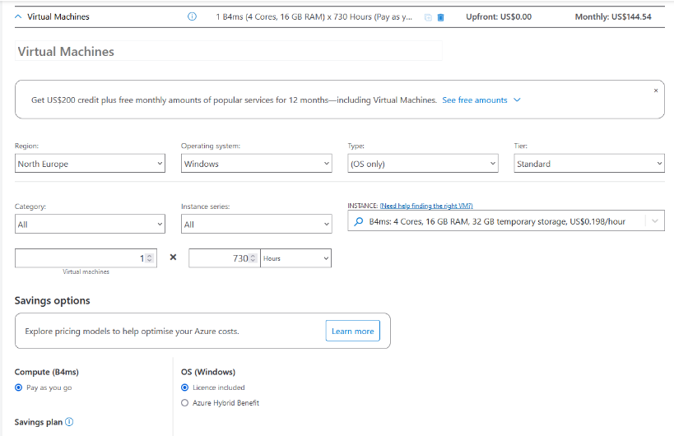
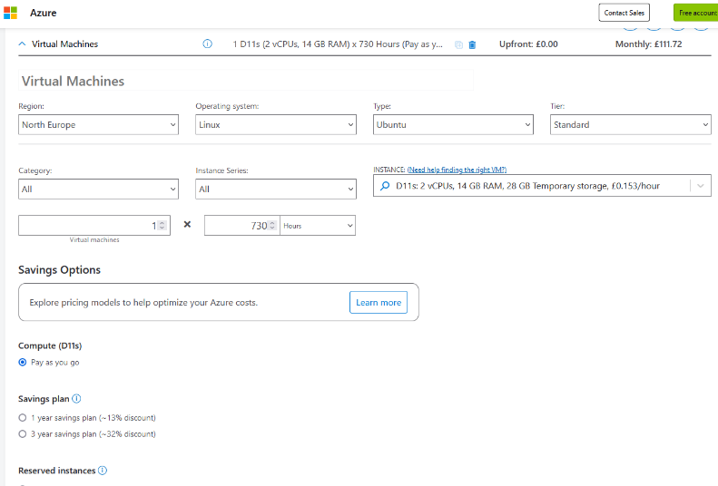
Screenshot 1
Screenshot 2
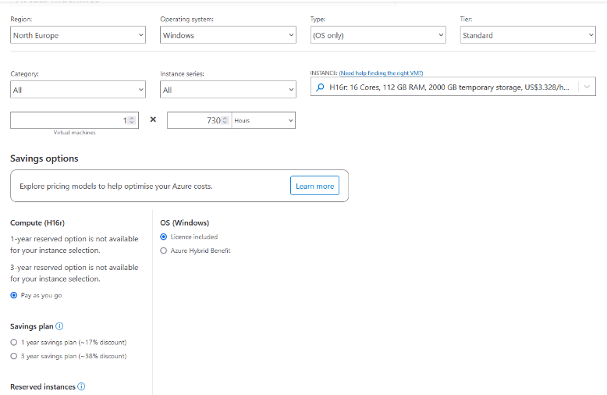
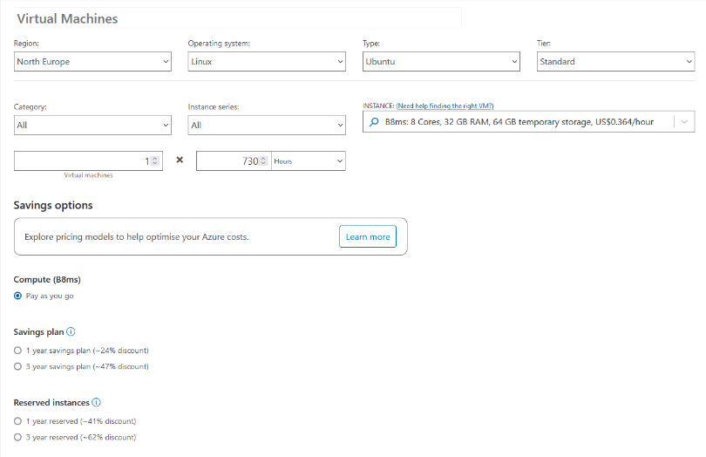
Screenshot 3
Screenshot 4

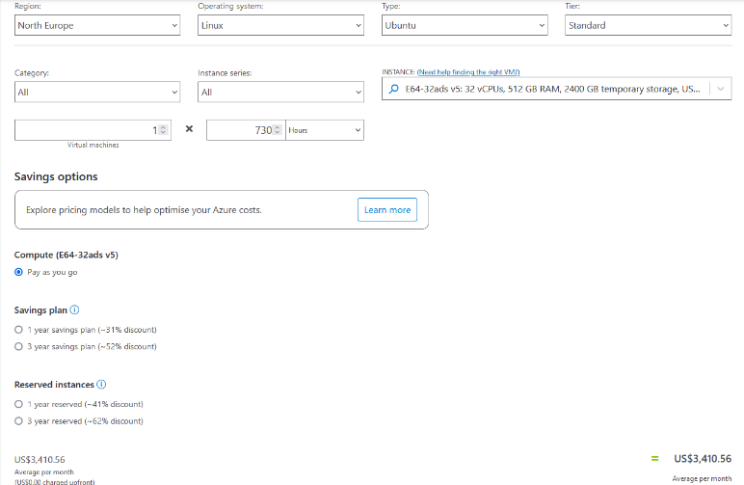

All the VMs are given identical parameters of region, tier and billing method and only the computing power represented by the processors, RAM, Operating Systems and Storage are following then scenario instructions.
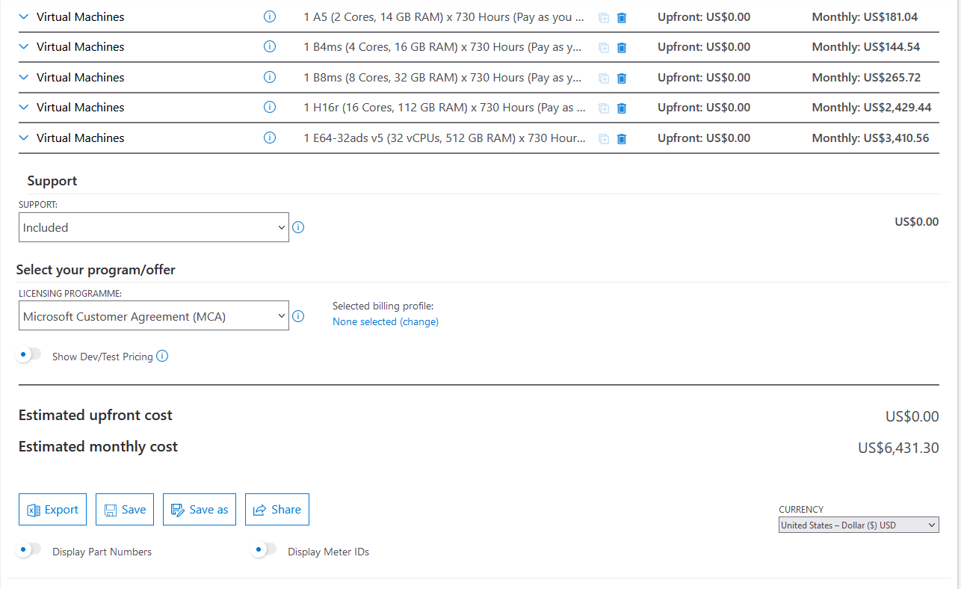
On the final screenshot the total estimated monthly price for pay-as-you-go billing method is 6431.30$
Keeping all the parameters same but changing only the billing method
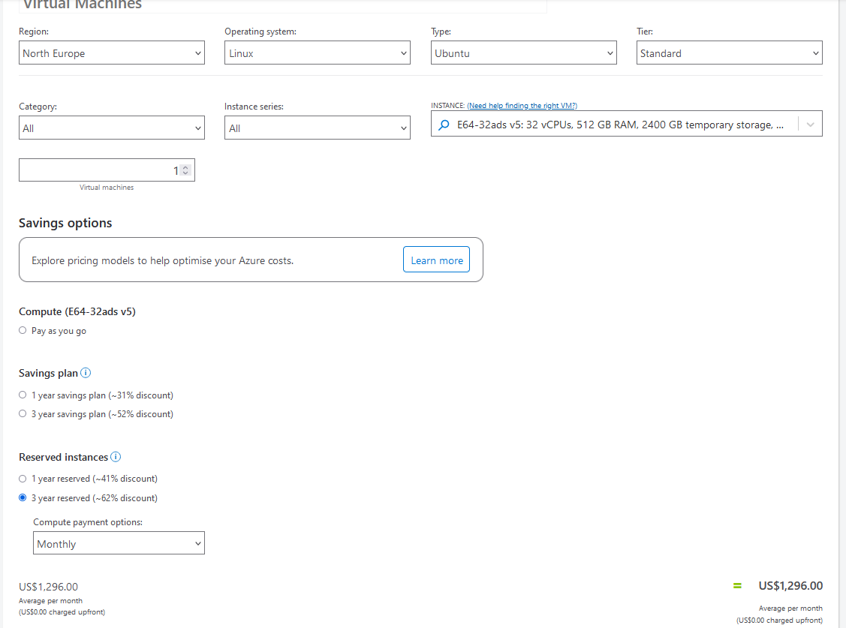

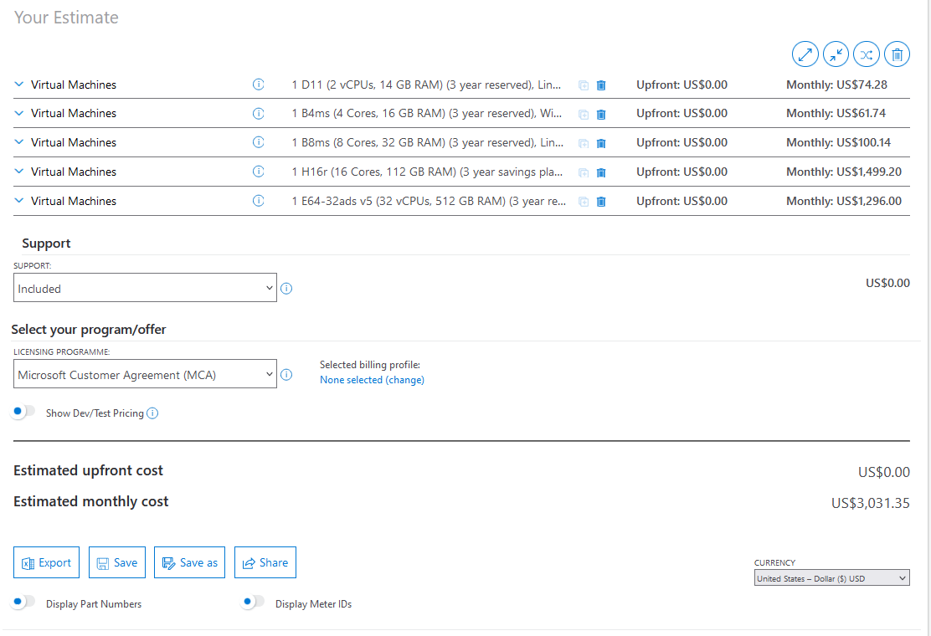
shows tremendous decrease in the estimated monthly costs for provisioning the cloud resources. The total price now is 3031.35 US dollars which is more than 50% less in comparison with the above calculations.
Screenshot 5

This is showing that significant savings could be done, and the finding are redy to be reported to the Aspire Finance manager.
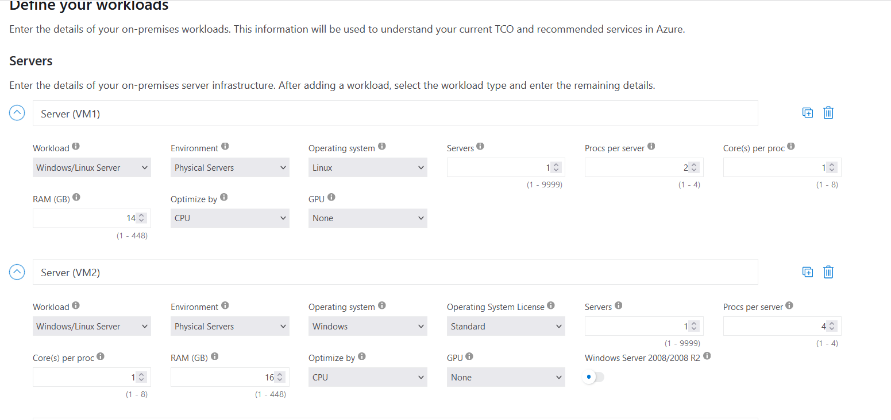
The real benefit from migrating physical Aspire Retailers infrastructure to the IaaS cloud model is revealed when the TCO calculator is used in order to give insight of what the cost of deploying physical servers would be compared to the virtual ones provisioned by Azure services.
Screenshot 6

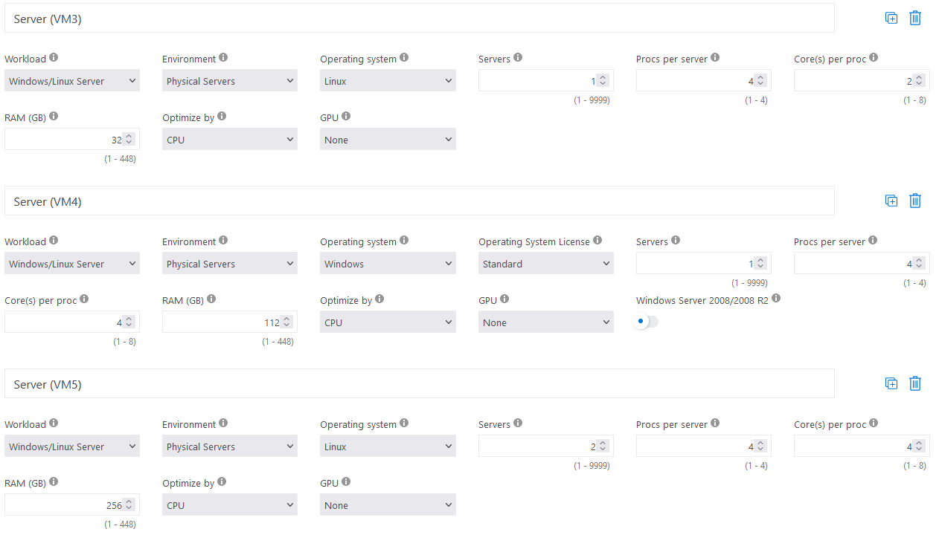
Screenshot 7

The corresponding parameters of the VMs are given to the physical ones where the Virtual CPUs are replaced with physical CPU cores. Eash physical server has been given the same RAM and Storage space as well. All other parameters are left to the default ones.
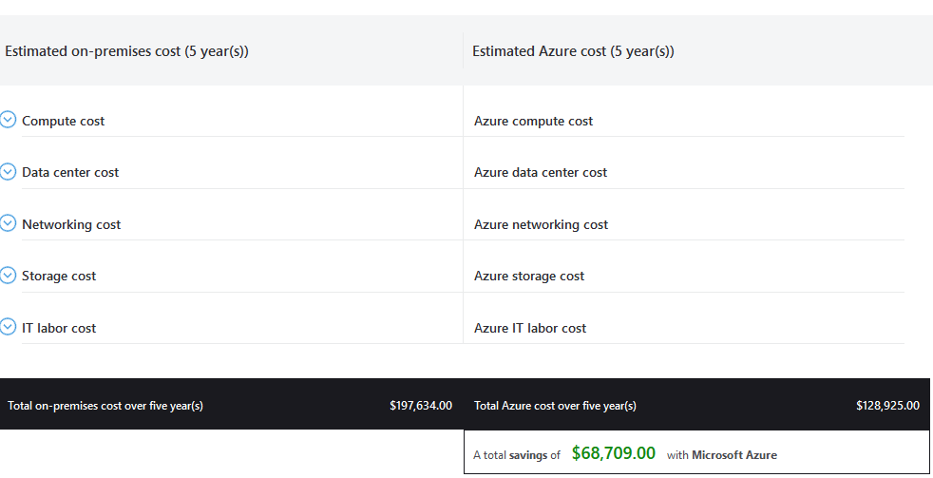
Finally, the calculations are summarized:

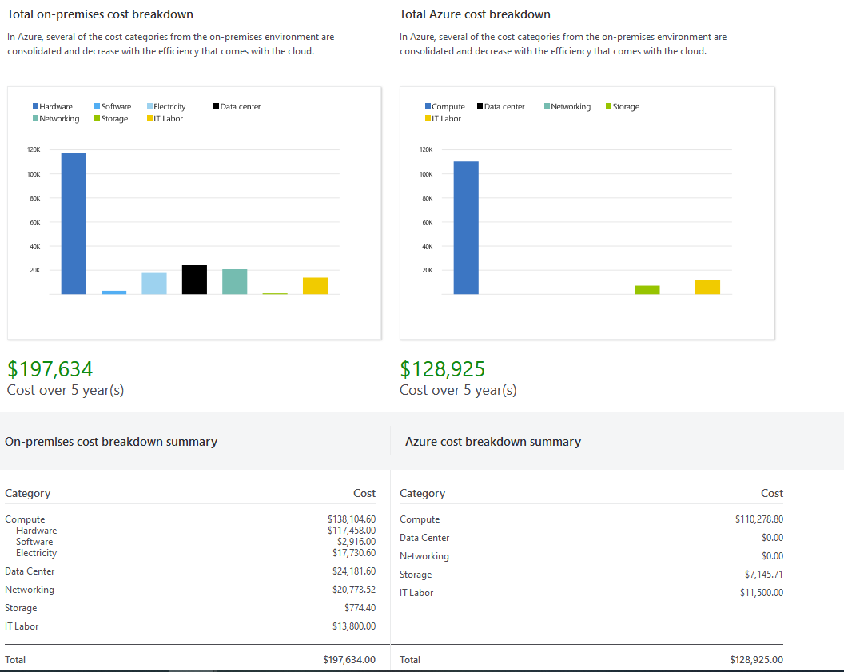
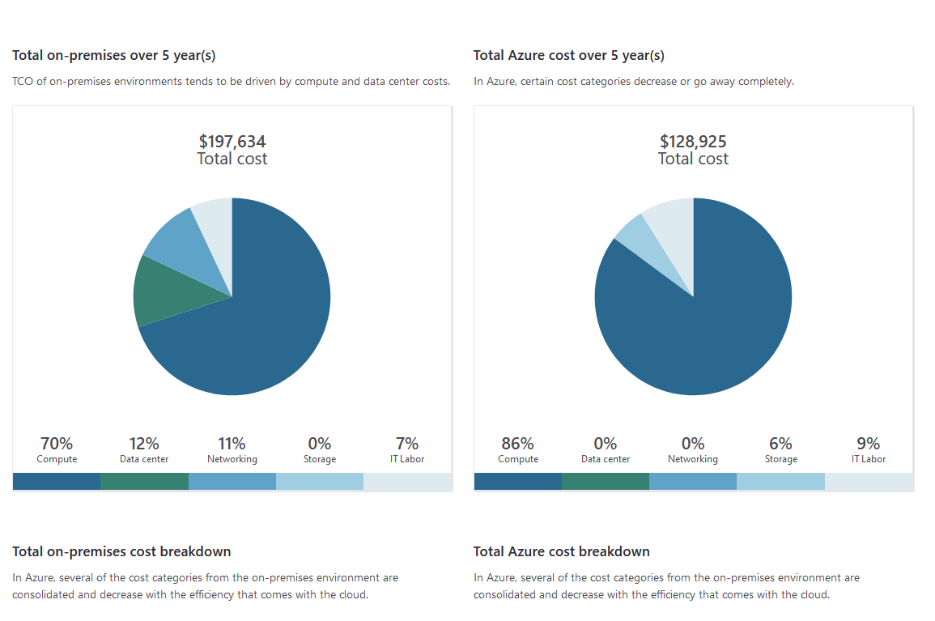
The results show undoubtedly the huge costs reduction from transferring the Aspire Retailers digital resources and applications to the Azure Cloud Platform.
Screenshot 8
Screenshot 9
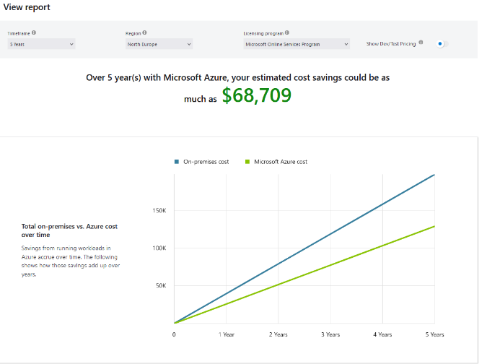
The final amount of savings for the period of 5 years have been estimated to 68709 US dollars.

Discuss Azure AD and how it supports managing and Identities

Azure Active Directory (Azure AD) is a cloud-based service provided by Microsoft that helps manage user identities and access, to software as a service applications. It offers features like user management sign on (SSO) and multi factor authentication (MFA). With Azure AD you can configure types of user accounts. Utilize a robust role-based access control (RBAC) system allowing users to be assigned as 'Global Users or 'Normal Users among other roles.
There are two types of user accounts in Azure AD: Member and Guest. Each account type has its set of default permissions.[28] Member users have permissions, such as managing profiles creating groups and registering applications. On the hand Guest users have limited permissions.
Configuring users also involves defining authentication methods for AD MFA. This includes both public profile contact information and private authentication methods for use. You can manage the authentication methods through the Azure portal, Microsoft Graph or PowerShell.[29]
To enhance security Azure AD supports custom security attributes that allow businesses to define attributes for their Azure AD objects. This feature extends user profiles categorizes applications and grants access, to Azure resources.[30] However, it's important to note that utilizing these attributes requires permissions and AD Premium P1/P2 licenses.
When it comes to managing roles Azure AD offers a range of defined roles that serve specific purposes and levels of administrative access. Among these the 'Global Administrator' role holds the authority granting access, to all administrative features in Azure AD. It's important to assign this role primarily to designated administrators.
Regular users typically have permissions. Can be assigned roles like User, Guest or job specific roles. For example, a user with the 'User Administrator' role can. Manage users and groups in Azure AD but cannot assign roles to others.[31]

Azure AD also supports the creation and assignment of custom roles, which allow for grained control over access rights. Creating custom roles requires an AD Premium P1 or P2 license and the user must be either a Privileged Role Administrator or Global Administrator.[32] Custom roles can be used to grant permissions for managing app registrations at either an organization level or, for specific Azure AD resources.
Additionally Azure AD seamlessly integrates with the Azure subscription model. Each subscription relies on AD for authentication and authorization with each subscription being able to trust one directory while an Azure AD can be trusted by multiple subscriptions.[33]
Azure AD Connect sync serves as a link, between an on premises Active Directory and Azure AD. This feature enables an identity solution that effectively maintains user identities across both directories. During the synchronization process it takes into account accounts accounts and linked mailbox accounts. It also gives attention to syncing groups.[34]
In summary Azure Active Directory stands out as a scalable and highly secure solution for identity and access management. With its ability to support user configurations, role assignments, custom security attributes and hybrid identity solutions Azure AD offers capabilities, for managing identities that cater to businesses of all sizes.

Creating users in Azure AD and assigning roles to them

In order to create users in Azure AD firstly we need to have available Active Directory tenant.
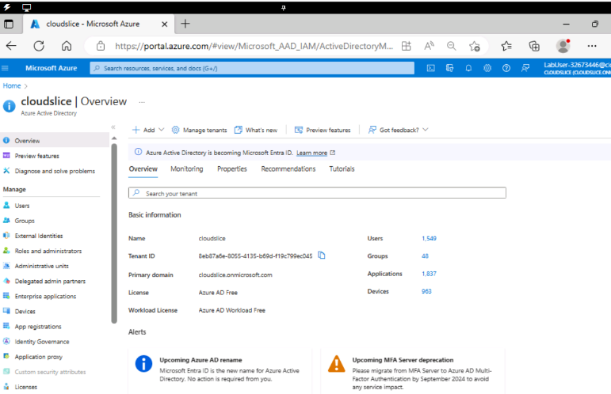
The first step is to navigate to Azure AD and click on the cloudslide overview. Then we should navigate to “manage tenant” and click o the plus sign saying create tenant.
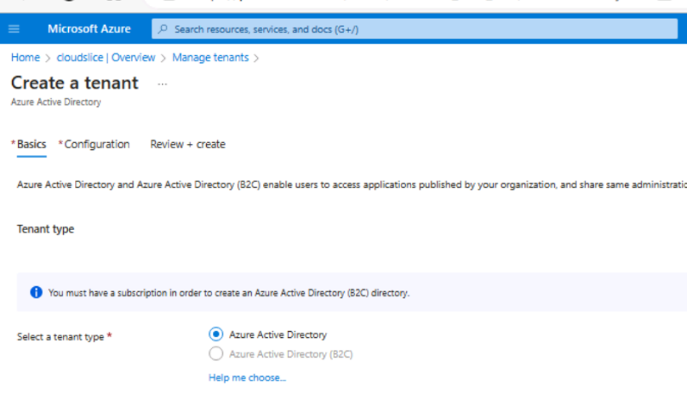
Screenshot 10
Screenshot 11

Next step is to select tenant type “Azure Active directory” and click on “next: configuration” button. The steps that follow are configuring organisation name, initial domain name and choose the location.
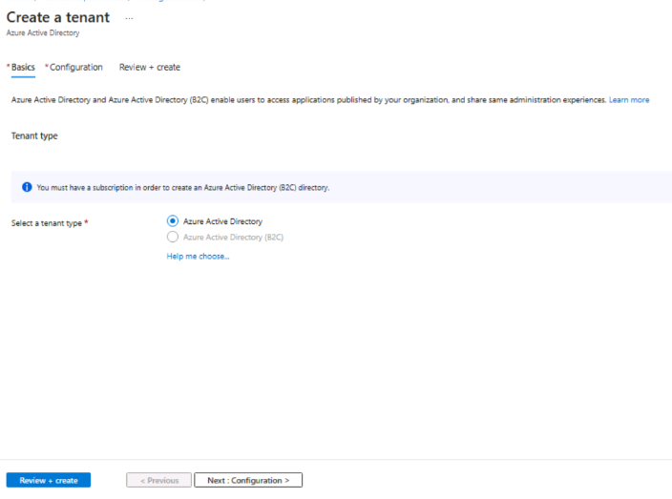
Screenshot 12

Screenshot 13
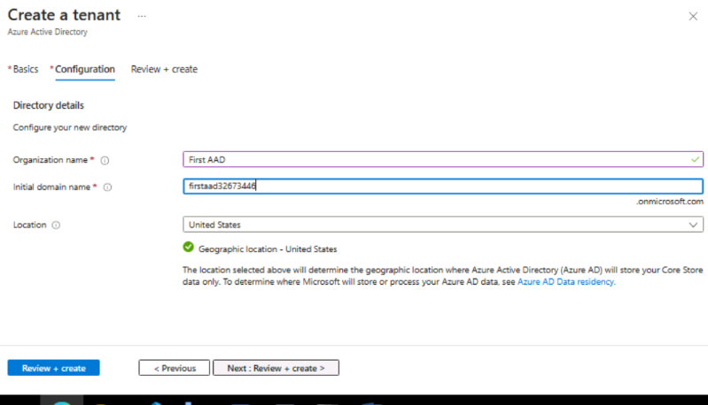
Finally, the tenant is created successfully. We have created a new tenant in Azure AD and it is time to create users that will be accommodated there. But first we have to switch on the new one.
Screenshot 14
Screenshot 15

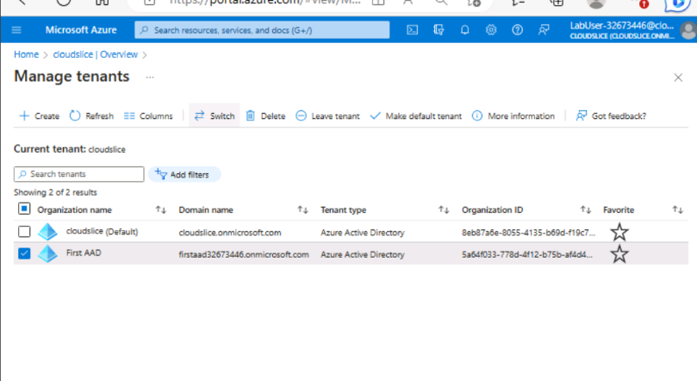
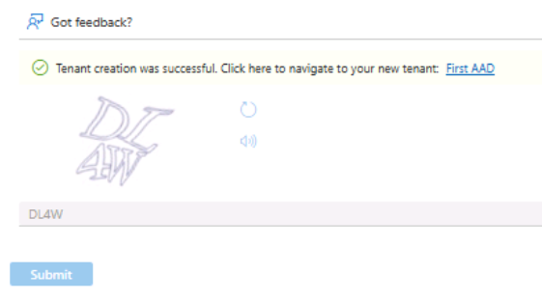
On the Active Directory blade, we need to click on users, then go to the preferred users account and click settings. After that we have to navigate to All Users and create a new user. Then we need to configure the details about the user set a username and usage location and confirm the creation.
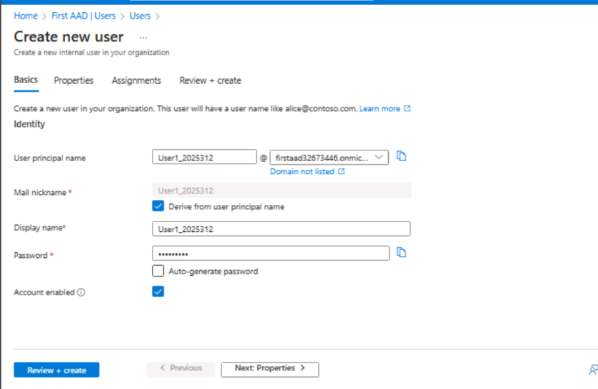
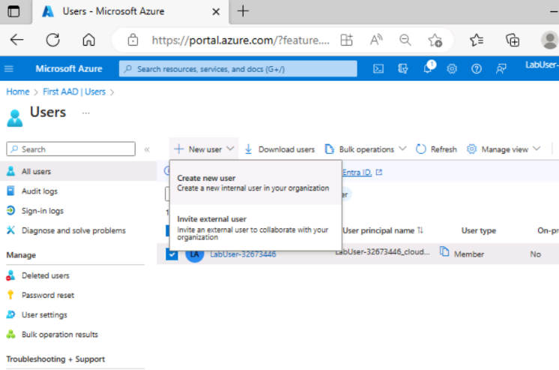
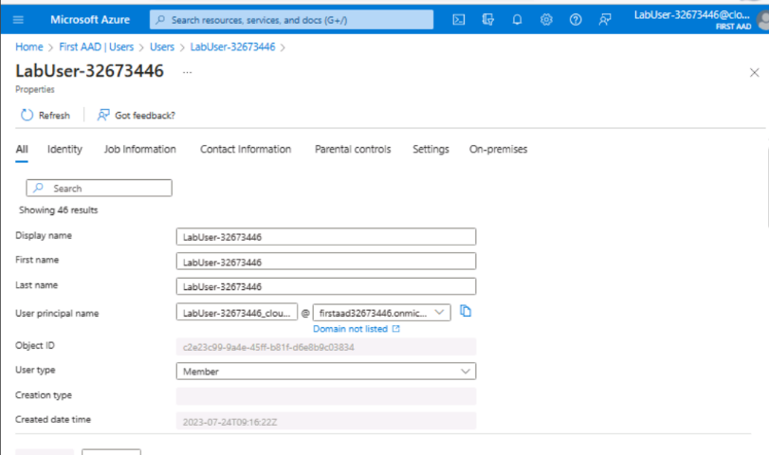
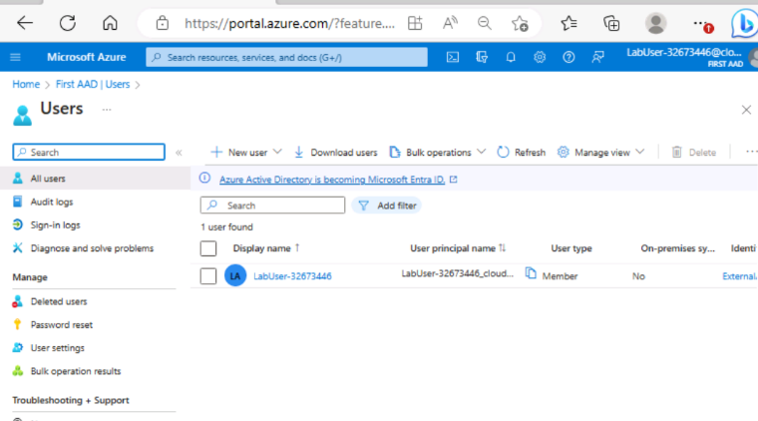
Screenshot 16
Screenshot 17
Screenshot 18
Screenshot 19

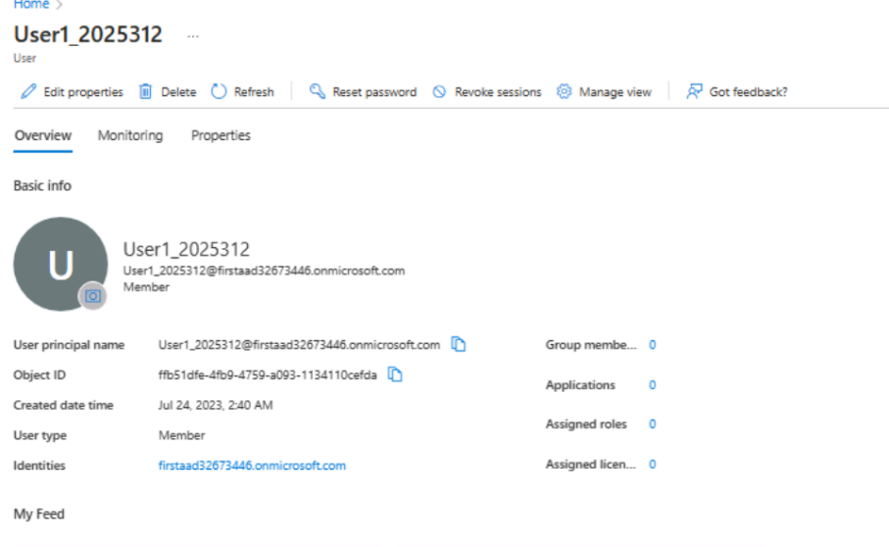
The technical time is a few minutes and the confirmation for the user creation appears.
Screenshot 20
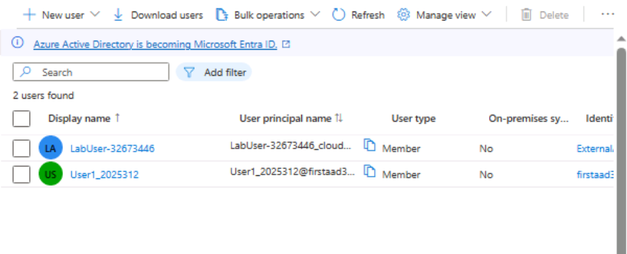
After the Azure AD page is refreshed the list of users show now and the newly created one:
Screenshot 21

The next step is to assign a role to the new user so it will be granted with specific permissions and the certain access to the tenant resources will be provided.
In the Mange section of the blade, we click on the Assign roles and then press the Add button. From the dropdown menu, a role needs to be selected and later assign to our user.

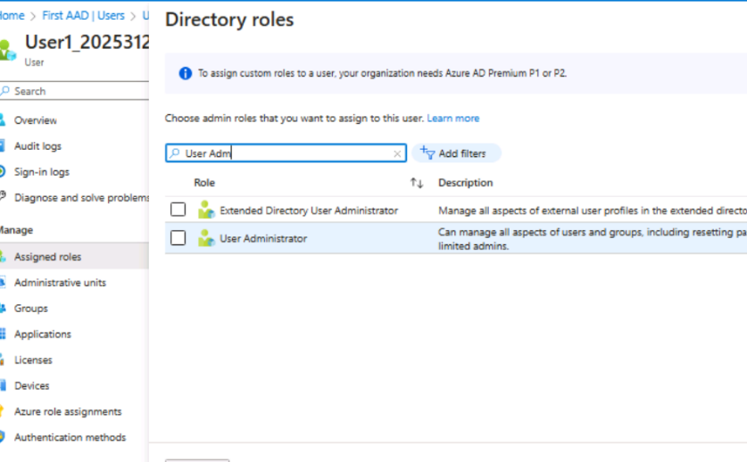
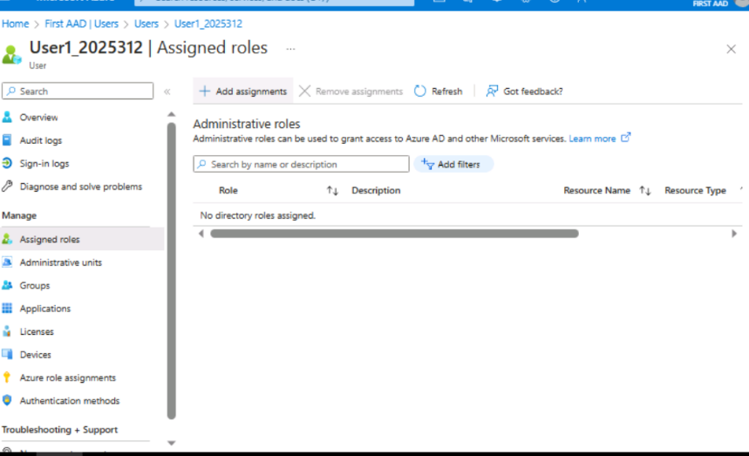
Screenshot 22
Screenshot 23

In order to check our user has the permission to login, a new private browser window is opened, and we sign into Azure AD with it. After that we can continue with the creation of the second user which is identical to the creation of the first one.

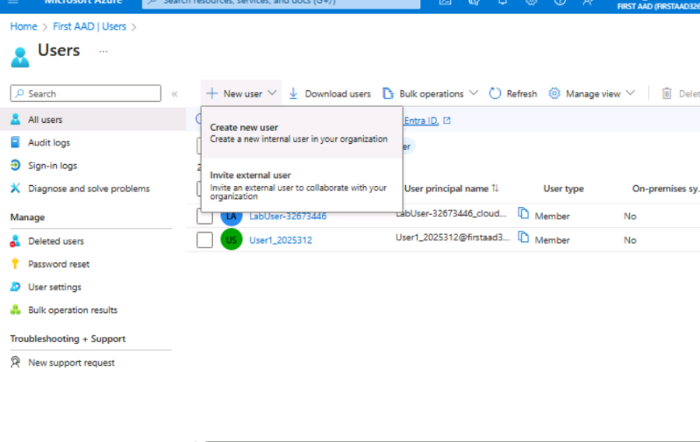
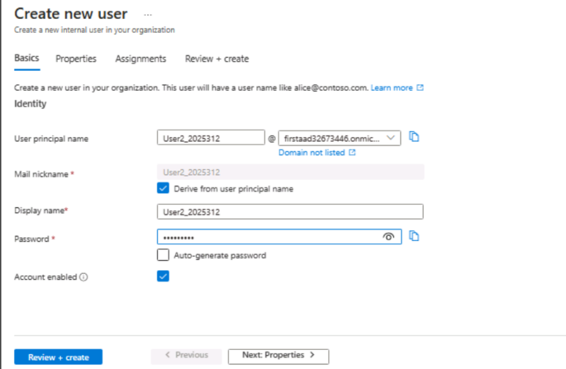
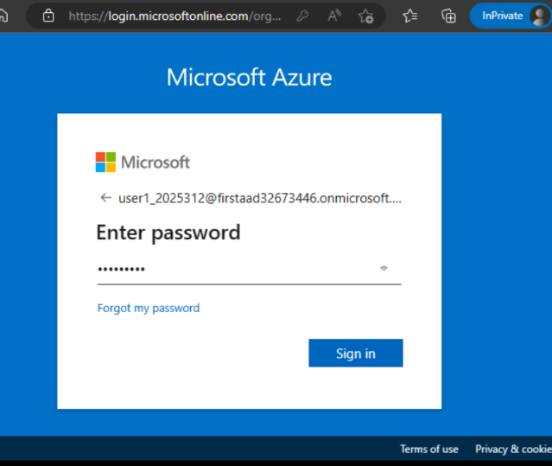
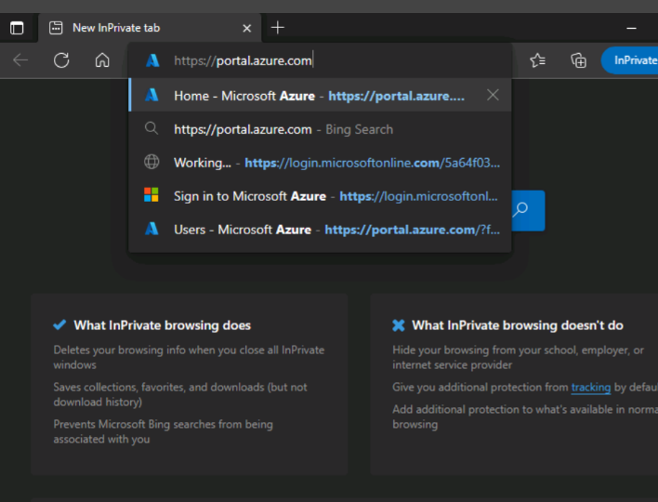
Screenshot 24
Screenshot 25
Screenshot 26
Screenshot 27
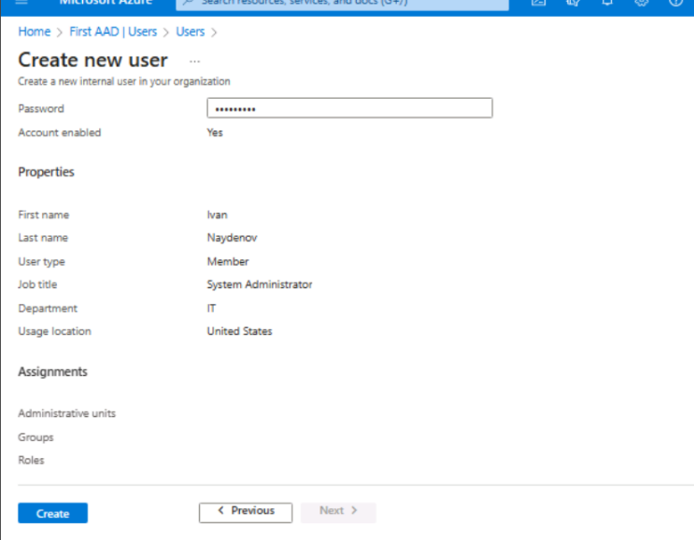
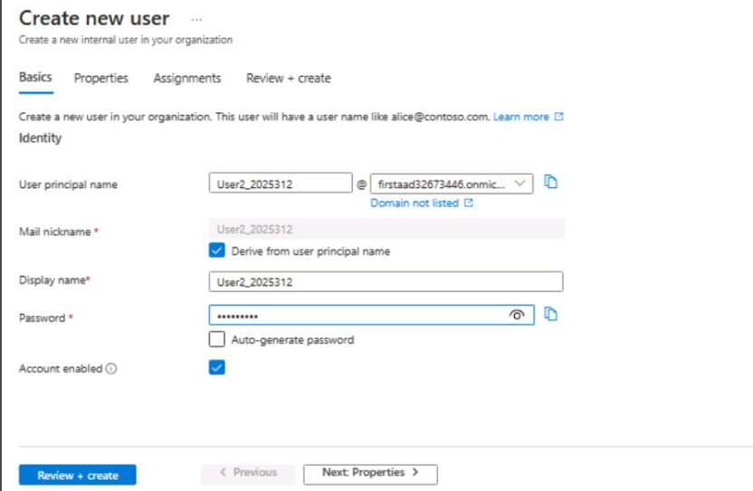
Screenshot 29
Screenshot 28

What is cloud governance strategy and how Microsoft Azure can help Aspire Retailer to secure access of cloud resources?

A cloud governance strategy refers to the collection of rules, protocols and controls that organizations implement in order to manage and regulate their cloud-based IT resources and operations. The main goals of this strategy are to align cloud usage with the organizations business objectives, ensure data privacy and security and meet requirements. This is especially important, in environments where remote work, BYOD (Bring Your Device) mobile usage and cloud applications common as identity management becomes a vital aspect of security.[35]
Microsoft Azure offers a range of services and tools that empower organizations like Aspire Retailers to develop a cloud governance strategy. Two notable examples are Azure Policy and Azure Blueprints, which play roles in maintaining compliance and control over the cloud environment.[35]
Azure Policy allows for the creation, assignment and management of resource compliance policies. It actively monitors resources to ensure they comply with the organization’s standards and regulations.[36] For instance, Aspire Retailers could implement a policy that restricts the creation of storage accounts to regions or enforces a naming standard, for resources. These measures promote consistency across the organization.
Azure Blueprints on the hand allow for the creation of a set of Azure resources that align with organizational standards and best practices. This makes it easier to develop solutions that're both efficient and compliant [36]. It also offers version control. Update management features making it simple to deploy governed cloud environments across an organization.
Another important Azure service is Microsoft Defender, for Cloud. It provides a security view. Analyses data to offer actionable recommendations while enforcing security policies for hybrid cloud workloads [36]. Additionally Azure Management Groups offer a way to manage Azure subscriptions collectively while Azure Cost Management allows for monitoring and controlling expenditures on Azure services .
For establishing a governance strategy Microsoft Cloud Adoption Framework plays a big role. It helps identify risks associated with moving to the cloud. Provides guidance on implementing technologies like monitoring tools, enforcement mechanisms and policy automation [37].
To ensure access to cloud-based resources for Aspire Retailers one suggested policy could be implementing Azures role-based access control (RBAC). This approach assigns permissions based on roles ensuring that users only have access, to the resources they need for their tasks. To safeguard information, from both external risks this approach aims to significantly minimize the areas vulnerable to potential attacks.
Microsoft Azure offers a range of tools to establish a cloud governance plan that aligns with the company’s goals guarantees secure and efficient access to cloud resources upholds data security measures and ensures compliance, with relevant regulations.

Suggest appropriate disaster recovery plan to the Aspire Retailers

In order to ensure the safety of data and maintain business integrity in the face of events, like system failures, natural disasters or cyber-attacks it is crucial for Aspire Retailers to have a disaster recovery (DR) strategy in place for their cloud environment. This strategy should align with their business needs and tolerance for risk. When developing their cloud-based disaster recovery plan Aspire Retailers should consider the following processes and strategies.
Assessing risks. Conducting a business impact analysis (BIA);[38] Start by identifying threats and vulnerabilities in the cloud infrastructure. These can include hardware failures, data breaches, natural cataclysm or human errors. Conducting an impact analysis will help determine the consequences of these disruptions on the business allowing for prioritization of applications and data that need to be recovered first.
Setting recovery goals; Clearly define Recovery Point Objectives (RPOs) and Recovery Time Objectives (RTOs). RPOs determine how much data can be lost before it significantly impacts company operations while RTOs specify how quickly systems must be restored to prevent service disruptions. These objectives will serve as guiding principles, for your disaster recovery approach.[39]
Ensure regularly backing up data, to another location in an area so that regional outages don't cause any harm. Azure offers data protection and recovery services like Azure Backup.
Consider using Azure Site Recovery (ASR) to automate the replication of your machines to a different region. This way if there’s a catastrophe you can switch over to the area. Then revert back once the main location is back online.[40]
It's essential to test your disaster recovery strategy on a basis to ensure it's valid. This will ensure that your staff knows exactly what steps to take in case of a crisis and can quickly resume operations.
Remember to keep updating your DR plan as business requirements and technology evolve. This will help ensure its effectiveness over time.
Having a disaster recovery strategy, with the mix of preventive, investigative and corrective measures will enable Aspire Retailers to recover quickly from any catastrophe while minimizing disruption to their business operations. With Azure’s enhanced capabilities and services, they can create a reliable DR plan.

References:

[1] Zac Francis, ‘5 Challenges Facing Retail in 2023’, 2023. https://www.edume.com/blog/2023-retail-challenges (accessed Jul. 22, 2023).
[2] Deloitte, ‘2023 retail industry outlook’. Deloitte Development LLC, 2023. Accessed: Jul. 22, 2023. [Online]. Available: https://www2.deloitte.com/us/en/pages/consumer-business/articles/retail-distribution-industry-outlook.html
[3] ‘What Is Cloud Computing? | Microsoft Azure’. https://azure.microsoft.com/en-us/resources/cloud-computing-dictionary/what-is-cloud-computing (accessed Jul. 22, 2023).
[4] ‘PaaS vs IaaS vs SaaS: What’s the difference?’, Google Cloud. https://cloud.google.com/learn/paas-vs-iaas-vs-saas (accessed Jul. 22, 2023).
[5] ‘IaaS vs. PaaS vs. SaaS | IBM’. https://www.ibm.com/topics/iaas-paas-saas (accessed Jul. 22, 2023).
[6] K. Morris, Infrastructure as Code: Managing Servers in the Cloud, First. United States of America: O’Reilly Media, Inc., 2016. [Online]. Available: http://oreilly.com/safari
[7] ‘Maximizing Cloud Performance: The Importance of Load Balancing’, Middleware. https://middleware.io/blog/cloud-load-balancing/ (accessed Jul. 22, 2023).
[8] Ben Lewis, ‘Three big benefits of cloud load balancing’, Insights from the load balancer experts, Apr. 06, 2021. https://www.loadbalancer.org/blog/three-big-benefits-of-cloud-load-balancing/ (accessed Jul. 23, 2023).
[9] R. Kestenbaum, ‘The Biggest Challenges Facing Retailers Now’, Forbes, May 17, 2022. https://www.forbes.com/sites/richardkestenbaum/2022/05/17/the-biggest-challenges-facing-retailers-now/ (accessed Jul. 21, 2023).
[10] Huawei Technologies Co., Ltd., Cloud Computing Technology, First. Hangzhou, Zhejiang, China: Springer, Posts & Telecom Press, 2023. Accessed: Jul. 23, 2023. [Online]. Available: https://doi.org/10.1007/978-981-19-3026-3
[11] A. Gajbhiye and K. M. P. Shrivastva, ‘Cloud computing: Need, enabling technology, architecture, advantages and challenges’, presented at the 5th International Conference - Confluence The Next Generation Information Technology Summit, 2014, pp. 1–7. doi: doi: 10.1109/CONFLUENCE.2014.6949224.
[12] ‘Choose a load balancer | Load Balancing’, Google Cloud. https://cloud.google.com/load-balancing/docs/choosing-load-balancer (accessed Jul. 23, 2023).
[13] mbender-ms, ‘What is Azure Load Balancer? - Azure Load Balancer’, Feb. 12, 2023. https://learn.microsoft.com/en-us/azure/load-balancer/load-balancer-overview (accessed Jul. 23, 2023).
[14] Muhammad Ayoub Kamal, Hafiz Wahab Raza, Muhammad Mansoor Alam, and Mazliham Mohd Su’ud, ‘Highlight the Features of AWS, GCP and Microsoft Azure that Have an Impact when Choosing a Cloud Service Provider’, IJRTE, vol. 8, no. 5, pp. 1–9, Jan. 2020, doi: 0.35940/ijrte.D8573.018520.
[15] J. Fulmer, ‘Top Cloud Providers & Companies 2022’, IT Business Edge, Dec. 20, 2021. https://www.itbusinessedge.com/cloud/compare-top-cloud-providers/ (accessed Jul. 23, 2023).
[16] ‘Top Cloud Service Providers: A Quick Comparison – Avenga’, May 05, 2021. https://www.avenga.com/magazine/top-cloud-service-providers/ (accessed Jul. 23, 2023).
[17] ‘Cloud Storage Classes – Amazon Simple Storage Service (S3) – AWS’, Jun. 13, 2018. https://web.archive.org/web/20180613200647/https://aws.amazon.com/s3/storage-classes/# (accessed Jul. 23, 2023).
[18] ‘Object Storage Classes – Amazon S3’, Amazon Web Services, Inc. https://aws.amazon.com/s3/storage-classes/ (accessed Jul. 23, 2023).
[19] ‘Cloud Products’, Amazon Web Services, Inc. https://aws.amazon.com/products/ (accessed Jul. 23, 2023).
[20] ‘Machine Learning (ML) and Artificial Intelligence (AI) - Overview of Amazon Web Services’. https://docs.aws.amazon.com/whitepapers/latest/aws-overview/machine-learning.html (accessed Jul. 23, 2023).
[21] Tabish Mufti, Pooja Mittal, and Bulbul Gupta, ‘A Review on Amazon Web Service (AWS), Microsoft Azure & Google Cloud Platform (GCP) Services’, presented at the ICIDSSD 2020, New Delhi, India, Feb. 2020. doi: 10.4108/eai.27-2-2020.2303255.
[22] mbender-ms, ‘Azure networking services overview’, Jul. 12, 2023. https://learn.microsoft.com/en-us/azure/networking/fundamentals/networking-overview (accessed Jul. 23, 2023).
[23] tamram, ‘Introduction to Azure Storage - Cloud storage on Azure’, Mar. 08, 2023. https://learn.microsoft.com/en-us/azure/storage/common/storage-introduction (accessed Jul. 23, 2023).
[24] MashaMSFT, ‘What is Azure SQL? - Azure SQL’, Apr. 24, 2023. https://learn.microsoft.com/en-us/azure/azure-sql/azure-sql-iaas-vs-paas-what-is-overview?view=azuresql-vm (accessed Jul. 23, 2023).
[25] M. C. Blogs, ‘Microsoft and OpenAI extend partnership’, The Official Microsoft Blog, Jan. 23, 2023. https://blogs.microsoft.com/blog/2023/01/23/microsoftandopenaiextendpartnership/ (accessed Jul. 23, 2023).
[26] ‘Data analytics design patterns | Cloud Architecture Center | Google Cloud’. https://cloud.google.com/architecture/reference-patterns/overview (accessed Jul. 23, 2023).
[27] ‘Pricing Calculator | Microsoft Azure’. https://azure.microsoft.com/en-us/pricing/calculator/ (accessed Jul. 24, 2023).
[28] barclayn, ‘Default user permissions - Microsoft Entra’, Mar. 13, 2023. https://learn.microsoft.com/en-us/azure/active-directory/fundamentals/users-default-permissions (accessed Jul. 24, 2023).
[29] Justinha, ‘Manage authentication methods for Azure AD Multi-Factor Authentication - Microsoft Entra’, Jul. 05, 2023. https://learn.microsoft.com/en-us/azure/active-directory/authentication/howto-mfa-userdevicesettings (accessed Jul. 24, 2023).
[30] rolyon, ‘What are custom security attributes in Azure AD? (Preview) - Microsoft Entra’, Jul. 19, 2023. https://learn.microsoft.com/en-us/azure/active-directory/fundamentals/custom-security-attributes-overview (accessed Jul. 24, 2023).
[31] shlipsey3, ‘Manage users and groups in Azure Active Directory - Training’. https://learn.microsoft.com/en-us/training/modules/manage-users-and-groups-in-aad/ (accessed Jul. 24, 2023).
[32] rolyon, ‘Create custom roles in Azure AD role-based access control - Microsoft Entra’, Mar. 10, 2023. https://learn.microsoft.com/en-us/azure/active-directory/roles/custom-create (accessed Jul. 24, 2023).
[33] barclayn, ‘Add an existing Azure subscription to your tenant - Microsoft Entra’, Jun. 30, 2023. https://learn.microsoft.com/en-us/azure/active-directory/fundamentals/how-subscriptions-associated-directory (accessed Jul. 24, 2023).
[34] billmath, ‘Azure AD Connect sync: Understanding Users, Groups, and Contacts - Microsoft Entra’, Jun. 27, 2023. https://learn.microsoft.com/en-us/azure/active-directory/hybrid/connect/concept-azure-ad-connect-sync-user-and-contacts (accessed Jul. 24, 2023).
[35] wwlpublish, ‘Build a cloud governance strategy on Azure - Training’. https://learn.microsoft.com/en-us/training/modules/build-cloud-governance-strategy-azure/ (accessed Jul. 24, 2023).
[36] tvuylsteke, ‘Governance, security, and compliance in Azure - Cloud Adoption Framework’, Apr. 03, 2023. https://learn.microsoft.com/en-us/azure/cloud-adoption-framework/ready/azure-setup-guide/govern-org-compliance (accessed Jul. 24, 2023).
[37] martinekuan, ‘Define corporate policy for cloud governance - Cloud Adoption Framework’, Apr. 24, 2023. https://learn.microsoft.com/en-us/azure/cloud-adoption-framework/govern/policy-compliance/policy-definition (accessed Jul. 24, 2023).
[38] ‘What is a business impact analysis (BIA)? Definition from WhatIs.com’, Storage. https://www.techtarget.com/searchstorage/definition/business-impact-analysis (accessed Jul. 24, 2023).
[39] ‘What is Recovery Time Objective? Definitions and related FAQs | Druva’. https://www.druva.com/glossary/what-is-recovery-time-objective-definitions-and-related-faqs (accessed Jul. 24, 2023).
[40] Y. P. Evangelist Product, ‘Azure Disaster Recovery: Azure-to-Azure and Physical-to-Azure’. https://bluexp.netapp.com/blog/azure-cvo-blg-azure-disaster-recovery-azure-to-azure-and-physical-to-azure (accessed Jul. 24, 2023).

