Student Name mark samuel’s
Student number 2318279
Module Code: LCLM4001 - Academic Skills (Feb 2024)
Lecturer Tim Hopkins
Reflective Report

I would like to start this reflective report by saying that I am extremely grateful for being given the opportunity to take part in academic skills. The feeling’s I had towards note taking was that it made me feel more relaxed knowing that when I need to do a report or homework, I just go back into my notes were everything is written. it Feels like your more in control of what is to come like essays homework watching YouTube videos and jotting stuff down. You have more other ways of taking down notes like on your phone, but I prefer writing it down more better for me and you are never know your computer could play up so notes is very good for me. it helps me to focus on what I am reading and hearing also it gives me good record of what I have learnt.

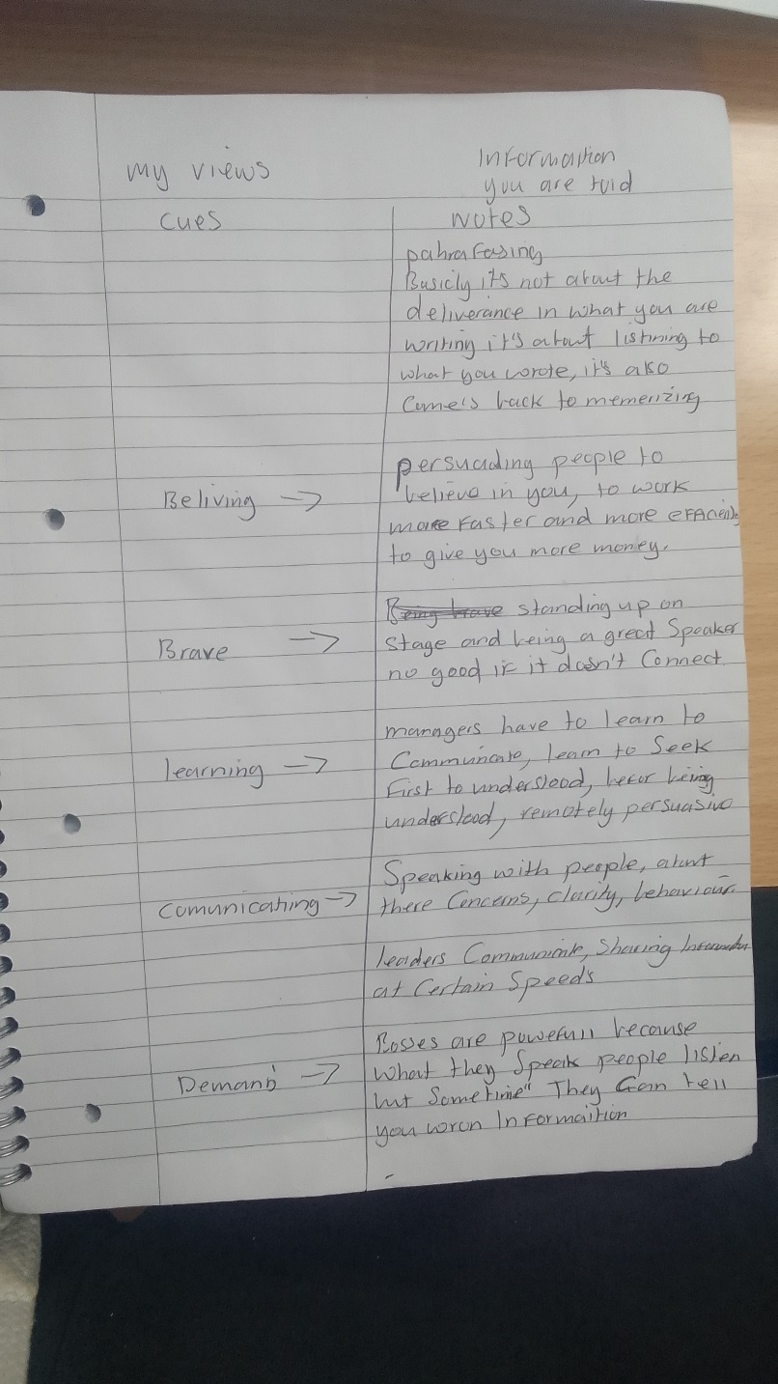

The good thing about taking notes is that it helps me focus on what’s more important, it also helps me to understand and remember material. The best part of it is when I have to do my homework or essay like now I just go back to my notes, I have just been doing my home work to submit it. I wrote every thing down, took me all day and I don’t know what I touched its all gone just like that. what I done for the next time i wrote it all down then converted over to my laptop so for me you cant beat note taking its very good keeps your stuff safe.

The few bad things I found out is that it can distract you from listening to lectures, and if the lecture is fast you must have time to organize. For me I didn’t find to many wrongs in note taking its help’s me a lot.

The experience I had towards note taking was interesting. the first time I started class I was looking at the drawing board a bit puzzled where I haven’t seen one of them for a long time. the teacher had given us a pen and paper and told us to take notes down and how important it was. as I was taking notes down I more understand what he was talking about so I could take his information and turn it into what was more comfortable
For me. so far it has been very useful indeed.

In week two we done practical note taking skills these included cornel notes, tabular, liner and spider diagram. we also learned about plagiarisms and self-plagiarisms, sentence’s and concluding sentences, topic sentences’ and paragraph’s
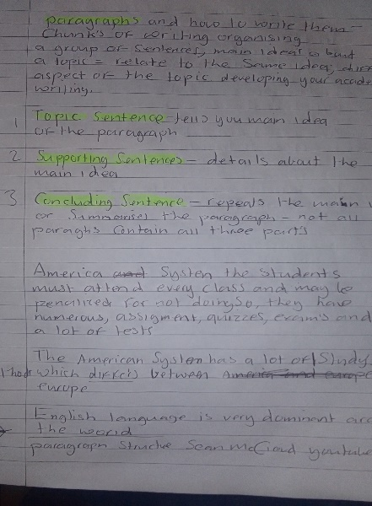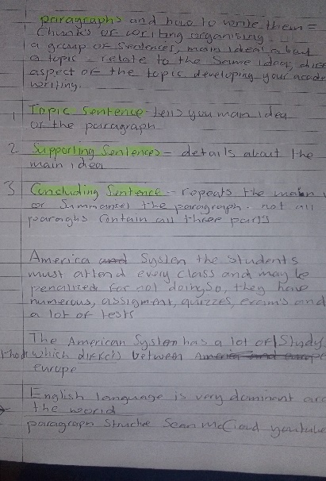
The end result to every thing I have learned so far from note taking is that I have learnt a lot already,Note taking is a good skill for me which I will always use in the future from now on. for the rest of the term and at home, I always store things in my head and now I can write some stuff in my diary like events I have coming up holidays and my kids activitys. I can go back in my notes before class starts and after class review, reflect on, and discuss the material in my notes.

The action I took towards note taking I watched a few stuff on youtube with lea david,carl pullein and jim kwik.I always have a diary on my desk now for when im sufacing on my computer. I have included relevent context I can turn my notes into action items I have also learnt to summarize effectively by highlighting takeaways.
If it rose again I have the skills to note take in a lot off chanells like spider diagram, cornell notes, analyzing and braking down my points reasearch, findings referencing paraphasing and summarizing so much more.And whats so funny is that when your here note taking you think its just writing down notes its much more to it that’s what I have learned.

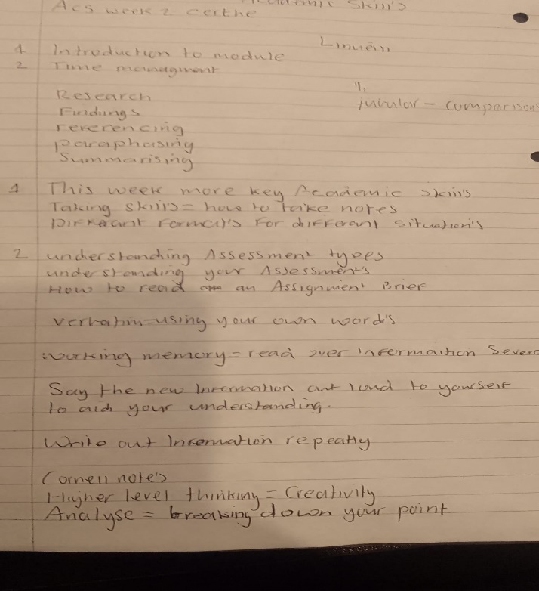
Academic writing is a formal style of writing used in universitys mostley in articles books and academic topics.what I learned in academic writing was formal,objective,cautions,succinct,impersonal,colloquial writing and of course academic writing.

The feelings I had towards academic writing was very supprising to know you can write in different styles.I just thought writing was writing so it was very intresting to me.I have come across all the words I have mentioned before but never knew the meaning, like fomal =avoiding spoken language,objective=standing back from others,impersonal=writing in ampartial style,so it was very intresting to me.

The good thing about academic writing is that you can use differant styles,I enjoyed paraphasing writing ideas from what you are learning about expressings the lectures ideas in to your own words.What I picked up in it as well is that you have to understand the source well to write your own words.Essays is attempt to answer qestions disscus topics sharing and disscussing ideas.Report is a reasearch to infrormation to process these are all the stuff I learned so it was very intresting

The bad thing in academic writing I found was poor sentence structure and the langage issues can make your writing seem unclear confusing and missunderstood. I noticed as well that paraphasing can lead to some one else work you don’t have your own ideas.
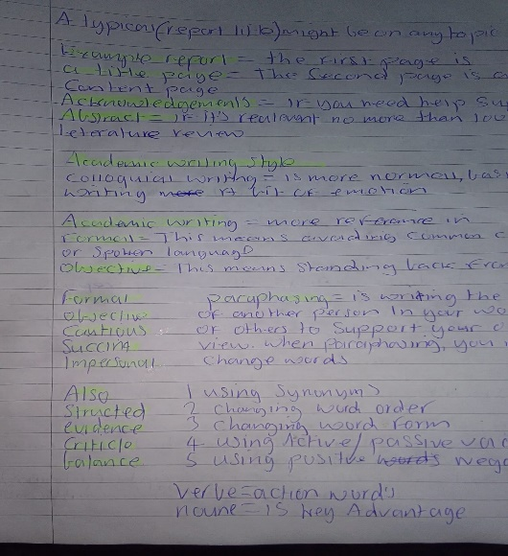
My eperiance with academic writing was a bit different and I didn’t know there was different styles of writing since I have been to college in a long while never got taught it so its very new to me but I like new challeges and im learning as I go a long its more the different languages to it formal objective colloquial and so on theres a lot of different styles.I done some reasearch on the topic on you tube followed a few people so im getting the hang of it.

The sense I got from academic writing was its more to do with communication ideas, information and reasearch and a lot of different headings that means something more, technical to study.Then you got the citation’s which is another part so there is a lot on board when it comes to academic writing and to store in your head.

The conclusion is to hightlight the key words in the presented in the essay,you can go back to the essay question to show that it as been corrected.Academic writing as more stuff to take down like notes keep doing reasearch on the topic to get the hang of it it will come easier as I study more and reasearch more on the topic.

The Action im going to take towards academic writing is more research get to understand it more watch some videos on youtube take down some notes read some essays learn the different languages find out there meanings.

Referance skills was a good topic acknowledging the source of informaition you have it makes it clear that you have to develop your own ideas.

The feelings I had towards referance skills was the ability to understand specific information. Giving and following directions and asking question.Taking notes recording details of information from sources you have read This subject is a bit more easier to do more straight foward it think referance is a bit like refered.

The good think I like with referancing is that you can refer to a book, journals and websites.You can find out the referance of the book like the publisher the title of the book the year author surname and initials.Normaly I would take a book and just read but I have now found out that there is more to it which I find interesting.Referancing also allows you to take words and ideas from you lectuer or writer which you can use yourself and change it around to what you think make sense.

The bad thing about is you can miss references and citations you can also miss page numbers as well it be regarded as plagiarism. The page number should always be cited as a referance and sometimes you can you can forget.The other thing I found is that you can referance something in the text and forget to put that in the referance list.You can do the citation but it as to much the referance list that’s another think you can forget and the referance list must appear in your essay some times you can get that back to front.The referance list as to be in alphabetical order that can be a problem as well so there a bit of bad points in referancing.
The sense I made of the situation in referancing was you have to have your evidence to support your argument, something to argue against. By referance a speaker indicates which things ( incuding a person) are being talked about.Its the name of the creator of a piece of information talked about in the right order.So basicly you have the surname the title the journal volume number the year, it’s a list of authors name in alphabetical order.
The conclusion to to the introduction should confirm that you understand the approach to the essay topic.The conclusion summarises what has already been stated to look up the report the points you have just stated.So what I have picked up so far from referancing is that its all to do with the authour the main title from a book the introduction all the points put in the right place.You have the primary and the secondary source in different perspectives.

.

The action towards referencing im going to learn more about and study the topic fluently. when I first started referencing I didn’t know it was to do with aurthour in the book and the surname, title’s, the year, the publisher and the date. so this is one of the topics im going to start reshearching on watching more things of youtube asking google more questions about it and taking notes down.



