Advanced Construction and Civil Engineering
ACBA 6004
Niki Hunwick 2016441

Contents
List of Figures 2
Introduction 3
Alex Exchange Design Building. 4
The Building Profile 6
Construction 6
Evaluation and Critique 7
Future Specifications 8
Operation energy usage 8
Improvements 8
Smart technology 9
Curtain Walling 10
Embodied Energy/Carbon 11
Opportunities for enhancements 13
Conclusion 14
References 15

List of Figures
Figure 1 - The Alex Design Building, showcasing the original building alongside its most recent extension. 3
Figure 2 - The site of The Alex Design Building. 4
Figure 3 - The Alex Design Building, showcasing its large glass facade. 5
Figure 4 - The Alex Design Building Roof showcasing the photovoltaic panels. 9
Figure 5 - Baglan Bay Innovation Centre's novel use of photovoltaic panels as the building facade. 10
Figure 6 - The Alex Design Building showcasing the large glass facade. 11

Introduction

This report will examine The Alex Design Exchange building, situated at the intersection of Alexandra Road and Pleasant Street, Swansea. It is one of the several University Wales Trinity St David campus within the Southwest region. Located in central Swansea and has its origin as the former Swansea central library before moving to the Civic Centre in Swansea. In November 2007 it closed its doors and was exclusively used by BBC Wales as set for the Doctor Who series. Later Swansea Metropolitan acquired the building and began a large redevelopment and extension, beginning in 2012 which then merged with University Wales, Trinity St David to become UWTSD. (Wales Online , 2015)

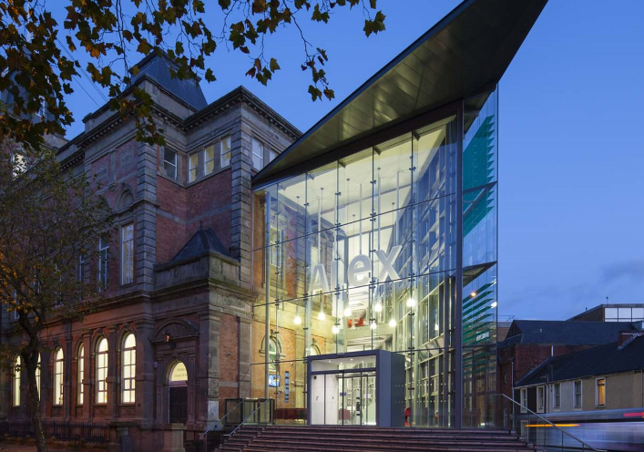
Figure 1 - The Alex Design Building, showcasing the original building alongside its most recent extension.

Alex Exchange Design Building.

The Alex design Building is the home to UWTSD School of Industrial Design and Swansea School of Glass along with the Institute for Sustainable Design and Cerebra Innovation Centre which comprises of two of the leading research centres within its field of design and innovation. (Geograph , 2014)
Its key focus on,
- Automotive Design.
- Product Design.
- Architectural Glass, and
- Digital Media.

Designed by Henry Holtom of Dewsbury in the classical Victorian style architecture which features typical and popular characteristics of its time in the mid-18th century with its symmetry, columns and arches drawing from the inspiration of ancient Roman architecture. One of its most notable features is the circular library known as the reading room, which is 26 metres in diameter with a domed top at a height of 7.6 metres. First opened in 1887 by Prime Minister William Ewart of Gladstone.
Later designated a building of special interest and was granted a Grade II listed building designate. (Wales Online , 2015)

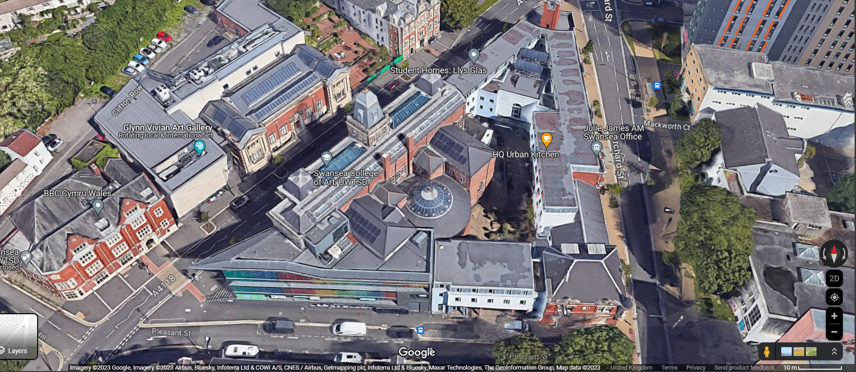
Figure 2 - The site of The Alex Design Building.

It has volume of 15,777.00 ^{m3}, during its most recent renovation 1477.00 ^{m3} on Pleasant street was demolished which included not only the structure but a lean-to kitchen building to the north, that was estimated to be addition to the original structure built in 1936. Its reason was due to the poor condition of the structure and its unfit purpose for the proposed new functions (Swansea Council, 2011)
The choice to use the Alex Design Exchange building as a case study is for its contrast between its 18th-century design along with its most recent additions such as its large glass curtain wall façade which aesthetically combines the two very different architectural styles, the 18th-century Roman architecture and today's modernisation of colourful cladding panels and large glass façade.

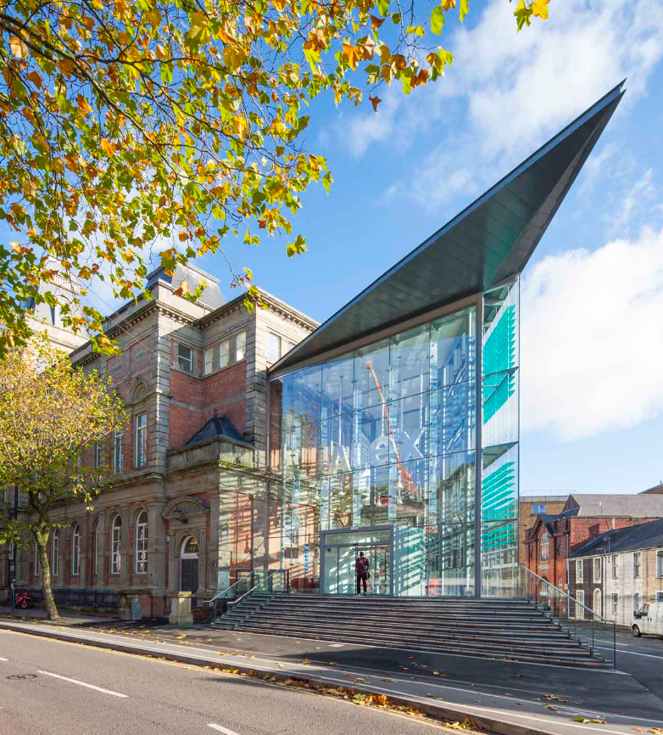
Figure 3 - The Alex Design Building, showcasing its large glass facade.

The Building Profile

Construction

Existing building materials and finishes
External walls
- Red facing brickwork with flemish bond,
- Brown Yorkshire sandstone, decorative dressing,
- Pebble dash rendered brick,
Roof
- Combination of natural and cement fibre slates on pitched roofs,
- Glass rooflights
- Bituminous felt to flat roofs.
Windows
- Wooden framed casements with opening fan light, with white painted finish.
Doors
- Wooden panelled door, with paint finish.

New building materials and finishes
- Structural glass mounted on spider brackets, facing Alexandra Road,
- PPC aluminium framed glass curtain walling, facing Pleasant Street,
- Slate plinth
Roof
- ‘Green’ flat roof to new extension
- Refurbishment of existing
Windows
- PPC aluminium framed for extension.
- Refurbishment or like for like replacement where need.
Doors
- Main entrance, glass door.
- PPC aluminium framed doors
- Roller shutter door.
- And new wooden door matching original style to rear.
- Redecorating any existing which remain.

Evaluation and Critique

Solid wall construction
Positives | Negative
Durable - superior strength and longevity | Insulation – Poor insulation properties.
Thermal mass – Ability to absorb and store heat therefore stabilising internal temperature. | Modifications – Challenging and costly to install new windows or doors.
Fire Resistance – Enhancing the safety of the building. | Damp – Susceptible to dampness.

Wooden framed windows/doors
Positives | Negative
Aesthetics – provides a good natural look. | Maintenance – Susceptible to weathering.
Insulation – Help maintain internal temperature. | Cost – Expensive in comparison to alternatives
 | Fire Resistance – Wood is a combustible material without any treatment.

Lathe and plaster internals
Positives | Negative
Sound Insulation – Provides good sound insulation and so offers quieter environment inside. | Fragile – prone to cracking.
Aesthetics – Provides a smooth, seamless finish. | Difficult to repair – Requires skilled labour to repair and can be costly and time consuming.
 | Weight – Heavy material.

Decorative sandstone rendering
Positives | Negative
Aesthetics – Visually appealing. | Maintenaince – Prone to weathering and erosion.
Protection – Additional barrier against weathering. | Cost – High quality material and skilled labour needed.
Versatility – Can show in various textures and colours. | Moisture – If not sealed properly leading to ingress of moisture.

Future Specifications

Operation energy usage

Improvements

A key part of legislation would come into play when designing the building today and to future specifications which would be the Part L, The Conservation of fuel, and power of the Approved Documents of the building regulations. It outlines the guidelines for energy performance of new and existing buildings.
Its legislation aims to significantly improve energy efficiency standards and lower domestic and commercial building's carbon footprint.
Its latest amendments came into force on June 15th aim to
- further reduce CO2 emissions by moving to alternative heating systems with lower emissions, such as heat pumps.
- A new metric in which to measure building performance and how they are calculated.
- New U-Values targets in anticipation of triple glazing and high-performance windows to be normal for specifications along with thicker walls.
- Provisions for photographic evidence and reports.
- And guidance for architects and designers to consider the new standards at the early stages of design in order to be compliant. (RIBA Architecture.com, 2022)

Smart technology
The most recent extension of the building showcases the advancements in using technology to help manage operational efficiency and user comfort through the use of example smart sensors. Using such systems can help regulate and optimise lighting and HAVC systems.
- Turning off lights when rooms are not occupied,
- Maintaining a steady temperature.
- Increasing or decreasing ventilation and filtration of air.
These systems allow real-time control of the internal environment to ensure the user's comfort but also play a pivotal role in reducing energy consumption and thus can significantly contribute to the sustainability of the building's operational profile by minimising unnecessary energy usage which in turn reduces operational costs.
Other systems that have been deployed during the recent renovation is the use of photovoltaic panels. (Figure 2) Harnessing solar energy and converting it into electricity, reduces the building's need for power from the national grid where some energy produced may not be from renewable sources so helps reduce its carbon footprint further and so lowers its environmental impact of greenhouse gas emissions. Although The Alex Design Building only implemented several panels. Other projects have gone as integrating photovoltaic panels as part of the building fabric with external cladding. (Figure 3)
These technologies are only to improve and help aid in providing better sustainable built environments that we work and live in.
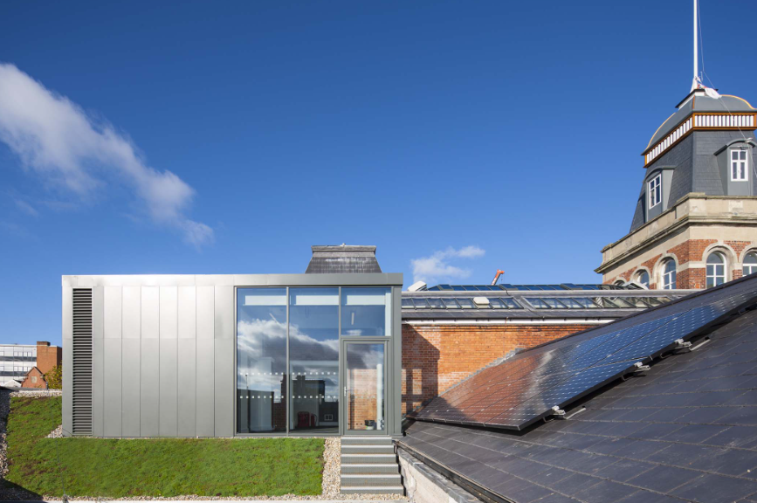
Figure 4 - The Alex Design Building Roof showcasing the photovoltaic panels.
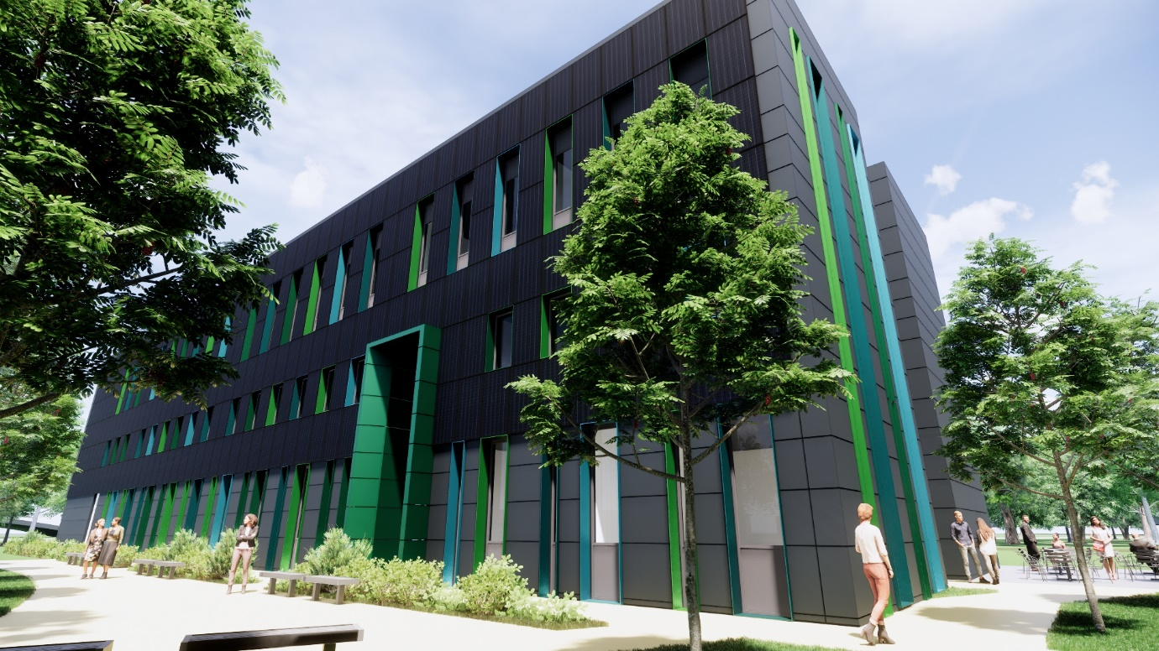
Figure 5 - Baglan Bay Innovation Centre's novel use of photovoltaic panels as the building facade.

Curtain Walling

The Alex Design Building makes uses of modern method of façade construction which is the large glass façade as shown in (Figure 6) alongside the pleasing and modern aesthetic it gives to the building, the double skin façade offers acoustic protection from the urban environment outside whilst offer ample natural light into the building. (Architecture.com, 2024)
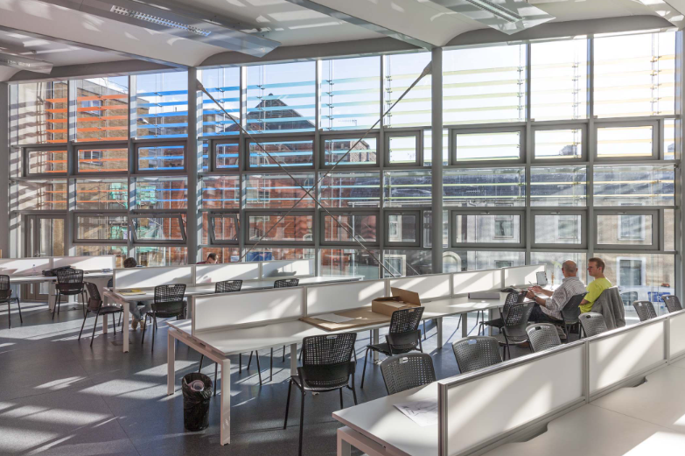
Figure 6 - The Alex Design Building showcasing the large glass facade.

Embodied Energy/Carbon

Embodied carbon where the emissions emitted from the process of construction. The carbon emission cost to bring the project to operational use. Minimising this can be achieved through selective material choice, employing alternative construction methods and inclusive of broader industry practices.
Materials such as,
- Sustainable certified timber.
- Recycled steel, and concrete.
- Bio-composite concrete
- Hempcrete
Not only can the selection of materials help but also using locally sourced materials to cut down on the transportation emissions moving materials and machinery to site.
An often-overlooked aspect is the emissions produced by extracting the raw materials needed and the energy to manufacture them along with the associated operational cost of the installation of materials and components. This of course can be offset through the use of renewable energy if available.
Here modern methods of construction such as off-site manufacturing can aid in reducing the carbon foot improving quality and processes due to the controlled environment in which components are manufactured and assembled.
Careful consideration of design can see structures designed so that they can easily be deconstructed for material recovery rather than being demolished, further lowering the demand for new materials and minimises waste therefore strengthening the circular economy of the construction industry. For the industry to adopt this new approach and standardise these practices industry-wide, clear regulatory frameworks need to be implemented along with incentives to adopt these new strategies and methods in turn could then lead to an environmentally responsible construction industry. (BlueBeam, 2023)

Opportunities for enhancements

If the building was to be built today there would be some opportunities for enhancements, some of which are already deployed within the new extension. There would also, be numerous building regulations that would have to be adhered to such as the Part L, the Conservation of Fuel and Power. It sets out comprehensive guidelines concerning energy efficiency, lighting, insulation requirements, ventilation, and heating systems.
With today’s modern methods of construction, there would be an opportunity to take advantage of offsite manufacturing which can help improve the quality of workmanship and tolerances, decrease waste, and lend itself to faster and more efficient construction, which can also decrease costs by implementing good resource management. All of this allows off-site manufacturing to be a good sustainable alternative but is not without its disadvantages, one of which is logistics, moving components from factory to site. Accessibility to the site and the assembly of components, especially if components are large or complex where good access is needed or heavy plant and machinery are needed to lift and install components along with disruption to the local community, access to roads may need to be restricted or closed while unloading components and of course the carbon footprint of transporting said components depending on the distance between factory and site. (HPD Construction , 2023)
The use of off-site manufacturing for the Alex building
Disadvantages | Advantages
- The location of the site is in Central Swansea and is situated on one of the main roads that runs through Swansea. Restricting access on this road would cause significant disruption to the community.  - The Site has no onsite parking or dedicated space for heavy plant or machinery that may be needed for offloading and installing components.  - The dense city might be difficult for large heavy vehicles such as artic lorries to navigate through safely. | - Could lead to less disruption to the local community and businesses due to fewer operatives on site, and less pollution such as noise and rubbish.  - Less congestion with parking for operatives and staff working on site. The dense city has limited options for parking and having fewer operatives reduces parking and traffic in the city.  - Potentially faster programme of work and in turn leads to less disruption from  the project overall.

I think off-site manufacturing could be a viable option for The Alex Design Building if the logistics could be mitigated. One option to mitigate this would be for deliveries of components to arrive at night or through off-peak hours when the traffic would be low and cause fewer disruptions. Although this in itself may not work as schemes such as Consideration Construction may recommend times through the day when work should be permitted or may even be enforced through the local authority by contract.

Conclusion

In conclusion, The Alex Design Exhange building has developed and intricately combine its historical heritage architecture with modern innovations and contemporary design, harmoniously pairing new modern materials such as its glass façade extension. The introduction of modern-day technology, including internal sensors, monitors, and photovoltaic panels, lends itself to the environmental and energy efficiency that are requisite for achieving more sustainable buildings in the future.
The building's reliance on solid wall construction, while maintaining its historical authenticity and durability, poses challenges for future upgrades to meet modern-day requirements. The use of wooden windows and doors comes with increased maintenance and the potential expense for repairs and restoration work if needed in the future. Similarly, the use of lathe and plaster for internal walls and ceilings, although providing good acoustic benefits, introduces concerns over costly and time-consuming repairs due to its fragility. Additionally, the building's decorative sandstone rendering, while visually pleasing, demands diligent maintenance to combat the effects of weathering and water ingress.
Should the building undergo more renovation work, a commitment to continue its focus on sustainability and the environment should be upheld, further enhancing the building's operational energy efficiency. It is crucial to continue finding ways to reduce its embodied carbon and energy through the selection of materials and techniques explored in the report, in turn ensuring its economic and environmental value. Exploring the use of off-site manufacturing promises improved efficiency, a reduction of waste, and better quality of components, albeit with its own set of challenges as noted in the report, particularly in a dense city such as Swansea.
The Alex Design Exchange Building showcases how a balance of historical architecture, combined with modern contemporary design, can be achieved, bringing the building up to modern-day standards while also incorporating today's imperatives of sustainability and urban development.

References
Architecture.com, 2024. Project ALEX (School of Industrial Design). [Online]
Available at: https://find-an-architect.architecture.com/powell-dobson-architects-ltd/cardiff/project-alex-school-of-industrial-design
[Accessed 7 January 2024].
BlueBeam, 2023. The Power of Using Locally Sourced Sustainable Building Materials. [Online]
Available at: https://blog.bluebeam.com/uk/the-power-of-using-locally-sourced-sustainable-building-materials/
[Accessed 11 January 2024].
Geograph , 2014. SS6593 : New and old, ALEX Design Exchange, Swansea. [Online]
Available at: https://www.geograph.org.uk/photo/4164125
[Accessed 08 January 2024].
HPD Construction , 2023. Advantages and Disadvantages of Offsite Construction. [Online]
Available at: https://www.hpdconsult.com/advantages-and-disadvantages-of-offsite-construction/
[Accessed 12 January 2024].
RIBA Architecture.com, 2022. New Building Regulations changes to Part L are now in effect. [Online]
Available at: https://www.architecture.com/knowledge-and-resources/knowledge-landing-page/new-building-regulations-changes-to-part-l-are-now-in-effect
[Accessed 15 Jan 2024].
Swansea Council, 2011. Planning Portal. [Online]
Available at: https://property.swansea.gov.uk/online-applications/simpleSearchResults.do?action=firstPage
[Accessed 01 January 2024].
Wales Online , 2015. wansea's former library building refurbishment nearly £5m over original budget - but university defends the spend. [Online]
Available at: https://www.walesonline.co.uk/news/wales-news/swanseas-former-library-building-refurbishment-8968562
[Accessed 05 Jan 2024].

