  Figure 1 https://tinyurl.com/vicMo  HTML & CSS Web Development  Edward Patch (1801492) | Abstract  This report will discuss the making of VictoMoto’s dealership website. The website should promote their products and general aspects of riding to create a small online community.  Jaymie Phillips  Internet Technology and Security (ACCA4018)

Table of Contents
Introduction 3
1. Requirements 3
1.1. Purpose 3
1.2. Subject 3
1.3. Target Audience 3
1.4. House Style 4
1.4.1. Colour Pallet 4
1.4.2. Logo Ideas 4
1.4.3. Website Layout Ideas 4
1.4.4. Header Ideas 4
2. Planning 5
2.1. Template 5
3. Implementation 6
3.1. Template 6
3.2. Home 6
3.3. Showroom 7
3.4. Sales 8
3.5. Adventures 8
3.6. Rideout’s 10
4. Validation 11
4.1. HTML 11
4.2. CSS 11
5. Evaluation 12
5.1. Test Plan 12
5.2. Improvements 14
6. Conclusion 15
7. References 15
8. Bibliography 15

Introduction
In this report, I will be talking about the VictoMoto’s website that I planned, constructed and evaluated. This report will cover the requirements, Plan implementation validation and evaluation of the website that was created for VictoMoto’s.

Requirements

Purpose
The purpose of the website is to showcase the different bikes available. The business request data website to showcase their products and to promote motorcyclist. the company wanted to have a page where other motorcyclist could promote events or share their images. In turn, this should advertise VictoMoto’s products.
The website should contain 6 pages, which include:
- Home - shows different styles of motorcycles.
- Showroom - shows VictoMoto’s products that are on offer.
- Sales - shows VictoMoto’s product line.
- Adventures – shows community multimedia.
- Rideouts – shows localised events.
- Contact Us – Allows consumers to contact us.

Subject
The subject of the website is retail/advertisement. VictoMoto’s platform isn’t a traditional dealer’s website. This website shows the products of VictoMoto’s products, but it advertises other dealerships to display different type of motorcycles. This website should allow other motorcyclist to connect by advertising events either donation based or to meet up.

Target Audience
The target audience would be a middle age audience, mainly 19+ years of age. The reason for this is that most motorcycles VictoMoto sells are A2/A licenses, which cannot be obtained until the age of 19/24 depending on the license type. The target audience would be aimed at motorcyclist that ride or interested in scooters, motorcycles or trikes.

House Style

Colour Pallet
#002244 |  | #900700 |  | #D4B300 |  | #30F9FA |  | #90EE90 |  | #FFFF00

Logo Ideas
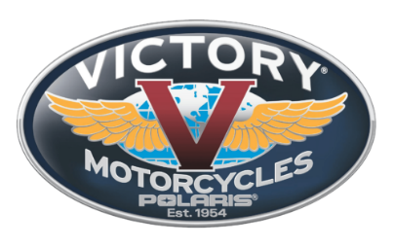 |  | 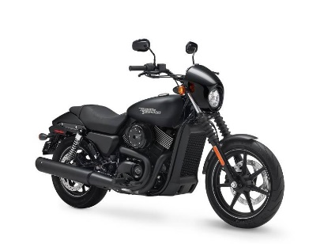

Website Layout Ideas
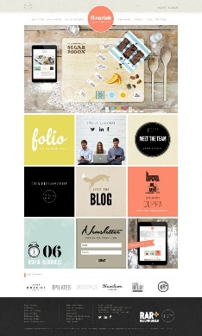 | 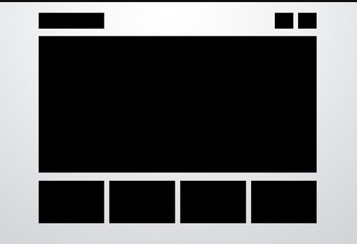 | 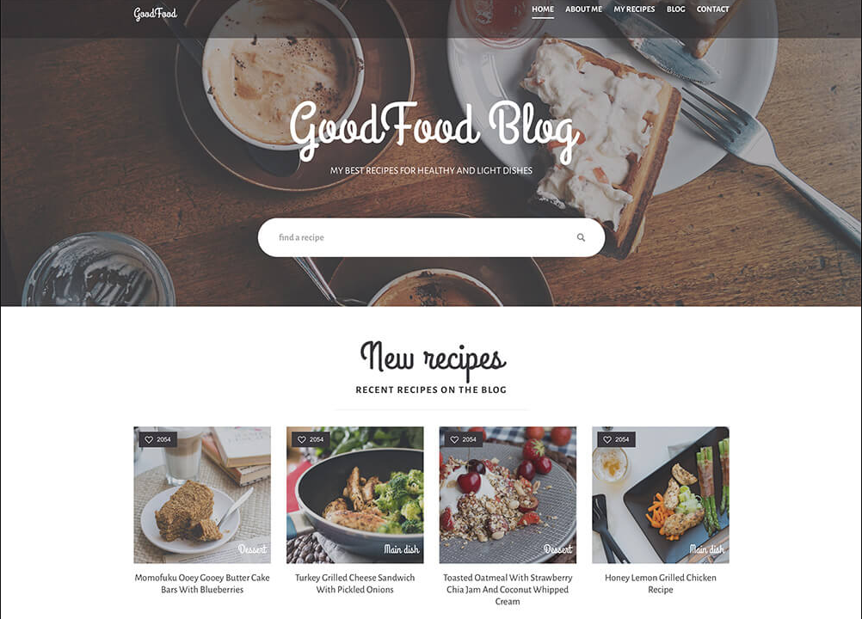

Header Ideas
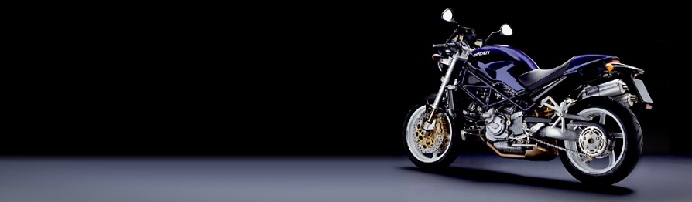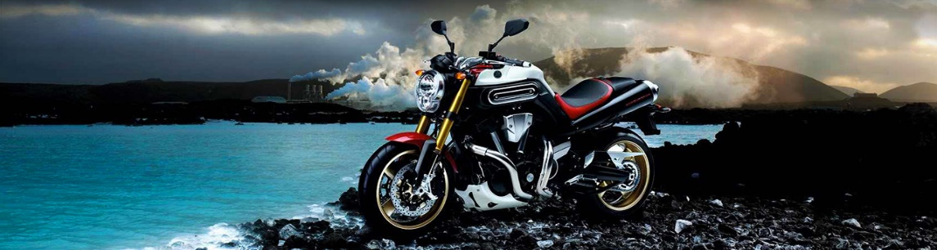
Image Sources:
Victory Motorcycles: https://motorcycle-logos.com/victory-logo/
Motorcycle: https://tinyurl.com/hLydaIs || https://tinyurl.com/motoHeaders || https://tinyurl.com/motoHeaders2

Planning

Template
I have created a website template with the software package, Adobe InDesign. The template below helped create a rough idea where the items should be placed on the website. This helped keep a consistency throughout the pages during the implementation process. The contact us hyperlink is going be inserted in the footer.
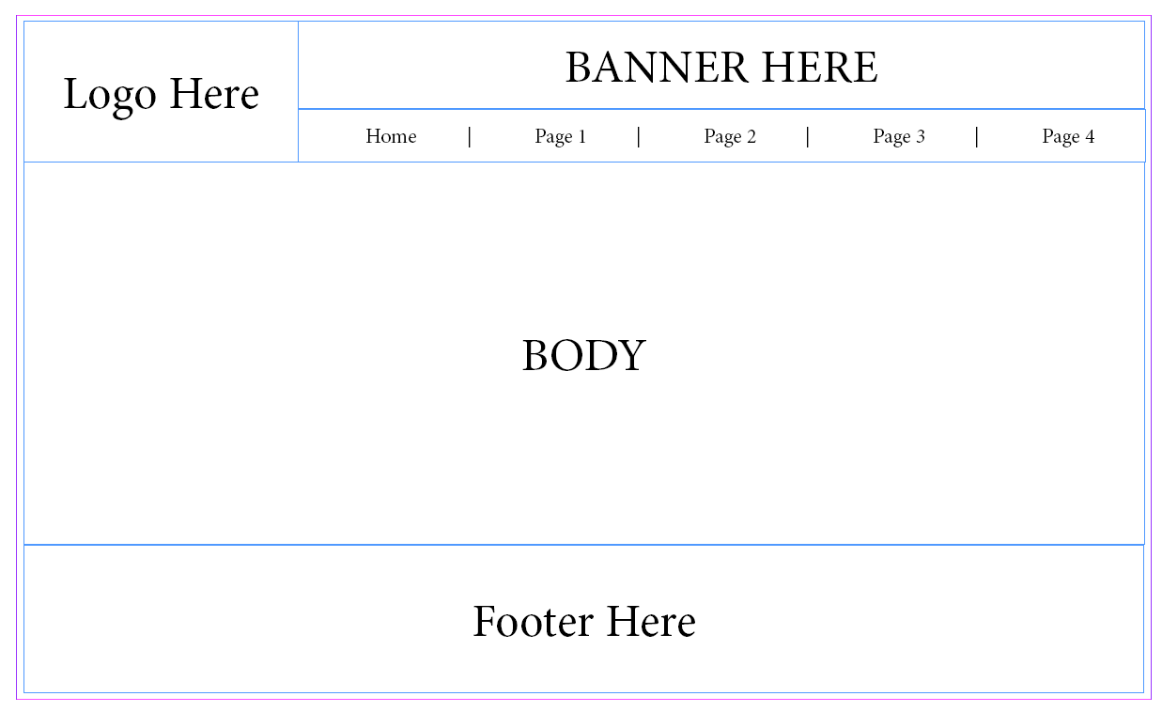

Implementation

Template
I created a template to reuse for each website. I have used Adobe Dreamweaver to help create the template and assign them to each page. Visual Studio was used to also help create and style the website. The template was used through all the webpages keeping a consistent house style.
The contact form was placed below the navigation bar instead of a new page. This made it easier for the customer to contact VictoMoto to make an enquiry, purchase or sell an item.
The footer has the VictoMoto logo included that rotates on the Y axis (390º) when the logo is hovered over and rotates back when the cursor moves off the logo.

Found: /Templates/VictoHouse.dwt

Home
The home page displays different styles and a range of makes of motorbikes. Each element contains an external link to a third-party website. Each element has a hover over action to make each link stand out.
Note: The containers are clickable but not the text.
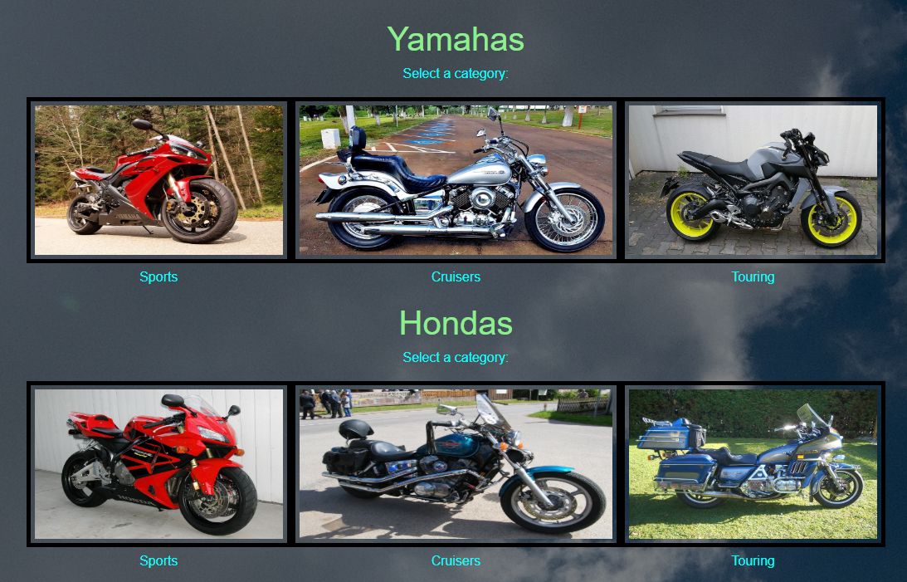
Found: index.html

Showroom
The showroom page has a slideshow that can be controlled by navigation controls. The information hyperlink will take the user to the sales page, highlighting the motorcycle that is on sale. The slideshow contains a title and a description on each element found on the slideshow.
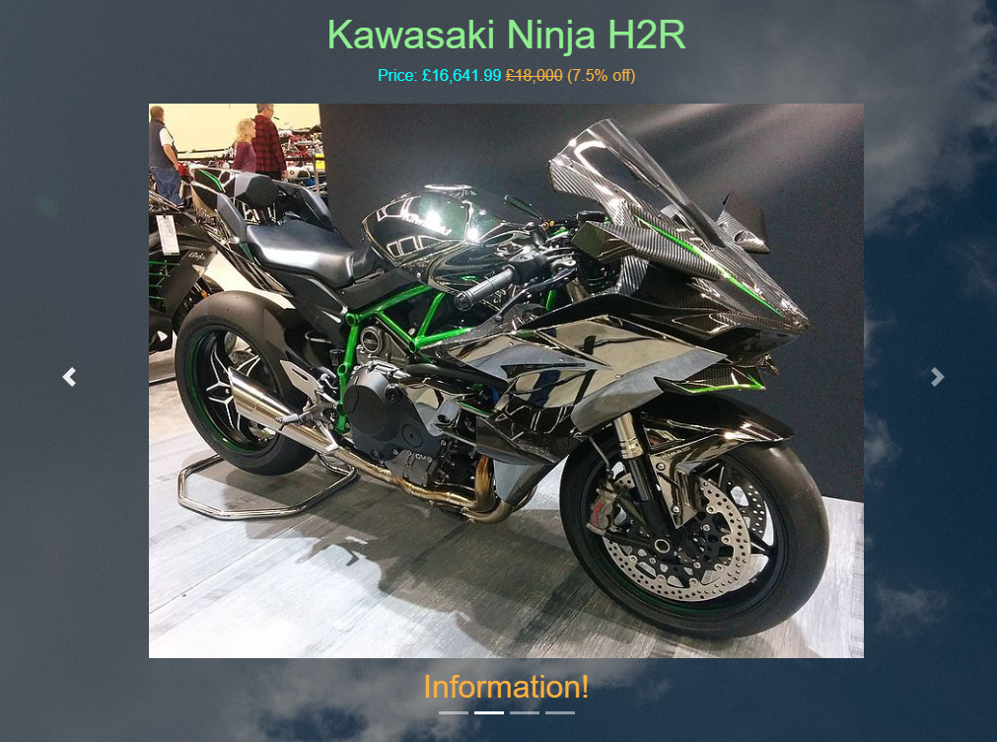
Found: showroom.html

Sales
The sales page has a few styling issues. The title should be positioned above the description and price tag, but it is positioned behind the price element. Top and Bottom containers were created to fix the problem, but it failed.
The links at the top of the page takes the user to different products on that page, to save the user from scrolling.
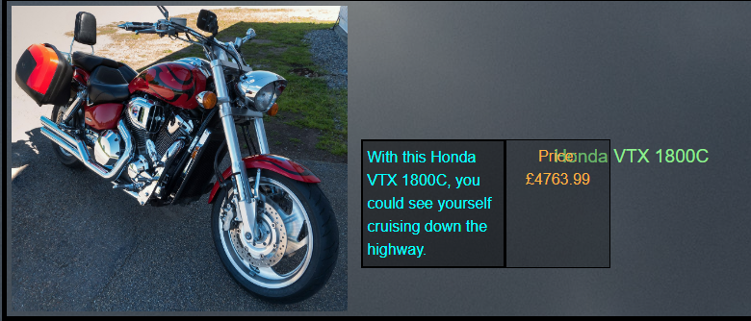
Found: sales.html

Adventures
On this page, there is videos of other motorcyclists’ adventures. The videos are hidden behind a button that shows the name of the video. These buttons at have hover animations to zoom in and out text. When a button is clicked the video will transition underneath the main title of the video and when clicked again it will hide by a transition.
Before:


After:
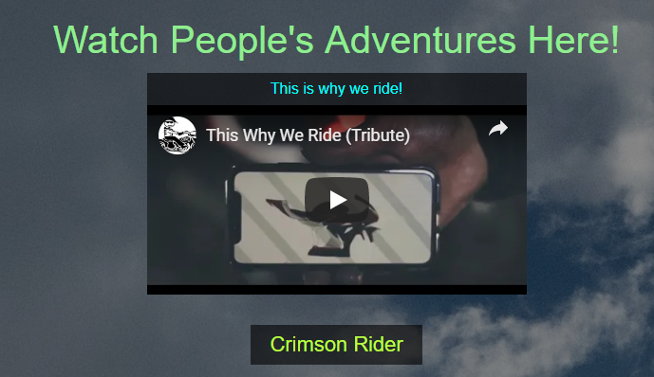
the videos implemented on this webpage are embedded from YouTube. the channel crimson rider is created by Edward Patch including the video. The contact option enables users to ask for video upload’s (via the Enquiry option) for VictoMoto’s to implement/attach the video to the website.
Further improvement could be implemented here to enable users to upload videos themselves. This would possibly require moderators to make sure the videos are related.

Rideout’s
This page lets users to add events locally to promote meeting with motorcyclist. The name, route, location and date and time is required to create an event. Similar, to the adventures page, in order to post, the user would have to contact VictoMoto via the Enquiry option.
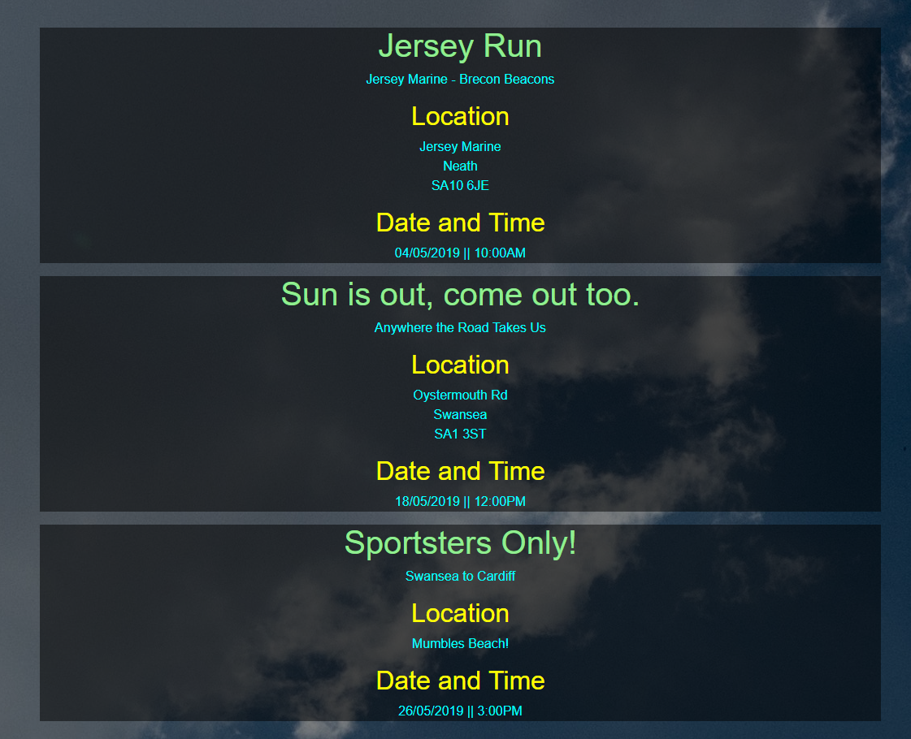
Further improvement could be implemented here to enable users to create, cancel and edit events themselves. This would possibly require moderators to make sure the videos are related.

Validation

HTML
According to Nu Html Checker, https://validator.w3.org/nu/#file, there was a total of 12 problems. The main problem was use of duplicate ID’s was mentioned six times with the tag features-caption. The code uses obsolete styling (<center>) but this method worked, whereas CSS did not work.
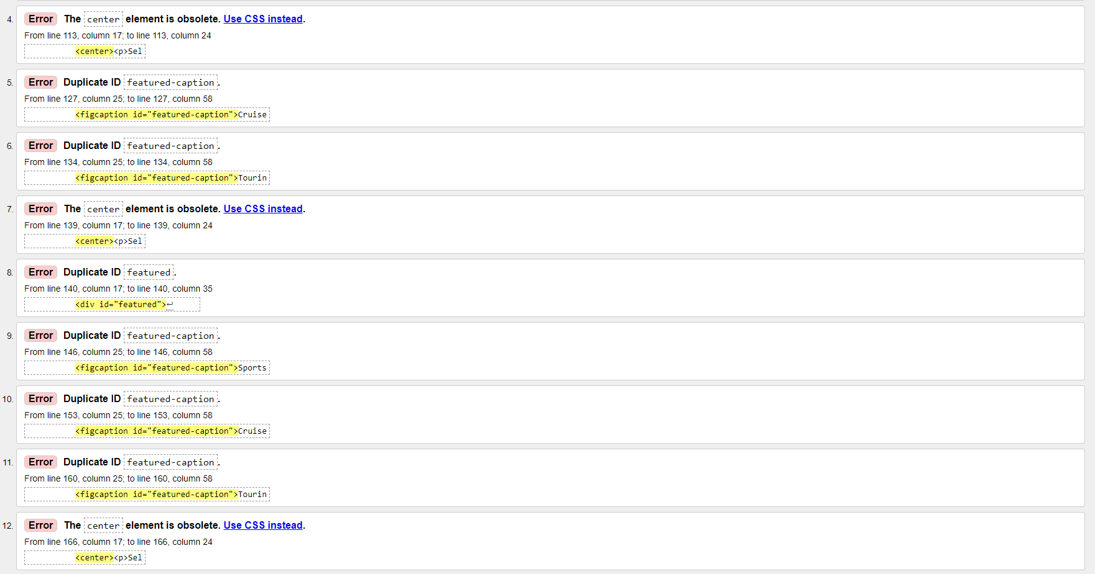

CSS
According to W3C CSS Validator, https://jigsaw.w3.org/css-validator/validator, CSS has only one error. This is a value error under #sales-name h1 selector, padding attribute. It contains a few typos of commas, where the attribute recognises gaps instead of commas.
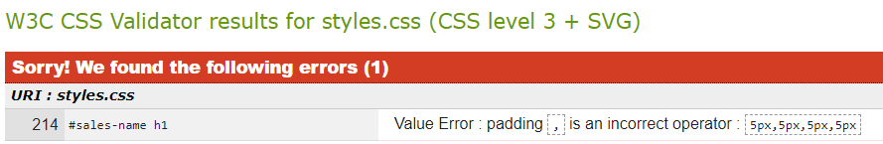

Evaluation

Test Plan
Project
Project | Description | Expected Result | Actual Result | Solution | Solved
Template Page | Logo | The logo should be on the left-hand side. | When the logo was positioned on the other side it pushed the navigation bar out. | Position the logo next to the navigation just offset to the right from the centre. | Solved
Template Page | Navigation Bar | The navigation bar should be in the centre. The mobile nav wasn’t working. | The navigation bar is in the centre. | Sourced and included the bootstrap.js for the slideshow and it worked for the navigation. | Solved.
Template Page | Navigation Links | The navigation links colours should be different from the bootstrap. | Didn’t know what style to override. | Needed to do research to find what tag to override. | Solved
Template Page | Contact Form | The contact form should be positioned underneath the navigation | The contact form was positioned beneath the navigation but the items inside the container were not centred. | By adding text-align: center; to the contact form would centre the elements. | Un-Solved
Template Page | Body | The body should not cover the whole page. | The body did not cover the whole page. | No solutioned required. | Solved
Template Page | Footer | The footer should be positioned underneath the body, with hyperlinks to enable users to navigate through the pages. | The footer was positioned underneath the body with working hyper-links. | No solution required. | Solved
 | Footer Logo | The logo should be positioned to the left with an animation that causes the logo to spin when the mouse hovers over. | The logo is positioned to the left, with a hover animation rotating the logo on the Y axis, 380º. | No solution required. | Solved.

Improvements
Referring to the 5.1 Test Plan (Page 12), the contact form would require a bit of work to make the styling look better. Problems that were not mentioned in the test plan, like the positioning of the elements on the sales page would require some more work.
On the sales box, the title would be better above the description and price, and the description and price should be positioned to the centre. The arrows demonstrate the improvement mentioned. The text could be much bigger to make it clearer. The website is responsive for different resolutions, although this webpage doesn’t seem to be responsive. The solution to this problem may be solved if the elements were positioned properly.
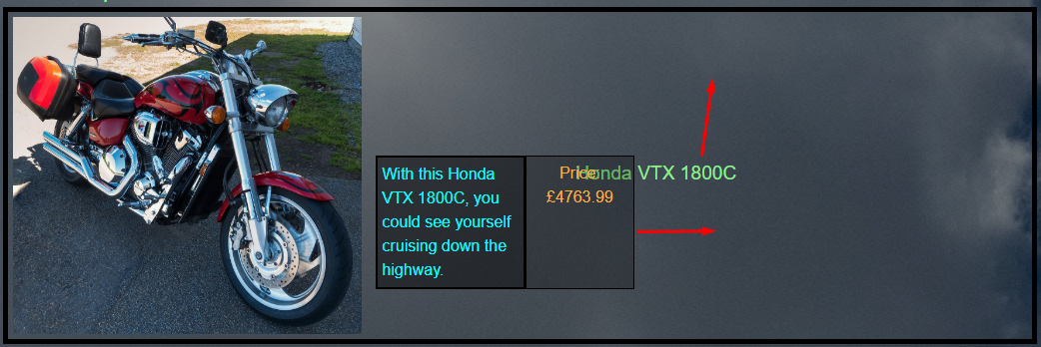
Also, footer is not fully responsive. When the page shrinks, the hyper-links escape their container. The logo seems to change the width and not the height, squishing the image.


