
Technology advances - specifically in the areas of e-Commerce and e-Business have rendered traditional models of organizational structure and theories of management roles obsolete in the light of the changing nature of 21st-century corporations.
Visions for the Future : Theoretical Perspectives on Management LCDB7008
Nicoleta Baltaret 2107487
2026
Table of contents:
1 Introduction 4
1.1 Background and Context 4
1.2 Case Study Selection and Report Aim 5
1.3 Report Argument and Structure 5
2. Literature Review 6
2.1 Traditional Organisational Structures and Management Theories 6
2.2 The Rise of e-Commerce and e-Business 9
2.3 Technology and the Changing Role of Management 12
2.4 Critical Debate: Obsolete or Transformed? 13
3. Amazon's Technological Transformation and Organisational Evolution 14
3.1 Amazon's Digital Business Model and Technological Evolution 14
3.2 Technology and Organisational Structure at Amazon 16
3.3 Technology and the Changing Role of Management at Amazon 17
4. Critical Evaluation 18
4.1 Are Traditional Organisational Structures Obsolete? 18
4.2 Have Traditional Management Roles Become Obsolete? 20
4.3 Critical Evaluation of the Claim 23
5. Conclusions, Recommendations and Limitations 26
5.1 Conclusion 26
5.2 Recommendations 27
5.3 Limitations and Future Research 28
List of references: 30
Appendix 1. Amazon Operational and Financial Highlights (2022–2024) 33
Appendix 2. Selected Evidence of Digital Transformation from Amazon Annual Reports 33

Table of Figures:
Figure 2.1.: Overview of Traditional Organisational Structures and Management Theories 7
Figure 2.2.1: Conceptual Framework of e-Commerce and e-Business as Drivers of Organisational Transformation 9
Figure 2.2.2: Relative Organisational Impact of e-Commerce and e-Business 10
Figure 2.4. Competing Perspectives on the Impact of Digital Transformation 13
Figure 3.3. Evolution of Managerial Roles in Amazon's Digital Transformation (2022–2025) 18
Figure 4.1. Critical Evaluation of the Impact of Digital Technologies on Traditional Organisational Structures 19
Figure 4.2. Evolution of Management in the Digital Era 23

Table of Tables:
Table 3.1. Amazon's Technology-Enabled Business Model and Organisational Implications 15
Table 3.2. Technology-Driven Changes in Amazon's Organisational Structure 17
Table 4.3. Critical Evaluation Matrix 25

1 Introduction

1.1 Background and Context
The rapid advancement of digital technologies has fundamentally reshaped the way organisations operate, compete and create value within the global economy. Developments in e-Commerce and e-Business, supported by artificial intelligence (AI), cloud computing, automation, robotics and big data analytics, have transformed traditional business models and accelerated the emergence of digitally enabled organisations. These technological innovations have altered organisational processes, customer interactions, supply chain management and strategic decision-making, creating new opportunities for efficiency, innovation and competitive advantage (Asbari, 2023; Kedah, 2023; Al-Ababneh et al., 2026). As a result, scholars and practitioners increasingly question whether traditional organisational structures and classical management theories remain suitable for organisations operating within the digital economy.
The growth of e-Commerce has extended beyond the simple digitisation of retail transactions to encompass integrated digital business ecosystems that connect organisations, suppliers, customers and strategic partners through advanced information technologies (Bello, Osmonbekov and Gilliland, 2024). Similarly, e-Business has expanded organisational capabilities by enabling firms to automate business processes, improve decision-making through real-time data and develop increasingly agile business models capable of responding rapidly to changing market conditions (Hendricks and Mwapwele, 2024; Krasnyuk et al., 2022). These developments have challenged many assumptions underpinning traditional management theory, particularly those relating to hierarchical organisational structures, centralised decision-making and clearly defined managerial authority.
Classical management theories, developed by scholars such as Taylor, Fayol and Weber, were largely designed for relatively stable industrial environments characterised by predictable production systems, clearly defined reporting relationships and standardised organisational processes. Contemporary organisations, however, operate within dynamic digital environments where innovation cycles are significantly shorter, customer expectations evolve rapidly and competitive advantage increasingly depends upon organisational adaptability rather than operational stability (Dickson, 2023; Johnson and Szamosi, 2025). Consequently, many researchers argue that technology has fundamentally transformed both organisational structures and managerial responsibilities by encouraging flatter organisational designs, greater decentralisation, increased collaboration and data-driven decision-making (Yurchuk, 2025; Weber, Büttgen and Bartsch, 2022).
However, despite the significant organisational changes associated with digital transformation, the argument that technology has rendered traditional organisational structures and management roles entirely obsolete remains contested. While digital technologies have undoubtedly altered how managers coordinate resources, communicate with employees and make strategic decisions, organisations continue to rely upon leadership, governance, accountability and structured decision-making to achieve organisational objectives (Porath, 2023; Bala, 2026). Rather than eliminating traditional management functions, technological innovation may instead have redefined managerial responsibilities by increasing the importance of strategic leadership, innovation management and digital capabilities. This suggests that technology should be viewed as transforming, rather than replacing, traditional organisational principles.

1.2 Case Study Selection and Report Aim
This report adopts Amazon as the case study within the global e-Commerce sector. Amazon represents one of the world's largest technology-driven organisations, having evolved from an online bookseller into a multinational corporation operating across digital retail, cloud computing, artificial intelligence, logistics, digital advertising and subscription-based services. Its sustained investment in AI, robotics, warehouse automation, AWS and data-driven decision-making makes it an appropriate organisation through which to evaluate the extent to which technological advances have reshaped organisational structures and managerial roles. At the same time, Amazon continues to place considerable emphasis on formal leadership principles, organisational culture, strategic planning and operational governance, providing an opportunity to examine whether traditional management concepts continue to coexist alongside digital transformation (Amazon.com, Inc., 2022; Amazon.com, Inc., 2023; Amazon.com, Inc., 2024; Amazon.com, Inc., 2025).
Accordingly, the aim of this report is to critically evaluate whether advances in e-Commerce and e-Business have rendered traditional organisational structures and management theories obsolete. Using Amazon as the primary case study, the report examines how digital technologies have influenced organisational design, leadership practices and managerial responsibilities, while assessing whether these developments represent a complete replacement of traditional management models or an evolution of their application within contemporary organisations.

1.3 Report Argument and Structure
This report argues that the claim is only partially justified. Although technological advances in e-Commerce and e-Business have fundamentally transformed organisational structures, operational processes and managerial practices, the available evidence does not demonstrate that traditional organisational models or management theories have become obsolete. Instead, Amazon illustrates the emergence of a hybrid organisational model in which digital technologies enhance organisational flexibility, innovation and operational efficiency while traditional management principles relating to leadership, strategic control, governance and organisational coordination continue to play a central role. Consequently, technology should be understood as reshaping the application of management theory rather than replacing its underlying foundations.
The remainder of this report first reviews the academic literature surrounding traditional organisational theory, e-Commerce, e-Business and digital transformation before examining Amazon's organisational evolution as evidence of technological change. The report then critically evaluates whether Amazon supports the proposition that technological advancement has rendered traditional organisational structures and management roles obsolete before presenting an overall conclusion based on the evidence reviewed.

2. Literature Review

2.1 Traditional Organisational Structures and Management Theories
Traditional organisational structures and management theories have long provided the conceptual foundation for how organisations coordinate activities, allocate resources and achieve strategic objectives. Developed during the late nineteenth and early twentieth centuries, classical management theories emerged in response to the operational demands of industrialisation, where organisations required clearly defined authority, standardised procedures and efficient coordination of increasingly complex production systems. Consequently, these theories emphasised hierarchical organisational structures, formal rules and managerial control as mechanisms for improving organisational efficiency and productivity (Dickson, 2023).
Figure 2.1 illustrates the principal components of traditional organisational structures and classical management theories. As shown, scientific management, administrative management and bureaucratic theory collectively advocate a hierarchical chain of command, formalised procedures and clearly defined managerial responsibilities. These characteristics were intended to maximise organisational stability, efficiency and accountability within relatively predictable industrial environments.

Figure 2.1.: Overview of Traditional Organisational Structures and Management Theories
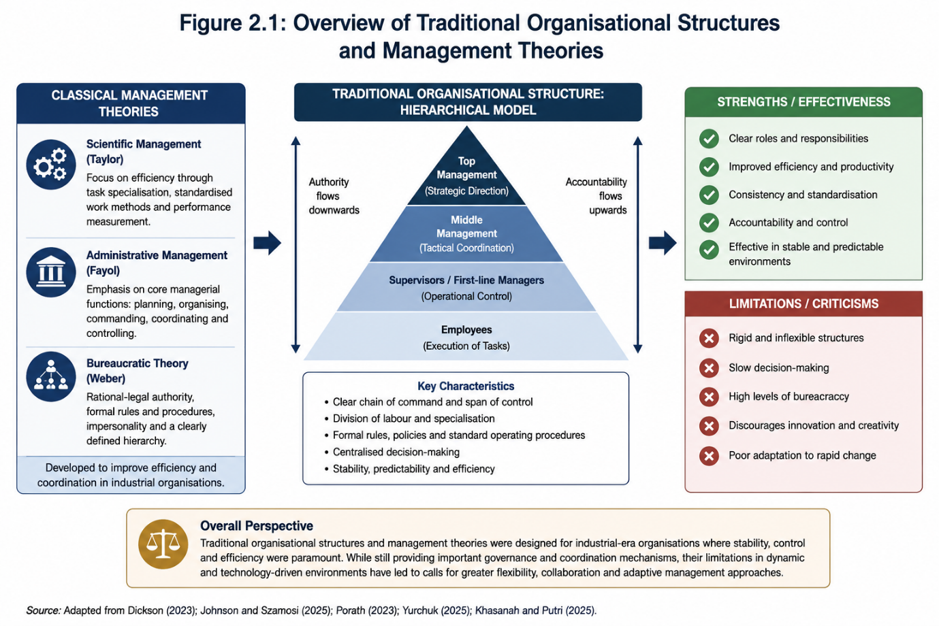

As illustrated in Figure 2.1, traditional organisational structures are characterised by a vertical hierarchy in which authority flows from senior management through middle management to operational employees, while accountability moves upwards through the organisation. Such structures facilitate clear reporting relationships, specialisation of labour and consistent decision-making, enabling organisations to maintain operational control and governance. According to Johnson and Szamosi (2025), these characteristics historically enabled organisations to improve productivity by clarifying managerial responsibilities and reducing uncertainty within operational processes.
Classical management approaches, particularly scientific management, administrative management and bureaucratic theory, share the common assumption that organisational effectiveness depends upon clearly established reporting relationships and the systematic division of labour. Managers are responsible for planning organisational activities, allocating resources, coordinating employees and ensuring organisational objectives are achieved through formal authority and structured decision-making processes (Johnson and Szamosi, 2025). Such approaches proved particularly effective in relatively stable business environments where market conditions evolved gradually and operational efficiency represented the principal source of competitive advantage.
The strengths presented in Figure 2.1 demonstrate why traditional management theories remain influential despite continuing technological advancement. Formal hierarchies provide organisations with governance mechanisms that support accountability, consistency and strategic control, particularly within large multinational corporations operating across multiple business functions. Porath (2023) argues that clearly defined organisational structures continue to facilitate effective coordination by establishing transparent lines of authority and responsibility, thereby reducing ambiguity in organisational decision-making. Consequently, hierarchical structures cannot simply be dismissed as outdated, particularly within organisations that require extensive coordination across geographically dispersed operations.
Nevertheless, the limitations identified in Figure 2.1 have become increasingly significant within technology-driven business environments. Bureaucratic organisational structures are frequently criticised for slowing organisational responsiveness, reducing innovation and limiting employee autonomy by concentrating decision-making authority within senior management (Yurchuk, 2025). As digital technologies accelerate market change, organisations operating within e-Commerce and e-Business environments increasingly require rapid decision-making, cross-functional collaboration and continuous innovation, characteristics that are often more difficult to achieve within rigid hierarchical systems.
More recent management literature therefore suggests that organisations must become increasingly adaptive to remain competitive within digitally enabled markets. Khasanah and Putri (2025) argue that contemporary organisations increasingly depend upon organisational flexibility, continuous learning and collaborative decision-making to respond effectively to technological disruption. However, this does not necessarily imply that classical management theories have become obsolete. Rather, many organisations retain formal governance structures while simultaneously incorporating more agile management practices, digital technologies and decentralised decision-making processes.
This distinction is particularly important in relation to the present study. The assignment question asks whether technological advances have rendered traditional organisational structures and management theories obsolete. The literature reviewed in this section suggests that although classical management models possess recognised limitations within rapidly evolving digital environments, they continue to provide essential mechanisms for governance, coordination and accountability. Therefore, the emerging debate is not whether traditional management has disappeared, but whether technology has fundamentally transformed its application within contemporary organisations. This debate provides the theoretical foundation for the subsequent discussion of e-Commerce, e-Business and Amazon's organisational evolution.

2.2 The Rise of e-Commerce and e-Business
The emergence of e-Commerce and e-Business represents one of the most significant developments influencing organisational transformation during the twenty-first century. Advances in digital technologies have enabled organisations to move beyond traditional transactional models towards integrated digital ecosystems that facilitate communication, collaboration and value creation across organisational boundaries. As illustrated in Figure 2.2.1, technological innovations such as artificial intelligence (AI), cloud computing, big data analytics, automation and Internet of Things (IoT) technologies provide the technological foundation upon which e-Commerce and e-Business systems operate. These technologies have enabled organisations to redesign business processes, improve operational efficiency and respond more effectively to increasingly dynamic market conditions (Asbari, 2023; Kedah, 2023).

Figure 2.2.1: Conceptual Framework of e-Commerce and e-Business as Drivers of Organisational Transformation
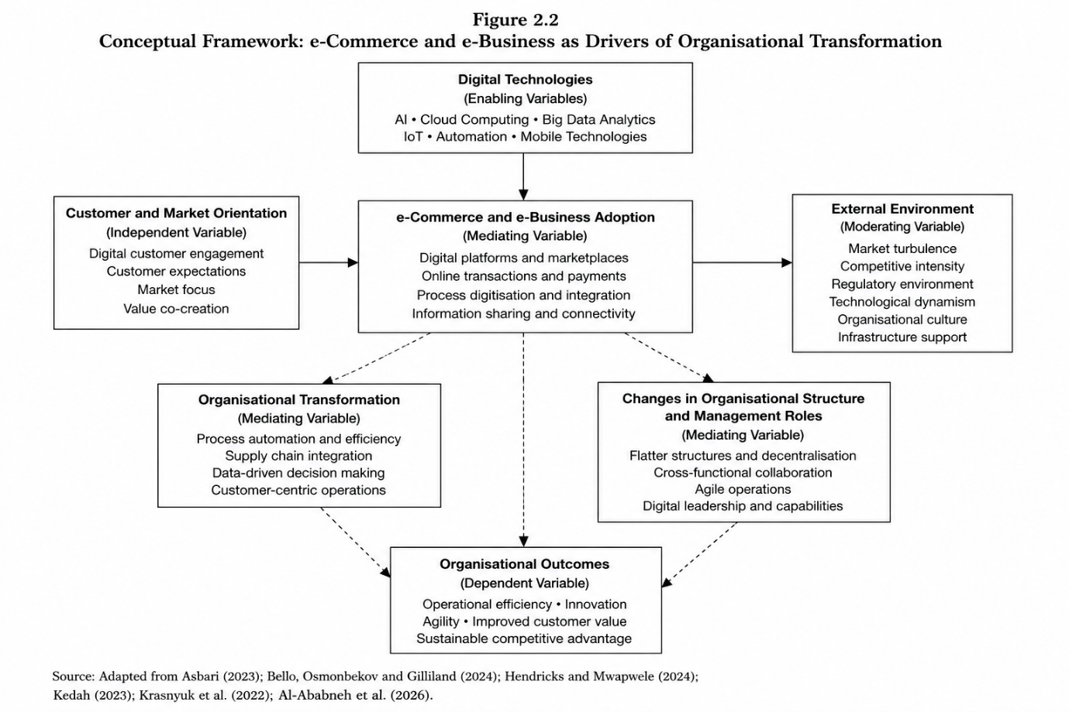

As illustrated in Figure 2.2.1, e-Commerce extends beyond electronic buying and selling by enabling organisations to develop integrated digital platforms that facilitate customer engagement, online transactions and continuous information exchange. Bello, Osmonbekov and Gilliland (2024) argue that digital platforms strengthen customer relationships by improving accessibility, responsiveness and value creation. Likewise, Hendricks and Mwapwele (2024) contend that e-Commerce enables organisations to integrate suppliers, logistics providers and customers into unified digital networks, thereby enhancing organisational responsiveness and operational efficiency across geographically dispersed markets.
In contrast, e-Business encompasses the broader digital integration of organisational processes rather than focusing exclusively on commercial transactions. According to Krasnyuk et al. (2022), e-Business incorporates enterprise-wide information systems that support process integration, knowledge management and organisational coordination. Similarly, Asbari (2023) suggests that organisations increasingly employ e-Business technologies to automate routine activities, improve organisational learning and strengthen evidence-based decision-making through real-time access to operational data. Consequently, e-Business should be understood as a strategic organisational capability that facilitates continuous organisational adaptation rather than merely supporting online sales.
The transformational effects of e-Commerce and e-Business are further illustrated in Figure 2.2.2, which conceptually summarises the principal organisational dimensions emphasised within the reviewed literature. Although the figure does not represent empirical measurement, it highlights the relative importance that contemporary research places on different aspects of digital transformation.

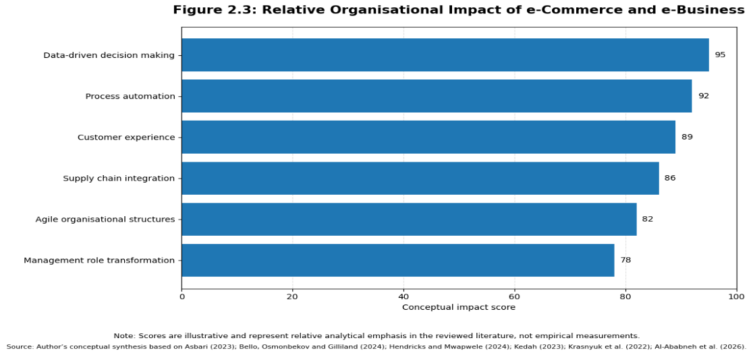
Figure 2.2.2: Relative Organisational Impact of e-Commerce and e-Business

Figure 2.3 indicates that the literature places the greatest emphasis on data-driven decision-making and process automation, reflecting the increasing reliance of organisations on digital information systems and intelligent technologies to support strategic and operational decisions. Automation reduces repetitive administrative activities while improving productivity, whereas data analytics enables managers to forecast demand, optimise resource allocation and respond more effectively to changing market conditions (Kedah, 2023; Al-Ababneh et al., 2026). These developments demonstrate that digital technologies increasingly influence not only operational efficiency but also the quality and speed of managerial decision-making.
The literature also identifies customer experience and supply chain integration as central outcomes of e-Commerce and e-Business adoption. Digital technologies enable organisations to personalise customer interactions, strengthen customer engagement and improve service delivery through real-time communication and integrated digital platforms (Bello, Osmonbekov and Gilliland, 2024). Simultaneously, digital supply chains improve coordination between suppliers, logistics providers and customers by facilitating continuous information exchange and greater operational visibility (Hendricks and Mwapwele, 2024). Together, these developments illustrate that digital transformation extends across organisational boundaries rather than remaining confined to internal business operations.
Beyond operational improvements, digital transformation has significant implications for organisational structures and managerial responsibilities. As shown in Figures 2.2.1 and 2.2.2, organisations increasingly adopt flatter organisational structures, cross-functional collaboration and agile operational practices to improve organisational responsiveness and innovation. Managers therefore perform roles that increasingly involve strategic leadership, digital innovation, organisational learning and change management rather than solely supervising routine operational activities. Nevertheless, these changing responsibilities do not necessarily eliminate the need for managerial authority, governance or organisational coordination. Instead, technology appears to redefine how managerial responsibilities are exercised within increasingly digital organisations.
This distinction is particularly important in relation to the assignment question. While the literature consistently demonstrates that e-Commerce and e-Business have transformed organisational processes, enhanced decision-making and encouraged more flexible organisational structures, the evidence does not conclusively support the proposition that traditional organisational structures and management theories have become obsolete. Rather, the literature suggests that digital technologies augment managerial capabilities while requiring organisations to balance technological innovation with established principles of governance, leadership and organisational control. Consequently, the debate shifts from whether technology has replaced traditional management towards understanding how technological advancement has redefined its application within contemporary organisations.

2.3 Technology and the Changing Role of Management
The widespread adoption of e-Commerce and e-Business has transformed managerial work by shifting emphasis from operational control towards strategic leadership, innovation and organisational adaptability. While classical management theories positioned managers as planners, coordinators and controllers operating within hierarchical structures (Dickson, 2023; Johnson and Szamosi, 2025), contemporary organisations increasingly require managers to lead digital transformation, facilitate collaboration and exploit technology to improve organisational performance (Weber, Büttgen and Bartsch, 2022). This transition reflects a change in managerial responsibilities rather than the disappearance of management itself.
A key consequence of digital transformation is the increasing reliance on data-driven decision-making. Digital platforms, artificial intelligence (AI) and business analytics enable managers to access real-time organisational information, improving forecasting, resource allocation and strategic planning (Li et al., 2023; Nalgozhina and Uskenbayeva, 2024). Consequently, managerial effectiveness increasingly depends upon the ability to interpret digital information rather than relying solely on experience or hierarchical authority. However, while technology enhances decision quality, it cannot independently determine organisational priorities, resolve ethical dilemmas or formulate long-term strategic objectives. This suggests that technology complements managerial judgement rather than replacing it.
Digital transformation has also altered organisational leadership. Weber, Büttgen and Bartsch (2022) argue that managers increasingly function as facilitators of innovation, organisational learning and cross-functional collaboration instead of exercising authority primarily through command-and-control structures. Likewise, Bala (2026) contends that digital leadership requires managers to balance technological implementation with employee engagement, organisational culture and strategic alignment. These perspectives indicate that management roles have expanded to incorporate digital competencies while retaining responsibility for organisational direction and performance.
Despite these developments, the proposition that technology has rendered management obsolete remains weakly supported. Automation has undoubtedly reduced managers' involvement in routine administrative activities, yet organisations continue to depend upon leadership for governance, coordination and change management (Musaigwa, 2023). Porath (2023) further argues that accountability and organisational control remain essential, particularly within large multinational organisations where strategic decisions extend beyond algorithmic optimisation. Therefore, technology has shifted managerial attention away from supervision towards leadership, but it has not eliminated the need for management itself.
Overall, the literature suggests that digital technologies have redefined managerial responsibilities rather than replaced them. Contemporary managers increasingly operate as strategic leaders who integrate technological capabilities with organisational objectives, employee development and innovation. Consequently, the debate should not focus on whether management has become obsolete but on how technological advancement has reshaped managerial practice within digitally enabled organisations. This distinction is central to the present study and provides the theoretical basis for examining whether Amazon represents the replacement of traditional management or its evolution.

2.4 Critical Debate: Obsolete or Transformed?
The literature presents competing perspectives on whether technological advances have rendered traditional organisational structures and management theories obsolete. As illustrated in Figure 2.4, the dominant view is that digital transformation has significantly reshaped management through greater organisational agility, data-driven decision-making and evolving leadership roles. However, there is considerably less support for the proposition that technology has completely replaced traditional management principles.

Figure 2.4. Competing Perspectives on the Impact of Digital Transformation
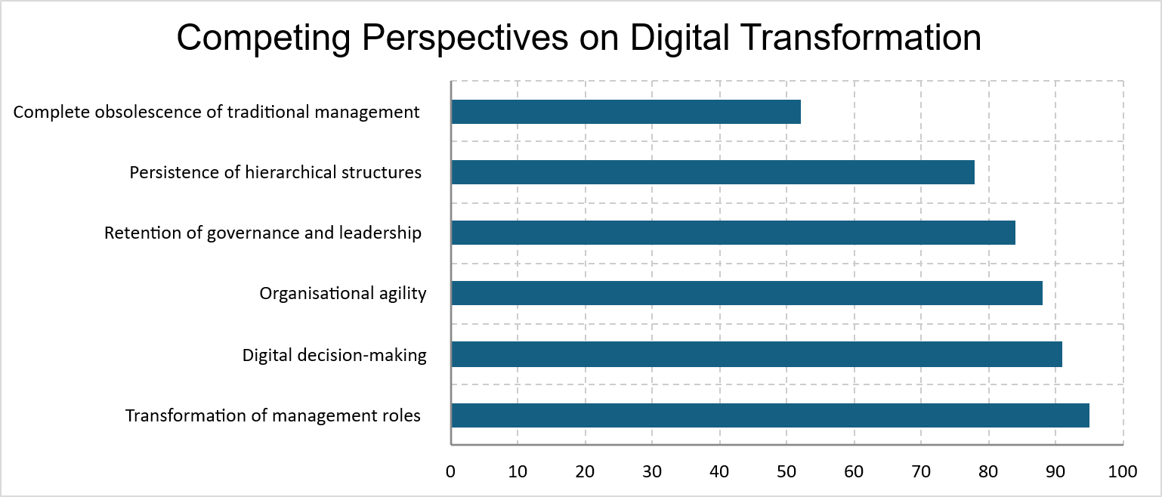While digital technologies have reduced reliance on routine managerial control, the literature provides limited evidence that they have displaced the core functions of management. Instead, technology is consistently portrayed as enhancing organisational responsiveness while preserving the need for strategic leadership, governance and accountability (Porath, 2023; Weber, Büttgen and Bartsch, 2022). Likewise, Bala (2026) and Musaigwa (2023) argue that digital transformation expands managerial responsibilities by requiring leaders to integrate technological capabilities with organisational learning, innovation and change management.
A notable limitation of the literature is its tendency to adopt a technology-centric perspective, often overlooking organisational context. The extent to which digital technologies reshape management depends on factors such as organisational scale, industry characteristics and governance requirements, suggesting that technological capability alone cannot explain organisational change.
Overall, the evidence supports an evolutionary rather than a replacement perspective. Traditional organisational structures and management theories continue to provide the foundation for organisational governance but have been adapted to operate within digitally enabled environments. This hybrid perspective forms the analytical framework for the following chapter, which evaluates whether Amazon represents the obsolescence of traditional management or its transformation through technological innovation.

3. Amazon's Technological Transformation and Organisational Evolution

3.1 Amazon's Digital Business Model and Technological Evolution
Amazon represents an appropriate case study for evaluating whether technological advances have rendered traditional organisational structures and management roles obsolete. The company has evolved from an online retailer into a technology-driven enterprise whose competitive advantage is built on the integration of e-commerce, cloud computing, artificial intelligence (AI) and digitally enabled logistics. Rather than operating as independent business units, these capabilities function as an interconnected digital ecosystem that supports operational efficiency, innovation and organisational growth (Kassem, 2023; Lin, 2024).
The Amazon Annual Reports (2022–2025) demonstrate that technology is embedded throughout the company's business model. Continued investment in Amazon Web Services (AWS), generative AI, robotics and machine learning has expanded Amazon's operational capabilities while strengthening customer experience and business scalability. These investments are not limited to product innovation but underpin core organisational processes, including fulfilment, supply chain coordination, demand forecasting and customer engagement. Consequently, technology has become a strategic organisational capability rather than simply an operational resource.
Table 3.1 summarises the principal technological capabilities underpinning Amazon's business model and their organisational implications. The evidence indicates that each technological investment contributes to improved organisational performance while simultaneously increasing the complexity of managerial coordination. For example, AI and automation enhance operational efficiency by reducing routine activities, whereas AWS provides the digital infrastructure that enables innovation across multiple business segments. Similarly, data analytics supports faster and more informed decision-making, yet its value depends upon managers' ability to interpret information and align technological capabilities with organisational objectives.

Table 3.1. Amazon's Technology-Enabled Business Model and Organisational Implications
Digital Capability | Organisational Contribution | Management Implication
E-commerce Platform | Global digital marketplace and scalable operations | Managers coordinate ecosystem performance rather than individual transactions
Amazon Web Services (AWS) | Cloud infrastructure supporting innovation and business scalability | Greater emphasis on strategic governance and technology investment
Artificial Intelligence and Automation | Operational efficiency, robotics and process optimisation | Managers supervise technology-enabled operations and organisational change
Data Analytics | Real-time business intelligence and customer insights | Increased reliance on evidence-based decision-making
Integrated Logistics Network | Digitally coordinated fulfilment and supply chain operations | Managers coordinate complex global operations across interconnected systems

The evidence suggests that Amazon's technological evolution has transformed organisational capabilities without eliminating the need for management. While digital technologies automate routine processes and improve organisational responsiveness, they also require strategic oversight, governance and cross-functional coordination. This finding supports the evolutionary perspective developed in Chapter 2, whereby technology redefines managerial responsibilities rather than replacing them. The following sections examine how these technological capabilities have influenced Amazon's organisational structure and the role of management in practice.

3.2 Technology and Organisational Structure at Amazon
Amazon's organisational structure demonstrates that technological innovation has reshaped organisational design without eliminating formal governance. The company's adoption of AI, automation and cloud technologies has enabled greater operational flexibility, yet strategic decision-making remains coordinated through established management structures. This supports the evolutionary perspective developed in Chapter 2, whereby technology modifies rather than replaces traditional organisational models.
A key example is Amazon's regional fulfilment network, which combines AI and machine learning with decentralised operational decision-making to improve inventory management and delivery performance (Amazon Annual Reports, 2022–2025). Although technology enables local responsiveness, strategic priorities and organisational coordination remain centrally governed. Consequently, technology has redistributed operational authority rather than removed hierarchical control.
Automation has similarly transformed organisational processes. Robotics and AI streamline fulfilment operations and improve scalability, reducing reliance on manual activities (Onggowidjojo and Ellitan, 2023). However, automation has increased organisational interdependence by requiring greater coordination between digital systems, operations and supply chain functions. Rather than simplifying organisational structures, technology has created new coordination requirements that continue to depend on managerial oversight.
Cloud infrastructure further reinforces this hybrid organisational model. AWS enables information sharing, system integration and collaboration across business units, improving organisational agility while maintaining enterprise-wide coordination (Lin, 2024). These developments indicate that technology has strengthened organisational integration rather than replacing the governance structures required to manage a complex multinational enterprise.

Table 3.2. Technology-Driven Changes in Amazon's Organisational Structure
Technology | Structural Change | Critical Evaluation
AI and machine learning | Data-driven operational coordination | Improves responsiveness but remains subject to managerial oversight
Regional fulfilment model | Greater operational decentralisation | Modifies hierarchy rather than replacing it
Robotics and automation | Automated fulfilment processes | Replaces routine tasks but increases coordination requirements
AWS and cloud infrastructure | Integrated digital operations | Enhances collaboration while strengthening organisational integration

3.3 Technology and the Changing Role of Management at Amazon
Amazon's technological transformation has shifted managerial responsibilities from operational supervision towards strategic leadership, innovation and data-driven decision-making. As shown in Figure 3.3.1., investments in AI, cloud computing and automation have expanded the managerial role beyond coordinating daily operations to leading digital transformation across the organisation.
The Amazon Annual Reports (2022–2025) highlight the growing use of AI, machine learning and real-time analytics to support forecasting, inventory management and customer experience. While these technologies improve the speed and quality of decision-making, they do not replace managerial judgement. Instead, managers are increasingly responsible for interpreting digital insights, allocating resources and aligning technological capabilities with organisational objectives.
The expansion of AWS and generative AI has further increased the need for cross-functional collaboration and strategic oversight. Managers play a central role in implementing digital technologies, coordinating organisational change and ensuring that innovation supports Amazon's long-term business strategy (Kassem, 2023; Lin, 2024). This demonstrates that technological capability complements rather than substitutes managerial expertise.
Amazon's Leadership Principles reinforce this transformation by promoting ownership, innovation and customer obsession. These principles indicate that effective management extends beyond adopting new technologies to fostering organisational adaptability and guiding employees through continuous change. Consequently, managerial effectiveness increasingly depends on leadership, coordination and strategic decision-making rather than routine operational control.
The evidence suggests that technology has redefined, rather than diminished, the managerial role at Amazon. Although automation has reduced the need for direct supervision of routine activities, strategic leadership, governance and organisational coordination remain essential. Amazon therefore demonstrates that digital transformation reshapes management practices while preserving the importance of managerial judgement and accountability.

Figure 3.3. Evolution of Managerial Roles in Amazon's Digital Transformation (2022–2025)
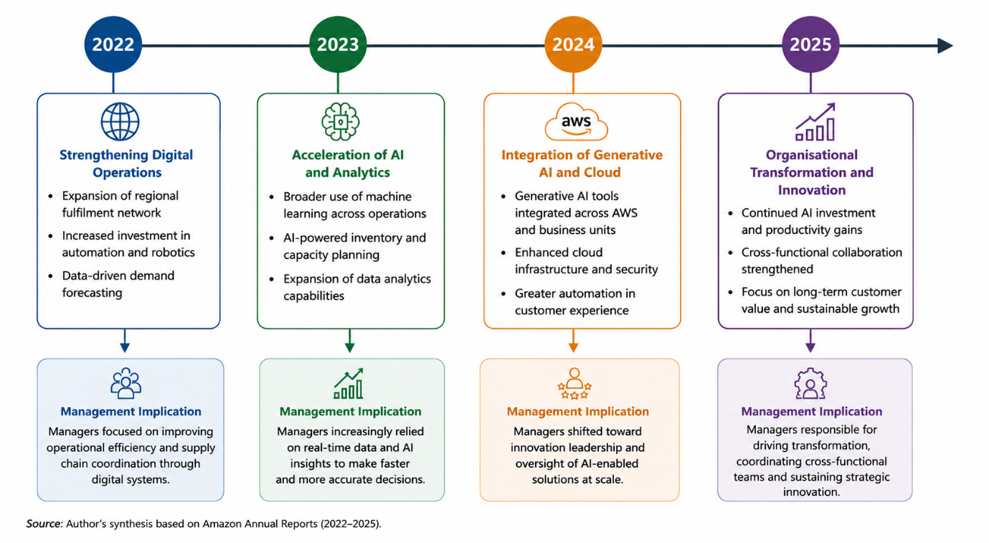

4. Critical Evaluation

4.1 Are Traditional Organisational Structures Obsolete?
The rapid advancement of e-Commerce and e-Business technologies has fundamentally altered the way organisations are designed and managed, leading many scholars to question whether traditional organisational structures remain appropriate in digital environments. The widespread adoption of artificial intelligence (AI), cloud computing, automation and data analytics has enabled organisations to decentralise operational activities, accelerate decision-making and improve organisational responsiveness. Consequently, proponents of digital transformation argue that hierarchical and bureaucratic structures are increasingly incompatible with the flexibility required by modern organisations (Asbari, 2023; Hendricks and Mwapwele, 2024). However, equating technological advancement with organisational obsolescence oversimplifies the relationship between technology and organisational design.
Support for this proposition stems from the ability of digital technologies to reduce dependence on traditional hierarchical coordination. AI-driven decision support, integrated digital platforms and cloud-based information systems enable operational decisions to be made closer to the point of execution while facilitating real-time communication across organisational boundaries. These capabilities challenge several assumptions underpinning classical organisational theories, particularly the reliance on rigid reporting relationships, functional silos and multiple layers of managerial supervision. From this perspective, e-Commerce and e-Business have transformed organisational structures by promoting agility, collaboration and decentralised decision-making.
Despite these developments, the Amazon case study demonstrates that technological transformation has not eliminated the need for formal organisational structures. As discussed in Chapter 3, Amazon's regional fulfilment model, AI-enabled operations and AWS infrastructure have significantly improved operational flexibility and information sharing. Nevertheless, these technologies continue to operate within clearly defined governance arrangements that maintain strategic coordination, accountability and organisational control. Rather than replacing hierarchy, technology has redistributed operational authority while preserving centralised strategic decision-making. This finding challenges the argument that digital transformation inevitably leads to the disappearance of traditional organisational structures.

Figure 4.1. Critical Evaluation of the Impact of Digital Technologies on Traditional Organisational Structures

A further limitation of the obsolescence argument is its tendency to focus primarily on operational efficiency while underestimating organisational complexity. As organisations become increasingly dependent on interconnected digital technologies, they require stronger governance mechanisms to manage cybersecurity, regulatory compliance, data management and enterprise-wide coordination. Amazon illustrates this paradox: although technology enables greater decentralisation of operational activities, the scale and complexity of its global operations simultaneously increase the need for structured leadership and organisational integration. In this context, technology reduces administrative constraints but strengthens the importance of strategic governance.
The evidence therefore suggests that the claim overstates the impact of technological advancement on organisational design. Digital technologies have undoubtedly reshaped traditional structures by increasing flexibility, collaboration and operational responsiveness. However, they have not rendered organisational structures obsolete. Instead, Amazon demonstrates that classical principles of hierarchy, coordination and accountability have been adapted to complement digital technologies, producing hybrid organisational structures that combine technological agility with formal governance. Consequently, organisational transformation is better understood as an evolutionary process rather than the replacement of traditional organisational models.

4.2 Have Traditional Management Roles Become Obsolete?
As previously mentioned, the rapid advancement of e-Commerce and e-Business technologies has fundamentally altered managerial work, prompting debate over whether traditional management roles remain relevant within digitally enabled organisations. Artificial intelligence (AI), automation, cloud computing and advanced analytics increasingly perform tasks traditionally associated with managers, including monitoring operational performance, analysing data and supporting routine decision-making (Weber et al., 2022; Li et al., 2023; Nalgozhina and Uskenbayeva, 2024). Consequently, some scholars argue that digital technologies have diminished the need for conventional management by replacing supervisory and administrative functions with intelligent systems (Asbari, 2023; Hendricks and Mwapwele, 2024). While these developments have undoubtedly transformed managerial practice, the evidence suggests that technology has altered managerial responsibilities rather than rendered them obsolete.
The argument supporting managerial obsolescence is primarily based on the automation of routine managerial activities. Digital technologies provide managers with real-time operational information, predictive analytics and automated workflows that reduce reliance on manual reporting, hierarchical communication and direct supervision (Weber et al., 2022; Li et al., 2023). Within e-Commerce organisations, AI-enabled systems continuously optimise inventory management, customer service, logistics and operational scheduling, allowing many operational decisions to be executed automatically. Such capabilities challenge classical management theories that emphasise close supervision, administrative control and sequential decision-making (Dickson, 2023). From this perspective, technology appears to reduce the significance of traditional middle-management roles by transferring operational control to intelligent digital systems.
However, this perspective overlooks the distinction between automating managerial tasks and replacing management itself. Although AI can generate recommendations, identify operational inefficiencies and support evidence-based decision-making, it cannot independently establish organisational priorities, resolve strategic trade-offs or assume responsibility for organisational outcomes (Johnson and Szamosi, 2025; Bala, 2026). The increasing complexity of digital organisations requires managers to interpret analytical outputs, coordinate cross-functional activities and exercise judgement where multiple organisational objectives compete. Rather than eliminating management, technological advancement has shifted managerial effort from operational supervision towards strategic leadership, innovation and organisational integration (Porath, 2023; Musaigwa, 2023).
Amazon provides a practical illustration of this transformation. As discussed in Chapter 3, the company extensively integrates AI, robotics, predictive analytics and cloud computing across its fulfilment network, AWS operations and customer-facing services to automate operational processes and improve decision speed (Amazon Annual Report, 2022; Amazon Annual Report, 2023; Amazon Annual Report, 2024). Nevertheless, these technologies operate within formal governance structures where managers remain accountable for organisational performance, risk management and strategic decision-making. Amazon's continued investment in generative AI, cloud services and digital infrastructure has expanded managerial responsibilities by increasing the need for cross-functional coordination, innovation management and long-term strategic planning rather than reducing managerial importance (Amazon Annual Report, 2025).
Furthermore, Amazon's Leadership Principles demonstrate that organisational success continues to depend upon managerial capabilities that technology cannot replicate. Principles such as Ownership, Invent and Simplify, Learn and Be Curious, and Deliver Results emphasise judgement, accountability, ethical responsibility and leadership rather than administrative supervision (Amazon Annual Reports, 2022–2025). These principles reinforce the view that competitive advantage arises not from technology alone but from managers' ability to leverage technological capabilities to achieve organisational objectives. Technology therefore functions as an enabler of managerial effectiveness rather than a substitute for leadership.
A further weakness of the obsolescence argument is its assumption that management roles remain static despite continuous organisational evolution. Classical management theories have historically adapted to changing economic and technological environments, and digital transformation represents a continuation of this evolutionary process rather than a complete departure from established management principles (Dickson, 2023; Johnson and Szamosi, 2025). Planning, organising, coordinating and controlling remain fundamental managerial functions, although they are increasingly supported by AI, automation and digital information systems. Consequently, the nature of managerial work has evolved from directing operational activities towards developing organisational capabilities, facilitating innovation and leading organisational change.
The evidence therefore indicates that the proposition that traditional management roles have become obsolete is only partially supported. Technology has undoubtedly reduced the need for managers to perform routine supervisory and administrative tasks through automation and data-driven decision-making. However, Amazon demonstrates that digital transformation simultaneously increases the importance of strategic leadership, organisational coordination, ethical governance and managerial judgement. Rather than eliminating management, e-Commerce and e-Business technologies have redefined managerial responsibilities, creating digitally enabled leadership roles that combine technological capability with human decision-making. Traditional management has therefore evolved to meet the demands of the digital economy rather than becoming obsolete.

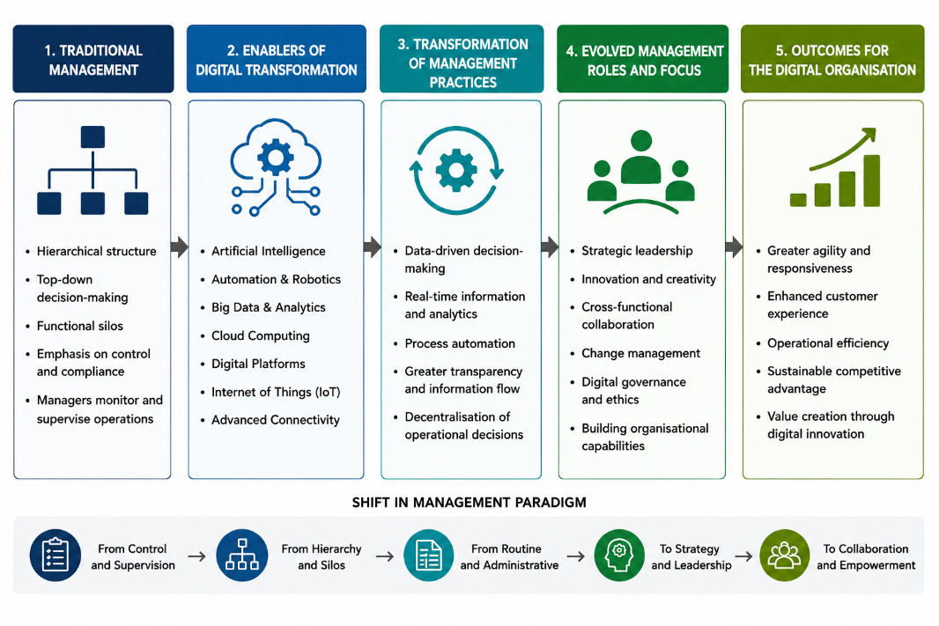
Figure 4.2. Evolution of Management in the Digital Era

4.3 Critical Evaluation of the Claim
The proposition that advances in e-Commerce and e-Business have rendered traditional organisational structures and management theories obsolete represents one of the most significant debates within contemporary management literature. Rapid developments in artificial intelligence (AI), automation, cloud computing and digital platforms have undoubtedly transformed organisational design and managerial practice, challenging assumptions underpinning many classical management theories (Asbari, 2023; Hendricks and Mwapwele, 2024). Nevertheless, the evidence presented throughout this study suggests that the claim overstates the extent of technological disruption. While digital technologies have fundamentally reshaped organisational operations, they have not eliminated the need for organisational structures or managerial leadership. Instead, they have accelerated the evolution of both.
The literature provides substantial support for the view that digital transformation has weakened the effectiveness of traditional hierarchical models. Classical organisational theories were developed within relatively stable industrial environments characterised by sequential communication, clearly defined reporting relationships and centralised decision-making (Dickson, 2023). In contrast, digital organisations increasingly depend upon integrated information systems, real-time analytics and cross-functional collaboration that enable faster decision-making and greater organisational flexibility (Weber et al., 2022; Li et al., 2023). From this perspective, e-Commerce and e-Business technologies reduce reliance on rigid bureaucratic structures by enabling decentralised operational control and continuous information sharing.
However, equating reduced bureaucracy with organisational obsolescence presents an overly deterministic interpretation of technological change. Organisational structures continue to perform essential governance functions by coordinating activities, allocating responsibility and ensuring organisational accountability. Digital technologies improve organisational agility but do not independently provide strategic direction or institutional control. Amazon clearly illustrates this distinction. The company's extensive use of AI, robotics, cloud computing and predictive analytics has transformed operational processes and increased organisational responsiveness, yet these technologies continue to operate within formal governance systems that support enterprise-wide coordination and strategic oversight (Amazon Annual Reports, 2022–2025). Consequently, technology modifies organisational structures without eliminating their underlying purpose.
A similar pattern emerges when evaluating the changing role of management. AI-enabled systems increasingly automate routine managerial activities, including performance monitoring, operational scheduling and analytical reporting, thereby reducing the need for direct supervision (Weber et al., 2022; Nalgozhina and Uskenbayeva, 2024). Such developments challenge aspects of traditional management theories that emphasise administrative control and hierarchical supervision. However, they simultaneously increase the demand for strategic leadership, organisational learning and cross-functional coordination. Managers are increasingly responsible for interpreting analytical insights, balancing competing organisational priorities and guiding organisational adaptation in environments characterised by technological uncertainty (Johnson and Szamosi, 2025; Porath, 2023).
Amazon again provides compelling evidence that managerial roles have evolved rather than disappeared. The organisation's continued investment in generative AI, AWS, advanced robotics and data-driven decision-making has reduced the importance of repetitive supervisory activities while increasing the significance of innovation, strategic planning and organisational leadership (Amazon Annual Reports, 2023–2025). Furthermore, Amazon's Leadership Principles demonstrate that organisational success continues to depend upon human judgement, accountability, ethical responsibility and long-term strategic thinking. Technology therefore enhances managerial capability but does not replace leadership itself.
The findings also suggest that neither classical nor contemporary management theories independently explain organisational performance within digitally enabled organisations. Classical theories continue to provide important foundations for governance, accountability, coordination and organisational control, whereas contemporary digital management perspectives explain how technology enhances organisational flexibility, collaboration and innovation. Amazon demonstrates that competitive advantage is achieved through integrating these complementary perspectives rather than replacing one with the other. The organisation combines formal governance mechanisms with decentralised operational execution, illustrating that digital transformation produces hybrid organisational models instead of entirely new organisational forms.
Therefore, the central claim of this report is only partially supported. Advances in e-Commerce and e-Business have unquestionably transformed organisational structures and managerial practice by reducing administrative complexity, increasing operational agility and enabling data-driven decision-making. Nevertheless, these developments have not rendered traditional organisational structures or management theories obsolete. Instead, technology has redefined their application within increasingly complex digital environments. Amazon demonstrates that sustainable organisational performance depends not upon abandoning classical management principles but upon adapting them to complement emerging digital capabilities. Consequently, organisational and managerial evolution, rather than obsolescence, provides the most appropriate interpretation of technology's impact on contemporary organisations.

Table 4.3. Critical Evaluation Matrix
Evaluation Dimension | Evidence Supporting the Claim | Counterargument | Evidence from Amazon | Overall Judgement
Organisational Structure | AI enables decentralisation and reduces bureaucracy | Governance and accountability remain essential | Regional fulfilment model, AWS integration, enterprise governance | Partially Supported
Management Roles | Automation replaces routine supervision | Leadership, judgement and coordination remain indispensable | Leadership Principles, AI-supported management | Not Supported
Decision-Making | Data analytics accelerates operational decisions | Strategic decisions continue to require managerial judgement | AI-assisted but manager-led decision-making | Technology complements management
Classical Management Theories | Digital organisations challenge rigid hierarchies | Planning, coordination and control remain relevant | Hybrid organisational structure | Adapted rather than obsolete
Overall Claim | Technology fundamentally transforms organisations | Transformation does not equal replacement | Integration of technology with governance and leadership | Claim is overstated

5. Conclusions, Recommendations and Limitations

5.1 Conclusion
This study evaluated the claim that technological advances, particularly in the areas of e-Commerce and e-Business, have rendered traditional models of organisational structure and theories of management roles obsolete by examining Amazon as a contemporary case study. Through a critical review of the literature and an evaluation of Amazon's organisational practices, the findings indicate that the proposition is only partially supported. Although digital technologies have fundamentally transformed organisational operations, organisational structures and managerial responsibilities, they have not eliminated the need for governance, leadership or strategic decision-making. Instead, technological advancement has redefined how traditional management principles are applied within increasingly digital business environments.
The literature review demonstrated that developments in artificial intelligence, automation, cloud computing and digital platforms have significantly changed organisational design by improving operational efficiency, enabling real-time communication and facilitating decentralised decision-making (Weber et al., 2022; Li et al., 2023; Hendricks and Mwapwele, 2024). These developments have reduced dependence on rigid bureaucratic structures and traditional supervisory practices, supporting arguments that many classical organisational models are less suited to highly dynamic digital environments (Asbari, 2023; Bello et al., 2024). However, the review also established that technology does not replace the underlying organisational functions of planning, coordination, accountability and strategic control. Rather, digital technologies enhance the effectiveness with which these functions are performed (Johnson and Szamosi, 2025; Bala, 2026).
The Amazon case study reinforced this conclusion by illustrating how technology transforms organisational capability without removing the need for effective management. Amazon has successfully embedded artificial intelligence, robotics, predictive analytics and cloud computing throughout its global operations to improve operational performance, customer responsiveness and innovation (Amazon Annual Reports, 2022–2025). Nevertheless, these technologies continue to operate within clearly defined governance structures supported by executive leadership, organisational accountability and strategic oversight. The organisation therefore demonstrates that technological capability complements formal organisational structures rather than replacing them.
Similarly, the findings indicate that traditional management roles have evolved rather than become obsolete. Routine managerial activities, including operational monitoring, scheduling and data analysis, are increasingly supported by intelligent digital systems. This enables managers to devote greater attention to strategic leadership, innovation, organisational change and cross-functional collaboration. Amazon's continued emphasis on leadership principles such as ownership, customer obsession and long-term thinking demonstrates that human judgement, accountability and ethical responsibility remain essential organisational capabilities despite increasing technological sophistication (Amazon Annual Reports, 2022–2025). Consequently, technology functions as a strategic enabler of management rather than a substitute for managerial leadership.
Overall, this study concludes that the assertion that advances in e-Commerce and e-Business have rendered traditional organisational structures and management theories obsolete overstates the impact of digital transformation. Technology has fundamentally reshaped how organisations are structured and managed by increasing agility, automating routine processes and supporting evidence-based decision-making. However, the evidence demonstrates that enduring principles of governance, leadership, coordination and organisational control remain essential for sustaining organisational performance. Amazon illustrates that competitive advantage is achieved by integrating technological innovation with established management principles rather than abandoning them. Therefore, organisational and managerial evolution, rather than obsolescence, provides the most appropriate interpretation of technology's impact on contemporary organisations.

5.2 Recommendations
Based on the findings of this study, organisations should approach digital transformation as a process of organisational evolution rather than technological replacement. While AI, automation and advanced analytics offer significant opportunities to improve efficiency and decision-making, these technologies should be implemented to support managerial capability rather than replace leadership functions. Organisations should therefore invest in digital technologies that complement human expertise while maintaining clear governance structures and strategic oversight.
Managers should also prioritise the development of digital leadership competencies. As routine operational activities become increasingly automated, managerial responsibilities will continue to shift towards strategic planning, innovation, organisational change and cross-functional collaboration. Organisations should therefore provide continuous professional development that equips managers with both technological knowledge and leadership skills, enabling them to effectively interpret data, manage digital transformation initiatives and lead multidisciplinary teams.
Furthermore, organisations should ensure that technological innovation is supported by appropriate governance and ethical frameworks. The increasing use of AI in organisational decision-making requires transparent accountability, responsible data management and ongoing human oversight to minimise operational and ethical risks. Amazon's experience demonstrates that sustainable competitive advantage is achieved by combining technological innovation with strong organisational leadership and customer-focused strategic decision-making rather than relying solely on technological capability.
Finally, organisations operating within digital markets should adopt flexible organisational structures that encourage collaboration and responsiveness while retaining sufficient managerial control to ensure strategic alignment, regulatory compliance and long-term organisational resilience.

5.3 Limitations and Future Research
This study is subject to several limitations that should be considered when interpreting its findings. First, the research adopted a single case study approach by focusing exclusively on Amazon. Although Amazon provides a highly relevant example of a digitally enabled organisation, its scale, technological capabilities and global market position may not be representative of organisations operating in different industries or smaller business environments. Consequently, the findings should not be generalised without consideration of organisational context.
Second, the study relied exclusively on secondary sources, including academic literature and Amazon's published annual reports. While these sources provided valuable insights into organisational strategy and technological development, they do not capture the perspectives and experiences of managers responsible for implementing digital transformation initiatives. Incorporating primary data through interviews, surveys or case-based observations could provide a deeper understanding of how technology influences managerial practice within organisations.
Future research could extend this study by conducting comparative analyses across multiple digital organisations operating in different sectors or geographical regions. Comparative case studies involving organisations such as Amazon, Alibaba and Walmart could provide broader insights into how technological transformation influences organisational structures and management practices under different competitive conditions. Additionally, future studies could examine the long-term implications of generative AI and emerging technologies on leadership, organisational governance and management theory as these technologies continue to evolve.

List of references:
Al-Ababneh, H.A., Alrhaimi, S.A., Al Adwan, M.N., Al Refai Mohammed, N., Sarıhasan, I., Vasudevan, A. and Mohammad, S.I. (2026) 'Evolution of E-Business from Traditional Trade to Digital Platforms', in AI-Driven Healthcare: Automation and Robotics. Cham: Springer Nature Switzerland, pp. 977–988.
Amazon.com, Inc. (2022) Annual Report 2022.
Amazon.com, Inc. (2023) Annual Report 2023.
Amazon.com, Inc. (2024) Annual Report 2024.
Amazon.com, Inc. (2025) Annual Report 2025.
Aniebonam, E.E. (2024) 'Strategic management in turbulent markets: A case study of the USA', International Journal of Modern Science and Research Technology, 1(8), pp. 35–43.
Asbari, M. (2023) 'Scope of e-business & e-commerce to business and modern life', Journal of Information Systems and Management (JISMA), 2(1), pp. 33–38.
Bala, H. (2026) 'Creative and Innovative Leadership and the Capacity to Manage Organisational Change', Spanish Journal of Innovation and Integrity, 50, pp. 53–60.
Bello, D.C., Osmonbekov, T. and Gilliland, D.I. (2024) 'E-business technological innovations: impact on channel processes and structure', in Internets, Intranets, and Extranets. CRC Press, pp. 3–25.
Bilovodska, O. and Zhurba, V. (2026) 'Prospects for e-commerce development under the digitalization of logistics processes: innovative technologies and global brand business models in retail', Збірник наукових праць Черкаського державного технологічного університету. Серія: Економічні науки, 27(1 (78)), pp. 96–108.
Bogue, R. (2022) 'Warehouse robot market boosted by Covid pandemic and technological innovations', Industrial Robot: The International Journal of Robotics Research and Application, 49(2), pp. 181–186.
Boone, L.E., Kurtz, D.L., Khan, M.H., Canzer, B., Harms, R. and Moreira, P.M. (2023) Contemporary Business. John Wiley & Sons.
Charles, I.I. and Uford, I.C. (2023) 'Comparative analysis and evaluation of business and financial performance of Amazon.com: A three-year period critical review of exceptional success', European Journal of Business, Economics and Accountancy, 11(2), pp. 69–92.
Dickson, R.K. (2023) 'Analysis of the traditional leadership theories: A review of contemporary leadership approaches and management effectiveness', Information and Knowledge Management, 13(5), pp. 9–23.
Dost, M. (2026) 'Hybrid entrepreneurship: navigating traditional employment while launching startups through a constructivist grounded theory approach', Journal of Small Business & Entrepreneurship, 38(1), pp. 158–178.
Hendricks, S. and Mwapwele, S.D. (2024) 'A systematic literature review on the factors influencing e-commerce adoption in developing countries', Data and Information Management, 8(1), p. 100045.
Johnson, P. and Szamosi, L.T. (2025) 'HRM in changing organisational contexts', in Human Resource Management. Routledge, pp. 31–53.
Kassem, S. (2023) Work and Alienation in the Platform Economy: Amazon and the Power of Organization. Policy Press.
Kedah, Z. (2023) 'Use of e-commerce in the world of business', Startupreneur Business Digital (SABDA Journal), 2(1), pp. 51–60.
Khasanah, N. and Putri, R.A. (2025) 'Analysis of understanding business strategy in contemporary management perspective: Literature study', Indonesia Accounting Research Journal, 12(4), pp. 184–192.
Krasnyuk, M., Kulynych, Y., Tuhaienko, V. and Krasniuk, S. (2022) 'E-business and e-commerce technologies as an important factor for economic efficiency and stability in the modern conditions of the digital economy (on the example of oil and gas company)', in Science of Post-Industrial Society: Globalization and Transformation Processes. NGO European Scientific Platform (Vinnytsia, Ukraine); LLC International Centre Corporative Management (Vienna, Austria).
Lazzarini, S.G., Boehe, D.M., Pongeluppe, L.S. and Cook, M.L. (2026) 'The normative core of relational stakeholder strategies: Explaining open buyer-supplier relations in the context of the Amazon rainforest', Business Ethics Quarterly, 36(1), pp. 69–111.
Li, L., Lin, J., Luo, W. and Luo, X.R. (2023) 'Investigating the effect of artificial intelligence on customer relationship management performance in e-commerce enterprises', Journal of Electronic Commerce Research, 24(1), pp. 68–83.
Lin, Z. (2024) 'Big Data Analytics in Supply Chain Optimization and Risk Management: A case study of Amazon', in SHS Web of Conferences, Vol. 208, p. 04024. EDP Sciences.
Miryala, N.K. and Gupta, D. (2023) 'Big Data Analytics in Cloud–Comparative Study', International Journal of Computer Trends and Technology, 71(12), pp. 30–34.
Musaigwa, M. (2023) 'The role of leadership in managing change', International Review of Management and Marketing, 13(6), p. 1.
Nalgozhina, N. and Uskenbayeva, R. (2024) 'Automating hybrid business processes with RPA: optimizing warehouse management', Procedia Computer Science, 231, pp. 391–396.
Nikolova, M., Tabassum, N. and Nayak, B.S. (2022) 'The Internal Organisational Environment in Amazon', in Modern Corporations and Strategies at Work. Singapore: Springer Nature Singapore, pp. 35–71.
Onggowidjojo, V. and Ellitan, L. (2023) 'Strategies for achieving competitive advantage: The case of Amazon', International Journal of Research, 10(9), pp. 249–265.
Porath, U. (2023) 'Advancing managerial evolution and resource management in contemporary business landscapes', Modern Economy, 14(10), pp. 1404–1420.
Rofiqi, Zainiyati, H.S., Niam, K., Kusaeri and Zuhri, A.M. (2026) 'Educational Leadership Transformation in Traditional Settings: Policy Adaptation and Distributed Authority in Indonesian Pesantren', Leadership and Policy in Schools, pp. 1–19.
Verma, R., Mathur, R., Pahuja, S., Kumar, P. and Dadwal, S. (2026) The Evolution of Human Resource Management: From Traditional Practices to Digital Twin-driven Approaches.
Weber, E., Büttgen, M. and Bartsch, S. (2022) 'How to take employees on the digital transformation journey: An experimental study on complementary leadership behaviors in managing organizational change', Journal of Business Research, 143, pp. 225–238.
Weber, S.M. and Seidler, T. (2026) 'Transforming towards commoning cooperatives: The potential of the pattern language of commoning for organisational learning', in Global Cooperative Economics and Movements. Routledge, pp. 448–469.
Yurchuk, N. (2025) 'Modern management theories in the formation of digital business concepts', Journal of Innovations and Sustainability, 9(2), pp. 10–10.

Appendix 1. Amazon Operational and Financial Highlights (2022–2024)
Indicator | 2022 | 2023 | 2024
Total Revenue | $514B | $575B | $638B
AWS Revenue | $80B | $91B | $108B
Operating Income | $12.2B | $36.9B | $68.6B
Strategic Technology Focus | AI chips, ML, AWS | GenAI, Bedrock, Q | Nova, Trainium2

Appendix 2. Selected Evidence of Digital Transformation from Amazon Annual Reports
Annual Report | Evidence | Relevance to Research
2022 | Regionalised fulfilment network supported by AI and machine learning | Demonstrates organisational restructuring to improve speed and efficiency.
2023 | Expansion of regionalisation, same-day fulfilment and Amazon Bedrock | Demonstrates integration of AI into organisational operations.
2024 | Significant investment in Trainium2, Amazon Nova and generative AI | Illustrates technology-driven strategic innovation.
2025 | Over one million robots operating in fulfilment centres and continued AI investment | Demonstrates technology-enabled operational transformation rather than managerial replacement.

