
Professional Career Development
Thonuma Hassan 1710575

March 29, 2018
University of Wales Trinity Saint David

Executive Summary
This report for professional career development will cover aspects of learning styles created by educational researchers. These learning preferences will enable the individual to gain experience and more of an understanding of what learning style is most suited for the person. This report will also cover the recruitment processes of a professional social worker.
Furthermore, the conclusion in this report will sum up the most important sections that is needed to be highlighted gathered from the sources of the main findings.

Table of Contents
Executive Summary 1
Introduction 4
Findings 5
Part One- Reflect on your learning journey (1st person format) 5
VARK Learning Style = Visual- Aural- Read/Write- Kinesthetic 5
Peter Honey and Alan Mumford Learning Style - Closely linked to David Kolb’s Experiential Learning Cycle. 6
SWOT Analysis- Closely linked to the Johari’s Window and the Skills Audit. 7
Figure 1.1 Johari Window 8
Figure 1.2 Self-assessment – Skills Audit 9
Figure 1.3 SWOT Analysis 11
Go MAD model- Linked with SMART & Maslow Hierarchy 11
Figure 1.4 Maslow Hierarchy of Needs 13
Figure 1. 5 Go MAD framework 14
Barriers and Improvements Considering the Personal Development Plan 14
Support Mechanisms 15
Figure 1.6 Personal Development Plan (PDP) 16
Monitor Development 16
Figure 1.7- The Reflective Cycle (Gibbs 1998) 17
Part 2 – Recruiting and Selecting for a Social Worker (third person) 18
Job Description 18
Personal Specification 18
Application Form 19
Interview stages 19
Recruitment Process 19
Preparing for Interview 20
Conclusion 21
Recommendations 23
Problem Solving Skills 23
Working Independently 23
Leadership Skills 23
Reflecting/ Monitoring 23
Bibliography 24
Appendices 31
VARK Learning Style Questionnaire Page 1 31
VARK Learning Style Questionnaire Page 2 32
VARK Learning Style Questionnaire Page 3 33
Peter Honey and Alan Mumford Learning Style Questionnaire Page 1 34
Peter Honey and Alan Mumford Learning Style Questionnaire Page 2 35
Peter Honey and Alan Mumford Learning Style Questionnaire Page 3 36
Peter Honey and Alan Mumford Learning Style Questionnaire Page 4 37
Kolb Learning Style 38
Skills Audit Template 39
SMART Goal 40

Introduction
The key aspect discussed in this report will be based on Professional Career Development, this enables the learner to develop by learning new techniques and styles. Using various types of methods from theorist that will benefit the researcher to progress in work and learning (Clin,2013). Professional Career Development is important in this social economy because technology in organisations have developed, the employee will have to improve and be open to learning new skills as well (Watts,2003).
Furthermore, the researcher will identify what suitable learning technique is preferred to work towards a social working career. Understanding what weaknesses and strengths the researcher possess will help improve the development needs for the individual to be successful in the chosen career pathway (Morgan,2017). Essentially, having self-awareness is important to develop and improve for employability as it helps with the individual to have a better understanding of what makes the person stand out and how they work in various type of situations (Watss,2003).
In addition, the researcher will then further investigate the recruitment process that is needed to find a suitable candidate for a social working role. Assessing the personal speciation, the job description, the application process that is needed for every job role as it helps with the organisation to improve in business and gives the organisation a good status (Sherzay,2015).

Findings

Part One- Reflect on your learning journey (1st person format)
In this section it will present the researchers learning journey through the career development, focusing on developing the writers learning styles. The individual has an ideal way of processing information in different ways. For instance, by putting together a variety of information, creating a solution for the problem, taking in the information and figuring out what it means, also understanding how to plan and study the information provided (CLIN 2013)

VARK Learning Style = Visual- Aural- Read/Write- Kinesthetic
The one learning style that is prominent that helps the individual to develop their own understanding and knowledge and find out what preferred learning benefits them is the VARK model ((Morgan,2017). This was created in 1992 by two men called Fleming and Mills (VARK learn, 2018). As observed by Morgan (2017), it is stated that VARK’s learning style is formed up of four sections that develop the individuals learning technique. Through Visual aid; learners prefer to use the help of pictures and images, whilst others wish to learn Aurally; by using methods such as using sounds or listening to music, also other learners may like to Read and Write the information down in order to become more familiarised with the information presented, on the other hand other individuals may prefer to be more hands on by undergoing rigorous activity to have in depth understanding- Kinesthetic (Morgan,2017).
Furthermore, an investigation was conducted by completing the VARK questionnaire to find out which method is most suited for my learning preference. Once completed I realised that I learn best by experimenting and doing activities to have an in-depth understanding; known as the Kinesthetic learning style. I also tend to fidget a lot and use my hands when communicating to present my point (VARK Learn, 2018). Refer to the appendices to understand my personal learning development of the VARK model. As being a Kinesthetic learner I learn best by having direct involvement with the activity ensuring I move around by undergoing group work or presentation. In some cases, I have shown much more of an understanding by working in a group to create a presentation slide to perform in front of an audience (Learning Style, 2018). Kinesthetic learners are often claimed to be poor at listening to information, instead they work effectively by manipulating things (Learning Style,2018). Essentially a social worker needs to have effective listening skills to understand the needs of the service user to acknowledge what help and support is available (Health Careers,2018)

Peter Honey and Alan Mumford Learning Style - Closely linked to David Kolb’s Experiential Learning Cycle.
In the same way another learning style that helps to develop the learner is the use of the Honey and Mumford learning style. This was created in 1992 by two men named Peter Honey and Alan Mumford (Morgan,2017), the learning style was closely worked with the learning style of David Kolb’s Experiential Learning Cycle that was made in 1984 (Morgan,2017). The purpose of the Kolb’s theory being created was to enable other individuals to learn and develop in themselves, mostly the Kolb’s Theory is still used for training or teaching purposes to develop the employees or students (Morgan,2017). In the same way Kolb’s Theory presents individuals preferred learning style when they are learning something new, the model benefits the person to reflect on the experiences by four factors (Mcleod,2017) -refer to appendices for more information regarding what the Kolb theory is and what it is made up of. Rosewell (2005) noticed that the Honey and Mumford learning style has four specific parts to it, focusing on the individuals method to learning and increasing ones understanding: Activist tend to learn by doing things, Theorist prefer to understand the whole task and take action after, Pragmatists most often like to see and visualise the practise and Reflectors like to look at things and think about what happened.
Considering the Honey and Mumford learning style a questionnaire was conducted to benefit the learner to help with knowing what learning style is suitable for the individual to continue with, also to acknowledge how others learning method differs from the individual themselves (Researchgate,2018). To realise what type of learning preference I follow through with, I participated in the questionnaire to understand what style of learning I am more effective in and to look for opportunities to use whether these styles can improve on my learning (Mobbs,2018). I found out whilst undertaking the questionnaire that I am a Reflector, this means I prefer to think through the topic and reflect on what has happened (Rosewell,2005). The most appropriate way for me to learn is by group discussion or observing activities (Mobbs,2018). In addition, I prefer to observe the situation and make careful judgement regarding this, then react to it by the best of my understanding (Rosewell,2005). I need to ensure what task I am doing uses the same principals and methods as everyone else, to know I am on the right track. As reflector it helps me gather information a conclude with an appropriate action (Mobbs,2018)
As observed by Cooper (2011), reflecting as a social worker regarding the Honey and Mumford style is crucial in this profession as it helps the practitioner control and reflect on strong feelings and helps with self- awareness, ensuring that the practise of the service worker is implemented in the right ethical approach.

SWOT Analysis- Closely linked to the Johari’s Window and the Skills Audit.
Equally important is the learning style of SWOT, it discusses the individuals Strengths- that is a positive internal aspect, also Weaknesses – a negative internal aspect, Opportunities- this is a positive external aspect and Threats- a negative external feature (SWOT Analysis,2018). As observed by Morrison (2016), Albert Humphrey created the SWOT Technique in the early 1960s to allow the person to identify the weaknesses that they have and convert it into their strengths. Morrison (2016) has also stated that Humphrey, seen that the less weaknesses the individual possesses the more opportunities is opened for the learner.
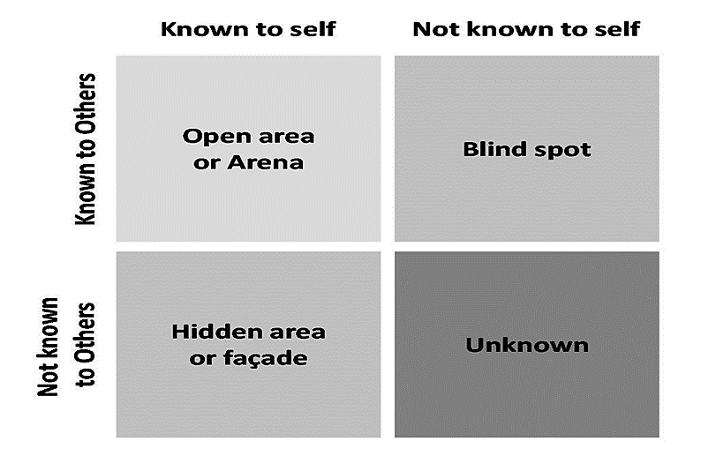
In certain aspects further training and development is achieved by using the Johari Window method, this was formed in 1955 by American psychologist Joseph Luft and Harry Ingham (Self- awarness,2018). This enables the learner to develop their own self- awareness, it also allows the person to have an in-depth knowledge of others in a group (Self-awarness,2018). In most cases it is mostly used in situations that require group work and discussions to allow everyone to improve on aspects like communication and team development, also relationships between other groups of people (Self- awarness,2018). Subsequently a social worker uses the Johari windows technique for team working to enable the practitioner to discuss the service users further care and treatment, in some situations other organisations may collaborate with the social workers regarding the client; such as GPS or Schools to express professional views on the care and support for the service user (Martin, Charlesworth and Henderson, 2010). The Johari Windows is sectioned in four parts, the model is outlined in Figure 1.1 as it explains what the individual knows about them self and what other people know about them (Communication Thoery,2018). Regarding my own learning I was not aware of my strong ability to have good IT skills as one group member identified that this is my strength, as they informed me that I have a broad understanding of computer literacy (Morgan,2017).

Figure 1.1 Johari Window

Also relating towards the SWOT analysis is the process of a skills audit, this is a procedure that a learner does to acknowledge what skills they already have, and to develop and identify the essential keys skills that is needed in a job role (The University of Edingburgh,2018). In other words, it helps the individual plan and develop the skills that needs to be improved for a future occupation (The University of Edingburgh,2018). As outlined in figure 1.2, it explains the reflection process; this is looking at important skills that is needed to be developed in, a feedback; this benefits the learner to create self-awareness to compare themselves with other individuals, organisational; being able to handle the organisation by having leadership abilities implemented by the employers, lastly focusing on working it out by taking immediate action to ensure that the goal is achieved (Megginson and Whitaker, 2007)
In the same way as the SWOT analysis I investigated my own skills audit that will be crucial for the current academic course that I am undertaking, and the potential abilities that I think is important for the future job. Refer to the appendices for the template of the skills audit that I completed (University of Edingburgh,2018).

Figure 1.2 Self-assessment – Skills Audit
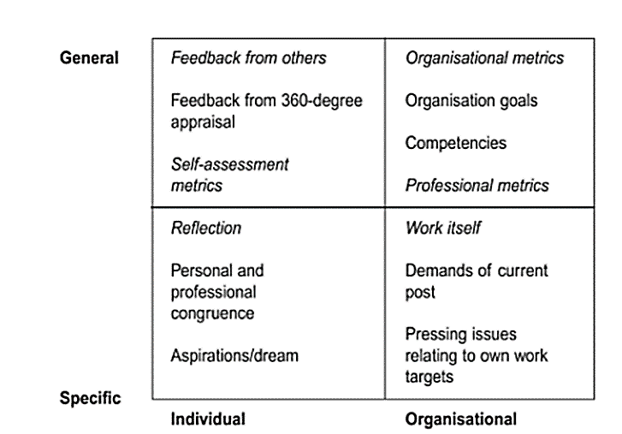

Furthermore, to self asses myself and to develop my learning style I investigated the SWOT Analysis to see what my strength and weaknesses were and to identify what opportunities and threat it possesses (Smartsheet,2018). I noticed that one of my strength is that I can communicate effectively with others without being afraid to express my own opinions. As I want to become a social worker communication is very important to create a professional relationship with the service users (Martin, Charlesworth, Henderson, 2010). I also further looked at my weaknesses and noticed that when a problem is given I struggle to solve the situation. Even social workers require effective problem-solving skills to find the solutions for the service users care and treatment (Martin, Charlesworth, Henderson, 2010). Essentially, the opportunities and threats were addressed by becoming more focused on finding strategies like creating mind maps to find other methods of solving the problem (Kent 2013). Refer to figure 1.3, the SWOT Analysis states what strength and weakness the researcher has converting these into opportunities and analysing the threats identified. (Smartsheet,2018)

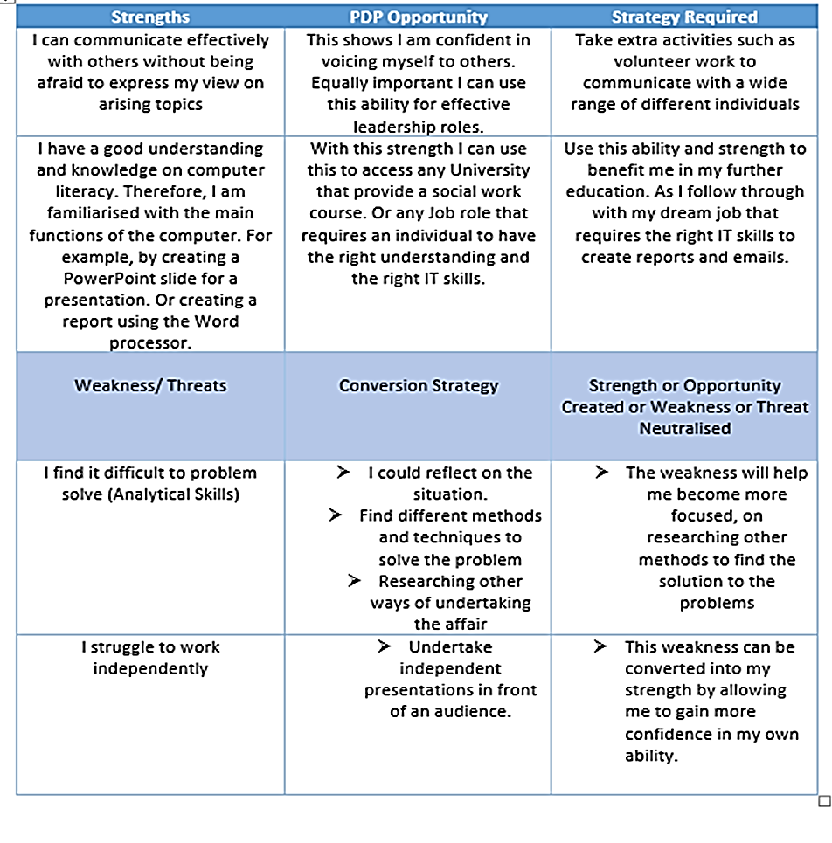
Figure 1.3 SWOT Analysis

Go MAD model- Linked with SMART & Maslow Hierarchy
In the same way another framework that enables the individual to develop their own understanding and knowledge, is the Go MAD framework. The framework helps the person to define their own goals, also allows the individual to think their processes through it for it to become a success (Go MAD,2018). Andy Gilbert stated that the framework he created helps to achieve whatever it is the individual is perusing in life to accelerate their progress (Go MAD,2018). In addition to this the Go MAD structure helps with businesses to improve their business performance and flexibility to develop other essential skills, or to gain basic teaching skills (Daper,2018). If an individual has a goal or an ambition that needs to be fulfilled the person needs to be SMART with their goals this is also linked to the Go MAD structure (Go MAD,2018). Being SMART means the individual needs to be Specific, ensuring that its Measurable, that its Achievable, also that it is Realistic enough to pursue, and making sure that it is Time bounded (Gilbert,2005). Further refer to the appendices to view my personal SMART goal objective. The Go MAD structure is formed up of seven processes each process is split into levels or parts (Go MAD,2018). The first one covering Personal Planning, the second one focusing more on Maintaining the Motivation and the last one concentrating on Making a Difference (Gilbert,2005).
The Personal Planning is the main foundation to build and create the goal that the individual wants. By focusing on the reason why they want this, what the goal is exactly, and how the individual will plan this through (Gilbert,2005). The framework also covers the individuals self-belief; to believe that the person can achieve the goal, personal responsibility; knowing what the individual needs to concentrate on, once this has been maintained then involving others is the next step. Once all procedure has been completed and followed through the last step will be taking an action and measuring the results (Gilbert,2005)
In all aspects the Go MAD framework can only function effectively when the individual is motivated enough to proceed on with their own learning and development, this is further linked in with Abraham Maslow hierarchy of needs in 1943 (McLeod, 2017). As observed by McLeod (2017), it states that Maslow hierarchy of needs begins with looking at the basic requirements first. This can be simple things that humans cannot live without such as access to food or shelter as this is the foundation of motivating a person to engage in further learning and development (Morgan,2017). As shown in figure 1.4, the theory is split into 5 sections the basic needs aspect needs to be met first for the other parts to be successful (Professional academy, 2018). As a social worker each parts of the Maslow’s needs must be considered at each stage of the service users physical requirements, to improve the individuals health, security (Art of Libraries, 2018). Essentially the Maslow’s needs are important for my own learning and development as attending an academic course gives me the sense of achievement to increase the learning skills I already and have and to develop the skills I do not possess (Burleson and Thoron,2017).

Figure 1.4 Maslow Hierarchy of Needs
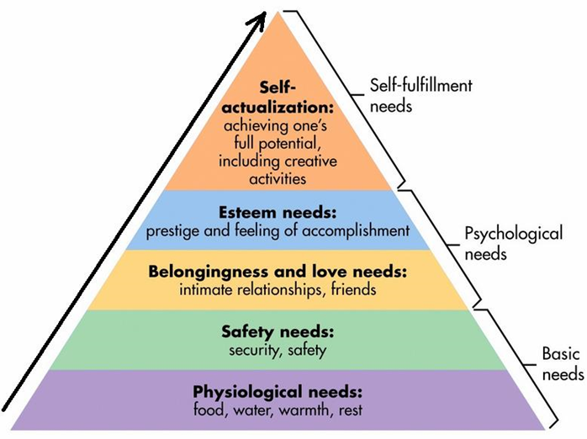

Furthermore, I investigated the framework to focus on my own personal goals that I would like to further proceed on in the future. This benefited me as it helped me acknowledge what I need to do in the process to excel in myself, and to acknowledge what actions and protocols that I must do to achieve this (Go MAD,2018). The framework is outlined in figure 1.5 explaining each strategy I will undergo to further improve in myself for future social working employability.

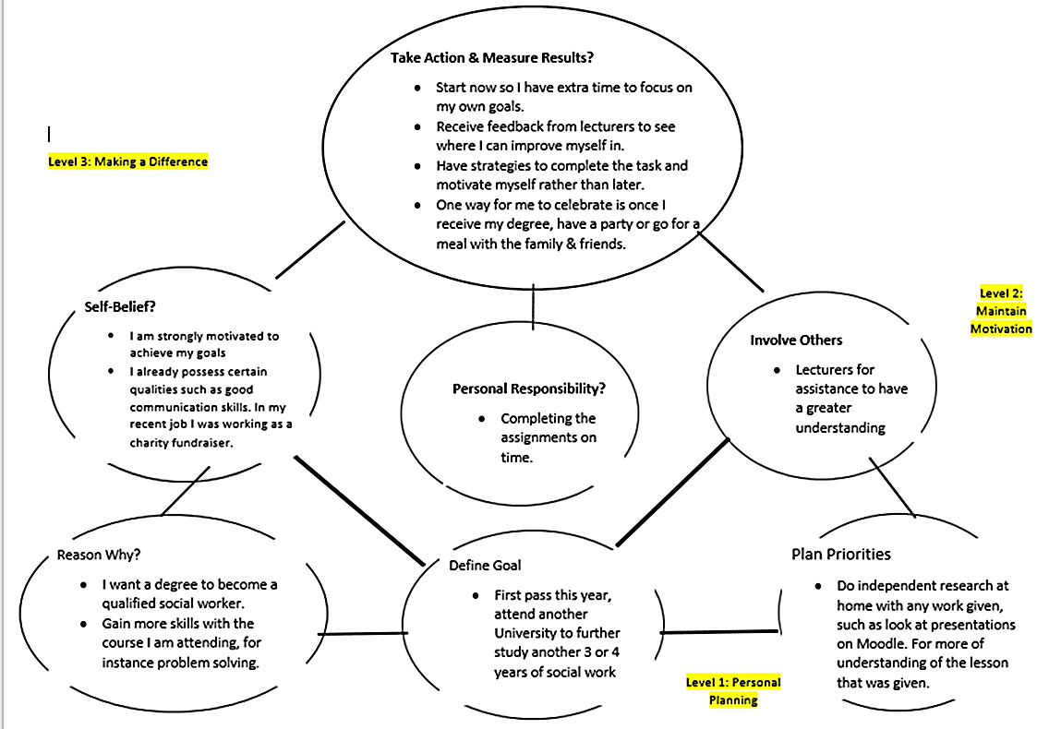
Figure 1. 5 Go MAD framework

Barriers and Improvements Considering the Personal Development Plan
In some cases, there are barriers that effects and even prevents the person from developing their own learning preferences. Certain emotional barriers can be a factor such as having less confidence and self-belief in themselves, it may even be because the individual does not possess enough skills that is required for their learning (Union Learn,2018). Furthermore, the individual needs to identify and improve the weaknesses to overcome the barriers that effect their learning and development. On the other hand, leadership skills can be struggle for me as I do not feel confident to lead a group or a team. As a social worker usually, the individual falls in a leadership role this requires them to organise or manage a community organisation or giving advice or guidance to an advocacy team (Rutgers,2018). To improve my learning, I will have to follow the Honey and Mumford learning style (Mogran,2017), as I have identified I am a reflector this suggests that I work much more effectively with others in group discussions and observing activities (Rosewell,2005).

Support Mechanisms
Regarding my weaknesses in leadership skills there is extra support available for me to access. Certain lecturers will assist me in my development in learning by constantly placing me in situations that require group work or discussions. Once my weaknesses have been mastered with the support of my lecturers I can then follow on with receiving a degree to prepare myself for different aspects of leadership roles in social work (Rutgers,2018).
Equally important, a Personal Development Plan (PDP) was created to benefit the individual to have self-awareness, identifying the skills that the person has and the skills that is required, it also helps the learner to acknowledge what skills they will need for their ideal career role or study (Bath,2018). Also, shown in figure 1.6 I created a table for my own Personal Development Plan to assist me on planning my own career development and educational (Bath,2018). The weakness that I have such as analytical skills stated will become my opportunity once I have taken actions towards it, as social workers use a lot of analytical skills in the occupation (Martin, Charlesworth and Henderson, 2010).

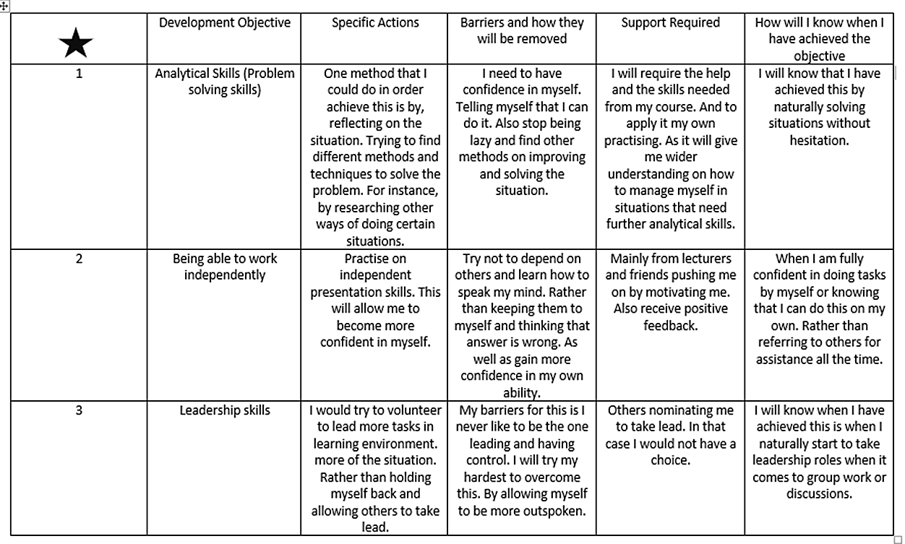
Figure 1.6 Personal Development Plan (PDP)

Monitor Development
In addition, Harris (2014) observed that once the learner has developed their own learning it is essential that the individual keeps track and progress of the learning methods that they have learnt. Harris (2014) further suggests that keeping track of the individuals learning helps with understanding such as knowing what they have learnt about the topic, also focusing on other materials that need to be learnt, and how much knowledge you already have regarding the subject. To monitor and reflect on my own learning I will follow the Gibbs cycle of reflection that was formed in 1988 for learners to think thoroughly regarding the experiences that the individual has encountered (Brookes,2018). Overall the Gibbs reflective cycle is beneficial for social workers as it helps with evaluating the positive aspects and developments that can be achieved later if the same situation arises again, allowing the practitioner to know what to expect by reflecting (Brookes,2018). This is shown in figure 1.7, to demonstrate the actions that are taken to reflect upon experiences (Brookes,2018). Also, creating a learning log will benefit me to help keep track of all the experiences that I have encountered to look back at points and know when I should act, by ensuring I stay specific to my goals (Project Learnet,2018). In some cases, social workers reflect even more when having to help another student on work placement, by ensuring that the personal skills they possess aids them in their own learning and experiences (Hardy,2017). Constantly social workers are selling themselves in other words personally branding themselves creating a reputation for themselves towards the clients, showing that they are considerate and caring about service user’s needs (Lake,2018).

Figure 1.7- The Reflective Cycle (Gibbs 1998)
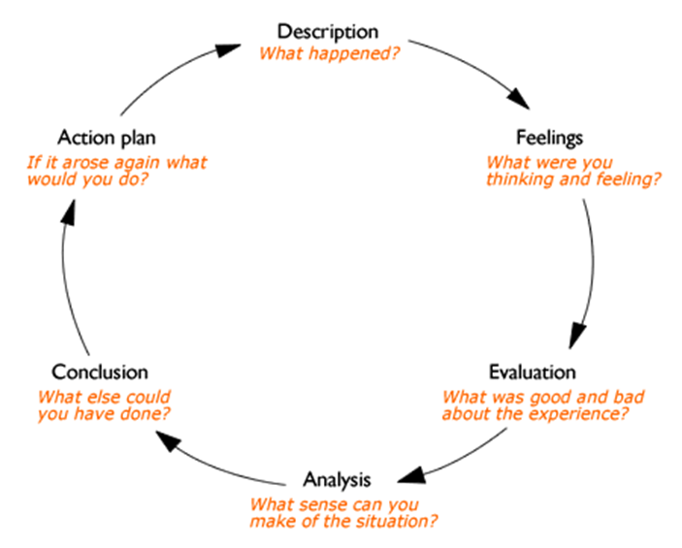

Part 2 – Recruiting and Selecting for a Social Worker (third person)

In addition to the self- awareness the report will then further investigate the recruitment process of a social worker, explaining the job description, personnel specification, the application process; such as the interview stages and what is expected to happen during this. As observed by Sherzay (2015), it claims that having the right recruitment process is important to have the right, suitable candidate for the business to excel.

Job Description
As an organisation in a social working sector the candidate must be able to have the right ability to support individuals and families that are going through traumatic times, making sure the individual is safeguarded by following the rules and regulations implemented (AGCAS editors, 2017). The right candidate will have responsibilities working under different types of groups that include elderly service users, young individuals, even people who have mental health issues, mostly people who are suffering from a lot of hardship in life that require the extra support (AGCAS, editors,2017). The requirements needed for a suitable social worker is mainly skills such as presenting effective empathy skills; the motivation and drive to improve the wellbeing of the service users, effective analytical skills; to find the solutions to problems whilst being under pressure, also to have good computer literacy is needed as the job requires to be in an office, occasionally visiting the clients. (Martin, Charlesworth and Henderson,2010)

Personal Specification
Moreover, the candidate will also need to have the right skills and knowledge of what to expect and the experience by having a suitable degree in social work, the regulations for social care in wales will need to be approved to further proceed on with the application process (Healthcareers,2018). The individual must demonstrate experience in previous social caring settings by the means of work experience such as placements in an elderly home, or youth centres (AGCAS editiors,2017). Essential skills such as effective communication skills, IT skills, the right effective listening skills and problem-solving abilities is needed for the right candidate (Healthcareers,2018).

Application Form
In most cases the organisation will require the candidate to present a curriculum vitae to present a personal profile, previous qualification, also within the curriculum vitae the organisation requires that the individual shows recent or previous job roles, it is also desirable to present transferable skills that individual may have that is suited to the social working occupation; such as good communication skills, IT skills, the ability to negotiate and handle caseloads, and an effective analytical ability (Martin, Charlesworth and Henderson,2010). The organisation would prefer if the candidate includes additional training and skills that allows the person to stand out and ensures that the specific curriculum vitae is different; such as additional training within a company in a health and social sector, or previous voluntary work in a youth club (Neugebauer and Evans- Brain,2017).

Interview stages

Recruitment Process
In this section of the report it will further discuss on the interview process explaining what the candidate will the need to do and what the organisation expects from the candidate. Having an interview is the crucial part of the application process it allows the employee to get to know the candidate a bit more and allows them to see how much the individual wants the job; by asking questions and investigating if they have inside knowledge of what the organisation expects from them (Morgan,2017).

Preparing for Interview
Furthermore, as observed by Aurora Horwood (2017), it is claimed that candidates applying for the social working role is expected to have some sort of understanding of the regulated legislations that is enforced to safeguard service users and to ensure the job is done to the right legal standards. Certain legislations need to be considered by the candidate such as the care act 2014, the Children Act 1989/2004, Mental Capacity act 2005 (Ones top social,2018). The organisation may ask questions to the candidate regarding why you chose to become a social worker? Allowing the employer to understand the candidate interest for the job What type of experience do you possess that is relevant to this job? Or even describe a demanding situation that you were in, how did you solve it? (Sanctuary Social Care,2018). The candidate to be themselves as it gives a good first impression of the person, the friendly environment of the assessment centre will allow the individual to be more comfortable by engaging with others in group work and role plays (Aurora Horwood, 2017). In essence personal branding of the candidate is important for the interview stage as it shows the individual made extra effort for the interview, such as having appropriate smart clothing; ensuring the person is not looking scruffy, also carrying notes pads shows the individual is taking the position serious in the interview, in some situations its perfect to have interview questions prepared in them (Sanctuary Social Care,2018).

Conclusion
In conclusion the researcher identified that the person is a Kinesthetic learner by undertaking the VARK learning style questionnaire created by Fleming and Mills (VARK Learn,2018), that shows the individual prefers to experiment and experience the situation to have more of an understanding (VARK Learn,2018).
The learner also noticed that another learning style that helps to improve a person’s learning preferences is the use of Honey and Mumford learning style (Morgan,2017) that is closely linked to the Kolb’s theory (McLeod,2017). The researcher completed the questionnaire and identified that the individual is a Reflector, by looking back at what happened (Rosewell,2005) it is beneficial for the individual to work in group discussions and observe the activities (Mobbs,2018). As Cooper (2011) discussed being a social worker the practitioner must be able to control emotions and be able to reflect on the experiences to provide the right possible treatment and care for the service user.
The report further discussed the researcher learning preferences regarding the SWOT analysis (SWOT Analysis,2018), that was conducted by the individual completing a table that shown the individual strength is having effective communication skills, this is crucial for a social working role (Martin, Charlesworth and Henderosn,2010). Moreover, the researcher noticed that analytical skills such as problem solving is a skill that the individual struggles with, as a social worker the individual requires to solve problems effectively therefore the researcher will research other methods to develop the problem-solving skills (Martin, Charlesworth and Henderosn,2010). As this is linked with the Johari’s window model the researcher noticed that IT skills was a strength that the person did not know of, until another individual realised that this the researchers blind spot (Morgan,2017). Considering this the researcher also completed a Skills audit template to list the potential skills that is important for the future job and academic learning (University of Edingburgh,2018).
Also, the researcher completed a Go MAD framework to allow the individual to know what must be achieved for it be successful (Go MAD,2018). Ensuring that the goals stated are SMART (Gilbert,2005). It can only be achieved once the individual is motivated enough by following the Maslow Hierarchy of needs (McLeod,2017). In essences the Gibbs Cycle helped the researcher to reflect and monitor on the individuals own learning (Brookes,2018)
In the second section of the report the researcher identified that having a recruitment process is important as it allows the organisation to see if the candidate is suitable with the right skills for the occupation as a social worker (Sherzay,2015).

Recommendations

Problem Solving Skills
To improve the problem-solving skills (Morgan,2017):
• Researching other methods/ ways to solve the problem

Working Independently
Being able to work independently can be worked out by (Sherzay,2015):
• Gaining confidence in own ability

Leadership Skills
To develop and improve leadership skills ensure to (Martin, Charlesworth and Henderson,2018):
• Volunteer to take some control of the tasks more often

Reflecting/ Monitoring
Also, to reflect on learning and experience having a
• Learning Log, will help to keep tract and monitor the learning developments (Project Learnet,2018)

Bibliography

AGCAS Editors. (2017),’ Social Worker’, [Online]. Available: https://www.prospects.ac.uk/jobs-prfiles/social-worker [2018, March,24]

Art Library. (2018), ‘Maslow’s Hierarchy Of Needs And Its Application In The Healthcare Industry’, [Online]. Available: www.artforlibraries.org/ [2018, March,22]

Aurora Horwood. (2017), ‘Preparing For The Assessment Centre’, [Online]. Available: https://thefrontline.org.uk/2017/09/26/preparing-for-the-assessment-centre/ [2018, March,25]

Bath University. (2018), ‘Personal Development Planning (PDP),’ [Online]. Available: www.bath.ac.uk/asc/study-skills/pesonal-devlopment-planning.html. [2018, March, 19]

Burleson, S, E and Thoron, A, C. (2017), ‘Maslow’s Hierarchy Of Needs And Its Relation To Learning And Achievement’, [Online]. Available: https://edis.ifas.ufl.edu/pdffiles/WC/WC15900.pdf. [2018, March,22]

CLIN, D, R, J, (2013). ‘Learning The Learning Styles and Preferred Teaching- Learning Strategies of First Year Medical Students’ [Online]. Available: https://www.ncbi.nlm.gov/pmc/articles/PMC3708205/ [2018, March,11]

Cooper, J. (2011). ‘The Need For More Critically Reflective Social Work’, [Online]. Available: www.communitycare.co.uk. [2018, March, 21]

Communication Theory. (2018), ‘The Johari Window Model’, [Online]. Available: https://www.communicationtheory.org/the-johari-window-model/ [2018, March,21]

Daper, R. (2018), ‘Go MAD About Coaching’, [Online]. Available: https://www.gomadthinking.com/shop/books/go-mad-about-coaching [2018, March,15]

Gilbert, A. (2005), ‘Go MAD The Act Of Making A Difference’, Leicestershire: Biddle Ltd

Go Mad. (2018), ‘What If You Could Improve Performance In Every Area Of Your Organisation’, [Online]. Available: https://www.gomadthinking.com [2018, March,17]

Hardy, R. (2017), ‘Top Tips On Reflective Writing For Social Work Students’, [Online]. Available: Available: www.communicatycare.co.uk/2017/11/20/top-tips-reflective-writing-social-work-students/. [2018, March, 19]
Harris, R. (2014), ‘Learning Strategy 4: Self-Monitoring’, [Online]. Available: https://www.virtualsalt.com/learn4.html. [2018, March,19]

Health Careers. (2018), ‘Social Worker’, [Online], Available: https://www.healthcareers.nhs.uk [2018, March,25]

Kent. (2013), ‘Problem Solving and Analytical Skills’, [Online]. Available: www.kent.ac.uk, [2018, March, 17]

Lake, L. (2018), ‘Personal Branding And What You Need To Know About It’, [Online]. Available: https://www.thebalance.com/what-is-personnal-branding-4056073. [2018, March,22]

Learning Style. (2018), ‘Overview Of The Seven Perceptual Styles’, [Online]. Available: https://www.learningstyles.org/styles/Kinesthetic.htmls. [2018, March,28]

Martin, V. and Charlesworth, J. and Henderson, E. (2010), Managing In Health and Social Care, (2nd Ed), Oxon: Routledge.

McLeod, S, A. (2017). ‘Kolb- Learning Styles, [Online]. Available: https://www.simplypsychology.org/learning-kolb.html [2018, March, 21]

McLeod, S. (2017), ‘Maslow’s Hierarchy Of Needs, [Online]. Available: https://www.simplypsychology.org/maslows.html. [2018, March,22]
Megginson, D and Whitaker, V. (2007), ‘Continuing Professional Development’, [Online], Available: https://books.google.co.uk [2018, March, 21]

Mobbs, R. (2018), ‘Honey and Mumford’, [Online]. Available: http://www2.le.ac.uk/departments/doctoralcollege/training/eresources/teaching/theories/harry-mumford [2018,March,13]

Morgan, P. (2017), ‘The Business Students Guide To Study And Employability’, London: SAGE

Morrison, M. (2016), ‘SWOT Analysis (SWOT MATRIX) Made Simple’. [Online]. Available: http://rapidbi.com/swotanalysis/#Definition [2018, March, 15]

Neugebeur and Evans Brian. (2017), ‘Certificate In Higher Education: Skills For The Workplace Student Yearbook, London: SAGE

One Top Social. (2018), ‘Social Work Interview Question: What You Need To Know’, [Online]. Available: https://www.onetopsocial.co.uk/social-work-interview-questions-need-to-know/ [2018, March,25]

Oxford Brookes University. (2018), ‘Reflective Writing: About Gibbs Reflective Cycle’, [Online]. Available: https://www.brookes.ac.uk/students/upgrade/study-skills/reflective-writing-gibbs [2018, March,22]

Project Learnent. (2018), ‘What Is Self-Monitoring?’, [Online]. Available: http://www.projectlearnet.org/tutorials/self-moiniting.html .[2018, March, 19]

ResearchGate. (2018), ‘Learning Styles Questionnaire’, [Online]. Available: http://www.researchgate.net/file.psotfilleLoadeer.html [2018, March, 13]

Rosewell, J. (2005), ‘Learning Styles’, [Online]. Available: http://www.open.edu/openlearn/ocus/pluginfile.php/629607/mod-resource/content/1/t175_4_3.pdf [2018,March,13]

Rutgers Online. (2018), ‘Three Key Leadership Skills Emerging in The Social Work Sector’, [Online]. Available: https://online.rutgers.edu/resoruces/articles. [2018, March,19]

Sanctuary Social. (2018), ‘Prepare For Your Social Work Job Interview’, [Online]. Available: https://www.sanctuarysocialcare.com/prepare-for-your-social-work-job-interview#. [2018, March,25]
Sherzay, Z. (2015), ‘The Importance Of A Strong Recruitment Process’, [Online]. Available: www.lucaspsg.ca/the-importance-of-a-strong-recruitment-process/. [2018, March,24]

Smartsheet. (2018), ’14 Free SWOT Analysis Templates’. [Online]. Available: http://www.smartsheet.com/14-free-swot-analysis-templates [2018, March, 15]

SWOT Analysis, (2018), ‘SWOT Analysis’, [Online]. Available: http://www.marketingteacher.com/subt-analysis/ [2018, March, 15]

The University Of Edinburgh. (2018), ‘Audit Your Skills’, [Online]. Available: https://www.ed.ac.ul/insititue.academic-devlopmenr/research-roles/research-only-staff/career-mangement/skills-audit, [2018, March, 21]

Union Learn. (2018), ‘Common Barriers To Learning’, [Online]. Available: https://www.unionlearn.org.uk/common.barriers-learning [2018, March,19]

VARK Learn. (2018), ‘The VARK Modalities’, [Online]. Available: https://vark-learn.com/introduction-to-vark/the-vark-modalties/ [2018, March,12]

VARK Learn. (2018), ‘The VARK Questionnaire How Do I Learn Best’, [Online]. Available: http://vark-learn.com/the-vark-questionnaire/ [2018, March,12]
Watts, T. (2003), ‘Why Career Development Matters’, [Online]. Available: www.careersengland.org.uk/documents/public/why-career-devlopment-matters.pdf. [2018, March,26]

Appendices

VARK Learning Style Questionnaire Page 1
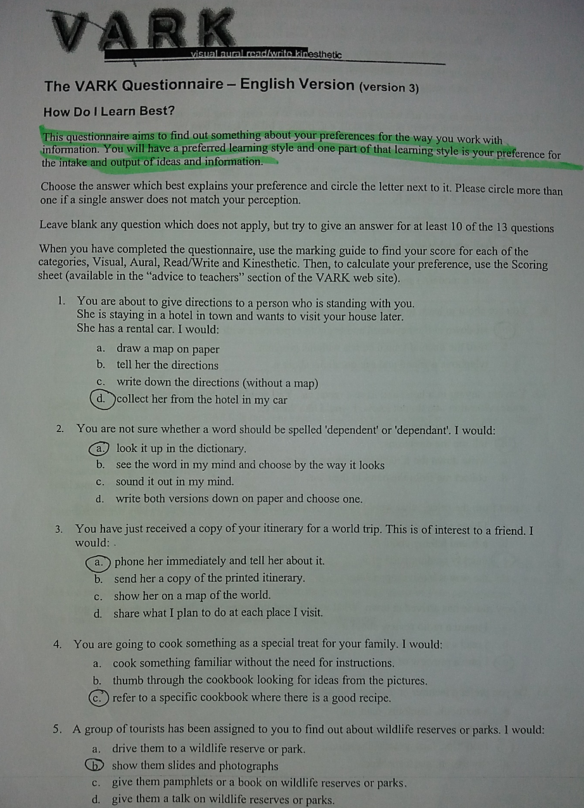

VARK Learning Style Questionnaire Page 2
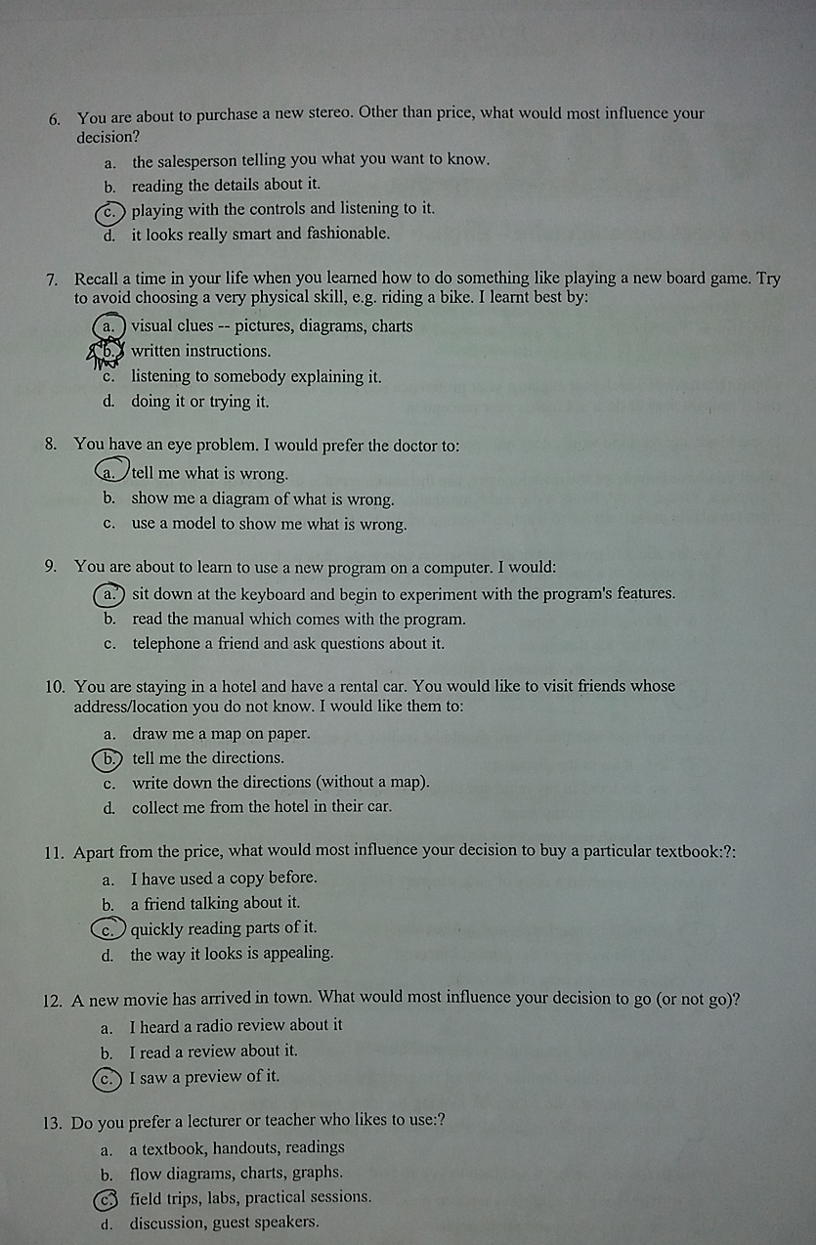

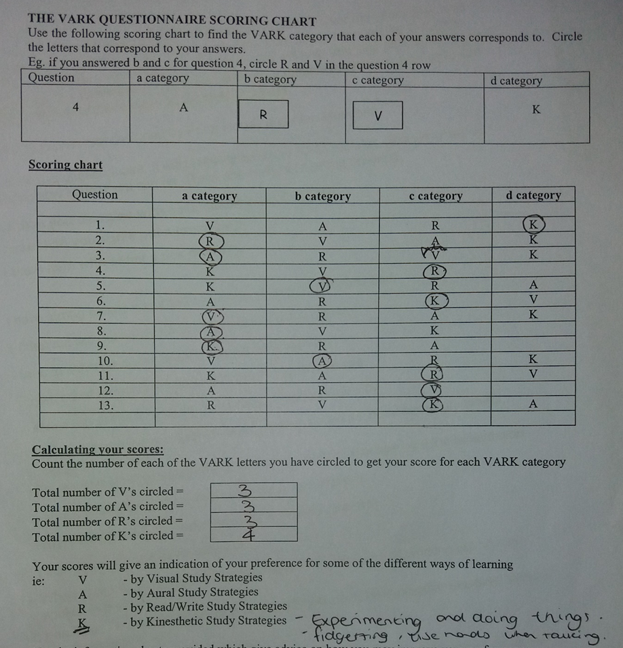
VARK Learning Style Questionnaire Page 3

Peter Honey and Alan Mumford Learning Style Questionnaire Page 1
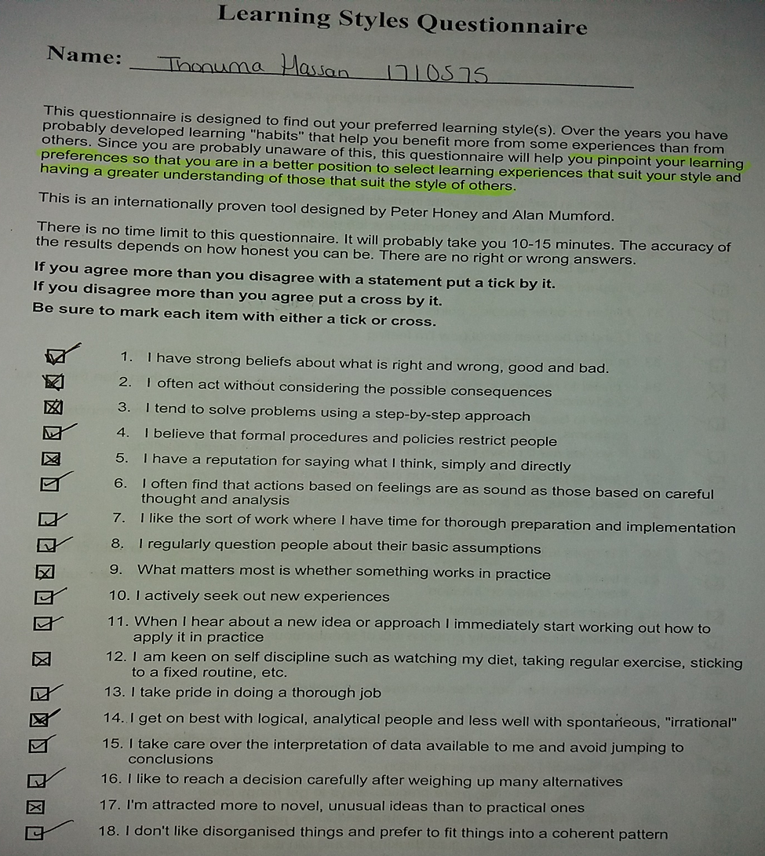

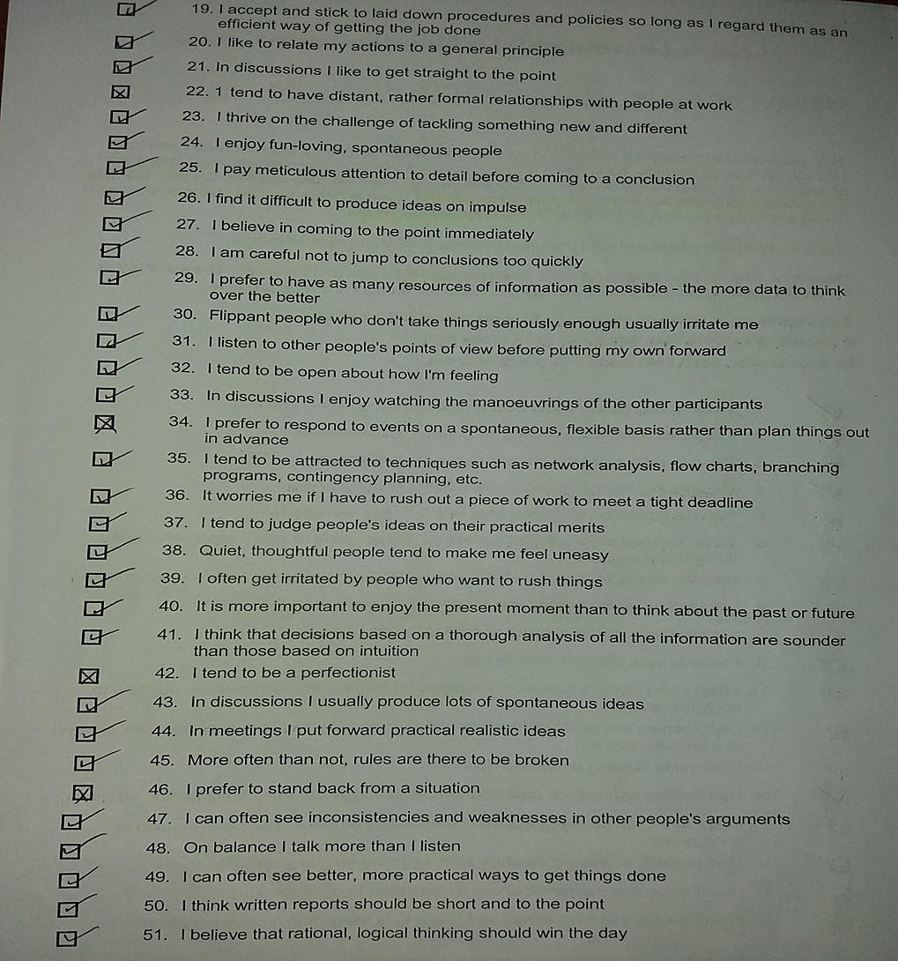
Peter Honey and Alan Mumford Learning Style Questionnaire Page 2

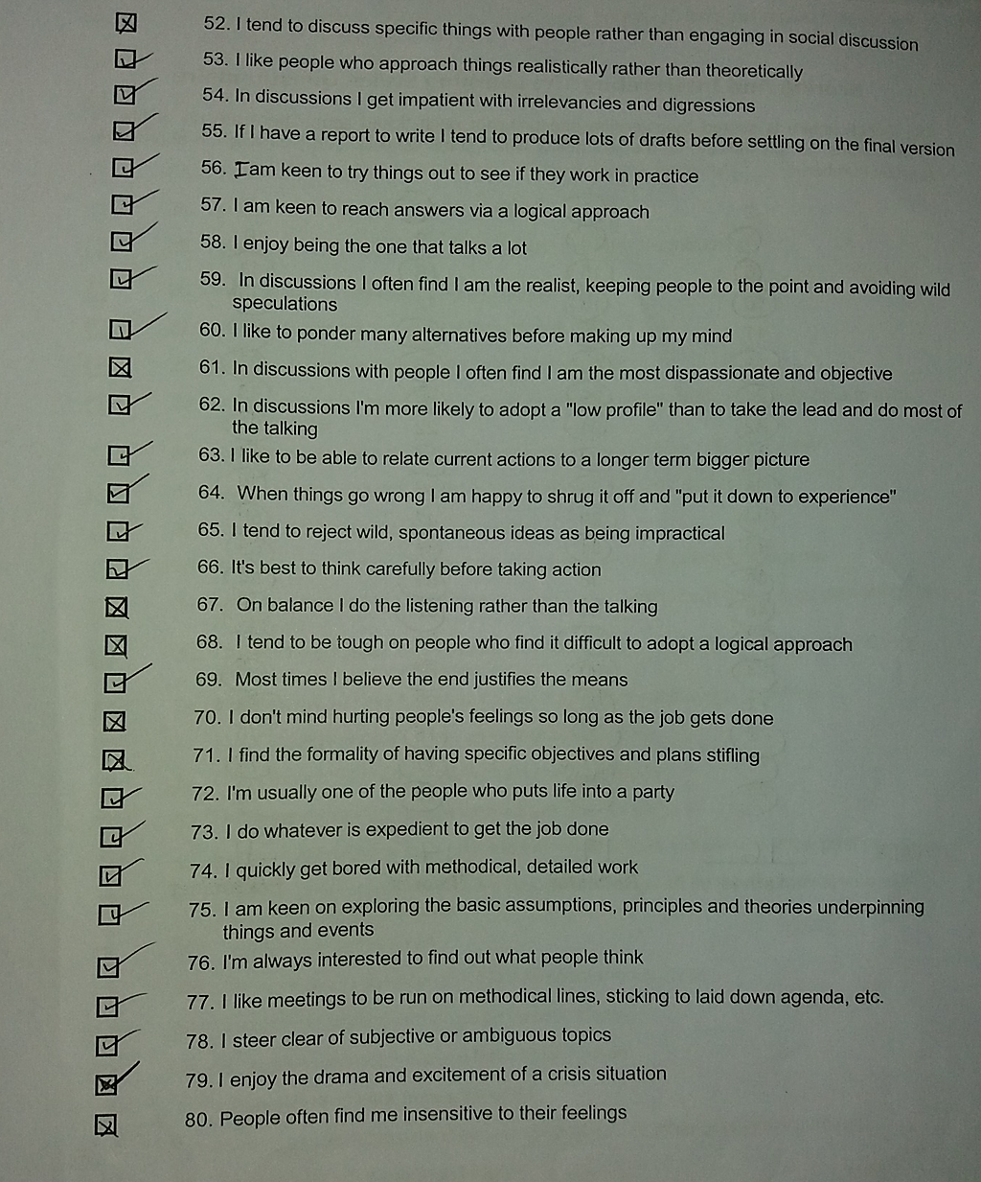
Peter Honey and Alan Mumford Learning Style Questionnaire Page 3

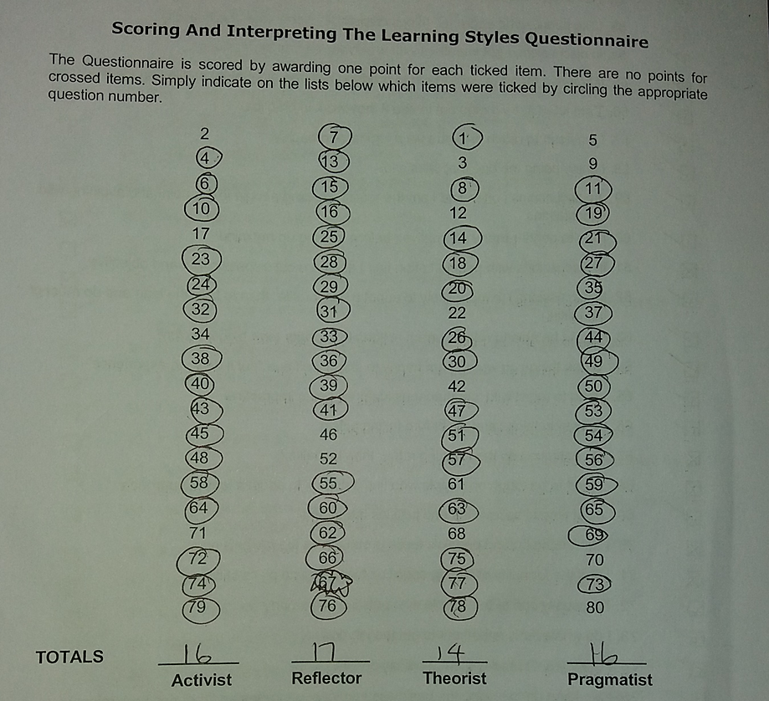
Peter Honey and Alan Mumford Learning Style Questionnaire Page 4

Kolb Learning Style
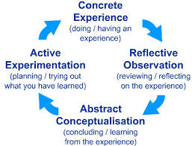
The Kolb theory is an Experimental Learning Cycle that highlights the importance of each type of learning styles. It is made up of 4 sections one being the Concrete Experience, the other Observation and Reflection on the Experience, and Theorising and Development of the ideas and lastly the Testing of the Concepts (Rosewell,2005). Underneath is the Kolb’s learning cycle discussing what each point covers.

Skills Audit Template
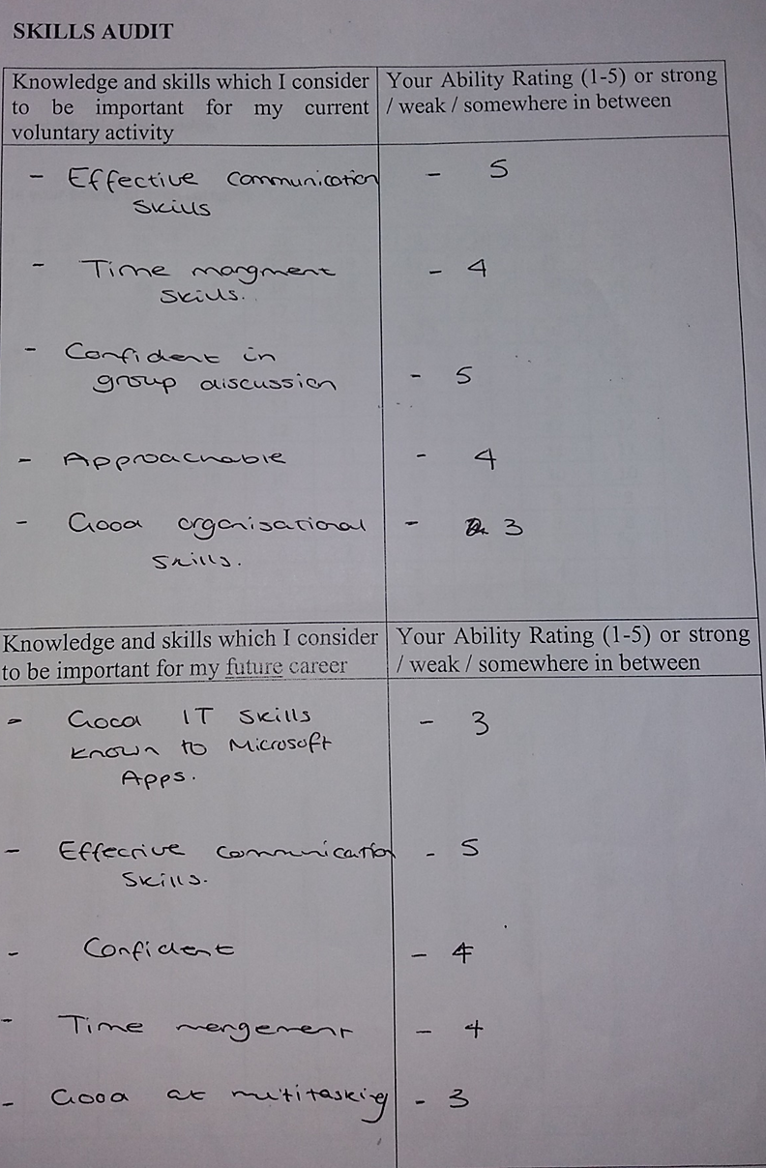

SMART Goal


