“Beauty is in the eye of the beholder”– a phrase we may hear on a daily basis but something we never realise occurs subconsciously every time we study a piece of artwork in a gallery or gaze upon another person’s face. Without realising it, our brains immediately determine whether that something is physically beautiful, and if so, we seem to be naturally drawn to it. Maybe this is the reason why today’s society is so obsessed with the term ‘beauty’. From the clothes we wear and the photographs we take, everything needs to be visually appealing otherwise no one will buy it.
A specific idea of beauty has been forced upon us in multiple ways, most commonly through social media due to its easy access to the public. Nowadays, most would see images of women with flawless skin, long healthy hair, slim waist and an hourglass figure, all achieved through excess photo editing along with the false promise that this is now the ideal body type and any woman can look like this. With these images and ideas being constantly fed to girls from a very young age, we begin to believe that these unrealistic expectations are the definition of beauty and anything other than this is classed as unattractive. As human beings, we strive for ‘perfection’ and it has been proven that some will go to extraordinary lengths to achieve this, such as extensive makeup and plastic surgery.
Despite all of this, our society’s depiction of ideal beauty is just another example of a developing idea. Only a hundred years ago, the term ‘beauty’ was seen in a completely different way. For example, in Ancient Greece (c. 500 – 300 B.C) nudity was a common part of society; the first important nude sculpture of Aphrodite of Cnidus showed that beauty in Ancient Greece meant plump and full-figured bodies. It seemed that eras such as Victorian England and the Renaissance preferred curvier, chubbier bodies too. It wasn’t until the Roaring 1920’s did the ideal body type become a lot skinnier; with their short hair, small breasts and boyish figure, curves were not the desired look for the first time in history. During the 1990s, the 16 year old model Kate Moss redefined beauty with her pale, thin and withdrawn figure, it seemed that ‘sickly was the new sexy’.
It seems that beauty has been nothing but a case of ‘trial and error’, constantly striving for perfection in everything that we see. It is also apparent that the term ‘beauty’ is defined by each individual, depending on what influences they have been introduced to. For example, some men might like curvy, big-breasted figures while others may prefer a skinnier, more petite body. Women of Ancient Greece wanted the curvaceous body of their beloved Goddess Aphrodite, while in the 1990’s, sickly Kate Moss was the beginning of a ‘Heroin Chic’ era. Nowadays, the ideal body type seems to be getting harder and harder to achieve; Photoshop is creating the illusion of smooth, blemish-free skin and a flawless hourglass figure which seems to be all but impossible to achieve. In other words, beauty is becoming more and more unnatural.
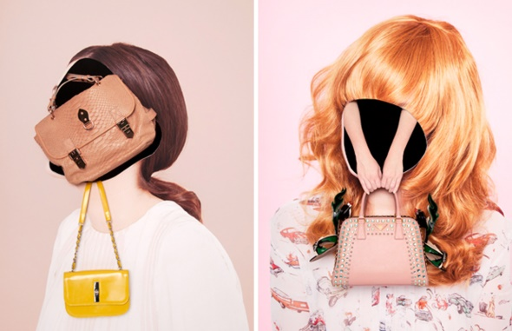
One artist that explores this through her work is called Ina Jang, who describes her approach to photography as, “playful, light-hearted and dreamy.” Her photomontage work consists of bright feminine colours, pictures clustered together in the form of shoes, handbags and makeup. This represents the obsessive consumerism that society tricks us into buying, with the hope that these objects will give us beauty, because they are beautiful themselves. Other projects such as ‘Utopia’ feature silhouetted female figures that embody passive, girlish stereotypes.
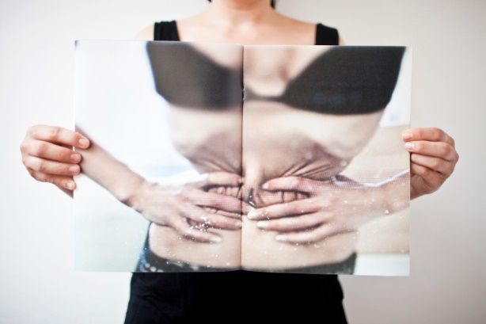
Many girls who are fed these stereotypical views on what beauty should look like are often negatively affected later on in life; mental health problems such as anorexia and body dysmorphia are unfortunately common. Laia Abril’s works tell intimate stories which raise uneasy and hidden realities related with sexuality, eating disorders and gender equality. Her work is very blunt, the content of her photos contain the opposite to what Ina Jang shows us; instead, her images contain rather gruesome and upsetting records of the effects of anorexia and other eating disorders, her colours harsh and bare.
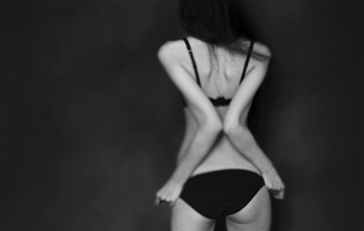
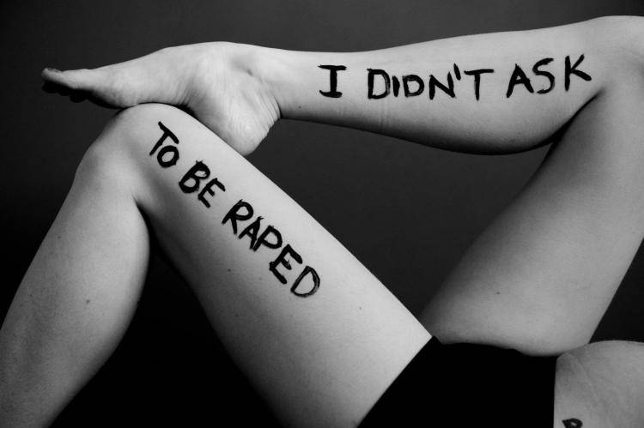
However, a third photographer known as Christine Benjamin, documents women of all ages who are still in recovery from mental illnesses and eating disorders. She is known as a Therapeutic Photographer, dealing with body image issues by photographing her subject in a way that enables them to see themselves differently than they have in the past. Her most widely known subjects are women who are recovering from breast cancer. Being a survivor herself, she understands the self-esteem issues they are currently going through and makes it her purpose to help others like herself. Photographing her subjects in black and white, they are incredibly powerful.
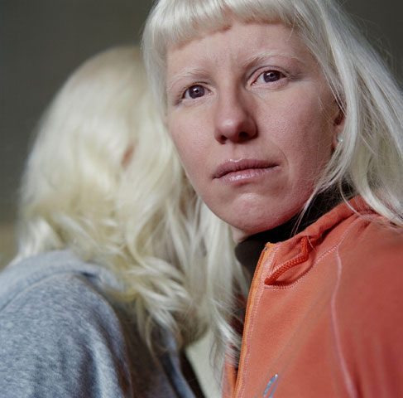
Liora K includes text into her images, putting an even stronger message across to her viewers; she makes it personal by painting the words onto her subject’s bodies and giving the problem a face, to let the viewer know that these issues within society are suffered by real women. Unlike Benjamin, these images directly address the problem, probably in an attempt to raise awareness amongst the general public.
And lastly, portrait photographer Paola Grenet, documents the minority groups of people that are usually labelled as outcasts due to their unusual appearance. For example, her portraits of albinos were taken to celebrate a ‘different kind of beauty’. Their pale and delicate looks reflect her idea of sublime beauty and wish to eliminate the stigma sometimes associated with the difference. Another project called ‘Barely Legal’ are a series of portraits of young women between the ages of 19 and 21; this is the age where most are eager to step outside the safety of their homes and take their first steps as an adult. But it is also a confusing and conflicting time of a young woman’s life, where they have difficulty being vulnerable despite their ‘professed desire for satisfying sex and relationships’.
For my expedition, I would use the Creative Bubble in Swansea City Centre as my work space; it is a simple square white room so all five photographers’ work would be visible as the viewer walks in. I want to see which artwork would attract the viewer first, proving that everyone sees beauty in different ways when different people are naturally attracted to different pieces of artwork. Firstly, I would hang four to five pieces of Ina Jang’s work up on one wall. However, the works would be vandalised either with spray paint or scratched with a sharp object, displaying my personal contempt of the stereotypical view of what beauty and femininity should look like. Four or five pieces will be hung up per artist in large A3, to ensure that size will not contribute to the attraction of the pieces; they are all equal. The artists’ names will also be written above their work.
Then finally, I would have a small table sitting in the centre of the room with a ballot box, a few pens and paper with one question written on it: which artwork were you attracted to first/the most? The viewer can vote and place inside the ballot box until I collect at the end of the day. I think it would be interesting, and somehow ironic, how the viewer would be judging on this expedition’s beauty nonetheless; because it is human nature. We search for beauty in everything we see, including the artwork which is criticising it.

http://www.inaphotography.com/
liora-k.format.com
www.laiaabril.com
https://www.theguardian.com/artanddesign/2016/jul/20/ive-seen-horrible-things-photographer-laia-abril-on-her-history-of-misogyny
paoladegrenet.com/
www.thesocialgeneration.com/illusion-physical-beauty/
https://thephilosophyforum.com/discussion/659/beauty-is-an-illusion
christinebenjamin.com/index.php/photography/gallery/olivia

