Sophie Morgan (1908091)
Material Science and Building Services
Lighting Layout and Sound Index Calculation

TASK A
A production area in a factory measures 60 metres x 24 metres x 8 metres in height.
The factory’s work benches are set at a height of 1m above the floor level.
The area’s reflectances are 0.3 for the ceiling and 0.5 for the walls.
The Lighting design specifies Fluorescent lamps in recessed louvre with DLOR of 50%.
(The actual size for the luminaires is 1200mm (1.2m) in length and 200mm (0.2m) wide.)
A Lighting Design Lumen (LDL) output of 18,000 lumens is required.
The illumination required for the factory area is 200 lux at the working plane.
Light Loss Factor = 0.75

1. Calculate;
- The Room Index
RI = (L X W) / Hm (L + W))
L = 60m W = 24m Hm = 8m -1m = 7m
RI = 60 x 24 / (7 (60 + 24))
RI = 1440 / 588
RI = 2.44897959
RI = 2.45

- The Utilisation Factor
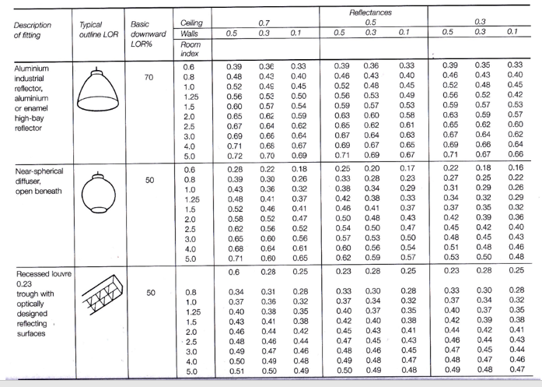
With the help of values RI = 2.45, DLOR (50%), ceiling reflectance (0.3) and wall reflectance (0.5), we can use the table to find out the UF.
UF = 0.46

- The Number of Lamps Required

N = E x A
F x UF x LLF
E = 200 lux A = 60 x 24 = 1440m² F = 18000 UF = 0.46 LLF = 0.75
N = 200 x 1440
18000 x 0.46 x 0.75
N = 288000
6210
N = 46.3768116
N = 47, rounded to 48 lamps for an even value
- A suitable layout (value for S) for the lamp fittings
Smax = 1.5 x Hm
The mounting height (Hm) = 7m
Smax = 1.5 x 7 = 10.5m

The maximum distance between lamps must be less than 10.5m.
As we require 47 lamps I would suggest rounding the value to 48 lamps and having 4 rows of 12 lamps. This would suggest a vertical spacing of 6m and a horizontal spacing of 5m between each lamp.
2. Plan layout of luminaire installation with points indicating the centre of fluorescent lamps in recessed louvre (600 x 600mm) on a scale of 1:250
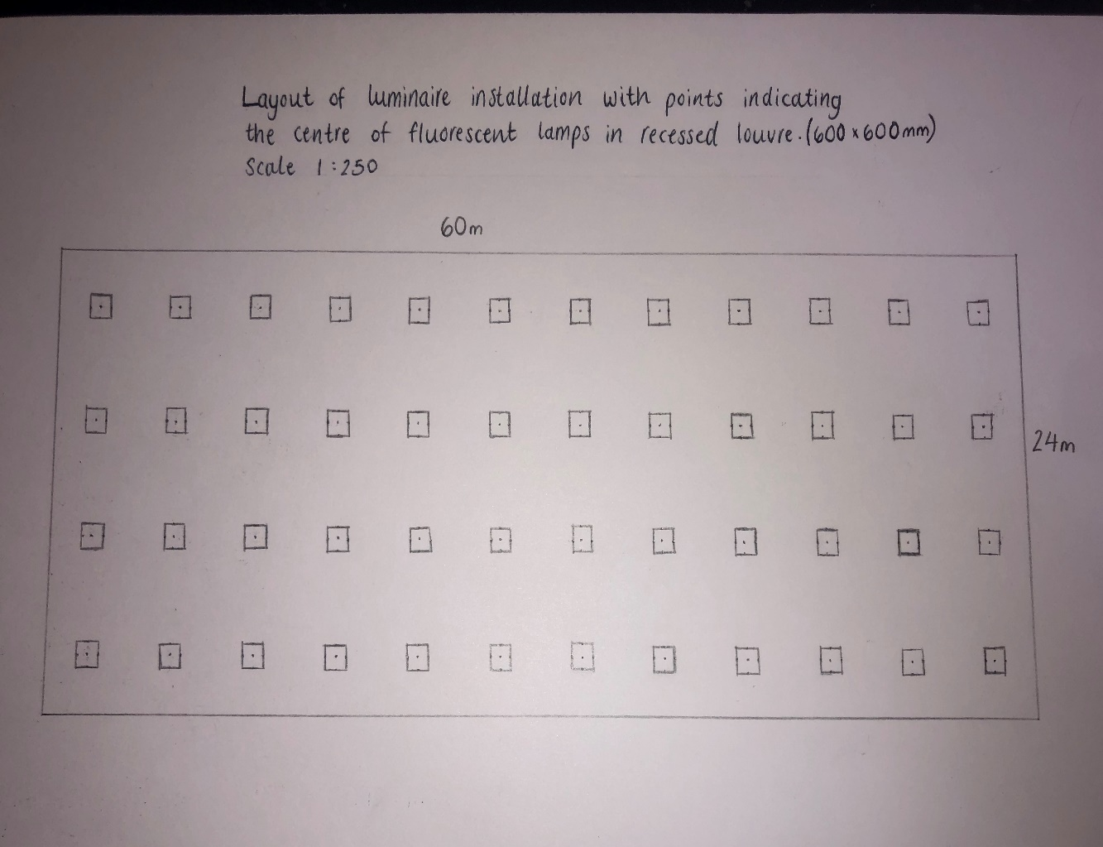

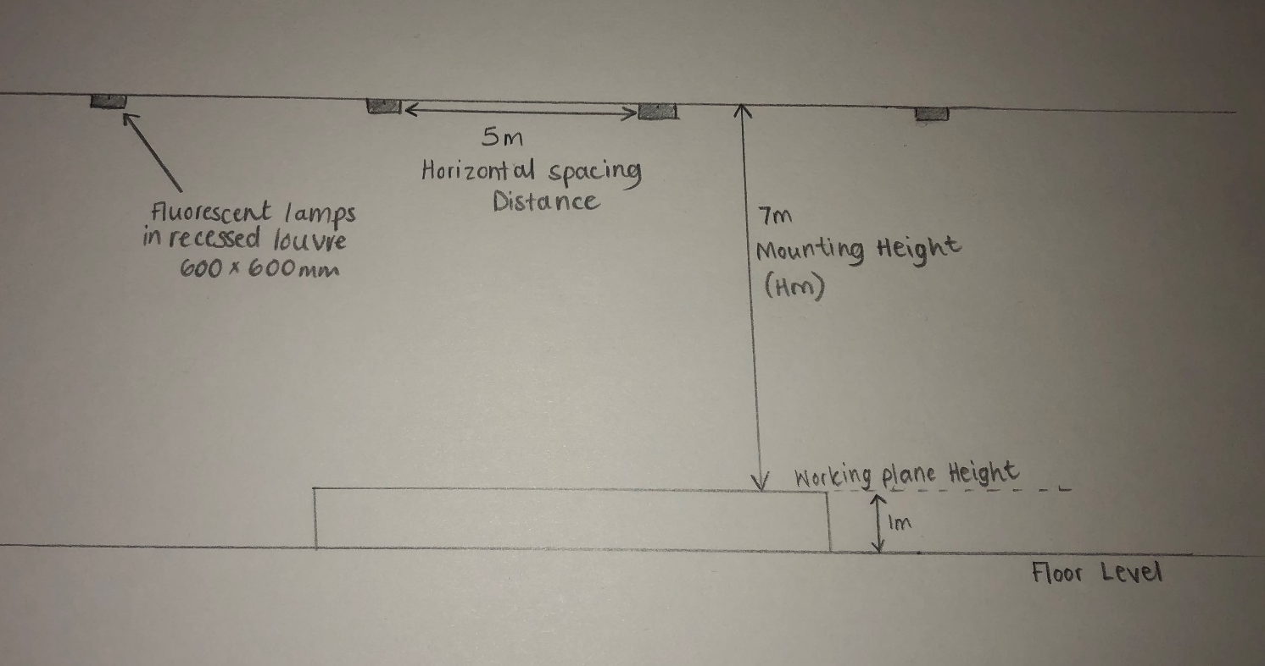
TASK B
1. A brick wall of area 20m2 contains a window of area 4m².
The values of sound reduction indexes are:
50dB for the brickwork and 10dB for the window.
Calculate the overall sound reduction index for the entire wall.

Brickwork T1 = ? A1 = 20-4 = 16 SRI = 50dB
Window T2 = ? A2 = 4 SRI = 10dB
Brickwork Window
SRI = 10 x ($\log{10 }$(1/T)) SRI = 10 x ($\log{10}$ (1/T))
50 = 10 x ($\log{10}$ (1/T1)) 10 = 10 x ($\log{10}$ (1/T2))
5 = $\log{10}$ x (1/T1) 1 = $\log{10}$ x (1/T2)
1/T1 = ${10}^{5}$ 1/T2 = ${10}^{1}$
T1 = ${10}^{-5}$ T2 = ${10}^{-1}$
T1 = 0.00001 T2 = 0.1

Tº = (T1 x A1) + (T2 x A2)
A1 + A2
Tº = (0.00001 x 16) + (0.1 x 4)
16 + 4
Tº = 0.40016
20
Tº = 0.020008

SRI = 10 x ($\log{10 }$(1/T))
SRI = 10 x ($\log{10}$ (1/0.020008)
SRI = 10 x ($\log{10}$ (49.980008)
SRI = 10 x 1.698796321
SRI for entire wall = 16.99dB

2. Implications of frequency and wavelength in internal sound management, partition wall construction technique and insulation choice.

Sound management within a building is a crucial factor in providing comfort for its occupants and a need to fulfil its duty. The frequency of a sound wave needs to be controlled so that the pitch is not too high for the human ear and doesn’t provide discomfort. Sound transmission is controlled by providing insulation and materials that alter the sound wave either by reducing or amplifying the pitch, depending on the circumstance needed.
Increasing the wall mass is one option to reduce sound transmissions. As the wall is thicker and therefore bares more weight it makes it harder for the sound wave to vibrate through the material, therefore reducing the energy it has (Gypsum Association , 2020). Also, by increasing the space between each stud we could increase the sound transmission capacity of the room. If the studs are arranged in a staggered manner it will help reduce the intensity of the sound and increase the absorption (Arjun, 2020). Using steel studs instead of wooden is considered a better option as steel studs are more rigid making harder for the sound waves to vibrate through them (Gypsum Association , 2020). Sound vibrations are often found to flank through little gaps or cracks within buildings, therefore these airborne sounds need to be blocked sufficiently by sealing off all gaps around walls, windows and doors using acoustic sealant or gasket material (InspectAPedia, 2020).
The use of partition walls within in a building significantly increases its Sound Transmission Class (STC) as it breaks up the path of the wave, reduces its energy then reemits it. To achieve a significantly higher STC rating requires adding a resilient channel to one side of a wall or decoupling the two sides of a wall with double framing. As there is no rigid connection between the two sides of the wall the sound transmission will be significantly reduced. By decoupling and increasing the mass, such as doubling the drywall layers, we will be able to help cut the transmission of low frequency sounds as well. For special situations such as music rooms, the cavity should be increased and fiberglass batts or other absorbing materials should be added to increase sound absorption (InspectAPedia, 2020).
The insulation choice of each building will be different depending on the buildings use and whether it needs the sound to be amplified or reduced. Concrete walls are more insulating than wooden walls as they have a bigger mass and so they would be better at reducing the sound transmission. Heavy concrete floors or floating floors are recommended to reduce the heavy noise vibration. Furthermore, having a carpet with a thick underlay will help absorb sound and reduce the noise of footsteps (Arjun, 2020). Isolation blankets should be placed in the airspace arrangements between wall panels to enable sound attenuation. Fiberglass, polyester and wool are also good examples of bulk insulation as they are very absorbing materials and will diffuse the frequency of the sound waves (Level, 2017). Porous absorbers are useful for high frequency waves and they change the sound energy into heat energy. Porous absorbers may include carpets, acoustic tiles, mineral wool etc. Panel absorbers are efficient in low frequency waves. They absorb the energy of the wave, converting them into mechanical vibrations in the panel which causes them to lose their energy. Panel absorbers include wood, plastic and other rigid materials.

References
(2017, August 29). Retrieved from Level: www.level.org.nz/passive-design/controlling-noise/controlling-noise-through-design-and-layout/noise-control-in-interior-partitions/
(2020, March 28). Retrieved from Gypsum Association : https://gypsum.org/the-basics-of-sound-control/
(2020, March 28). Retrieved from InspectAPedia: https://inspectapedia.com/BestPractices/Sound_Control_in_Buildings.php
Arjun, N. (2020, March 28). Retrieved from The Constructor : https://theconstrucotr.org/building/construction-techniques-in-acoustic-planning-of-a-building/14976

