

Emily-Kate Flewin – 1801668
Powertrain and control – M5X00404

Contents
Introduction 2
Task One - 3
Task Two - 7
Conclusion 10
Bibliography 11

Introduction

The aim of this report is to analyse the performance characteristics of a real engine and to show the simulation model of the engine in order to predict the thermodynamic characteristics of an engine cycle. The report will assess the limitations and the feasibility of the validated simulated model of the real engine.
There will be two sections to the report, the first section will determine the performance characteristics of the engine by simulation using variables such as the cylinder pressures, temperatures, polytropic indexes and work done by the engine at varying RPM’s. The section will explain the performance of the engine using plotted graphs, from there it will be decided if the engine is performing to the standard that is required of it.
The second and final section of the report will use mathematical tools for example the first principles of thermodynamics to develop a correct thermodynamic simulation of the engine. It will present the physical processes that are required to occur in an internal combustion engine. On top of this a comparison between the simulated data and data from an actual internal combustion engine will be made to determine any discrepancies and/or limitations in the engine.

Task One -
The first and basic graph that has been created is one that displays the position of the piston according to the crank angle. To find the piston position the following formula was used: $$Piston Position=\frac{a}{2}+\frac{l}{2}-\cos\left(∅\right)-\frac{l}{2}*cos(\sin^{-1}(\frac{a}{l}\sin\left(∅\right))$$
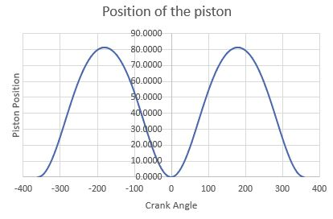
As the connecting rod and bearing travel in a circular motion it starts at -180 degrees and finishes at 180 in this simulation, as the connecting rod is being rotated about the crank mechanism the piston is lowering and rising. This is shown in the diagram below the piston reaches bottom dead center at -360, 0 and 360 degrees. This is a positive start as the data shows that it can be used to simulated the engine correctly and accurately.
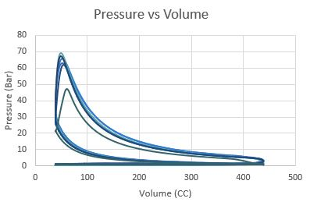
The next graph to be made is the pressures of the cylinders against the volume of the cylinders. As shown in the diagram there are multiple RPM’s that have been used, 6000, 5000, 4000, 3000, 2000 and 1000 this has been done to show the difference between the pressure against volume when the engine is working at different speeds. The graph shows the Otto cycle of the engine, known as the four-stroke cycle, each of the cylinders require four strokes of the piston, revolving the crankshaft twice to produce a power stroke (Heywood, 1988)
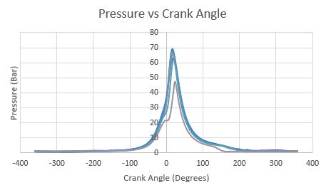
The graph displaying Pressure against crank angle as shown below, depicts the varying RPM’s reaching almost 70 Bar almost immediately after the crank angle reaches zero which is almost top dead center for the piston position. From the graph you can see that the grey line used to show 1000 RPM is much lower than that the rest of the RPM’s this is will later be used in the determination of the performance of the internal combustion engine.
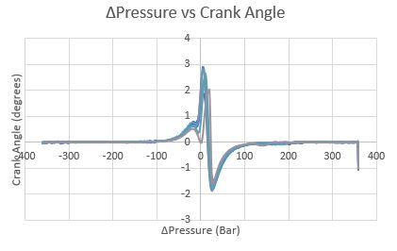
This graph is ΔPressure against the crank angle. It displays the change in pressure from one movement of the crank angle to another. As you can see the pressure almost reaches its highest point when the crank angle is at zero. This is because the piston is at the very top of the cylinder causing more pressure to be exerted into the chamber before lowering dramatically to below zero when the crank angle begins to reach 180 degrees. To find the change in pressure the first value for pressure is subtracted from the second value for pressure.
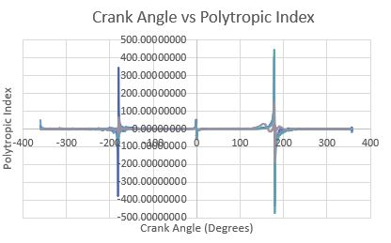
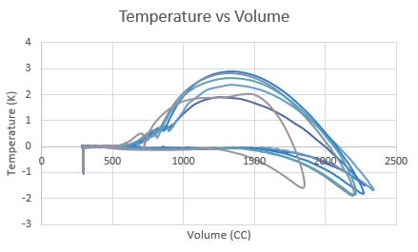
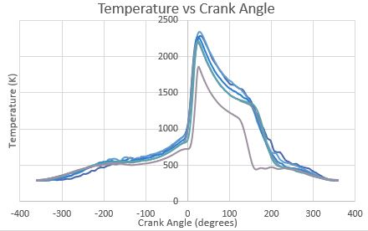
The above graph shows the temperature of the piston against the crank angle, as shown the temperature does not reach zero at any point therefore the engine is constantly running and there is heat within the cylinder. The grey line associated with the RPM speed 1000 is much lower than that of the rest of the RPM speeds.
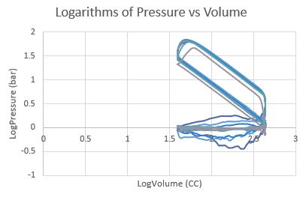
This graph depicts the logarithm of pressure against the logarithm of volume for the RPM speeds of 6000, 5000, 4000, 3000, 2000, and 1000. The lightest grey line is the RPM speed 1000, as shown it is very much lower than the rest of the RPM speeds which suggests that the engine may not be performing to the best ability as the 1000 RPM trace should be much closer to the rest of the RPM speeds. The logarithms of pressure and volume have been found by using the values for pressure and volume and simply putting them into logarithm(x).
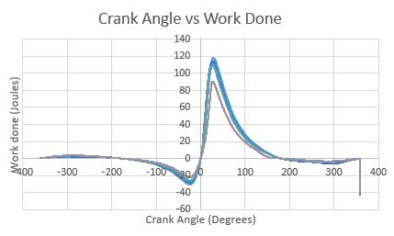
The graph above shows the work done by the engine. Much like with the graph depicting the logarithms of pressure against volume the RPM speed of 1000 is lacking joules for work done. This may be because the engine is just starting to speed up or that the engine is not performing to the best that is possible. To find the work done in Joules multiply the mean cylinder volume by Δvolume.

Task Two -
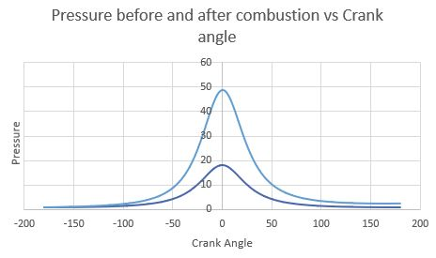
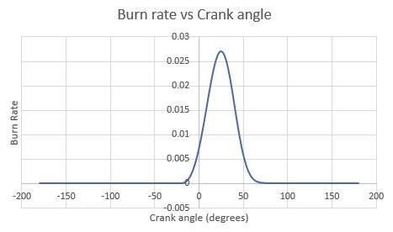
The graph above is depicting the pressure before and after the combustion occurs in the cylinder. As shown the lighter blue line is the pressure after combustion hence the high value for pressure. Both lines peak at zero showing that the pressure builds up before hitting it’s peak during this time which is when the cylinder reaches top dead center.
Whereas the graph below shows a peak after zero, this delay is because the compression happens at zero followed by the burn rate.
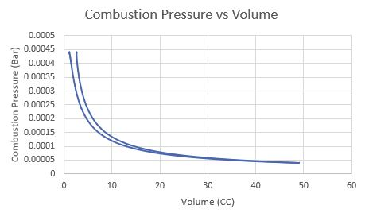
These two graphs show the combustion pressure against the volume and crank angle. The graph above does not illustrate the Otto cycle, the only other explanation is that this is the performance of an automobile engine using non-detonating fuel (Taylor, 1985). This is not the case therefore the graph is incorrect, along with the graph that is below.

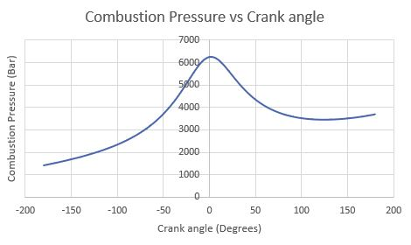
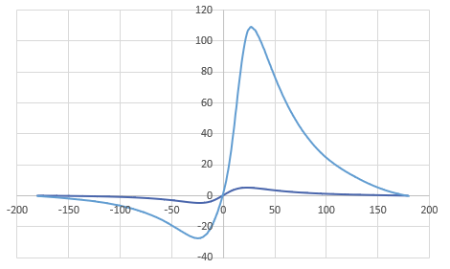
This graph represents the work done over the crank angle, the lighter blue is the data from the real engine. As shown in the graph there is an issue with the amount of work done as supposedly the work done by the real engine is over 100 joules. This does not correlate with the simulated data therefore there is a very very large discrepancy.
This could be an issue with the engine or an issue with the calculations. It is most likely an issue with the calculations, therefore it cannot be determined if there are any discrepancies with the engine or not. As the model is not correct the validation of the model against the real data is invalid. If this model were to be created again and simulated again there would be much more time spent on correcting it and ensuring that the simulation is correct.

Conclusion

In conclusion the simulation is very poor, when compared to the real data there is not much that is accurate therefore no real comparison can be made.

Bibliography
Heywood, J. B., 1988. Internal Combustion Engine Fundamentals. s.l.:s.n.
Taylor, C. F., 1985. The Internal Combustion Engine in Theory and Practice. s.l.:s.n.

