
DIGITAL SKILLS AND RESEARCH METHODS
The Impact of Virtual Learning Environment


Module Code: BMSW4003
Research Report

Lecture: Suneth Fernando
Student: Mariana Ungureanu2129381

University of Wales Trinity Saint David

Contents
Introduction 3
Overview of Virtual Learning Environment 3
Background 3
Literature Review – Virtual Learning Environment 3
Aims And Objectives Of This Research 3
Aims of This Research 3
Objectives 3
Method (Primary Research) 3
Results 3
Discussion 4
Conclusion 4
References 5

Introduction
As the covid-19 situation has created a drastic change in the educational system so that people are interested in learning in the virtual method. The rate of the virtual learning has been increased since the global pandemic. Virtual learning is broadly known as a system to teach the students by using internet. The teaching can be done through Zoom, messenger or Skype. Also, the students get their comfort to stay in the house and attend classes. It enhances the students’ learning capabilities. The report has been created for investigating the significance of the virtual learning environment of University of Wales Trinity students of the Saint David London Campus by using the primary and the secondary method the research has been conducted to collect useful information.

Background Review of literature
Title of the research
The title of the research project is, “The significance of the virtual learning environment on the University of Wales Trinity students of the Saint David London Campus students.
Reasons for online learning choices
I have chosen the topic for the research project because I did not get the chance to attend the virtual learning in the Covid-19 situation as I have already done my courses. But I have heard that my juniors are getting the online classes during that pandemic period. Also, they are getting some benefits and challenges. To investigate that I have decided to make the research in this topic. I found in a survey that the online learning has been increased by 95% after the global pandemic. People are using various platforms to learn more and enhance their capacities. It also presents that students are more comfortable in attending the virtual learning courses as they must do their jobs at the same time. Online learning helps the students to attend the classes from anywhere. This is the best thing of the virtual learning system. As the topic attracted me to find the importance of the virtual learning, so that I have chosen the topic for the research project.
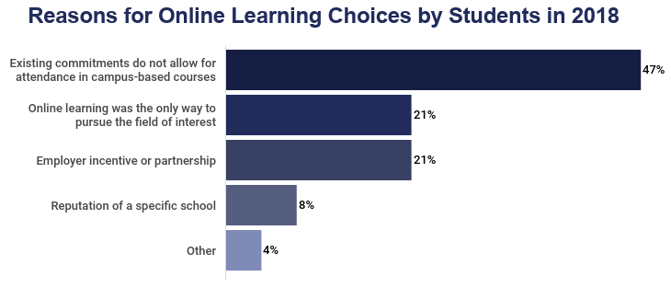
Figure: Reasons for online learning choices
Source: (Peat & Mary, 2019)

Literature Review – Virtual Learning Environment
Virtual Learning Environment (VLE) is broadly known as a learning environment which is based on using the technologies. The teachers provide lessons and resources so that the students are able to learn a lot of things. Their capabilities and competencies are enhanced by the virtual learning environment. For example, in the Covid-19 situation, all the schools and colleges were shut down. So that nobody could attend the classes. It was greatly hampering the education system. Therefore, people started relying on using the virtual learning system so that they just need to have their computer or laptop or a smart phone. By connecting with the internet, people used to attend classes.
The students got the chance to get the lecture sheets and presentation in the pdf format so that while attending the online class, they got the brief understand through it. Also, the teacher took the online assignments and homework. The students uploaded their assignments by using the university portal. Also, the teachers published their result report on their ID portal with some feedbacks (Kurilovas, 2009). The students as well as the teachers faced some challenges while the virtual classes. Sometimes the internet got interrupted, sometimes the electricity problem raised. So that the teachers and the students got huge distraction. There were some IT risks are noticed. Such as, human errors, hardware malfunction, software failure, spam, virus and many more. The technology risk is also known as the information technology risks which badly impacts on the businesses. As the educational institutions are also doing businesses, so that it got huge troubles for educating the students in the virtual learning system. The system helped in engaging the students with the studies. The students were virtually engaged with the classes so that understanding the class lectures became easy for them. So that they got the opportunity to use their imagination on the reality. Also, the students got the case solve styled exams which helped them to grow their thinking level regarding a topic and get a sharp memory.
The students got the chance to get different kinds of learning as well due to the virtual learning system. The collaboration among the students increased too. Because of the advancement of the technology, the teachers also noticed that the students are communicating with each other’s for solving the home tasks. So, they were divided in small groups. The teachers also virtually assisted them to solve as topic. By getting the power point slides, the student got the brief idea from the lecture notes. So the topic became clearer to them for understanding.
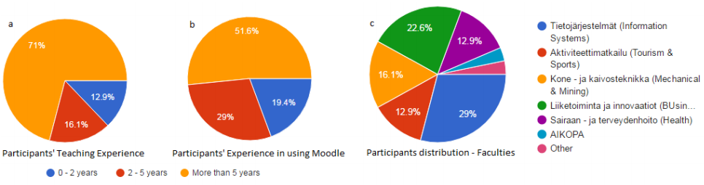
Figure: Impact of Moodle on the learners
Source: (Peat & Mary, 2019)
There are various terms and policies which are needed to maintain the virtual learning method. The UK Government has set two legislation policies, such as, The Uniform Electronic Transaction Act (UETA) and The Electronic Signatures in Global and National Commerce Act (ESIGN). So that no illegal activities will be conducted during the virtual learning. As the students are getting virtual learning environment through using internet so that they can attend several online courses. It helps them to create new ideas for choosing a better career. Because the students are the backbone of a nation. The students got the opportunities to learn the computer programming, data science, data management, network security and many more. These learning is going to help them to hold a good position in the corporate world. They will be able to contribute to the country’s developing.
People are interested in learning using the virtual method as a result of the drastic changes brought about by the COVID-19 situation in the educational system. Since the global pandemic, virtual learning has grown more rapidly. Virtual learning is generally understood to be a method of instructing students online. People can conduct the instruction using Skype, Zoom, or a similar programme. Additionally, the comfort of staying at home while attending class benefits the students. It improves the students' capacity for learning.
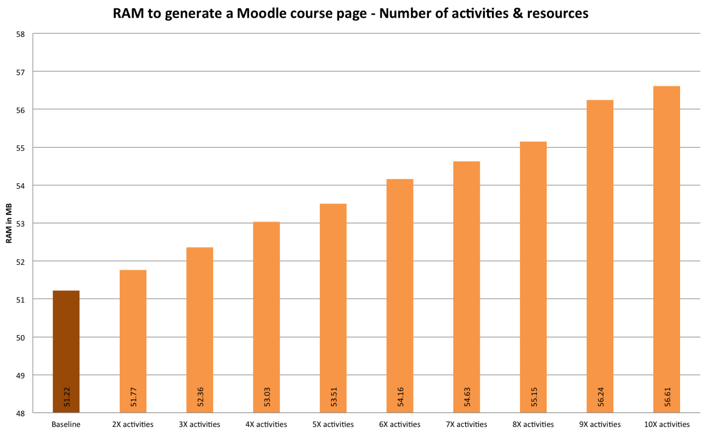Figure: Impact of Moodle on the learners
Source: (Reese & Sasha, 2015)
The opportunity to download the lecture notes and presentation in pdf format allowed the students to quickly understand the material while taking the online course. The instructor also completed home assignments and online assignments. Using the university portal, the students uploaded their assignments. Additionally, the teachers posted their result report and some comments on their ID portal (Reese & Sasha, 2015). During the virtual classes, both the teachers and the students encountered some difficulties. The internet would occasionally go down, and occasionally there would be an electrical issue. In order to greatly distract both the students and the teachers. Some IT risks have been identified. Examples include mistakes made by people, problems with hardware or software, spam, viruses, and many more. Information technology risks are another name for the technology risk, which has a negative effect on businesses. Since educational institutions are also businesses, teaching students using a virtual learning system has become extremely challenging. The system was useful in getting the students interested in their studies. The students were virtually involved in the lessons, which made it simple for them to comprehend the lectures. So that they could use reality as a canvas for their imaginations. Additionally, the students took exams in the form of case studies, which helped them develop their critical thinking skills and their memory.

Aims and Objectives of This Research

Aims of This Research
The main aim for creating this research is to investigate the significance of the Virtual Learning Environment (VLE) – the learning experience of the students within University of Wales Trinity Saint David London Campus.
Objectives
For the research project some objectives are set, these are presented below,
- To investigate the significance of the virtual learning environment of the University of Wales Trinity Saint David London Campus.
- To identify the ways for the development of the virtual learning environment.
- To gather various kinds of knowledge by the virtual learning environment.

Research questions
- How is the virtual learning environment creating greater scopes for the learning process?
- What are the challenges faced by the students during the virtual learning process in University of Wales Trinity Saint David London Campus?
- What is the significance of the virtual learning process?

Method

Research Approach
There are two types of the research approach, such as the quantitative research approach and the qualitative research approach. In this research project both the approaches have been used (Peat & Mary, 2019). By using the qualitative approach, the secondary information has been gathered for analysing the research project’s topic. And by using the quantitative approach, the primary information has been collected through the online survey tactic.

Collection method of data
In this research project, the data has been collected by several styles. The secondary data has been analysed the research project's topic has been gathered using the qualitative approach. Additionally, the primary data was gathered using the quantitative approach and an online surveying strategy. So that there were 1-to-10-point scale for the questionnaire. There were also Yes-No questions to gather either the positive or negative reaction from the respondent. By using the Microsoft word, the questionnaire was created.

Sampling method
For conducting the research project, the random sampling method has been used. So that the 9 students were selected from the University of Wales Trinity students of the Saint David London Campus. The students were selected on the random way. For gathering information, the researcher gave the full comfort to the students. The students did not any pressure for providing their opinions. Also, the students’ name and information are hidden by the researcher.

Method of their analysis
Microsoft Excel, a spreadsheet programme, was used to complete the research analysis phase of this study, which was conducted using the survey method by the online platform. The graph chart that has been provided in the report with the appropriate illustration has been used to measure the information from the spreadsheet software.

Ethical considerations
Since the respondents' personal information and data were not revealed during the research's completion process, the ethical consideration was successfully upheld. Additionally, the research has been given the proper latitude to obtain participants' opinions on the research topic in order to strengthen the report's authenticity.

Analysis

Question 1: Do you prefer to use VLE for Higher Studies?
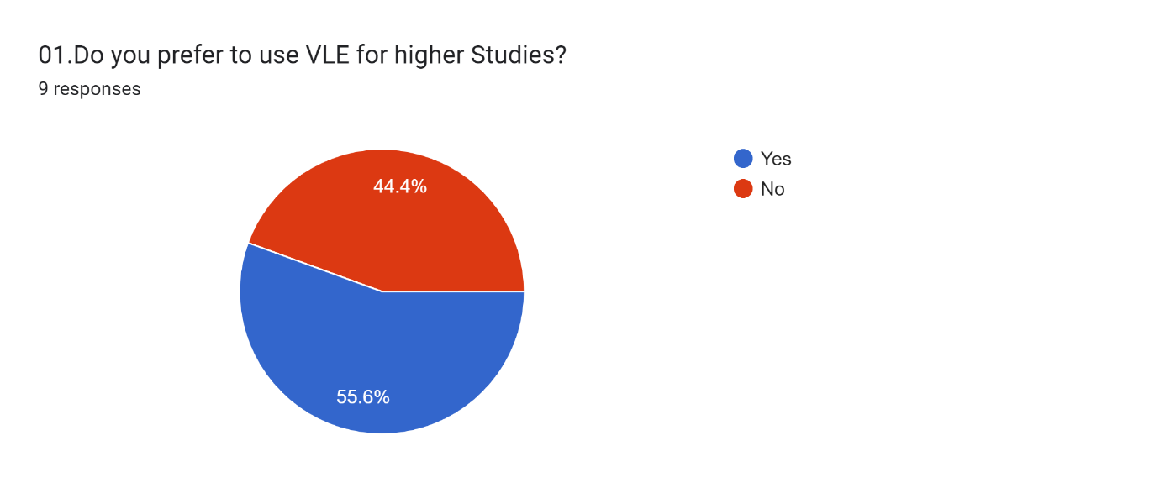
In the graph, 5 respondents said they have used VLE whereas the rest of the four responded in the negative. In short more than 50% use VLE for higher studies.
Question 2: Did you have proper training to use VLE for your studies?
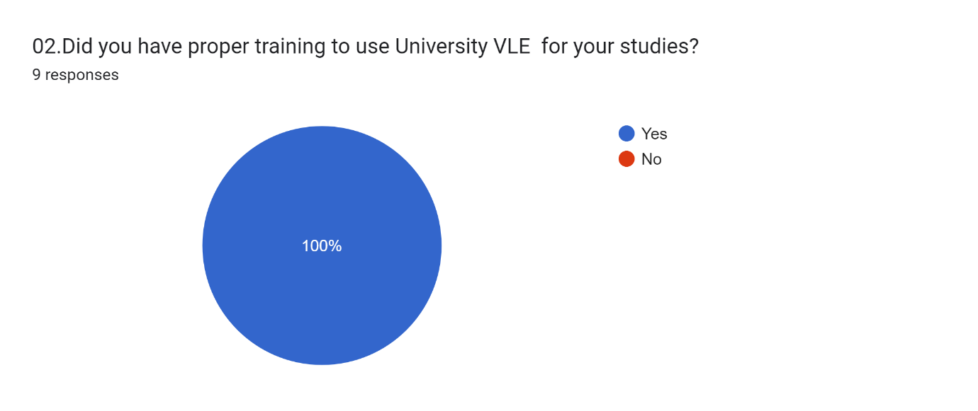
In response to this question, every responded said that they have had proper training in using the VLE.

Question 3: Do you have an experience in relation to the usage of VLE?
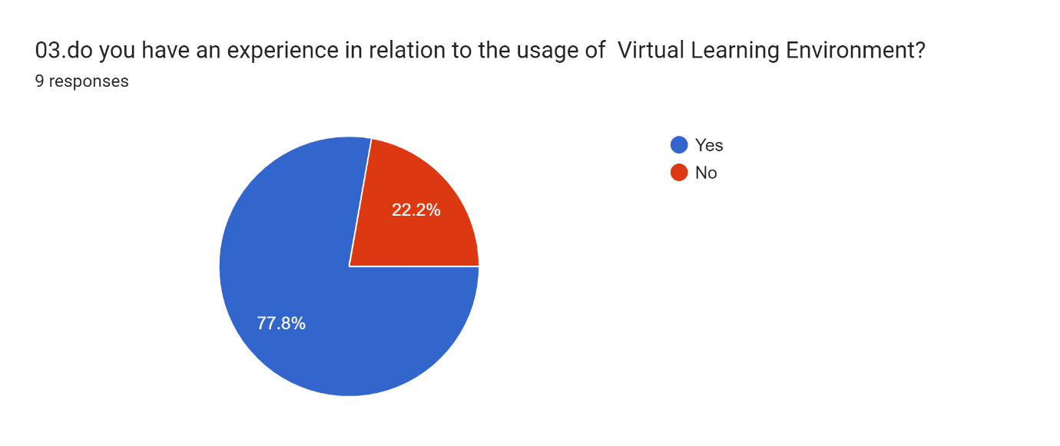
When asked about their experience of using VLE, 77.8% respondent said that they had some experience in using VLE. The rest 22.2% did not have any.
Question 4: Would you like to the university continue to use VLE platform after the pandemic as well?
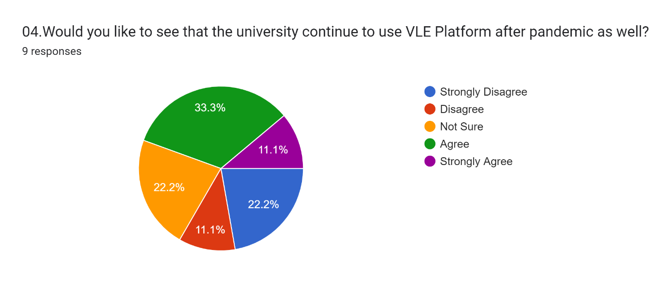
The response to this question is quite evenly dispersed. The major response is however leans towards agreement. 3 agreed and 1 person strongly agreed with the proposal to continue the VLE platform. 2 respondents remained neutral. Then again, 2 people strongly disagreed while 1 person only disagreed.

Question 5: Do you prefer to communicate with you lecturers and your friend via VLE?
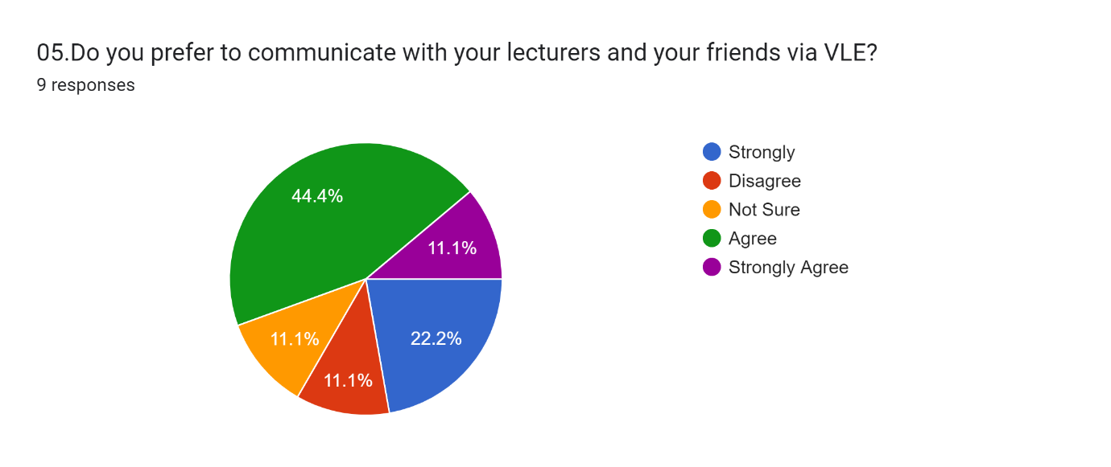
According to the graph, 11.1% of respondents are strongly in agreement with the statement, 44.4% agree, 11.1% have given neutral responses, 11.1% are disagreeing, and 22.2% of respondents are strongly disagreeing. Thus, the majority of the students want to use VLE for their personal and academic communication.
Question 6: Please rate the impact of online learning platform on your academic studies during the pandemic?
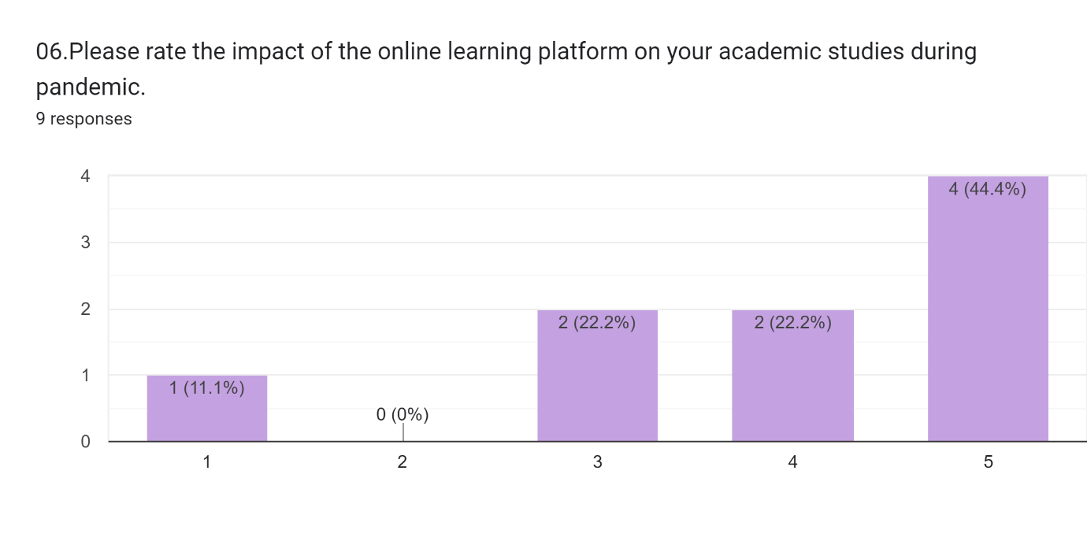
Observing this graph, majority of the students have enjoyed their time during study via online leaning platform during the pandemic. 3 students rated their experience 5 where 2 students have rated their experience 4.
Question 7: Please, rate your experience to you studies in VLE?
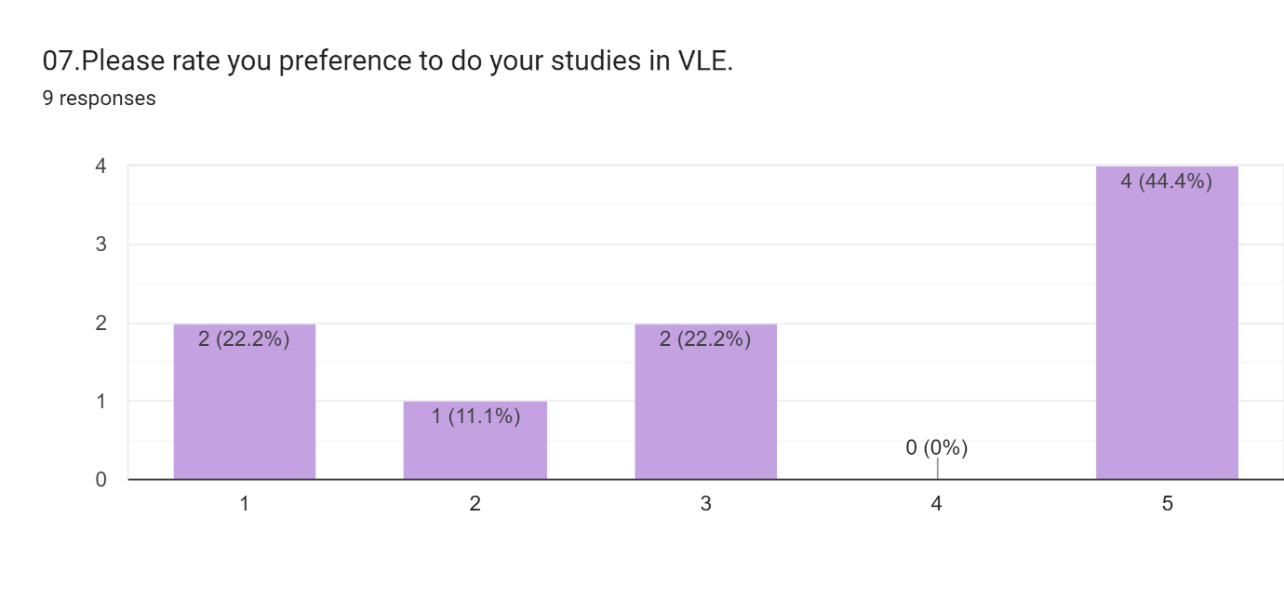
Students had a diverse response to this question although 4 students prefer VLE, the rest is split between the rating 3, 2 and 1 respectively.
Question 8: Does university e-learning platform provide the appropriate support to learning?
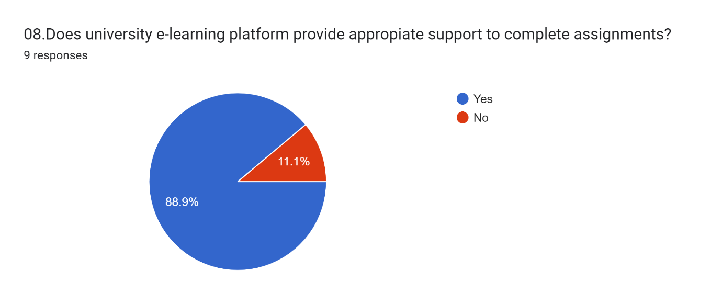
According to 88.9% respondents, university e-learning platform provides the appropriate support to learning.
Question 9: Do you dine the required and appropriate resource in VLE for each module you study?
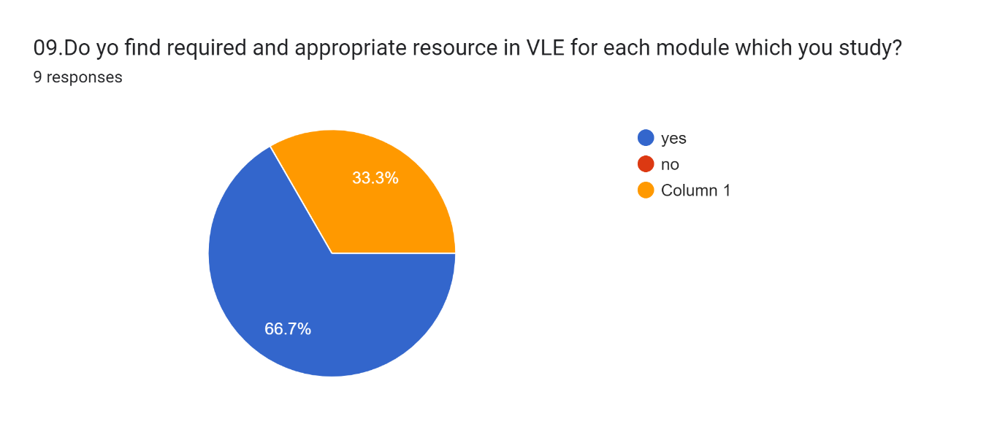
6 students find their necessary study materiel through VLE while the rest 3 do not find it useful.
Question 10: Since, lockdown how satisfied are you in relation to the support which you received from lectures, university admin and management through VLE towards your studies?
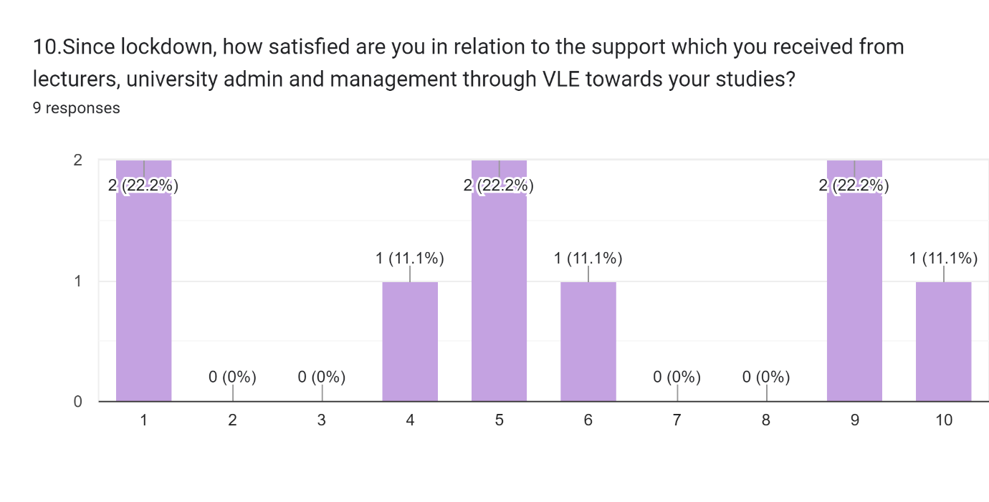
According to the data, 2 students are not satisfied at all and hence rate 1 while 1 student is extremely satisfied had has rated 10.

Discussion
The results prove that most of the students have agreed that they can participate in the University of Wales Trinity Saint David London Campus's virtual learning environment and expand their knowledge by using the Moodle platform. The findings demonstrate that most students are in favour of using the Moodle platform to engage in the online learning environment offered by the University of Wales Trinity Saint David London Campus and further their education. The findings demonstrate that most students are saying that the virtual learning environment provided by the Moodle platform is receiving positive reviews from academic staff and teachers.

Conclusion
People are interested in learning using the virtual method as a result of the drastic changes brought about by the COVID-19 situation in the educational system. Since the global pandemic, virtual learning has grown more rapidly. Virtual learning is generally understood to be a method of instructing students online. People can conduct the instruction using Skype, Zoom, or a similar programme. Additionally, the comfort of staying at home while attending class benefits the students. It improves the students' capacity for learning.

References
Byungura JC, Hansson H, Mazimpaka O, Thashmee K. Exploring teacher adoption and use of an upgraded eLearning platform for ICT capacity building at University of Rwanda. InIST-Africa Week Conference, 2016 2016 May 11 (pp. 1-11). IEEE.
Moodle Statistics. Moodle Stats. https://moodle.net/stats/ (accessed Aug 4, 2017)
Peat, Mary (July 2019). "Towards First Year Biology online: a virtual learning environment". Educational Technology & Society. 3 (3): 203–207.
Reese, Sasha (September 2015). "Online learning environments in higher education: Connectivism vs. dissociation". Education Information Technology. 20 (3): 579–588.
Andersson AS, Grönlund Å. A conceptual framework for e-learning in developing countries: A critical review of research challenges. The electronic Journal of information systems in developing Countries. 2009 Jul 25;38.
Kurilovas E. Methods of multiple criteria evaluation of the quality of learning management systems for personalised learners needs. InECTEL'2009 Workshop" Learning Management Systems meet Adaptive Learning Environments 2009 Sep 29.

Appendix


