COMMUNICATION

DANNA MICHELLY QUINONES RODRIGUEZ

1916136

EFFECTIVE TEAM WORKING AND COMMUNICATION

LECTURER
TIMOTHY HOPKINS

MAY / 4 / 2020

CONTENT

Introduction Section ..............................................................................................................................................3

SECTION I

- What is Communication?...............................................................................................................................................4

  - Methods of Communication....................................................................................................................................4
  - Verbal Communication............................................................................................................................................4
  - Oral Communication................................................................................................................................................4
  - Written Communication...........................................................................................................................................4
  - Non-Verbal Communication....................................................................................................................................4
  - Visual Communication.............................................................................................................................................4
  - Communication in the Workplace...........................................................................................................................5

SECTION II

- Effective Communication in Organisations……………………………………………………………………………5

  - How communications works between management and employees:
Tone/ Choice of Language /Level of Formality/Active Listening/
Proxemic/Kinesics-S.O.L.E.R./Personal Awareness – KEYS………..……………………………………………5-6

SECTION III

- Models of Communication………………………….....................................................................................................6

3.1Theory of Shannon and Weaver………………………............................................................................................7
3.1Figure 1……………………………………………………………………………………………………………..7
3.2Theory of Berlo………………………......................................................................................................................7
3.2Figure 2…………………………..............................................................................................................................7
3.3Theory of Schramm…………………………...........................................................................................................8
3.3 Figure 3………………………….............................................................................................................................8
SECTION IV

- Case Study………………………..............................................................................................................................8-9
4. Figure 4…………………………...............................................................................................................................8
- Conclusion……………………….................................................................................................................................9

- References…………………..…..................................................................................................................................10

- Appendices…………………………...........................................................................................................................11

  - Appendix………………………………………………………………………………………………………...11
  - Appendix………...………………………………………………………………………………………………12
  - Appendix……..……………………………………………………………………………………………….…13
  - Appendix……………………………………………………………………………………………………..14-15
  - Appendix………………………………………………………………………………………………………..16
  - Appendix………………………………………………………………………………………………………..17

INTRODUCTION SECTION

This report will show the comprehension in communication, encompassing different methods, examining the results and how the elements involved has a full influence during the development of communication during the first module.

The report is divided into four sections, Demonstrating the different methods of communication: Oral Communication; Written Communication; Non-Verbal communication and Visual Communication.

The second section includes how the communication could be made effective in a business organisation and why the importance of managers and persons in charge in communicating with employees appropriately to increase efficiency and success in the organisation.; the next sub-headline cover how the communications work between management and employees and what the purpose in the following components: Tone; Choice of Language; Level of Formality; Active Listening; Proxemic; Kinesics - S.O.L.E.R. and Personal Awareness – KEYS.

The third section will begin sharing the different theories and schemes in communication created for pioneers of the time most known as; Shannon – Weaver, Berlo, and Schramm, they were professionals who investigated models to facilitate the analysis and comprehension in the communication process with diagrams that will be illustrated corresponding to each model with examples.

The last section is related to the case study of the importance of active listening in the workplace, observing the participation that the members of the organisation are taking part; specifically in the use of verbal and nonverbal communication skills and how they are used to reinforce the team success.

SECTION I

1. DEFINITION OF COMMUNICATION

Communication would be seen as a simple process where information is sent and received, but considering the importance it has in human life, being it is essential for every individual to create bonds, share day by day, express with others, feelings, gestures, emotions and behaviours, however, in communication, there are other factors that intertwine and help the process such as tone of voice, facial expressions, position, writing and the senses.

1.1 METHODS OF COMMUNICATION

in the module of the first week of the university the topic of communication was covered explaining the different types of communication, which are used for all times, depending on the context or situation, it all depends on who is sending the message, the purpose and how it should be communicated. Mary December is an exercise in class, formal writing that refers to an email that should be sent assertively, formally with effective communication.

  - The process of Verbal communication, is between the sender and receivers, is established for symbols transmitting a message by words may be spoken or written, called Oral Communication and Written Communication.

  - Oral Communications has included speeches, discussions, debates, face to face talks, telephony conversations, video-conferencing, interviews and chats, those play an important role in organisations making them effective forms of oral communication, constituting with speed, tone of voice, clarity of speech and non-verbal communication supported by body language.

  - written communication is the most traditional manner type of communication using paper and other mediums, being formal or informal, written communication is understood to be a system of written symbols as a language for writing: letters, emails, memos, SMS, reports, newspapers, computer print-outs, checks and books. It is essential for any formal business communication where employees and management can manage reliable records.

  - As mentioned above, there are several types of communication, and among them, Non-Verbal Communication, is defined by not using words or writing, but it is considered which is the most important because more is perceived than words can express; through gestures, signals, posture, body movement and physical appearance, therefore, messages are expressed through non-linguistic means.

  - Visual Communication is focused on providing support through; images, drawings, illustrations, diagrams, photographs, among others. In general, it is an aid to facilitate and reinforce written communication, such as presentations in the workplace, where with a diagram it is effectively explained on a topic that visually supported, staff members may learn more clearly than just written words, illustrating information or ideas, which adds positive support to communication.

  - THE IMPORTANCE OF COMMUNICATION IN THE WORKPLACE

communication has become the main requirement in the workplace. According to ( Study.com, 2013)

Workplace communication is very important to companies because it allows companies to be productive and operate effectively. Employees can experience an increase in morale, productivity and commitment if they are able to communicate up and down the communication chain in an organisation.

Analysing the communication in the workplace is the main basis by which an organization succeeds. employees are the vital factor that constitutes the functioning of the company or organization, therefore creating an optimal work environment through communication, leading to the achievement of its objectives.
management must use means by which the development of the exchange of information or ideas provides the correct understanding.

SECTION II

2.2 HOW COMMUNICATION CAN BE EFFECTIVE IN A BUSINESS ORGANISATION

Throughout the reading in chapter five has been found, the compression of communication can be made effective in the business, removing the barriers of listening; Which make communication difficult for employees, management and clients.

Effective communication is an important resource at all levels of an enterprise to improve efficiency and establish good positive relationships. Businesses who invest time and resources in providing consistent communication lines will effectively create confidence among workers, contributing to improved efficiency, performance and overall morale. Whereas workers who interact with colleague efficiently (Michael Page, nd.)

  - COMMUNICATION BETWEEN MANAGEMENT AND EMPLOYEES

When communication is referred to, it covers many aspects within it, but when communication is happening between management and employees, some variables are activated, which are understood as the tone of voice, formality, choice of language, proxemic, Kinesics( S.O.L.E.R.) and personal awareness(K.E.Y.S.), each one, can be practised in the work environment following the guidelines of the authors of the chapters reviewed in class as well as exercises.

Be aware of formal communication between management and employees must be established by clear and well-organised lines of communication by management;
this leads to the tone of voice being used appropriately, the pitch, the volume and speech. Considering these factors, this will relieve the mood also thoughts, therefore, the type of relationship that must exist beforehand between management and employees to lead to fluid and trustworthy communication.

Accordingly, the proxemic helps the distance that must exist between the members; considering the personal and social zone as the most suitable to work if not otherwise lead to detail and affect commitment to the job at hand. Kinesics refers to body movements, gestures and postures that have an influencing role to provide personal information as well as personal appearance facial expressions and eye contact is primordial in the workplace to enhance the messages between co-workers.

Active listening becomes the main tool for managers and employees for the successful development of their roles, to creates close links, stimulates participation, keeps an open mind, focuses on the main direction of the speaker's message, and prepares to listen, but combining S.O.L.E.R. techniques, all physical and psychological barriers to distraction are eliminated, maintaining a comfortable, proactive communication between speaker and listener, following guidelines such as face the speaker squarely, open posture, Lean towards the speaker slightly without invading their personal space, Maintain good eye contact without invading or intimidate and remember that being relaxed in moments of silence, indicates that communication can continue without being forced, it will go on. (Griffiths and Dunham, 2017)

Personal awareness and KEYS are linked, when in an organization, both management and employees are allowed to develop an individual professional communication through KEYS, this process creates awareness, which helps to identify strengths, weaknesses to improve, thus improving communication skills with a variety of audiences and situations. thus adding a self-awareness in the non-verbal and verbal cues when interacting, finally making a self-reflection after an interaction has ended. wondering if the performance was satisfactory during the communication, how could it be improved, examining in this way it can be strengths for future interactions. In this section, understanding the topic establishes the ability to practice adequate communication that works between management and employees. (Quintanilla and Wahl, 2017)

SECTION III

- MODELS OF COMMUNICATION

From a personal understanding brief explanation in the content of the module corresponding to week two, the models and theories of communication; Shannon-Weaver, Berlo and Schramm were introduced, learning, definitions of the theories, what each one is for and how it is put into practice. A clear example of this is the exercise Maria and Pedro, which with a series of questions, should be applied to which model could correspond, in the following models exposed in this section a brief explanation of each, will be given along with Maria and Pedro exercise applying what it was learned in class.

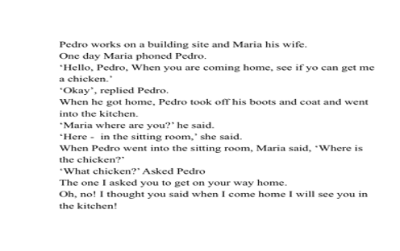

3.1 SHANNON -WEAVER COMMUNICATION MODEL

What type of channel can serve to transmit the maximum amount of signals? What part of the transmitted signals will be destroyed by noise on the path from the sender to the receiver?
Shannon - Weaver take into consideration to create a study based on the effective transmission of messages. As the technical aspects and problems of communication such as noise, this model offers an explanation to the communication factors that machines generate as a means of transmission of messages through the transport of signals. The Shannon-Weaver model is a linear, or one way, communication.

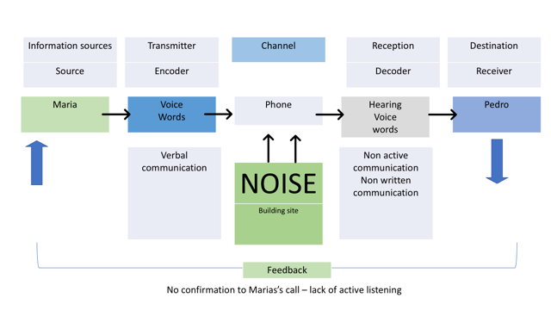
Figure 1 Danna, PowerPoint

3.2 BERLO COMMUNICATION MODEL

Berlo affirms that communication contains several aspects that make the message arrive accurately, it is when the sender and receiver share the same common point, and the aspects that make this theory have this result are that there must be affinities such as communication skills, attitude, knowledge, social system and cultures for both parties so that the message is delivered effectively and with purpose.
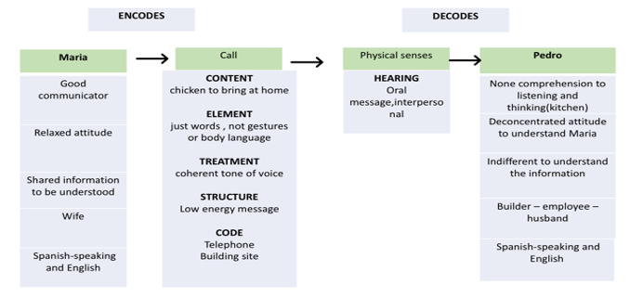
Figure 2 Danna, PowerPoint

3.3 SCHRAMM COMMUNICATION MODEL

Schramm theory is different from the two previous models because it emphasises in the message, the sender sends a message to the receiver; with an immediate reaction by the receiver, it is interpreted it decodes it according to the experiences, what it understands by its social norms, thus it encodes a message back; feedback maintaining the flow of Communication. The sender interprets the message and generates another feedback, keeping the conversation cycle.

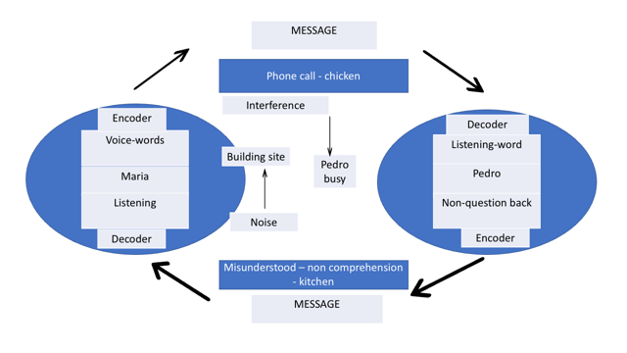
Figure 3 Danna, PowerPoint

SECTION IV
CASE STUDY

My case study contributes to knowledge about active listening communication, and specifically in my volunteering teamwork environment, each person who attends the meetings participates actively giving their views, always taking into account the cultural diversity within it. The reflective question asked in the volunteer discussions are led by managers with the ability to adapt, listen, tone of voice, cordial manner and comprehension that the ideas that can flow through the section therefore also being aware of all the different or ambiguous points of view since due to this confrontations could be created by any type of disagreement, the active listening and communication in the group, in general, is positive since all the people who are part of the work. We want to cultivate good relationships with our colleagues and friends, where each person is motivated, feel interests, vision and mission to make the work environment prosper and give good service to the community.

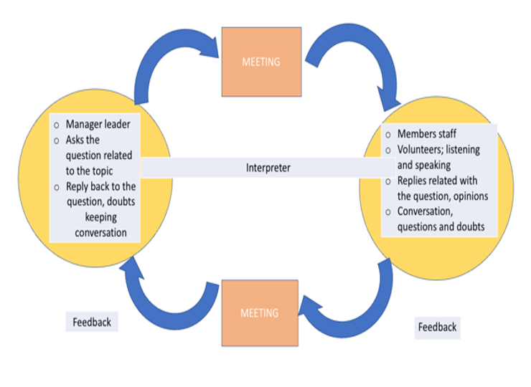
Figure 4 Danna, PowerPoint

A good example in positive leadership communication; it is the current situation of COVID-19; is to check-in and support one another. A good leadership interaction would be in the first place; contact all the volunteers and members of the staff through emails, messages, telephone calls and creating video-conferencing, where several members we can participate actively expressing our difficulties, at that moment the person how to lead the conversation becomes in passive listener asking question allowing clear emotions and freely talk.

The person who is addressing all the concerns gathers and asking the open-ended question for information, giving us support through communication. Using virtual communication incorporate closeness wherever we are, and at the moment we are making the most of each integral part of what makes communication a tool of primary need for human beings, to take actions either in academic, professional and personal roles in life.

- CONCLUSION

to conclude the compilation of the report in the first module based on communication; Likewise, in the performance of learning in the first term of the university with respect to communication methods, also the application in the daily life of communication theories, in addition to how to apply them. The information provided by the lecturer was clear, offering resources and activities in class, as well as at home and as active participation. communication is the essential tool of human beings; By knowing how to use it also as the different components and structure, it can be effectively managed in the workplace, organisations and among co-workers, eliminating barriers that prevent communication from having the highest achievement.

- REFERENCES

Michael Page (nd) The importance of good communication in the workplace. [online] Available at: https://www.michaelpage.co.uk/advice/management-advice/development-and-retention/importance-good-communication-workplace (Accessed: 29th April 2020)

Study.com (2013) Workplace Communication: Importance, Strategies & Examples. [online] Available at:
https://study.com/academy/lesson/workplace-communication-importance-strategies-examples.html (Accessed: 29th April 2020)

Quintanilla,K. M. and Wahl, S. T. (2017) 'Verbal and Non – Verbal Communication', in Andrew, M., Michaela, S. and Paul, K. T. (eds), Certificate in Higher Education: Skills for the Workplace Student Yearbook. London: SAGE

Griffiths, B.A. and Dunham, E. B. (2017) 'Communication', in Andrew, M., Michaela, S. and Paul, K. T. (eds), Certificate in Higher Education: Skills for the Workplace Student Yearbook. London: SAGE

7. APPENDICES

7.1

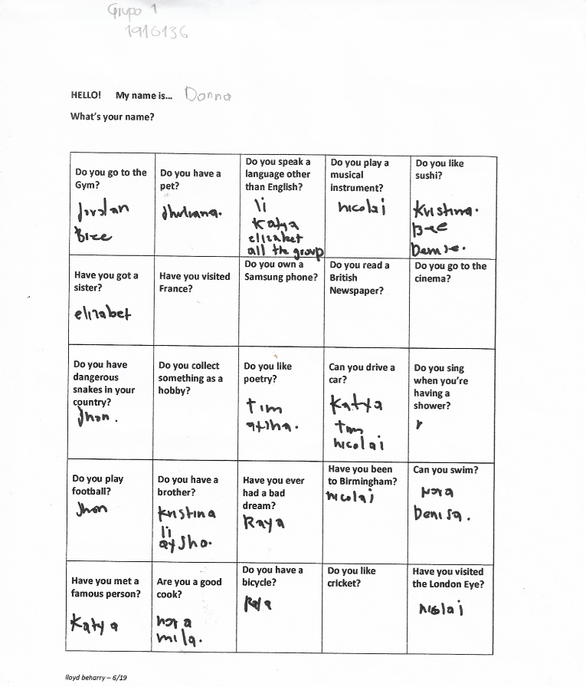

7.2

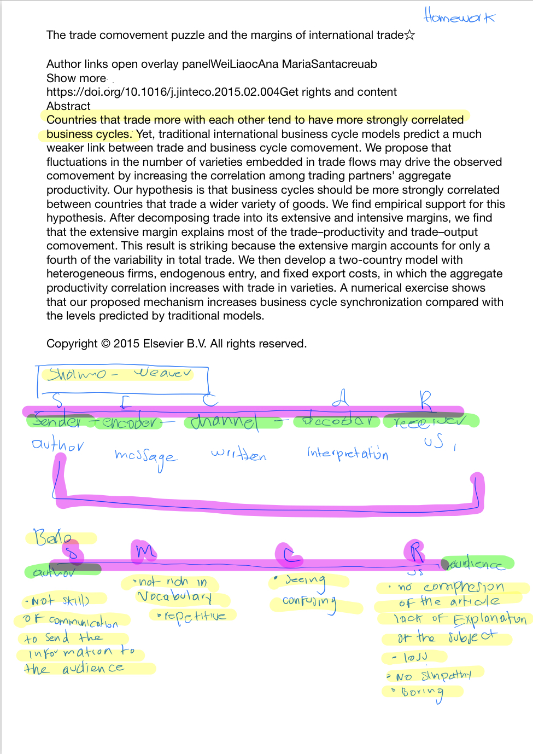

7.3

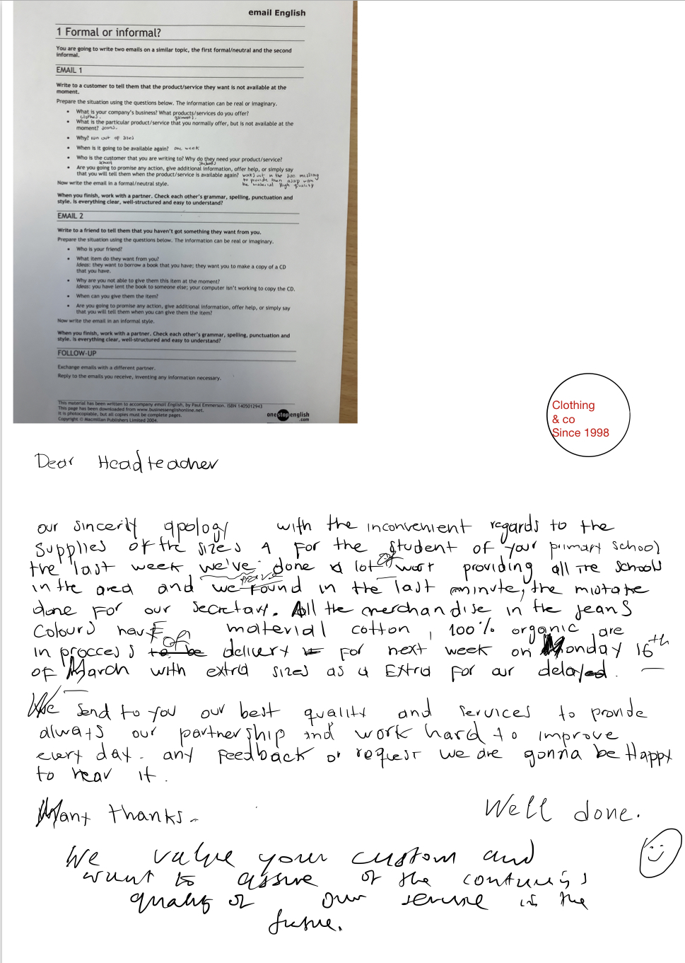

7.4

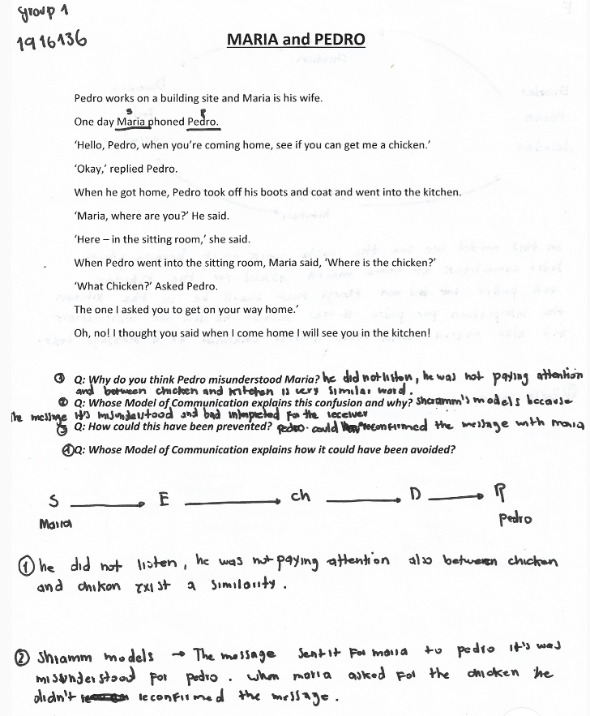

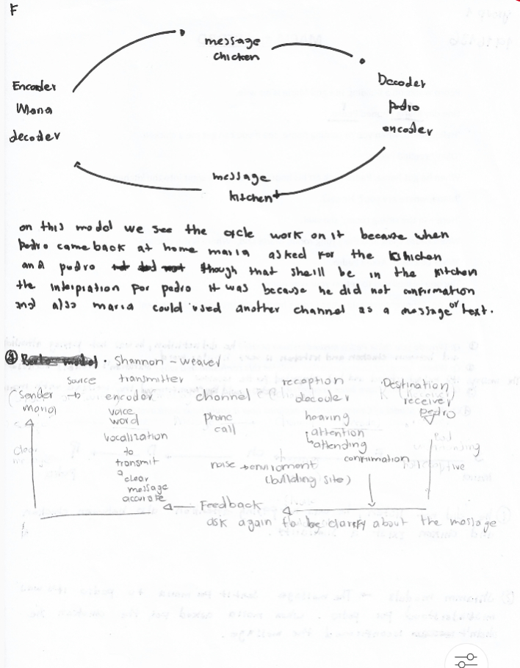

7.5

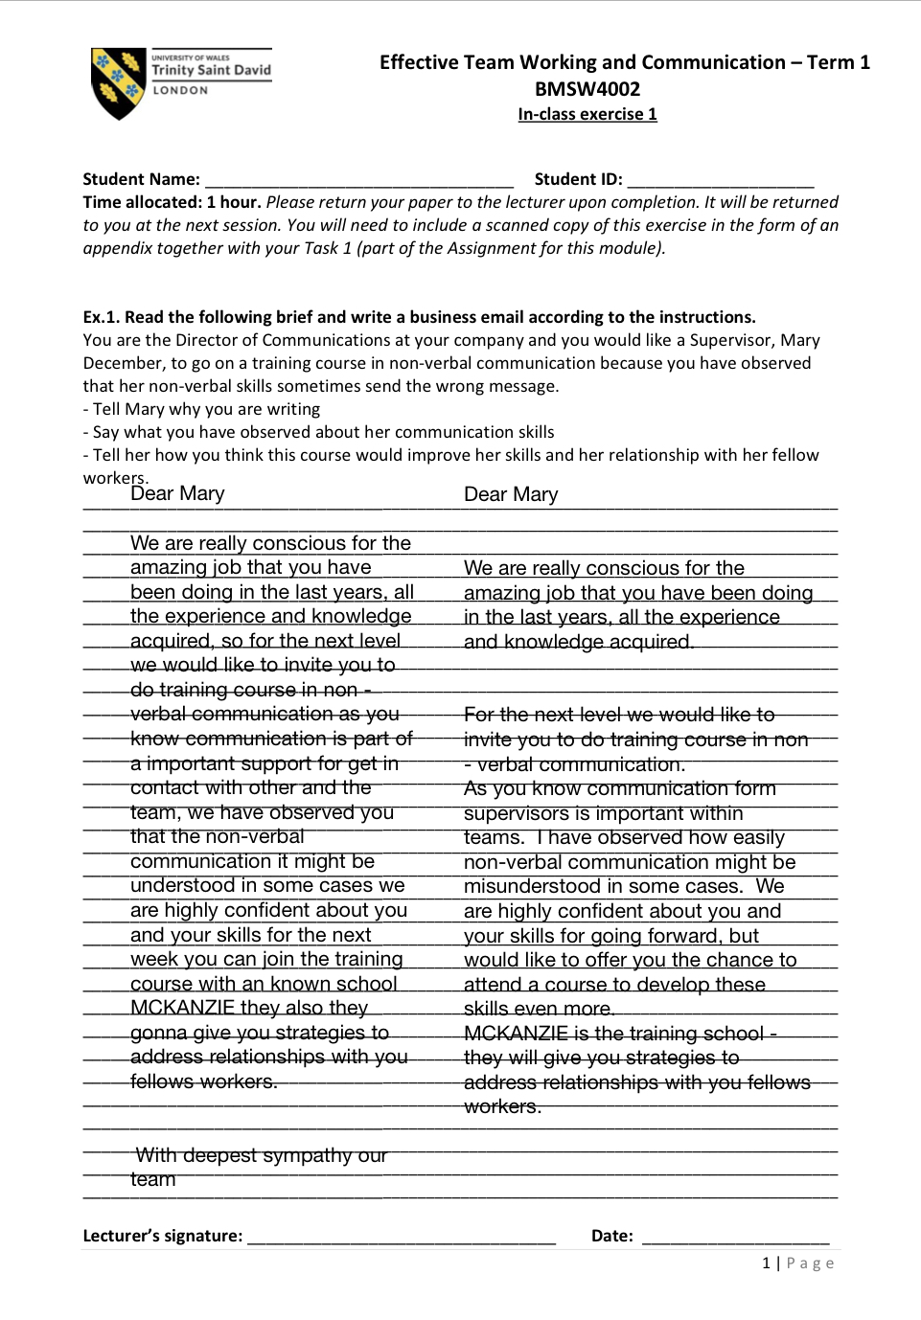

7.6

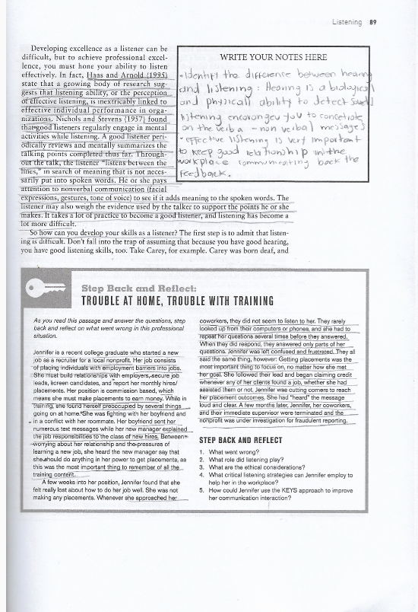

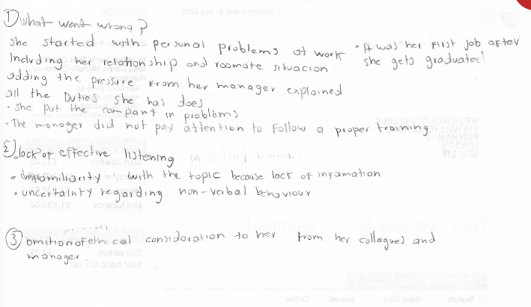



7.7

