Digital Competence

Luciana Stafi - 2130653
Lector Sadie France
Week - 7

University of Wales Trinity Saint David

What does digital competence mean?

Digital competence means a set of knowledge, attitudes and skills that allow us to use digital technology and systems correctly.
Digital competence can help us to complete certain projects or statistics. Still, at the same time, it allows us to be confident and know how to interact and collaborate digitally (Digital competence: the vital 21st-century skill for teachers and students, 2022).
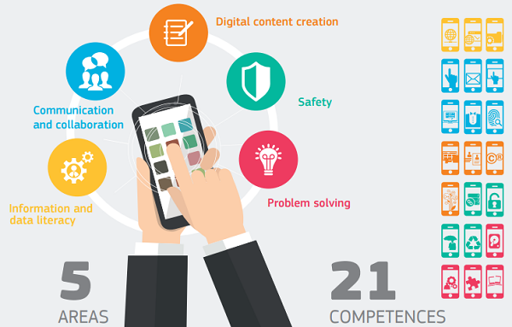
(Picture source: https://www.schooleducationgateway.eu/en/pub/resources/tutorials/digital-competence-the-vital-.htm)
Why are digital skills important?
Digital skills are important for business because, during the Covid 19 pandemic, the demand for digital skills was affected as companies moved from physical to digital headquarters (Why Digital Skills Are the Foundation of Our Future Workforce, 2022).

Reference list

- Salesforce News. 2022. Why Digital Skills Are the Foundation of Our Future Workforce. [online] Available at: <https://www.salesforce.com/news/stories/what-are-digital-skills/> [Accessed 16 June 2022].

- SchoolEducationGateway. 2022. Digital competence: the vital 21st-century skill for teachers and students. [online] Available at: <https://www.schooleducationgateway.eu/en/pub/resources/tutorials/digital-competence-the-vital-.htm> [Accessed 16 June 2022].

