TOWELL & SONS LTD
- site name and address | - KING ROAD, Swansea, sa1
- revision no. | - 1a
- prepared by | - owen towell
- prepAration date | - 02/04/2020
- construction phase start date | - 06/05/2020
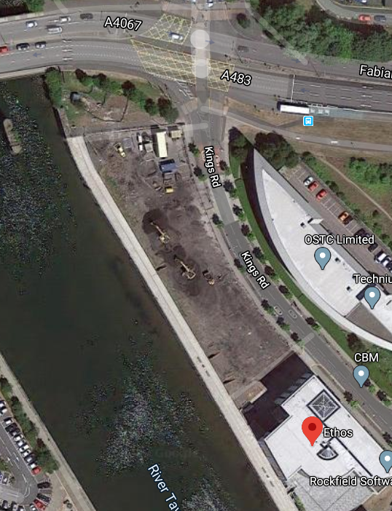
  - CONSTRUCTION PHASE PLAN

  - towell & Sons ltd
  - 35 Garth View
  - pengam
  - blackwood
  - np12 3rt
  - 01443 829553

CONTENTS

1. Description of project
1.1 Project description
1.2 Programme details
1.3 Key dates
1.4 Details of Key Role Holders
1.5 Existing Records and Plans
1.6 F10

2. management of the work
2.1 Management Structure and Responsibilities
2.2 Health and Safety Goals
2.3 Arrangments for monitoring and review of health and safety performance
2.4 On-Site Liaison Arrangments
2.5 Consultation with the Workforce
2.6 Arrangments for the exchange of design information
2.7 Management of Design Changes
2.8 The Selection and Control of Contractors
2.9 Arrangments for exchange of health and safety information between contractors
2.10 Site Security
2.11 Site inductions
2.12 On-site training
2.13 Welfare and hygiene
2.14 Reporting and investigation of accidents, incidents and near misses (RIDDOR)
2.15 The production and approval of risk assessments, method statements and written systems of work
2.16 Site rules
2.17 Fire and emergency procedures

3. Arrangments for controlling significant site safety rules
3.1 Waste management
3.2 Preventing falls
3.3 The maintenance of plant and equipment
3.4 Traffic routes and segregation of vehicles and pedestrians
3.5 Storage of materials

4. Arrangments for controlling significant site health risks
4.1 Manual handling
4.2 Use of hazardous substances & arrangements for health monitoring
4.3 Reducing noise and vibration

5. the health and safety file
5.1 Layout and format
5.2 Arrangements for the collection and gathering of information
5.3 Storage of information

6. additional site documentation

1. DESCRIPTION OF PROJECT

1.1 Project Description
1.1.1 To construct a single, two-storey detached domestic building with a loft room. Foundations to be a concrete strip with block and block cavity wall construction. Walls to be partial fill cavity insulation with smooth render finish externally. Plinths, soldier courses over all opening and porch pillars to be natural sandstone.
To the ground floor; suspended concrete beam and block floor. To the upper floor; traditional solid timber with particleboard sheet covering.
All doors and windows are to be light oak wood effect uPVC with sealed double-glazed units. The roof structure is to be trussed rafters at a 40o pitch with a natural slate covering and closed eaves.
Dwelling to comprise of the following rooms:
GROUND FLOOR:
- Lounge
- Study
- Hall
- Kitchen/Dining area
- Utility
UPPER FLOOR:
- 3no Bedrooms
- 1no En Suite
- 1no Bathroom
LOFT:
- Storage Areas

The full scope of works is defined on drawings*
- FLOOR PLANS (DWELLING) DRAWING NO.1
- ELEVATIONS (DWELLING) DRAWING NO. 2

* All of the above works are to be undertaken in conjunction with the appropriate construction issue drawings. WE AWAIT THE ISSUE OF CONSTRUCTION DRAWINGS.

1.2 PROGRAMME DETAILS
1.2.1 Please see appended proposed construction programme

1.3 KEY DATES
1.3.1 Proposed start 6th of May 2020 (Site set up) thereafter w/c 11th of May for the commencement of works.
1.3.2 See key dates/milestones as per Construction Programme

1.4 DETAILS OF KEY ROLE HOLDERS
TITLE | ADDRESS DETAILS
CLIENT | University of Wales Trinity Saint David  1 Kings Road,  Swansea  SA1 8PH
CA/ARCHITECT | Volute Architects  22 Merton Green  Caerwent  Monmouthshire  NP26 5AT
PRINCIPLE DESIGNER | Volute Architects  22 Merton Green  Caerwent  Monmouthshire  NP26 5AT
PRINCIPLE CONTRACTOR | Towell & Sons Ltd  Unit C5, Britannia Centre for Enterprise,  Blackwood  NP12 3SP
QUANTITY SURVEYOR | Towell & Sons Ltd  Unit C5, Britannia Centre for Enterprise,  Blackwood  NP12 3SP
ECOLOGIST | Soltys Brewster  4 Stangate House,  Stanwell Rd,  Penarth,  CF64 2AA

1.5 EXISTING RECORDS & PLANS
RECORDS | DATE RECEIVED | PROVIDED BY
Health and Safety File | Not Issued | N/A
Drawings (Construction Issue) | Tender issue drawings only. | N/A
Site Investigation | Not issued | N/A
Ecologist Report | Not issued | N/A
Existing Service Information | Not issued | N/A
Pre-Construction Information | Limited information | N/A

1.6 F10 CONSTRUCTION PROJECT NOTIFICATION
1.6.1 Under CDM REGS 2015 this project does meet the notification thresholds of:
- Work lasting longer than 30 days with more than 20 workers on site
- Work involving 500 person-days of work
And is therefore notifiable to the Health and Safety Executive
1.6.2 Contract Administrator to issue Towell & Sons Ltd a copy of the F10 notice once issued.

2. management of the work

2.1 MANAGEMENT STRUCTURE AND RESPONSIBILITIES
COMPANY | ACTIVITY | NAME | ROLE
TOWELL & SONS LTD | Overall responsibility for H&S & Welfare. | Owen Towell | Managing Director
TOWELL & SONS LTD | Implementation and development of CPHSP on site. | Shaun Green | Site Manager
TOWELL & SONS LTD | Preparation of draft construction H&S plan for implementation & development by the site manager | John Lawson | Office Manager
ATLANTIC SCAFFOLD | Scaffolding – Admin support to the site  Works overseen by: | Colin Davis | Scaffold Contractor
GP Groundworks | Groundworks – Admin support to the site  Works overseen by: | James Haskell | Groundworks contractor

2.1.2 All contractors will provide suitable supervision for their works – evidence must be provided of competency and experience. Work will be arranged to give nominated working supervision sufficient time to undertake their supervisory duties.

2.1.3 TOWELL & SONS LTD safety policy contains details of the responsibilities of all within the organisation and is reiterated during company training sessions.

2.2 HEALTH AND SAFETY GOALS
2.2.1 This project will be coordinated and administered in such a way as to minimise risk and to safeguard the client, residents and any visitors to the site and broader site area, employees, contractors, members of the general public and any other persons who may be affected by our works. Visitors will be required to confirm their presence on-site with site manager/foreman and will be inducted and signed in and required to sign out on departure. All reasonable measures will be in place to mitigate any negative impacts that our on-site activities have on the surrounding environment.

2.3 MONITORING AND REVIEW
2.3.1 All on-site happenings will be supervised constantly by our Site Manager. We will engage the services of an external safety consultant if required.
2.3.2 Sub-contractors need to have sufficient supervision on their on-site activities and may be required to comment on the health and safety requirements being met at site meetings. The RAMS given by the subcontractor shall determine the control and evaluation procedures of the contractor.
2.3.3 Health and safety assessment meetings will be conducted at regular intervals throughout the contract duration. Particular considerations should be paid to any alterations that occur as the project progresses, including the appropriate steps to ensure effective monitoring of health and safety.

2.4 ON-SITE LIAISON
2.4.1 The appointed site manager will act as the liaison between project administrations and operatives and management of the premises adjoining the work.

2.5 CONSULTATION WITH THE WORKFORCE
2.5.1 Operatives on site will be encouraged to consult with the appointed site management at every opportunity.
2.5.2 TOWELL & SONS LTD has adopted an 'open door' policy, where the operatives are encouraged to contact site managers for any on-site questions and insights.
2.5.3 If subcontractors introduce any operatives to the site who do not recognise English as their first language, the Site Manager must determine whether additional steps are required to ensure that accurate and appropriate knowledge, guidance, preparation and oversight are given to them. We may then seek advice from an external consultant as appropriate.
2.5.4 The site manager will provide a suggestion box for use by site personnel.

2.6 ARRANGMENTS FOR THE EXCHANGE OF DESIGN INFORMATION
2.6.1 Any design information will be exchanged during site meetings with designers and sub-contractors.
2.6.2 As deemed necessary by the nature of any design changes, we will distribute design information to the client, principal designer and our sub-contractors via the most appropriate means.
2.6.3 Records of issue will be retained.
2.6.4 Should a design change warrant a review of working methods, our and/or our sub-contractors risk assessments, and method statements will be amended with information to be conveyed to the workforce via toolbox talk.
2.6.5 All sub-contractors will be provided with a copy of the site-specific hazards.

2.7 MANAGEMENT OF DESIGN CHANGES
2.7.1 Details of any further designers appointed by the principal contractor (including subcontractors with design input, design of temporary works, etc.) will be recorded in Section 1.4.
2.7.2 As a general rule, we will inform the principal designer with details of our appointed designers and of our management plans for designs which change as the project progresses.

2.8 SELECTION AND CONTROL OF SUB-CONTRACTORS
2.8.1 TOWELL & SONS LTD will appoint sub-contractors based on previous experience and/or answers provided to competence questionnaires provided at tender stage.
2.8.2 Where sub-contractors are involved in design work, their names will be forwarded to the Principle designer.
2.8.3 Where sub-contractors have provided RA and MS, the site manager, will examine all documentation and ensure it is relative and detailed prior to any commencement of works.

2.9 ARRANGMENTS FOR EXCHANGE OF HEALTH AND SAFETY INFORMATION
2.9.1 The appointed site manager is responsible for organising the exchange of information.

2.10 SITE SECURITY
2.10.1 Every part of the construction site shall, as so far is reasonably practicable, have its perimeter identified by suitable signage and be cordoned off using heras fencing, to include suitable warning signs (bi-lingual) and fluorescent markers.
2.10.2 The perimeter of the scaffold will be secured by a minimum of 3m hoarding. All other work areas and storage to be secured by hoarding.
2.10.3 All equipment and materials will be safely stored within locked, site compounds and ladders to be removed at the end of the day and safely stored.
2.10.4 Our site manager will be responsible for conducting an end of day checks. These checks will include; all ladder guards are fitted or are stored securely; perimeter hoarding/fencing to the scaffold is secure; perimeter hoarding/fencing to the construction site is secure; all safety & warning signs are clearly displayed; out of hours emergency contact details are displayed; all tools, materials etc. are securely stored in designated areas; the site is clean and tidy; fire watch is complete for any Hot Works permits; All operatives and visitors have signed out; a physical sweep of the site undertaken to check for any unauthorised persons.
2.10.5 Suitable warning signs will be placed to warn third parties of our construction works, and contact details will also be displayed.
2.10.6 We will provide all necessary temporary barriers to segregate our working area.
2.10.8 Access/egress to and from the site will be controlled in a manner which is proportional to each location.

2.11 SITE INDUCTIONS
2.11.1 All operatives on-site / visitors will be in receipt of the site induction prior to being allowed on-site – including delivery drivers etc.
2.11.2 All site personnel and visitors will sign in and out at the site office.

2.12 ON-SITE TRAINING
2.12.1 As well as attending and providing site inductions, sub-contractors will be instructed to provide their operatives with relevant on-site training; these will consist of task appropriate toolbox talks, RA and MS.

2.13 WELFARE & HYGIENE
2.13.1 Welfare facilities will be provided by TOWELL & SONS LTD from day one of the construction phase. It is proposed that a cabin with mess and handwashing facilities will be located in a designated area on site.
2.13.2 It is proposed to use a designated site cabin within site to undertake site manager’s inductions.
2.13.3 Daily cleaning regime of the site welfare facilities are to be implemented.
2.13.4 Sub-contractors are required to provide an appointed person and first aid kit for treating minor injuries.

2.14 RIDDOR PROCEDURES
2.14.1 HSE Guidelines state that all contractors will make themselves aware of the procedures for reporting any accident and/or dangerous occurrences as detailed in the RIDDOR regulations 2013.
2.14.2 The site manager must be made aware of any incidents or near misses at the earliest opportunity and written into the on-site accident book.

2.15 PRODUCTION & APPROVAL OF SAFETY DOCUMENTATION
2.15.1 All subcontractors will be given a copy of the site-specific hazards, and the designers risk register before compiling any RA or MS.
2.15.2 RA will be carried out for all specific works. The site manager will examine said documents and once approved, works may proceed, subject to all identified control measures being in place.
2.15.3 Where the risk assessment identifies the need for a written method statement to be prepared, this will be handed to the site manager in good time to allow it to be reviewed before site operations commence.

2.16 SITE RULES
2.16.2 Generic site rules will be displayed on the poster located within the mess and site cabin. These must be adhered to at all times, being enforced by our site manager. Site-specific rules will be developed and where necessary, displayed.

2.17 FIRE AND EMERGENCY PROCEDURES
2.17.1 The emergency procedures posted that includes key contact telephone numbers will be displayed in the site accommodation. Contact number for emergency services is 999.
2.17.2 Fire Action Notices will be displayed at locations on the site as determined by the fire risk assessment. These notices will set out the procedure to follow in the event of a fire.
2.17.3 Fire escape routes and exit signs will be erected.
2.17.3 In the event of a fire, the site manager or his deputy will review the live site attendance register and ensure all operatives/visitors have evacuated the site and made their way to the designated Muster point. The exact location and severity of the fire will be determined, and the Fire and Rescue Service may require contacting detailing the site address, the extent of the fire, if any persons are not accounted for and the existence and location of hazardous, flammable or explosive substances.
2.17.4 Based on the findings of the fire risk assessment, TRAINED STAFF may attempt to fight the fire with fire extinguishers provided; however, only when it is deemed safe to do so.
2.17.5 Hot works should if at all possible not be carried out on site. Should the requirement be unavoidable, then a permit must be issued and strictly adhered to.
2.17.6 We will implement fire safety policies, procedures and records to demonstrate compliance with our duties under the Construction (Design and Management) Regulations 2015 and the Regulatory Reform Fire Safety Order 2005.

3. CONTROLLING SIGNIFICANT SITE SAFETY RISKS

3.1 WASTE MANAGEMENT
3.1.1 All waste will be removed from the work area regularly. Designated skips will be provided for recyclable and non-recyclable materials. A Copy of TOWELL AND SONS LTD, Natural Resources Wales Higher Tier Waste Carriers License registration, number CB/PE5152DL to be held on-site.
3.1.2 The site manager will ensure regular collections of waste.

3.2 PREVENTING FALLS
3.2.1 Trestle platforms bay be used by contractors, provided they are, at all times, founded on a firm, level surface and be fully boarded to at least 600mm at all times.
3.2.2 Purpose designed systems, such as the Safestand Access System can be used, or standard trestles with guard rail brackets.
3.2.3 Mobile scaffold towers will be used in preference to trestle platforms and/or ladders wherever reasonably practicable. PASMA operatives only.
3.2.4 All roofing works shall be undertaking in accordance with the guidance contained in the HSE publication, HSG33 – “health and safety in roof work’. Separate method statements will be prepared for roofing works and appended to this document.
3.2.5 Suitable edge protection (permanent or temporary) will be provided at all levels to prevent the risk of falls from height.

3.3 USE AND MAINTENANCE OF PLANT AND EQUIPMENT
3.3.1 No person(s) will be permitted to operate any plant or machinery unless trained, competent and authorised to do so. Where appropriate, the site manager will require evidence of training.
3.3.2 plant and machinery will be carefully selected so as to be safe and suitable for its intended purpose. The site manager will request copies of current, thorough inspection certificates for the hired-in plant from either contractor or hire companies
3.3.3 All our plant and equipment are subject to company and statutory maintenance, inspection and rest requirements.

3.4 TRAFFIC MANAGEMENT & SEGREGATION OF VEHICLES AND PEDESTRIANS
3.4.1 A Traffic Management Plan detailing the access and egress arrangements to the site is detailed below. They will be developed by the site manager to reflect the changes throughout the project.
3.4.2 Deliveries and loading of vehicles will be controlled by Vehicle Marshalls. We will look to arrange deliveries and collections outside of peak traffic times to minimise disruption.
3.4.3 Before commencement of operation, signs will be erected which warn all non-construction personnel of the works in progress. The signage will make clear segregation of construction traffic routes and members of the public.
3.4.4 Provision will be made for the segregation of vehicular and pedestrian routes, both during access and movement around the site.
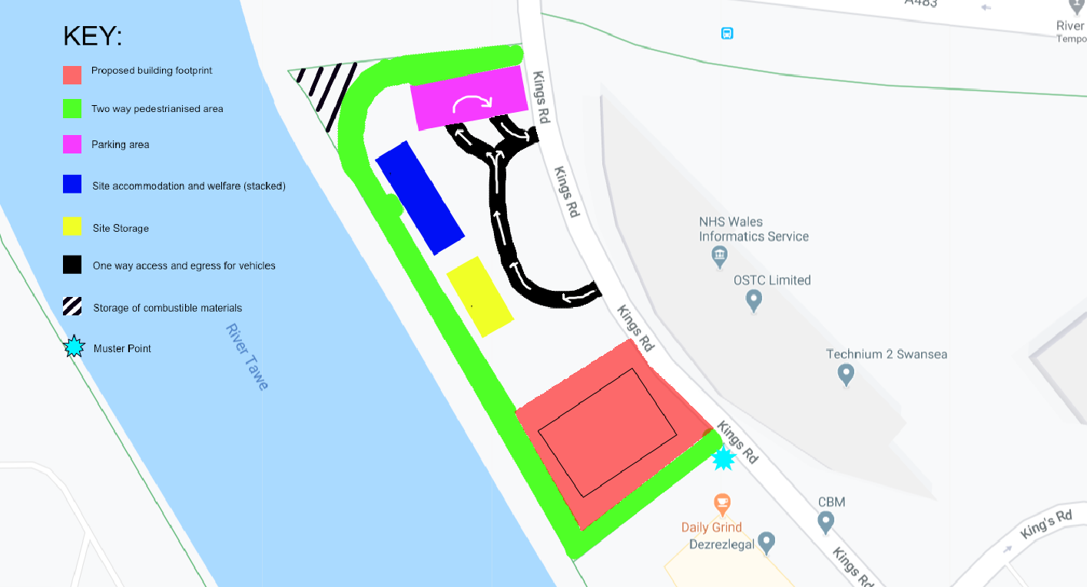
3.4.5 Access will be maintained for emergency services at all times to the site, in addition to the neighbouring premises.

3.5 STORAGE OF MATERIALS
3.5.1 Careful management is required, and the site manager will need to make considerations with regards to the location of stored materials. Materials must be placed so as to avoid causing any obstruction and done so safely.

4. CONTROLLING SIGNIFICANT SITE HEALTH RISKS

4.1 MANUAL HANDLING
4.1.1 Manual handling should be avoided whenever fairly practicable and mechanical methods will be used.
4.1.2 Where unavoidable, the site manager, will evaluate operations.
4.1.3 A description of the lifting processes will be displayed in site cabins.
4.1.4 Consideration while arranging the site layout will be made to allow the use of mechanical appliances.
4.1.5 The specification will be checked, to establish if any heavy/unwieldy materials have been designed in. We will risk-assess this accordingly.

4.2 USE OF HAZARDOUS SUBSTANCES AND ARRANGEMENTS FOR HEALTH MONITORING
4.2.1. There are currently no activities being undertaken which require health monitoring.
4.2.2 We will minimise the mechanical cutting of stone wherever possible
4.2.3 Abrasive wheels will be provided with dust suppression and may only be operated by holders of a current Abrasive Wheels Training Certificate.
4.2.4 All personnel will receive information relating to this hazard and control measures, i.e. use of PPE and the maintenance of a high standard of personal hygiene.

4.3.1 REDUCING NOISE AND VIBRATION
4.3.1 We will endeavour to minimise the number of noise emissions caused by site work by using properly maintained work equipment. PPE will also be used where necessary.
4.3.2 Operatives will not be exposed to levels of vibration above the daily minimum. Work methods will be planned and equipment selected to minimise risks associated with hand and whole-body vibrations.

5. THE HEALTH AND SAFETY FILE

5.1 LAYOUT AND FORMAT
5.1.1 As determined by the principal designer in the pre-construction information pack.

5.2 ARRANGMENTS FOR THE COLLECTION AND GATHERING OF INFORMATION
5.2.1 The site manager will collect and gather information for the file, where that information is available on site.
5.2.2 The sub-contractors will each be provided with a list of information required for inclusion in the health and safety file.
5.2.3 Information requested for inclusion in the file must be provided by sub-contractors no later than two weeks before practical completion.

5.3 STORAGE OF INFORMATION
5.3.1 Information relevant for the file will be stored within the site office and head office.
5.3.2 File information will be provided to the Principal Designer as it becomes available or as a single package.

6. ADDITIONAL SITE SAFETY DOCUMENTATION:
6.1 The site manager will ensure that the following documentation is available on site.
A. Site Induction Schedule
B. Site Rules
C. Risk Assessment and Method Statement Schedule
Job Specific RA & MS
Job Specific RA & MS – Subcontractors
Generic RA
D. Traffic Management Plan & Site Drawings
E. SAFETY INSPECTION REPORTS
Site Managers Weekly Checklists
F. RECORDS OF STATUTORY INSPECTION
(Scaffold/Excavation/Lifting & Plant/Electrical/Other)
G. BLANK / COMPLETED TOOLBOX TALKS
H. TRAINING CERTIFICATES / PLANT OPERATORS LICENCES
I. SERVICES INFORMATION
Drawings and correspondence from utility and other service providers
J. PPE REGISTER
K. ACCIDENT AND INCIDENT REPORT FORM
L. INSURANCES
M. PRE-CONSTRUCTION INFORMATION PACK
N. FIRE RISK ASSESSMENT / MANAGEMENT PLAN

