Name: Mirabela Mutcu
ID: 2108200
Module: Problem Solving
Assignment 2: REPORT

Table of Contents
The Introduction 3
The summary of the Case Study 3
Complex Look into the problem: cause and effect analysis 4
The external analysis: macro environment 4
The internal analysis: Micro environmental 5
Solutions to consider 6
Planning the application of the solutions 6
Evaluation of the solution 7
Conclusion 8
The bibliography 9
Appendix One: Fishbourne Diagram 10

The Introduction

The accompanying report is composed with the principle motivation behind talking about central issues that have been brought up in the Presentation for the Problem-Solving module. Having this as a primary concern, all through the show, four given prerequisites have been met having into account the given contextual analysis. In this show the SWOT and PESTLE examination will be applied on the given contextual investigation to then have the option to propose various arrangements which to assist with the tackle of the issue. Hence, this multitude of themes will be more explained in this scholarly paper guaranteeing that the crowd figured out how to comprehend it right.

The summary of the Case Study

The given contextual analysis is about the Mid Cheshire Hospital NHS Foundation Trust which has begun to manage the staff non-appearance issue, and regardless of whether their objectives have been met, this issue has expanded, thing that has diminished the nature of the administrations that are advertised. The idea of the issue, as it has been referenced in the past slide is staff truancy which since it has expanded in time exhibits that reality that staff has affected each other to be missing while seeing that there are no actions taken against their activities. The effect of this issue was upon the development of the organization as they have paid large chunk of change and the nature of the administrations gave diminished also. The insights addressed for the situation study are showing the seriousness of issues. For instance, it is referenced for the situation concentrate on that as a result of the non-attendance the trust needed to pay around £1 million, aside from that, the rising number of individuals missing affected the abatement in the nature of the administrations that are conveyed to the patients. This isn't great particularly we are on about the wellbeing and prosperity of individuals.
Having as a main priority all that has been examined over, the issue has to do with the Human Management procedures that are applied in the organization. It ought to be exploited all representatives that are working in the organization to keep them roused and ensure that every one of the undertakings they should finish are done as such in time following the assumptions. The supervisory group ought to include better in the inspiration of the representatives as though they are persuaded, they will connect more, and consequently the presentation that they will have in the errands they in all actuality do will increment too.

Complex Look into the problem: cause and effect analysis

Social issues, which indicate the local environment, are another significant factor. People can express the right points of view, think, act, or alter their ideas. Impact forces move through them (GSE, 2022).As a result, full-time employees become influenced by the advice of former specialists and leave the field, resulting in a staffing shortage both inside and outside the clinical site.
The clinical environment requires the expectation of innovation. The NHS's staffing shortages can be alleviated by making effective use of the most recent innovations as well as all electronic devices and the potential effects they have had on the world. Meetings and examinations, among other activities, can be carried out online (depending on the case and the patient's condition).Additionally, innovation can be utilized to speed up diagnosis, enhance individual conditions, and boost patient confidence in the clinical setting (NHS, 2022).
External factors are also legitimate to consider. In some instances, a breach of contract or a violation of the law may occur if policies, ordinances, and rules are not followed. For instance, the NHS will be held accountable if a representative is fired without good cause because the law may have been broken. However, if delegates missed schedules and programs, arrangements may have been shared (HSE, 2022).

The external analysis: macro environment
Regardless, the microenvironment is investigating the outside climate of something, intending what's going on remotely. This kind of climate should be researched intermittently to ensure that preventive measures are being set contingent upon (Ghuman, 2010). To examine the Macro climate of the issue the PESTLE investigation will be applied, implying that it will be taking a gander at the Political, monetary, social, mechanical, lawful, and natural (Hussey and Jenster, 2001).
Investigating the political elements: these have to do with the choices that are being taken by the public authority, thusly in this issue, one political component has to do with the Brexit choice as this has affected many individuals from different nations to surrender their positions. Further the financial variables have to do with the money related sway over the organization on account of the issue. With regards to the contextual investigation, one financial issue has to do with the assessments that are paid in any event, for the missing staff. Further the social elements relate to the inclinations of individuals, impact, etc. With regards to this contextual analysis, the individuals from staff are affecting each other to be missing as they see nothing is going on. With regards to the innovative variables, these have to do with the improvement of innovation and its impact in various settings. Talking about this contextual investigation, the organization needs to consider potential new computerized techniques that could end up being useful to the representatives be more inspired for the work they complete. The lawful variables allude to strategies, rules, and guidelines that are being executed regarding the organization. These are applied to all individuals that work in the organization and should be followed. Accordingly, in the trust, there are work guidelines that should be kept assuming there is an agreement that has been agreed upon. Finally, the natural variables can be forestalled by providing for representatives the chance of working remotely so the contamination levels are being diminished.

The internal analysis: Micro environmental

The microenvironment is something contrary to the large scale climate and this since this is investigating the inward components of the issue/individual/organization. Accordingly, to research these interior components, the most well-known structure utilized is the SWOT examination (Badenhorst-Weiss, 2008). The SWOT investigation represents qualities, shortcomings, valuable open doors, and dangers. In the show this inside climate system is being applied working on it concentrate on that has been given (Pahl and Richter, 2009. For instance, the qualities for the situation study incorporate that by perceiving the number of individuals are missing, they are turning out to be more mindful of the need of progress in their association. The shortcomings have to do with the nature of administrations that are conveyed to patients as it ought to be at a significant level. Further, open doors have to do with the use of new procedures which to assist with the Human Resources Management. Finally, the hindrances for the organization have to do with the time it would take to carry out the new systems.

In any case, the association should examine these obviously to comprehend that the association needs a change regardless of what amount of time it will require, it is slow on the uptake, but still good enough.

Solutions to consider

- Observing answers for the association for the situation study is critical on the grounds that generally the organization will keep on coming up short while paying cash and losing execution, likely even clients. Subsequently, considering all the data that has been up to this point aggregated, a portion of the arrangements considered include:
- Sort out gatherings to make it clear to the workers that following their timetables is obligatory, this ought to declare ahead of time intensive calls, messages and letters sent home to ensure that the correspondence has shown up at the representative.
- Contemplate carrying out remunerating techniques to the representatives that are chipping away at or more their objectives, so they feel appreciated for the work they are doing. This will add to the further inspiration of the representatives.
- Apply approvals to the ones that are advancing truancy on various occasions. These ought’s to be proposed as supervisory crew and informed to the representatives while in the gathering, so they know what results will be confronted. faced.

Planning the application of the solutions
Taking into consideration the troubles mentioned withinside the previous explanation, the selection to teach humans approximately pills and offer beneficial and modern repayment plans is an affordable and legitimate purpose that may be finished via way of means of cautiously inspecting the records with a purpose to be made to be had to the sector to teach them approximately pills. This way that everybody must have the ability to take part withinside the mission, so a massive venue must be selected for folks that want to be there in person. Likewise, to present each one of the top notch situations to humans, the whole have to try to be exhibited to the folks who cannot absolutely come as a ways as possible, but must be a bit of it.
Additionally, the election's behaviour indicates nice outcomes in phrases of lowering team of workers shortages with the help of funders and patrons, despite the reality that the timetable of honours and bounties can be a bit greater chaotic. As a end result, preparations for instructional camps and complete repayment plans that help agent and destiny employee concept are being taken into consideration at this point. As a end result of elections, fewer humans will go away the scene, and the team of workers scarcity problem will regularly disappear. Patient contentment with the extent of care acquired is likewise a degree of success. The degree of care might be a good deal higher, and the extent of care might be decreased if there aren't sufficient humans, all through tough instances whilst shortages are a problem.

Evaluation of the solution
As it has been referenced in the past area, arrangements are significant. Investigating the proposed arrangements, it is critical to refer to that they are completely connected to each other for achieving the target of uniting representatives and supporting them to work in a roused manner. Assuming the representatives will be more mindful of the limitations, rewards, and decides that are in effect recently executed, they will most presumably change their mentality confronting the organization. Assuming they will see that all that has been referenced is applied also, they will then see, that the activities that they have had up to this point, are not any more acknowledged.
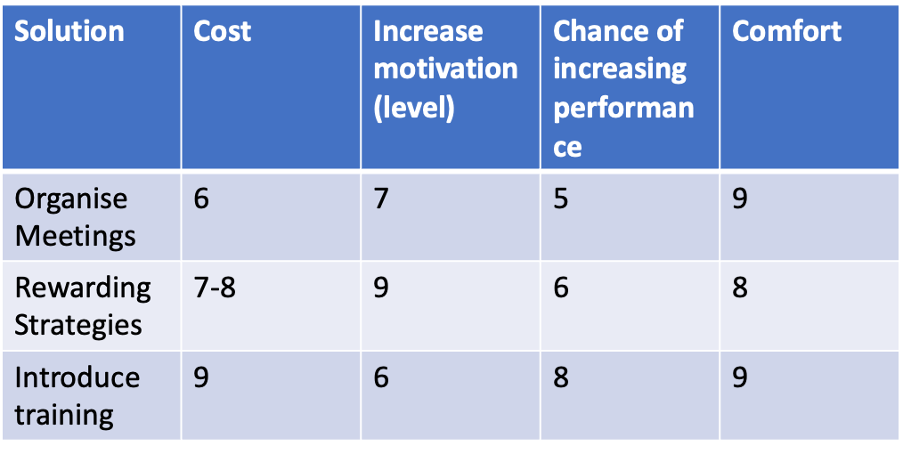
As the grid attached in the above table discusses, the main conclusion to draw is that all the proposed solutions would be effective on different levels, however, the most effective strategy that the company could apply has to do with training. By introducing training, the employees will become more confident with the work they do.

Conclusion

In conclusion, the issue is extremely complex and may result in fatal outcomes if the necessary approach is not taken. In any case, if the organization stringently follows the given arrangements and consequently keeps a suitable degree of examination and consistent control to monitor what is going on consistently, upgrades in representative way of behaving and work execution are noticed to be increasing. In addition, the medical field has advanced to the point where there is no longer a labour shortage in relation to the number of people who need nursing care and the level of care they require. This has had a positive effect on the number of people who need nursing care. The worst thing ever.

The bibliography

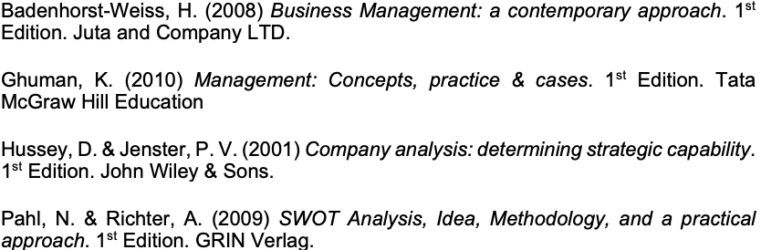

Appendix One: Fishbourne Diagram



