

Rhys Ratner (1803424)
Materials Engineering
Assignment 1

Plastic has thousands of uses, its versatility, and virtual indestructability, practically unmatched in the world of synthetic materials. According to a report from the Guardian newspaper, an estimated 8.3 billion tons of plastic has been produced since the 1950s, and only 9% of it has been recycled.

As a direct result of founding research from India in 2006, The Department of Transport recently announced a £1.6 million UK trial of a plastic road technology developed by the Scottish company MacRebur, to help contribute to the management of the recycling of plastics, whilst drawing upon the durability of the product.
Task:
- Evaluate plastic, considering physical, mechanical, and chemical properties, as a material for use in civil engineering projects. Your evaluation should draw upon the development of Thermoset, thermosetting and Elastomeric polymers.
- Analyse the application of waste plastic materials in road construction, giving examples of its design methodologies and incorporation, from case study, both national and international.
- Critically evaluate the materials practicality, functionality, and future potential in this application, with reference to professional opinion, both positive and negative.

Table of Contents
- Introduction……………………………………………………. Page 3
- Plastics……………………………………………………………. Page 4-6
  - – Thermoplastics……………………………………….. Page 4
    - - Properties of Thermoplastics………….. Page 4
  - – Thermoset Plastics………………………………….. Page 4
    - – Properties of Thermoset Plastics……. Page 5
  - – Elastomers…………………………………………….. Page 5
    - – Properties of Elastomers………………. Page 5
- Plastics in Road Construction…………………………. Page 6
  - – Construction Methods…………………………… Page 6
    - – Wet Process…………………………………. Page 6
    - Dry Process…………………………………….. Page 6
  - – International Solutions………………………….. Page 6
    - – United Kingdom……………………………. Page 6
    - – India……………………………………………… Page6-7
    - – Ghana…………………………………………… Page 7
    - – The Netherlands…………………………… Page 8-9
- Critical Analysis……………………………………………… Page 9
- Conclusion…………………………………………………….. Page 10
- References…………………………………………………….. Page 11-12

- – Introduction
Plastic is one of the most widely used materials on the planet. It’s properties as a material makes it a versatile material. Plastic is also one of the wort materials to negatively impact the environment. In the essay, research, and an evaluation of the properties of plastics will be carried out, drawing upon their use as a civil engineering material. How plastics are used to construct roads will be researched and how several countries have adopted this method of road construction to try and turn the tide on the effect of waste plastics. After evaluating plastic as a civil engineering material and reviewing the properties of plastics, critical analysis will follow discussing practicality, functionality, and the future potential of the use of plastic in road construction.

- – Plastics
Plastic is a widely used material across the world and is used for many different purposes. Plastics are mainly synthetic materials (manmade), made from polymers. Polymers are long modules built around chains of carbon atoms, usually with hydrogen, oxygen nitrogen and sulphur filling the gaps. Poly means many, therefore polymers are by repeating monomers, polymers (many monomers). (Woodford, 2019).
There are 5 main types of thermoplastics.
- Polyethylene Terephthalate (PETE or PET) which makes up 96% of all plastic bottles and containers in the USA.
- High Density Polyethylene (HDPE) which was originally used for pipes, drains and culverts but is now used for a variety of products.
- Polyvinyl Chloride (PVC) which is what is mostly used for windows and doors.
- Low Density Polythene (LDPE) this is uses for packaging and containers.
- Polypropylene (PP) which is used for clothes, medical applications and constructing cars.
(Technologies, n.d.)
There are also other plastics we use such as nylon, fibreglass, polycarbonate, and acrylic which are used for products such as DVD’s, eyeglasses, and exterior light fixings.
  - – Thermoplastics plastics
Thermoplastics are resin that is hard at room temperature but becomes soft upon heating. The two processes used to mould thermoplastic is usually injection moulding or blow moulding, they are poured into the mould and take the shape of that mould when melted and cool into the required shape. One of the main properties of thermoplastics is that they are reversible, which means they can be reheated and remoulded into a different shape. The flip side of this property is that they are more prone to softening, deforming, and losing some of their other physical properties when exposed to extreme heat. (Matmatch, n.d.).
The main ways to process thermoplastics is by extrusion moulding, vacuum forming, thermoforming, and injection moulding. (Matmatch, n.d.).
    - – Properties of Thermoplastics
Thermoplastics have many properties that would make them suitable to be used as a civil engineering material and other properties that make them unsuitable.
Some of the physical properties are the melting point of thermoplastics is less than the degradation temperature, therefore the polymers that make up the plastics molecular structure deteriorates before the plastic melts. (Matmatch, n.d.) So, if thermoplastics are exposed to heat they can deform and deteriorate from their properties. (Wikipedia, 2020).
Based on the 5 main types of thermoplastics their density averages at between 900kg/m³ and 1000kg/m³ with the exception of Polyethylene Terephthalate (PET) and Polyvinyl Chloride (PVC) that have higher densities of 1350 kg/m³ and 1440kg/m³. The melting points of those plastics average out at between 120˚C and 260˚C with PET having the highest melting point and LDPE with the lowest. (SubsTech, n.d.)
  - – Thermoset/Thermosetting Plastics
Thermoset plastics, alternatively to thermoplastics undergo irreversible chemical reaction or cure brought by pressure, time and het during the moulding process. Therefore, thermoset plastics cant be reshaped by melting. Thermosets have a strong chemical structure which allows them to keep their mechanical and chemical properties when subjected to a wide range temperature range. (Rebling, n.d.).

The four ways that Thermosetting plastics are produced in injection moulding, Vacuum formed, extruded and rotation moulding. Injection moulding and extrusion are the two most used processes for producing plastic. Injection moulding is a process to produce many the same plastic items. Vacuum forming is used to create shapes that can be pressed into a mould. Extrusion produces plastic using a heated rotator screw creating pipes that can be cut to any length. Rotational moulding is use for producing plastic that is hollow.

    - – Properties of thermoset plastics.
There are many properties that would make thermosetting plastics a good material to be used in civil engineering projects. Thermoset plastics are generally stronger than thermoplastic due to their cross-linked polymer structure (3D). (Wikipedia, 2019)
The physical properties of thermoset plastics are that they have a density in the region 0f 1120kg/m³ and 1550kg/m³. Melamine Formaldehyde has the highest density of 1550kg/m³ (SubsTech, n.d.). A maximum working temperature ranging from 80-180°C, with Epoxy having the highest with 180°C. Due to the high density of thermoset plastics it is a suitable material to be used in civil engineering works.
Some mechanical properties of Thermoset plastics are, a tensile strength ranging from 50-65mpa melamine formaldehyde having the highest of 65mpa. (Soffar, 2019) (SubsTech, n.d.). A compressive strength ranging 140mpa-240mpa with Melamine formaldehyde having the highest with 240mpa.
Most Thermoplastics are resistant to weak acids and alkalis. This would make them a good civil engineering material as the material can withstand the elements of the natural environment.
  - – Elastomeric Polymers (Rubber, Neoprene, EPDM, Butyl rubber)
Elastomers differ from thermoplastics and thermoset plastics as they have a good capacity for great elastic deformation under stress. Therefore, they can be stretched to almost double their original size without suffering permanent deformation. This is due to the polymer chain, which is coiled, interwoven and highly twisted when set. Because of its structure, when an elastomer is stretched the polymer chain will become uncoiled and straight, and when the stress has stopped the chain goes back to its original, coiled structure.
    - – Properties of Elastomers
Elastomers are polymers that possess high elasticity that can be stretched to a large extent. Therefore, they hold properties that make them suitable and unsuitable for civil engineering materials. (Kopeliovich, 2017).
Some of the physical properties of elastomers is that they generally have a density between 850-950kg/m³ apart from Neoprene which is denser with 1230kg/m³. Elastomers also have a max working temperature of around the 100°C mark. (Kopeliovich, 2017)
Some of the mechanical properties of elastomers is that they generally have good abrasion resistance and a high tear strength. Also, Elastomers have an elongation allowance of around 9x their original shape, except for rubber which is only 3x. This is due to their molecular structure which allows them to be stretched to a high degree. (Kopeliovich, 2017)
The chemical resistance of elastomers varies with every type. For example, EDPM and rubber have poor chemical resistance. Neoprene has good chemical resistance and Butyl has good resistance to acid and alkalis but a poor resistance to solvents, fuels, and oils. (Kopeliovich, 2012)
  - – Evaluation
After looking at all the properties of the three different types of plastic groups each group have set of properties. Thermoplastics have good chemical resistance and can be melted and reshaped to any mould. Thermoset plastics are very dense, strong and have an extremely high melting point. Elastomers have good abrasion resistance and can elongate to up to 9x their original size.

- – Plastic as Road Construction
In recent years, the effects of plastic waste on the environment is at an all-time high. Therefore, recycling, and reusing plastic is crucial in the battle against global warming. Due to the increase in global warming. Several countries have started developing ways to use waste plastic as a material in road construction.
  - – Construction Methods
There are a couple ways that waste plastic materials can be incorporated into road construction. A dry process, wet process, and as prefabricated units. (Manu Sasidharan, 2019)
    - – Wet Process
In the wet Process the waste plastic is crushed into a powder form and added to the hot bitumen mix. The powdered plastic is directly mixed with bitumen before the aggregate is added to form the tarmac mix. It is essential that an even mix of bitumen and plastic is used, with a temperature range of 155˚C and 165˚C. it is suggested that 6-8% plastic waste powder is used with the bitumen. (Sahu, 2016) (Manu Sasidharan, 2019)
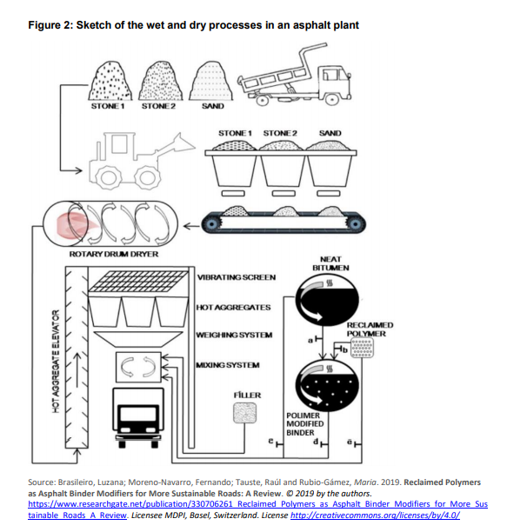
    - – Dry Process
During the dry process, waste plastic is shredded and added to the hot aggregate. It is suggested that the plastic size should ideally be 2-3mm for a better spread on the aggregate. Impurities in the mixture should not exceed 1%. When added to the aggregates they are heated to 170˚C then, the shredded plastic softens and melts to form a coating around the aggregates. The bitumen is heated to 160˚C and gets mixed in with the plastic-coated aggregate. (Sahu, 2016) (Manu Sasidharan, 2019)
The percentage of shredded waste plastic in bituminous mixes should be between 5% to 10% of the weight of bitumen indicated by laboratory tests, with 8% being the optimum percentage.
Compared to the wet process it is proved that the dry process has better properties such as Marshall stability and indirect tensile strength. Therefore, the dry process shows a higher resistance to withstand load and to resist deformation. (Mishra, 2018) (Manu Sasidharan, 2019).
  - – International solutions
It seems that a number of countries have adopted using waste plastic in road construction. The United Kingdom, India, The Netherlands, Ghana, and Ethiopia have all adopted this way of reducing waste plastic. (Manu Sasidharan, 2019)
    - – United Kingdom
A Scottish based company, MacRebur, has developed a way to use waste plastic mixed within the asphalt. The waste plastic was mixed into the asphalt instead if traditional bitumen and has been used by the company on projects in Durham county council and Carlisle Airport. MacReuber has also been involved in constructing plastic roads in South Africa, the United States and Australia. (Begle, 2018)
The UK government has set up real-world tests across 8 local authorities including Kent, Reading, Cumbria, Bedfordshire, Staffordshire, Suffolk, Birmingham, and Buckinghamshire with a £23 million investment. (Department of Transport, 2019)
    - – India
India seems to be the most advanced, experienced when using waste plastic in road construction. India has used waste plastic in road construction of rural roads and national highways and has approved the use of waste plastic as a default way of renewal with hot mixes for roads 50km outside urban areas with over 500,000 population. Some governing bodies like The Indian Road Congress and the National Rural Roads Development have published guidelines for the use of waste plastic in hot bituminous mixes during road construction. (Government of India , 2015)
In the last 18 years, India has used waste plastic to construct more then 2500km of road. It is reported that the roads performed well without potholes, rutting up and ravelling up to ten years later. The root cause of defects in the road is poor binding between bitumen and aggregate but, binding between plastic coated aggregate and bitumen is stronger in comparison to regular road construction. (Mishra, 2018)
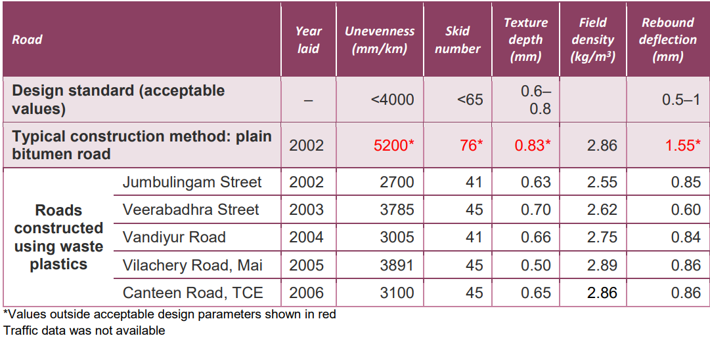

Table 1 - Conditions of roads constructed in India using waste plastic. (Manu Sasidharan, 2019)
According to Vasudevan et al. (2012) a 3 tonne/km reduction in carbon dioxide emissions when a tonne of waste plastic was used every km. (Vasudevan, 2012) (Manu Sasidharan, 2019)
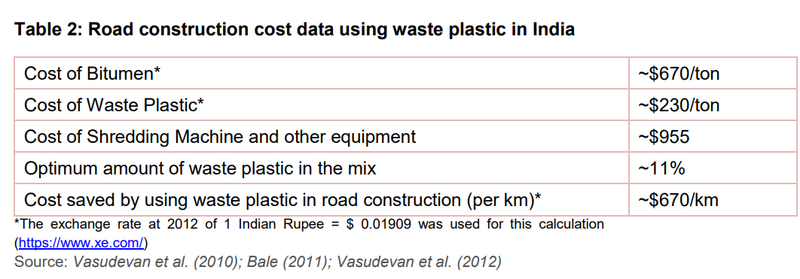
Table 2 - India road construction cost data (Manu Sasidharan, 2019)

    - – Ghana
NelPlast Ghana Ltd, a plastic recycling company based in Ghana, produce pavement blocks from waste Plastic. Ghana’s Ministry of Environmental, Science, Technology and Innovation have approved the pavement blocks and used them in road construction in Accra. (Manu Sasidharan, 2019)
    - – The Netherlands
A Dutch consortium of companies comprising of KWS, Wavin and Total, have developed a concept of using recycled plastic in cycle tracks. (PlasticRoad, 2019). A 30m cycle track has been entirely built from Modular, hollow blocks and prefab units manufactured from recycled plastic. The cycle track is fully operational in Zwolle municipality. (PlasticRoad, 2019) Another cycle track is under construction in the Steenwijkerland municipality. (PlasticRoad, 2019).

- – Critical Analysis
I think that using plastic in rad construction can revolutionise the way roads are constructed in the future. Having said that, using plastic in road construction comes with its own set of challenges. One of the biggest challenges is collecting and storing the waste plastic. Good quality collecting, storing, and cleaning are crucial processes when using waste plastic in road construction Separation is critical because only:
- Films (carrier bags, disposable cups) of thickness up to 60 microns (PE, PP, PS)
- Hard foams (PS) of any thickness
- Soft foams (PE and PP) of any thickness
- Laminated plastics of thickness up to 60 microns
Can be used for road construction (Centre of Innovations in Public Systems, 2014). (Manu Sasidharan, 2019)
Using plastic for road construction also possesses problems when considering Health and Environmental hazards. (Chakraborty, 2017) Identified that when constructing roads using waste plastic materials leaching of toxic components during cleaning which is a chemical hazard. Another chemical hazard is that in the construction process hazardous chlorine-based gases and generated. Having said this, (White, 2019) reported that both hazards did not have any adverse effects and were negligible. (Manu Sasidharan, 2019)
As well as health hazards and sorting waste plastics, there is no regulatory framework in place for using waste plastic in road construction. It is important to establish legal and technical basis for the use of this technology with an adequate regulatory framework. (Mogadishu Municipality, 2018).
On the other hand, there are some advantages to using Waste plastic in road construction. Based on research in India (as seen in Table 1) it seems that when using plastic coated aggregate roads performed better in 4 out of the 5 categories researched. The categories where plastic was superior included Unevenness (mm/km), skid number, texture depth (mm) and rebound deflection (mm). It is also more cost effective to use waste plastic in road construction. As shown in Table 2, in India in 2011, there was a saving of $670 per km. Also, in Ethiopia in 2014, there was a saving of 10.06% per km compared to traditional road construction.
Based on the positives and the negatives of using plastic for road construction I believe that it has a good future potential to be apart of how we construct our roads. As it stands today, it seems that using waste plastic in roads is practical or functional. Based on the evidence of professional opinions there, is not enough infrastructure in place to support using waste plastic in road construction. As it is shown above, there is no framework in place and there are only certain types of plastics that can be used for road construction. Having said that, potentially, this method of road construction can revolutionise the way we build roads. After the research carried out in Ghana and Ethiopia Using plastic in roads saves money and performs better. Also, based on the properties of plastics, both physical and mechanical they would be practical and functional for road construction. Plastics have a high density and a high melting point. This makes plastics adequate for road construction because their properties allow them to physically and mechanically support the requirements to be a material in road construction.

- – Conclusion
To conclude, in the above essay an attempt to review of the properties of thermoplastic, thermoset plastics and elastomers has been carried out, with an evaluation of these properties drawing upon their suitability to be used as a civil engineering material. Also, an effort has been made to analyse the application of waste plastic as a material in road construction. Discussing international application and the different types of constriction methods. Finally, critical analysis has been attempted on the use of plastic whilst considering practicality, functionality, and future potential using positive and negative points whilst referencing professional opinion and evidence.

6.0 - References
Begle, S., 2018. First Road in U.S. Made With Recycled Plastic Paved on Campus. [Online]
Available at: https://ucsdguardian.org/2018/11/04/first-road-u-s-made-recycled-plastic-paved-campus/
[Accessed 9 Novemner 2020].
Centre for Innovations in Public Systems , 2014. Use of Plastics in Road Construction; Implimentation of Technology and Roll out. [Online]
Available at: http://www.cips.org.in/documents/Published_Documents/e-Books/2015/Urban-Governance/Use-of-Plastics/Use-of_Plastics.pdf
[Accessed 17 November 2020].
Chakraborty, A. a. S. M., 2017. Utilization & Minimization of Waste Plastic in Construction of Pavement: A Review. In: International Journal of Engineering Technology Science and Research 4(8). s.l.:s.n., pp. 2394-3386..
Department of Transport, 2019. Technological trials to help future proof roads. [Online]
Available at: https://www.gov.uk/government/news/technological-trials-to-help-future-proof-roads
[Accessed 10 November 2020].
Government of India , 2015. Use of plastic waste in bituminous mixes in construction of National. s.l.:s.n.
Kopeliovich, D. D., 2012. Properties of polymers - Elastomers. [Online]
Available at: https://www.substech.com/dokuwiki/doku.php?id=properties_of_polymers
[Accessed 10 November 2020].
Kopeliovich, D. D., 2017. Elastomers. [Online]
Available at: https://www.substech.com/dokuwiki/doku.php?id=elastomers
[Accessed 10 November 2020].
Manu Sasidharan, D. M. E. T. &. D. M. B., 2019. Using waste plastics in road. [Online]
Available at: https://assets.publishing.service.gov.uk/media/5d41b34040f0b60a86a5e5dc/595_Use_of_Waste_Plastics_in_Road_Construction.pdf
[Accessed 13 November 2020].
Matmatch, n.d. Thermoplastics vs. Thermosetting Polymers: Properties, Processing and Applications. [Online]
Available at: https://matmatch.com/learn/material/thermoplastics-vs-thermosetting-polymers
[Accessed 21 October 2020].
Mishra, B. a. M. G., 2018. Use of plastic waste in bituminous mixes by wet and dry. In: Proceedings of the Institution of Civil Engineers - Municipal Engineer. s.l.:s.n., pp. 1-11.
Mogadishu Municipality, 2018. Somali Urban Resilience Project; Environmental & Social. s.l.:s.n.
PlasticRoad, 2019. A Revolution in Building Roads. [Online]
Available at: https://www.plasticroad.eu/en/
[Accessed 17 November 2020].
Rebling, n.d. Thermoset Plastic Materials. [Online]
Available at: https://rebling.com/custom-molding/thermosets-materials/
[Accessed 06 November 2020].
Sahu, A. a. R. S., 2016. Application of waste plastic materials in road constructio. s.l.:s.n.
Soffar, H., 2019. Thermoplastics properties, types, uses, advantages and disadvantages. [Online]
Available at: https://www.online-sciences.com/industries/thermoplastics-properties-types-uses-advantages-and-disadvantages/
[Accessed 21 October 2020].
SubsTech, n.d. Knowlage source on materials engineering. [Online]
Available at: http://www.substech.com/dokuwiki/doku.php?id=main_page
[Accessed 8 November 2020].
Technologies, S. S. a., n.d. Properties of polymers. [Online]
Available at: https://www.substech.com/dokuwiki/doku.php?id=properties_of_polymers
[Accessed 21 October 2020].
Thomas , n.d. Comparison of Thermoset Versus Thermoplastic Materials. [Online]
Available at: https://www.thomasnet.com/articles/plastics-rubber/thermoset-vs-thermoplastics/
[Accessed 19 October 2020].
Vasudevan, R. A. R. C. S. B. S. a. R. V., 2012. technique to dispose waste plastics in an ecofriendly way - Application in Construction of flexible pavements. In: Construction and Building Materials 28. s.l.:s.n., pp. 311-320.
White, G., 2019. Evaluating recycled waste plastic modification and extension of. Liverpool, s.n.
Wikipedia, 2019. Thermosetting polymer. [Online]
Available at: https://simple.wikipedia.org/wiki/Thermosetting_polymer
[Accessed 08 November 2020].
Wikipedia, 2020. Thermal degradation of polymers. [Online]
Available at: https://en.wikipedia.org/wiki/Thermal_degradation_of_polymers
[Accessed 21 October 2020].
Woodford, C., 2019. Plastics. [Online]
Available at: https://www.explainthatstuff.com/plastics.html#ther
[Accessed 14 October 2020].

