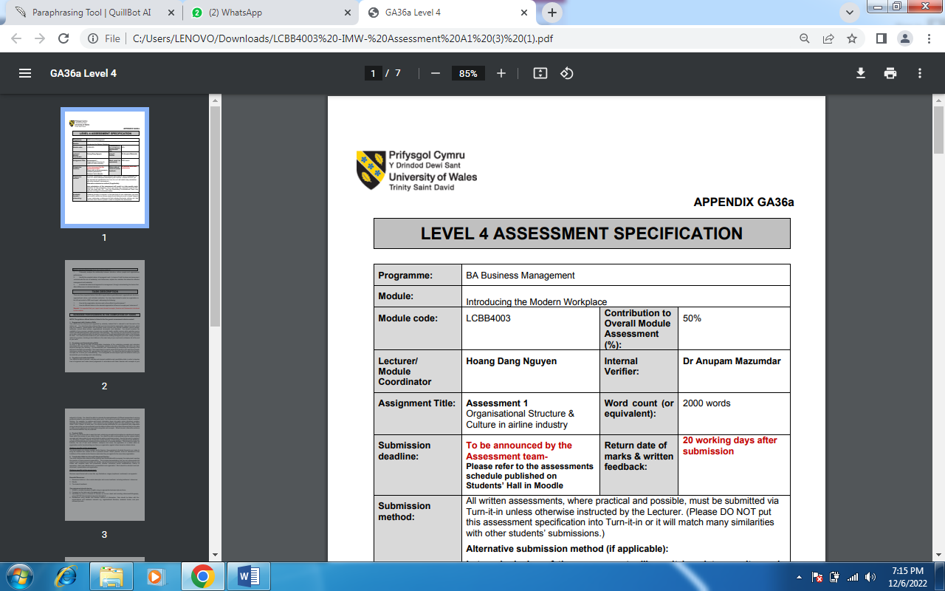

Student Name and ID: Tatiana Prutean 2121754
Module Title: Introducing the Modern Workplace
Module Code: LCBB4033
Lecturer: Aparna Venkatesen

Submission Date 06.01.2023

Table of Contents
Introduction 1
Organizational Structure of British Airways 2
Leadership Style of British Airways 4
Organizational Culture of British Airways 6
Employees Behaviour in British Airways 9
Factors Impacting Employees Behaviour 9
Conclusion 12
Recommendation 12
References 13

Introduction
This document thoroughly describes British Airways' organizational business procedures (BA). This analogy comprises several organizational structure elements, such as organizational design, control structures, management style, leadership style, motivation style, and structural style. This review will serve as an interesting comparison given that British Airways just underwent managerial and leadership changes. The present study will also suggest the suitable leadership styles which need to be adopted by British Airways, and the factors will also be highlighted that impact the behavior of employees in British Airways (Kassem, 2022).
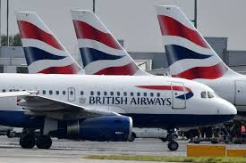
Figure: British Airways
Source: (Kassem, 2022).

Organizational Structure of British Airways
Open Skies, British Airways City Flyer, and British Airways World Cargo are the three subsidiaries of British Airways, a public limited company. The subsidiary transports mail, freight, and passengers. With operations in France and America, Open Skies is a wholly-owned subsidiary of British Airways. In 2008, the subsidiary commenced operations. Despite the rumour that only business class services were provided by Open Skies additionally, it offers an economy class. Due to internal changes in the business environment and outside demands, the aviation market is a competitive industry, forcing BA to change its mode of operating and shift from government to privatize organization. Being a government-run company made it difficult for BA to change its travel fares in reaction to the market. Owners of British Airways are shareholders with different legal identities from the company who purchase shares on the stock market. If the corporation fails to fulfil its responsibilities, each shareholder will retain the share capital they invested in, not their personal property (Cozmuta, 2021). Because the airline is a limited private concern, the government is not involved in its management. Its long-term goals include maximizing profit while concentrating on maintaining and increasing exceptional customer service and rising to the pррosition of the top premium airline in the globe. An organization's organizational structure is crucial because it affects how the organization will operate to achieve its goals and objectives (Kuljanin, 2021). There are many different levels of authority but few managerial levels at British Airways because of its flat organizational structure. Due to how customer-focused its company is, the airline has established a divisional structure. The advantages of this strategy for managers include clear job position identification, shortened decision-making processes, and straightforward department-to-department management. This increases efficiency since everyone has the chance to utilize their varied skills effectively. Still, it can also be inefficient because managers now have many individuals reporting to them, increasing their workload (Tiemeyer, 2021).
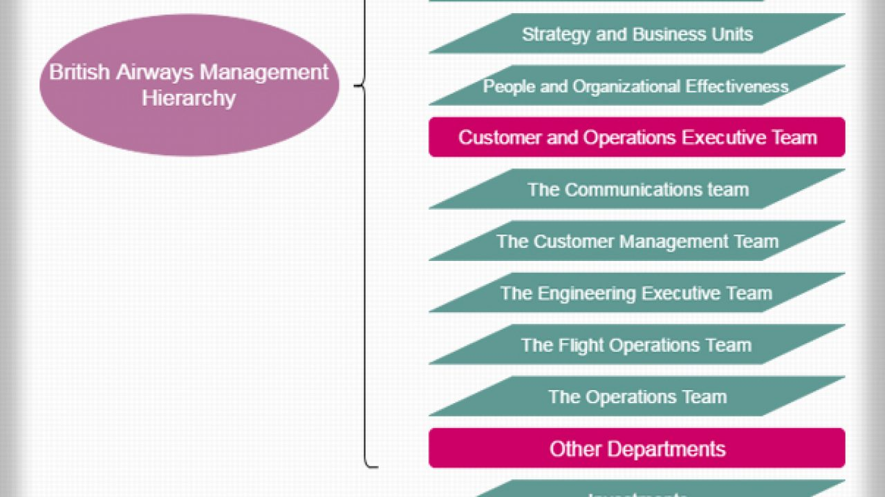
Figure: British Airways Organizational Structure
Source: (Tiemeyer, 2021).

Leadership Style of British Airways
This leadership style also jeopardized the key corporate tenets of customer satisfaction and service excellence. However, due to the reorganization of BA's operations, the brand is now strongly linked to the transformational leadership paradigm. Since the company's previous processes and procedures needed to be fixed, Willie Walsh, its CEO, first employed this leadership style. A reduction in the rigid hierarchical leadership structure was a reflection of the CEO's vision for managing the company effectively. The current organizational structure of BA is rather simple. Top-level management and bottom-level management are separated by just one level (Blissett, 2021). Since it has been so straightforward to convey the CEO's enthusiasm for the company to lower-level employees, this management structure is an ideal match for the company's transformational leadership style. The CEO of the company have come to the point to have the “detail team” for the purpose of getting or attaining the target. We discover that the contingency theory of leadership effectively captures BA's shift in leadership after looking at the change from the autocratic to the transformational leadership style.

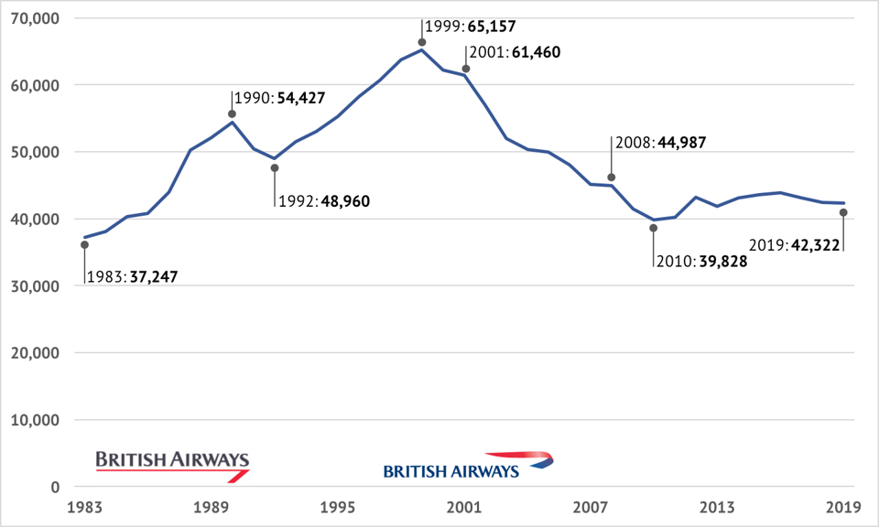
Figure: Shift in Revenue Due to Changing Leadership Style from Autocratic to Transformational
Source: (Blissett, 2021).
At the beginning British airways have used the autocratic theory of leadership but soon by the year 2000 it has switched to the transformational leadership style which have resulted in bringing revolution in the revenue of the company and the organization have made huge success. But later on by the year 2019 the revenue have shown the decline which means that leadership style have to be adopted in such a way that will assist all the situations.
According to the contingency hypothesis, the best leadership position depends on the circumstances (Smith, 2022). According to the contingency theory, leadership style is only ideal for some organizations. Different leadership philosophies are required for various situations. The contingency hypothesis is founded on the idea that followers' loyalty and performance and a leader's abilities all impact an organization's success. When BA first began operations, there was little to no competition and a lot of government regulation. The atmosphere was favorable to authoritarian governance. The company have changed its leadership style from autocratic to transformational after privatization (Martins-Osarenkhoe, 2021).
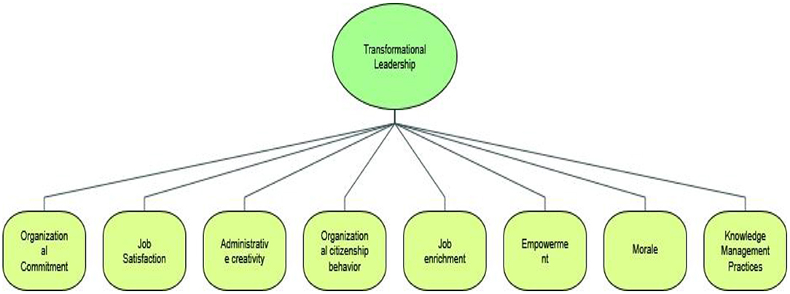
Figure: Transformational Leadership Style in British Airways
Source: (Martins-Osarenkhoe, 2021).

Organizational Culture of British Airways
Companies adopt various organizational cultures depending on their type of organization. The four main types of organizational culture are control, competition (market), and creativity (adhocracy). The collaboration environment is friendly and welcoming. Managers are viewed as the mentors or parents of a vast extended family in an organizational culture that values inclusion highly. In this kind of culture, long-lasting relationships flourish, and cohesiveness within the group is essential. Teamwork, cohesiveness, and involvement are also strongly stressed in this culture because there is a great deal of concern for people. Because of the strong emphasis on "thinking outside the box," the creative culture places great importance on innovation and taking risks. The control culture establishes a highly regulated method of communication between employees and their superiors, distinguishing it from the creative and collaborative cultures (YILMAZ, 2022).BA uses a competitive organizational culture. After the company was privatized, a competitive organizational culture was adopted. Books have noted that while British Airways works to demonstrate its performance, the competitive organizational culture places a lot of emphasis on accomplishments and success. This quest for strong profits is an effort to keep the business afloat in the face of rising employee unrest and escalating shareholder demands (Bernauer, 2022).
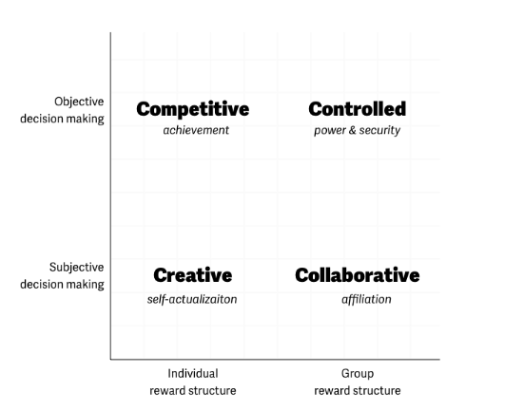
Figure: Types of Organization Culture
Source: (Bernauer, 2022).
BA rewards its employees financially. This motivating framework was covered in earlier parts of this study when BA's bonus program was developed to reinforce the company's operational changes by stressing customer service and quality. The scientific management theory, which Frederick Taylor devised, is defined by this framework for motivation. The idea holds that people are primarily motivated by money. The theory asserts that incentives are required to boost productivity because people are not naturally driven to work. To achieve higher-level requirements like safety and self-actualization, employees must first meet their fundamental needs, according to Maslow's theory of motivation. This theory supports BA's motivational framework. By the way, addressing these needs typically involves expensive upgrades. For example, if a worker already has enough money to fulfil fundamental necessities such as food, shelter, and clothing, they will need more to cover the next degree of need (Cozmuta, 2021).
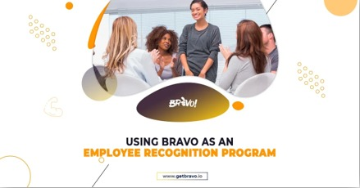
On the other hand, BA updated its grade-based management pay scheme with a new broad-band approach that more closely aligns reward to individual performance and aptitude. However, BA Bravo's recognition program enables it to acknowledge employees across the organization for their efforts and achievements. Employees attempt to raise their productivity to earn larger rewards, which meet higher-level needs. As a result, this motivational dynamic complements BA's motivational architecture. Here, BA and the employees both triumphs.

Figure: British Airways Employee Recognition Program
Source: (Cozmuta, 2021).
Everyone is treated equally and without bias at British Airways, regardless of origin, colour, sex, age, culture, or religion. Additionally, they strive to offer the best degree of client satisfaction consistently. They always provide the highest level of security and foster a friendly atmosphere for each passenger as they board their aircraft. British Airways places a high priority on the health and safety of every passenger, so it is their responsibility to make each one feel welcome and to ensure their security at all times (Connor, 2019).

Employees Behaviour in British Airways
Employee behavior within the organization is a crucial component of the collective behavior of the organization. Employee behavior within the organization is influenced by several factors, some of which are directly tied to the employees and others related to the business's work environment. The following list includes some key elements that affect employee behavior at British Airways.
- The individual's personality determines the behavior of the employees within the organization. It is also connected to professional and personal growth.
- How a person views his responsibilities, and the 2organization's goals and objectives influence their behavior.
- How people feel about their jobs, and their aims and ambitions determine how they behave at work.
- How a person learns determines how they work for an organization.
- Leadership, communication, motivation, organizational structure and culture, group work, peer experience, etc., are among the elements associated with the organizational environment that impact employees' behavior in addition to the previously listed individual characteristics (Kim, 2022).

Factors Impacting Employees Behaviour
Leadership Styles
The leadership style of the CEO directly impacts the performance of an organization. Mr Keith Williams, the CEO of BA, has a unique personality that informs his leadership approach. According to the way leaders think, there are both transformational and transactional leadership styles. British airways use the transformational leadership style; however, they are now proceeding towards situational leadership, which means that every situation demands a different leadership style. The same leadership style must always account for the best solution to every problem. It has been seen that when British Airways switched from autocratic leadership towards transformational leadership, the employees' dealings with the customers changed, and the company's revenue has generated to a great extent. These leadership philosophies have a significant impact on how employees behave (Lee, 2022).
Motivational Theories
As a result of the employees' frequent lack of readiness for such changes, it has been observed that any organizational change within the company encounters various issues. For managers working inside a company, motivational theories are very useful because they allow managers to use the employees' efficacy by adopting any of these theories in accordance with the amount of employee motivation. To encourage employees to perform more efficiently, managers determine the aspects that can aid their productivity and give rewards accordingly. The corporation uses a range of measures to compare wages and other benefits to the external labour market. The majority of UK employees are represented by BA's New Airways Pension Scheme (NAPS) pension fund, which has 35,000 deferred members and pensions in addition to slightly under 34,000 active members (Hong, 2022).
Teamwork
Individuals form groups to gain affiliation, security, power, recognition, the accomplishment of certain goals, etc. Task groups are those organized specifically to complete a specific task. Employees within the group significantly impact each other's behaviour and, ultimately, the group's behavior, which greatly affects the group's actions. Because people learn about different types of cultures in the same setting, diversity encourages innovation and creativity among team members. British Airways has created and implemented a new diversity training programme for management. This consists of a lengthier workshop and a customized e-learning programme. British airways also promoted team-building exercises, and team members learned more about each other's interests, shortcomings, qualities, and strengths using team-building exercises (Bayram, 2022).
Communication
Technology is crucial to the efficiency of the teams working in enterprises. The importance of information technology inside a company is increasing as new technologies are introduced daily since they make it easier for teams to work effectively and efficiently. The following are some examples of technologies that have had a minor impact on how the British Airways team communicates:
Group wares
The firm extensively uses this very helpful technology to schedule meetings virtually. It makes it possible for teams to meet without being confined to a single location.

Email
This example of asynchronous communication enables team members to communicate regardless of their time zone or location. However, using email inappropriately might occasionally prove catastrophic for the team (Liu, 2022).

Conclusion
As it defines the behavior of the processes used in an organization, the behavior of the individuals within it, etc., organizational behavior plays a significant role in the effectiveness and efficiency of an organization's results. The report discusses several organizational behavior facets crucial to understanding organizational behavior. Organizational structure and culture vary, while several elements, including technology, impact teamwork. Managers apply motivational theories in addition to their leadership style to motivate their staff to produce good results. British Airways have attained a transition in its leadership style, such as its switch from autocratic to transformational. It is now in the phase of proceeding towards situational leadership so that a better solution can be attained by implementing a leadership style according to the situation.

Recommendations

British Airways must adopt the situational leadership style so that it will not restrict itself to only one leadership theory and will change its leadership style whenever the situation demands changes. On the other hand, the flat structure of British airways is good because it tends to have a wide range of control over all the activities. Still, British airway has to focus more on the development and learning of the employees, and that’s why the organization have to take the initiative and should promote the coaching of the employees to improve their services. The factors which need to be focused on to sustain the employee’s behavior include effective teamwork, communication, leadership and motivation initiatives. Technology have to be made advance for the purpose of strong communication in this way the behavior of the employee will also become positive.

References
- Bayram, M., 2022. Factors affecting employee safety productivity: an empirical study in an OHSAS 18001-certified organization:International journal of occupational safety and ergonomics, 28(1), pp.139-152..
- Bernauer, V., 2022. Reflections on the evolution of a long-term study of airline cultures: an interview with Albert J. Mills and Jean Helms Mills.:Equality, Diversity and Inclusion: An International Journal..
- Blissett, E., 2021. Phil Taylor and Sian Moore (with Robert Byford), Cabin Crew Conflict: The British Airways Dispute 2009–11.
- Connor, G., 2019. The British Overseas Airway Corporation: A History.. s.l.:Air Power History, 66(4), pp.60-60.
- Cozmuta, A., 2021. Selling ‘The World’s Favourite Airline’: British Airways’ privatisation and the motives behind it.. s.l.:Business History, pp.1-20.
- Cozmuta, A., 2021. Selling ‘The World’s Favourite Airline’: British Airways’ privatisation and the motives behind it.. s.l.:Business History, pp.1-20..
- Hong, S. S. M. J. S. a. K. T., 2022. Analysis of airline employees’ perceptions of corporate preparedness for COVID-19 disruptions to airline operations.:Transport Policy, 119, pp.45-55..
- Kassem, R. S. A. a. G. C., 2022. CSR, credibility, employees' rights and legitimacy during a crisis: a critical analysis of British Airways, WizAir and EasyJet cases.:Employee Relations: The International Journal, (ahead-of-print)..
- Kim, S. W. A. H. H. a. Y. M., 2022. How does the COVID-19 pandemic influence travel industry employees in Hong Kong? Structural relationships among airline crew’s job-related stressors, mental health and other consequences.:Asia Pacific Journal of Tourism Research, 27(1), pp.69-85..
- Kuljanin, J. K. M. B. B. M. N. a. R. M., 2021. The effect of LCC market entry on dominant FSC's price into long haul sector: A case of Norwegian competition on British Airways' prices on selected transatlantic routes:Journal of Air Transport Management, 91, p.102016..
- Lee, C. J. E. K. S. P. J. a. P. Y., 2022. Impact of perception of COVID-19 on NPI, job satisfaction, and customer orientation: Highlighting three types of NPIs for the airline industry.:Journal of Air Transport Management, 100, p.102191..
- Liu, J. T. Y. L. S. T. Z. H. L. a. Z. J., 2022. Compliance with COVID-19-preventive behaviours among employees returning to work in the post-epidemic period.. s.l.:BMC public health, 22(1), pp.1-10.
- Martins-Osarenkhoe, C., 2021. Exploring Participative Leadership Improvements Executive Leaders Need to Manage Effectively in Babcock University, Ilishan, Ogun State (Doctoral dissertation, Colorado Technical University).
- Smith, L., 2022. Midwife at Britain’s Rebirth?: The British Overseas Airways Corporation and the Projection of British Power (Doctoral dissertation, The University of Essex)..
- Tiemeyer, P., 2021. Phil Taylor and Sian Moore, Cabin Crew Conflict: The British Airways Dispute 2009–11 (London: Pluto Press 2019).. s.l.:Labour: Journal of Canadian Labour Studies/Le Travail: revue d’Études Ouvrières Canadiennes, 87, pp.208-210..
- YILMAZ, R., 2022. Evaluation of organizational ethics in terms of businesses: The case of Virgin Atlantic Airways and British Airways.. s.l.:International Journal of Aeronautics and Astronautics, 3(2), pp.98-109..

