

Assignment Title: The use of atypical contracts in an organization.
(Zero-hour contract)

Student name- Tiamiyu Hamza
Student No- 1504813
Module Name- Managing People
Module Tutor- Dr Mushfiqur Rahman

Executive Summary: The advent of the zero-hour contract has generated so many controversies in recent time. It becomes even more so controversial depending on the angle at which you are viewing the subject. While the employees scream exploitation though still lapping up the flexibility it affords, the employers are saving cost by not entering into any specific contract with employees and are able to fill unstable vacant posts with fewer formalities.
With the argument so far generated from both sides and in order to protect their corporate image, some companies are of recent moving their staff who are on zero-hour contract into a more stable specific contract working hours. While this might not signal the death knell for the zero-hour contract, we might see its modification to give it a more friendly face.

Table of Contents:

1.0 Introduction:
2.1 Critical Review of Literature
2.2 Knowledge and understanding of the contracts
2.3 Analysing atypical employment contracts (Zero hours or Part-time)
2.4 Practical applications and development of the contracts
2.5 Skills and professional practices
3.0 Conclusion
References:
Appendix:

1.0 Introduction:
Globally, there has been massive loads of people employed on temporary contracts, commonly known as atypical, such as zero hours, part-time and term time in the last few years. This, without doubt, is a common occurrence in countries such as the United Kingdom where the availability of temporary and part-time work has led to flexibility in the labor market and this, in turn, has helped in keeping the unemployment rate down during the period of recession (ibe, 2015).
In line with the assignment, the zero-hour contract will be carefully examined in the view of companies that uses them and their pros and cons enumerated both for the workers and the employers alike.

2.1 Review of Literature
In line with other writers on this topic, the Office for National Statistics (ONS) agreed’ there is no single definition of what zero-hours contracts are’. While some contracts are explicitly called zero-hours contract, other definitions are available elsewhere. However, the common factor in all the definitions is the inability to guarantee a minimum working hours’ (Anon., 2017)
While agreeing with the above, the CIPD viewpoint defines zero-hours contracts as an agreement between two parties that one may be asked to perform a task or work for another, but there is no minimum set contracted hours. They went further by saying, unlike what is available in another employment contract, a zero hours contract offers no guarantee of work. According to them, many employers make use of such contract to cover work fluctuation and likewise, many individuals also find it to be a suitable working arrangement (Anon., 2017).
Flynn and Lockett 2017, writing in the sun newspaper categorized a zero-hour contract as a casual contract that allows companies to employ staff without any assurance of continued work. Employees only work when their services are in need and little notice is given before shifts.
Writing in the House of Commons briefing paper, Pyper and Brown 2016, agreed that many companies in the retail and hospitality industries are increasingly taking on staff on zero-hours contracts – a situation where people make themselves available to work as at when required but have no guaranteed hours of work. This according to them provides the employer with a pool of people who could be basically described to be ‘on-call’ and can be used at the snap of a finger. They went on further that while as an employer under the zero-hour contract, you are not obliged to offer work nor are the workers obliged to accept any work you offer them, they reminded the employers that, it is important to be aware of the provisions of the National minimum wage regulations which state that workers on ‘standby time’, ‘on-call time’ and ‘downtime’ must still be paid the national minimum wage if they are at their place of work and are required to be there. This in essence means, it is against the law to ask employees to ‘clock off’ when things are quiet but required to remain on the premises. They both agreed that zero-hours contracts may suit some people who want occasional earnings and are able to be entirely flexible about when they work. However, the unpredictable nature of working times means that there won't be job or hours for everyone (Pyper & Brown 2016).
See appendix 2.

2.2 Knowledge and understanding of the contracts
To show its widespread usage among companies across the Uk, Wallace 2017, writing in the Telegraph asserted that close to a million British workers are employed on zero-hours contracts. Quoting from the office of National Statistics, he concluded that there are 1.7 million zero-hours contracts across about 905,000 workers at the end of 2016. This means an average worker has 1.8 jobs at any given time.
By extension, zero-hours presently accounts for 2.8 percent of all people in employment in the country and the contract as we have already known does not offer any guaranteed working hours and can, therefore, lead to highly variable employment and pay from week to week with staff working on an average of 25 hours per week.
See appendix 1
2.3 Analysing atypical employment contracts (Zero hours)
Flexibility
This type of contract is most suitable for those who don’t want to be engaged or bolt down to the 9-5 kind of job, people who demand flexibility in their day to day working life. These could be students and working mums who find this kind of contract a great way to work. It enables them to turn down hours when they are busy or when they are on holiday (Sambas, 2017)
The opportunity of working different jobs at the same time:
The beauty and the luxury offered by this contract is the opportunity to work at different jobs simultaneously. This became possible through the legislation which came into force in May 2015,” prohibiting employers to enforce an exclusivity clause which restricts workers to work for other employers” (Sambas, 2017)
Field Experience:
The experience and skills gained in any role be it zero-hour or otherwise could become useful as an addition to CV. This would definitely favor the employees when in search for future roles as continuous history of work experience could be established.
The possibility of a permanent contract:
It can provide an opportunity for easy access to work for that company you really want to work for if no fixed contract or full-time available.This can, in turn, lead to a permanent position.

Extra pay:
Since there are no fixed hours, a key advantage here is the chance or opportunity to do as many extra hours as available translating into more pay for the individual.
Free Time:
Again, lots of free time are available for personal improvement. Zero-hour contract will give you that much needed time to obtains skill and qualifications needed to pursue a new career since the individual is not on full-time contract (Sambas, 2017)
Unpredictable Hours:
The inability to predict your working hours can be a problem affecting individual life, as planning for social gathering or chores becomes pretty difficult.
Less work than expected and little income:
You might have been promised a certain number of hours at the beginning of the week, this may not be guaranteed and you have no right to complain or do anything about it. This becomes worrisome as it will affect your money planning and your status financially. Obtaining loans and mortgages become almost impossible as a result. In the worst scenario, you can report for work and send back home without ever minding your transport cost.
Poor Communication:
Poor communication and feeling of insecure might emanate as a result of the individual not having the same cordial relationship with his manager as one would have expected in a normal employment.
Ease of dismissal and Increased pressure:
A major disadvantage of the zero-hour contract is the ease at which you can be made redundant and told to go. This is according to the policy of the contract. The emotional impact of this could be enormous.
Although flexibility is offered theoretically by the contract by giving you the opportunity to turn down jobs, many will still pressure you to turn up for a shift at the last minute. While guilt feeling might creep in when turned down, this may affect the possibility of you being called in the future for more hours of work (Sambas, 2017).

2.4 Practical applications and development of the contracts
Among companies using the zero-hours in the UK, the focus of this essay will be on Mcdonald fast food company which has gained undue publicity of recent on this issue of Zero-contract.
According to Ruddick 2017, writing in the Guardian, about 115,000 workers are on zero-hours contract in Mcdonal food outlets across the UK. This, in no small measures, confirms the company as one of the biggest users of this form of contractual work in the country. He termed the contract a controversial one as companies can use it to exploit workers by offering them unpredictable working hours and changing their shifts at short notice.
Staff in its restaurants across the country has complained about their inability or struggling to get loans, mortgages and even mobile phone contracts because of their employment not guaranteed as the week roll by.
According to the staff, paying rent and bills can be a nightmare when you don’t know how much you’ve got coming at the end of each month. Also, planning childcare is almost impossible when you are at the beck and call of employers constantly with no fixed schedule hours of work (Ruddick, 2017)
The scenario above will definitely impugn on the abilities of the workers to perform to their best as they are less motivated due uncertainty of working hours and are not presented the opportunity to work to their utmost desired hours. This is in sharp contrast to the improved performance theory as postulated by Olander and Thogersen (1995).
However, defending the company, the chief executive of Mcdonald’s UK, Paul Pomroy said the vast majority of their employees are happy with their flexible contracts, but agreeing further that some of them have come forward to tell the management that more fixed hours will help them get better and easier access to financial products which had hitherto eluded them (Ruddick, 2017).
Despite this assertion by the chief executive, the company has of recently witnessed mass protest and strike across its many restaurants across the country on this vexed issue of zero-hour contracts. This has forced the company to change or amend its stand and thereby instituted policy, giving the option to staff on zero-hours contract to move to fixed contracts with a minimum number of guaranteed work every week. Staff has been offered contracts in line with the average hours of work they do per week. The company plans to initially extend fixed contracts to about fifty restaurants before rolling it out across the country to existing and new employees as the year goes by (Ruddick, 2017).
This move, no doubt, is a significant development in the debate concerning the zero-hour contract across the country.

2.5 Skills and professional practices:
Before engaging staff on zero-hour, employers must think carefully and come to a decision if this was the best option. If not other forms of employment should be explored which might deliver better benefits than zero-hour. This, in essence, is to prevent embarrassment and protect the corporate image of the organization as zero-hour can only be termed to be fair when the flexibility it banters can work effectively for both the employer and the employee (Cipd, 2017).
It is also very important for organizations to ensure that there are written contracts which spells out the true position, entitlements and what is required of their zero-hours contract staff. This will portray, whether they are seen as workers, self-employed or employees, all of which comes with its attendant benefits (Cipd, 2017)
If a worker is not sure or unclear about what his/her employment status, rights or obligations are under a zero-hour contract, they should ask, as the knowledge of this is the key to the legal protection they will benefit from while working (Cipd, 2017)

3.0 Conclusion:
The debate on zero-hour has been a contentious one of late. This has also assumed political coloration among the major political parties in the United Kingdom. The main focus here is on ‘what are companies using this form of contractual employment doing right and what are they doing wrong. Are they exploiting workers by reducing their labor cost and still enjoys flexibility which it offers, while the individual is left with an unstable job and lack of financial security? In the end, people want to know if the much-touted flexibility actually benefits both the employer and the individual.

References:
Anon., 2017. CIPD. [Online]
Available at: http://www.cipd.co.uk
[Accessed 11 December 2017].
Anon., 2017. Office for National Statistics. [Online]
Available at: http://www.ons.gov.uk
[Accessed 11 December 2017].
Fallon, N., 2013. What part-time economy means for employers. Business news daily, 29 November.
Flynn, E. & Lockett, J., 2017. What are Zero-hours contracts, how many workers are on them and why do employers use them., London: The Sun Newspaper.
ibe, 2015. Fairness in the Workplace: Staffing and employment contracts. Business Ethics Briefing, Issue 47.
Pyper, D. & Brown, J., 2016. Zero-hours Contracts. House of Commons Briefing Paper, 13 April.
Ruddick, G., 2017. Mcdonald's offers fixed contracts to 115,000 UK zero-hours workers, London: the guardian.com.
Wallace, T., 2017. Almost one million Britons on Zero-hours contracts., London: The Telegraph.
Cipd. (2017, December 19). Cipd UK. Retrieved from Cipd website: https://www.cipd.co.uk/knowledge/fundamentals/emp-law/terms-conditions/zero-hours-guide
Sambas, J. (2017, December 15). career addict. Retrieved from careeraddict.com: https://www.careeraddict.com/zero-hour-contracts-pros-cons

Appendix 1:
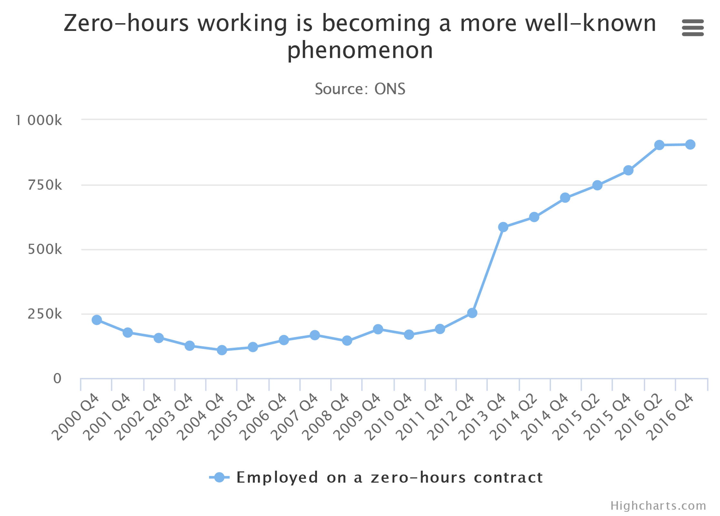From the above, by the end of 2016, close to one million workers were employed on zero-hour contract.
Appendix 2:
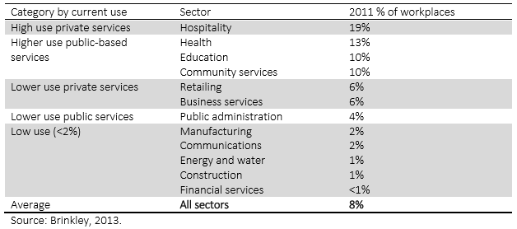

Use of zero-hours contracts in workplaces by industrial sector

