Thomas Rhys Evans
Student No: 1810164
Network Operating Systems and Services (NOSS)
(ACCA5023)
Worksheet 1
Table Of Contents
Heading | Page Number
Part 1 – Practical work | 1
Task 1: Virtual Machine Creation – Server | 1
Task 1: Virtual Machine Creation – Client | 3
Task 1: Operating system install – server | 5
Task 1: Operating system install – client | 14
Task 2: Virtual Network Configuration – Server 1 | 21
Task 2: Virtual Network Configuration: Client 1 | 24
Task 2: Virtual Network Configuration: Server 2 | 26
Task 2: Virtual Network Configuration: Client 2 | 29
Task 2: Verifying connectivity – Server 1 and Client 1 | 31
Task 2: Verifying connectivity – Server 2 and Client 2 | 33
Part 2 – Observational task | 35
a) Hypervisors | 35
b) IPV4 Subnet masking | 35
c) Cloud Computing | 36
i) Storage | 36
ii) Software as a service (SaaS) | 36
iii) Platform as a service (PaaS) | 37
iv) Infrastructure as a service (IaaS) | 37
V) Benefits and drawbacks | 37
d) Terminologies | 37
i) PING | 37
ii) Active Directory | 37
iii)Firewalls | 38
iv) PAE | 39
v) No-eXecute (NX) | 39
vi) OOBE (Out-of-box-experience) | 39

Part 1 – Practical work
Task 1: Virtual Machine Creation – Server
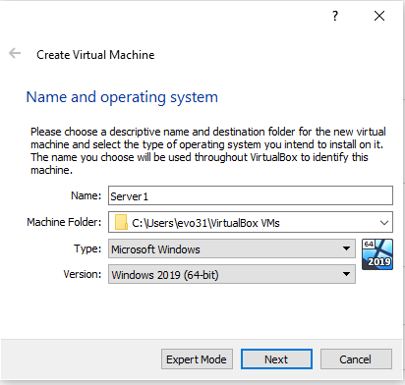
To begin building the environment, we need to create the virtual machines. This will allow operating systems to be installed on these virtual machines, which can then be configured. Initially, the name of the virtual machine is chosen, along with the specified operating system.
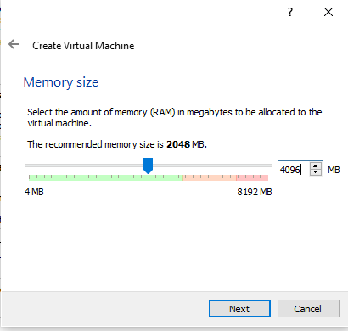
RAM is then allocated to the virtual machine. When creating virtual machines, it is prudent to remember that the host’s hardware is utilised by the guest virtual machine. This means we need to be careful when assigning RAM. We cannot assign more RAM than our host machine has, and we must also be wary of how much RAM we provide each virtual machine, as running too many VM’s at the same time can cause both the host machine and VM’s to become unresponsive.
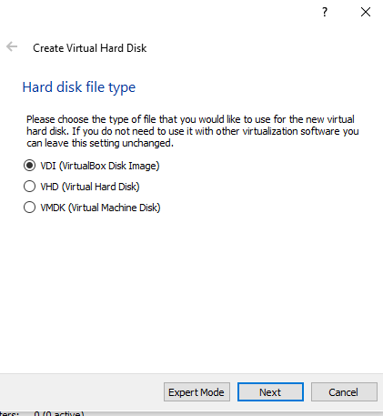
Once RAM is assigned, we also must assign the VM storage space. As before, storage space is provided by the host, so we are limited to what we can assign.
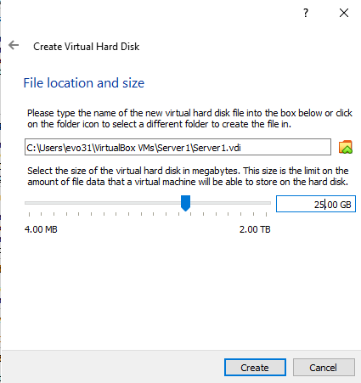
As we are only installing an operating system and little else, a relatively small storage spare of 25GB is applied to the server virtual machines. We repeat this process to create ‘Server2’, leaving us with two separate VM’s ready to install 2 instances of Windows Server 2019
Task 1: Virtual Machine Creation – Client
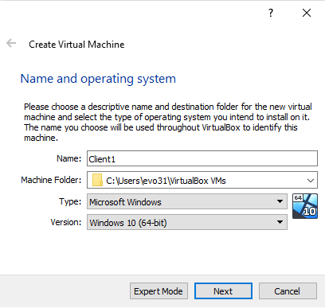
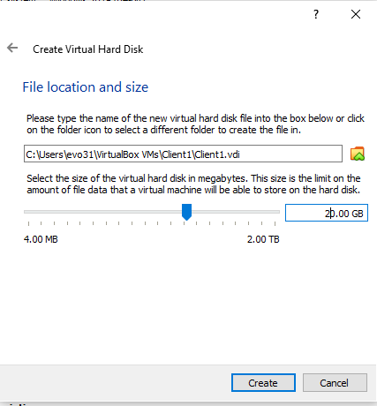
In a nearly identical repetition of the previous process, two VM’s are created, this time in preparation for installing two instances of Windows 10. As before, RAM and storage quotas have to be assigned to each VM. The process is repeated for ‘Client2’, leaving the following 4 VM’s created.
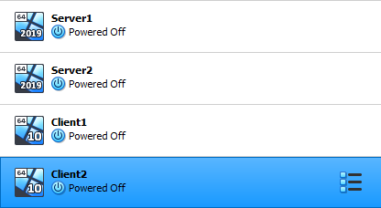
Task 1: Operating system install – server
After creation of the VM, the operating system must then be installed. An image file (.ISO) is mounted within the VM. This is similar to inserting a disc into a physical computer, but in this case, we have no physical disc or computer. Both are virtual.
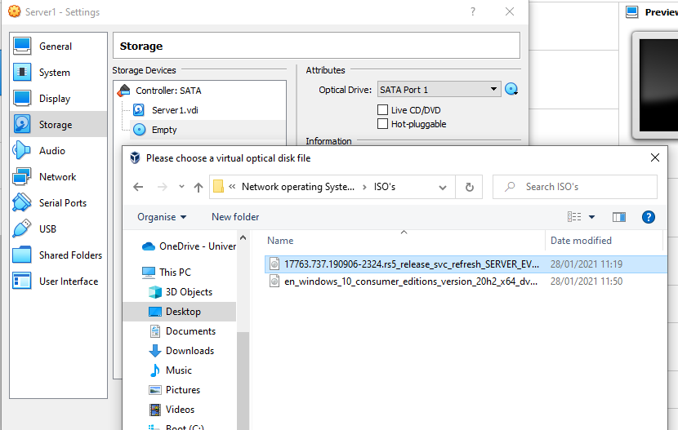
The correct .ISO is chosen, for Windows Server 2019. Before starting the VM, configuration is needed to optimise the VM, allowing it to run at as best performance as possible.
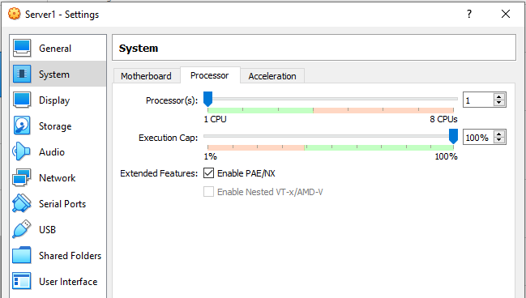
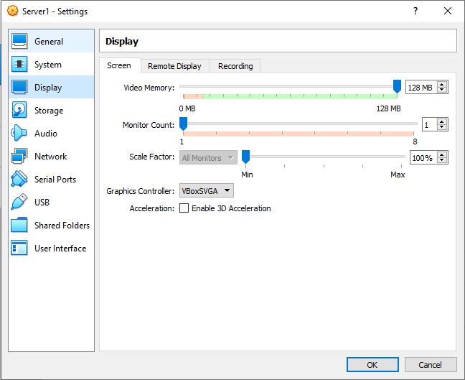
Enabling PAE/NX allows 32-bit operating systems access to more than the 4GB of RAM they can normally use. Increasing the Video memory to 128mb ensures proper rendering of graphics within the VM. Once VM configuration is complete, the installation of Windows itself can begin.
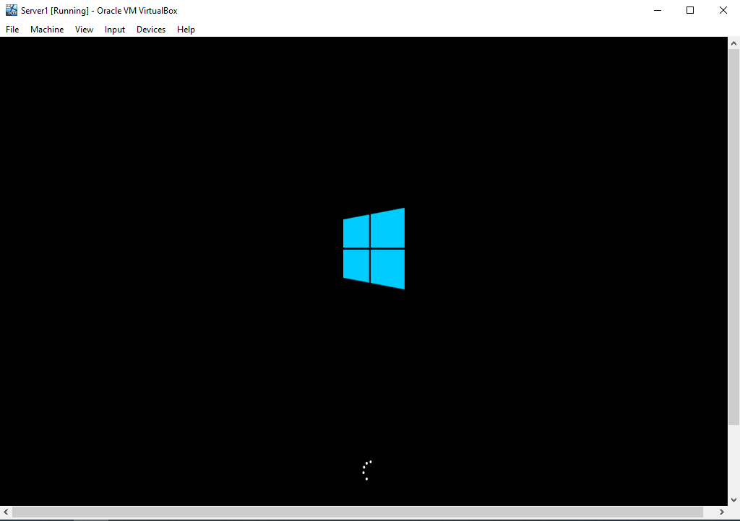
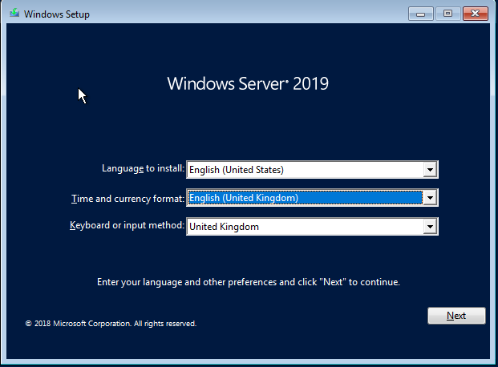
The VM is started and begins to boot. As the .ISO file of windows server has been mounted, the VM uses this to boot, beginning the Windows set up process as seen above. After choosing the applicable keyboard and language settings, the correct operating system must be chosen.

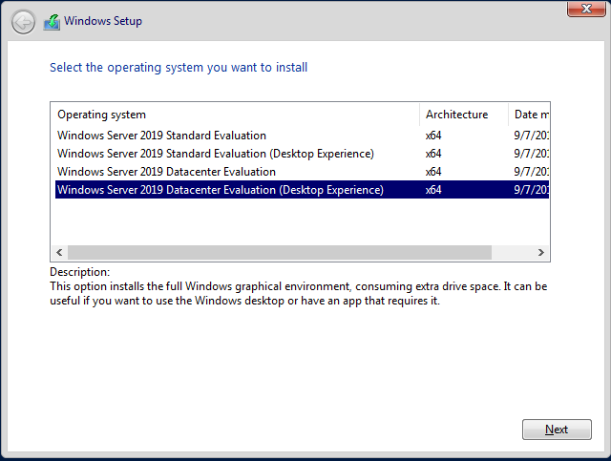
In this instance, ‘Windows Server 2019 Datacenter Evaluation (Desktop Experience)’ is chosen
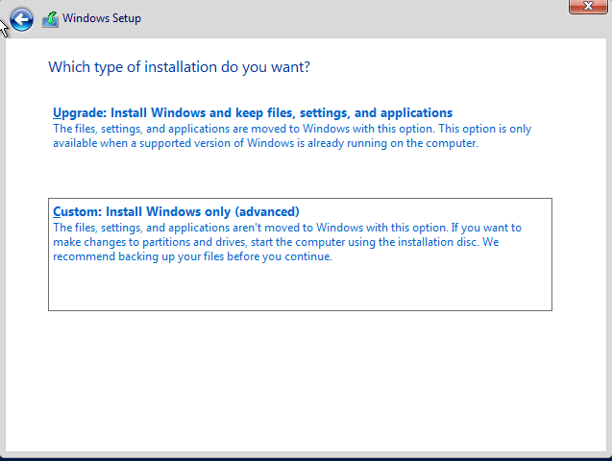
“Install windows only” must be chosen as there is no version of windows already installed on this VM
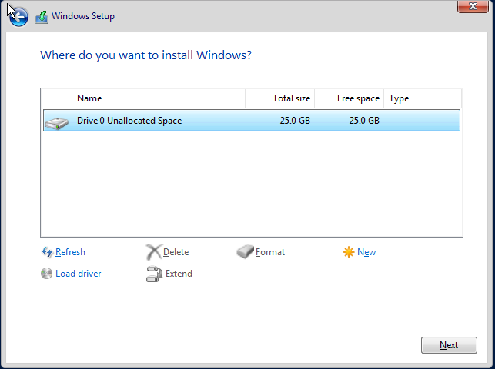
Only one drive was created whilst configuring the VM. This is where the OS is to be installed
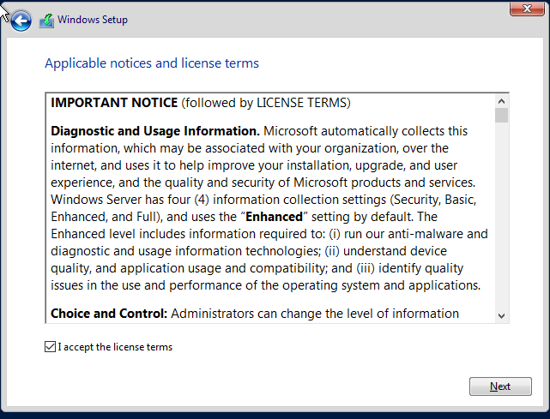
After acceptance of the license terms, the installation of ‘Windows Server 2019’ begins
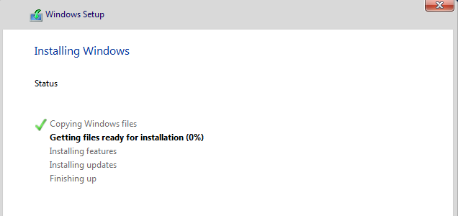
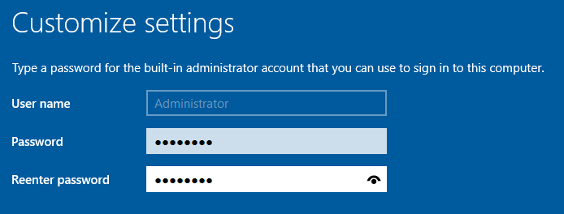
Towards the end of the set up process, an administrator password must be chosen. This is an option that cannot by bypassed. Microsoft force the setting of this password to ensure that the administrator account on the machine is properly protected and not left accessible to everyone who accesses the device.
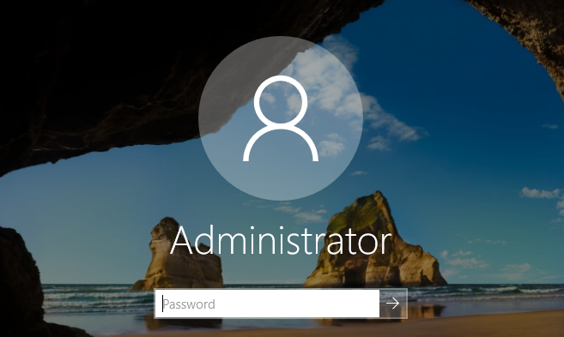
The OS is now installed and the local administrator account is created, allowing the user to log on to the device.
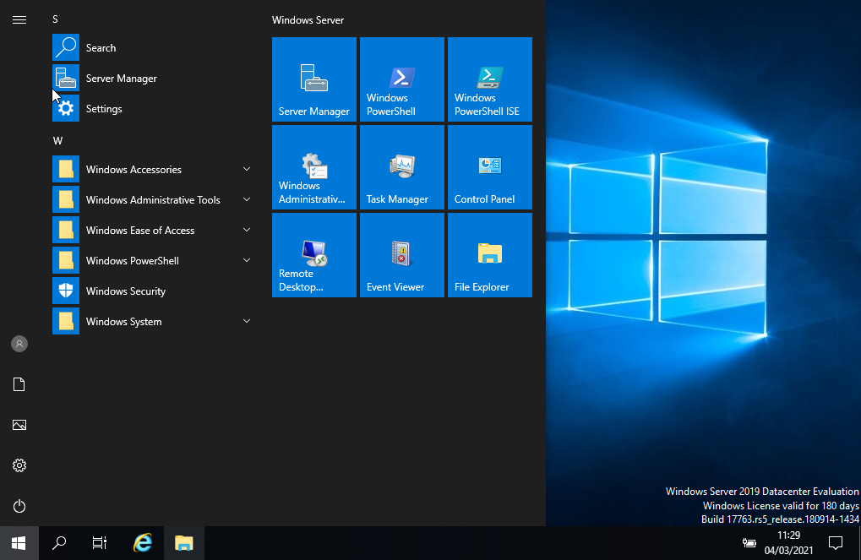
As we can see, Windows Server 2019 has been installed on the VM. The process is then repeated for the ‘Server2’ VM, leaving 2 separate instances of “Windows Server 2019” installed.

Task 1: Operating system install – client
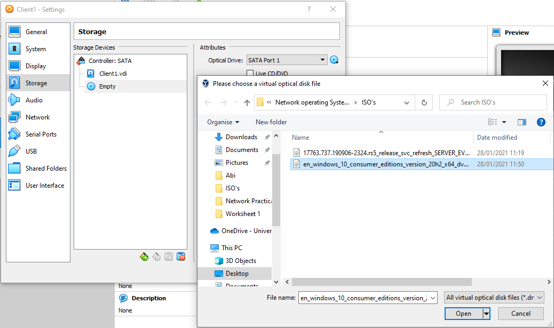
Similar to the server set up process, the .ISO file of windows 10 must be mounted within the ‘Client’ VM’s
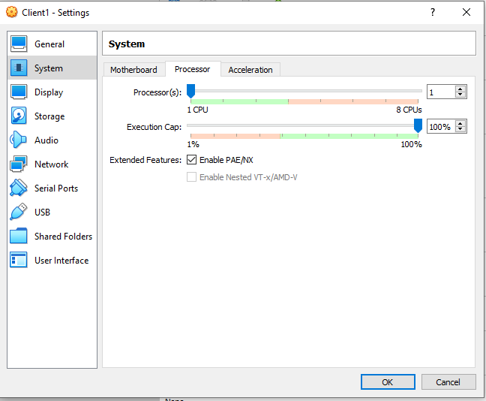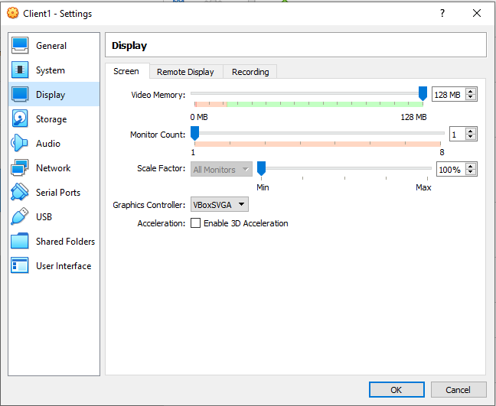
After mounting, the same optimisation takes place before the set up begins
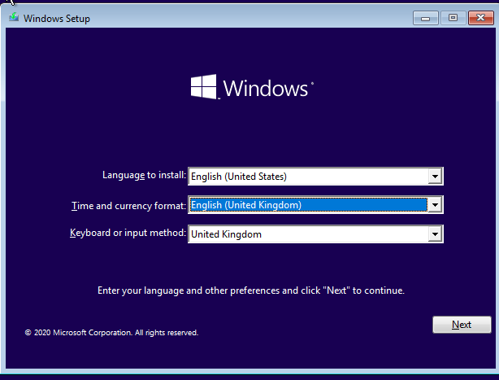
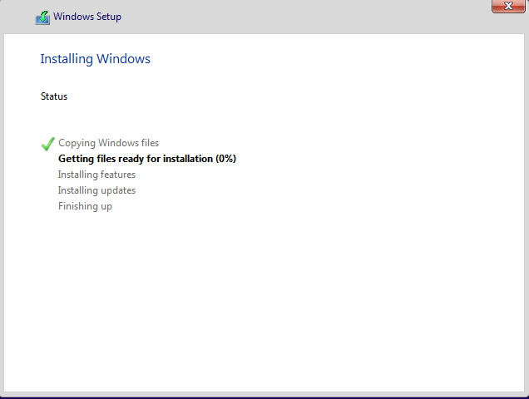
Keyboard and language settings are selected before the installation process starts
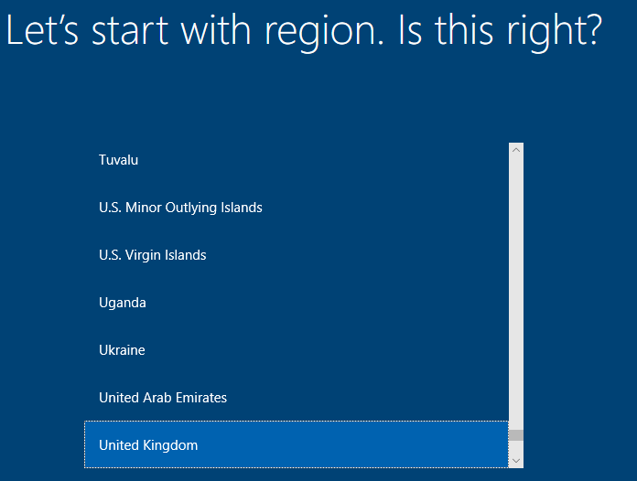
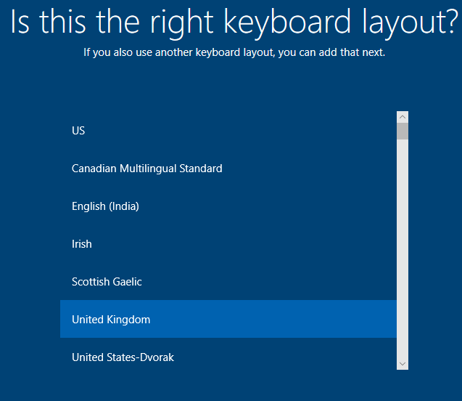
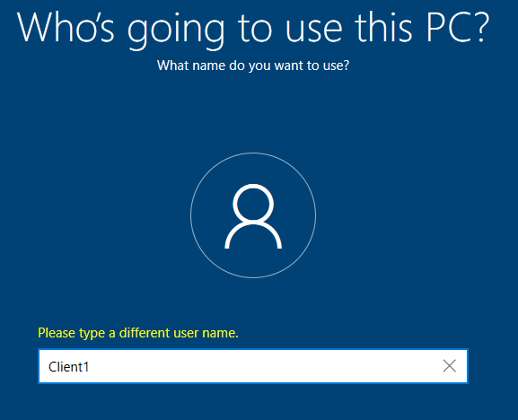
After some slightly different set up configuration steps, Windows 10 is installed on the VM
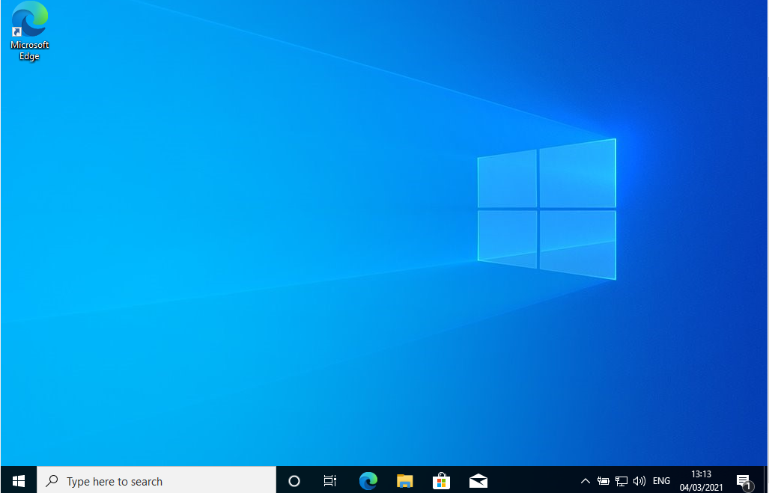
This process is then repeated for ‘Client2’. 4 VM’s now have operating systems installed:
Server1 – Windows Server2019
Server2 – Windows Server2019
Client1 – Windows 10
Client2 – Windows 10
Task 2: Virtual Network Configuration – Server 1
After OS installation, the VM’s are shut down in order to configure network settings.
On ‘Server1’, a network called ‘PublicNet’ is created on adapter 1 of the VM
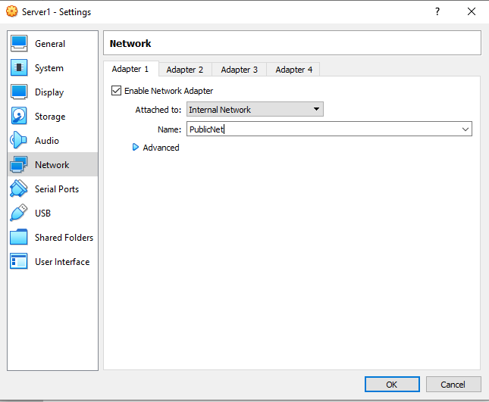
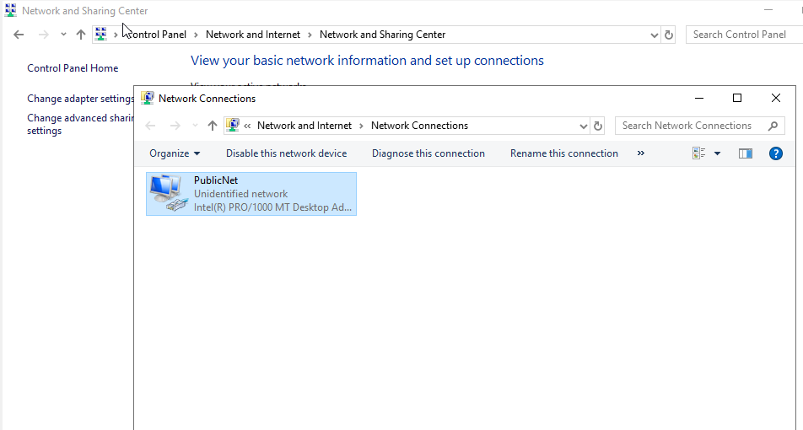
After configuration on the VM, the VM is powered on to allow configuration within Windows itself. The adapter is renamed to match the ‘PublicNet’ naming convention, before IPV4 details are entered into the configuration fields.
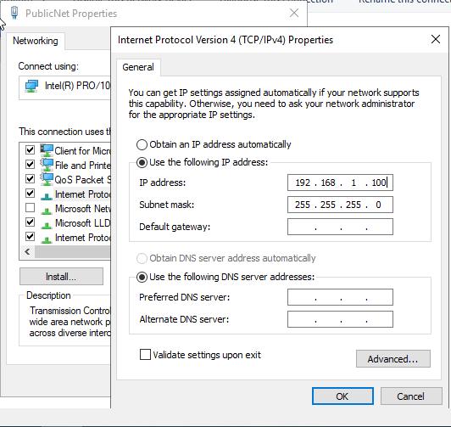
‘Server1’ is to have two separate adapters, with a different network configured on each.
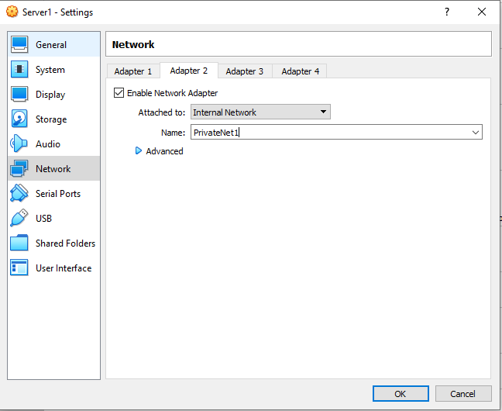
With the VM shut down, adapter 2 is enabled and named ‘PrivateNet1’. Again, the VM is powered on and IP details are configured within Windows
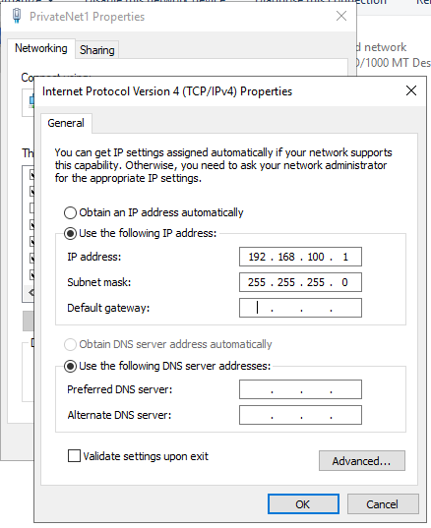
Task 2: Virtual Network Configuration: Client 1
Each client only needs a single adapter enabled. ‘Client1’ will talk to ‘PrivateNet1’ and ‘Client2’ will talk to ‘PrivateNet2’. As before, with the VM shut down the adapter is enabled and named.
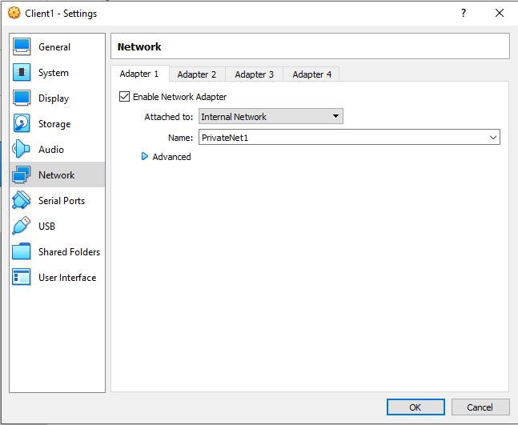
Before the VM is powered on and IP details are configured within windows.
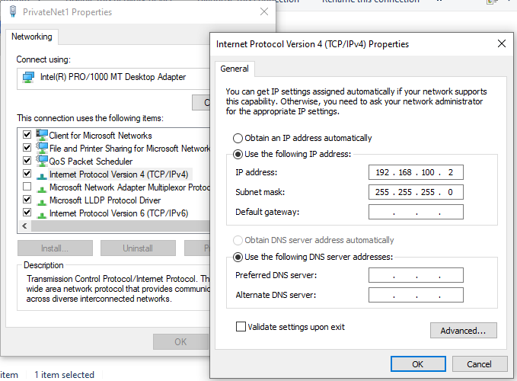
Task 2: Virtual Network Configuration: Server 2
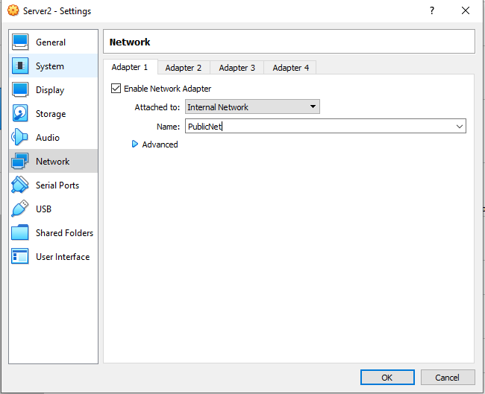
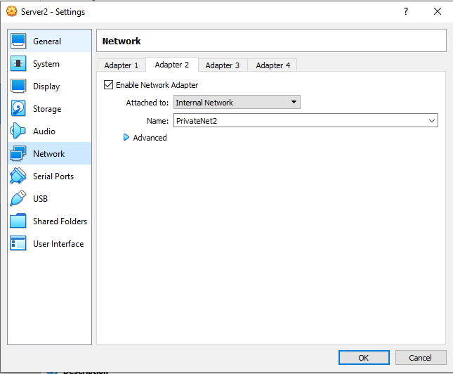
The same steps are followed for ‘Server2’, however ‘Server2’ will have a network called ‘PrivateNet2’ as opposed to ‘PrivateNet1’
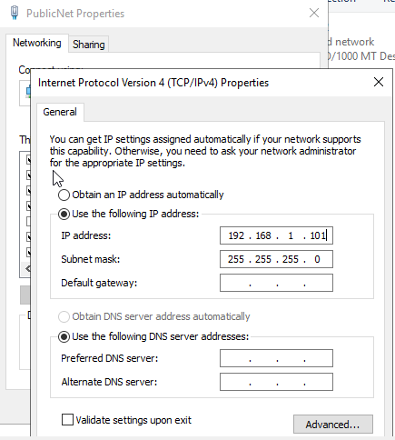

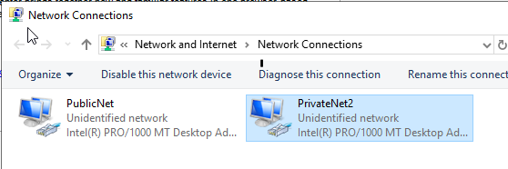
IP details are configured within Windows as above

Task 2: Virtual Network Configuration: Client 2
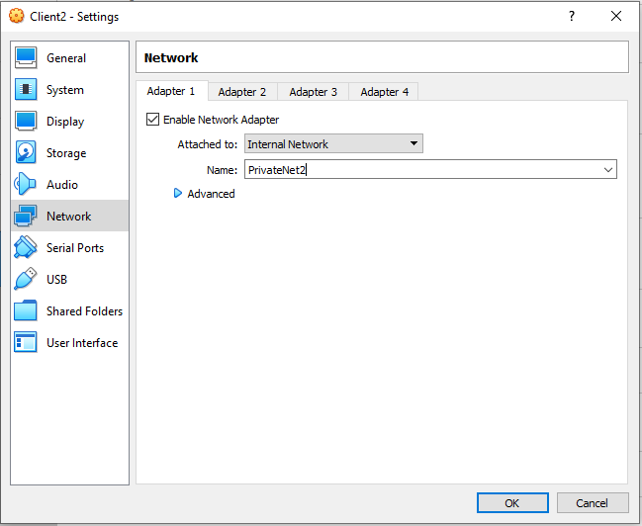
Similarly, as with ‘Client1’, only one adapter on ‘Client2’ is needed, but this time the adapter is on ‘PrivateNet2’. The VM details are configured before the VM is powered on, then IP details can be configured within Windows
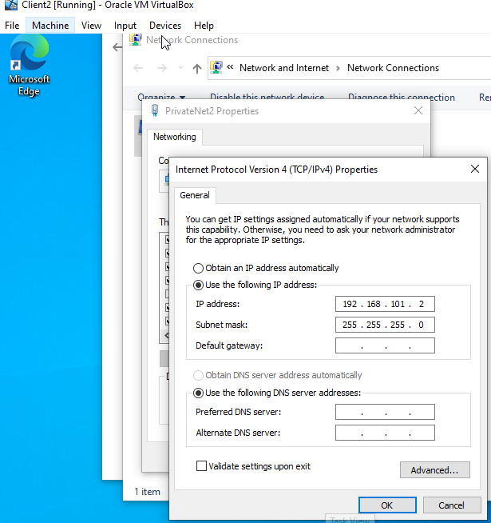
Task 2: Verifying connectivity – Server 1 and Client 1
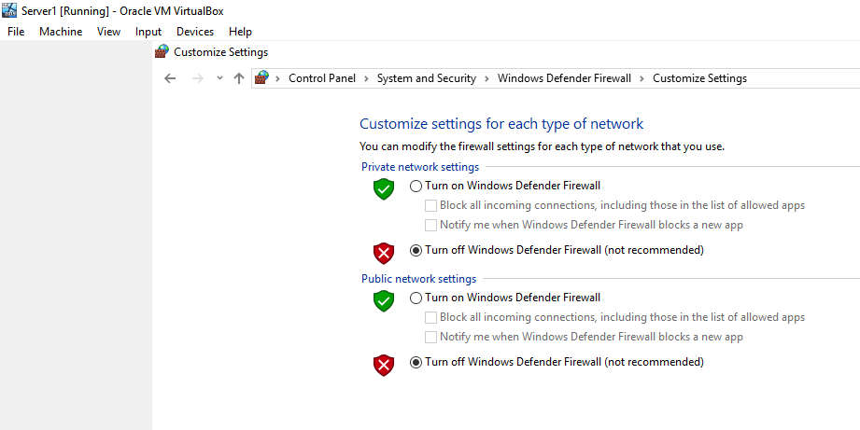
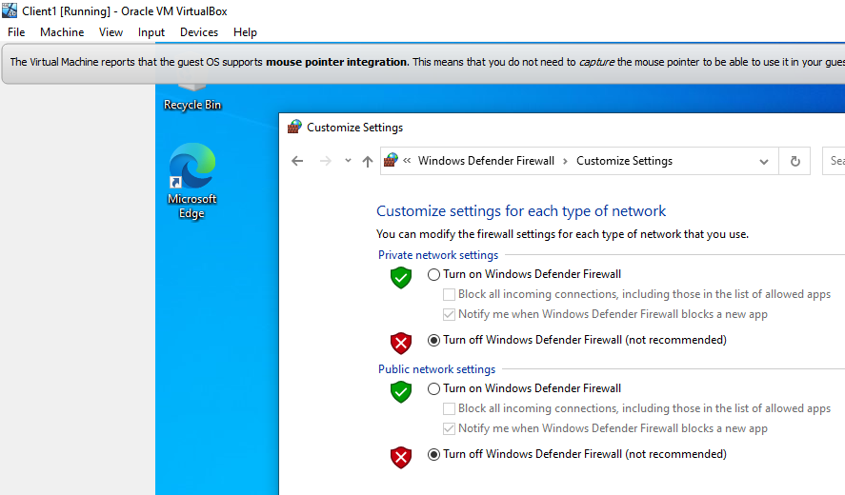
By default, Windows firewall is enabled by Microsoft and as part of this software firewall, ICMP is blocked. This disables our ability to verify connectivity between the server and client VM’s by using ping. To allow verification of connectivity, windows firewall is turned off on all server and client VM’s.
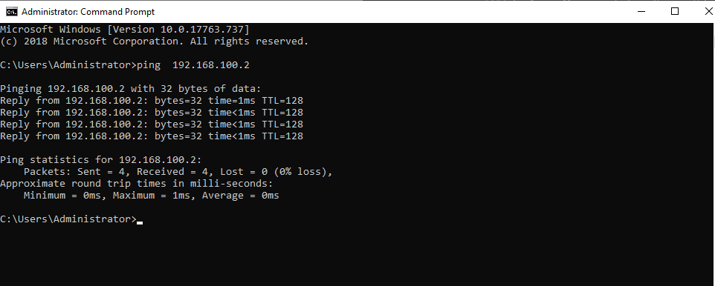
After the firewall is disabled, ‘Server1’ pings ‘Client1’ and receives a reply, verifying connectivity.
Task 2: Verifying connectivity – Server 2 and Client 2
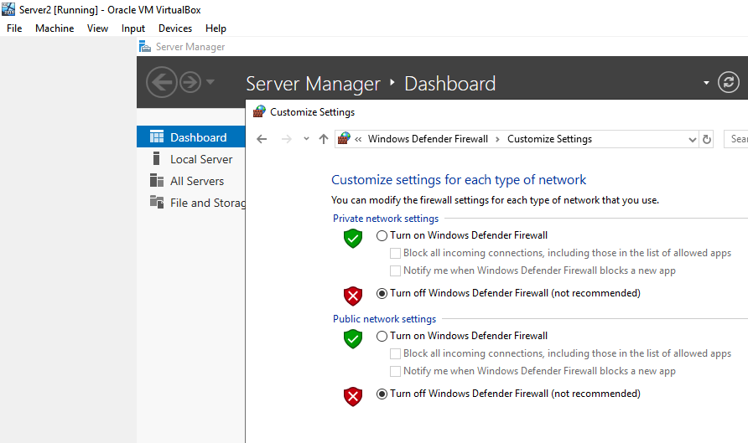
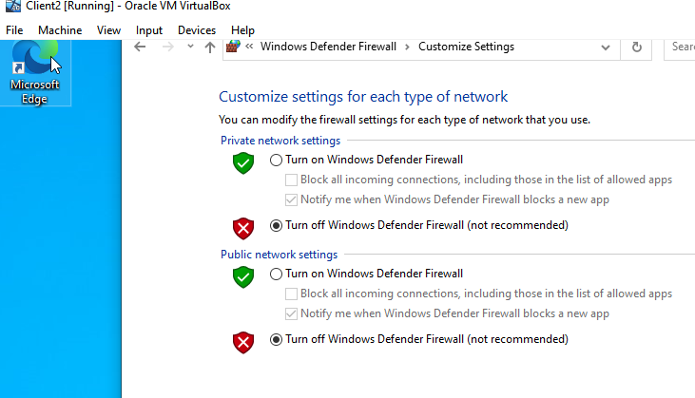
For reasons mentioned above, windows firewall is disabled
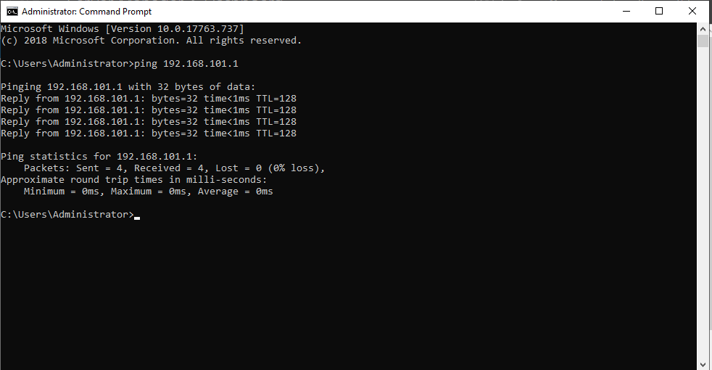
The connectivity verification is completed by performing a ping between ‘Server2’ and ‘Client2’

Part 2 – Observational task
a) Hypervisors
When talking about virtualisation in the world of computing, the role of a hypervisor is to “separate the operating system and applications in a computer from the underlying physical hardware” [1]. By allowing this separation of hardware and software, the host device is able to run multiple virtual machines (VM’s) on the same system.
Hypervisors are divided into two different types, type 1 and type 2. There are a number of differences between the two types, and each offer their own benefits and drawbacks. Type 1 hypervisors, sometimes called “Bare-metal” hypervisors [2], run directly on the hardware of the host machine and can run without the need of loading a host operating system beforehand. As such, this type of hypervisor doesn’t have to contend with any underlying operating systems for access to resources or device drivers and is considered to be much more efficient than type 2 hypervisors. As type 1 hypervisors don’t run an underlying operating system, they are also much more secure than type 2 hypervisors. Operating systems often fall victim to common and newly discovered vulnerabilities. Removing the underlying OS ensures that each VM is completely isolated from the next. If a threat or any other malicious activity befouls a particular VM, then the others will not be affected [1]. Due to their higher security and efficiency, type 1 hypervisors are considered better for uses within enterprise environments, such as datacenters, and some examples of type 1 hypervisors are Microsoft’s “Hyper-V” and Citrix’s “Xen Server” [3]. As with anything that results in higher efficiency though, the cost of type 1 hypervisors and the associated hardware are much more expensive than the free offerings you get with type 2 hypervisors, which often run on personal PC’s. Whereas type 1 hypervisors run directly on the host hardware, type 2 hypervisors require installation on an existing operating system. This means the hypervisor relies on the host OS to “to undertake certain operations like managing calls to the CPU, managing network resources, managing memory and storage” [1]. Examples of type 2 hypervisors are Microsoft’s “Virtual PC” and Oracle’s “VirtualBox”.

b) IPV4 Subnet masking
A subnet mask is used to divide an I.P address into two parts, the host portion and the network portion of the I.P address. An I.P address is a 32 bit number used to uniquely identify a host on a TCP/IP network [4]. Each part of an I.P address is split into 8 binary bits, called an octet. For example. 192.168.100.1. In TCP/IP, the parts of the IP address that are used as the network and host addresses aren't fixed [4]. Without a subnet mask, the network and host addresses of an I.P address cannot be determined. For this, another 32 bit number called a subnet mask is needed. If a subnet mask of 255.255.255.0 is used for the example I.P address above, we are able to ascertain that the network address of the I.P address is 192.168.100.0 and the host address is 0.0.0.1. This is because in binary, 255 equates to 11111111. When this is laid out, it becomes easier to comprehend:
I.P address: 192.168.100.1
In binary: 11000000.10101000.01100100.00000001

Subnet mask: 255.255.255.0
In Binary: 11111111.11111111.11111111.00000000

I.P Address Binary: 11000000.10101000.01100100.00000001
Subnet Binary: 11111111.11111111.11111111.00000000

The bits above in the subnet binary that display the number one denote the network portion of the address and the parts that display by the number zero denote the host portion.

Subnetting allows network administrators to divide networks into smaller sub networks, or “subnets”. For instance, if the network “192.168.100.0” needs to be divided into four equal subnets, then a network administrator can create four network addresses with the subnet masks /26 (255.255.255.192). The binary of this subnet masks is: 11111111.11111111.11111111.11000000 and the four networks created are

Network 1: 192.168.100.0/26
Network 2: 192.168.100.64/26
Network 3: 192.168.100.128/26
Network 4: 192.168.100.192/26

Each network gets 62 hosts allocated and four networks are created from one network I.P address by effectively “borrowing” bits used for the host address and using them for the network portion.

c) Cloud Computing
In recent history, cloud computing has seen a dramatic rise in its use, both within enterprise environments and for individuals. Cloud computing can be widely defined as “the delivery of computing services over the Internet” [5]. Storage services, software packages and even infrastructure such as servers can now be provided to consumers via the cloud.
i) Storage
Cloud storage services allow both individuals and organisations access to large amounts of storage space without the need for large capacity hard drives or numerous pieces of removable media. Products such as ‘Dropbox’ offer individuals 3Terabytes of storage for £19.99 a month [6]. This offers users a much higher capacity for storing their data without the need for purchasing additional hardware and an added benefit for individuals is that these plans can be cancelled at any time. If for any reason the storage capacity is no longer needed, the subscription can be cancelled or in sometimes lowered to a smaller amount, allowing much more flexibility. However, if the cloud service providing the hosting ever becomes unreachable, so does the data. This may result in a period of time where data becomes unusable, or in a worst case scenario, data could be lost permanently.
ii) Software as a service (SaaS)
Software services via the cloud allow individuals and organisations to use applications over the internet. Organisations can rent the use of an application and then users can connect to it via the internet, often over a web browser. “All of the underlying infrastructure, middleware, app software and app data are located in the service provider’s data centre” [7]. Using SaaS allows organisations to rapidly scale their application offerings to staff, whilst leaving the purchasing and maintenance of all other infrastructure to the provider. This is particularly useful for organisations with little on-site infrastructure that need to quickly commission an application with little up-front cost [7]. SaaS services often allow individuals to access the application from any (or most) devices with an internet connection, offering a greater degree flexibility than installing single use pieces of software on individual devices. As with cloud storage services though, if the provider encounters any issues on their end that bring the application down, then all users of that application will be unable to access it. Common SaaS offerings are webmail such as Gmail, Hotmail etc as well as the new Microsoft office product “Microsoft M365” which allows users access to the range of office products but in web app form.

iii) Platform as a service (PaaS)
Platform as a service allows organisations to purchase a “complete development and deployment environment in the cloud” [8]. This type of cloud computing area is mainly used by developers and provides an environment to manage and host applications with access to a range of tools from the platform itself through to support, testing and development [9]. All of the resources, such as server infrastructure, storage space and networking, as well as database management systems and development tools [8], can be purchased on a pay-as-you-go basis, again, minimising upfront costs and allowing organisation to rapidly deploy complex tools to their staff.
IV) Infrastructure as a service (IaaS)
One of the most rapidly expanding areas in cloud computing is that of IaaS. Infrastructure as a service allows organisations to purchase access to server infrastructure and storage space within the cloud, without the need for purchasing any physical hardware. This allows organisations access to what would normally be expensive hardware without the need for any capital outlay or upfront cost. Organisations can also increase, or decrease, their requirements at will, ensuring they only pay for what they truly need, which can also reduce on going costs. Market leaders in this area are Microsoft’s “Azure” and Amazon’s “Amazon Web Services” (AWS).
V) Benefits and drawbacks
No matter what the reason for using cloud computing, from individuals using free storage services, to organisations deploying complex cloud computing infrastructure environments, the benefits and drawbacks are widely the same. Upfront costs are minimised, and sometimes completely removed by implementing cloud computing services. Cloud computing allows for rapid deployment of complex apps, flexible scalability and provides access to data stored in the cloud from a wider variety of devices and locations. Historically security was a concern with cloud computing, but even this concern is being quickly allayed and offerings from companies such as Microsoft, Amazon and Google can often offer more stringent security profiles than most organisations could achieve in-house.
Issues with cloud computing lie in redundancy and bandwidth links between the host site and the cloud provider’s servers. As mentioned previously, if the cloud provider ever becomes unreachable, then so does the access to the data stored there. Also, if the speed of the network link between your site and the cloud provider isn’t fit for use, then transferring data can become an issue. Retrieving data from cloud servers may cause delays in working and cause applications that rely on that data to become unresponsive. If cloud services are used to back up large quantities of data, then trying to restore this data in a disaster scenario over a low speed internet link may result in delays of hours, or sometimes days, in bringing systems back online.
d) Terminologies
i) PING
‘Ping’ is a “network diagnostic tool” used to test connectivity between two nodes, or devices, on a network [10]. From the command prompt, network administrators can verify connectivity by sending ICMP echo request packets to the specified destination host. PING is a widely used network diagnostic tool and can be found in almost all operating systems, such as Linux and MAC, as well as being found in the vast majority of networking tools such as SolarWinds, WireShark etc
ii) Active directory
Active directory is a windows software service used by network and IT admins to store and search or retrieve directory data about objects on the domain. The data stored includes “Information about user accounts, such as names, passwords, phone numbers” [11] as well as objects such as servers, printers and PC’s. Active directory is a Windows only product, but other similar software packages are available for alternative OS’s. These include FreeIPA for Linux [12] and Apple Open Directory for MAC, although joining MAC computers to a Windows domain is possible.
iii) Firewalls
Firewalls are key components in secure networks and can be both hardware, or software only. Hardware firewalls and software firewalls are often used in conjunction with each other to increase security across a network. Cisco are seen as market leaders in networking equipment, and their ‘ASA’ range of firewalls are used by organisations the world over to block incoming and outgoing network traffic via their ports. The higher end models of these firewalls also have integrated intrusion prevention, which can perform rule based inspection on traffic and take automatic steps to prevent malicious or suspicious traffic. These types of firewalls can be installed anywhere that traffic inspection needs to take place. This can be on the boundary of a network, in between separate sites on a network, or even installed directly “in front” of servers or other devices to protect individual machines from unwanted traffic.
Software firewalls differ in the sense that they are installed on a single device. Whereas hardware firewalls can protect entire networks and sites from malicious traffic, software firewalls tend to only protect the single device they are running on. An example of a popular software firewall is the in-built “Windows Firewall” that comes installed on the windows operating system.
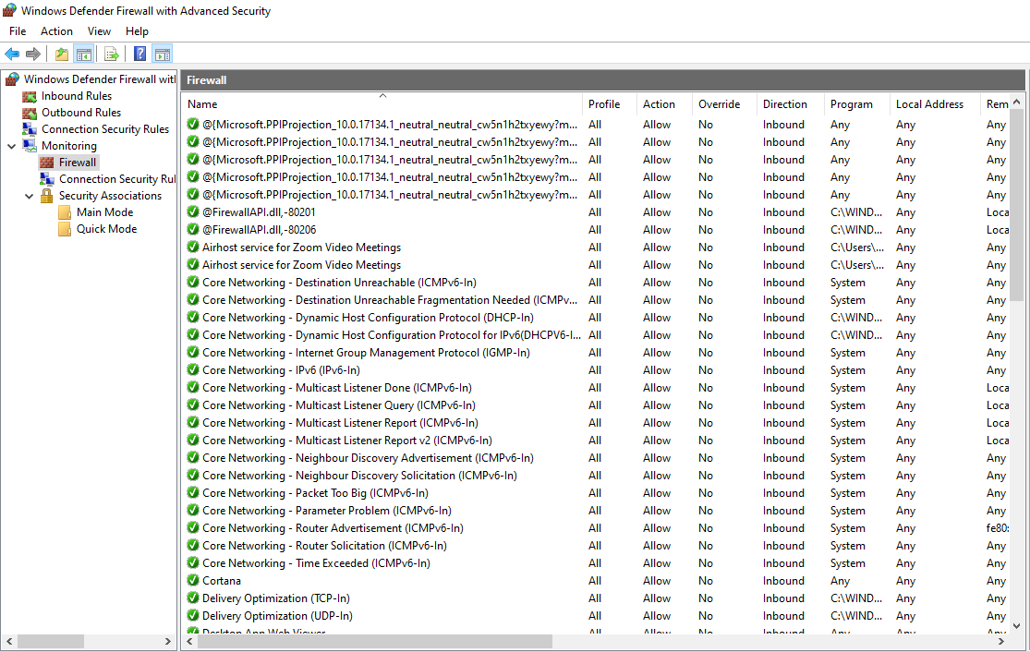
Figure 1 Example of default Windows Firewall settings
Windows firewall will come pre-configured with a variety of inbound and outbound rules to help protect your PC from potentially malicious traffic, an example of this being ICMP. To be able to receive PING requests, this must be allowed through Windows Firewall explicitly, or the firewall must be turned off.
The Linux OS is slightly different, in that the base build is already much more secure than Windows. Whereas Windows will often allow the majority, or all, outgoing traffic, ports on Linux remain closed until they are explicitly opened by the user of the system. With ports closed by default, the need for a software firewall on Linux systems is greatly reduced. This doesn’t mean that software firewalls such as ‘IPTables’ [13] shouldn’t be used on Linux, as anything that can be used to increase security of a device should be implemented if possible, but the need for software firewalls is less than on Windows devices. Apple Mac’s use their own version of a software firewall which is built into their OS, much the same as Windows Firewall.
iv) PAE
PAE is an acronym that stands for “Physical Address Extension” [14]. Enabling PAE within virtual box allows 32-bit operating systems to access more than their normal 4GB of RAM. This is particularly useful for users of higher spec machines who are able to give their VM’s more than 4GB of RAM to operate. This relates to 32-bit OS’s and the fact they can only address a maximum amount of memory equal to 4.3billon bits [15]. Even if every one of these memory addresses was accessed by a 32-bit machine, this equates to a maximum amount of 4GB of memory. Any spare RAM cannot be utilised. Enabling this feature within Virtualbox allows larger memories to be addressed, allowing utilisation of larger segments of RAM than would be possible normally
v) No-eXecute (NX)
NX is a processor feature that “allows memory pages to be marked as non-executable” [14]. This protects the CPU from attacks from malicious software. This feature works by stopping malicious programs from inserting their code into other program’s storage areas and running code from there [15].
vi) OOBE (Out-of-box-experience)
OOBE is the term used for describing what users first experience when switching on their devices after purchase, often including the very first steps they undertake to configure initial access to their system. Users will be familiar with choosing settings such as language and keyboard settings, and sometimes having to manually set date and time, although this often now completes automatically once the device has been connected to a network. Companies such as Windows and Apple have gone to great lengths to make this process as straightforward, quick and painless as possible. On newer OS’s, such as Windows 10 and Apple’s latest OS, users can often simply login to their Microsoft/Apple accounts, allowing the device to automatically sync a wide variety of settings for the user. Windows and Apple devices are often pre-configured to such an extent that the user has to do little to no additional configuration to begin carrying out day-today tasks such as browsing the web or accessing their emails.
Linux is different in this regard. Very rarely do devices come pre-installed with the Linux operating system. It is seen as an operating system used by IT savvy individuals and is often installed manually by individuals after purchase of a device, often running side-by-side, or even in place of the Windows operating system that was there before it. This does not mean that the same principles are not followed, with users being asked to choose settings such as language, keyboard layout and time zone [16], but with Linux, the user is expected to carry out more of the initial configuration by themselves. To the average user, this may seem like a hinderance, but for users more inclined to use Linux OS’s, this is a positive, as it allows for a more granular installation, without unnecessary applications or services being installed without the users knowledge or permission.

[1] | “Medium,” 24 May 2019. [Online]. Available: https://medium.com/teamresellerclub/type-1-and-type-2-hypervisors-what-makes-them-different-6a1755d6ae2c. [Accessed 06 March 2021].
[2] | R. Bhardwaj, “Type-1 vs Type-2 Hypervisors,” [Online]. Available: https://networkinterview.com/type-1-vs-type-2-hypervisors/#:~:text=Type-1%20vs%20Type-2%20Hypervisors:%20Difference%20Table%20%20,%20%20Inferior%20%206%20more%20rows. [Accessed 06 March 2021].
[3] | D. Davis, “top-5-enterprise-type-1-hypervisors,” 12 May 2013. [Online]. Available: http://www.virtualizationsoftware.com/top-5-enterprise-type-1-hypervisors/. [Accessed 06 March 2021].
[4] | “Understand TCP/IP addressing and subnetting basics,” Microsoft, 21 September 2020. [Online]. Available: https://docs.microsoft.com/en-us/troubleshoot/windows-client/networking/tcpip-addressing-and-subnetting#:~:text=A%20subnet%20mask%20is%20used,and%20see%20how%20it%27s%20organized.. [Accessed 06 March 2021].
[5] | Microsoft, [Online]. Available: https://azure.microsoft.com/en-gb/overview/examples-of-cloud-computing/. [Accessed 07 March 2021].
[6] | Drobox, [Online]. Available: https://www.dropbox.com/en_GB/. [Accessed 07 March 2021].
[7] | Microsoft, [Online]. Available: https://azure.microsoft.com/en-gb/overview/what-is-saas/. [Accessed 07 March 2021].
[8] | “What is PaaS,” Microsoft, [Online]. Available: https://azure.microsoft.com/en-gb/overview/what-is-paas/. [Accessed 07 March 2021].
[9] | “Cloud Market Share,” Kinsta, [Online]. Available: https://kinsta.com/blog/cloud-market-share/. [Accessed 07 March 2021].
[10] | “PING,” Techopedia, [Online]. Available: https://www.techopedia.com/definition/2452/ping. [Accessed 07 March 2021].
[11] | “Active Directory Domain Services Overview,” Microsoft, [Online]. Available: https://docs.microsoft.com/en-us/windows-server/identity/ad-ds/get-started/virtual-dc/active-directory-domain-services-overview. [Accessed 08 March 2021].
[12] | “FreeIPA,” FreeIPA, [Online]. Available: https://www.freeipa.org/page/Main_Page. [Accessed 08 March 2021 ].
[13] | “IPtables,” [Online]. Available: https://www.tutorialspoint.com/unix_commands/iptables.htm. [Accessed 08 March 2021].
[14] | “Windows-HArdware,” Microsoft, [Online]. Available: https://docs.microsoft.com/en-us/windows-hardware/manufacture/desktop/paenxsse2-support-requirement-guide-for-windows-8. [Accessed 08 March 2021].
[15] | “When do I have to use PAE,” Superuser, [Online]. Available: https://superuser.com/questions/1118712/when-do-i-have-to-use-pae-nx. [Accessed 08 March 2021].
[16] | “why-the-first-impression-matters,” Ubuntu, [Online]. Available: https://ubuntu.com/blog/why-the-first-impression-matters. [Accessed 03 March 2021].

