Synthesize a Solution to a Potential Real-Life Scenario – Hyper Fort Bring Your Own Device
Mark Huntly (1809693)
ACCA4018 – Internet Technology and Security
10th January 2019

Table of Contents
2 Abstract 3
3 Introduction 3
4 IT consumerism 3
5 Bring Your Own Technology / Device (BYOT / BYOD) 3
5.1 Definition 3
5.2 Why BYOD? 4
5.3 Benefits and Advantages 4
5.4 Challenges and Disadvantages 5
6 BYOT Framework 6
6.1 Online Safety 6
7 Wireless Networks 7
8 Cloud Services 8
9 Data Accessibility and Security 8
9.1 Intellectual property 8
9.2 Staff Access 8
9.3 6.3 Customer Access 9
10 Guidelines on Security 9
10.1.1 Online 9
10.1.2 Offline 10
10.2 Framework Policy 11
10.2.1 User policy and Eligibility 11
10.2.2 Acceptable use Policy 12
10.2.3 Device management 12
10.2.4 Device support 12
10.2.5 Security Policy 12
10.2.6 Leavers 13
10.2.7 Lost, stolen or failed Devices 13
10.3 Data Protection Policy 13
11 Implementation Data Flow 13
11.1 Architecture, configuration and countermeasures 14
11.2 Mitigating Strategy 14
11.3 Device Management 14
11.3.1 Management Software 14
11.4 Results / Findings & discussions 14
12 Conclusion, Recommendation and future work 17
13 References 18

Abstract
Considering the growth of IT consumerism, the growing trend of Bring Your Own Device (BYOD) is hard to ignore. This report looks at what BYOD means and the benefits and challenges, specifically in terms of security. It also looks at vulnerabilities and threats of implementing BYOD and what needs to be considered overall. The consideration is given to a policy for a BYOD framework and how this can protect the company and its employees. It finally looks at the data flow process, the design of a network for BYOD and the mobile device management software needed within the framework.

Introduction
There is a rise in IT consumption, partly due to the perceived status of the company laptop, Blackberry, or more recently, smartphone. As a result, the computing power that is carried around in a mobile device now is more than was available in early desktop computers. This has given way to a phenomenon called Bring Your Own Device (BYOD) or Bring Your Own Technology (BYOT) within the workplace as employers come under pressure to allow employees to use their own devices for business.

IT consumerism
We live in a culture of consumerism, in other words, buying goods to use as and when it is felt they are needed. IT consumerism is the purchase and use of electrical goods such as computers, tablets, smartphones, even e-book readers, smart watches, satnavs, smart TV’s and home assistants such as Google Home or Amazon’s Echo Dot.
As the ‘internet of things’ continues to grow so does the list of IT consumer goods.
Earnst and Young proports that estimates suggest that “in about five years, the number of mobile devices will be about ten billion – one and a half devices for every man, woman and child on planet Earth” [1]. This now means that ownership of devices that will connect to the internet wirelessly is prevalent, as is home wireless high-speed broadband. With the rise in cloud-based services, devices such as laptops, tablets and smartphones provide the ability to work anywhere that a connection to the internet is present.

Bring Your Own Technology / Device (BYOT / BYOD)

Definition
Because of the reasons stated above, more companies are under pressure to implement a policy to allow the use of privately owned devices in a professional capacity in the workplace. This is commonly known as Bring Your Own Technology (BOYT). This is a developing phenomenon which allows employees within a company to use their own mobile devices; such as laptops, tablets or smartphones for example, within the work place. This can also be referred to as Bring Your Own Device (BYOD) [2, 3, 4, 5].

Why BYOD?
As the general consumer has seen company executives with laptops, smartphones and later with tablets used in a professional capacity, this has led to the want for these devices by consumers for general connectivity. Take for example the Blackberry smartphone. These were seen as very desirable status symbols to a degree.
The development of ‘the cloud’ and ‘cloud services’ has aided connectivity, both in a professional and a personal capacity as consumers demand more of and consume more from their personal devices.
As a result of these factors, most people will have their smartphones and mobile technology very close and in some cases in constant use. It is a given, in this day and age, that most employees will have their smartphone on their desks as they work. These devices are used more and more for quick internet searches and tutorials, aiding learning, and also for connectivity both socially and professionally.
For this reason, the perk of a company phone is becoming less desirable as employees prefer to carry one device rather than two and employees feel more comfortable with their own layout and Operating System (OS) to be more productive.

Benefits and Advantages
When benefits, or advantages, to BYOD are considered, there are quite a few that can be thought of. In amongst these are four main benefits to focus on:
- Employee satisfaction – People feel comfortable with their technology now. With a BYOD policy, employees can choose the technology and operating system that they feel most comfortable and at ease with. This can lead to greater efficiency and suitability to a certain task or role. Pillay et al proport that a survey conducted by Acorn Marketing as well as research commissioned by VMWare showed that sixty four percent of employees within multinational companies across the Asian and Australian region said that; “productivity had increased due to efficiency and ease of use by selecting personal devices for work purposes which in turn lead to greater employee happiness and satisfaction”.[2]
- Employee productivity and Data Accessibility – As a natural progression of the first point, it is easy to see that; because of satisfaction, comfortability and ease of use being increased, leading to greater efficiency, productivity increases. Stieglitz and Brockman found that;
“mobile enterprises can increase workforce productivity by providing employees with real-time access to data in various situations (e.g., while in business meetings) and by faster provisioning of ad hoc communication possibilities.”[3]
This eludes to the accessibility of data, from any location with internet connectivity. This allows employees to be able to work ‘out of hours’ or from any location through cloud services, with real time connectivity, accessing emails and other applications needed.
This is backed up by a survey conducted by Capgemini Consulting showed that;
“Mobile workers who use mobile devices for both work and personal purposes put in 240 more hours per year than those who do not.”[4]
- Colleague Collaboration – The advantage of cloud services, aside from accessibility, is the ability to connect and, through these services, collaborate with colleagues whether it be sharing documents, productive conversation or the ability to share and co-author documents across the internet from anywhere. This naturally feeds into the productivity covered in point ii.
- Cost – This point has deliberately been left until last as it is far from the top reason for implementing BYOD and probably the most contended. Arguably there is a cost saving in eliminating the need to purchase end user units. This however could be offset by the cost of infrastructure for a lot of the challenges as seen below as well as assistance in expenses to purchase employee chosen devices and potentially connectivity. [4]

Challenges and Disadvantages
Looking at the flip side, there are several areas to look at that will present a challenge to BYOD. Devices used by employees for business use within BYOD adoption will, in general, be used for personal use also. This arguably could be usage by more than one member of the family, and applications for games and media, as an example, will be installed on the device alongside the corporate applications. This raises several discussion points as follows;
- Social Media – It is a good possibility that a personal mobile device will be used for social media surfing and contact. This includes personal social media such as Facebook and Instagram among others, as well as professional networking social media such as LinkdIn. There could potentially be several issues around social media. The possibility of these sites being used in work time may prove distracting and may need managed for example, however the bigger concern could be data leakage, and this could involve issues discussed in the following points.
- Malware and Spyware – There are many ways in which viruses could infect a device, mobile or otherwise. This could be through malicious websites, social media as discussed using ‘clickbate’ links, emails and more. The larger concern is the protection of personal devices, or the lack of, in line with a company policy. The main concern is the spread of the virus across a network for example or the information that could be obtained through potential spyware and ‘man in the middle’ attacks.
- Data Leaks – Employees own devices being used for business purposes brings the issue of data management and storage. Because of the ability to access corporate data for their day to day tasks, employees’ devices could potentially carry confidential information. Whilst a benefit of BYOD, cloud computing and mobile devices is a better-connected work community, that leads to better collaboration, the risk is in the collaboration tools used and their safety. There needs to be consideration of data leakage through these vulnerabilities.
- Loss of data – Given the assumption that own devices access corporate information, as well as the above there is potential risk of the loss of corporate data. This could be lost through several means, particularly breakage or loss. The breakage of a personal device could be through corrupt files or the physical device breaking or the loss or theft of a device. In the latter scenario, the finder, or thief, would potentially have access to sensitive corporate information and data. This would be a concern.
- Termination of employment / Redundancy of device – The principle of BYOD is that employees use their own devices for business. These devices, therefore, remain the property of the employee. Two scenarios to consider in this situation are an employee leaving the company, whether that be dismissal or resignation, and an employee upgrading a personal device, rendering the old device redundant. The device in question may hold corporate information and data that needs to be removed. In the case of an employee leaving - confidential corporate data is at risk of misuse. In the case of redundant devices – the device may be sold or handed down to a family member as is the case with mobile phones in particular. Here too is the concern for confidentiality.
- Multi-platform devices – A further challenge to consider is the number of different devices and operating systems used. Consider just some of these. In the case of a smartphone, users have preferences towards iPhone, Blackberry, Samsung, Huawei, Sony and many more. Within this constraint there are different operating systems, such as Android and IOS, to name two. Computers can run IOS (apple), Windows (Microsoft) or Linux. This potentially creates a logistical challenge for the support of these devices and operating systems.
- User complacency – Human nature and ignorance to the dangers and threats mean that there can be a complacency on the part of the user. This can range from leaving devices unattended and screens unlocked, opening dangerous apps and websites, not updating operating systems or anti-virus software, to using insecure passwords, or no passwords, or sharing a password with a family member or work colleague. Human interaction is a vulnerability that needs to be considered.
This creates concerning issues for the management of data and IT devices within the company framework. A policy should be considered for each of the risks and challenges involved.

BYOT Framework
The answer to the many challenges faced is to ensure there is a robust framework in which a policy protects and secures the systems, company assets and data and ensures good management and support of the system is in place.

Online Safety
Within this framework it is important to consider, in the main, four key points through all the further topics;
- Availability – There needs to be the availability of a network to connect to, and the corporate data needed to perform a task is readily accessible. This is one of the three key principles in the ‘CIA Triad’, the ‘A’ [5 - 7]. For an efficient operation and productivity, it is imperative that the IT systems used to provide the framework, need to be maintained and managed sufficiently to ensure that systems and data are accessible 99.999% of the time (the five nines) [6].
- Data Integrity – There is an importance for the data used within the business to be true, accurate and complete. This is the ‘I’ of the three key principles of the ‘CIA Triad’, and therefore protecting against any unauthorised modification. Consideration needs to be given to assessing any threats or vulnerabilities and to safeguard against these [5 – 7].
- Data Privacy – The ‘C’ key principle to the ‘CIA Triad’ is confidentiality. It is essential to maintain data confidentiality and to only make this accessible to those with authorised access [5 – 7].
- Authorisation and Authentication – As a result of the above it is essential that there is a robust authentication framework in place and the policy reflects this.

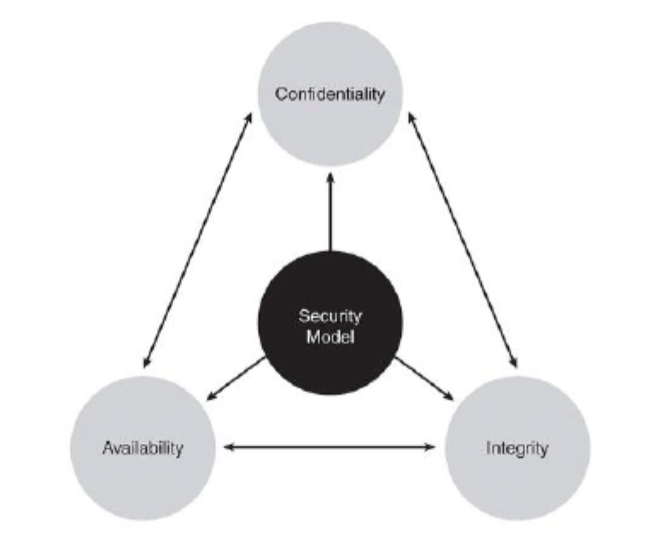
Figure 1 - CIA Triad [7]
There is a need to maintain a secure environment to mitigate threats to the system. It is important to understand where these threats can come from, assess the vulnerabilities within the system, and limit them. These threats can consist of but are not limited to; attacks through malware. This is viruses; executable code that can infect a device, worms; malicious programs that can replicate themselves, trojan horse; malicious code that can sneak into the system under the guise of another program, game or application, ransomware; code that is downloaded which will then encrypt all data files within a system or network allowing attackers to demand a ransom to decrypt the data.
There are numerous ways that vulnerabilities within the framework are exploited by attackers and a good security policy will cover regular assessment and remedies to these. This needs to consider the physical assets as well as the virtual network. Vulnerabilities include but are not limited to; physical interfaces such as USB ports, virtual interfaces such as emails or update reminders, allowing phishing attacks and ransomware attacks etc, open web interfaces or ports and week authentication and passwords.

Wireless Networks
Typically, IT managers have controlled security of the networks by ensuring end user devices are connected through a hardwired network. With mobile devices now taking prevalence through BYOD, the landscape for the corporate network has changed.
To accommodate a BYOD framework, a wireless network needs to be established within the confines of the company premises. This is usually in the form of a wireless local area network (WLAN), using IEEE 802-11 wi-fi [8]. Most end user devices such as laptops, tablets and smartphones, are wi-fi enabled and this should be the standard network interface connection. Consideration now needs to be given to the security of the WLAN and the accessibility by staff using their own devices. All the above challenges and points need to be considered within the framework for this and, once again, the policy needs to reflect this. Protection against potential ‘man in the middle’ attacks and ‘denial of service’ attacks through a breach of the network should be considered. Whilst this is relevant to the WLAN, it is also relevant to the physical wired LAN.

Cloud Services
In the mobile world we live in, cloud computing has become a trend. This is seen in services such as Google Drive, MS OneDrive, Dropbox and others. Cloud computing, or services, allows an on-demand access to data bases, applications and more through a platform on the internet. This same principle allows for cloud services within the corporate environment. By accessing cloud services, staff could work from anywhere giving much more flexibility and mobility.
For clients to access information and commercial applications, cloud services provide a secure solution. [9] [10]

Data Accessibility and Security
As per the CIA Triad, data needs to be available, true and its confidentiality protected. As a result, restricted access and data protection is essential. This should also consider confidentiality of staff and client details as per the ‘General Data Protection Regulation’ (GDPR) [11]. As well as levels of authorised access, data should be monitored and audited to hold staff to account on their use and access.

Intellectual property
The company’s intellectual property, such as the names of products or brands, inventions, the design or look of products or written work, carries a high value and therefore also needs to be protected. This can be done through copyright, patent or trademark [11] however consideration needs to be given to this within the framework. Consideration also needs to be given to who can access and use it and the vulnerability of theft of intellectual property. For this reason, there needs to be authorised levels of access her also, and a form of monitoring, accountability and auditing.

Staff Access
Access control via a system of Authentication, Authorisation and Accounting (AAA) [12]. Authentication is simply identification of a person or device by the credentials provided. Once the person or device has been authenticated, there is a need to account for the resources used and data accessed by the authorised personnel for auditing purposes. It is prudent to consider the level of authorisation given to staff based on position and duties within the company. AAA alongside network access control lists (ACL) [13] will allow for this and cover virtual private networks (VPN) [14] as well as physical network router control.

6.3 Customer Access
The AAA control model should also be used for client access within the cloud-based services provided. Although not accessing the depth of information and data within the corporate environment, it is essential to ensure that only clients are authorised, through online authentication, to access services and information securely. It is also vital to monitor who accesses the services and material offered. Not only does this allow an audit function, but it will allow for monitoring customer activity to offer a better service.

Guidelines on Security
Security should be considered both physically and virtually, across the intranet and internet. It is also important that employees’ devices are secured with password protection as well in case of previously discussed theft or loss for example. Security is the essentially important topic within the BYOD framework. This will provide the protection, availability and integrity of data, and security of company assets.

Online
There are many online vulnerabilities to consider. Cyber criminals or hackers will look to exploit these vulnerabilities to be able to affect a computer system or network [15]. It is these exploits that can lead to the infection of a computer system or a network. Access can be gained in numerous ways including;
- Man in the middle attack – this attack will target the data that passes between end points and is a commonly recognised attack. This can occur by a hacker intercepting a broadcast signal, redirecting all traffic through himself. This would affect data in transfer, potentially risking security, integrity and availability. [16]
- Social Engineering attack – This form of attack targets human weakness. This is done by using manipulation techniques thereby eliciting sensitive information. This can come in the form of phishing, through emails, messaging and social media as well as web advertising, spear phishing, a more precisely targeted form of phishing, whaling, targeting the hierarchy of a business in the same ways and baiting, offering something enticing in exchange for, or to gain login information or private data. [17, 18]
- Sniffing – This attack is like the ‘man in the middle’ attack. In this case a hacker will take a ‘packet sniffer’ tool to detect and tap packets of data travelling across a network or internet, potentially risking its security and integrity. [19]
- Spoofing – In this attack, a hacker masquerades as another user or device to steal data, bypass access control and authentication or even to spread malware. [20]
- Zero-day attack – This is an unknown form of exploit. Hackers have knowledge of a vulnerability which is unknown to developers thereby giving the hackers a free pass to attack any target completely undetected. ‘Zero-Day’ refers to the day developers learn of the vulnerability. [21]
As well as theft of data, threat to the integrity of data and denial of service, there is also the threat of malware through these attacks. Malware (malicious software) can take several forms and can attack a computer and spread through a network. These forms include;
- Virus – This is commonly and, erroneously used as a term for all malware, however, a virus specifically is a malicious executable program that can replicate itself and attach itself to other executable programs. It can be carried over a network or via a removable storage device, attack data in storage and infect your computer file system, RAM, operating systems and more. Different forms include, but are not limited to resident viruses, multipartite viruses and polymorphic viruses. [24, 25]
- Worm – This is a malicious standalone code that can replicate itself and spread through a network, looking for vulnerabilities and causing it to slow down. It will replicate itself by finding a vulnerable host and move on from there in the same manner. [25, 26]
- Trojan – Also known as a ‘trojan horse’, this gets its name from the legendary wooden horse that is sent to Troy by the Greeks with soldiers inside [27]. Using the same principle, the malicious program will masquerade or bind to another legitimate non executable program such as a gif file and gain entry to a device. This has now moved to mobile devices also. Once into a system, this software can delete or damage files, remotely control devices, launch ‘denial of service’ attacks and steal information. [28]
- Logic bomb – This is a piece of code, or program, which is hidden within a main system program or application and is triggered by certain events, to cause harm to a system, such as deletion, alteration or encryption of files. The trigger could be a date or time or a specific function for example. [29]
- Scareware – This is a program that uses ‘social engineering’ [17, 18] and is set to cause shock or anxiety and to scare the user into doing something. This can often pose as a bogus anti-virus program and a pop-up will try to trick the user into downloading the malware or unnecessarily buying software. More worryingly, this could contain a much more dangerous malware called ‘ransomware’ [32]. [30]
- Ransomware – As stated above, this is one of the more dangerous malicious software. This will either lock a user out of their system, demanding a fine or ransom, depending on the form, or more recently, encrypting data files within a system or network with the purpose of demanding a ransom to decrypt the data. Consider the high-profile case of the NHS cyberattack [31]. This threatens the integrity and availability of the data. [32]
- Spyware – This does as it describes. This program will infiltrate a device and steal user information such as personal information, internet usage and more. This is mainly performed through data capture or by keystroke logging [33]. This threatens the security of data. [34, 35]
It is important to be aware of these threats and to ensure best effort is made to protect against them.

Offline
As much of a risk is to only consider online threats and ignore that there can be offline vulnerabilities too. These can include;
- Bluesnarfing – This is a similar process to ‘bluejacking’, sending unsolicited messages to a mobile device using Bluetooth connectivity, or ‘bluebugging’, taking control of a mobile device using Bluetooth connectivity, Bluesnarfing is the theft of information or data from a mobile device via a Bluetooth connection. This affects the security of data. [36]
- Rogue access point attacks – Rogue access points are devices, generally on a wireless network, operating a connection that is not sanctioned for use on that network by an administrator. This could give way to ‘denial of service’ attacks or data theft. [22, 23]
- Shoulder surfing – Consideration needs to be given to who has access to premises and who is within the vicinity of a person using a device. This is exactly as it seems, a possible threat of an unauthorised person gaining password or user information by watching, whether this is in close proximity or using binoculars or like see.
- Piggybacking / Tailgating – This is as simple as an unauthorised person tagging along with an authorised person to gain access to a restricted area. It could be, for example, that a door is held open when an unauthorised person calls out to an authorised person and seems to be in a rush. This leaves a network or hardware susceptible to a physical attack, threatening the security and integrity of data, or allowing deletion, threatening the availability of data.
Taking these threats into consideration, it is important to mitigate as much as possible physical vulnerabilities as well as cyber threats.

Framework Policy
There needs to be some thought given to this prior to employees being allowed to use their own devices. For the reasons above, it is imperative to ensure there is a policy in place to cover the security and use of devices, and that all the points discussed are taken into consideration.

User policy and Eligibility
This section needs to cover the eligibility of the user. Consideration will be given to;
- A user agreement being signed.
- The user being trained in security awareness.
- The user being risk assessed prior to authorisation.
- The owners’ agreement to the device being password protected (this will also be shown in device management policy)
- The owners’ agreement to the device to be set to lock itself after a designated time period.
- The owners’ agreement to keeping the operating system on the device up to date and not jailbroken.
It is also important to consider personal data in this section. This should cover the handling of personal data, and privacy. It should also include accountability, absolving the company of responsibility of personal data in the case of theft, software crash or errors and virus or malware infection. [37]

Acceptable use Policy
There should also be included an acceptable use policy covering the use of the device, both in work hours as well as on and off the premises. This should cover;
- Defined acceptable use, i.e. activities directly or indirectly supporting the business.
- Limited personal communication, i.e. social media, or recreation, i.e. reading and game playing.
- Access to certain websites are blocked during work hours or whilst connected to the corporate network.
- Storage and transmission of data, illicit materials and proprietary information. [37, 38]
By instigating policies as per section 7.1.1 and 7.1.1.1, this should go towards mitigating points i, ii, iii, v, vi and vii within section 2.4.

Device management
This section considers the management of the device by the user and remote management in the event of lost or stolen devices. This will set out expectations for;
- The type of device allowable. (which version Ipad, Iphone, Blackberry maybe).
- The operating system allowable. (which version Android, Apple IOS, MS Windows, Linux etc.)
- The ability to encrypt data. (Consideration to ‘encryption at rest’).
- The installation of mobile device management (MDM) software and cloud use. This will also cover the legal requirements and governance expectation and the risk protection, and that the employee meets the expected standards of security as well as be able to use their device safely, with as little disruption and with an easy mind in a personal capacity.
- Who will check and validate the device? [37, 38]
This will work towards mitigating points ii, iii and vi of section 2.4.

Device support
The support of devices is important for an efficient working environment however becomes logistically difficult for IT support desks due to the variation of devices and software. In this instance there should be consideration given to this in the policy. This should cover;
- Who is responsible for the upkeep and maintenance of the device?
- Updating devices and keeping them updated.
- Who to contact with issues or failures. Should owners contact manufacturer for example. Is IT support outsourced for devices or software help or kept in house? [37, 38]
This will go towards mitigating vulnerabilities of data leakage and protect the company with clear responsibilities laid out.

Security Policy
This section will reinforce a lot of the above however it does go more into detail on the security procedures to protect the company and its employees / clients. Consideration should be given to;
- Authorisation and authentication, at its simplest, password and pin protection on a device.
- Type and strength of passwords and company expectations on what a password includes. This should also consider where passwords are stored.
- Data encryption.
- Client and subcontractor policies.
- Type of information accessed and downloaded.
- Access to company materials and networks including how and where.
- The extent of access to company data and materials.
This covers most vulnerabilities to exploit and the breach of devices and networks. [37, 38]

Leavers
As discussed in point v of section 2.4, whether an employee resigns or has been dismissed, there needs to be consideration given to the company data left on a device, and the employee data held by the company. This section needs to consider how to handle these issues, including the use and remote deletion or removal of mobile device management (MDM) software, and company data, as covered in above policies.

Lost, stolen or failed Devices
Once again, data security is key here, both company and personal data. The device needs to be able to be locked or wiped (all information deleted) should the device fall into the wrong hands. Three areas to consider are;
- As already mentioned, the permission of MDM software, and more importantly the remote management and removal of this.
- A device finding app should be installed so that in the event of lost or stolen devices, they can be traced and potentially remotely wiped to protect personal data.
- The prompt and timely reporting of a lost or stolen device.

Data Protection Policy
Data protection can overlap with several of the above points. However, to be as diligent as possible, and to satisfy GDPR [1], there needs to be consideration given to;
- Personal data that has been provided by owners when signing up to the policy.
- How the mobile device management handles personal data.
- Who will provide and manage or administrate the MDM software and their data policies.
In formulating this policy, research has been made on other BYOD policies as referenced and a policy included in the appendix. [37, 38]

Implementation Data Flow
To consider the implementation of a BYOD framework, a data flow diagram gives a good overview of the process. Having completed a flow diagram, it is shown in figure 2.
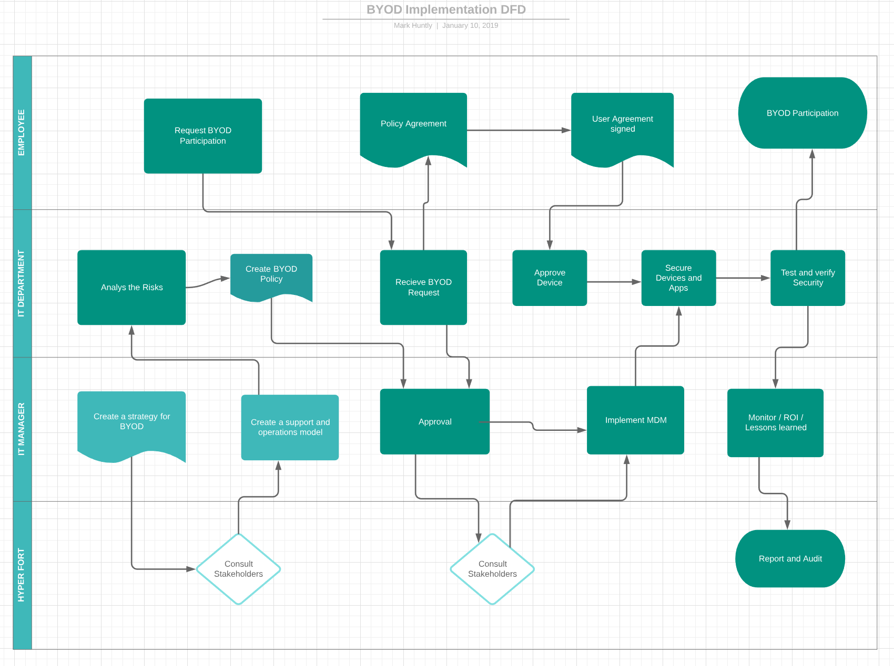
Figure 2 - BYOD Implementation Strategy DFD
Further to this there is also an IT security architecture framework (Appendix 1) attached.

Architecture, configuration and countermeasures
The architecture of the network is a large part of the framework and this needs to include everything discussed within this report. A network topology has been designed and a link provided in the appendix.

Mitigating Strategy
Mitigation of threats and vulnerabilities is highly important in securing a BYOD framework and should be considered as part of a wider information security strategy [39]. Within the policy and configuration of the network, it is aimed to show any strategy to mitigate data loss, leakage and integrity or misuse and allow for router redundancy to mitigate the interruption to network flow. It is also good to hold a separate strategy, itemised in a document for clarity.

Device Management
It is important to look at remotely managing the devices as already discussed. There have been several ways mentioned throughout the report and included in the policy. There needs to be an ability to monitor accountability as well as security measures. There are numerous methods for doing this and cloud software is the most efficient.

Management Software
Device management software has started to become more sophisticated due to the popularity of consumer devices being used in enterprise and BYOD. For the management of company devices, there has long been software such as Blackberry Enterprise Server and Microsoft Exchange Active Sync, however, this lacks the sophistication and capability to manage non-proprietary devices within a BYOD scenario. There is now new MDM software with the sophistication that allows the management of multi-platform devices while offering security functionalities with ““centralized, scalable visibility and control” [39].
With so many products on the market, it is important to consider the individual security and mobility needs and policy of the company and to choose based on alignment of these to the MDM software companies vision and allow smooth integration to company infrastructure and procedure. It will also need to provide authentication and encryption of data. [39]

Results / Findings & discussions
Products to consider are supplied by companies such as IBM, Cisco, VMWare, Microsoft, Intune and MobileIron and more (see figure 3) [40]
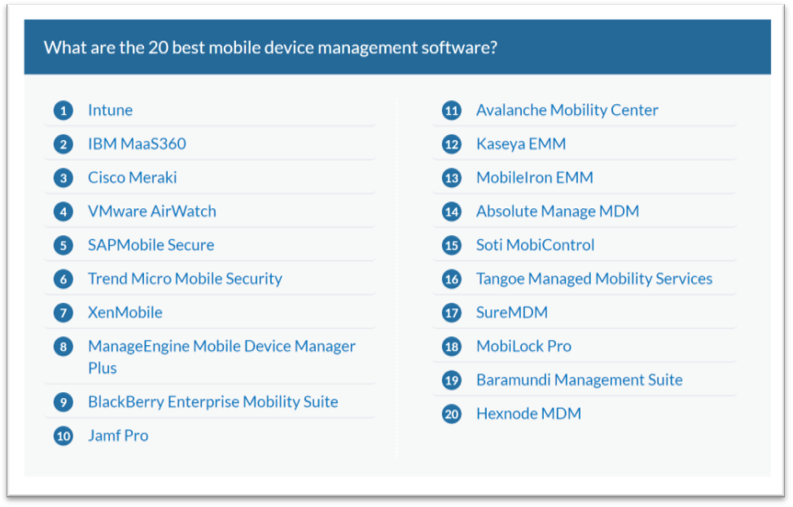
Figure 3 - top 20 best mobile device management software [40]
Intune has the top spot however it is worth repeating that it is important to choose based on the needs of the business and ease of integration and use. Software such as XenMobile or VMware Airwatch, for example, have easy to use interfaces and good reporting and monitoring structure. All these allow the choice of apps to be used or downloaded within the MDM framework. To demonstrate this, highlights from Intune are as follows;
- Mobile device & app management
- Advanced Microsoft Office 365 data protection
- Integrated PC management
- Integrated on-premises management
- Identity & access management
- Information protection
- Identity-driven security [40]

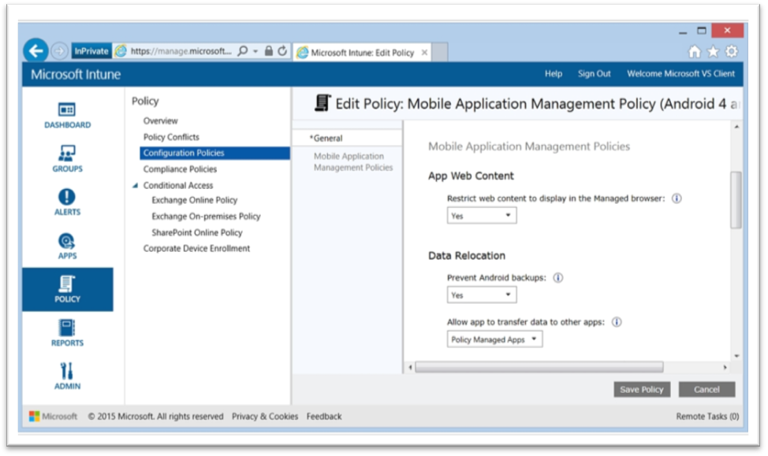
Figure 4 - Intune screenshot - top 20 best mobile device management software [40]
And highlights from VMware Airwatch are as follows;
- Quick configuration
- Open architecture and scalable system
- Flexible integration
- Automatic upgrades and same day support
- Device level encryption
- Real-time MDM deployment [40]

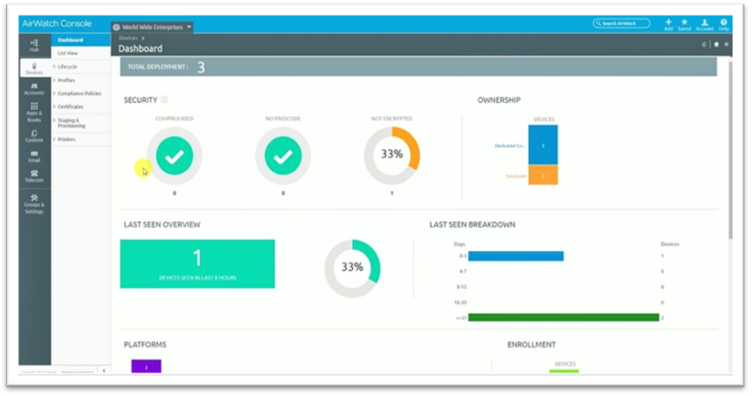
Figure 5 - Intune screenshot - top 20 best mobile device management software [40]

Discussion should be around the needs, security and protection of the business and the implementation of a full framework which considers policy, network design and MDM software with VPN as each of these are key to a successful implementation of BYOD within the company.

Conclusion, Recommendation and future work
BYOD can offer some great benefits such as productivity and employee satisfaction. BYOD also presents numerous challenges to a company in terms of infrastructure such as implementation and support and device management such as security, software, VPN and more. Within this are key discussions such as data security, data protection and integrity, access, authorisation, accountability and vulnerabilities. A robust, well thought out framework will go a long way to mitigating these considerations and a robust policy will help to reduce vulnerabilities from human interaction and varied devices. Furthermore, there needs to be a good backup procedure in place and strategies for continued availability for work, considering the network and redundancies within that. It is important to have a good network in place and the management, monitoring and maintenance is key.
It is recommended to review the policy for wording and legal status before implementation. There should also be research into MDM software solutions, including numerous reviews and tests a few before reaching a decision on one. Look carefully at individual needs and integration, also to ease of use and scalability.

Bibliography

[1] | Ernst & Young, “Insights on Governance, Risk and Compliance - "Bring Your Own Device - Security and Risk Considerations for Your Mobile Device Program",” September 2013. [Online]. Available: www.ey.com/GRCinsights. [Accessed 7th January 2019].
[2] | A. Pillay, H. Diaki, E. Nham, S. Senanayake, G. Tan and S. Deshpande, “Does BYOD Increase Risks or Drive Benefits?,” Parkville, 2013.
[3] | S. Stiegiltz and T. Brockman, “Increasing Organizational Performance by Transitioning into a Mobile Enterprise,” MIS Quarterly Executiv, pp. 1 - 16, December 2012.
[4] | Capgemini Consulting, “Bring Your Own Device - Its all about Employee Satisfaction and Productivity, not Costs!,” 2013.
[5] | S. M. Anderson, Information Security Framework, West Lindsey District Council, 2015.
[6] | S. Duquennoy, J. Eriksson and T. Voigt, “Five-Nines Reliable Downward Routing in RPL,” Computer Science, 6th October 2017.
[7] | L. Sheldon, “Implementing Information Security Architecture and Governance: A Big Framework for Small Business,” 2016.
[8] | S. Banerji and R. S. Chowdhury, “On IEEE 802.11: Wireless Lan Technology,” International Journal of Mobile Network Communications and Telematics (IJMNCT), vol. 3, no. 4, July 2013.
[9] | Y. Jadeja and K. Modi, “Cloud Computing - Concepts, Architecture and CHallenges,” in International Conference on Computing, Electronics and Electrical Technologies (ICCEET), 2012.
[10] | S. Dillon, F. Stahl and G. Vossen, “BYOD and Governance of the Personal Cloud,” International Journal of Cloud Applications and Computing, March 2014.
[11] | Department for Digital, Culture, Media & Sport, “Data Protection Act 2018 Factsheet Overview,” 24th May 2018. [Online]. Available: https://assets.publishing.service.gov.uk/government/uploads/system/uploads/attachment_data/file/711162/2018-05-23_Factsheet_1_-_Act_overview.pdf. [Accessed 20th December 2018].
[13] | Cisco, Access Control Lists: Overview and Guidelines.
[14] | Cisco, How Virtual Private Networks Work, 2008.
[15] | Anonymous, “The digital arms trade; Cyber-security,” The Economist, vol. 406, no. 8829, pp. 65-66, 2013.
[16] | M. Conti, N. Dragoni and V. Lesyk, “A Survey of Man in the Middle Attacks,” IEEE Communications Surveys & Tutorials, vol. 18, no. 3, p. 1, 2016.
[17] | K. Thornton, “5 Types of Social Engineering Attacks,” Datto, 12th September 2018. [Online]. Available: https://www.datto.com/blog/5-types-of-social-engineering-attacks. [Accessed 7th January 2019].
[18] | F. Mouton, L. Leenen and H. S. Venter, “Social engineering attack examples, templates and scenarios,” Computers & Security, vol. 59, pp. 186 - 209, March 2016.
[19] | N. Patel, R. Patel and D. Patel, “Packet Sniffing: Network Wiretapping,” IEEE International Advance Computing Conference (IACC 2009), pp. 2691 - 2696, March 2009.
[20] | J. R. Van Der Merwe, X. Zubizarreta, I. Lukcin and A. Rügamer, “Classification of Spoofing Attack Types,” in European Navigation Conference (ENC) 2018, Gothenberg, 2018.
[21] | L. Bilge and T. Dumitras, “Before we knew it: An empirical study of zero-day attacks in the real world,” in Proceedings of the 2012 ACM conference on Computer and communications security, 2012.
[22] | “Understanding Rogue Access Points,” Juniper Networks, [Online]. Available: https://www.juniper.net/documentation/en_US/junos-space-apps/network-director3.1/topics/concept/wireless-rogue-ap.html#jd0e16. [Accessed 7th January 2019].
[23] | M. Samra, M. Mengi, S. Sharma and N. K. Gondhi, “Detection and Mitigation of Rogue Access Point,” International Journal of Scientific and Technical Advancements, pp. 195 - 198, January 2015.
[24] | I. Khan, “An introduction to computer viruses: Problems and solutions,” Library Hi Tech News, vol. 29, no. 7, pp. 8 - 12, September 2012.
[25] | L. A. Hughes and G. J. DeLone, “Viruses, Worms, and Trojan Horses,” Social Science Computer Review, vol. 25, no. 1, pp. 78 - 98, 2007.
[26] | A. Pratama and F. A. Rafrastara, “Computer Worm Classification,” (IJCSIS) International Journal of Computer Science and Information Security, vol. 10, no. 4, pp. 21 - 24, April 2012.
[27] | “Trojan horse Greek Mythology,” Encyclopædia Britannica, inc, 27th September 2018. [Online]. Available: https://www.britannica.com/topic/Trojan-horse. [Accessed 7th January 2019].
[28] | Z. Zhenfang, “Study on Computer Trojan Horse Virus and Its,” International Journal of Engineering and Applied Sciences (IJEAS), vol. 2, no. 8, pp. 95 - 96, August 2015.
[29] | B. Sharma, “A Pragmatic Way of Logic Bomb Attack Detection Methodology,” Indian Journal of Science and Technology, vol. 10, no. 20, pp. 1 - 5, May 2017.
[30] | J. Giles, “Scareware: the inside story,” The New Scientist, vol. 205, no. 2753, pp. 38 - 41, March 2010.
[31] | C. Graham, “NHS cyber attack: Everything you need to know about 'biggest ransomware' offensive in history,” 20th May 2017. [Online]. Available: https://www.telegraph.co.uk/news/2017/05/13/nhs-cyber-attack-everything-need-know-biggest-ransomware-offensive/. [Accessed 10th January 2019].
[32] | J. P. Tailor and A. D. Patel, “A Comprehensive Survey: Ransomware Attacks Prevention, Monitoring and Damage Control,” International Journal of Scientific Research, vol. 4, June 2017.
[33] | T. Ozlak, Keystroke logging (keylogging), 2008.
[34] | J. Wieslander, M. Boldt and B. Carlsson, “Investigating Spyware on the Internet,” 2003.
[35] | Symantec, “What is spyware? And how to remove it,” January 2018. [Online]. Available: https://us.norton.com/internetsecurity-how-to-catch-spyware-before-it-snags-you.html. [Accessed 8th January 2019].
[36] | G. Legg, “The Bluejacking, Bluesnarfing, Bluebugging,” 4th August 2005. [Online]. Available: https://www.edn.com/Pdf/ViewPdf?contentItemId=4017819. [Accessed 8th January 2019].
[37] | NHS South Gloucestershire Clinical Commissioning Group Quality and Governance Committee, BRING YOUR OWN DEVICE POLICY (BYOD), NHS South Gloucestershire Clinical Commissioning Group Quality and Governance Committee, 2015.
[38] | IT Manager Daily, “BYOD Policy Template,” Catalyst Media Network, 2018.
[39] | A. Dedeche, F. Liu, M. Le and S. Lajami, “Emergent BYOD Security Challenges and Mitigation Strategy,” 2013.
[40] | “20 Best Mobile Device Management Software in 2019,” FinancesOnline, 14th December 2018. [Online]. Available: https://financesonline.com/mobile-device-management/. [Accessed 9th January 2019].

Appendix
Appendix 1 – IT Security Architecture Framework
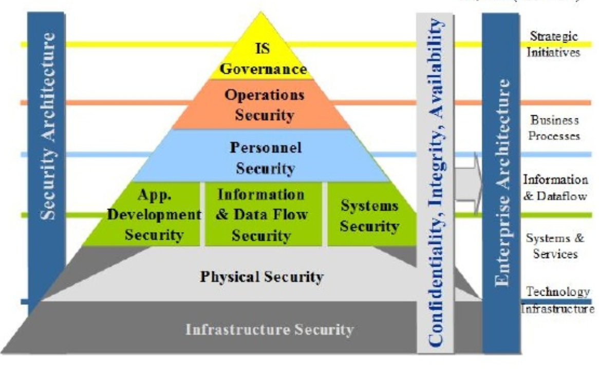

Appendix 2 – BYOD Policy
BYOD Security and Usage Policy
For the purposes of clarity this document refers to personal data and identifiable data. ‘Personal data’ is defined as data and information held on devices pertinent to the owner and their non-work usage of the device. ‘Identifiable data’ is defined as work-related information held on devices and enabled by the 3rd party mobile device management software.
1. ELIGIBILITY
1.1 All Hyper Fort employees are eligible for authorisation, provided they are risk assessed, undertake security awareness training and are able to satisfy the terms of access and sign the accompanying user agreement. Contractors are not eligible for authorisation. Contractors are not provided with Hyper Fort email addresses and as such are unable to satisfy the terms of access. Temporary employees will be managed on a case-by-case basis. By default, temporary employees issued with a Hyper Fort email address will be treated as permanent employees. Temporary staff who are not covered by an employment contract are required to sign a confidentiality agreement prior to being given access to information processing facilities as per the Hyper Fort’s ‘Use of Personal Information Policy’. The Employee User Agreement is at Appendix 2. 5
3. DEVICES AND SUPPORT
3.1. For a personal smartphone and / or tablet device to be considered within this policy it must be able to ‘encrypt at rest’. This is primarily an operating system / software function and requirement.
3.2 The basic requirements are as follows,
- Apple devices running iOS6 or later, and specifically; ♣ iPhone 4 onwards ♣
- iPad2 onwards, including the iPad Air and all versions of the iPad Mini
- Blackberry Phones
- Android devices – Non-Jailbroken with Android OS 4.4 onwards with adequate security conditions.
- Windows devices – Windows 7 onwards with adequate security conditions. Windows phones security condition is currently unproven and therefore are not permitted.
3.3 Devices that do not support ‘encryption at rest’ are not permitted to access the Hyper Fort IT infrastructure.
3.4 Devices must be presented to the Head of IT at the time of submission of the user agreement to validate the information requirements of the agreement.
3.5 Personally owned laptops will be permitted to connect with the Hyper Fort Exchange Server with sufficient security conditions and anti-virus software. It is essential that operating system and anti-virus software are kept updated at all times.

4 ACCEPTABLE USE
4.1 Hyper Fort defines acceptable business use as activities that directly or indirectly support the business. Hyper Fort has a seperate ‘Acceptable Use of Information & Communication Technologies Policy’ as an element in the overall policy.
4.4 Staff should ensure that any personal data use does not put work-related identifiable information at risk. For example, sharing the device with identifiable information on it with others, such as family and friends, or downloading apps which could access such information. 4.5 Corporate identifiable data can only be created, processed, stored and communicated on personal devices running Hyper Fort’s chosen Mobile Device Management (MDM) client software. Devices not running MDM can connect to Hyper Fort guest network providing an internet connection, but will not be granted access to the corporate infrastructure.
4.6 Hyper Fort Information Governance Management System outlines considerations of acceptable use. Employees must not:
- Share personal usernames and / or passwords or leave devices logged in and unattended at any time.
- Save or transmit proprietary information belonging to another company that is outside of that company’s intended usage, terms and conditions.
- Engage in external business activities.
- Cause offence to any individual (including members of staff or the public) or risk damaging the organisation’s reputation by either creating, accessing, storing or sending/posting any images, files, messages or data that could be said to be abusive, sexist, racist, defamatory, obscene or otherwise offensive or inappropriate or breach confidentiality/privacy of any individual or commercial organisation. This includes personal use of social media outside of work.
- Use ‘social media’ to communicate on behalf of the organisation unless this is a normal or delegated and accepted part of their role.
- Use organisation facilities for advertising / fund raising not directly connected with the organisation, other than the use of any social notice board facilities.
- Use data that identifies individuals unless absolutely necessary.
4.7 Employee use of Hyper Fort IT infrastructure and access via personally owned devices is as follows;
- Calendars - Access permitted.
- Email - Access permitted.
- Contacts - Access permitted.
- Documents – Authorised access permitted
4.8 Each element permitted above is individually configurable within personal devices. For example, whilst a device may be able to access the services listed above the user may wish to access only one or some of the permissions available to them.
4.9 Employees are not permitted to allow anyone else to access identifiable and organisationally sensitive information stored on their device. This will be managed as follows:
- Calendars – Staff will be expected to mark ‘sensitive’ meetings as private in their calendar.
- Email – Staff will be expected to ensure others do not access email on their device. (see ‘e-mails’ within the CCG ‘Acceptable Use of Information & Communication Technologies Policy’).
- Contacts – Staff will be expected to ensure that others do not access their work related contacts.
- Documents – when permitted access to documents will be via a further level of security.
4.10 Hyper Fort has a zero-tolerance policy for texting or emailing while driving (whatever the device make and model) and only hands-free talking while driving is permitted.
5 REIMBURSEMENT
5.1 Hyper Fort will not reimburse employees for some or all of the cost of personal devices. Neither will they pay employees an allowance to purchase a device for work purposes.
5.2 Staff should discuss with their line-manager any issues with cost implications as a result of using their device for business purposes (for example, where it is evident that specific business calls made have led to an employee call plan being exceeded).
5.3 Hyper Fort will not cover any damage to personal devices. It is recommended that device owners insure their device as part of their home contents insurance and, if necessary, advise their insurer that the device will be used for work purposes at home and at work locations.
6 SECURITY
6.1 Employees wishing to use their personal devices as per this policy will be required to download to their device an approved Third Party App (from Hyper Forts contracted supplier). This application enables the organisations IT provider to manage Hyper Fort’s infrastructure and enable certain security features on the device.
6.2 The security features enabled aim to ensure that;
- Hyper Fort meets it’s legal requirements for Information Governance and associated risk assessment.
- The Employee meets the expected standards of security as an employee.
- The Employee is able to use their device in a personal capacity with as little disruption as is possible.
6.3 The user agreement requires employees to log the device model and serial number and log the phone number where applicable.
6.4 In order to prevent unauthorized access, devices must be passcode protected using the features of the device. The device must also lock itself with a password or PIN if idle for five minutes.
6.5 ‘Jailbroken’ Apple or Android devices are strictly forbidden from accessing the Hyper Fort infrastructure.
6.6 The employee’s device must be enabled with the ‘Find my iPhone’ App for Apple devices (and similar software for other operating systems where appropriate) in order that personal data may be remotely wiped by the user. Identifiable data may also be remotely wiped by the Hyper Fort’s IT Provider using the Third Party Security Software if;
• the device is lost
• the employee terminates his or her employment
• IT detects a data or policy breach, a virus or similar threat to the security of the company’s identifiable data and technology infrastructure.
Security features and settings within the third party software can be found in the DATA PROTECTION Policy
7.1 Personal data provided by device owners in the sign-up to this policy will only be used by Hyper Fort for the purposes of device registration and management.
7.2 Hyper Fort, its contracted IT Provider and the MDM Software will not pass on or share personal data internally.
7.3 Hyper Fort, its contracted IT Provider and the MDM Software will not pass on or share personal data to any other party or organisation.
8 RISKS/LIABILITIES/DISCLAIMERS
8.1 Hyper Fort and the Hyper Fort’s contracted IT support provider reserves the right to disconnect devices or disable services without notification.
8.2 Lost or stolen devices must be reported to the Hyper Fort’s IT Department IT Service Desk promptly and within 24 hours via email at ITServiceDesk@hyperfort.com or by phone on ---- --- ----. Employees are also responsible for notifying their mobile data carrier immediately upon loss of a device.
8.3 The employee is expected to use his or her device(s) in adherence to Hyper Fort’s acceptable use policy as indicated in Section 4 above.
8.4 The employee is personally liable for all costs associated with his or her device as per the paragraph on reimbursement above.
8.5 Hyper Fort cannot be held accountable for any risks to an owners personal data, including but not limited to, the partial or complete loss of personal data due to an operating system crash, errors, bugs, viruses, malware, and/or other software or hardware failures, or programming errors that render the device unusable, unless the Mobile Device Management solution can be proven to be responsible.
8.6 Hyper Fort reserves the right to take appropriate disciplinary action up to and including termination of contract for noncompliance with this policy.

Appendix 2.5 – BYOD Employee User Agreement

HYPER FORT
BRING YOUR OWN DEVICE (BYOD) - EMPLOYEE USER AGREEMENT

By completing and signing this user agreement ……………………………………………..
…………… (print name) agrees to adhere to the policy as is in place at the time of signing
…………………………………………….(date)
Make and Model of personal device; Phone Manufacturer Apple Model iPhone
……………………………………………………
Serial Number……………………………………
Phone Number… (+44) …………………………
Software Version………………………………..
Tablet Manufacturer Apple Model iPad ………………………
Serial Number…………………………………….
Software Version…………………………………
I confirm that this device is passcode protected I confirm that this device has not been ‘Jailbroken’ I confirm that this device is set to lock itself with a password or PIN if idle for five minutes I confirm that the operating system on this device is up to date and will be maintained User

Signature……………………………………………………. Date………………....

Appendix 3 – Mobile Device Security

SECURITY SETTINGS OF THE MOBILE DEVICE MANAGEMENT SOFTWARE AS APPLIED TO DEVICES

The table below lists the security parameters as installed by the Third Party Security Software. Individual device security options may also be applicable under the corporate policy which go further than the table below.



