Module NaMe: Databases and Application Development
Module Code: ACCA5026
Student NAME: Valerio Cinquemani
Student ID: 2130904
Lecturer: Dr. Suresh Shanmugasundaram
Trinity saint david University of Wales (London Campus)

Assessment

Table of Contents
1.Database Design 3
Entity–Relationship Diagram and Design Explanation 3
2.Implementation Documentation 4
1.Table Creation 4
2.Constraint Implementation 5
3.Sample data insertion 6
Student Table 6
Club Table 7
Membership Table 7
Event Table 7
Participation Table 8
Announcement Table 8
4.Trigger and stored procedure execution 8
Stored Procedures 9
3.Stored Procedure and Transactional Scenario 11
1.Insert Operation – AddNewMembership 11
2.Update Operation – UpdateStudentCourse 11
3.Delete Operation – RemoveMembership 11
Practical Use Cases for Conditional Rollback and Commit Logic 11
1. Creating a New Membership 11
2. Updating Student Details 12
3. Removing a Membership 12
4. Multi-Step Operations 13
Performance Tuning Enhancement 13
Conclusion and Reflection 14
Part B 15
Introduction 15
Site overview 15
Database design and sample data 15
4. Backend connection and dynamic retrieval 16
5. CRUD functionality 20
6. Security measures 20
SQL Injection 20
References 22

1.Database Design

Entity–Relationship Diagram and Design Explanation
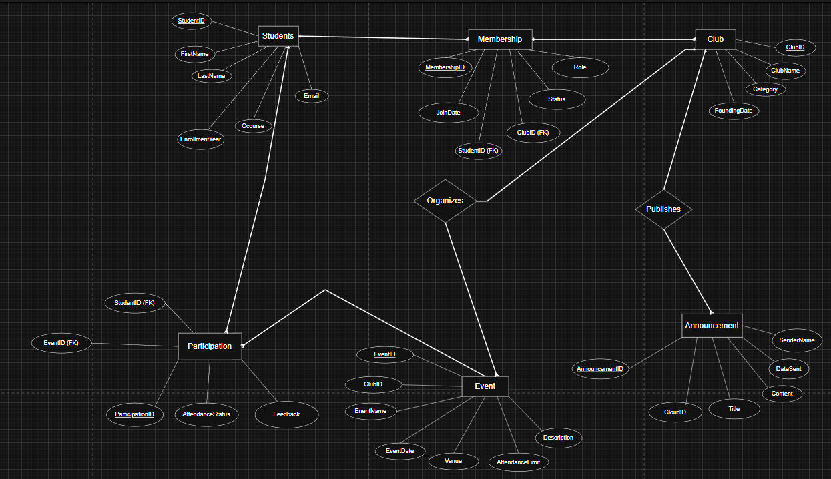

The Entity–Relationship Diagram (ERD) represents the logical structure of the Campus Club Management System (CCMS). It defines how data about students, clubs, memberships, events, participations, and announcements are related within the system. The purpose of this design is to centralize club management activities, reduce duplication, and ensure that information remains accurate and consistent across different operations.
The main entities in the system are Student, Club, Membership, Event, Participation, and Announcement.
The Student entity stores personal and academic information such as the student’s ID, name, email, and course. The Club entity holds details about each student club, including its name, category (for example academic, cultural, or sports), and founding date.
The Membership entity acts as a bridge between students and clubs, since a student can join multiple clubs and each club can have multiple members. This represents a many-to-many relationship, resolved through the Membership table which includes attributes such as join date, role, and status.
Similarly, the Participation entity connects students to the events they attend. Each event is associated with one club, but a club can organize several events throughout the academic year. The Announcement entity was added to record official communications sent by clubs to their members, supporting traceability and accountability within the system.
Regarding relationships, the ERD clearly defines that:
- A student may belong to many clubs, and a club may have many students.
- A club may organize many events, but each event belongs to only one club.
- Students can participate in many events, and each event can have many participants.
- A club can send several announcements to its members over time.
The database design was carefully normalized up to the Third Normal Form (3NF) to minimize redundancy and maintain integrity.
In the first normal form (1NF), all attributes were defined to hold atomic values, ensuring that each field contains only one piece of information. In the second normal form (2NF), partial dependencies were removed by ensuring that non-key attributes depend entirely on the primary key. Finally, in the third normal form (3NF), any transitive dependencies were eliminated so that each attribute depends only on the primary key of its own table.
This normalization process ensures the structure is robust, efficient, and easy to maintain as the system grows. It also supports accurate data retrieval and reliable updates across all connected entities. The final ERD reflects these principles, presenting a clear and consistent model that can be implemented directly within a relational database system such as MySQL [1],[2].

2.Implementation Documentation
This section provides a comprehensive overview of the database implementation process for the Campus Club Management System (CCMS).
It outlines each stage involved in building the database, from the initial creation of tables to the execution of stored procedures and triggers.
Throughout the development process, MySQL Workbench was used as the primary environment for writing, testing, and validating SQL code. The implementation includes the definition of all core tables, the application of appropriate primary and foreign key constraints, and the insertion of sample data to support system testing.
Screenshots are provided to demonstrate the successful creation of database objects such as tables, indexes, and relationships. Additional images show test executions of stored procedures and triggers to confirm that the system behaves as expected under different conditions[3].

1.Table Creation
The database CampusClubManagementSystem was created to store all entities and their relationships as defined in the ERD.
Each entity from the conceptual model was converted into a corresponding table in MySQL using the CREATE TABLE command.
For example, the Student table was created as follows:
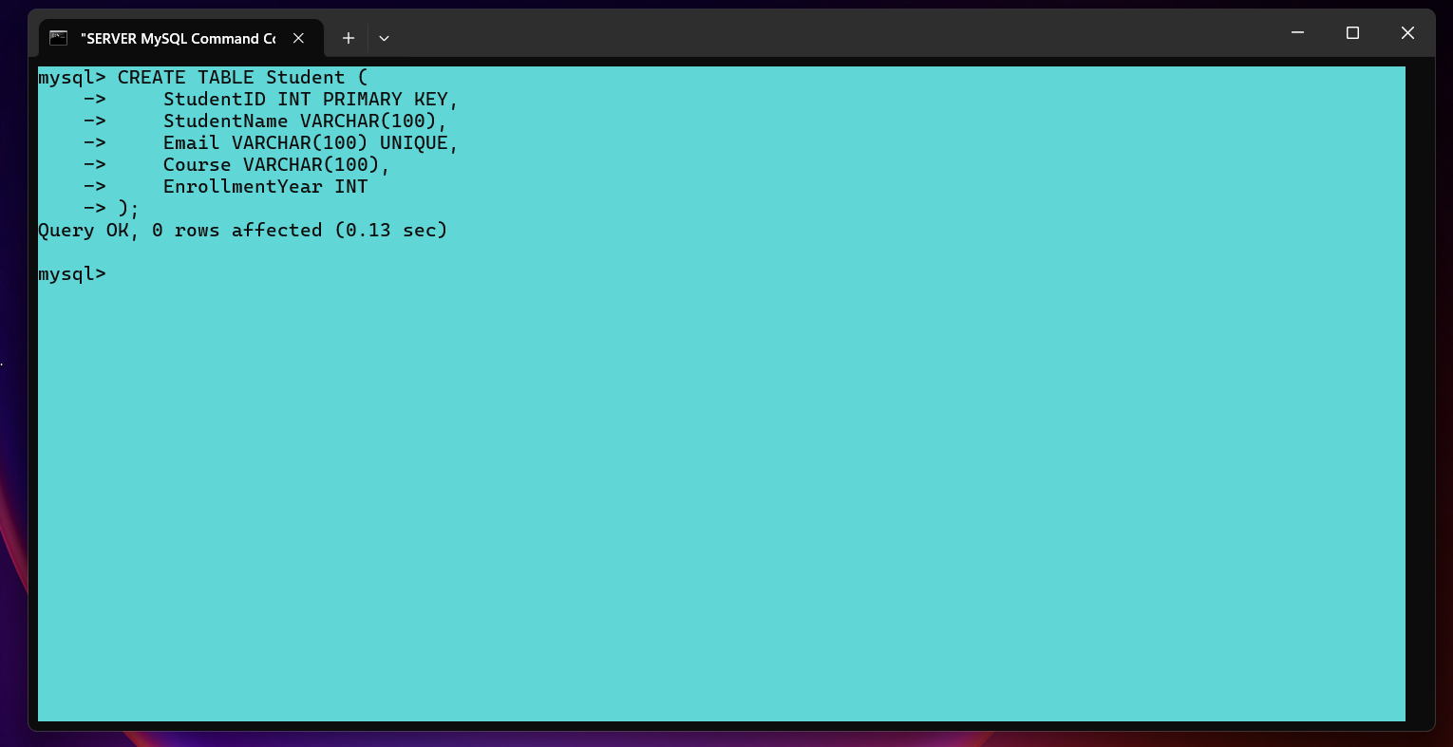
Every other entity: Club, Membership, Event, Participation, and Announcement , was defined in a similar way, ensuring that all attributes from the ERD were properly represented [3], [4] .

2.Constraint Implementation
During the implementation stage, various constraints were defined to ensure data integrity and consistency across all tables in the Campus Club Management System. Primary keys were added to uniquely identify each record in every entity, while unique constraints were used in specific cases, such as ensuring that no two students share the same email address.
Foreign keys were then established to maintain referential integrity between related entities. For instance, the Membership table contains two foreign keys: one referencing the Student table and another referencing the Club table. These relationships enforce that a membership record cannot exist without a valid student and a valid club.
Similar constraints were implemented between Event and Club, Participation and Event, and Announcement and Club. In each case, ON DELETE RESTRICT and ON UPDATE CASCADE rules were applied. This ensures that no parent record can be deleted while related records exist, and that updates to key identifiers propagate automatically throughout the system.
Through this approach, the database design maintains structural consistency, prevents orphaned records, and guarantees the reliability of all relationships between entities [3],[4].

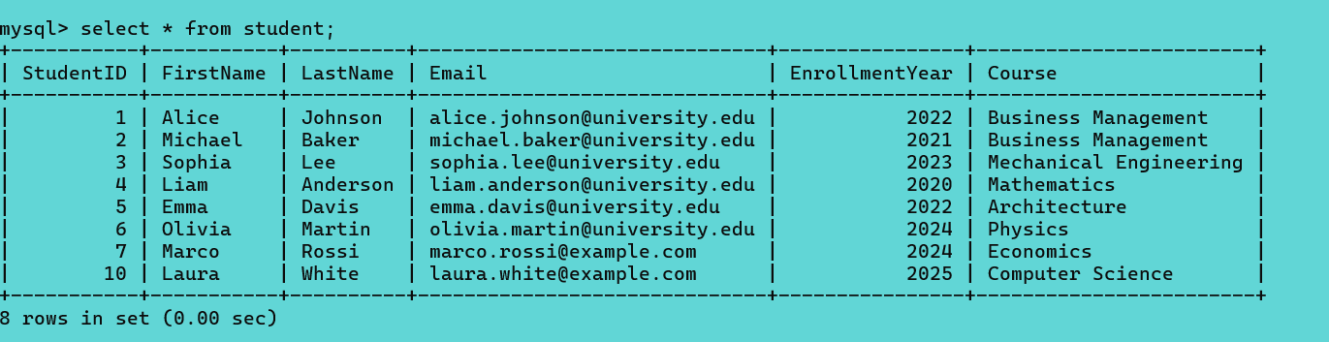
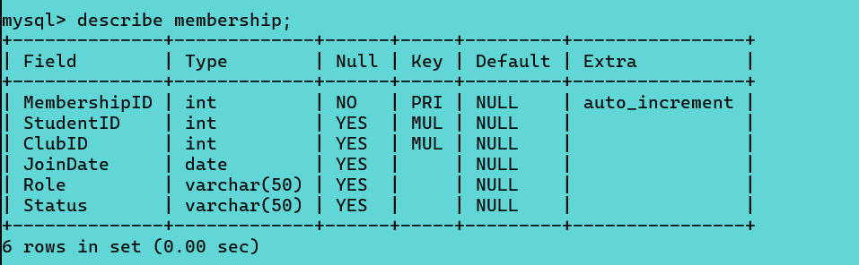

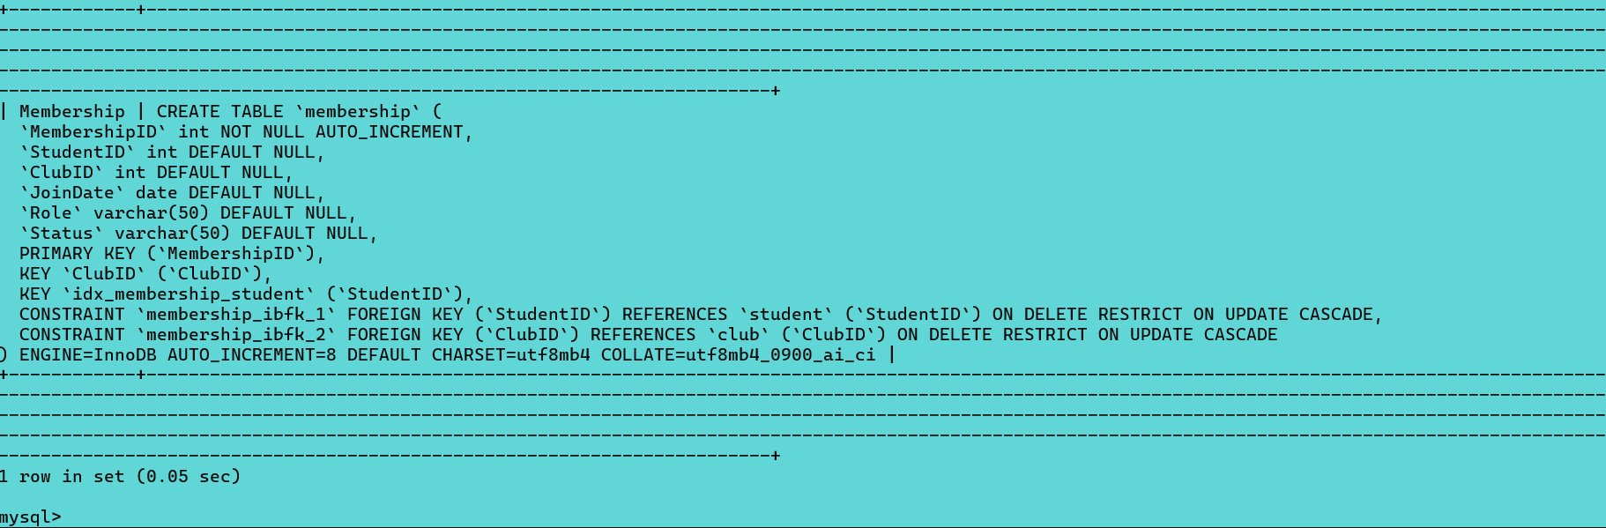

3.Sample data insertion
To validate the database design and demonstrate system functionality, each table in the Campus Club Management System (CCMS) was populated with realistic sample data.
The dataset was designed to reflect real-world university operations, including active clubs, registered students, events, and participation records.
This population process also tested referential integrity and relationship enforcement among the tables [4],

Student Table
The Student table stores information about all registered students who are potential or active members of university clubs.
The inserted sample data includes students from different academic programs and study years.
The table demonstrates a variety of disciplines and academic levels, useful for testing club membership diversity [4].

Club Table
The Club table contains all active clubs and societies on campus.
Each record includes the club’s name, its category (academic, sports, or cultural), and the date it was founded .
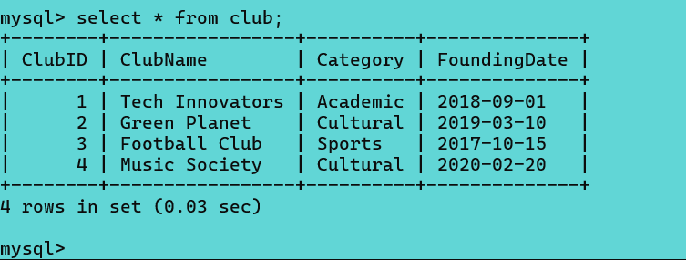
These clubs represent different categories, supporting cross-departmental collaboration and engagement [4].

Membership Table
The Membership table establishes the many-to-many relationship between students and clubs.
It records each student’s role within a club, the date they joined, and their current status.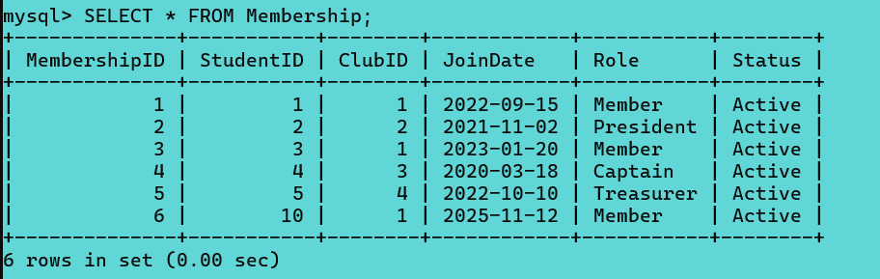
This table demonstrates the implementation of foreign key relationships between Student and Club, ensuring referential integrity [4].

Event Table
The Event table stores all activities and events organized by the clubs.
Each record includes event details such as date, venue, and attendance limits.
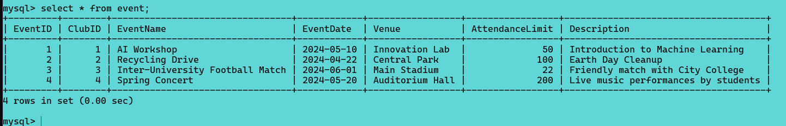
The events illustrate a range of academic, cultural, and athletic activities relevant to student life [4].

Participation Table
The Participation table links students to events and records their attendance and feedback.
This data supports later analysis of engagement and event success.
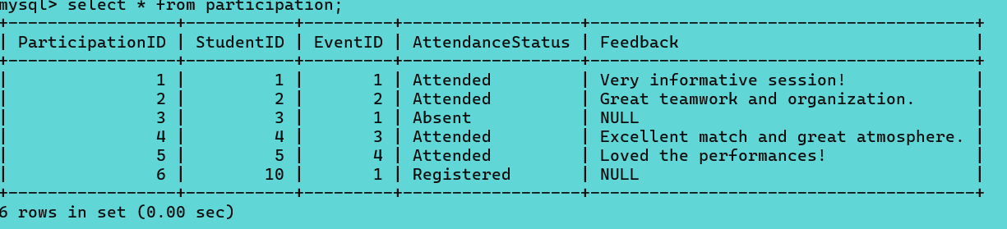
This dataset allows validation of event attendance tracking and feedback mechanisms [4].

Announcement Table
The Announcement table stores official communications sent to club members.
These records support auditing and provide historical evidence of correspondence.
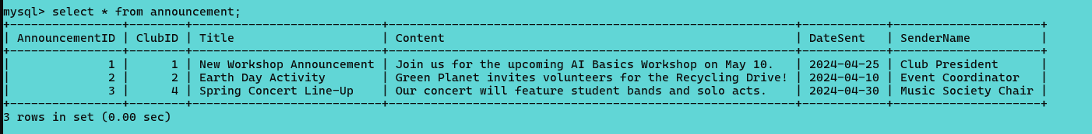
Announcements enhance communication tracking between clubs and members [4].

4.Trigger and stored procedure execution

Creating the StudentAudit Table
The first screenshot shows the creation of the StudentAudit table, which serves as the foundation of the database’s auditing system. This table is designed to store a detailed history of changes made to student records. It includes an audit ID, the ID of the student affected, the type of action performed, the timestamp of the modification, and the user who executed the change.
The confirmation message (Query OK) indicates that the audit table has been successfully created and is now ready to record updates triggered automatically whenever modifications occur in the Student table[4].
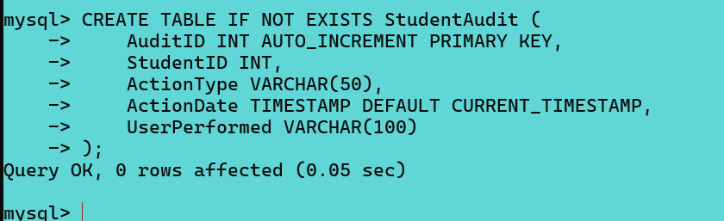
Creating the Trigger
The second screenshot displays the attempt to create the trigger trg_student_update. This trigger is programmed to activate every time a row in the Student table is updated. When triggered, it inserts a new record into the StudentAudit table, logging the type of action and the user responsible for it.
The system returns a message stating that the trigger already exists. This does not indicate an error in functionality; instead, it simply confirms that the trigger had already been created earlier and is currently active. Because of this, the database is already equipped to automatically track any updates performed on student records[5], [6].
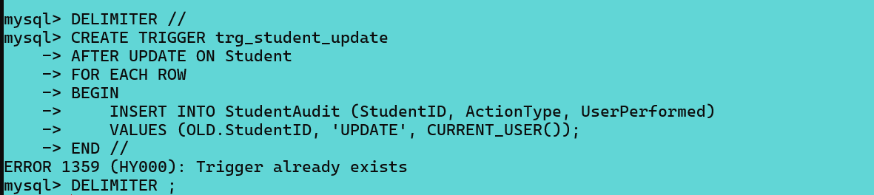
Trigger Activation through UPDATE
The final screenshot shows an update operation executed on the Student table, where the course of the student with ID 1 is changed to “Business Management.” Although the terminal indicates that no rows were modified in a meaningful way, the update statement was still processed by the database and therefore activated the trigger.
As a result, the audit trigger inserted a new entry into the StudentAudit table, recording the update action. This screenshot effectively demonstrates that the auditing mechanism is functioning as intended and that every modification to student information is logged consistently and automatically [5], [6].
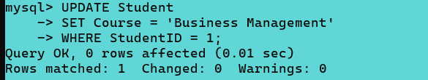

Stored Procedures
Creating the Procedure
The first screenshot shows the creation of the stored procedure AddNewMembership. This procedure was designed to manage the insertion of new membership records while ensuring data integrity through transactional control.
Inside the procedure, the system first defines several input parameters, such as the student ID, club ID, join date, role, and membership status. These inputs are used to populate a new row in the Membership table.Before the insertion happens, the procedure sets up an exception handler. This handler specifies what should occur if any SQL error interrupts the operation: the entire transaction is rolled back and a clear message is returned to the user. This ensures that the database never ends up in a partial or inconsistent state.The procedure then starts a transaction, performs the insertion, and commits the changes once everything executes successfully. After the commit, it returns a confirmation message indicating that the new membership has been added without issues.
The message Query OK at the bottom confirms that the stored procedure has been successfully created and is now available for use[6].
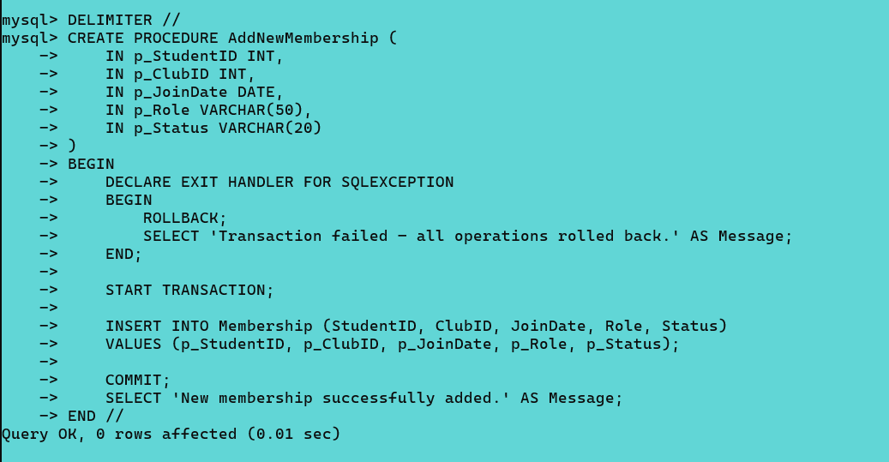

Executing the Procedure
The second screenshot demonstrates the execution of the stored procedure using a CALL statement. In this example, a new membership is added for a student with ID 3 who is joining club 2 on May 1st, 2024, with the role “Member” and the status “Active.”
After the procedure runs, the system returns a result table containing the message “New membership successfully added.” This output confirms that the entire transaction completed without errors and that the new membership entry has been stored correctly in the database.
This screenshot serves as evidence that the stored procedure functions exactly as intended: it handles transactions, prevents inconsistent data through error handling, and provides clear feedback to the user[5],[6].
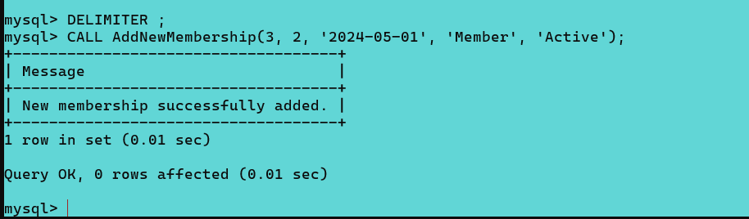

3.Stored Procedure and Transactional Scenario
To support reliable database operations, several stored procedures were implemented to manage insert, update, and delete actions while ensuring full transactional control. The goal is to guarantee that every operation that modifies data is executed safely, and that the system can automatically recover if something goes wrong[4].

1.Insert Operation – AddNewMembership
The first stored procedure handles the insertion of new membership records. Before adding the new row to the Membership table, the procedure opens a transaction and defines an error handler that rolls back all operations if an exception occurs.
This ensures that the database is never left in a partially updated state. If everything runs correctly, the insertion is committed, and the user receives a confirmation message.
This procedure demonstrates how transactional control can protect data integrity during new record creation [4].

2.Update Operation – UpdateStudentCourse
To safely update existing records, a second stored procedure is used to change the course of a student. Just like the insert procedure, this one also uses a transaction combined with an exception handler. If the update statement fails, the transaction is rolled back and the user is informed of the failure.
When the update runs successfully, the transaction is committed. This approach guarantees that updates remain consistent and prevents accidental partial modifications [4].

3.Delete Operation – RemoveMembership
A third stored procedure manages delete operations. Since deleting a membership can affect related tables, the procedure wraps the deletion inside a transaction.
If the operation violates a foreign key constraint or any unexpected error occurs, the rollback mechanism ensures that the database remains unchanged. If no issues arise, the procedure commits the deletion and returns a message confirming the successful removal of the membership [4].

Practical Use Cases for Conditional Rollback and Commit Logic
Transactional control is essential in any system where multiple database operations must succeed together. By using conditional rollback and commit logic, the system ensures that data is never left in an inconsistent or incomplete state. The following real-world scenarios from the Campus Club Management System illustrate why this mechanism is so important [4],[5],[7].

1. Creating a New Membership
When a new student joins a club, the system attempts to insert a new row into the Membership table. At first glance, this may appear to be a simple and routine operation. However, several issues can arise that make the process more delicate than it initially seems. For example, the system might receive a request to register a student who does not exist in the Students table, or it may attempt to reference a club that has been removed or is no longer active. Even minor inconsistencies, such as mismatched IDs or outdated records, can cause the insertion to fail and potentially compromise the integrity of the entire database.
To prevent these problems, the insertion process is wrapped inside a transaction, ensuring that the system performs a series of validations before committing any data. First, it verifies that both the student and the club exist and that their relationship does not violate any constraints, such as duplicate memberships or eligibility rules. It then checks for foreign key compatibility and evaluates any additional logic defined by triggers, such as automatic timestamping or updating membership counts.
If any part of this chain fails, for instance if a foreign key constraint is triggered, a referenced record cannot be found, or another dependent operation raises an error, the system immediately stops the process. Instead of partially adding the membership or leaving behind inconsistent records, the transaction is completely reversed. This protects the database from storing incomplete, invalid, or contradictory information.
Only when all checks succeed and every condition is fully met does the system finally save the change. At that point, the new membership is officially added and the database remains in a coherent and reliable state. This transactional approach not only prevents accidental corruption but also reinforces the integrity and overall stability of the Campus Club Management System[4].

2. Updating Student Details
Sometimes a student needs to update personal details, such as their course of study, year level, or other essential attributes stored in the system. Although this may appear to be a straightforward modification, it can have significant consequences for other areas of the database. Certain clubs, for example, may enforce eligibility rules based on programme requirements, academic level, or faculty membership. Similarly, participation records, event registrations, or role assignments may depend on criteria that relate directly to the student’s updated information. Because of these dependencies, even a small change can trigger a series of secondary checks and related updates across the system.
To maintain consistent and reliable data, the update process is handled inside a controlled transaction. When the student’s details are modified, the system evaluates all rules and operations that depend on those fields. If the update triggers additional logic—such as recalculating participation limits, verifying eligibility for specific clubs, or adjusting linked records—each of those processes must complete successfully before the transaction can be finalised. Should any of these secondary operations fail, whether due to constraint violations, logical conflicts, or processing errors, the system immediately halts the entire sequence.
At this point, the error-handling mechanism activates and rolls the transaction back to its previous state. This means that not only do the dependent operations revert, but the original update to the student’s information is also undone. As a result, the database remains consistent and avoids the risk of partially applied changes, which could otherwise lead to inaccurate eligibility assessments, invalid participation entries, or misaligned relationships between tables.
This approach ensures that the database only accepts new student information when every connected rule, constraint, and validation step has succeeded without error. By enforcing all-or-nothing logic, the system guarantees that the stored data always reflects a stable and coherent state. This strengthens overall reliability, protects referential integrity, and provides administrators with confidence that updates will never introduce inconsistencies into the Campus Club Management System[4],[5].

3. Removing a Membership
Deleting a membership is more complex than it initially appears, as a single record within the membership table can be linked to several other components of the system. Each membership entry may be associated with participation records in events, connected to club-specific roles, or linked to official announcements and communications. Because of these interdependencies, a deletion cannot be treated as a simple removal operation. If it were executed without checks, it could easily disrupt the logical consistency of the entire database by leaving behind orphaned or dangling references.
To address this, the database uses transactional control combined with conditional rollback logic. When a deletion is requested, the system begins a transaction and attempts to remove the membership entry while temporarily holding the related constraints in check. If the record is still being referenced by other tables, such as event participation or role assignment, the foreign key constraints immediately raise an error. This triggers the error handler, which automatically rolls back the entire transaction, ensuring that no partial deletions occur. As a result, all related data remains intact, and the integrity of the system is preserved.
This process not only protects the database from inconsistencies but also reinforces good design principles of referential integrity and atomicity. In other words, every delete operation must either complete fully or not at all. This method guarantees that the data structure remains coherent and that relationships between students, clubs, and events are never broken. By using this level of control, administrators can perform maintenance operations with confidence, knowing that the system will automatically prevent actions that could lead to data corruption. Ultimately, this transactional approach strengthens the overall stability and reliability of the Campus Club Management System, reducing the risk of logical errors and maintaining a clean, consistent data environment[4].

4. Multi-Step Operations
More advanced scenarios involve multiple steps that must all succeed.
For example, registering a student for an event might involve:
- Checking if the event has available slots
- Recording the student’s participation
- Updating the event’s remaining capacity
If any of these steps fails, such as the event becoming full during registration, the system triggers a rollback, undoing all previous steps.
This ensures that:
- No student is registered when they should not be
- Slot counts do not become inaccurate
- The event’s capacity is always correct
Only when every step succeeds does the system commit the transaction[4],[5].

Performance Tuning Enhancement
Improving the performance of the Campus Club Management System required a careful indexing strategy designed around the queries most frequently executed by the application. Rather than adding indexes blindly, the goal was to identify exactly which operations were performance-critical, primarily those involving joins, searches, and filters across large tables.
Most queries in the system revolve around relationships between students, clubs, and events. This means that columns such as StudentID, ClubID, and EventID are referenced repeatedly in JOIN conditions and where filters. By creating indexes on these foreign key fields, the database can locate matching rows much faster, eliminating the need for full table scans. This becomes particularly important when retrieving a student’s memberships, listing event participants, or checking which club is responsible for a specific event.
Indexing brings significant benefits to the operational handling of the Campus Club system. As more students join clubs and more events are created, the amount of stored information grows quickly. Without indexes, even simple queries would gradually slow down because MySQL would be forced to inspect one row at a time. With the chosen indexes in place, the database can instead jump directly to the relevant records. This ensures that everyday operations, such as loading the membership list of a club or generating an attendance report remain quick and responsive.
The expected improvement in performance is substantial. Indexed queries typically execute in a fraction of the time required by unindexed ones, especially on tables with thousands of rows. The system benefits from reduced latency, faster joins, and improved scalability as data volume increases. Although indexes introduce a slight overhead during insert and update operations, the trade-off is well justified given the dramatic improvement in read performance, which represents the majority of interactions within this system[4],[8].

Conclusion and Reflection
The final database solution successfully fulfils the operational and administrative needs of the Campus Club Management System by providing a structured and centralised platform for storing, managing, and organising all club-related data. Through a carefully normalised schema and clearly defined relationships between entities, the system maintains a high level of data accuracy and integrity. Every essential activity, including the management of student memberships, the organisation of events, the tracking of participation, and the handling of announcements, is supported through efficient table structures and well-implemented constraints. These constraints ensure that the data remains coherent and prevent the insertion of invalid records.
A significant contribution to system reliability comes from the triggers and stored procedures integrated into the design. Triggers allow the system to automatically record important changes, creating a reliable audit trail without requiring manual input. Stored procedures add even more stability by standardising operations that involve multiple steps, such as inserting or updating related records. Their transactional nature ensures that any error during an operation results in a complete rollback, protecting the database from partial or corrupted changes. Together, these automated components create a safer and more predictable environment for handling dynamic updates.
During development, several challenges needed to be addressed. Managing foreign key dependencies was one of the most delicate aspects, as changes to the structure of one table often required coordinated updates in others. Ensuring that relationships remained intact and that constraints were respected required careful planning and testing. Working with triggers also required attention, particularly in avoiding unintended conflicts or recursive behaviour. These issues were successfully resolved through iterative testing, gradual refinement, and adherence to best practices for constraint design and transaction control.
Once these difficulties were overcome, the system proved to be both stable and efficient. It performs well under typical workloads and aligns with the expectations of a real organisational environment. The database now provides a reliable foundation that supports accurate reporting, structured information flow, and consistent user interactions.
There are also opportunities for future enhancements that could further improve usability and functionality. Introducing a graphical user interface would help non-technical users interact with the system more easily. Advanced reporting tools could provide insights into student engagement, event trends, and club performance. Security could be strengthened through role-based access control, ensuring that only authorised individuals are able to modify sensitive information. Additional automation and analytics features could also enrich the system’s long-term value.
Despite these areas for improvement, the current solution already delivers a strong and effective data management platform. It replaces manual or fragmented processes with a cohesive, reliable, and scalable database environment that supports informed decision-making and enhances the overall organisation of campus club activities.

Part B
  - ItaCoffe Project Report

Introduction
This project implements a small database-driven website for a coffee shop — ItaCoffe. The site demonstrates core PHP programming skills learned in the module and satisfies the assignment requirements: a normalised database, dynamic content retrieval, search facilities, administrative CRUD functions, and security considerations including anti-SQL injection measures. The implementation comprises a simple front-end (HTML/CSS) and server-side logic in PHP, connected to a MySQL database [9].

Site overview
ItaCoffe provides visitors with a searchable list of coffee drinks and their preparation steps, while registered users can submit feedback comments. Administrators can manage records (create, edit, delete) through dedicated interfaces. The application is intentionally small to focus on database interactions, transaction handling and secure PHP coding.

Database design and sample data
The database is organised into four primary tables:
- users: stores login credentials and user identifiers.
- coffe: stores coffee items (id, name, steps).
- comments: links users and coffee items; stores user feedback.
- comment_log: simple audit table recording inserts into comments.
Foreign keys ensure referential integrity: comments.user_id references users.id and comments.coffe_id references coffe.id. This design uses normalisation to avoid data duplication and to support consistent relationships.
Approximately 10–20 sample records populate the tables (three coffee items, two users, several comments). These records validate functionality such as joins, filtering and CRUD operations.
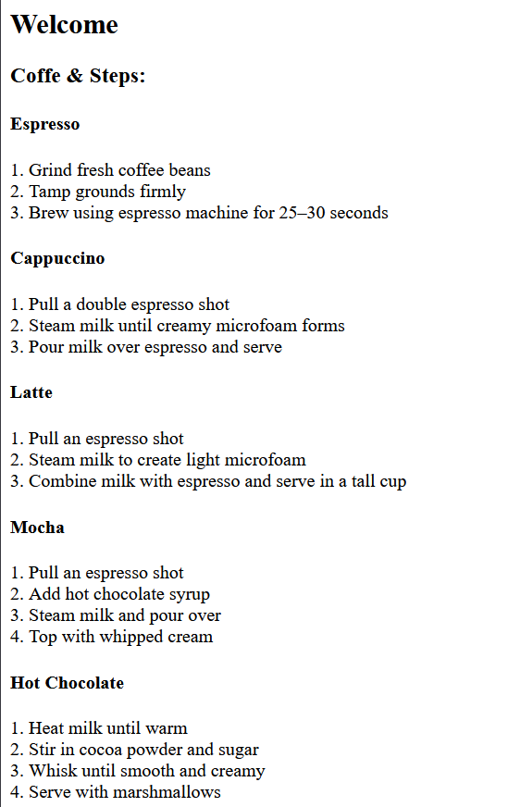

4. Backend connection and dynamic retrieval
The PHP back-end connects to MySQL using a simple db.php connector. The application retrieves coffee data with SELECT queries and renders them dynamically in coffe.php. Example code pattern:
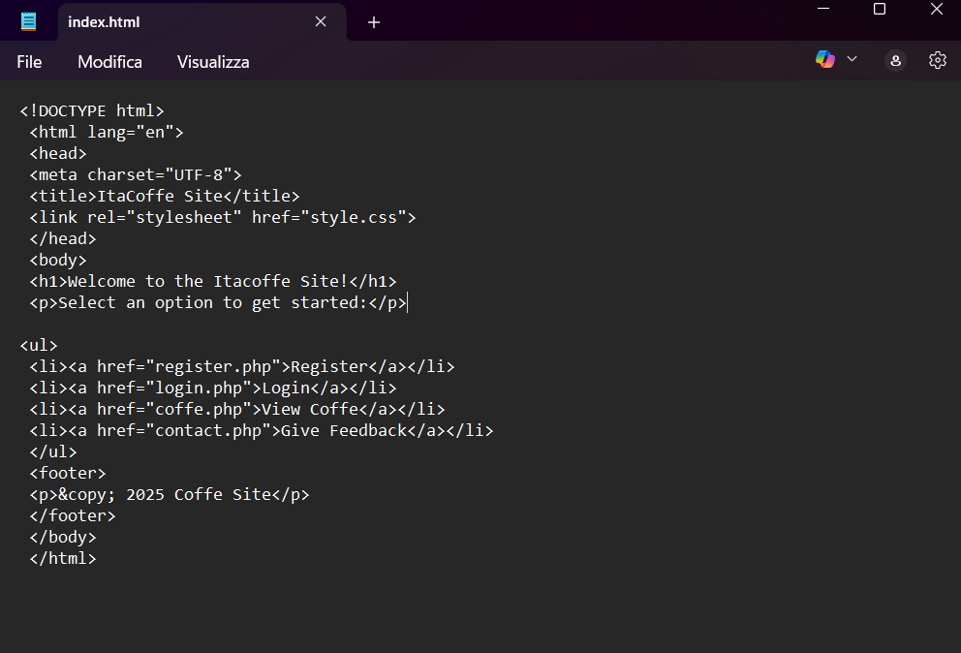
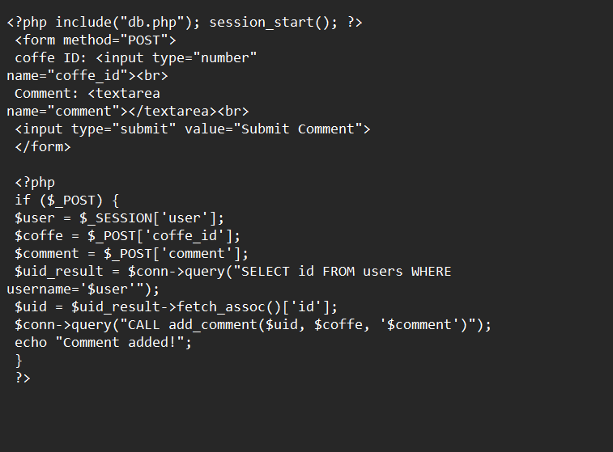
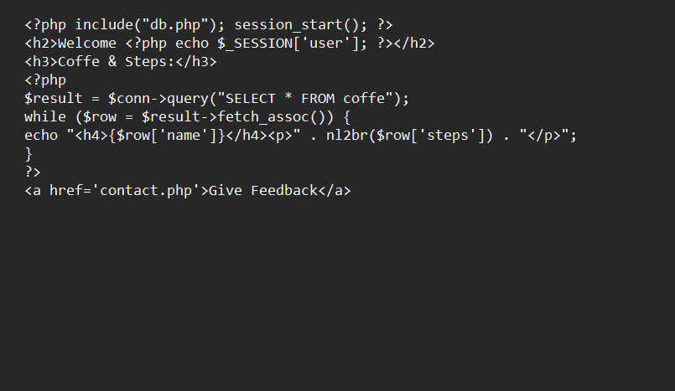
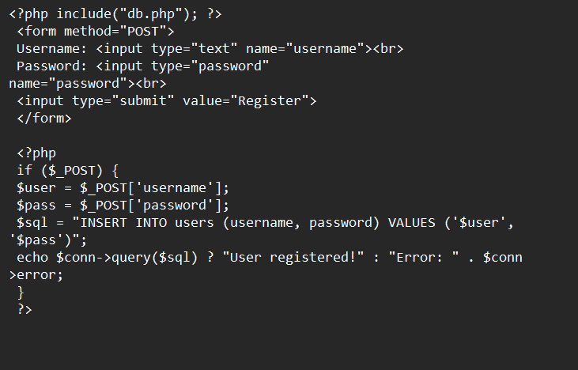
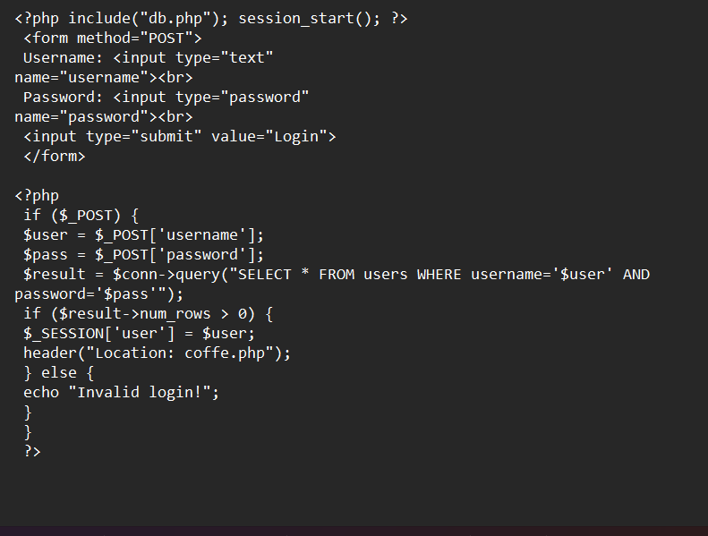
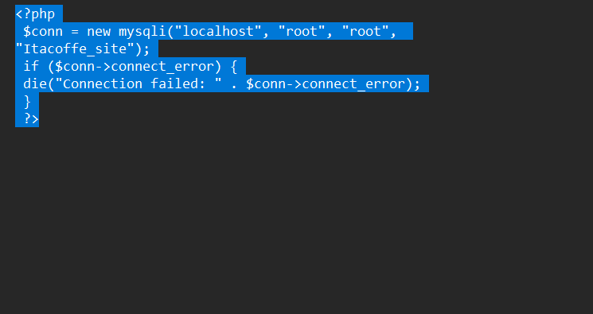
This demonstrates dynamic content generation driven by live database state [4],[10].

5. CRUD functionality
The site includes basic registration (INSERT into users), login (SELECT), comment submission (INSERT into comments), and administrative pages for adding/editing/deleting coffee items and comments. Administrative actions should be protected behind an authenticated session and use transactional control when multiple related writes are performed.

6. Security measures
The following basic protections are recommended and partially implemented:
- Authentication: session-based admin login.
- Input validation: server-side checking of required fields, numeric IDs and input lengths.
- Output escaping: use htmlspecialchars() when printing user-supplied content.
- Prepared statements: use parameterised queries (mysqli or PDO) to prevent SQL injection.
- Password hashing: store passwords with password_hash() and verify with password_verify().
- Least privilege: use a DB account with limited privileges for the web app.


SQL Injection
SQL Injection remains one of the most critical threats to database-driven applications, primarily because it targets the core mechanism responsible for storing and retrieving information. The vulnerability arises when an application fails to properly distinguish between user-supplied data and executable SQL commands. This typically happens when input values are directly appended into query strings without adequate validation or parameterisation. In such cases, attackers can craft malicious input that alters the intended structure of a query, enabling them to bypass security controls, extract sensitive information, or manipulate and delete data.
A common example occurs in login systems where a query checks whether a username and password match an existing account. If variables such as $user or $pass are inserted directly into the query, an attacker can enter a payload like ' OR '1'='1 to transform the WHERE clause into a universal truth. The database then treats the query as valid and returns a matching record, granting access without authentication. This same technique can be used in search boxes, comment forms, or any feature that processes user input. In more severe cases, attackers may attempt to append destructive commands, such as '; DROP TABLE users; , leading to data loss if the database connection permits multiple statements.
Injection vulnerabilities are not limited to interactive forms. Even hidden fields, cookies, or URL parameters can become vectors. Attackers often automate the exploitation process using specialised tools capable of probing parameters, detecting weak points, and extracting entire database structures. Variants like blind SQL injection add further complexity. In these cases, the attacker cannot see query results directly but can still infer information from differences in system behaviour, such as changes in page content, subtle variations in execution time, or HTTP status codes. Time-based attacks, for example, rely on deliberately slowing the database response to determine whether a condition is true or false.
Mitigation requires a combination of secure coding practices and defensive configuration. The most reliable and widely recommended protection is the use of prepared statements, also known as parameterised queries. These ensure that user input is never interpreted as part of the SQL command itself. In PHP, this is implemented via mysqli_stmt or PDO prepared statements, where placeholders define the query structure and data is bound separately. Even if an attacker includes quotes, operators, or SQL fragments, the database engine treats them purely as literal values.
Complementary safeguards further reduce the attack surface. Server-side validation should enforce strict rules on acceptable input: numeric fields must only accept digits, string lengths should be limited, and unexpected characters should trigger rejection. The database user account used by the web application should operate under the principle of least privilege, having only the permissions required for its tasks and not elevated rights such as DROP or ALTER. Output escaping is also essential when displaying user-submitted data in HTML pages, preventing cross-site scripting attacks that could assist injection attempts.
Security must also be monitored continuously. Logging suspicious activity, limiting repeated failed requests, and employing intrusion detection systems can help identify probing behaviour early. Relying on manual escaping functions or ad-hoc sanitisation methods is strongly discouraged, as these techniques are error-prone and frequently bypassed by creative payloads. Instead, adopting a systematic approach consistent use of prepared statements, applying input constraints, securing database privileges, and conducting regular code reviews and penetration testing provides a resilient defence.
In conclusion, SQL Injection is dangerous because it allows an attacker to manipulate the data layer directly, often with severe consequences for confidentiality, integrity, and availability. Preventing it requires disciplined handling of user input and a commitment to secure development practices. By treating all user data as untrusted and ensuring it can never alter SQL command logic, developers can significantly reduce the likelihood of injection attacks and maintain the integrity of their applications[11], [12], [13].

References
[1] N. Amran, F. D. Saiful Bahry, A. H. Abdull Razak, M. S. Muksin and N. A. Abdul Rahaman. N. Amran, F. D. Saiful Bahry, A. H. Abdull Razak, M. S. Muksin and N. A. Abdul Rahaman. Database conceptual diagram using ERD and data dictionary metadata for SME construction business. Database conceptual diagram using ERD and data dictionary metadata for SME construction business. IJARBSS IJARBSS 1212(10), 2022. . DOI: 10.6007/ijarbss/v12-i10/15142.
[2] N. Anisah Mohd Saad and M. Muniandi. N. Anisah Mohd Saad and M. Muniandi. The reflections on the using of oracle data modeler in creating entity relationship diagram (ERD). The reflections on the using of oracle data modeler in creating entity relationship diagram (ERD). IJRP IJRP 6666(1), 2020. . DOI: 10.47119/ijrp1006611220201601.
[3] W. Kießling, G. Köstler, D. Urheberrecht and D. Augsburg. W. Kießling, G. Köstler, D. Urheberrecht and D. Augsburg. Preference SQL -design, implementation, experiences. Preference SQL -design, implementation, experiences. .
[4] A. Beaulieu, B. • Cambridge, • Farnham, K. • Sebastopol and T. • Tokyo. A. Beaulieu, B. • Cambridge, • Farnham, K. • Sebastopol and T. • Tokyo. Learning SQL. Learning SQL. .
[5] V. Panwar. V. Panwar. Optimizing big data processing in SQL server through advanced utilization of stored procedures. Optimizing big data processing in SQL server through advanced utilization of stored procedures. .
[6] A. Behrend, C. Dorau and R. Manthey. A. Behrend, C. Dorau and R. Manthey. SQL triggers reacting on time events: An extension proposal. SQL triggers reacting on time events: An extension proposal. .
[7] D. Lee, W. Mao, H. Chiu and W. W. Chu. D. Lee, W. Mao, H. Chiu and W. W. Chu. Under consideration for publication in knowledge and information systems. Under consideration for publication in knowledge and information systems. .
[8] C. G. Corlăţan, M. M. Lazăr, V. Luca and O. T. Petricică. C. G. Corlăţan, M. M. Lazăr, V. Luca and O. T. Petricică. Query optimization techniques in microsoft SQL server. Query optimization techniques in microsoft SQL server. .
[9] S. Sotnik, V. Manakov and V. Lyashenko. S. Sotnik, V. Manakov and V. Lyashenko. Overview: PHP and MySQL features for creating modern web projects. Overview: PHP and MySQL features for creating modern web projects. .
[10] J. Melton. J. Melton. SQL language summary. SQL language summary. .
[11] J. Clarke. J. Clarke. SQL injection attacks and defense second edition. SQL injection attacks and defense second edition. .
[12] K. Wei, M. Muthuprasanna and S. Kothari. K. Wei, M. Muthuprasanna and S. Kothari. Preventing SQL injection attacks in stored procedures. Preventing SQL injection attacks in stored procedures. .
[13] S. W. Boyd and A. D. Keromytis. S. W. Boyd and A. D. Keromytis. SQLrand: Preventing SQL injection attacks. SQLrand: Preventing SQL injection attacks. .

