

Human Resource Management 2nd Assignment

Student name: Viorica Bivol
Student ID: 2115546

Module name: Human Resource Management
Module code: LCMB7000
Lecturer name: Gladius David Kulothungan

Table of Contents
INTRODUCTION…………………………………………………………………………..3
Company background………………………………………………………………………4
- Change Management……………..……………………………………………...6
  - Change Management Approach……………………………………………….6
  - Strategic Change Management for the SEC...…………………………………6
- Staffing: Retention……………………..………………………………………...9
  - Importance of employee retention…………………………………………….9
  - Staffing Retention Strategies approached by SEC…………………..……….10
- Leadership development………………………………………….…………….11
  - Leadership development framework………………………………….……...11
  - Leadership development approached by Samsung…………………….…….12
CONCLUSION……………………………………………………………………………..14
Recommendations…………………………………………………………………………..15
Bibliography 16

Introduction
Armstrong Michael (2014) states that the concept of Human Resource Management (HRM) dates back to 1980, being perceived from the beginning as a philosophical framework composed of several theories of behavioural science, in the field of strategic management, human capital and industrial relations. Nowadays, based on the fact that HRM's approach is that the behavioural relationships of employees can be manipulated by managerial operations, the definition framework of this concept is structured. Thus Human Resource Management is the framework of management decisions made up of policies and practices, which aim to manage labour relations, with the aim of achieving the individual skills of employees, which focuses on ensuring the well-being of employees in situations of stress and offering a beneficial balance between professional and private life, which ultimately tends to lead to the performance of the organization in which they operate (Bach & Edwards, 2013).
Globalization is a common term today, both at the level of the country, the economy, and the enterprise. A key term that plays an important role in the global economy is represented by multinational enterprises (MNEs) (Yaw & Smith, 2003). HRM in a MNE plays an important role in solving problems that arise in a global business. Therefore, when a company sets its goal to develop internationally, it is necessary to create a link to direct human capital and to promote the established principles of development of the local business with the international one. According to Schuler R. S. (2009) International Human Resource Management (IHRM) represents a methodological framework comprising the practices and theories of managerial human resources activities that have an impact on the management of human resources in an organization in an international environment.
Therefore, for a multinational enterprise with the competitiveness of human capital to cope with changes in the dynamic global environment, it must address HRM practices and policies through IHRM.
Next, this report will focus on addressing three areas addressed in HRM / IHRM proposed by the Human Resource Director of an International Technology Company.
Samsung Electronics Company (SEC) is a multinational IT company, where in the study analysed by Interbrand, a corporation that focuses on brand analysis and consulting, Samsung ranked 5th in the top of the most outstanding global brands in 2020 (Samsung, 2020).
In the following, through the prism of a Director of Human Resource Department within the SEC company, the three areas in HRM / IHRM, will be reported to this company:
- Change management.
- Staffing: Retention.
- Leadership development.
The three strategies outlined above are intended to address HRM and IHRM practices and policies to create a talented, valuable human resource capital that will contribute to the company's performance.
Company background
Samsung Electronics Company LTD was founded in 1969 with the main purpose of participating in the development and growth of the Samsung Group. Currently, the SEC is one of the most well-known organizations in the field of sales of electronic and computer products, with its headquarters located in Suwon, South Korea (Chun, 2015).
SEC (Samsung Electronics Company), produces a wide variety of electronic products some of them being, smartphones, tablet PCs, televisions, home appliances, telecommunication equipment, semiconductors solid etc.
SEC consists of three departments as shown in figure 1.1, these being:
- component department.
- consumer electronics department and.
- IT/mobile department.
IT/mobile department is composed of three divisions including wireless divisions, network divisions and media solution divisions.

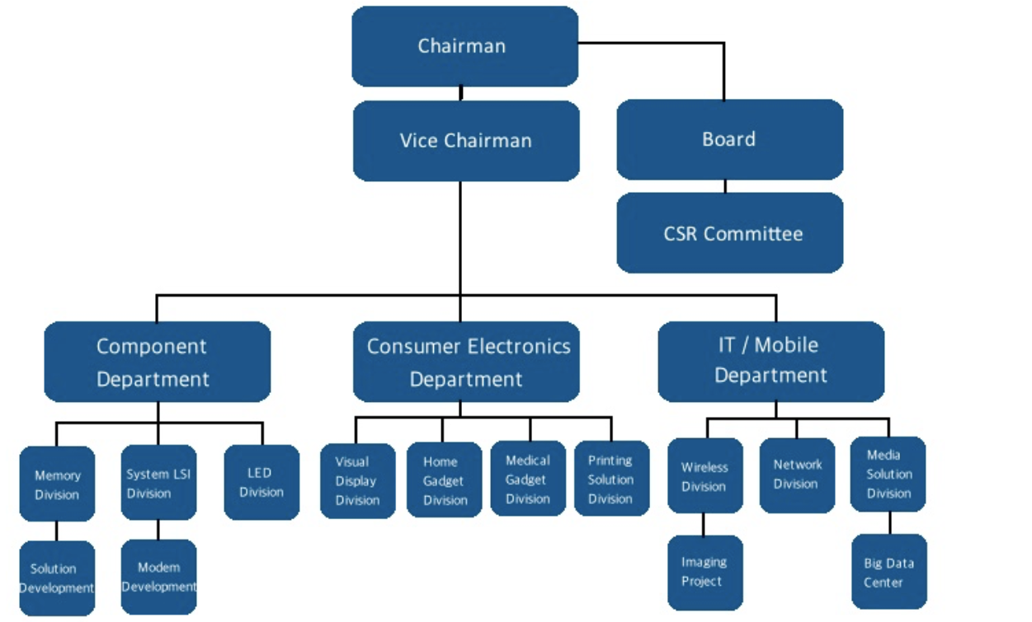
Figure 1.1 Organizational Structure of SEC
Source: (Jeong, 2013)
According to Forbes (2020), Samsung, an international employee and business organization all around the world, has been recognized as the number one in 2020 as one of the best employers in the world.
By the end of 2019, the SEC had 230 operating centres globally, including: production subsidiaries, sales subsidiaries, design, research and development centres.
According to Samsung “SUSTAINABILITY REPORT 2020” (2020), SEC currently employs 287,439 people worldwide.
Figure 1.2 shows how the number of employees varied from year 2009 to year 2020.
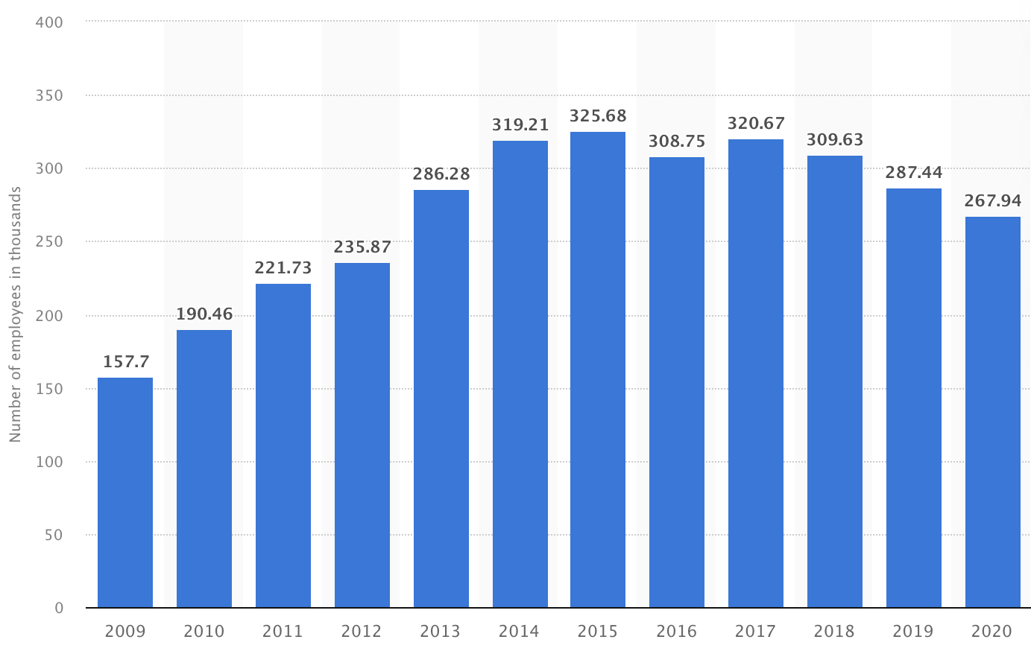
Figure 1.2 Number of Samsung Electronics employees worldwide from 2009 to 2020
Source: https://www.statista.com/statistics/236919/number-of-samsung-electronics-employees-worldwide/
- CHANGE MANAGEMENT

  - Change Management Approach
International Human Resource Management is known as an area that implements HR practices and theories internationally. Thus, the change management approach provides that in a dynamic and uncertain international environment, collaboration between IHRM and HRM is paramount in multinational enterprises (Davidson & Dean, 2019). The change management approach refers to the planning, initiation, implementation, control and stabilization of the change processes that take place at the corporate level, as well as at the personal level (Armstrong, 2009). Management changes are directed and implemented in order to provide strategies or personal development programs for employees.
- Strategic Change Management for the SEC Human Resource Department
According to Oliver Recklies (2001), two types of changes are known:
- Organizational development- which is based on contrasting the organizational objectives with the individual ones of the employees.
- Reengineering- which is also known as corporate transformation or business transformation. This is a form of change management that combines all the elements of the processes that have evolved over time.
Therefore, for the managerial change process to be successful, the manager or director of the Human Resource Department must be aware of the phases of the change process and what final result they want for this process. Sang Chul Jung (2014) states that the collapse of one of the global financial services companies, Lehman Brothers Holdings Inc., in 2008 has increased global competition in human resources, leading companies to adopt innovations and strategies in this area by implementing practices and HRM policies. However, in technology companies, such as the SEC, the need to implement a change management strategy is more necessary due to the dynamic and changing environment. Therefore E. Aldemir (2010) argues that strategic change models encourage organizations to implement the necessary steps in their system to achieve corporate goals.
Kotter's eight step model represents a change management model, focusing leadership on the model. The steps in Kotter's change model can be grouped into three categories:
- Generation.
- Consolidation.
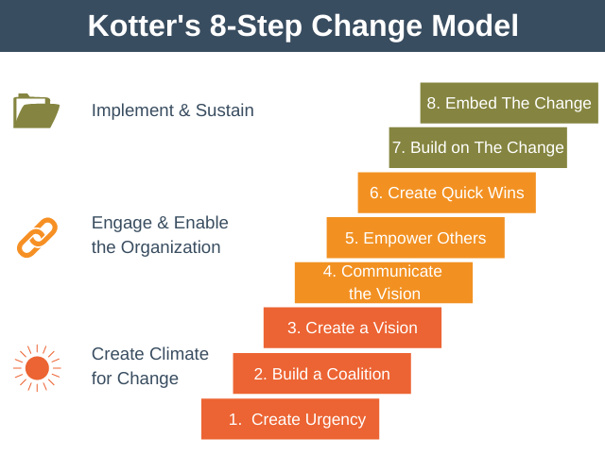
- Anchoring.
Figure 1.3 Kotter’s 8-Step Change Model
Source: https://expertprogrammanagement.com/2021/02/kotters-8-step-change-model/

Step 1. Create Urgency - The director of the SEC's human resources department must develop the motivation of the company's staff by communicating why it is important to sustain the cause of the business in order to achieve the company's objectives. The Human Resources Department should communicate to employees about opportunities and threats and receive feedback from them.
Step 2. Build a Coalition- In the context of this step, the HR manager should focus on providing training and developing a group of talented employees who would contribute to and promote change (Bailey , et al., 2018). This stage also focuses on the implementation of new processes such as recruitment, training and promotions that are associated with the culture of the organization. Samsung Company in order to ensure and support the continuous training and development of its employers, it has created a program for this purpose called Samsung Electronics Employee Relations Development (SEED) in 2017 (Samsung, 2020).
Step 3. Create a Vision- It is supposed to create and develop a vision towards the whole team of employees and to inspire the fact that the cooperation on this vision will take place together, forming a team (York, 2009). As part of this stage, the SEC's human resources should know the company's mission statement, which is "We will devote our human resources and technology to create superior products and services, thereby contributing to a better global society." (Samsung, 2020).
Step 4. Communicate the vision - During this stage, the team works on the vision and mission of the company, while leaders and managers are concerned with the changes that need to occur (Reed, 2017). Thus, Samsung needs to implement communication channels between employees and the management system, so that the communication of the vision takes place as frequently and as clearly and comprehensively as possible. Samsung, in order to reach the full potential of the human capital, must link its vision to everything inside the company, from the operations carried out by the staff to the culture of the company. Also, the SEC could create images with the results obtained after the vision was communicated and make a comparison, all these images could be distributed by email to employees to motivate them.
Step 5. Empower Others- Resistance to change can lead to obstacles when a team works together on the company's vision, but also in the team these obstacles must be removed so that the process of change does not stop. Currently, an obstacle that stands in the way of professional change and that influences the value chain of human resources is to stop the process of career growth after birth or the difficulty of developing in professional life. To this end, Samsung aims to provide equal employment opportunities for all gender representative and people with disabilities, regardless of race, age and gender, and considers this to be a corporate social responsibility (Samsung, 2016).
Step 6. Create Quick Wins- When small changes are made successfully, a small victory is created, so the entire team of employees will be motivated to achieve more performance (Crawshaw , et al., 2017). Therefore, the change processes within Samsung company must include the plans to improve the change as well as the remuneration and recognition systems rewards of the employees involved in the process of obtaining performance through change.
Step 7. Built on The Change- During this stage, several changes are made and produced. At this level, change is strengthened by motivation in encouraging responsibility for the change process. The victories of the changes declared too early, which are consolidated to be a failure are a cause that determines their repetition and extension (Sims, 2010). To this end, the human resources department should:
- to communicate to the employees what went well and what did not happen after each victory.
- setting more progressive goals.
Step 8. Embed the Change- The final stage of this change model involves ensuring that the change process is incorporated into the company's organizational culture. In order for the change process to be kept in common by employees, Samsung must recognize and honor the contribution of key employee members who contributed to the completion of the change.
Kotter’s eight step change model offers the advantage of being simple, thanks to the linear system the model provides a more predictable and easier to manage change process (Aldemir, 2010). On the other hand Duncan C. (2015) claims that one of the limitations of this model is that it refers only to organizational changes, not taking into account the personal transition that occurs with the change.
- Staffing: Retention
  - Importance of employee retention
Staff retention is the process by which employees are encouraged to remain in the organization for as long as possible (Vasantham & Swarnalatha, 2016). An innovative and correct employee retention system is a concern of the employer to create an environment that motivates employees through HRM practices and policies in the organization, which ensure that their needs are met. The retention of the key employees, of the qualified ones ensures the performance of the company by satisfaction of the clients, of the increase of the number of sales, by ensuring the collegial relations of work and well-established organizational knowledge. Also, the retention of the staff saves the company from additional expenses, but also from the efficient use of time, because the process of looking for, recruiting and training a new employee involves additional costs.
In Figure 2.1 attached below is shown an employee retention model.
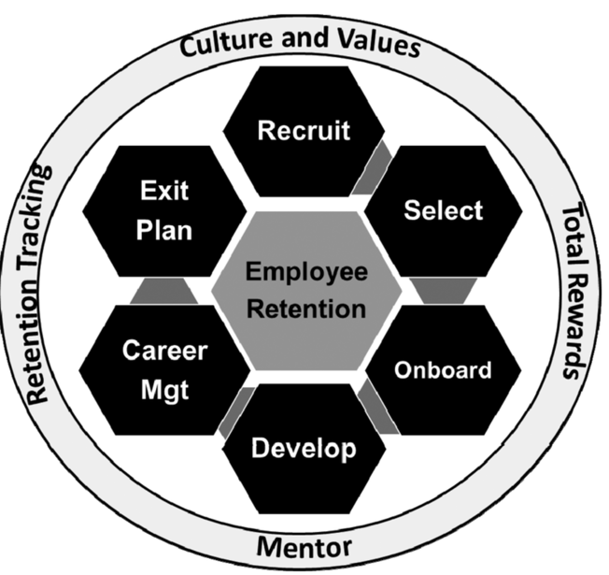

Figure 2.1 Employee Retention Model
Source: https://www.researchgate.net/figure/Employee-Retention-Model_fig1_301309341
  - Staffing: Retention strategies approached by Samsung Company
The IT industry is a dynamic one, which happens that once every 5-6 months a new technology appears and is to be developed to the public. Thus, Samsung pursues the retention of employees who already know how to cope with changes in the technological environment and to be in step with innovations.
One of the strategies implemented by Samsung in order to retain employees is reward and motivation. Remuneration and employee motivation is one of the most important strategies at the level of multinational companies. An adequate remuneration and motivation strategy will lead to an efficient recruitment and retention of human labour capital (Hume, 1995).
There are two methods of rewards within the SEC:
- Extrinsic rewards this type of remuneration involves the provision of incentives, such as bonuses, job security, company shares. Due to them, the staff is not only motivated to stay in the company, but also to achieve performance.
- Intrinsic rewards- It refers to the remuneration that takes an intangible form, and is manifested by appreciation, positive feedback from the manager, offering the chance to grow in the career, etc.
Another strategy staff retained by Samsung was to designate a flexible benefit portal in 2012 called Highlights, in collaboration with Thomsons Online Benefits, which allowed employees to access and apply for potential benefits. offered by the company. According to Samsung (2022), the company is providing at the moment the following benefits for its employees:
- Comprehensive healthcare.
- Work Life Success – helping to synchronize work and personal life.
- Financial wellness.
- Family first
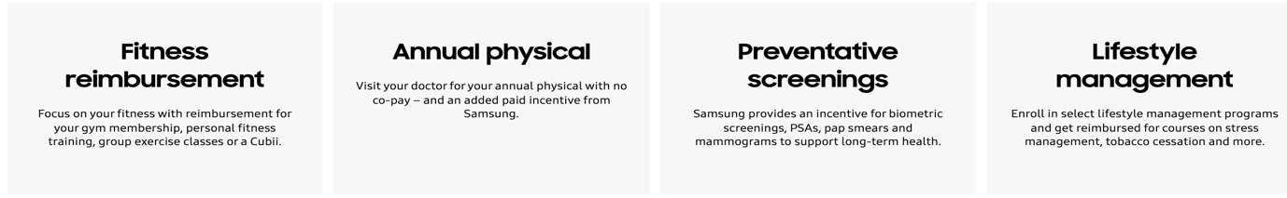
- Incentives
Figure 2.2 Incentives offered by Samsung
Source: (Samsung, 2022)
Another Samsung-led staff retention strategy is the implementation of Samsung's pensions communication campaign. Thus, in order to promote pensions, as a benefit offered by the company for employees, a "Pensions Champions" team was appointed, which was provided with adequate training with information sheets, so that it could further inform other employees (Crawford, 2014).
- Leadership development
  - Leadership development framework
Jingjing Wang (2014) states that leadership can be defined as the performance of an individual to influence, motivate and make others contribute to the efficiency, and performance of the organization to which they belong.
According to National Minority AIDS Council (NMAC) (2015) there are eleven principles of Leadership:
Figure 3.1 Principles of Leadership
Source: (National Minority AIDS Council, 2015)

Leadership development represents the process by which potential employees are trained through various managerial methods to fill vacant senior positions (Ryan, 2008).
Figure 3.2 attached below represents the differences between management and leadership.
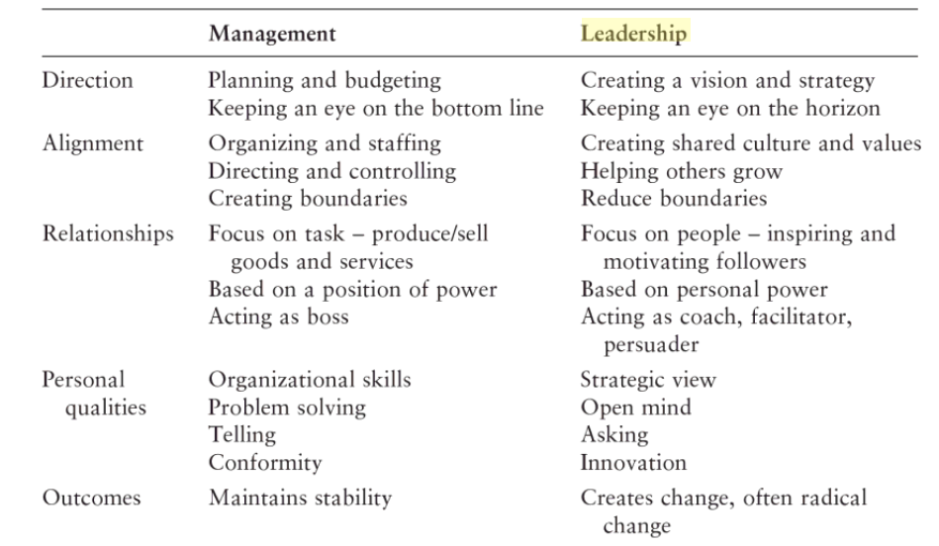
Figure 3.2 Difference between management and leadership
Source: (Ryan, 2008)
  - Leadership Development approached by Samsung Co.
Samsung Electronics' main goal is to maintain global leadership. Samsung Co. employees bbenefit from specially developed programs to stimulate the improvement of driving skills. Thus, (Samsung Engineering, 2016) confirms the fact that a set of efficient tools are put at the disposal of human resources to ensure the sustainable development and growth of the corporation.
The development strategies and programs of the Leadership Development for Managers implemented within the SEC are:
- Developing Personal Leadership
- Problem Analysis and Decision Making
- Implementing the Delegation Process
- The Coaching Process
- Handling Mistakes
- Conflict Management
- Manage Change Effectively
- Striving for Continuous Improvement

Through the Samsung Leadership Program, employees are offered opportunities to become expert leaders in research and development, marketing, sales, service, logistics, production, and business management.
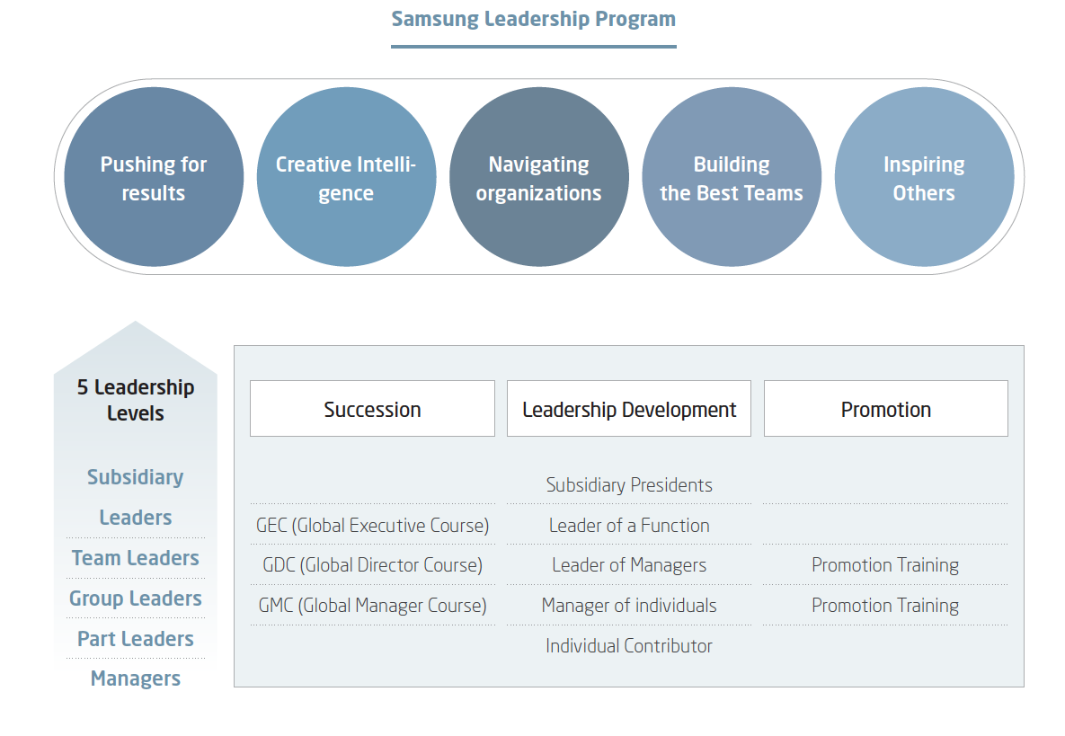Figure 3.3 Samsung Leadership Program
Source: (Samsung, 2016)

Conclusion
Multinational companies such as Samsung Electronics are part of a dynamic economic and technological environment, always prone to change. In this sense, a studied aspect that would generate competitiveness are the human resources of the company. Thus, the Human Resources Department must establish theories, practices and policies that would generate the creation of an efficient working capital.
The HRM and IHRM areas of concern transposed to Samsung in this report were:
- Change Management.
- Staffing: Retention.
- Leadership Development.
In a short context, it can be concluded that change management models generate steps and practices that could easily be taken over by the human resources manager and implemented to create a better understanding of the company's vision and the changes to be achieved. missions to be achieved.
Staffing: Retention strategies implemented by Samsung are beneficial in order not only to motivate and retain existing employees, but also to recruit new talent from the market capital of human resources
Due to the implementation of a Leadership Development program, SEC is an effective competitor in the technology market.

Recommendations to make the human resources capital of Samsugn Company feel appreciated and that it belongs to the vision and mission of the company
- The use of several change management models that could be implemented, one of which is the ADKAR model.
- Better communication of the staff about the vision and mission of the company, by establishing and training a certain group of employees to be responsible for their communication to other staff.

Bibliography

Armstrong, M., 2014. Armstrong's handbook of human resource management practice.. 13th ed. London: Kogan Page.
Bach , S. & Edwards, M., 2013. Managing Human Resources : Human Resource Management in Transition. 5th ed. Hoboken, New Jersey: John Wiley & Sons, Incorporated.
Schuler, R. S., 2009. International human resource management.. 3rd ed. Abingdon [England] ;; New York, NY :: Routledge.
Yaw , A. D. & Smith, I. G., 2003. Globalization, Employment and the Workplace: Diverse Impacts. 1st ed. London; New York: Routledge.
Chun, J., 2015. STUDYLIB. [Online]
Available at: https://studylib.net/doc/8218255/how-samsung-electronics--organizational-structure-and-cul...
[Accessed 02 January 2022].
Samsung, 2020. Samsung Newsroom Canada. [Online]
Available at: https://news.samsung.com/ca/samsung-electronics-ranks-top-five-in-interbrands-best-global-brands-2020-recognized-by-forbes-as-one-of-the-worlds-best-employers
[Accessed 02 January 2022].
Jeong, J., 2013. The New Organizational Chart of Samsung Electronics (삼성전자새조직도), Japan: Money Today.
Forbes, 2020. WORLD'S BEST EMPLOYERS. [Online]
Available at: https://www.forbes.com/lists/worlds-best-employers/#7a3abcee1e0c
[Accessed 02 January 2022].
Samsung Corpotation, 2020. SAMSUNG ELECTRONICS SUSTAINABILITY REPORT 2020. [Online]
Available at: https://images.samsung.com/is/content/samsung/p5/uk/aboutsamsung/pdf/Sustainability_report_2020_en_F.pdf
[Accessed 02 January 2022].
Davidson, P. & Dean, C., 2019. Positioning Change Management and International Human Resource Management, Brisbane: Academia.edu.
Armstrong, M., 2009. Armstrong's Handbook of Management and Leadership: A Guide to Managing for Results. 2nd ed. London: Kogan Page.
Recklies, O., 2001. Managing Change – Definition und Phases in Change Processes, Berlin: THEMANAGER.ORG.
Jung, S. C., 2014. The Analysis of Strategic Management of Samsung Electronics Company through the Generic Value Chain Model. International Journal of Software Engineering and Its Applications, 8(12), pp. 133-142 .
Aldemir, E., 2010. Models and Tools of Change Management: Kotter’s 8 Steps Change Model, s.l.: ResearchGate.
Samsung, 2020. Samsung Research. [Online]
Available at: https://research.samsung.com/news/SEED-Samsung-Electronics-Employee-Relations-Development
[Accessed 02 January 2022].
Bailey , C., Mankin , D., Kelliher , C. & Garavan, T., 2018. Strategic Human Resource Management. 2nd ed. Oxford: Oxford University Press.
York, K. M., 2009. Applied Human Resource Management : Strategic Issues and Experiential Exercises. 1st ed. Los Angeles: SAGE .
Samsung, 2020. Samsung. About Us. [Online]
Available at: https://www.samsung.com/levant/about-us/company-info/
[Accessed 02 January 2022].
Reed, S. M., 2017. A Guide to the Human Resource Body of Knowledge (HRBoK). 1st ed. New Jersey: John Wiley & Sons .
Samsung, 2016. SAMSUNG SUSTAINABILITY REPORT 2016. [Online]
Available at: https://images.samsung.com/is/content/samsung/p5/uk/aboutsamsung/SAMSUNG_SUSTAINABILITY_REPORT_2016_ENG-PEOPLE.pdf
[Accessed 02 January 2022].
Crawshaw , . J., Budhwar, P. & Davis, A., 2017. Human Resource Management : Strategic and International Perspectives. 2nd ed. London: SAGE.
Sims, R. R., 2010. Reforming (Transforming?) A Public Human Resource Management Agency : The Case of the Personnel Board of Jefferson County, Alabama Cover one. 1st ed. Charlotte, North California: Information Age Pubblishing Inc..
Cartlidge, D., 2015. Construction Project Manager's Pocket Book. London; New York: Routledge.
Vasantham, S. & Swarnalatha, D., 2016. NEED AND IMPORTANCE OF EMPLOYEE RETENTION IN ORGANIZATION RELATED TO HUMAN RESOURCE MANAGEMENT. New Delhi: Laxmi Book Publication.
Hume, D., 1995. eward Management: Employee Performance, Motivation and Pay. 1st ed. New York: Wiley.
Samsung, 2022. Samsung Careers. [Online]
Available at: https://www.samsung.com/us/careers/benefits/
[Accessed 02 January 2022].
Crawford, R., 2014. Employee Benefits. [Online]
Available at: https://employeebenefits.co.uk/issues/november-2014/samsung-evolves-benefits-strategy/
[Accessed 03 January 2022].
Wang, J., 2014. Globalization of Leadership Development : An Empirical Study of Impact on German and Chinese Managers. 1st ed. Bayreuth: Springer .
National Minority AIDS Council, 2015. LEADERSHIP DEVELOPMENT, Washington: National Minority AIDS Council (NMAC).
Ryan, R., 2008. Leadership Development: A Guide for HR and Training Professionals. Oxford, UK: Routledge.
Samsung Engineering, 2016. SAMSUNG ENGINEERING SUSTAINABILITY REPORT, s.l.: Samsung.
Samsung, 2016. SAMSUNG SUSTAINABILITY REPORT 2016 PEOPLE, s.l.: Samsung.

