

  - Module: Application Development
  - Lecturer: Dr Kemi Ademoye
  - Program: BSc/HND Computing
  - Submission Deadline: 9th December 2019
  - Student Name: Ruzy Aktar
  - Student No. 1708215
Introduction
For this module the author will be creating a responsive website, using Bootstrap, JavaScript and CSS. The website should be adaptable to use on devices such as mobile phones, tablets, and a web browser when minimizing the screen. A responsive website should allow users to view all the content on the page when viewing on a small screen or web browser if making the screen smaller.

Application Development Concepts
Application development is the process of designing, building, and implementing software applications. It can be done by massive organizations with large teams working on projects, or by a single freelance developer. Application development defines the process of how the application is made, and generally follows a standard methodology. [1]
Application development have a lot of elements, this means thoroughly thinking about what the size is for the programme. However, also what procedures needed.
An appealing website should be able to do numerous tasks, such as the images must be clear for their vision. Also, the colors that are used must be a good contrast to be able to read text as well as getting the viewers interest.
To make sure this application is put into action the author has explored all the requirements such as design fundamentals, which then must be implemented in the authors application.

Design Principles
Good web design always caters to the needs of the user. Each page of your website needs to have a clear purpose, and to fulfill a specific need for your website users in the most effective way possible [2].
This includes the layout that’s ideal for the person viewing the page. As well as text and color. This also includes any JavaScript that is used for interactive feature designs. When doing this the author must think of individuals who may have any disabilities e.g. vision. A picture can speak a thousand words, and choosing the right images for your website can help with brand positioning and connecting with your target audience[2]

Mobile first
A “mobile-first” approach involves designing a desktop site starting with the mobile version, which is then adapted to larger screens (contrary to the traditional approach of starting with a desktop site and then adapting it to smaller screens) [3].
Mobile devices are now the primary means by which users are accessing Web sites, and the number of people using sites on mobile devices is projected to triple within the next year. Today, smartphone sales have actually surpassed personal computer sales [4].
Overall, creators who come up with website ideas must think about individuals who are always busy, meaning every website must be responsive to view on mobile phone devices and navigation must be tailored to fit on mobile phone screens.

Purpose
Initially all websites must have a purpose otherwise it will be hard to gain viewers attention as it will have no worth to them. If the contents of the website don’t match then it will look unprofessional as well as leaving viewers confused.

Colors
Colors on a web page must have good quality contrast, this is important to viewers as they will be the ones loading the web page on their mobile phones or computers.
Well, one of the first things that designers learn about when pursuing their new career, is the concept of “colour theory”. For the uninitiated, colour theory is a combination of art and science that focuses on the way the human brain responds to certain combinations of colour. It addresses not only the practical nature of colour, such as how one hue can make part of a website stand out, but also the psychological impact of different tones and images.
When it comes to designing a website, colour is just as important as usability and navigation. [5]

Navigation
Menu navigation exists to help us find content and it should be simple and intuitive. When looking at a website, our expectation is to navigate with ease and have a great experience. Primary navigation should stand out and be consistent throughout the site. Typically, a main menu will sit along the top of the page in the centre or aligned to the left or right of the page. Another way of identifying a main menu is the way it is treated: the main menu is usually designed to contrast against everything else so that your eye is easily drawn to it. [6]

Usability and User Experience
Usability experience initially means how the viewer interacts with the website. Such as, users should find it very simple when using a design interface. They should be able to accomplish their goal when visiting the website e.g. shopping, university research etc.

Requirements
The purpose of the author’s website is to advertise her home baking business. She will be using JavaScript, HTML, CSS. Target audience for the website will be individuals looking to purchase sweet treats for their own desires or venues that need dessert catering. The website will be called ‘Rosays’. The author thought of this when thinking of her own name and implementing it to a catchy phrase. All the contents on the website have a relation to the topic of the website. And have a useful interface adaptable on a mobile phone.
The pages on the website are called
- Home
- About
- Cakes
- Treats
- Events
- Contacts

Design
The design the author has opted for is mobile first. The author has made her website this so her website would bond with mobile devices. This then is good for in the future for individuals to view on bigger devices such as computers.

Colors
The individuals using the website will notice the background of the website is a light pink color. This is done for aesthetics, this is executed for visual pleasing. However, it is also done to give it a feminine feeling to the website allowing users to know it is a woman behind the baking.

Student Purpose
Purpose is to allow users to notice the author is a home baker, who has created 6 pages with all the required information, that allows her to advertise her business.

Student Navigation
The student has used a simple navigation bar at the left-hand side of the page. This is done to allow users to see the bar as soon as they enter the page and it is easy to view.


However, to make the navigation bar responsive the author has added a drop-down navigation bar for users who may wish to use this on their smaller screens.

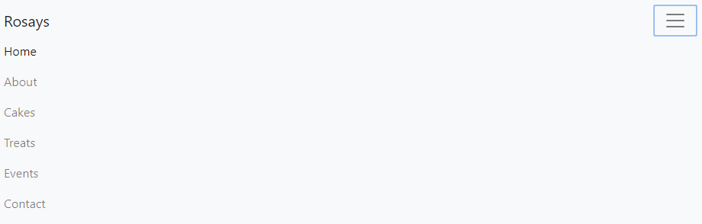
Code below has been used to implement this.

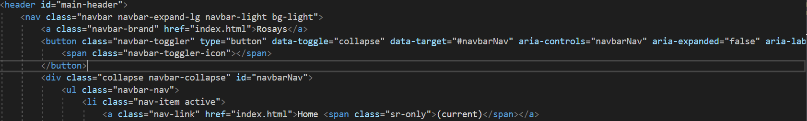

Implementation
The author has used JavaScript this is done on the second page called ‘Cakes’. The author has opted for this idea because she has laid out her cakes on a grid in rows and instead of having all the descriptions underneath she has used an onClick element.
JavaScript is an interpreted programming language still it simplifies development of complex web applications by allowing the developers to simplify the application’s composition. The developers can use JavaScript libraries to create DOM boundaries. This shadow DOM further makes web browsers deliver documents with widely used HTML tags like select, div and input. [8]
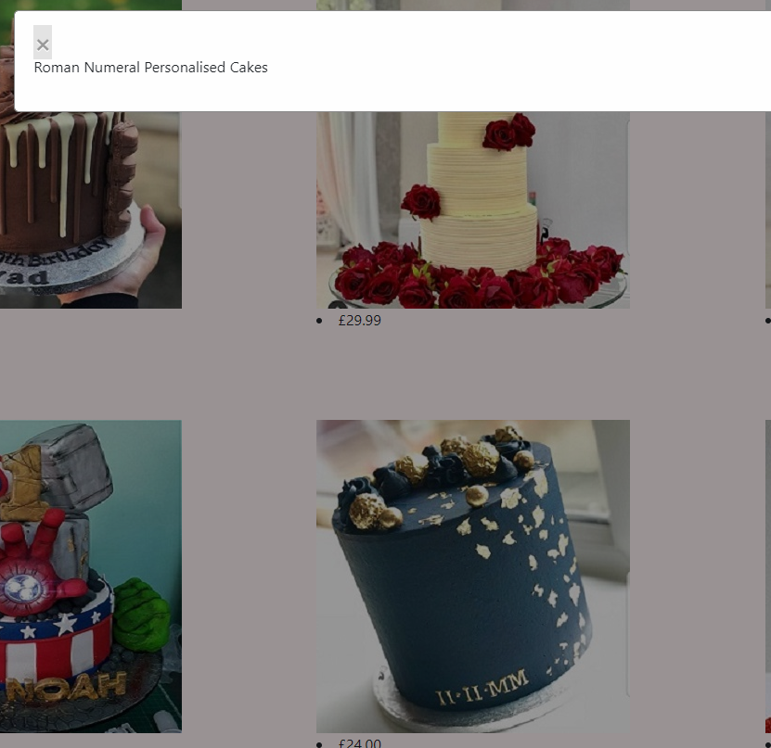

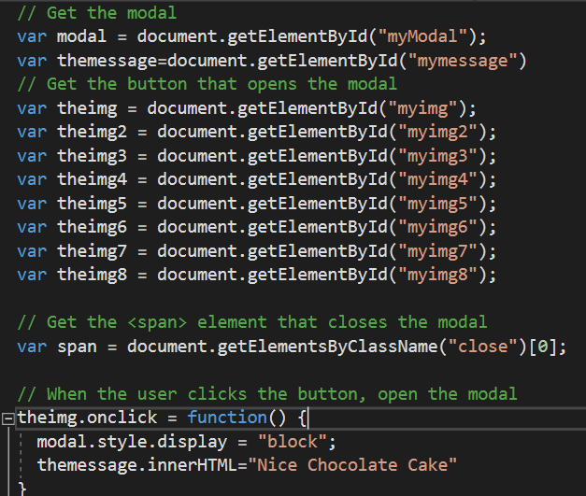

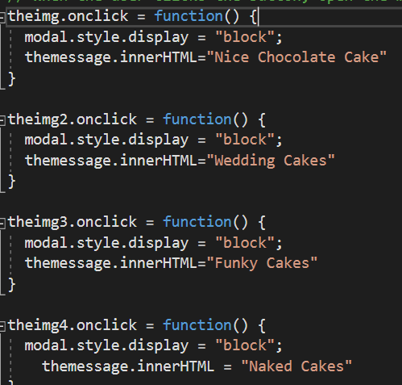
To implement this, she has used this code. The Modal plugin is a dialog box/popup window that is displayed on top of the current page [7]. Some parts of the modal code have been researched and used but additional code has been implemented inside to make the whole task work. Such as, below you can see I have added a message to correspond with the HTML page which is the next picture.

Below as you can see I named each picture by a number so the computer knows which picture needs the onClick message. Each picture must have a different number otherwise the programme won’t know which want to focus on.
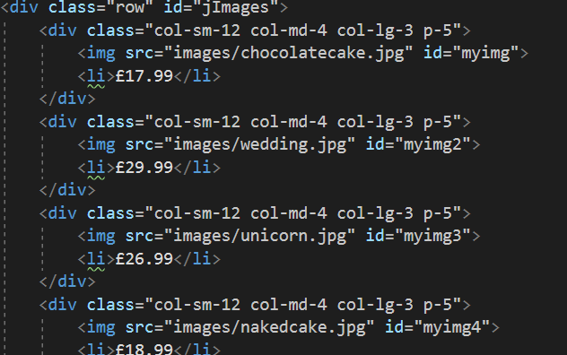

Another feature I have added is the Rose icon, the author has chosen a rose because her name is Rosiey and for her home baking business she has named it Rosays which sounds like a rose.
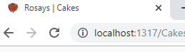
Below is the code the author has used to insert her icon. This just shows where the icon comes from within the image file.

Footer
The author has added a footer where the information about the author is e.g., who is the creator of the website. Below are pictures and the codes used to implement this.
This is an example of what all websites will look like with a header and footer.

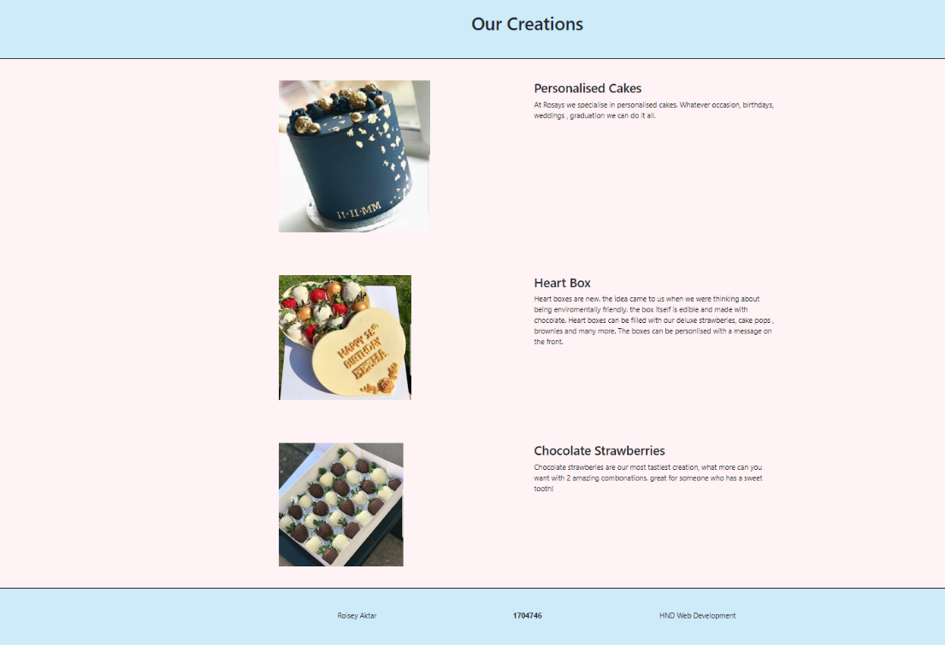

And this is the coding behind the footer
Footer
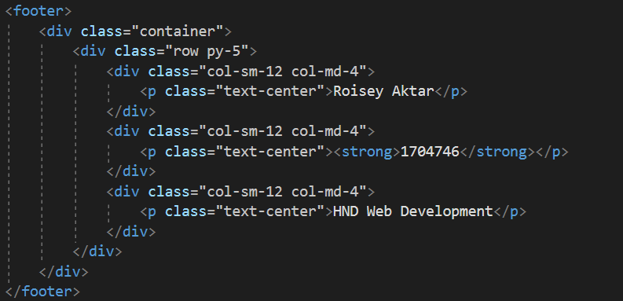

Below is the code used to make the blue border. Which relates to the Css file.
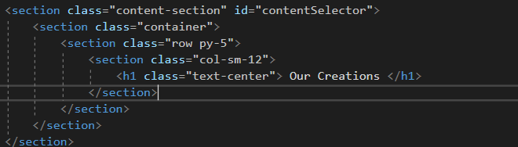

References
- https://kissflow.com/rad/types-of-application-development-methodologies/#
- https://shortiedesigns.com/blog/10-top-principles-effective-web-design/
- https://www.atinternet.com/en/glossary/mobile-first/
- https://www.uxmatters.com/mt/archives/2012/03/mobile-first-what-does-it-mean.php
- https://fabrikbrands.com/website-colour-schemes-colour-in-website-design/
- https://www.butterfly.com.au/blog/design/10-steps-for-better-website-navigation
- https://www.w3schools.com/bootstrap/bootstrap_modal.asp
- https://torquemag.io/2018/06/why-millions-of-developers-use-javascript-for-web-application-development/

marking criteria and Student FEEDBACK

This section details the extent to which the assessment criteria are demonstrated by you, which in turn determines your mark. The marks available for each category of skill are shown. Lecturers will use the space provided to comment on the achievement of the task(s), including those areas in which you have performed well and areas that would benefit from development/improvement.

Common Assessment Criteria Applied (Assignment 1) | Marks available | Marks  awarded
1. Engagement with Literature Skills

Unfortunately the submitted research is not what the assignment brief asked you to research and demonstrates poor engagement with essential reading and little evidence of wider reading. Please ensure that you read the assignment brief carefully in future and verify anything that is unclear with your lecturer. Expand the scope of references to further improve your research work. (Grade mark: 4.00%) | 25 | 1
2. Knowledge and Understanding Skills

3. Cognitive and Intellectual Skills

Unfortunately the submission does not really include the required work for this section. Please read the assignment brief carefully. (Grade mark: 5.00%) | 20 | 1
4. Practical Application Skills

A good attempt featuring a simple website with well-thought out content and some very basic JavaScript. No API has been used. For your JavaScript, learn how to refactor repeated code into a reusable function with parameters for what varies. A fair attempt at achieving a responsive design, but the layout of the Cakes page needs to be revisited. (Grade mark: 50.00%) | 50 | 25
5. Transferable Skills for Life and Professional Practice

he report is satisfactory but generally does not meet the requirements of the assignment brief. See your report for additional comments. Also, learn how to rephrase the content from reference sources in your own words as your Turnitin similarity score was on the high side. (Grade mark: 40.00%) | 5 | 2

Assignment Mark (Assessment marks are subject to ratification at the Exam Board. These comments and marks are to give feedback on module work and are for guidance only until they are confirmed. ) | Late Submission Penalties (tick if appropriate) |  | 29%
 | Up to 1 week late (40% Max) |  | 29%
 | Over 1 week late (0%) |  | 29%

