Serena Jonathan (2306363)
2306363@student.uwtsd.ac.uk
ACCA6028: Socket Programming and Concurrency Implementation
Assignment 2 – Chat Application

Contents
Introduction 2
System Design 2
Username System 3
Public Messaging 4
Private Messaging 4
Online User List 5
Join and Leave Notifications 6
Multithreading 7
Error Handling and Best Practice 7
Limitations 7
Conclusion 8

Introduction
This project involved the development of a multithreaded networked chat application using C++ and Winsock2 socket programming. The application was designed using a client-server architecture to allow multiple users to communicate simultaneously through a console-based interface.
The project was developed within Microsoft Visual Studio using two separate projects under one solution: a server application and a client application. The server is responsible for managing connections and distributing messages, whilst the client allows users to connect and communicate with one another.
The application demonstrates low-level socket communication, concurrent processing through multithreading, and real-time message transmission between connected users. Additional functionality such as usernames, online user viewing, and private messaging was also implemented to extend the overall scope of the project.

System Design
The application follows a client-server architecture. The server manages all incoming client connections and distributes messages between users, whilst clients connect to the server in order to participate in the chat.
TCP sockets were implemented using the Winsock2 library. TCP was selected instead of UDP because reliable communication and ordered packet delivery are important within a messaging application.
The server listens on port 54000 for incoming connections. Whenever a client connects, the server creates a dedicated thread responsible for handling communication with that user. This allows multiple clients to communicate simultaneously without preventing the server from accepting additional connections.
A mutex was implemented to ensure thread-safe access to shared resources such as the connected client list and username map. This prevents race conditions when multiple threads access shared data simultaneously.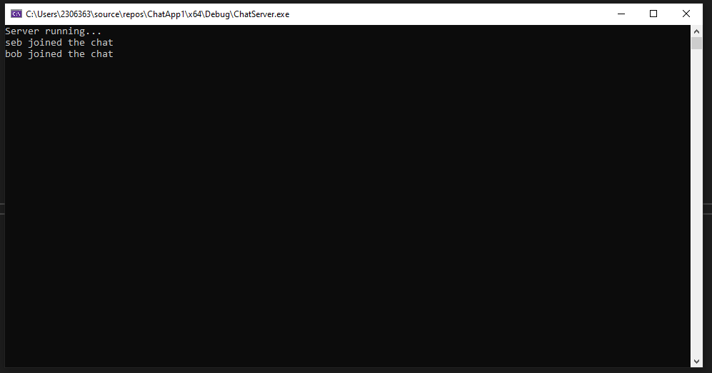Figure 1: Server application accepting incoming client connections.

Username System
A username system was implemented to improve communication clarity between connected users. When a client initially connects to the server, the first message sent is interpreted as the user’s chosen username. The username is stored by the server and associated with the corresponding client socket. All future messages are then displayed alongside the sender’s username. The server also sends out notifications whenever users join the chat room. This improves awareness of currently active users.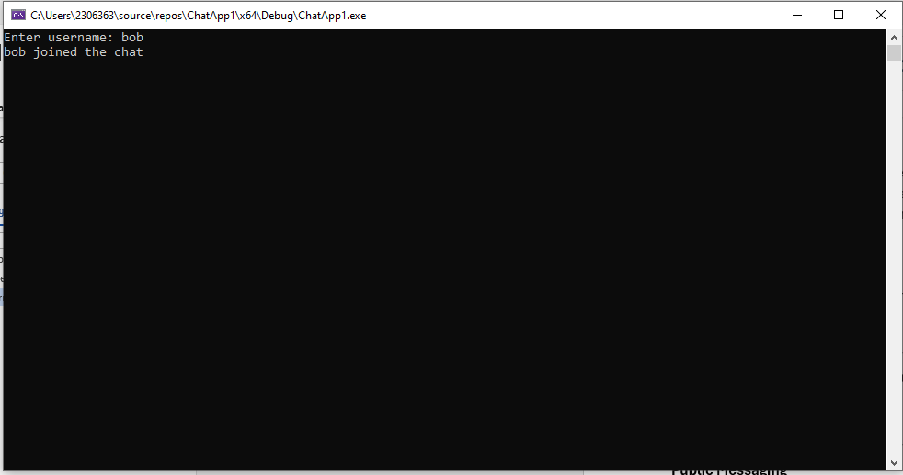Figure 2: Client applications connecting to the server using usernames.

Public Messaging
The application supports public messaging between all connected users. When a client sends a message, the server receives the data and broadcasts it to every other connected client. The broadcasting system was implemented using a vector containing all currently connected client sockets. The server iterates through this collection and distributes the message individually to each client. This functionality demonstrates real-time communication and server-side message distribution.

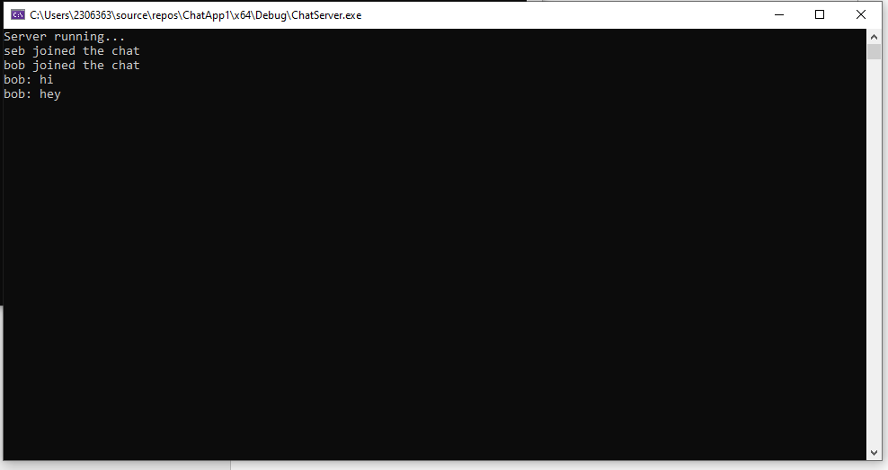Figure 3: Public message broadcasting between connected clients.

Private Messaging
An additional feature implemented within the application was private messaging. This allows users to communicate directly with a specific individual user rather than broadcasting messages to the entire chat room. Private messaging was implemented using the /pm command in the following format:
/pm username message
When the command is detected, the server identifies the target username and sends the message only to the selected recipient. This feature demonstrates string parsing, conditional logic, and selective socket communication.

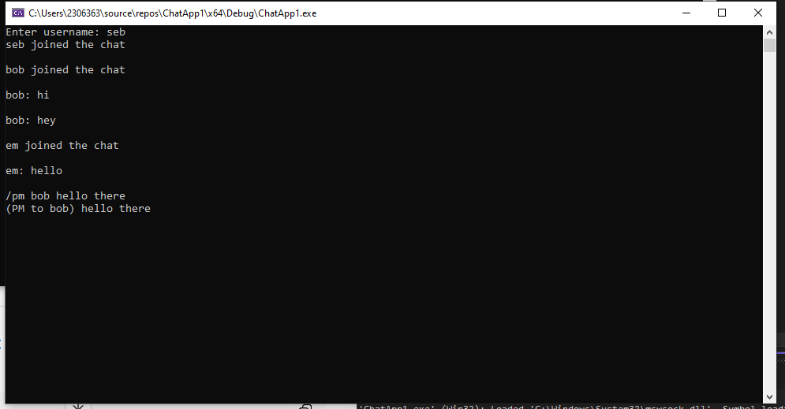Figure 4: Private messaging functionality using the /pm command.
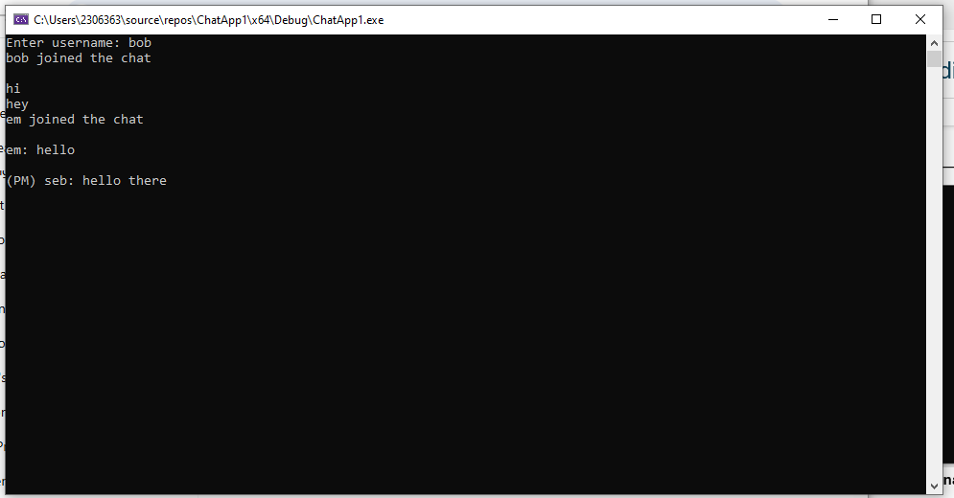
Figure 5: Private message function successful.

Online User List
The application includes a functionality allowing users to view currently connected clients through the /users command. When the command is entered, the server loops through the stored username map and returns a list of connected users to the requesting client. This improves usability and demonstrates dynamic server-side data handling.

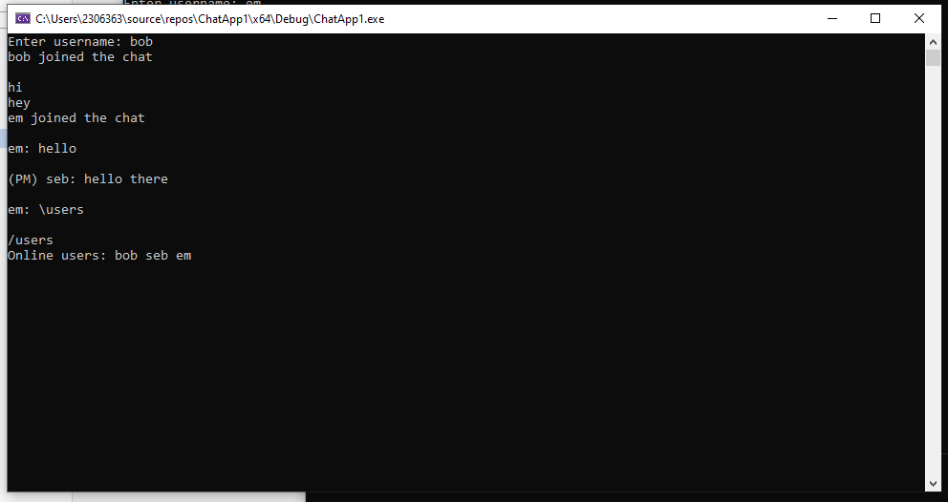 Figure 5: Online user list displayed to a connected client.

Join and Leave Notifications
The server broadcasts notifications whenever a user joins or leaves the application. This improves user awareness and creates a more interactive environment. When a client disconnects, the server removes the associated socket and username from the active collections before notifying the remaining users. Proper cleanup of disconnected clients helps prevent invalid socket references and improves application stability.
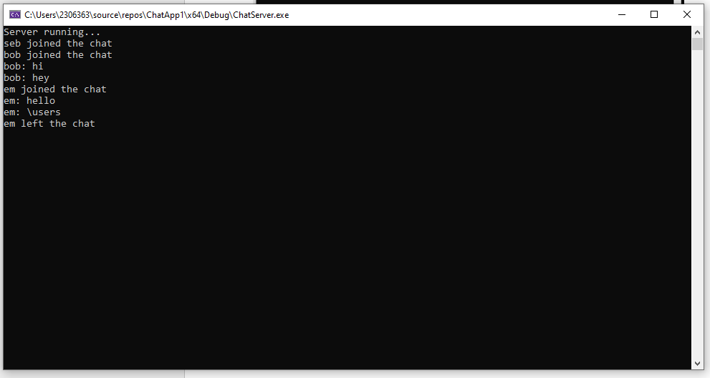
Figure 6: Server notification when a user disconnects from the application

Multithreading
Multithreading formed an important component of the application design. Without multithreading, the server would only be capable of processing one client at a time, resulting in blocking behaviour and poor scalability. Each connected client is managed within its own detached thread. The client application also uses a separate thread to continuously receive incoming messages whilst allowing users to continue typing outgoing messages. To ensure thread safety, mutex locking was implemented whenever shared resources were modified. This reduced the likelihood of race conditions and improved overall reliability.

Error Handling and Best Practice
Basic error handling was implemented throughout both the client and server applications. When a client attempts to connect to the server, the connection result is validated and appropriate feedback is displayed if the connection fails.
The server also monitors for client disconnections using the recv() function. If zero or fewer bytes are received, the server assumes the client has disconnected and removes them from the active user collections.
Several networking best practices were also considered during development. The codebase was separated into client and server applications to improve readability and maintainability. Functions were divided according to responsibility, such as message broadcasting and client handling, creating a more modular structure.
Lastly, TCP sockets were selected instead of UDP because reliable communication and ordered packet delivery are essential within a messaging application.

Limitations
Although the application successfully achieved its objectives, several limitations remain.
Firstly, the application currently uses a console-based interface, which is less visually appealing than a graphical interface. Secondly, the system currently operates only on localhost (127.0.0.1), meaning communication is limited to the local machine.
The application also lacks encryption and authentication features, meaning messages are transmitted in plain text. Finally, message persistence was not implemented, so messages are lost once users disconnect or the server closes.

Conclusion
In conclusion, this project successfully demonstrated the implementation of a multithreaded networked chat application using C++ and Winsock2 socket programming. The final system supports multiple simultaneous users, public messaging, private messaging, online user management, and join or leave notifications.
The project provided practical experience with socket programming, multithreading, concurrency control, and client-server architecture. Overall, the application meets the core requirements of the assignment, and provides scope for further development and improvement.

