Pojarnicu Cristina Andreea (1814440)

Presentation on team-working

TUCKMAN’S 5 STAGES OF DEVELOPMENT GROUP
&
GROUP DYNAMICS

In 1965 the psychologist Bruce Tuckman proposed the 5 stages of team development named: ‘Tuckman’s Stages for a Group’ each of this stage help member of a group to build up a team by different characteristics. Tuckman said that these stages are necessary for a team to grow to project plans, to know how to resolve a problem, to know how to find the solution, to plan the work and to get the results that they expected.
The team development model explain that during this stages the team develops maturity , ability , integrity and team leader change leadership style. (Free-management-ebooks.com, n.d.)

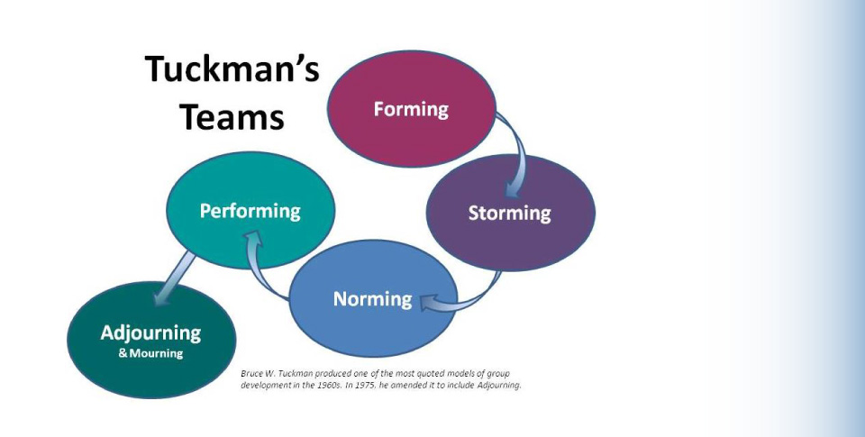

FORMING STAGE

On the first stage called FORMING the team has just been introduced and each member of the group is polite and excited to start something new and get to know each other. This stage is about building up relationships with the members of the group and start to: identify roles, project skills, identify the responsibility of each member of the team. On the first stage the attention is focused more on people and the communication between them, that on the work. Into the FORMING STAGE the team are focused only to the leader guidance. An example of FORMING is when people get a new job where they don’t know none inside of that company and they must face with the 5 stages of Tuckman theory. (Toggl.com, n.d.)

STORMING STAGE
Into the second stage the team know already each member of the group and now their point of view changed, and conflict is coming out. Each team instead to be focused on their tasks, they are more focused on the impression that they make for the other member of the group. During this stage into the team the members are feeling more confident to express their opinion even is none is asking for it that is why important that the manager or the team lead into the position has to remind them who is the leader. (The Happy Manager, 2017-2019)

NORMING STAGE
If the team arrived at the NORMING stage, means that team members accept their position and start to appreciate their team members’ strengths. Into this stage each member of the group working to contribute to achieve the goals of his team and they start to develop a problem-solving process. Norming stage is about harmony, mutual respect and trust between the team members. The leader/manager of the team as to become a mentor for the team and be careful that the team doesn’t spend to much time on unnecessary task. (Toggl.com, n.d.)

PERFORMING STAGE
If the team arrived at the PERFORMING stage means that the members has developed all the skills necessary for teamwork such as communication, organisation, time management, problem solving , decision making , creativity. Into the fourth stage team member already know each one role and duties and the team has a high autonomy and the members look after each other to be sure that each of their duties help the team to achieve the final goal. (Businessballs.com, 2019)

ADJOURNING STAGE
In 1975 Tuckman refined his theory and added the last stage know as adjourning or deforming. This stage is about the break-up of the group where each member has to move to new things and try different experience. An example is when people must leave their job to star a new one or maybe has to move into different departments and they will need to star again from the first stage. (Businessballs.com, 2019)
GROUP DYNAMICS
Group Dynamics Definition

‘’Group dynamics is a set of behavioural and psychological processes that occur within a social group or between groups. It refers to the "nature of groups, the laws of their development, and their interrelations with individuals, other groups, and larger institutions" (Cartwright and Zander, 1968). (Kbmanage.com, 2009-2018)
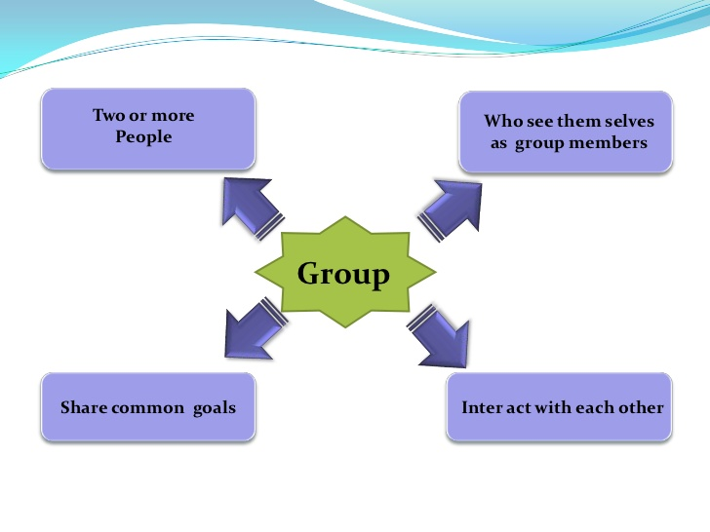
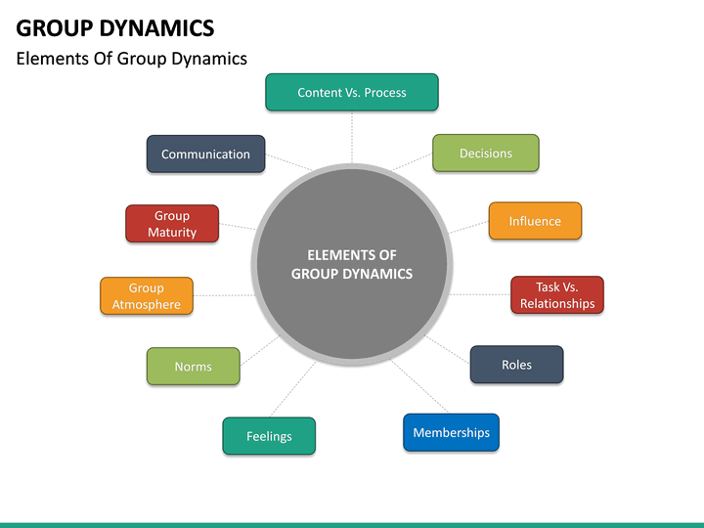

Reference list
- Toggl.com. (n.d.). 5 Stages of Team Development. [online] Available at: https://toggl.com/stages-of-team-development/ [Accessed 8 Jun. 2019].

- Free-management-ebooks.com. (n.d.). Bruce Tuckman's Stages for a Group. [online] Available at: http://www.free-management-ebooks.com/faqld/development-02.htm [Accessed 8 Jun. 2019].

- The Happy Manager. (2019). Teamwork Theory | Tuckman's Stages of Group Development. [online] Available at: https://the-happy-manager.com/articles/teamwork-theory/ [Accessed 9 Jun. 2019].

- Businessballs.com. (2019). Tuckman: Forming, Storming, Norming and Performing - BusinessBalls.com. [online] Available at: https://www.businessballs.com/team-management/tuckman-forming-storming-norming-performing-model/ [Accessed 9 Jun. 2019].

- Kbmanage.com. (2019). Group Dynamics - What is it? Definition, Examples and More. [online] Available at: https://www.kbmanage.com/concept/group-dynamics [Accessed 9 Jun. 2019].

