Q. Critical evaluation and review of one museum exhibition
The British Museum
The British Museum was built and founded in 1753, and when it opened it was largely made up of objects from the collection of Sir Hans Sloane. The Sloane collection contained 160 ancient Egyptian objects which has formed a cornerstone of the museum from its inception. The collection today is one of the biggest assemblages of these cultural artefacts outside of Egypt, which were obtained during the British campaign of Egypt after the defeat of Neapolitan’s Army and were taken to the museum in 1802. The Egyptian collection within the British Museum is divided into five different rooms; for the purpose of this review the ‘Early Egypt’ room, located on level 1 of the British Museum, will be the main focus of the analysis. However, it is also evident that to analyse the collection properly we must also consider the general details of the other rooms.
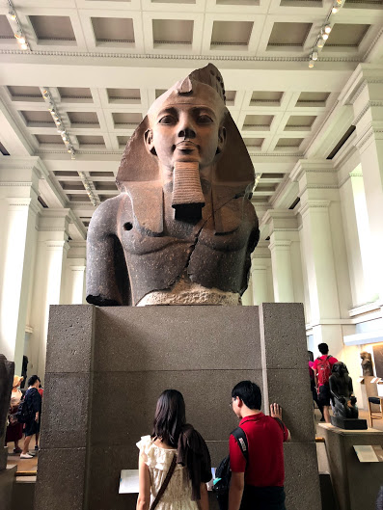
The sculpture gallery located on the ground floor adjacent to the ‘Great Court’ is the biggest room of Egyptian antiquities within the museum, with most of the largest pieces being displayed here. One of the museum’s most important objects, the Rosetta Stone, is housed within the sculpture gallery and attracts millions of visitors each year. This gallery is a great representation of the magnificent building works of the ancient Egyptians as it displays countless items, including a head fragment of a colossal statue of Ramesses II (see Fig. 1) as well as sections of pillars from the Temple of Karnak. When venturing upstairs to the majority of the Egyptian collection the first room in a succession of four rooms that visitors meet is the Egypt and Nubia collection. This gallery displays ancient Egypt’s connection to its neighbouring culture and civilisation, that was at times throughout history considered as part of Egypt itself. A significant part of this collection is a wall painting denoting the battle of Kadesh.
Figure 1: Ancient Egyptian Sculpture Gallery, British Museum. (2019) Author’s Own Image.

The next room which visitors encounter is the early Egypt exhibit which represents Egypt as it was from pre-history until the building of the first pyramids, which roughly translates to pre-dynastic times till 3rd dynasty Egypt. Following the early Egypt room patrons to the museum enter the gallery ‘Egyptian Death and Afterlife: Mummies’. This gallery is made up of various mummies, coffins, funerary objects and other aspects that would have been used by ancient Egyptians for their journey to the afterlife. The final ancient Egyptian room is named ‘Egyptian Life and Death’, the focal point of this room being the tomb chapel of the Egyptian noble, Nebamun. This room is made up of sections of wall painting, and after much conservation work are now displayed together within this gallery and are used to allow the public to see what an idealised Egyptian life would be.
Moreover, the ‘Early Egypt’ gallery is by far one of the most interesting in the collection, as not only is it not the conventional ideology of ancient Egypt in museums, it sheds light on other aspects of Egyptian culture. The main purpose of this exhibition is to suggest to visitors that ancient Egypt has more to offer than death, afterlife and pyramids. This gallery’s main focus is on life in pre-dynastic Egypt through to the building of the first pyramids. The gallery is made up of sixteen cases, with ten surrounding the walls of the gallery and six freestanding cases spaced out throughout the room. Each case within the gallery is well spaced out allowing the patrons of the museum to move freely around the room, combined with the natural sunlight being allowed into the room through many panelled windows on the ceiling of the gallery. Both the space and the natural light encourages patrons to visit the room as it contrasts with the aesthetic in all the other Egyptian rooms in the museum.
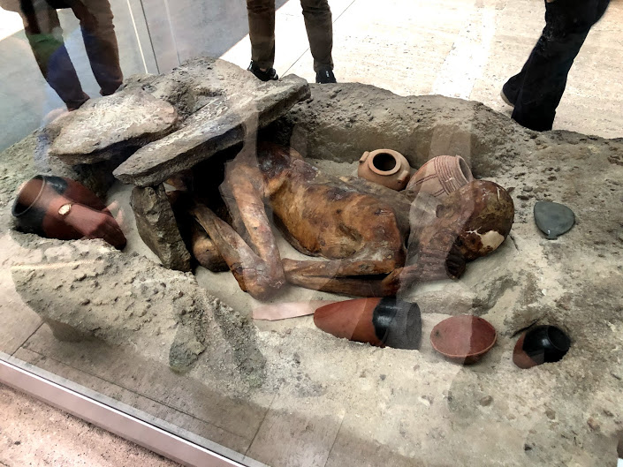
The most interesting objects within this collection are a replica of the Narmer palette, which is one of the most significant objects within ancient Egyptian history as it is seen by many Egyptologists and academics as the moment of unification of Egypt. The palette depicts the pharaoh Narmer unifying the two states of Upper and Lower Egypt as one, by smiting the enemy which in Egyptian iconography is considered the most important role and symbol of the pharaoh; it connotes this person is able to be the protector of Egypt and to ensure the right order of Maat. Another significantly important object within this exhibition is the display of the Gebelein Man. The mummy of the Gebelein man is nicknamed ‘Ginger’, and the mummified remains are the earliest example of natural mummification found in Egypt to date. This man was discovered in the small village of Gebelein, buried in a small dug out hole in the sand placed in the foetal position, with stone slabs placed on top of the burial which has been partly reconstructed within the gallery of the British Museum. The remains were naturally mummified due to the extreme dryness and heat of the surrounding dessert, although the burial was simplistic it contained a number of grave goods such as pots, pottery dishes and other everyday life items of ancient Egypt.
Figure 2: Gebelein Man Burial, British Museum. (2020) Authors Own Image.
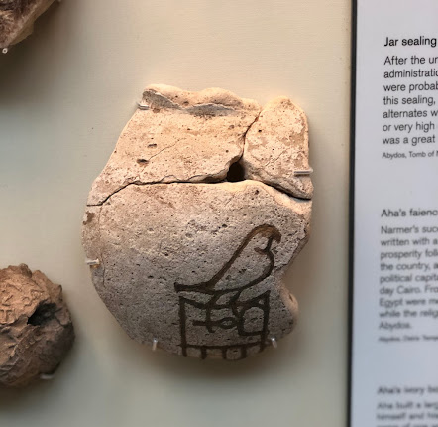
My personal favourite of these objects is a pottery fragment with the name of the ancient pharaoh of Egypt, Aha. The reason for this selection is that we know very little about the earliest rulers of ancient Egypt. The image we see on this fragment is known as a serekh, which is an early example of a cartouche in which the royal name of the Pharaoh would be recorded. The word ‘serekh’ comes from the ancient Egyptian word meaning façade, which is evident as the bird in figure 3 is placed on top of a palace façade. The earliest form of the Egyptian language is still by and large unexplained, this example along with a small number of others containing the earliest form of hieroglyphs gives us more insight into one of the world’s first written languages.
Figure 3: Faience Pot Fragment, British Museum. (2020) Authors Own Image.
The technical and constructed aspects of this exhibition also allow it to have an impact on the patrons that visit this collection. Each case has a number of descriptive labels as well as numbers added to each object allowing the visitors to easily follow the collection and find out as much information as possible. Audio guide numbers are attached to each case within the exhibition, which gives a more detailed description of different items within the case. The main interactive attraction within this gallery is an autopsy table of the Gebelein Man, which allows each visitor to see the different layers of the remains. While analysing the gallery it became evident a number of children and families were specifically attracted to the table as it allows individuals to take a step further into the investigation of the exhibit.
Furthermore, the exhibition has many strengths and weakness. The most significant strength of this gallery as a whole is the amount of information present for each object: not only does each object have a single label explaining what it is and where it came from, but also a variety of separate labelling has been added to allow the audience a fuller picture on the case as a whole. Another important aspect of this collection which allows it to stand out from the other Egyptian rooms in the British Museum is the use of a time line, which is used to explain to the audience different important events within the pre-dynastic period of Ancient Egypt, such as the first evidence of individuals settling in the desert and the first example of pottery making and other craftsmanship.
The collection as a whole has many strengths as it consists of a wide variety of objects that cover various aspects of daily life within ancient Egypt, such as tools, pots and containers, religious objects, and personal items. However some weakness within this collection must also be considered, specifically the lack of explanation as to how ancient Egypt transitioned from pre-dynastic time, which some may consider simple way of life, to the grandeur that is associated with ancient Egypt today.
In conclusion, the ‘Early Egypt’ exhibition in the British Museum is a great example of the use of a wide variety of objects to allow the audience to contemplate additional aspects of this remarkable civilisation that is outside of the conventional public perception of ancient Egypt. The gallery is effective as it uses a variety of different mediums to educate all types of audiences within the exhibition, ensuring that is accessible and allows the intended message to become obvious to all the patrons. Overall this gallery is a great example of an exhibition that allows each individual to have a memorable experience and learn something they possibly did not previously know.

Bibliography

Cavendish, R. (2009) ‘The British Museum Opened’, History Today, Vol. 59, No. 1, P. 13–14
Yasaitis, E, K. (2006) ‘Collecting Culture and the British Museum’, Curator, Vol. 49, No. 4, P. 449–463

Cavendish, R. (2009) 13-14
Yasaitis, E, K. (2006) 449–463

