Student Name: Carys Myfanwy Williams
P Number: 1802348
Programme of Study: BA Illustration
Module: ADAD4010
Word Count: 1602
Lecturer: Julia Lockheart, Ryan Moule, Scott L Smith, Gwen Beynon, Rob Jones, Martin Bush

“Curating could be about making the impossible things possible” (Hans Ulrich Obrist, 2014). I am going to be curating a fashion show. The fashion show will be based around sustainable materials and use illustrations based on nature to create beautiful clothing design. This is to raise awareness for climate change and animal endangerment issues which is a highly potent subject area at the moment and something a lot of people feel strongly about. As a result, I believe it would attract large audiences, male and female from a variety of backgrounds. “The fashion exhibition has taken precedence and certain institutions have gained scholarly and popular acclaim for their shows” (Annamari Vӓnskӓ and Hazel Clark, 2018) and because of this I would like to hold my fashion show in a large, open space, by doing so I would be able to fit large numbers of people in the venue to watch the show.
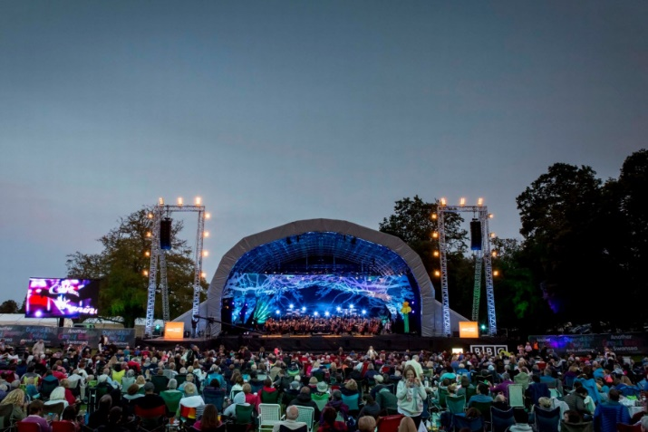
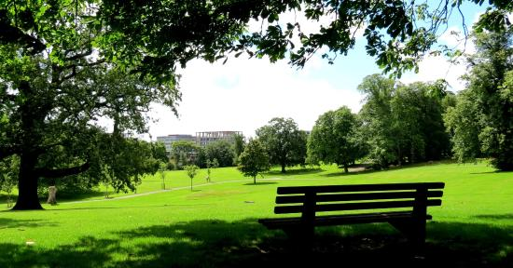
I considered British Fashion Council’s own show space -180 The Strand, London. However, I then decided it would be much more in keeping with the sustainable fashion show, to hold the event in a local and outdoor location, widely available to the public and with a much vaster space to work with. Holding the show outdoors also connects viewers much more to nature and their own environment and really enables them to visualise and take on board any small changes they could personally make to their lifestyle which would impact the planet in a positive way. I believe that holding the event in Singleton Park would suffice. Singleton Park, being local to the area, holds a “strong sense of place” (Relph, 2007) and relationship with the public, which would increase likelihood of community motivated change, which is the aim of the sustainable show, to educate and showcase eco-friendly alternatives to popular ‘fast fashion’ - “small steps add up to big shifts” (Greta Eagan, 2014)

Singleton Park has been used for various large events and concerts but can also provide a relaxed and peaceful environment with beautiful scenery and will undoubtedly trigger many memories and unconscious impressions with local people who will feel a connection to this place, as their home. I believe it is a great opportunity to curate a show based heavily on perception of place; since the show is being held outdoors, there is so much more going on around you than there would be in an exhibition or show held in a single room. I am pleased with my choice of venue because it is different to other fashion shows - “Under no circumstances do what everyone else was doing” (Hans Ulrich Obrist, 2014) – I want to promote the idea of sustainability and recycling to the public and inspire them with my fashion designs to create, “if more of us picked up the lost art of sewing… we could all be our own fashion designers” (Elizabeth L. Cline, 2012).

“equally eventful are the journeys we take” (Casey, 1996). I’d like to think about the journey from place to place in regards to the catwalk. The model is in a different place at the start and the end of catwalk. They are taking ‘journeys’ back and forth between those places, showcasing designs. What can I do, to make sure that the model takes the audience on their personal journey up and down the catwalk? What can I do to ensure that this ‘journey’ down the catwalk is exciting and memorable for the audience? Firstly, the product must be eye-catching and appealing, the product namely being the clothing on display, which is what most people would consider to be the ultimate product and objective of a fashion show. However, the product could also refer to the space that the audience are occupying, since this entire show is in many ways a product, something that has been designed/curated, produced and is then being consumed by the public. It is therefore just as important to focus on the design of place and reality as it is to design the inanimate objects/product - the clothing in this case - in order to create a vivid and memorable all-round experience for the viewer. I think that in addition to the already natural, green space that Singleton Park offers the fashion show, it’s important to mix human interaction to create a “spirit of place” (Relph, 2017), a distinctive identity for this fashion show held in singleton park. I believe the venue could benefit from displaying simple slogans/signs with memorable sentences or lexis relating to recycling and sustainability in order to get the underlying point of the show across to the audience and prompt a reaction.

I have thoroughly researched materials and resources that are sustainable and leave a low carbon footprint. ‘Fast fashion’ has made clothing easily accessible and cheap. Most High Street fashion stores stock clothing made using synthetic fibres and mass-production methods, creating low quality garments which subsequently lead to large textile waste. Since synthetic fibres don’t degrade properly, this is putting massive strain on waste management and as a result, filling landfills with copious amounts of fabrics that we cannot get rid of.

The aim of the sustainable fashion show is to showcase various designs of clothing that are made using sustainable materials, dyes and methods that don’t damage the environment and raise awareness for the greener alternatives to the general high street and online ‘fast fashion’ retailers.
The main issues with textiles made from cheap synthetic materials are the chemical processes involved in the making of them. Although even natural material such as cotton can cause more damage to the environment than people realise, due to the farming methods needed to grow vast quantities for the textile industry. Insecticides, pesticides and fertilisers are sprayed onto non-organic cotton crops and the high volumes of water used on crops are washing the chemicals into bodies of water and causing a process called eutrophication which occurs when water is overly enriched with minerals, causing excess growth of algae on the water surface. This in turn begins blocking sunlight and starts depleting oxygen levels in the water rapidly, this can destroy the entire ecosystems in lakes and ponds and decrease biodiversity. Since Pesticides are poisonous, they are also affecting nearby residents and cotton farmers, who are usually located in developing countries and many people have died as a result of contaminated water and cancer from exposure to high levels of chemicals.
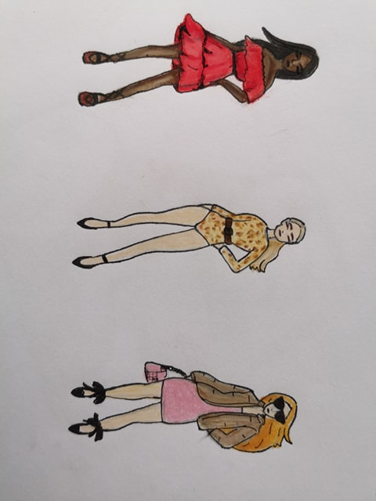
Some eco-friendly fibre alternatives I have looked at for use on clothing shown at my fashion show are organic cotton, hemp, bamboo and animal fibres such as wool and silk. Furthermore, all clothing will be dyed earthy colours, in keeping with the theme of sustainability and nature, using only natural plant and vegetable dyes.

Figure 1- Three illustrations showcasing sustainable design sketches (Carys Williams, 2019)
I designed these based on animal prints and earthy, natural colours which can be easily obtained from vegetable and plant based dyes. They are just an example of the types of clothing that can be manufactured using sustainable methods and show that eco-friendly clothing only has to differ from ‘fast fashion’ in regards to the reduction of waste and environmentally toxic production methods.

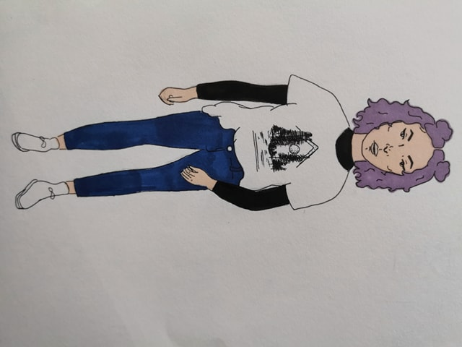

Figure 2 – Illustration of girl wearing sustainable T-shirt design (Carys Williams, 2019)
I designed this t-shirt as an example of how various illustrations could be used on plain t-shirts, made from organic cotton for example. This particular design relates to nature (forest, trees, moon) but a wide range of illustrations could be used, such as different landscapes or animal portraiture.
I have researched designers for inspiration on the types of clothing I would like to include in my fashion show;
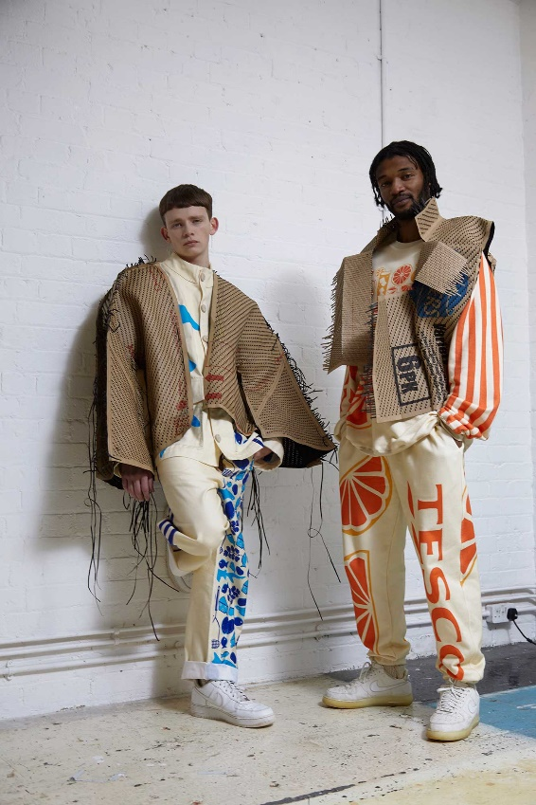
Figure 3- Breadline collection by Bethany Williams “We want not just to comment on a community, but work in their social spaces to try to create a change through furthering economic gain for charity… The current collection ‘Breadline’ particularly wants to highlight and help find solutions to the hidden hunger in the UK, specifically working alongside the Vauxhall Food Bank and Tesco to achieve this. We have developed an exchange of fresh fruit and vegetables (from Tesco) for waste items from the food banks users household. We have developed a collection using these waste materials, plus recycled cardboard and ‘Tesco everyday value’ branded organic prints, all donated by Tesco” (Bethany Williams- sustainable fashion designer)

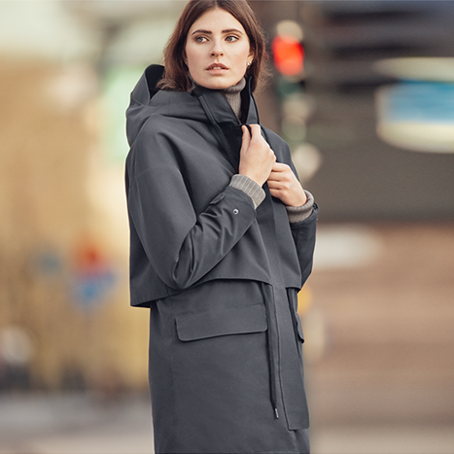
Figure 4 – Tretorn is a brand that produces many different types of clothing and outerwear such as parkas made using recycled PET bottles and consumer plastics and jackets created from discarded fishing nets, Tretorn clothing is 100% sustainable and made for longevity. Yet looks no different from day to day high street clothing.
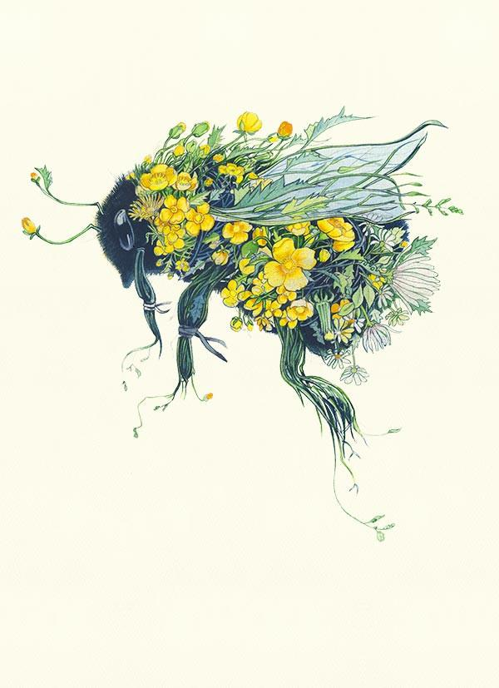
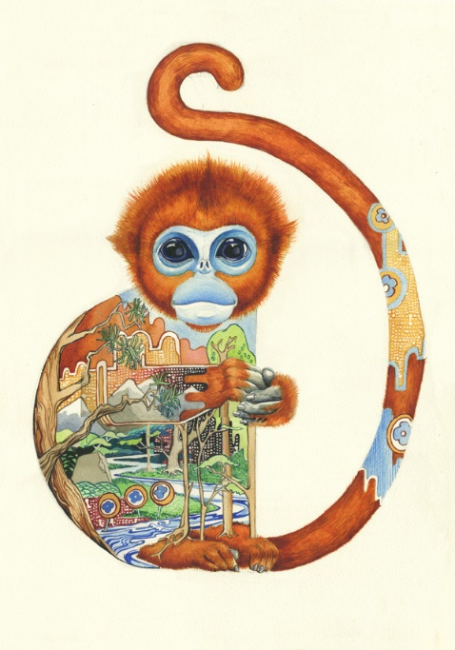
I have also researched Illustrators for designs/ design inspiration and examples of what could be included on the clothing displayed in the fashion show;
Figure 5 and 6- I discovered artwork by an illustrator called Daniel Mackie, who paints animals in watercolour paint with their natural habitats inside their bodies. I’ve chosen to include his artwork as I believe it relates well to the underlying issues that I would like to cover in my fashion show.
Considering all the aspects of research together with my own ideas and design, I believe that I am well equipped to produce the fashion show. I believe it will cover the notions of importance of space and place in regards to curatorship and provide the viewer with an immersive experience in a surprisingly natural, relaxed environment. It is something I believe to be different to traditional fashion shows and I believe it could play a vital role in change for the environment.

Bibliography

Annamari Vӓnskӓ and Hazel Clark (2018) – Fashion Curating: Critical Practice in the Museum and Beyond
Edward Casey (1996) – How to get from space to place in a fairly short stretch of time: phenomenological prolegomena -https://www.academia.edu/13590861/How_to_Get_from_Space_to_Place_in_a_Fairly_Short_Stretch_of_Time
Edward Relph (2007) - Techné: Research in Philosophy and Technology, Spirit of Place and Sense of Place in Virtual Realities -https://doi.org/10.5840/techne20071039
Elizabeth L. Cline (2012) – Overdressed: The Shockingly High Cost of Cheap Fashion, Penguin
Greta Eagan (2014) – Wear No Evil: How To Change The World With Your Wardrobe, Running Press
Hans Ulrich Obrist (2014) – Ways of Curating, Penguin
Jessica Davies (2019) Harpers Bazaar - https://www.harpersbazaar.com/uk/fashion/what-to-wear/g19491797/the-best-and-still-chic-sustainable-brands/
Marianne Izen (2016) – WJEC biology for A2, Illuminate Publishing
Sarah Butler (2018) The Guardian- https://www.theguardian.com/business/2018/dec/29/fast-fashion-giving-way-sustainable-wardrobe
Yi-Fu Tuan (1977) – Space and place: The Perspective of Experience, University of Minnesota Press

Artwork and Design References
Bethany Williams (2019) – Figure 3, http://www.bethany-williams.com
Carys Williams (2019) – Figure 1, Three illustrations showcasing sustainable design sketches, Pen and coloured Pencil
Carys Williams (2019) – Figure 2, Illustration of girl wearing sustainable T-shirt design, Pen and Promarker
Daniel Mackie, artist (accessed 2019) – Figure 5 and 6, Monkey and Bee Illustration
Tretorn (2019) – Figure 4, https://eu.tretorn.com

